

Programme: Master of Business Administration
Module: Marketing Management
Module code: LCMB7024
Assignment Title: Assessment component 1: Marketing Environment Analysis

Name: Yagnik Bharatbhai Bhakhar
Student ID: 2431085

Word Count: 2576
Table of Contents
Task 1: External marketing environment analysis 3
1.1 Introduction 3
1.2 Overview of the macro-environmental factors 4
1.3 Factor 1: Technological advancements in the EV industry 4
1.3.1 Industry-level impact 4
1.3.2 Impact on pioneer company (Tesla) 4
1.3.3 Impact on follower company (BMW) 6
1.3.4 Critical Evaluation of opportunities and threats 6
1.4 Factor 2: Environmental regulations and sustainability policies 6
1.4.1 Industry level impact 6
1.4.2 Impact on pioneer company (Tesla) 7
1.4.3 Impact on follower company (BMW) 7
1.4.4 Critical Evaluation of opportunities and threats 7
1.5 Summary 8
Task 2: Market response and strategic evaluation 8
2.1 Introduction 8
2.2 Marketing response by Tesla and BMW 9
2.3 Comparative evaluation between Tesla and BMW 10
2.4 Comparative evaluation: Pioneer vs Follower 11
2.5 Strategic Success and limitations Assessment 11
2.6 Conclusion 12
Reference List 13

Task 1: External marketing environment analysis
1.1 Introduction
Electric vehicle (EV) is one of the fastest growing and changeable industries in the world economy due to the implementation of the technology and the demands of the regulations aimed at the environmental sustainability. The world EV market, estimated as US$993.0bn in the year 2025 worldwide for the management of the industry (Statista, 2025). In this rapidly developing sector, Tesla is an innovative organisation, leading in terms of technological and strategic achievements, and BMW is a follower organisation, modifying its long-standing experience in the automotive market to become an electric player. The companies both work in the environment, which is highly affected by the fast technological development and strict environmental conditions, that prominently affect the marketing, production, and the strategic decisions of the companies. This section critically looks at these two macro-environmental factors and how they affect pioneering and follower firms in the EV industry.
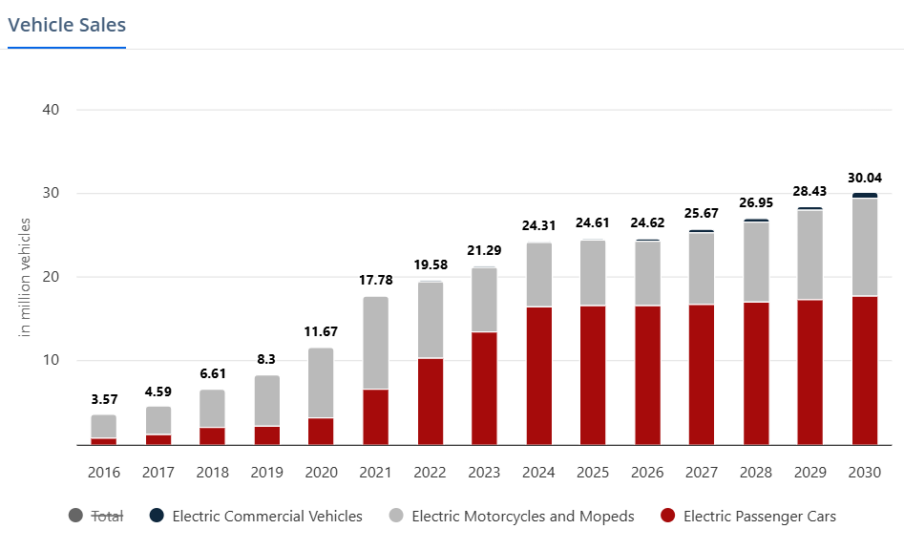
Figure 1: Sales of vehicles all over the world
(Source: Statista, 2025)
1.2 Overview of the macro-environmental factors
The external marketing environment refers to the macro-level forces that are not directly controlled by an organisation, but define the market environment, consumer behaviour, and competitive strategy (Forliano et al., 2025). Among the PESTEL elements, which affect the EV industry, the technologies and environmental aspect is the most significant influence on the industry. The innovations in the battery performance, vehicle range, and autonomous driving are technologically promoted, and the manufacturers are subjected to environmental regulations that require them to comply with sustainability and emission-reduction objectives. All this reinvents the competitiveness in the industry and marketing strategies of both Tesla and BMW.
1.3 Factor 1: Technological advancements in the EV industry
1.3.1 Industry-level impact
The EV industry has been based on technological innovation. Advances in battery chemistry, especially the lithium-ion and new solid-state technology have significantly increased energy density, car range, and charging time (Yu et al., 2023). The International Energy Agency observes that the price of batteries has dropped by more than 80 percent since 2010 and EVs are becoming more competitive than internal combustion engine (ICE) automobiles (IEA, 2025). In addition, advances in artificial intelligence (AI), self-driving, and integration of Internet of Things (IoT) have transformed consumer demands towards intelligent and connected cars.
The resulting technological advancement has increased the market demand of technologically aware and environmental conscious customers forcing automakers to focus on research and development (R&D) as one of their major marketing differentiators. The growing use of digital capabilities, including updates over the air and predictive maintenance, not only indicates a change in value propositions based on products but also the technology. Unlike traditional petrol or diesel-powered vehicles, EVs are not responsible for polluting the environment with harmful pollutants. EVs currently have a higher upfront cost and limited driving range compared to traditional vehicles, although these factors are rapidly improving with technological advancements.
1.3.2 Impact on pioneer company (Tesla)
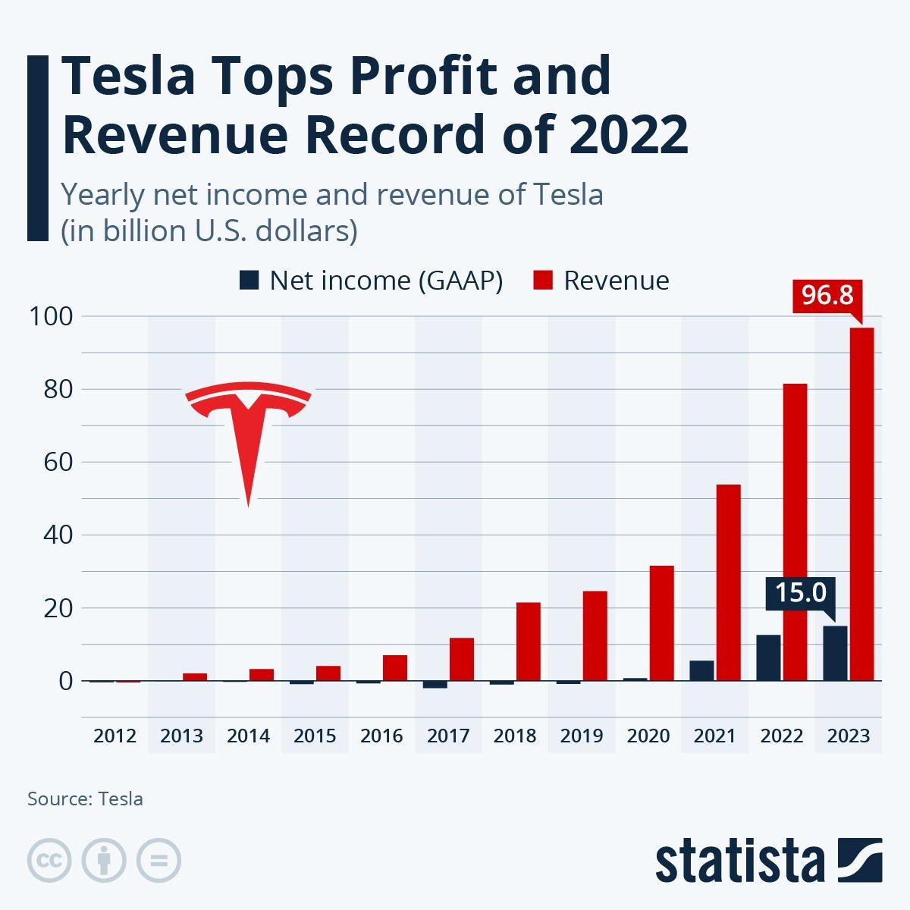
Figure 2: Profit rate of Tesla globally
(Source: Statista, 2025)
Being a new organisation, Tesla has made use of technological innovation as its core competitive and marketing resource. This is because of the Tesla company ever investing in proprietary battery technology and its Gigafactory network, making it possible to achieve economies of scale and cost benefits in large-scale production (Tesla, 2024). Autopilot and Full Self-Driving (FSD) systems at Tesla only make it more of a leader in software-based mobility innovation. In terms of marketing, Tesla uses the strategy of disintermediation, which avoids the use of the established dealerships in control of customer experience and information, and directs to the digital technologies of such interaction (Medium, 2020). Tesla’s innovation strategy is deeply rooted in its mission to accelerate the world’s transition to sustainable energy. Tesla adopts a holistic approach which integrates advanced technology, a culture of continuous improvement, and a willingness to take calculated risks.
1.3.3 Impact on follower company (BMW)
BMW, on the other hand, being a follower organisation, was more conservative in its transition strategy in the beginning. Its strategy of Power of Choice gave customers the options of ICE, hybrid, and all-electric (BMW Group, 2024). Although this diversification move served to keep the company its current customers, it also weakened its initial visibility in the EV market. The technological reactions adopted by BMW have resulted in in-modular electric platforms and incremental battery development as opposed to radical innovation. Autonomous cars are expected to dramatically reduce accidents caused by human error and enhance traffic flow, ultimately leading to safer and more efficient roads. But new trends like the Neue Klasse platform and driver-assistance systems portray that BMW is putting increased efforts to bridge the innovation gap. This shows the future of BMW technology is intrinsically linked with autonomous driving. Such a revolutionary approach to mobility has the significant impact to reshape road safety and transform the overall driving experience.
1.3.4 Critical Evaluation of opportunities and threats
Innovation brings both opportunities and threats to both pioneers and followers. In the case of Tesla, the high rate of innovation helps it to maintain the first-mover advantage but puts it under pressure to constantly be a leader in the technological disruption. In the case of BMW, technological change provides a platform to capitalize on the brand equity that exists in the company and embracing innovations that have been tested by the innovators. But the follower firms will be branded imitators instead of innovators, a factor that may undermine brand differentiation (Posen et al., 2023). Altogether, the competition in the industry is driven by the technological level, and it requires flexibility in the marketing approach, especially in conveying the credibility of the innovations.
1.4 Factor 2: Environmental regulations and sustainability policies
1.4.1 Industry level impact
Another macro factor that has been overwhelming the EV industry is the environmental regulation. International agreements like the Paris Agreement and the Fit for 55 packages by the European Union have put serious targets of reducing the level of emission. Other countries such as the UK have declared their intention to prohibit the sale of new petrol and diesel vehicles by 2035 (UK Government, 2024). These policies introduce the pressure and motivation of autos to electrify their collections. Also, the level of consumer awareness about climate change and sustainable consumption has led to the growth of consumer need to mobility that is eco-friendly, and sustainability is now one of the primary marketing messages in the industry.
1.4.2 Impact on pioneer company (Tesla)
The business model of Tesla is intrinsically consistent with the sustainability agenda of the world. The mission of the company, which is to speed up the shift to sustainable energy in the world, is both a marketing proposal and a company philosophy (Tesla, 2024). Tesla has been able to obtain a regulatory advantage, such as EV tax credits and carbon trading revenues, by becoming a sustainability pioneer at this point. Nevertheless, growing criticism of its battery recycling and sourcing of raw materials indicates the conflict between innovation and environmental responsibility. Marketing-wise, Tesla has a good environmental positioning that attracts consumers with ethical concerns and makes them loyal and promote its products based on the common values of sustainability.
1.4.3 Impact on follower company (BMW)
In the case of the BMW, the performance-oriented brand image at the beginning was a strategic threat to the performance of the company by environmental regulations. However, the company has increasingly adopted the sustainability as a main brand story. The strategy of the BMW company is named Circular Economy, and it is aimed at recycling, renewable production, and reduction of life-cycle carbon (BMW Group, 2024). This is evidenced by the introduction of its i-series products (e.g. i4, iX), which do not violate any emission standards but still retain the prestige of the brand. Regulatory conformity also has an impact on the marketing communication of BMW, as its focus is shifted in favour of responsible innovation, rather than speed and engineering accuracy. The necessity to adhere to various regulatory regimes around the world exerts cost pressures, however, especially on the process of converting its large supply chain.
1.4.4 Critical Evaluation of opportunities and threats
Regulations of the environment can be considered an inhibitor and a driver of innovation. In the case of Tesla, they justify its current mission and improve its competitiveness. In the case of BMW, they create change and promote strategic re-alignment, but at the expense of finances and operations. Pioneers have the advantage of structural congruence with sustainability objectives and followers are likely to have more costs in adaptation (Parra‐Requena et al., 2024). However, environmental compliance may come to the rescue as a distinguishing factor when well conveyed in open and true marketing stories. The changing green policy environment therefore keeps transforming marketing practices, branding and consumer relationship in the EV market.
1.5 Summary
The EV market is a business subject to the simultaneous forces of the accelerated technological advancement and strict regulations that control the ecological situation, which in turn characterize the industry as its external marketing environment. These macro factors create innovation, differentiation, and sustainable growth. However, present strategic and operational problems. In the case of Tesla, technological advantage and early regulatory application has cemented its innovative brand and leadership. In the case of BMW, the process of the follower is strategic adaptation, that is, the use of the technological diffusion and regulatory learning to reposition itself competitively.
Task 2: Market response and strategic evaluation
2.1 Introduction
Based on the previous discussion of the external marketing environment, this part will critically assess the way two organisations, which are part of the electric vehicle (EV) industries- Tesla, the leading firm, and BMW, the follower, have reacted to changes in technology and environmental policies. Both organisations are functioning in a highly competitive and sustainability market environment. However, the strategic orientations of the two companies also vary significantly: Tesla focuses on the technological leadership and sustainability integration as its marketing and operation model, whereas BMW is using its heritage, brand image and the adaptive innovation to re-brand itself in the electric age. In this section, the strategic and marketing responses of both will be assessed and contrasted using theoretical frameworks like the Porters Generic Strategies, Ansoff Growth Matrix, and the Rogers Diffusion of Innovation Theory to see how successful each one of them was in comparison to the other.
2.2 Marketing response by Tesla and BMW
The two companies Tesla and BMW have had very different marketing resolutions of external environmental pressures identified in Task 1. A strategy of Tesla is based on technological leadership and direct-to-consumer marketing with innovation as the main differentiating factor (Han, 2021). Through unremitting investments in AI-based autonomous technology, battery performance, and online ecosystems, Tesla has made itself a representation of sustainable technology. It markets through brand evangelism and consumer experience and does not spend much money on paid advertising and depends highly on social media involvement. Tesla uses marketing strategies like direct sales, unlike other automakers who sell through franchised dealerships. A global network of company-owned showrooms and international galleries has been developed, most of which are located in core urban areas.
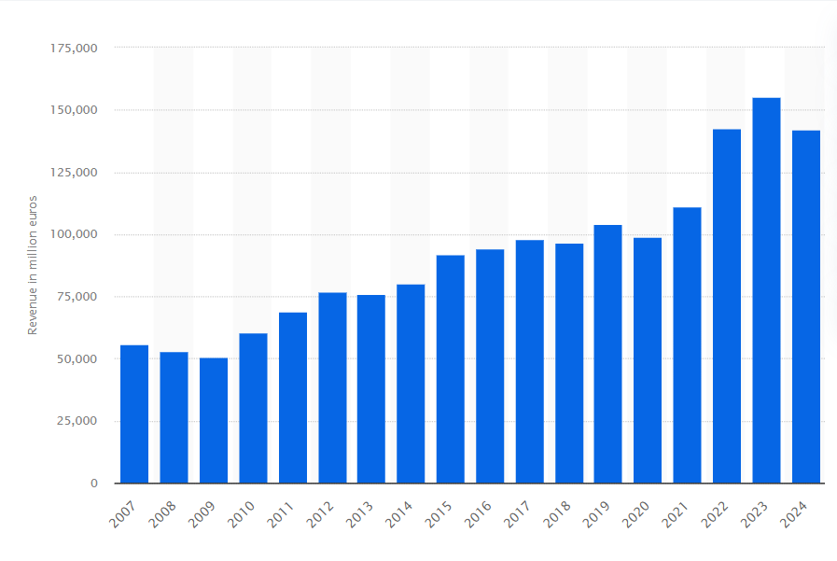
Figure 3: Revenue of BMW from 2007 to 2024
(Source: Statista, 2025)
On the other hand, BMW pursues a strategy of adaptation whereby it incorporates the electric mobility under the traditional BMW brand as a sub-brand called BMW. The BMW marketing focuses on the luxury, reliability, and performance combined with the combination of traditional advertising and digital storytelling (Christensen et al., 2022). The company resorts to hybrid campaigns, i.e. demonstrating its sustainability measures and partnership in renewable energy, to increase brand credibility. BMW strategy is also highly based on dealership networks and customer service which is a more traditional yet reliable market strategy (Awewomom et al., 2024). BMW’s global marketing strategies continue to set benchmarks in the automotive world. Marketing strategy has continually adapted from classic print ads to cutting-edge digital campaigns ensuring BMW remains “The Ultimate Driving Machine” in the eyes of consumers.
In general, although Tesla is an innovative brand by using innovation as a means of branding and direct communication, BMW depends on gradual adaptation, and its response to the marketing aspect is to keep the brand heritage and move to more environmentally friendly mobility.
2.3 Comparative evaluation between Tesla and BMW
During a comparative analysis of Tesla and BMW, there are two different strategic orientations to the same issues regarding the environment. As a pioneer, Tesla has an approach of being proactive and risk-taking, which is reflected in the Ansoff Growth Matrix by market penetration and diversification, which is to move to new energy segments and service software oriented. Being an environmentally aware and tech-focused product, its marketing flexibility and technology make it stronger, and it will be largely attractive to a first-mover advantage (Platzek et al., 2025).
As a follower, BMW is more conservative and follows the Resource-Based View (RBV) approach, with the help of brand equity, engineering expertise, and customer loyalty. This tactic is a stability measure but restricts its innovation speed as compared to Tesla. The marketing reply of BMW shows that there is a balance between the classic luxury attractive and the slow-going sustainability communication.
Importantly, the strategy that Tesla is pursuing leads to greater differentiation and predisposes it to operational risks and reliance on constant innovation. The lesser dynamism in the adaptation of BMW is compensated by the fact that it guarantees the uniform quality and long-term consumer loyalty. The difference in their reactions highlights the role that the external forces play in creating different but complementary marketing paths in the same industry (Gonzalez et al., 2022). Simply, Tesla has a pioneering strategy that drives change in the industry, but BMW has a follower model which is a sign of strategic stability in the normative frameworks.
2.4 Comparative evaluation: Pioneer vs Follower
Using the generic strategies as developed by Porter to compare Tesla and BMW, one can easily point to the differences in strategic orientation. Tesla has a narrow differentiation strategy, and it targets consumers that appreciate advanced technology and environmentalist orientation. Its model is based on technological exclusivity and emotional branding to establish high perceived value. BMW, on the other hand, pursues a wide differentiation strategy, aiming to cater to several segments ranging between the traditional drivers to the environmentally friendly customers that dilutes its image of innovativeness but still includes the brands (Czinkota et al., 2021).
As per the Diffusion of Innovation model, Tesla is the example of the innovator and early adopter phases, which form the consumer attitudes and technological norms (Xia et al., 2022). BMW is a type of early majority, having a later arrival in the market, after physical market confirmation. Tesla, even though its strategy would give it quick market penetration and a highly differentiated brand, would give its competitors the scalability and flexibility needed in a highly complex global marketplace, which is provided by the strategy adopted by BMW.
2.5 Strategic Success and limitations Assessment
The two organisations have been successful in the application of different strategic paradigms. The innovative approach has ensured technological and environmental dominance across Tesla as a model of innovativeness and brand authenticity. Nonetheless, weaknesses are excessive reliance on founder-driven image, high production cost, and low diversification of other segments other than the premium.
The success of the pioneering approach can be attested to by Tesla market capitalisation, which exceeds USD 800 billion in 2024, and the market share of Tesla in the global EV market, which is 18% (News18, 2025). Though the EV segment of BMW remains smaller, it increased by 74 percent in 2024, which shows that the company is making a gradual, but serious shift (BMW Group, 2024). This is an indication that the two strategies have a possibility of succeeding provided they are supported by the organisational assets and brand image.

2.6 Conclusion
Finally, comparison of the reaction of Tesla and BMW to technological and environmental macro factors shows two possible but different strategic paradigms of EV industry. The innovative strategy based on the constant innovation and sustainability that Tesla has implemented has reformed the expectations of consumers and the norms in the industry. BMW follows a strategy of follower which is slower to evolve but capitalizes on the brand heritage and systematic change in producing long term competitiveness.

Reference List
Awewomom, J., Dzeble, F., Takyi, Y.D., Ashie, W.B., Ettey, E.N.Y.O., Afua, P.E., Sackey, L.N., Opoku, F. and Akoto, O., (2024). Addressing global environmental pollution using environmental control techniques: a focus on environmental policy and preventive environmental management. Discover Environment, 2(1), p.8. https://link.springer.com/content/pdf/10.1007/s44274-024-00033-5.pdf
BMW, (2024). BMW Group Report 2024. Available at: https://www.bmwgroup.com/en/report/2024/downloads/BMW-Group-Report-2024-en.pdf [Accessed on: 01.11.2025]
Christensen, H.R., Nexø, L.A., Pedersen, S. and Breengaard, M.H., (2022). The lure and limits of smart cars: visual analysis of gender and diversity in car branding. Sustainability, 14(11), p.6906. https://www.mdpi.com/2071-1050/14/11/6906
Czinkota, M.R., Kotabe, M., Vrontis, D. and Shams, S.R., (2021). Designing effective promotion and advertising strategies. In Marketing Management: Past, Present and Future (pp. 553-606). Cham: Springer International Publishing. https://www.researchgate.net/profile/Demetris-Vrontis/publication/354106239_Designing_Effective_Promotion_and_Advertising_Strategies/links/6283aa7717ae76609bfd306a/Designing-Effective-Promotion-and-Advertising-Strategies.pdf
Forliano, C., Battisti, E., De Bernardi, P. and Kliestik, T., (2025). Mapping the greenwashing research landscape: a theoretical and field analysis. Review of Managerial Science, pp.1-50. https://link.springer.com/content/pdf/10.1007/s11846-025-00856-3.pdf
Gonzalez, C., Agrawal, V., Johansen, D. and Hooker, R., (2022). Green supply chain practices: The role of institutional pressure, market orientation, and managerial commitment. Cleaner Logistics and Supply Chain, 5, p.100067. https://www.sciencedirect.com/science/article/pii/S2772390922000403
Han, J., (2021). How does Tesla motors achieve competitive advantage in the global automobile industry?. Journal of Next-generation Convergence Information Services Technology Vol, 10(5), pp.573-582. https://pdfs.semanticscholar.org/93e3/6bab363ff045eb1e1bc10a4b8c9f36530aca.pdf
IEA, (2025). Batteries and Secure Energy Transitions. Available at: https://iea.blob.core.windows.net/assets/cb39c1bf-d2b3-446d-8c35-aae6b1f3a4a0/BatteriesandSecureEnergyTransitions.pdf [Accessed on: 01.11.2025]
Medium, (2025). A Peak at game changing distribution strategy: Tesla. Available at: https://medium.com/@moumesh/a-peek-at-gaming-changing-distribution-strategy-tesla-ea54b5acf40#:~:text=It%20allows%20the%20dealers%20to,unheard%20of%20in%20traditional%20cars. [Accessed on: 01.11.2025]
News18, (2025). India's Exports May Touch Record USD 800 Bn This Year: Piyush Goyal. Available at: https://www.news18.com/business/economy/indias-exports-may-touch-record-usd-800-bn-this-year-piyush-goyal-9218479.html [Accessed on: 01.11.2025]
Parra‐Requena, G., García‐Villaverde, P.M., Ruiz‐Ortega, M.J. and Córcoles‐Muñoz, M.M., (2024). Strategic resilience nexus: Connecting pioneering and sustainability orientations. Business Strategy and the Environment, 33(8), pp.8784-8797. https://onlinelibrary.wiley.com/doi/pdf/10.1002/bse.3943
Platzek, F., Schmitz, A.K. and Hagen, A., (2025). The Role of First-Mover Advantages in Sustainability: Conceptualizing the Sustainability Transformations of Green and Conventional Brands. Business & Society, p.00076503251343359. https://journals.sagepub.com/doi/pdf/10.1177/00076503251343359
Posen, H.E., Ross, J.M., Wu, B., Benigni, S. and Cao, Z., (2023). Reconceptualizing imitation: Implications for dynamic capabilities, innovation, and competitive advantage. Academy of Management Annals, 17(1), pp.74-112. https://www.researchgate.net/profile/Jan-Michael-Ross/publication/360750347_Reconceptualizing_Imitation_Implications_for_Dynamic_Capabilities_Innovation_and_Competitive_Advantage/links/64b63cc495bbbe0c6e44f2fb/Reconceptualizing-Imitation-Implications-for-Dynamic-Capabilities-Innovation-and-Competitive-Advantage.pdf
Statista, (2025). Electric Vehicles - Worldwide. Available at: https://www.statista.com/outlook/mmo/electric-vehicles/worldwide?srsltid=AfmBOopSpJTZgroR6UnhAlmo--SQcx1LY0cgAqM6m79rrQ8Bq_CSNJ9b [Accessed on: 01.11.2025]
Statista, (2025). Electric Vehicles - Worldwide. Available at: https://www.statista.com/outlook/mmo/electric-vehicles/worldwide?srsltid=AfmBOopSpJTZgroR6UnhAlmo--SQcx1LY0cgAqM6m79rrQ8Bq_CSNJ9b [Accessed on: 01.11.2025]
Statista, (2025). How Successful Is Tesla?. Available at: https://www.statista.com/chart/26705/yearly-net-income-and-revenue-of-tesla/?srsltid=AfmBOopOJlNd9MNYgQDGc8fRY8xLdOmh1WaAXHTmhx6q_4chioyLvtpi [Accessed on: 01.11.2025]
Statista, (2025). Revenue of BMW Group from 2007 to 2024. Available at: https://www.statista.com/statistics/264340/global-revenue-of-bmw-group/?srsltid=AfmBOoolsEBo9O30bTiJrhIKdoQoPK3vU9Upb8BuzaAipyiQuf26fF9M [Accessed on: 01.11.2025]
Tesla, (2024). Annual financial statement. Available at: https://ir.tesla.com/_flysystem/s3/sec/000162828025003063/tsla-20241231-gen.pdf [Accessed on: 01.11.2025]
Xia, Z., Wu, D. and Zhang, L., (2022). Economic, functional, and social factors influencing electric vehicles’ adoption: An empirical study based on the diffusion of innovation theory. Sustainability, 14(10), p.6283. https://www.mdpi.com/2071-1050/14/10/6283/pdf
Yu, X., Chen, R., Gan, L., Li, H. and Chen, L., (2023). Battery safety: From lithium-ion to solid-state batteries. Engineering, 21, pp.9-14. https://www.sciencedirect.com/science/article/pii/S2095809922006282

