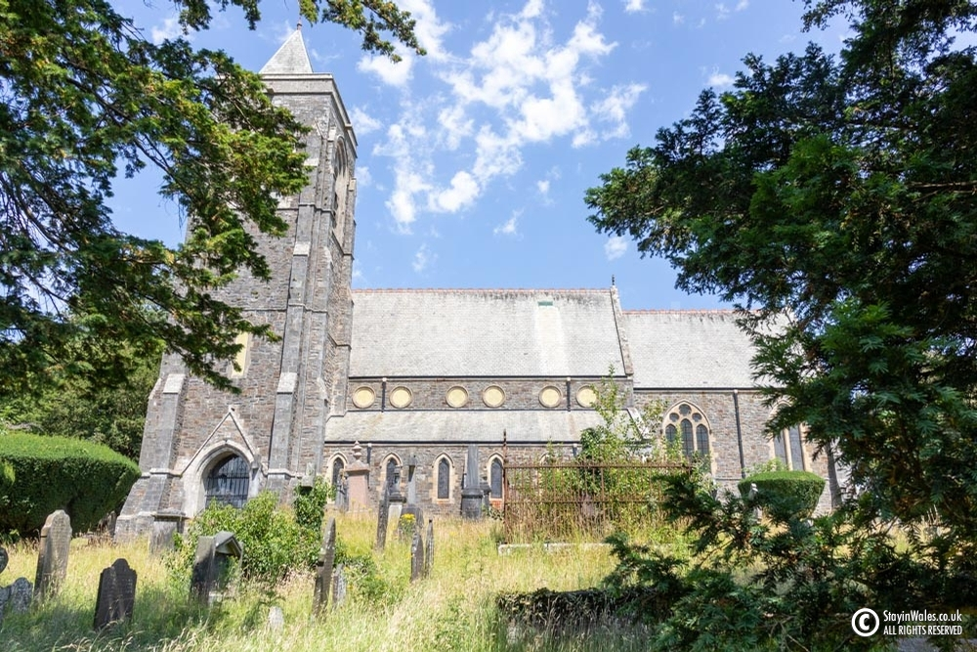

St Peters Church
Maesllan
Lampeter
SA48 7EN
52°06’54”N 4°04’55”W
An Anglian parish church still in active use by the local community

An amalgamation of data collected over the period of 2 weeks through study of a selection of graves at St Peters church on the Brwyn Road. The collection of information obtained has been through the use of physical drawings of the graves, pictures via a mobile phone and of the use of a hand scripted map to reference the location of the graves themselves. However unfortunately some of the stones selected due to their material and age are missing some of their inscriptions.
My study is on the type of crosses used within this graveyard. I have selected 17 crosses throughout the gravesite as an average. However, a few of these contain resemblance to the styles we admire today is the Celtic Cross motif.
My aim is to see if there is any correlation between them using the type of stone, location within the sight, style and year they were erected. To gauge if a particular cross was more popular or what compelled the individual to use this type of symbology.

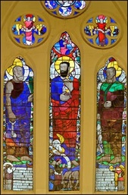

Built between the years 1867 -1870 this grade 2 listed building was designed by the Somerset born Robert Jewell Withers in the a high Victorian Gothic style. This construction was commissioned to replace the poorly built church by W. Wittington of Neath during 1836-1838. The grounds to which the current church resides was first recorded to house the original Church of St Peter in 1291 (Wikipedia). Notability the church can be recognised by the use and style of its stained glass windows which were of Wilhelmina Geddes who was one of the revered and ‘foremost stained glass artists of her time’(history points)
Situated near the heart of Lampeter market town which fell under the rule of Edward 1 in 1282 which brought about establish trading, markets and annual fairs including the Dalis horse fair till 1939. By the 1800s Lampeter would become a drovers gathering point where livestock would be sent on to the South East of England (Cardigan bay properties) The town has been renowned for it visitations through history of gentry and individuals of stature. the Archbishop of Canterbury and Gerald of Wales were just so who while on touring Wales to recruit for the third crusade they gave sermons on the morning of 2nd April 1188. Many men were noted to of ‘took the cross’ in this town of Lampeter (history points)

An introduction to the concept of the type of information provided on a gravestone for means of identification was first compiled during the lectures in the weeks leading up to the reconisonce visit. Thereafter on the physical visit to the graveyard it became more apparent that the types of crosses used and their individual iconography vaired vastly. As such only a limited number were selected to study. In my study I wished to examine the types of crosses used in rememberance to aquire if there was any corrilation between them and discover more about them.

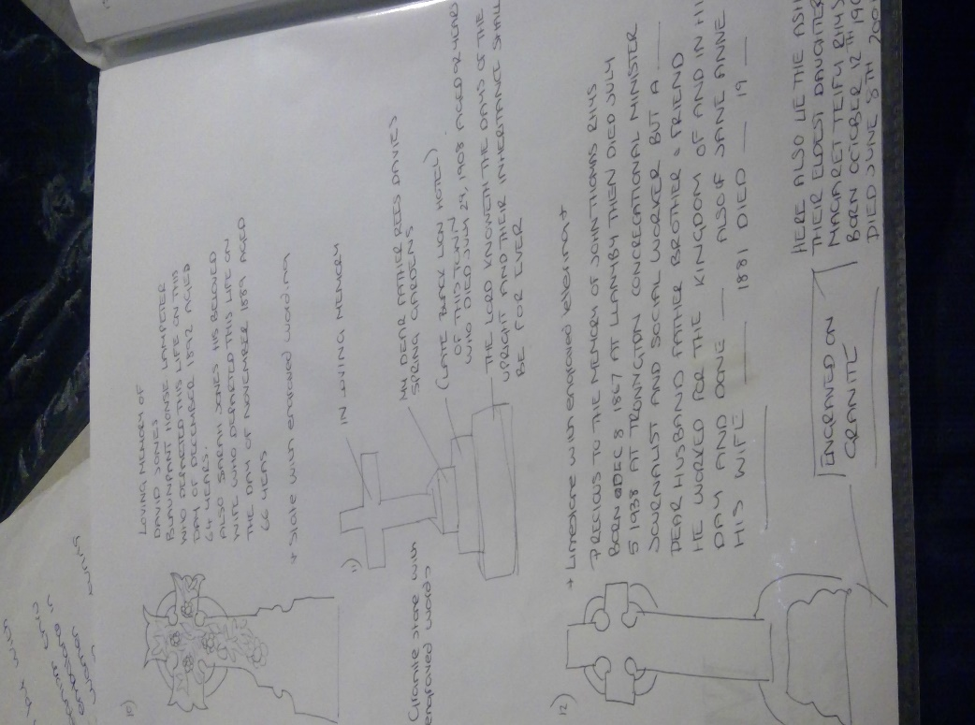

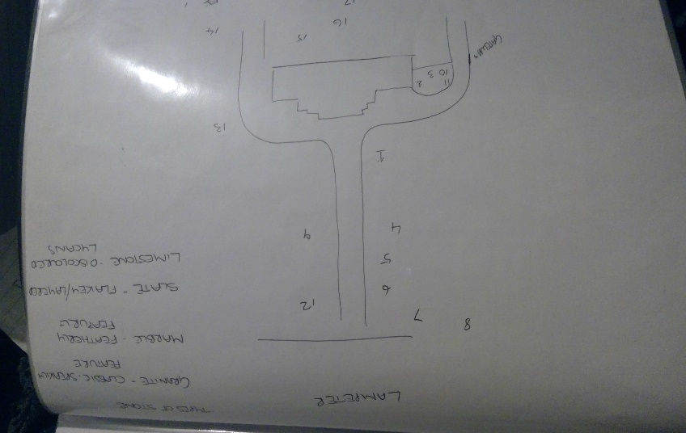

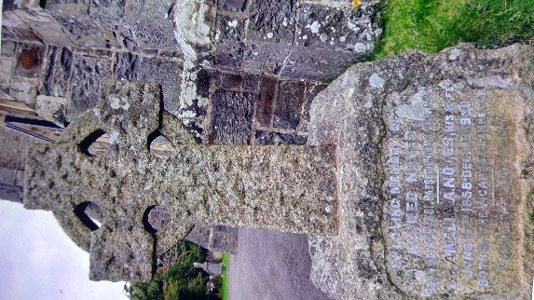
Grave 1)

IN LOVING MEMORY OF ALFRED NAYES.
BORN OCT 3Rd 1851.
PASSED ON OCT 3rd 1935.
ALSO AMELIA NAYES HIS WIFE JUNE
17th 1858 DEC 11th 1930.
BOTH OF THE VICARAGE OF LAMPETER.

# Made from limestone with led infill lettering#

East of the church facing east
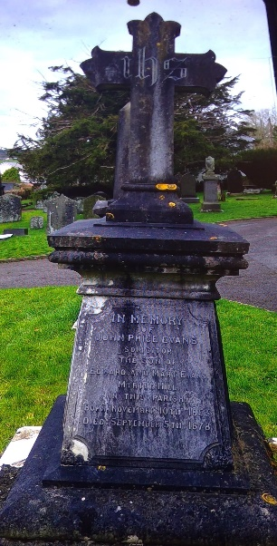
GRAVE 2)

Engraved on base:
IN MEMORY OF JOHN PRICE EVANS
(SOLICITOR)
THE SON OF EDWARD AND MARY EVANS
MYRTLE HILL IN THE PARISH BORN NOVEMBER 10th 1853
DIED SEPTEMBER 5th 1878

Made from slate with led infill lettering
East of the church facing east

GRAVE 3)

Engraved on base:

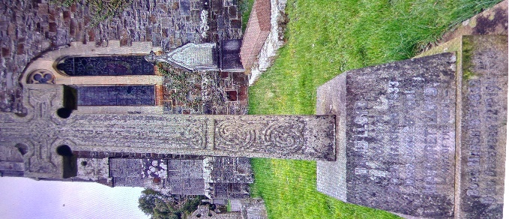
DAVID LLOYD SOLICITOR BORN MARCH 26th 1833. DIED JUNE 28th 1901
MAGARET LLOYD
-WIFE OF THE ABOVE-
BORN MARCH 15th 1832. DIED DECEMBER 22nd 1911
Additional information on the base :
ALSO THE AFOREMENTIONED
DANIEL JONES (1847-1934)
CANON AND CHANCELLOR OF THE CATHEDRAL CHURCH OF SAINT
DAVIDS (1903-1934)
ALSO OF THEIR SON WILLIAM F LLOYD. MEDICAL PRACTITIONER M.R.C.S
ENGLAND, L.R.C.P. LONDON AND M.B.,B.CH CAMBRIDGE. WHO DIED AT
WINDSOR ON THE 12th MAY 1938 AGED 74 YEARS

Made from granite with led infill lettering#
South east of the church facing east

GRAVE 4)
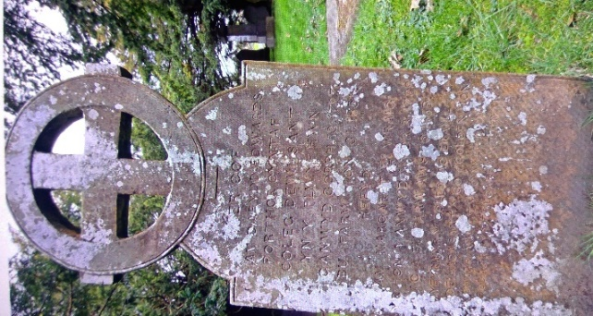
Engraved on base:
COF
AM DAFYDD EDWARDS
PORTHR CYNTAF
COLEC DEWI SANT
YN Y PLWYF HWN
CANWYD GORPH 13 1787
BU FARW ION 31 1851
HEFYD
MARGARET ET WRAIG
R HON A ANWYD HYDR.3 1789
AC A FU FARW AWST 6 1855
MYFYRWYR Y COLC AC ERAILL
ADEILADASANT Y GOG COLOFN HON

Made from granite with engraved writing
South West of the church running along the path facing east

GRAVE 5)

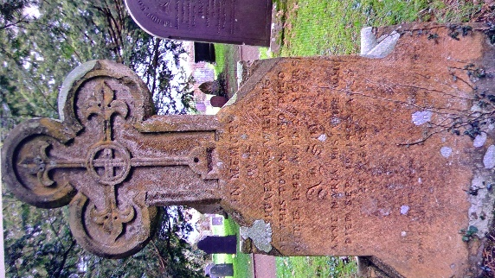
Engraved on base:
IN MEMORY
JOSHUA EVANS WILLIAMS
OF THIS TOWN WHO DIED
IN MEMORY JOSHUA EVANS WILLIAMS
OF THIS TOWN WHO DIED OCT 15 1942 AGED 24 YEARS
ALSO
ANEE MARIA HIS WIFE WHO
DIED SEP 10 1942 23 YEARS
ALSO ANEE MARIA HIS WIFE WHO DIED SEP 10 1942 23 YEARS

(there is an inscription at the very bottom below but it is not readable)
Made from granite with engraved lettering

South West of the church running along the path facing east

GRAVE 6)

Engraved on base:
JENKIN DAVIS PRINTER, PUBLISHER STATIONERS HALL OF THIS TOWN
1841-1892 AND HIS DEAR WIFE MARY 1847-1925
ALSO THEIR GRANDSON BRINLEY LEWELL
ELDER SON OF REV OWIL_ AND LOUISE
18__ -1909

Engraved on cross:
CHERISHED MEMORIES

#Made in limestone with wording in led#

South West of the church running along the path facing east

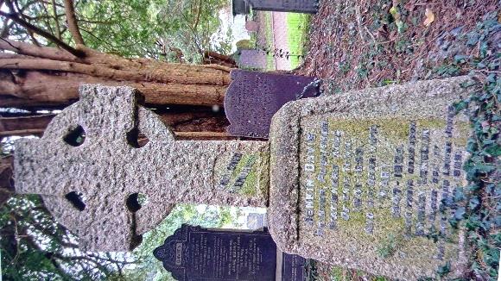
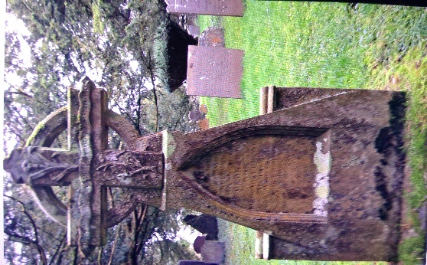
GRAVE 7)

Engraved on base :
IN MEORY OF HE BELOVED CHILDREN OF GOERGE AND MARGARET
PRATLEY. HANNAH DIED AUGUST 10 188_
IN MEMORY OF THE BELOVED CHILDREN OF GEORGE AND MARGARET
AGED 5 MONTHS. ANNE DIED NOV 22 1871
PRATELY. HANNAH DIED AUGUST 10 188_
(the rest of the inscription is sadly lost)

#Made from granite with the lettering carved from the stone#
South West of the church running along the path facing eas

GRAVE 8)
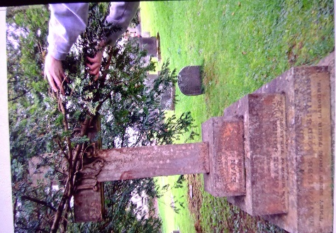
IN LOVING MEMORY OF EVANS JONES
IVY BUSH INN OF THIS TOWN
WHO DIED MAY 23 1865 AGED 47 YEARS
OF GRACE JONES WIDOW OF THE ABOVE WHO
DIED MAY 27 1898 AGED 81 YEARS
`THEY REST FROM THEIR LABOUR`

Made from granite with the lettering carved from stone
Positioned south east of the church facing east running parallel with the path

GRAVE 9)

Engraved on the base:
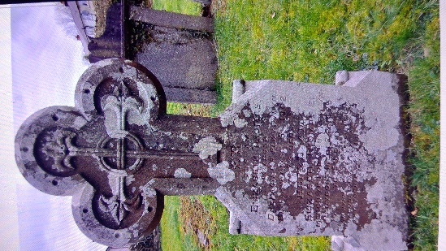
COF AM
ELIZABETH THOMAS
IVY BUSH
DREFACH O’R PLWYF HWN
BU FARN AWST 61862
YN 73 OED
HEF YL AM
VN 59 OED
ELIZABETH THOMAS E I MERCH YR HON A FU FARW YN
PENYBONT MED 24 1875
VN 59 OED
(some inscription lost)
South West of the church path facing east

Made from granite with carved lettering into the stone

GRAVE 10)
Engraved on base:
LOVING MEMORY OF DAVID JONES
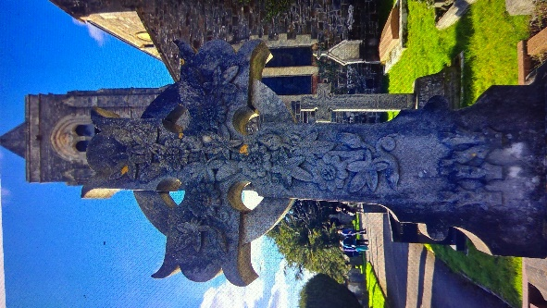
BLAUNPANT HOUSE LAMPETER
WHO DEPARTED THIS LIFE ON THIS DAY OF DECEMBER 1892
LOVING MEMORY OF DAVID JONES
AGED 64 YEARS
ALSO SARAH JONES HIS BELOVED WIFE WHO DEPARTED THIS
LIFE ON THETHIS DAY OF NOVEMBER 1889 AGED 66 YEARS DECEMBER 1892
AGED 64 YEARS
#Made from slate with engraved lettering#

Made from slate with lettering engraved into the stone
South east of the church running parallel with the east church path

GRAVE 11)
Engraved on cross:
IN LOVING MEMORY
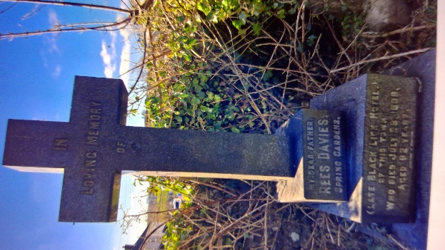
Engraved on the base layers:
IN LOVING MEMORY
MY DEAR FATHER REES DAVIES SPRING GARDENS
(LATE BLACK LION HOTEL) OF THIS TOWN WHO DIED JULY 29, 1908

AGED 92 YEARS
THE LORD KNOWETH THE DAYS OF THE UPRIGHT AND THEIR INHERITANCE SHALL BE FOREVER

Made from granite with the lettering engraved into the stone
South of the church facing east running parallel with the path

GRAVE 12)
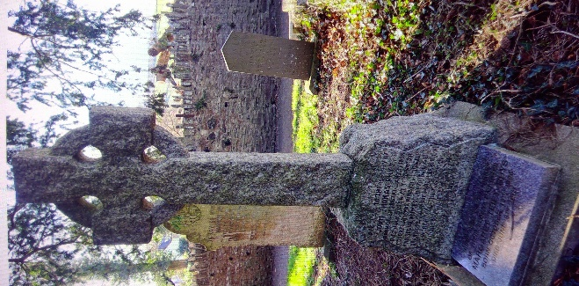
Engraved on base:
PRECIOUS TO THE MEMORY OF JOHN THOMAS RHYS
BORN DEC 8 1867 AT LLANYBY THEN DIED JULY 5 1938
AT TRONNGTON CONCREGATIONAL MINISTER JOURNALIST AND
SOCIAL WORKER BUT A ___DEAR HUSBAND FATHER BROTHER & FRIEND HE WORKED FOR THE KINGDOM OF AND IN HIS DAY AND DONE _ ALSO OF JANE ANNEE HIS WIFE _ 1881 DIED _ 19__

Made from limestone with the lettering engraved into the stone

Engraved below on a plaque in granite reads:
HERE ALSO LIES THE ASHES OF THEIR ELDEST DAUGHTER MARGARET
TEIFY RHYS BORN OCTOBER 12th 1906 DIED JUNE 8th 2001

West of the church facing east running pararllel with the path

GRAVE 13)

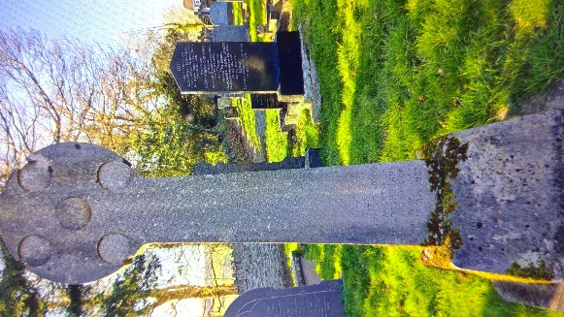
Engraved on the trunk: (partially remaining)
ALSO OF THEIR BELOVED DAUGHTER JANE
THE DEAR WIFE OF COSMO DEWIMATHEWS
DIED 13 MAY 1937 27 YEARS

Engraved on the base:
THE CASTLE HOTEL OF THIS TOWN DIED NOV 1923

Made from granite with engraved lettering
North of the church facing east running close to the north path

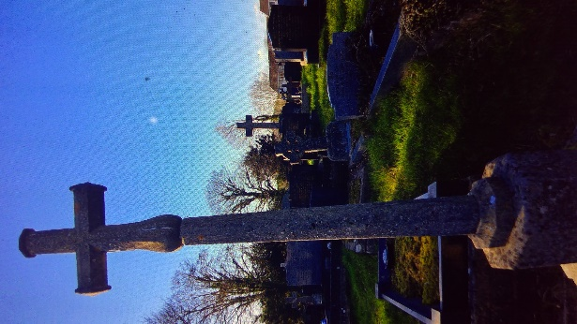
GRAVE 14)

WITH J HANKS CIVING
TO COD
THE LIFE OF DAVID CHARLES LOYD
BRONYO ER LAMPETER
DIED JUNE 26th 1934 61 YEARS

Made from granite with the lettering carved into the stone in 3d
North of the church facing east running close to the north path

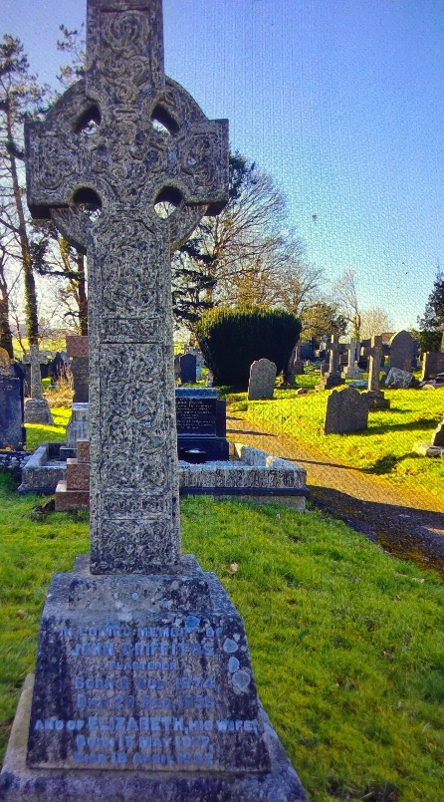
GRAVE 15)

Engraved at base:
IN LOVING MEMORY OF JOHN GRIFFITHS
PLASTERER BORN 8 AUG 1874
DIED 20 DEC 1956
AND OF ELIZABETH HIS WIFE
BORN 13 MAY 1877
DIED 18 APRIL 1962

#Made from limestone with led lettering#
North of the Church facing east running parallel with the north path

While looking for corrilations between the 15 crosses selected in my study to discover if a certain type of cross bore more significance in certain time periods, I found but a few that bore any such insight. The graves selected were at different parts of the sight. It is apparent However there were a greater amount of ones bearing a reflection on a Celtic form be that from the iconography engraved on the cross itself or the shape in close proximity to the church. It is believed the traditional Celtic cross as per St Patricks influence is a sign of Irish decent and that the presence of these in graveyards can be indicative of Irish decent, yet this was not found. The 1800’s saw an increase in Celtic stylisation and from the 1860’s began to show apparent in graveyards. This can be seen in graves 2, 6 and 12 where the birthdates of the deceased were at this time showing a desire for the Celtic revival. The use of limestone within the Celtic styling is apparent which adds authenticity to it’s aesthetic charm as well as the stone being easier to calve. However the stone itself does not wear considerably well and over time the lettering becomes distorted. This can be seen on two crosses I had examined in the north of the grounds which were unreadable. In gravestone 6 the inscription was inlaid with LED. I observed that the Celtic stylistic crosses I had examined were situated within close proximity to the church itself and boarders of its pathways and that limestone crosses were not favoured in the newer graves.

Pennick, N (1997) The Celtic Cross: an illustrated history and celebration. London

