Desk Top Study and Site Walkover

Proposed Swansea Foreshore Ice Cream Parlour

Oystermouth Road

Date: January 2019

Study and Walkover Carried Out By: Nathan Cameron

Contents
Introduction – Page 3
Desktop Study
Site Description – Page 3
Site History – Pages 3 – 6
Radon Map – Page 7
History Bore Holes – Pages 8 – 11
Site Walkover
Site Walkover – Pages 12 – 14
Advanced Site Investigation
Advanced Site Investigation Techniques – Pages 15 – 18
Construction Details
Foundation and Sub Structure Detail – Page 19
External Wall and Window Detail – Pages 19 - 20
Door Intersection Detail – Page 20
Roof Detail – Page 20
Ground Floor Detail - 21
Site Layout Detail – Page 22
Plant and Machinery – Pages 22 – 23
Bibliography – Page 24

Introduction
The City and County of Swansea has partnered up with the Marriott Hotel to construct a new restaurant / ice-cream parlour in between the Marriott Hotel and Swansea Council Offices in the foreshore of Swansea Bay.
I will be completing a desk top study of the area where the proposed building is to be built to provide a more in depth understanding of the site.
The development consists of a three storey building which will facilitate a restaurant, ice cream parlour and managers apartment. Currently, the existing site is a beachfront public footpath and cycle path running parallel with Swansea Bay. There are patches of grass which are raised above floor level with plenty of trees and bushes.
Site Description
National Grid Reference - SS 65405 92279. Grid Reference Finder. 2019. Grid Reference Finder. [ONLINE] Available at: https://gridreferencefinder.com/.
The site is situated south of Swansea City Centre and sits between The Marriott Hotel and the Swansea City and County Council Building which both look over the Swansea Bay. The postcode for the site is SA1 3SS. The site is approximately 400m² in a rectangular shape adjacent to the footpath of the Swansea Foreshore.
The current use for the site is where the Marriott Hotel is located. The hotels car park is directly to the right of the site and to the left is the car park of the Council building. South of the site is the coastal path which is in constant use by the public which could cause issues with safety in day to day site proceedings.
Site History
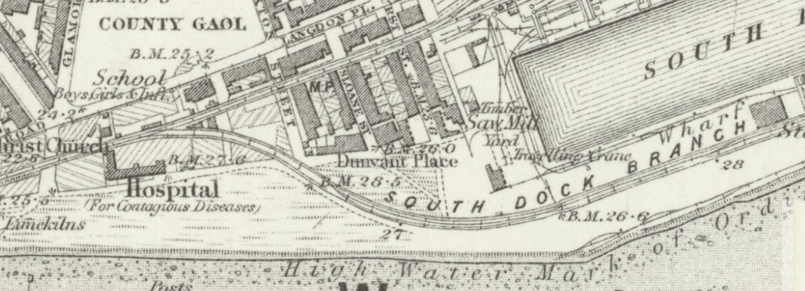
(Maps.nls.uk, n.d.) [7]
This image is a map of Swansea in 1884, it depicts the site as being a large open area of sand, and this would suggest that there was no development present at the time other than a single train line running through the site. Around the site there are a few buildings consisting of gas works, a timber yard a couple streets houses nearby. To the left of the site there is an old hospital site for contagious diseases, although this is a fair distance from the site itself there could be old findings of hospital grounds or items that may have been buried in the surrounding area when excavations take place.
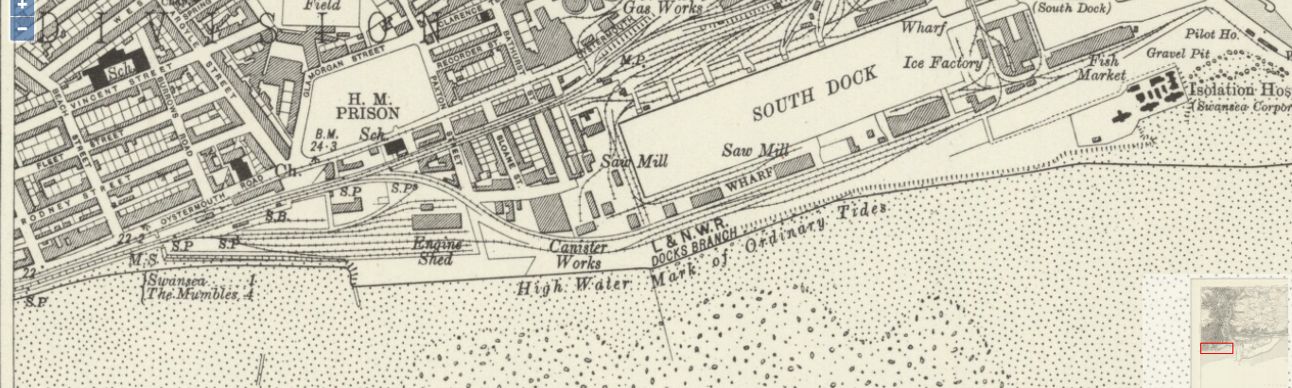
(Maps.nls.uk, n.d.) [8]
This image is a map of the same area but in 1921. The only change to the site consists of a canister works situated on the site, around the site an engine shed has been developed with more train lines and new houses have been erected around the area. The addition if a prison has also been implemented to the north west of the site.
The newly built canister works and engine shed could result in a lot of soil contamination to the site due to the possibility of fuel spills.
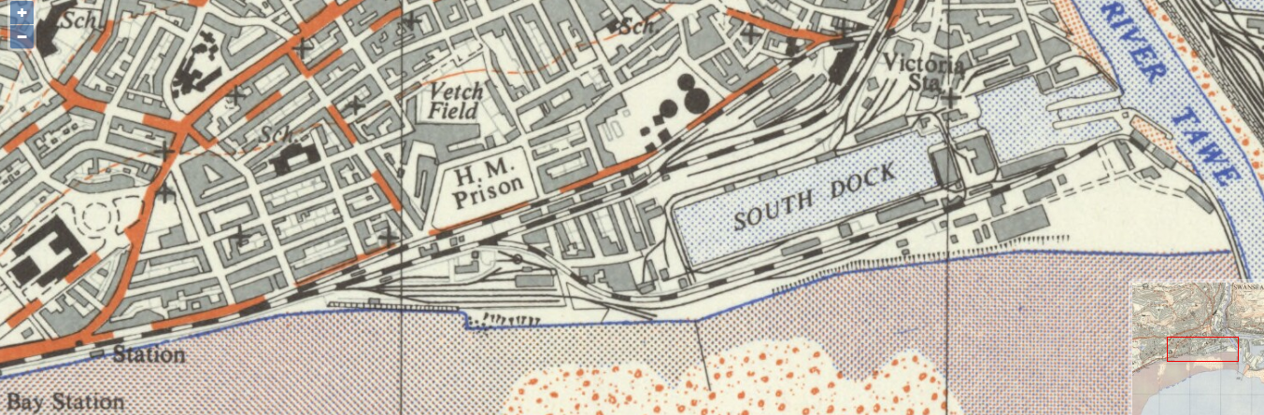
(Maps.nls.uk, n.d.) [9]
This is a map of 1951. Not a lot has changed since the previous map of the area except from additional railway lines through the site and new roads north of the site. The houses, canister works, engine shed and prison are still present.
The old gas works was first opened in 1841 by the Swansea Gas Light Company. It was built on a plot of land on The Burrows, east of the Corporations field.
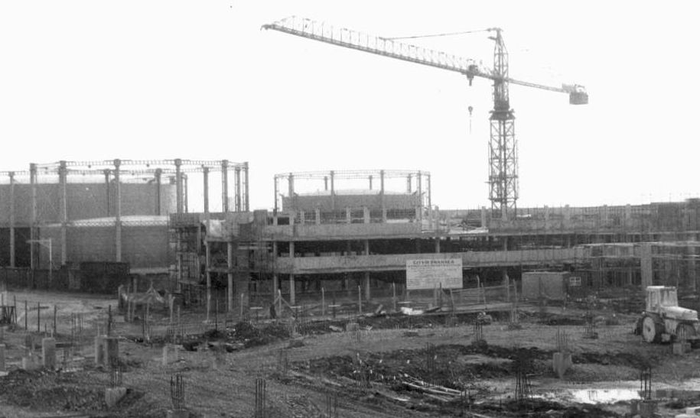
Photograph of the gas works under construction. ANON , Swansea Gasworks Site Oystermouth Road [ONLINE]. Available at: https://ididitthisway.wordpress.com/2016/02/04/gasworks/#jp-carousel-5325 [3]
There is a possibility that this land has been affected by the disturbance of mining in the past. This will need to be taken into consideration when it comes to designing the foundation type which would be suitable for the project due to the possibility of the ground collapsing into the mines that have been left behind. Requesting a report from the coal authority will help to gain an understanding in this. “This information should be checked in accordance with Ciria SP 32: Construction Over Abandoned Mine Workings, 2002” – (LABC Technical Manual, 2019) [4]
The archives should be checked through to determine if any previous planning applications have been made for the area, these applications could hold information of the ground conditions and could give information on suitable foundation designs for the site. With this, checks could be made through environmental health files and through reports from houses that have been build in the surrounding areas of the site to achieve a better understanding of the soil type of the area. This could also identify if the ground is ‘made up ground’ of waste soil or if it is natural soil.
Looking through previous planning applications I have found the following information:
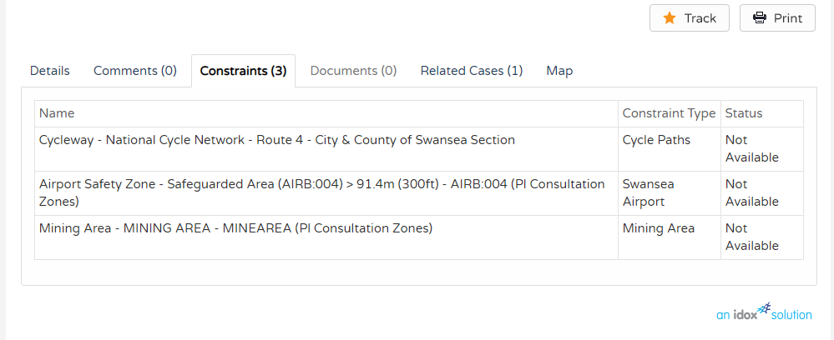
(Anon, n.d.) [2]
This existing application shows 3 restraints. The first is the cycle path. The cycle path will remain untouched throughout the construction phase.
The second being the airport safety zone for Swansea airport – it shows that this safety is for more than 300ft. so this proposed job will not be interfering with that.
Finally, the area was previously a mining area. Although the land very close to the beach and it is very unlikely that any mine shafts exist underneath the ground it may need to be checked with the coal authority to ensure this is 100% the case
Due to the old canister works and engine sheds being on the site, there could be fuel contamination within the ground. Consulting an environment agency would help resolve this problem.

Radon
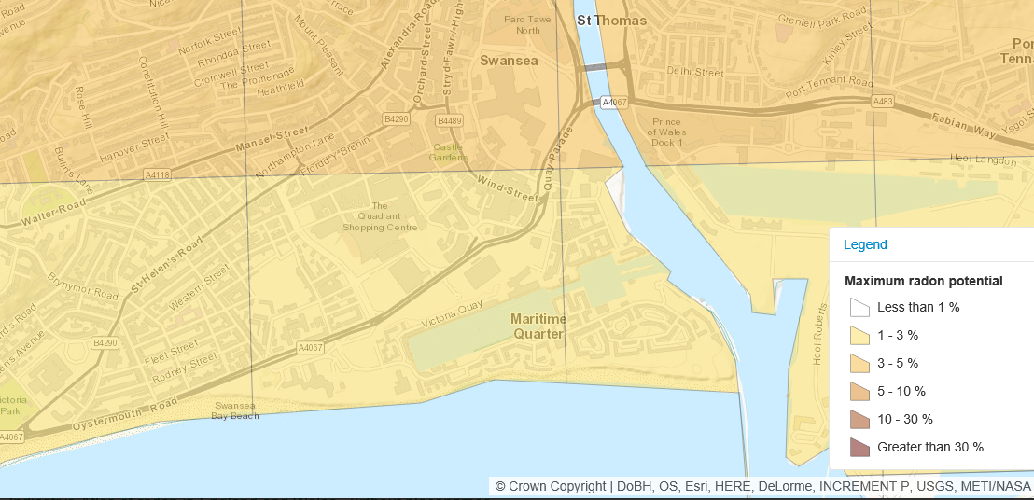
UK Radon. (2016). UK maps of radon. Available: http://www.ukradon.org/information/ukmaps [10]
This site is not considered to be affected by Radon, as per the above map showing the radon potential of the surrounding areas. This means no radon protection measures will need to be taken in the construction process.

Bore Holes
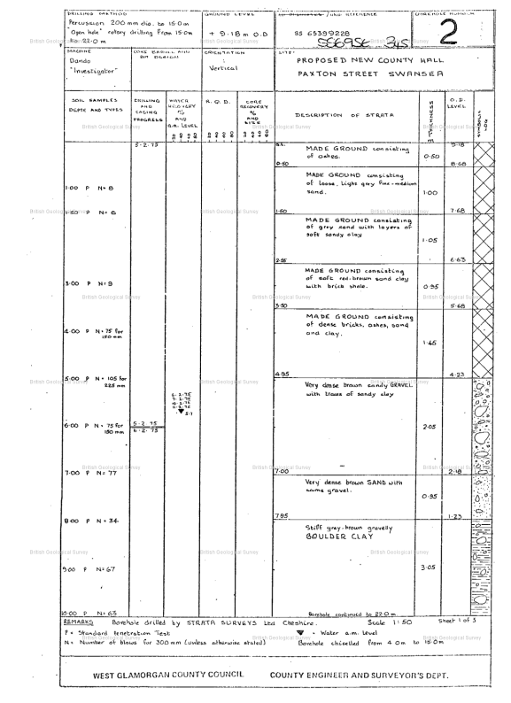
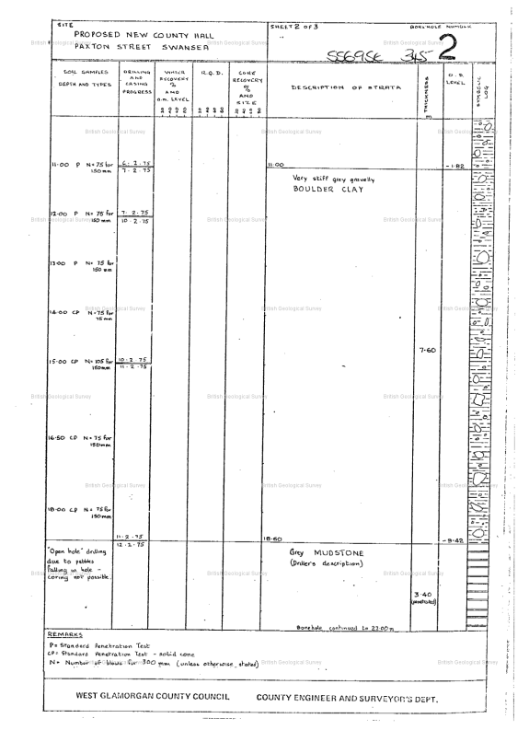
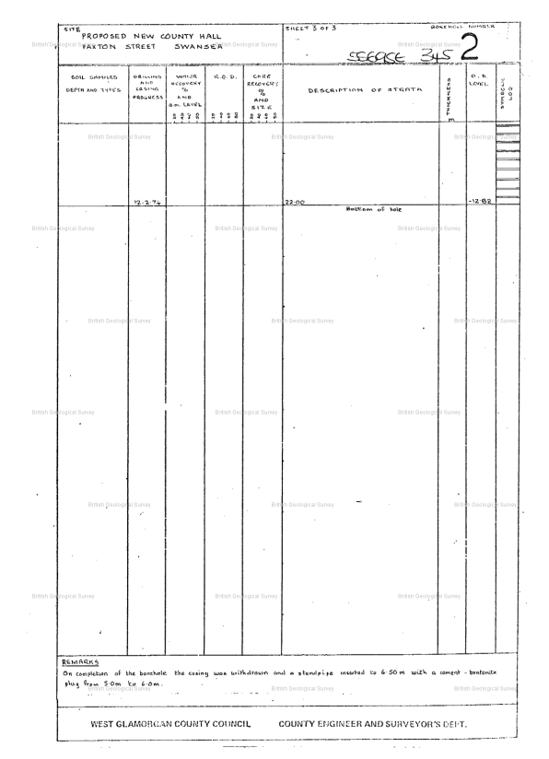
(Scans.bgs.ac.uk, 2019) [5]
The images here show previous bore hole surveys carried out by Strata Surveys Ltd on the area in which the proposed ice cream parlour is to be situated.
This shows that the land is mostly made up land consisting of sand, clay, brick shale, ashes, gravel etc etc. This also tells us that the water table is rather high at 5.7m down below ground.
The bore hole went as far down as 22m.

Site Walkover
I carried out a site walkover to identify any items of the site which could lead to problems during the pre construction and construction phase. The following photographs indicate items in which I feel may be important for the project.

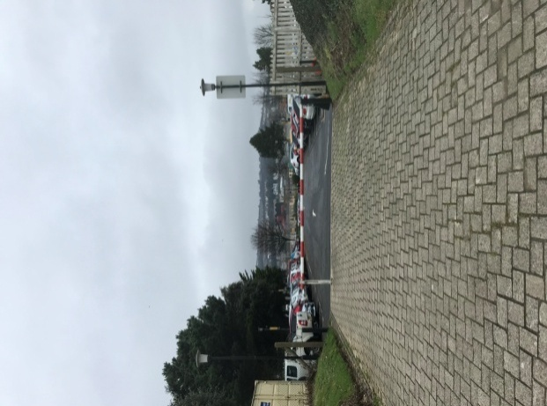
This photograph is of the car park of the Marriott Hotel adjacent to the proposed site. This is what will be used as the site access. The horizontal bar can be removed and replaced with substantial gates that can be locked. The entrance will be wide enough for vehicles of all sites to get through for deliveries of materials or plant. This will also be very useful to prevent any unauthorized person entering the site.

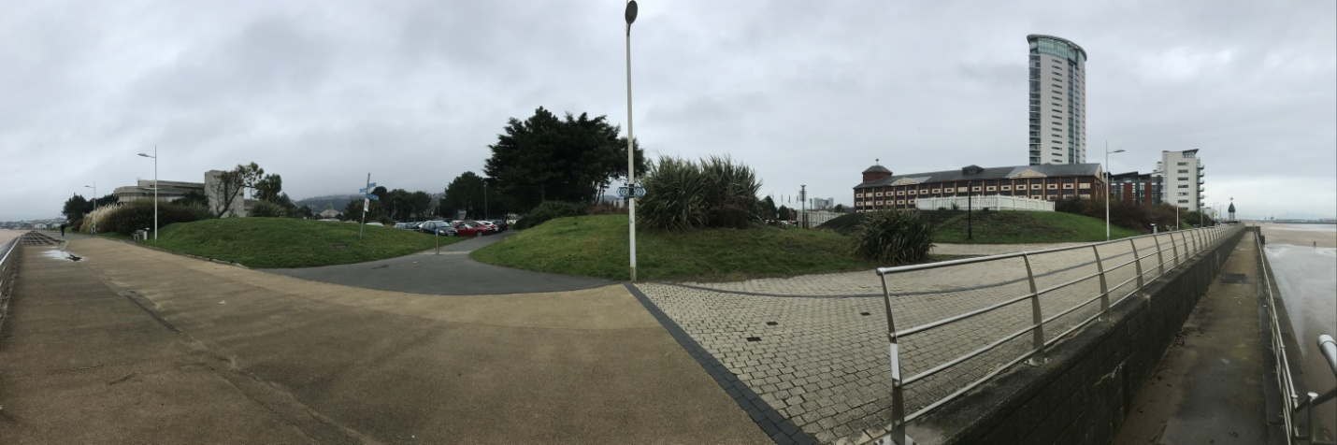
The above panoramic photograph shows the general area of the site along the pedestrian coastal path which runs alongside it. The light in the middle of the photograph will need to be maintained throughout the project to ensure that no disturbances are caused to pedestrians walking along the path at night. But the area surrounding the light will need to be CAT scanned to identify any electrical cables running through the site that we can avoid when digging the foundations for the ice cream parlour. The temporary site hoarding will be erected along the grass line and path area.
The photograph shows that the grassy areas of the site are raised above initial ground level, these grassy areas will need to be reduced and cleared off site along with all the trees and bushes surrounding the site. The photograph also shows a path running from the pedestrian path to the council offices on the left. This path will need to be taken up and removed from site as it runs through the middle of the site. Whilst this path will now be removed, a new path may need to be put in place between the pedestrian path and the council offices.

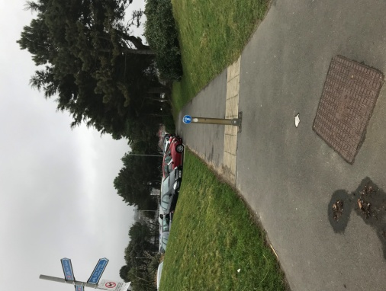

This photograph identifies a manhole in front of the path from the coastal path to the council offices. This can be used to investigate if any drainage routes underneath the site which can be used for the new ice cream parlour.

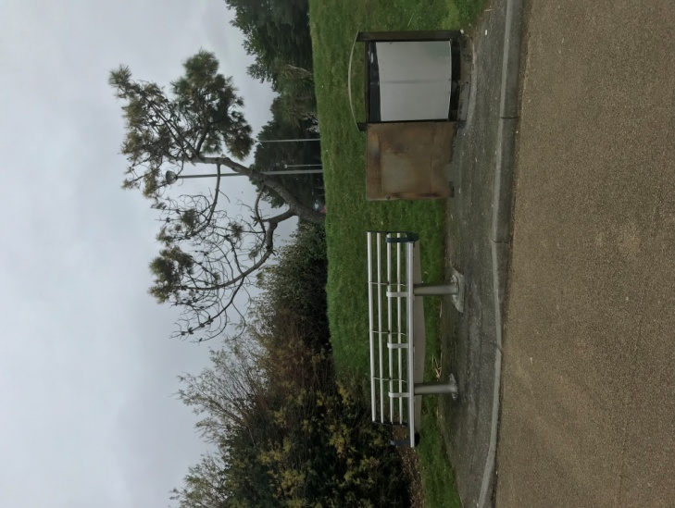
This photograph again shows how the grassy areas of the site are raised above ground level – as previously mentioned this will need to be leveled out and removed off site.
With items such as the bench and rubbish bin, these can be removed prior to work commencing on site and put safely in storage so that when the job is complete they can be reinstated for users of the new ice cream parlour to use.

Topological Features
The site is a mixture of flat land a raised land. There are also some paved areas that may need to be taken up. The raised land will need to be leveled out when all topsoil is removed.
Trees and Vegetation
The site does have some trees and vegetation inside and around the perimeter such as small trees and bushes. These trees look young in appearance and of no high value therefore I cannot see why there would be a problem in re-housing them during construction.
Existing / Previous Construction
Other than the Marriot Hotel and Council Offices there are no other buildings nearby.
Site Accessibility
Site access is satisfactory, with vehicles being able to get into site via the Marriot Hotel car park. The exit will also be through that car park.
Traffic should not be affected as the site is off the main road. This is also the case with any public transport.
Pros of the Site
- Satisfactory Site Access
- Close proximity to the bus station
- Close to extra car parking from the LC2.
Cons of the Site
- Cycle path south of the site cannot be disrupted at any time.

Advanced Site Investigation
Utility and Drainage Drawings
When in the preconstruction phase, you must contact the utility and service providers and contact the drainage authority to get drawings of the site. This will help you to identify if there are any under laying services beneath the site that need to be mapped out, or to see if there are existing services there that could be connected to in order for the site to have electricity, gas and drainage.
CAT Scanning
A CAT scanner is a piece of equipment that lets you identify cables that are underground without digging out any land. It can help you understand how deep in the ground they are and where they are heading. This will be the first step of the advanced site investigation.
How it works is by carefully hovering the piece of equipment just on top of the topsoil. When the scanner beeps, that indicated that there is a cable underneath. The consistency of the beeps then indicates how deep the cables lay.
This is important because it helps mitigate any cables being hit and caught in the foundation dig phase of the project – which could lead to serious injuries and possibly fatalities.
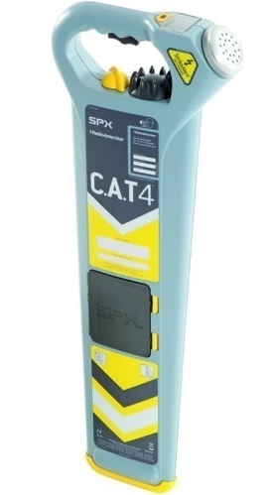
This is a photograph of a typical cat scanner.
(Sealand Survey and Safety Equipment, n.d.) [6]

Utility Detection and Mapping
Sumo Survey Services are a company that carries out surveys of this kind. They carry out a survey in which they will give you exact locations of any services that are under the ground. Using a laser scanner that is pushed along the site and it will identify what is below the ground instantly. This can then be marked out before excavation.
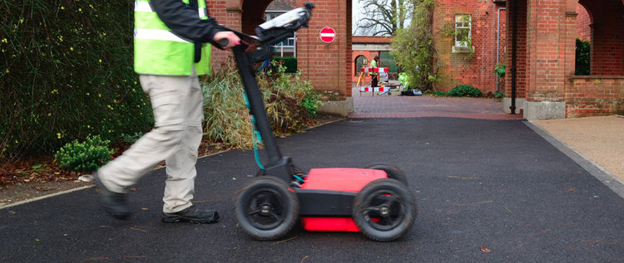
“Using the latest detection technology including electro-magnetics, signal induced threading and ground penetrating radar, SUMO locate metal pipes, plastic pipes, drainage systems, electricity cables, telecoms and fibre optic cables. In fact, almost any buried utility”
(Anon, n.d.) [1]
Tree Surveys
Around the site of the proposed ice cream parlour there are numerous trees. These trees may have to be removed or the foundations would have to be suitable to the trees surrounding it, but the removal of trees can become a costly process.
A tree survey will be carried out to identify what your options are before you start the construction process.
You must take into considering the following items:
- Species of the tree
- The size of the tree, this is in relation to how much water is taken by the roots.
- The proximity, the measurement should be taken from the centre of the trunk to the nearest part of the foundation.
Ecology Survey
An ecology survey will be needed on site to identify if any protected species live within the area such as bats and certain types of birds. These animals will need to be re housed before construction starts if they are present on site.
Bore Holes and Trial Pits
Bore holes and trial pits are a method that can be used during the advanced site investigation stage.
Bore holes are a method of site investigation that determined hat soil is underneath to ground. There are two ways of doing this – open holes or core holes. These bore holes help us to determine what the land is made up of, water content and how low the water table is from ground level which will be a very important factor considering how close the site is from the sea.
When the soil is extracted from the ground it is taken to a laboratory to test for its strength, permeability and consolidation characteristics. This gives the laboratory an average value in which they can recommend an appropriate foundation type based on that value.
Trial pitting is slightly different. A trial pit is an excavation in the ground and it is used to sample the ground to identify its composition and structure. A trial pit is ideally 3 times the depth of the proposed foundation type and will be dug before any construction works start, but after a CAT scan.
With bore holes and trial pits they should be spread out evenly around the site to ensure that the whole area is accounted for, not just the area in which the proposed building is situated.
These methods are usually done by a Chartered Geologist or a Chartered Engineer and must comply with BS EN 1997-2 : 2007 Eurocode 7 – Geotechnical Design – Part 2: Ground Investigation and Testing.
This drawing indicates the locations of which I will have the bore holes and trial pits to examine the type of foundation and the depth of which that they will have to be. The bore holes are identified as BH and the trial pits are identified as TP.
I have chosen to lay out the bore holes and trial pits in the way that I have so that the surveyor can obtain a wealth of information for the entire site. The more bore holes and trial pits that are there the more of an understanding can be gained.
The trees that are scattered around site are also identified on the drawing. It is likely that these trees would have to be removed so that it does not interfere with the strength of the foundations.

Foundation and Sub-Structure Detail
After identifying that the soil on the site is made up ground to approximately 5m with the natural ground being made of dense sand and gravel I have decided to use piled foundations. The pile will be bored and filled with concrete.
“Piled foundations are particularly employed where soft or loose soils overlay strong soils or rocks at depths that can be reached conveniently”. (LABC Technical Manual, 2019) [4]
The depth of the concrete fill and ring beam will be 500mm and the width will be 700mm to ensure there is a steady base for the structure.
The piles will be bored down to bedrock and filled with concrete. The pile will then be capped with an appropriate ground beam system. There will be connections between the beam and the pile to ensure the loads are transmitted effectively. Concrete will then be poured on the beam.
The sub structure will consist of standard cavity wall insulation, formed with brickwork external and block work internal skins with partial fill cavity insulation. The blocks are to be 100mm 7n concrete blocks and the partial cavity fill will be of 80mm thick.
The centre line of the cavity wall must coincide with the centre line of the foundation. The cavity concrete fill will be kept 225mm below the DPC. The DPC will be no lower than 150mm above ground level. A cavity tray will be fitted within the cavity and weep holes are to be implemented every 1500mm along the external block wall to ensure any water within the cavity will be able to escape.
Telescopic ventilators will be implemented to ensure ventilation within the void underneath the block and beam flooring that is to be on top. The ventilators are to be included at 2000mm centres along the external block wall.
The block and beam flooring will be topped with a layer of DPM, 100mm insulation and a 100mm later of concrete screed. Where the floor beams bear onto superstructure then a DPC must be provided underneath.
The above information is all in conjunction with BS 8004 Code of Practice for Foundations
Please see ‘Foundation and Sub-Structure Detail’ sketch enclosed within this document.
External Wall and Windows
The external wall will continue with a face brick external wall and blockwork internal with a cavity and 80mm cavity insulation wall up until the first floor. From there the external wall will start to be built with 100mm 7n concrete blocks, such as the internal wall, and will have a Parex render on the face of the blockwork. The render will have a drip bead at the bottom where the blockwork meets the brickwork to ensure there is no water residue on the face bricks that may cause discolouration.
The windows will be made of PVC-U. The window will sit on an external architectural stone cill which will sit on the brickwork external wall. The stone cill will have a water bar to prevent water ingress. Cavity closers will be put in place on reveals, base and top of the window before the window is fitted. The end of the cavity tray will be turned up to prevent water ingress
A concrete stone head will be built in above the window, and a cavity tray will be placed above that with weep holes implemented at 400mm centres to ensure all water within the cavity void is able to escape. A 215mm reinforced concrete lintel will be above the window on the internal wall to ensure the wall has the structural integrity it needs to hold in place.
The window frame will be completed with a mastic sealant around all sides.
Please refer to the ‘External Wall and Window Intersection Detail’ sketch for reference of the above.
Doors
The door set will be of an aluminium framing. The door will sit on an external architectural stone cill, just like the windows mentioned above, and will also have a concrete stone head above it. Cavity closers will also be fitted to the reveals, base and top of the door. The stone head will also have a cavity tray above it with week holes implemented at 400mm centres to ensure all water can escape the cavity.
215mm reinforced lintels will also be built into the opening to ensure the internal wall will be structurally sound.
The door frame will be completed with a mastic sealant around all sides.
Please refer to the ‘Door Jamb Detail’ sketch for reference of the above.
Roof
The detail sketch enclosed is of the flat roof of the kitchen area.
The roof construction begins with 225x50 grade 3 roof joists spaced at 450mm centres. These will sit on the wall plate of the internal wall. 100 to nothing x 50 soft wood firring pieces will be fixed to the joists to suit a fall of 1:80 and 18mm weather and boil proof (wbp) plywood deck will be fixed upon the firring. A vapour control layer will then sit between the plywood deck and the 165mm insulation board. 1.5mm thick rubber membrane will then top the roof off to ensure no water manages to get into the roof system.
The roof system will have a fall of 1:80 to ensure all water runs off the roof into the gutter system and down the downpipe located at the coin of the building.
Where the flat roof meets the external wall of the upper floors, a metal upstand will be fitted and will run underneath a code 4 lead flashing that will be dressed down from the external wall. This will stop any water ingress and all water will then run down the roof into the rainwater system.
Please see the ‘Roof Detail’ sketch enclosed within this document for reference.
Ground Floor
The ground floor will consist of a block and beam structure. The beams will sit on the internal wall of the building, with a DPC in between and the blocks will be laid between the gaps. A thin cement topping will be laid on top of the blocks before a DPM is laid underneath the 100mm insulation boards.
A 100mm thick layer of screed will be laid, which will finish level with the DPC of the internal and external wall.
Underneath the block and beam flooring will be a void. This void will be ventilated by a telescopic cavity vent that runs through to the external wall.
Please see the ‘Foundation and Sub Structure Detail’ sketch enclosed in this document for information regarding the ground floor design.

Site Layout
As previously mentioned, the site access is from the Marriot Hotel car park. We can utilize space in the Marriott Hotel Car Park for parking area, agreed by Marriott Hotel. The site perimeter will be segregated from the public using close board hoarding. The hoarding will have ‘peep holes’ every few meters so that members of the public can see progress on site. From the main access gates there will be heras fencing around the perimeter of the site for pedestrian access to the welfare cabins – this fencing will then continue to the building area and from the building area to the material storage area. There will be a smoking and vaping shelter outside of the entrance gate.
The welfare cabins will consist of an office 20ft office unit which will be situated on top of a 20ft canteen and drying unit. Stairs will be in place outside to ensure access to the offices is available. The male and female toilets will be next to the canteen.
There will be a 20ft storage container, with a lockable coshh store next to it, on site also for workers to keep tools, plant, materials and any other items they wish to keep safe. A double bunded diesel bowser and spill kit will be located next to the storage container. There will be battery charging points within the storage container.
The material lay down area will be next to the to the storage container so that when deliveries comes in it can be quickly moved into storage if applicable.
The skip will be near the main gate so that skip exchanges will be fast and effective. The skip will contain site waste such as packaging only. Wood waste and any stone will be off sited and taken to be recycled.
The areas in front of the welfare facilities will be utilized by the telehandler to load materials onto the loading bays and there is enough room for the machine to manoeuvre itself into position and turn around.
The building will have scaffolding around it for access.
Please see the Site Layout Sketch enclosed within this document for reference.
Plant & Machinery
On a construction site of this nature many types of plant and machinery is used to complete the work safely and effectively.
The number 1 machine that will be used is a telehandler. They’re diverse and can move around on all different types of terrain. With the long reach of a telehandler they are ideal to get materials from ground level to upper levels of buildings via loading bays.
An excavator will be needed to remove all top soil from the site and a roller to smooth out and level the site.
A piling rig will be used in the piling process on site.
When the foundations are being dug then an excavator will be needed in order to do the work quickly and effectively. This will save time and money instead of digging the foundations by hand. A dumper will be needed to move the excavated soil to a waste location to be off sited. A concrete wagon will then be needed to get concrete on site and a concrete pump will be needed to get the concrete into the desired location.
Once the foundations are filled and the substructure starts to be built up then basic plant such as a cement mixer.
When the block and beam flooring is going into place on the first and second floors, a crane will be needed on site to lift the items into place. The crane will be mobile and will in between the building area and materials area to ensure it manages to reach all necessary items but won’t be in the way of other vehicles.

Bibliography
[1] Anon, (n.d.). [online] Available at: https://www.sumoservices.com/sumo-survey [Accessed 24 Jul. 2019].
[2] Anon, (n.d.). [online] Available at: https://property.swansea.gov.uk/online-applications/applicationDetails.do?activeTab=constraints&keyVal=ZZZZSDEVXB170 [Accessed 24 Jul. 2019].
[3] ANON , Swansea Gasworks Site Oystermouth Road [ONLINE]. Available at: https://ididitthisway.wordpress.com/2016/02/04/gasworks/#jp-carousel-5325
[4] LABC Technical Manual. (2019). 8th ed.
[5] Scans.bgs.ac.uk. (2019). Page 1 | Borehole SS69SE345 | Borehole Logs. [online] Available at: http://scans.bgs.ac.uk/sobi_scans/boreholes/370246/images/10677923.html [Accessed 24 Jul. 2019].
[6] Sealand Survey and Safety Equipment. (n.d.). Radiodetection CAT 4+ Depth. [online] Available at: http://sealandsurvey.co.uk/radiodetection-cat-4-depth/ [Accessed 24 Jul. 2019].
[7] Maps.nls.uk. (n.d.). View: Glamorgan XXIV (includes: Coed Ffranc; Swansea.) - Ordnance Survey Six-inch England and Wales, 1842-1952. [online] Available at: https://maps.nls.uk/view/102342508 [Accessed 24 Jul. 2019].
[8] Maps.nls.uk. (n.d.). View: Glamorgan XXIV (includes: Coed Ffranc; Swansea.) - Ordnance Survey Six-inch England and Wales, 1842-1952. [online] Available at: https://maps.nls.uk/view/102342505 [Accessed 24 Jul. 2019].
[9] Maps.nls.uk. (n.d.). View: SS69 (includes: Swansea / Abertawe) - Ordnance Survey 1:25,000 maps of Great Britain, 1937-1961. [online] Available at: https://maps.nls.uk/view/94816133 [Accessed 24 Jul. 2019].
[10] UK Radon. (2016). UK maps of radon. Available: http://www.ukradon.org/information/ukmaps

