The Failure of International Treaties to Solve Climate Change

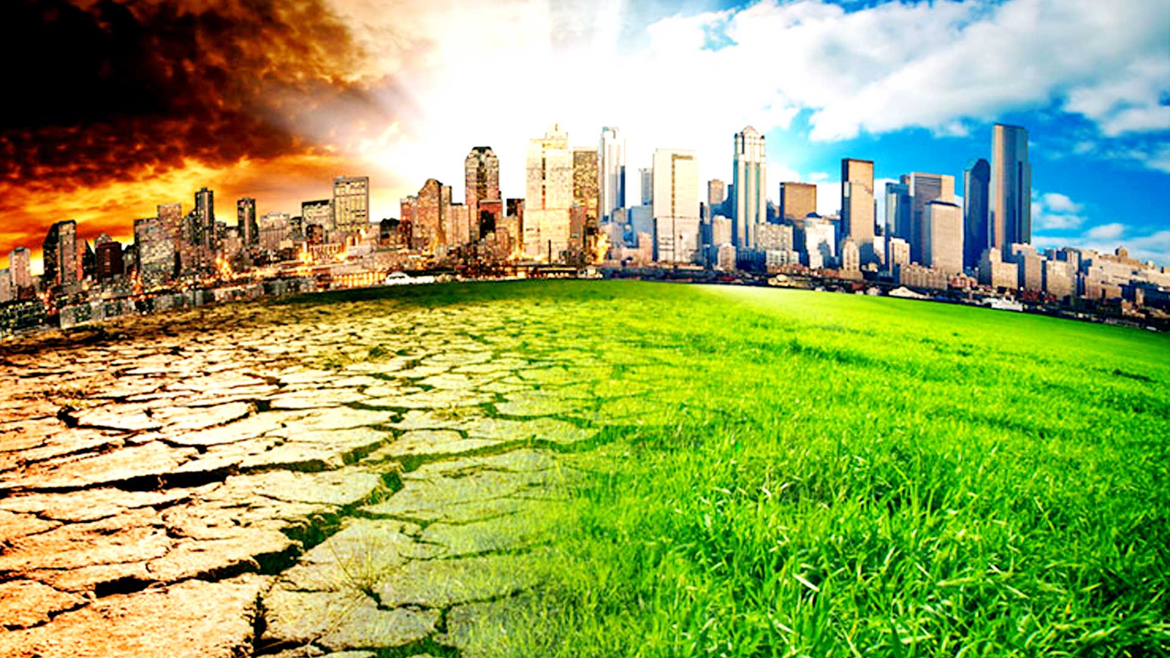

BMSP6007
Economics of Sustainability

Chloe Wilson

Executive Summary

Research revealed that there are numerous concerns associated with the Paris Agreement which are preventing the treaty from being successful in combating climate change issues.
Firstly, disputes between developed countries and developing countries were identified as being one of the most controversial issues within the Paris Agreement as developed countries were not providing the expected $100 billion annual pledge. This financial resource was recognised as being essential to allow developing countries to change. Secondly, voluntary mitigation targets were considered ineffective as there were little enforcement mechanisms in place to encourage countries to set more ambitious targets. However, it was recommended that Governments adopt a similar approach to the Montreal Protocol by enforcing regulations, setting specific timeframes as well as penalties for non-compliance. Lastly, global ratification and non-withdrawal were deemed essential to avoid countries putting economy and emissions before environmental concerns.
Global agreements on climate change were deemed obligatory requirements and if not achieved this could result in ecosystems collapsing and economies underperforming.

Contents

1.0 Introduction 4

2.0 Issues 5
2.1 Issue One - Developed World Vs Developing World 5
2.2 Issue Two – Voluntary Mitigation Targets 8
2.3 Issue Three - Countries not Ratified or Withdrawing 10

3.0 The Need for Global Agreements 11

4.0 Conclusion 12

6.0 Bibliography 13

1.0 Introduction

This report will evaluate the three main concerns associated with the failure of international treaties to solve climate change. This will be achieved by firstly, analysing the differences between the developed world and developing world, secondly, why countries are not ratified or withdraw from agreements and finally, why mitigation targets are voluntary. The report will also consider whether global agreements are still necessary to combat climate change and a recommendation will be proffered to improve their effectiveness.
The UN Framework Convention on Climate Change (UNFCCC) was established in 1992 and was the first significant treaty developed in response to climate change issues (United Nations, 1992). Since then, several climate summits have been held (see fig 1) (Iberdrola,2021) and this report will primarily identify the issues associated with the Paris Agreement whilst referring to the previous policies to support the discussion.
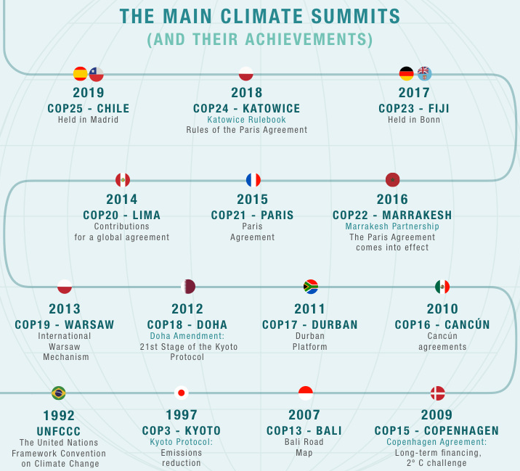

(Fig 1) (Iberdrola,2021)
The Paris Agreement was established in 2015 at COP21 and came into force in 2016. The treaty was adopted by 197 UNFCCC members with the main aim of limiting global warming to below 2°C but more favorably 1.5°C compared to industrial levels (United Nations, 2021).

2.0 Issues

This section will analyse the three main concerns that have prevented the successful implementation of international treaties on climate change by specifically investigating the Paris Agreement.

2.1 Issue One - Developed World Vs Developing World

Since 1990 policy makers have discussed whether developed or developing countries are considered more responsible for climate change issues (Kirby,2018). The Kyoto Protocol was established in 1992 and it only required developed countries to contribute towards reducing greenhouse gas emissions. However, according to Stavins, et al (2017) international cooperation is vital to achieve a significant advancement in mitigating climate change. The Paris Agreement recognised that climate change was a global challenge which required the involvement of every country (European Union, 2016).
It is argued by developing countries that developed countries, including the United States and the European Union, are primarily responsible for climate change due to emitting significant quantities of greenhouse gases since the Industrial Revolution. It is further argued that as these countries were able to develop their economies with minimum constraints (Odendahl,2016) they should be more obliged to contribute under the Paris Agreement (see fig 2) (Maizland,2021).

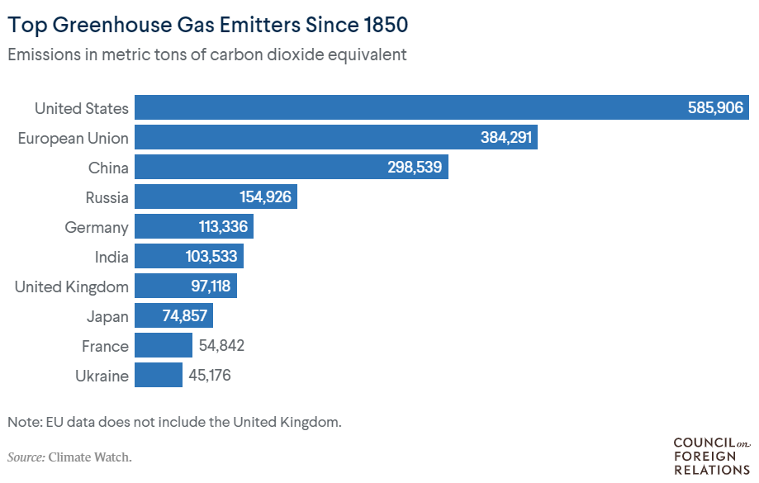
(Fig 2) (Maizland,2021)
Equally developed countries argue that China and India have a responsibility to do more to address climate change issues (Maizland,2021) as they were recognised to be amongst the top global emitters of greenhouse gases in 2017 (see fig 3). China took full advantage of being exempt from the conditions of the Kyoto Protocol and within a decade their GDP had almost tripled and their carbon emissions doubled which led to them becoming the largest greenhouse gas emitter (The Economist, 2020).

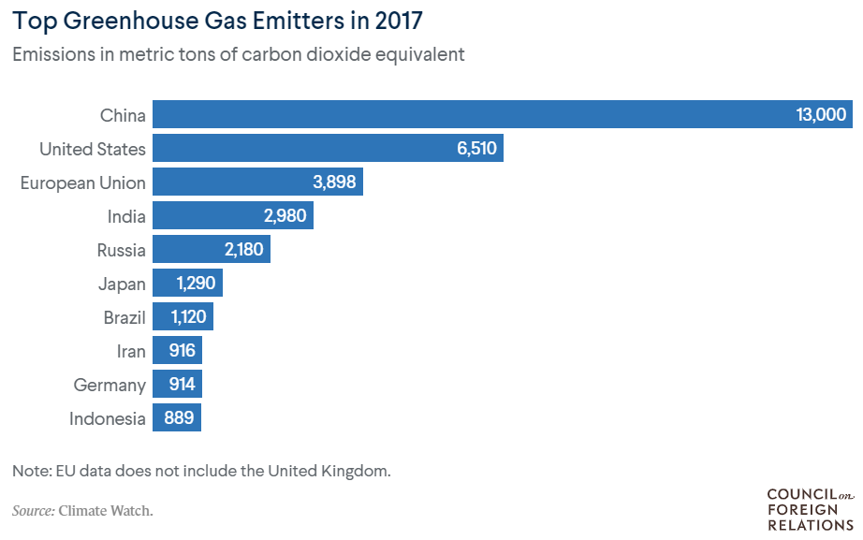
(Fig 3) (Maizland, 2021)

The Environmental Kuznets Curve models a theory-based relationship between economic advancement and environmental degradation that can be illustrated as an inverted U shape (see fig 4) (Kaika, et al 2013). It implies that the early stages of industrialisation are associated with increasing levels of pollution and that more advanced development is related to an increasing concern for environmental quality and an associated strengthening of environmental regulation (IBID). China have exhibited significant economic growth, however, this has been accompanied by significant greenhouse gas emissions with environmental quality not being considered. Therefore, China is positioned on the incline between the pre-industrial and industrial economy of the Environmental Kuznets Curve whereas the majority of western countries are on the decline.

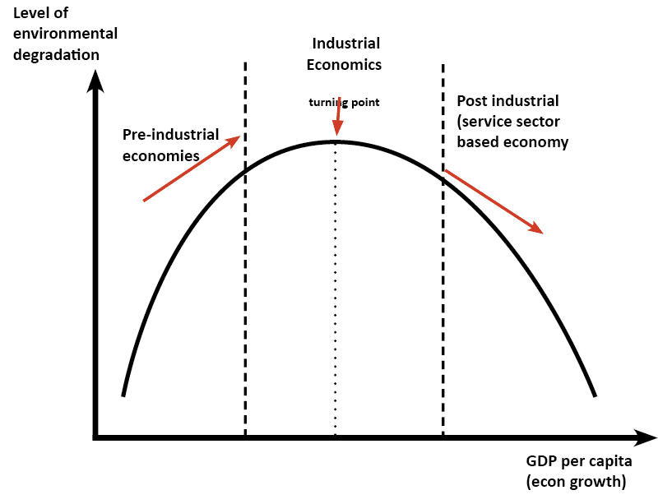

(Fig 4) (Kaika, et al 2013)
The Green Climate Fund is an essential element of the Paris Agreement (The Green Climate Fund, 2021) and requires developed countries to provide financial, technical, and capacity building support to developing countries (United Nations, 2021). This allows developing countries to enhance existing resources and set more ambitious global warming goals (Streck, et al 2016). However, one of the most controversial issues that reoccurs at the Paris Agreement conferences is the level of support developed countries commit to providing (Clemencon,2016). Developed countries are expected to pledge $100 billion annually to achieve mitigation and adaption (The Green Climate Fund, 2021), however, this commitment has not yet been achieved and will be addressed at the upcoming COP26 conference (United Nations, 2021).
Despite the issues between the developed and developing countries, there are also significant conflicts between the developed nations. For example, the EU believes that legally binding protocols are most effective when combating climate change issues which is supported by environmental groups. However, America considers that voluntary pledges are the most suitable approach, a view which is supported by industry (European Parliament, 2015).

2.2 Issue Two – Voluntary Mitigation Targets

According to Sangroula (2013) international laws lack enforcement qualities and many treaties are unsuccessful due to the absence of regulations. The UNFCCC initially created the Kyoto Protocol which was considered a legally binding, top-down approach, however, this was replaced with the Paris Agreement which is considered to be a self-determined, voluntary, bottom-up approach (Bhushan,2017). It is believed that voluntary mitigation targets or Nationally Determined Contributions (NDCs) are vital for the Paris Agreement to be successful as there are differing circumstances and conditions within each country (United Nations, 2016). However, Streck, et al (2016) believes that a major concern associated with the Paris Agreement is that there are minimal enforcement mechanisms.
The Paris Agreement requires countries to provide NDCs which are updated every five years. NDCs are non-binding independent plans that are formulated by each country to highlight the different targets, polices and measures that have been implemented to achieve the global targets of the Paris Agreement (United Nations, 2021). However, some of the commitments identified in the NDCs are viewed as insufficient as in 2019 only 67 members had pledged commitments to achieve net-zero emissions. Figure 5 highlights that CO2 emissions are set to increase if more countries do not commit to net zero emissions (Charlton,2019). The UK has set the most ambitious climate change targets and has pledged to reduce emissions by 78% by 2035 compared to 1990 levels. If achieved, this will result in the UK being three-quarters of the way to reaching net-zero by 2050 (Gov.UK, 2021).
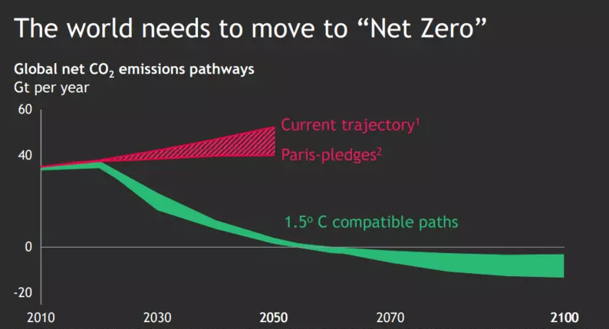

(Fig 5) (Charlton,2019)
According to Mills-Novoa et al (2018) vital action is required by all nations. It is anticipated that the current NDC ambitions will result in 2.8°C warming by 2100 and it is emphasised that NDCs need modification and increased efforts (Hare, et al 2017). According to WWF (2018) the difference between 2°C and 1.5°C is extremely significant and if countries do not act, ‘a climate catastrophe is inevitable’. This difference could potentially result in three times as many people being exposed to extreme heatwaves if 2°C is achieved instead of 1.5°C (IBID). This prediction is even more stark as countries are not on track to reach the minimum 2°C in line with the Paris Agreement (Chadwick,2021).
The overarching conclusions of the report are that
“Current commitments expressed in the NDCs are inadequate to bridge the emissions gap in 2030. Technically, it is still possible to
bridge the gap to ensure global warming stays well below 2 and 1.5

C, but if NDC ambitions are not increased before 2030, exceed-
ing the 1.5

C goal can no longer be avoided. Now more than ever, unprecedented and urgent action is required by all nations” (p. 4).
The overarching conclusions of the report are that
“Current commitments expressed in the NDCs are inadequate to bridge the emissions gap in 2030. Technically, it is still possible to
bridge the gap to ensure global warming stays well below 2 and 1.5

C, but if NDC ambitions are not increased before 2030, exceed-
ing the 1.5

C goal can no longer be avoided. Now more than ever, unprecedented and urgent action is required by all nations” (p. 4).
The overarching conclusions of the report are that
“Current commitments expressed in the NDCs are inadequate to bridge the emissions gap in 2030. Technically, it is still possible to
bridge the gap to ensure global warming stays well below 2 and 1.5

C, but if NDC ambitions are not increased before 2030, exceed-
ing the 1.5

C goal can no longer be avoided. Now more than ever, unprecedented and urgent action is required by all nations” (p. 4).
The UN Global Compact is the world’s most significant corporate sustainability framework and requires 160 countries to implement and align sustainable procedures with ten universal principles on human rights, labour, the environment and anti-corruption (Karbassi,2021). In 2015, 17 global goals were developed by the United Nations and 12 of these goals were directly related to climate change issues as well as climate change having its own separate goal (United Nations, 2016). The UN Accenture report from 2015 recognised that 43% of CEOs believed that science-based targets were vital mechanisms (United Nations, 2015), however, in 2019 very few industries were adopting science-based action on climate change as only 35% of CEOs said that they had plans to set targets (United Nations, 2019). This was significantly surprising as in the same year 86% of CEOs agreed that climate action was critical in order to achieve the global goals (see fig 6) (IBID). This evidence highlights that voluntary commitments are potentially ineffective and that there is a need for more enforcement.
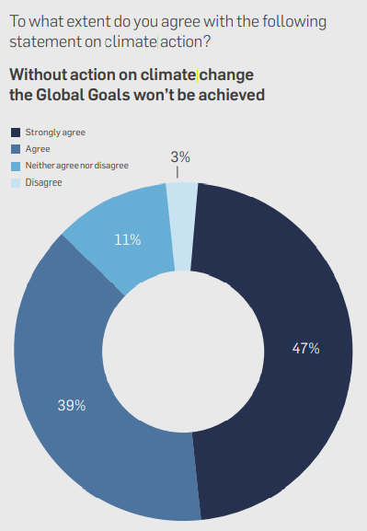

(Fig 6) (United Nations, 2019)

The Montreal Protocol was established in 1987 to protect the ozone layer from chlorofluorocarbons (CFCs) and has been recognised as the most effective environmental policy (Leahy,2017). The Montreal Protocol was signed by 197 countries and was the first policy to achieve global ratification (United States Environmental Protection Agency, 2020). This treaty has resulted in 99% of ozone-depleting chemicals being eliminated, however, there are still some remaining developing countries that have not yet eliminated destructive substances due to economic resources. Due to this, the Multilateral Fund was set up to support developing countries (Leahy,2017). The Montreal Protocol formulated regulations for ozone-depleting substances to be banned within a period of time which meant countries and industries were required to develop and adapt to using alternative chemicals. Whilst the main attempt of the agreement was to achieve change through collaboration and the use of finance from the Multilateral Fund, there was the threat of exclusion from funding and suspension from treaties, such as trading, if there was non-compliance (United Nations, 2021). It is argued that this approach involves rigid standards, nevertheless, it has proven to be effective (Elizabeth,2020). The Paris Agreement is legally binding, however, there are very few monitoring mechanisms or implementation protocols (Rajendran,2021) which are potentially restricting the treaty from being successful.

2.3 Issue Three - Countries not Ratified or Withdrawing

The Paris Agreement is currently ratified by 197 UNFCCC members, however, Iran, Iraq, Libya, Yemen, Eritrea and Turkey have not ratified the agreement and these countries represent 4% of the global greenhouse gas emissions (Dimitrov,2021). Turkey, the only G20 country to not formally approve the agreement, was reluctant to ratify due to concerns over being classified as a developed country with contribution obligations (Apparicio, et al 2020). This resulted in them securing ‘special circumstances’ which allowed them to opt out of providing financial resources, however, they still cannot access climate cash, a condition President Recep Tayyip Erdoğan has said must change if Turkey is to ratify the agreement (IBID).
In 2017 Donald Trump withdrew America from the Paris Agreement, but, due to the nature of the treaty America was not able to officially withdraw until 2020 (BBC,2017). Trump was concerned with economic growth rather than environmental concerns and believed that the Paris Agreement would be costly and have a significant effect on existing industries (Hersher,2020). It was predicted that the Paris Agreement would destroy $2.5 trillion of America’s gross domestic product by 2035 (Loris,2017). Smith (2021) argues that climate-driven disasters will have more of an impact on economic prosperity, for example, in 2020 alone there were 22 climate related events in America which cost $95 billion in damages.
Additionally, it has been advocated that America withdrew from the Paris Agreement because of lobbyist groups. Lobbying against sustainable principles does not allow any progress to be achieved on climate change issues. This is recognised as an issue in America as several companies actively lobby for changes in policies (Slob, et al 2010) which delays any progress towards a more sustainable future.
This withdrawal was recognised as influencing other countries with Saudi Arabia, Kuwait and Russia adopting a similar mindset and supporting America’s effort to dispute the science suggesting global warming. However, these countries did not pull out of the Paris Agreement (McGrath,2020) and America rejoined once Biden became President in 2021 (Blinken,2021). If America did not rejoin this would have resulted in a significant shortfall of funding for developing countries, preventing them from committing to ambitious targets (Hersher,2020). There is still a risk that parties could withdraw from the agreement which has created uncertainty and a lack of trust.

3.0 The Need for Global Agreements and Recommendation

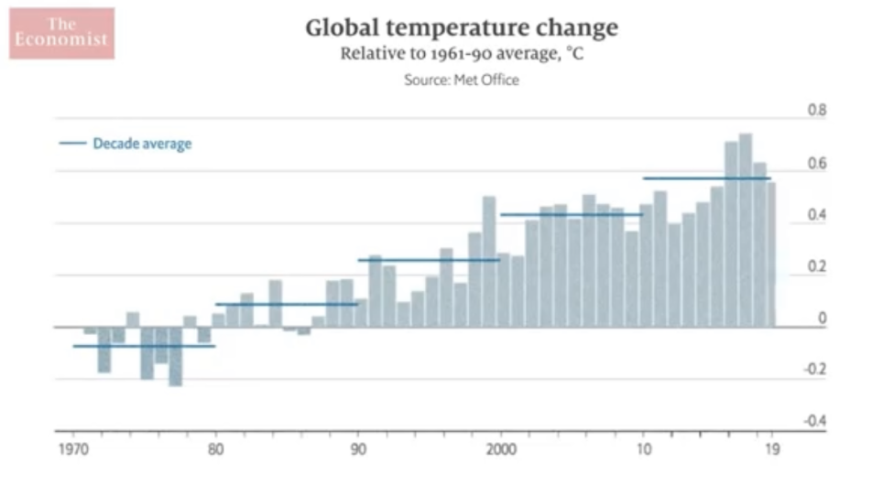
Undoubtedly climate change is a critical issue that needs addressing globally and has been described as, ‘the defining human development issue of our generation’ (United Nations, 2020). Throughout the past 50 years political compromises have repeatedly enabled governments to avoid taking effective action and this has resulted in CO2 emissions doubling, with every decade being warmer than the previous one (see fig 7).
(Fig 7) (The Economist, 2020)

The evidence provided within this report identifies that there is a significant need for global intervention to combat climate change as the Paris Agreement has the potential to achieve its aims but also the potential for countries to not ratify and withdraw. The Paris Agreement has not been successful in combating climate change globally and it could be argued that this is partly due to the voluntary commitments that countries pledge through their NDCs. For example, in 2019 only 67 countries had formulated plans to achieve net zero emissions by 2050.
The Montreal Protocol demonstrated that global challenges can be rectified when all countries ratify a policy and when stricter regulations are enforced. Global ratification is essential as the Kyoto Protocol only required developed countries to comply with regulations which resulted in China becoming the largest greenhouse emitter.
For the Paris Agreement to become successful it would be necessary to adopt a similar approach as the Montreal Protocol by enforcing regulations, setting specific timeframes and penalties for non-compliance. This would allow the desired 1.5°C target to be achieved which would reduce climate-driven disasters, achieve economic prosperity and global sustainability. By setting the same target for all countries and with expected delivery by 2050 this ensures that businesses and Governments are unified and operating on a level playing field.
If stricter global regulations are not implemented, then there is a potential risk that climate change could continue and this would result in ecosystems collapsing and economies underperforming.

4.0 Conclusion

This report has shown that there are several issues associated with the implementation of international treaties to solve climate change. Firstly, the disputes between developed and developing nations have resulted in insufficient financial pledges, which is limiting the developing world from achieving mitigation and adaptation. Secondly, self-determined NDCs have proven to be ineffective as there are little enforcement mechanisms to encourage countries to set more ambitious targets. However, this could be rectified through the recommendation of enforcing stricter regulations to achieve the desired 1.5°C goal. Lastly, global ratification and non-withdrawal is essential to avoid countries putting economy and emissions before environmental concerns.

Despite the issues associated with the Paris Agreement, it is still considered a significant development in humanity’s attempt to overcome climate change and international treaties are deemed essential.

6.0 Bibliography

Apparicio, S., & Sauer, N. (2020, August 13). Which countries have not ratified the Paris climate agreement? Retrieved from Climate Home News: https://www.climatechangenews.com/2020/08/13/countries-yet-ratify-paris-agreement/
BBC. (2017, June 02). What is the Paris climate deal and why has Trump pulled the US out? Retrieved from BBC News Round: https://www.bbc.co.uk/newsround/40130616
Bhushan, C. (2017, March 27). After 25 years of failure, we should abandon the UNFCCC. Retrieved from Climate Home News: https://www.climatechangenews.com/2019/03/27/25-years-failure-abandon-unfccc/
Blinken , A. (2021, February 19). The United States Officially Rejoins the Paris Agreement. Retrieved from US Department of State : https://www.state.gov/the-united-states-officially-rejoins-the-paris-agreement/
Chadwick, M. (2021, March 16). What is the Paris climate agreement and why does it matter? Retrieved from GreenPeace: https://www.greenpeace.org.uk/news/what-is-paris-climate-agreement-and-why-does-it-matter/
Charlton, E. (2019, December 13). Who's promised net-zero, and who looks likely to get there? Retrieved from World Economic Forum: https://www.weforum.org/agenda/2019/12/countries-companies-net-zero-carbon-emissions/
Clemencon, R. (2016). The Two Sides of the Paris Climate Agreement: Dismal Failure or Historic Breakthrough? The Journal of Environment & Development, 1-24.
Dimitrov, R. (2021). The Paris Agreement in 2021: Canada in a Global Context. Canada: Ivy Business School .
Elizabeth, K. (2020). THE MONTREAL PROTOCOL OR THE PARIS AGREEMENT AS A MODEL FOR A PLASTICS TREATY? AJIL Unbound, 212-216.
European Parliament. (2015, November). Climate policies in the EU and USA. Retrieved from European Parliament: https://www.europarl.europa.eu/RegData/etudes/BRIE/2015/571347/EPRS_BRI(2015)571347_EN.pdf
European Union. (2016, January). The Paris Agreement: A new framework for global climate action. Retrieved from European Union: https://www.europarl.europa.eu/RegData/etudes/BRIE/2016/573910/EPRS_BRI(2016)573910_EN.pdf
Gov.UK. (2021, April 20). UK enshrines new target in law to slash emissions by 78% by 2035. Retrieved from Gov.UK: https://www.gov.uk/government/news/uk-enshrines-new-target-in-law-to-slash-emissions-by-78-by-2035
Hare, B., Ancygier, A., Parra, P., & Marez, L. (2017). Facilitating Global Transition: The Role of Nationally Determined Contributions in Meeting the Long-Term Temperature Goal of the Paris Agreement. Berlin: NDC Partnership.
Hersher , R. (2020, November 03). U.S. Officially Leaving Paris Climate Agreement. Retrieved from National Public Radio: https://www.npr.org/2020/11/03/930312701/u-s-officially-leaving-paris-climate-agreement?t=1621592664474
Iberdrola. (2021). Climate negotiations: 25 years of searching for consensus on the fight against climate change. Retrieved from Iberdrola: https://www.iberdrola.com/environment/international-agreements-on-climate-change
Kaika, D., & Zervas, E. (2013). The Environmental Kuznets Curve (EKC) theory—Part A: Concept, causes and the CO2 emissions case. Energy Policy, 1392-1402.
Karbassi, L. (2021). Advancing Sustainable Development. Retrieved from United Nations : https://www.unglobalcompact.org/what-is-gc/our-work/sustainable-development
Kirby, A. (2018, September 17). Are developing nations equally to blame for climate change? Retrieved from Climate Home News: https://www.climatechangenews.com/2013/09/17/developing-nations-equally-to-blame-for-climate-change-report/
Leahy , S. (2017, September 25). Without the Ozone Treaty You’d Get Sunburned in 5 Minutes. Retrieved from National Geographic: https://www.nationalgeographic.com/science/article/montreal-protocol-ozone-treaty-30-climate-change-hcfs-hfcs
Loris, N. (2017, June 01). 4 Reasons Trump Was Right to Pull Out of the Paris Agreement. Retrieved from The Heritage Foundation: https://www.heritage.org/environment/commentary/4-reasons-trump-was-right-pull-out-the-paris-agreement
Maizland, L. (2021, April 29). Global Climate Agreements: Successes and Failures. Retrieved from Council on Foreign Relations: https://www.cfr.org/backgrounder/paris-global-climate-change-agreements
McGrath, M. (2020, November 04). Climate change: US formally withdraws from Paris agreement. Retrieved from BBC News: https://www.bbc.co.uk/news/science-environment-54797743
Mills-Novoa, M., & Liverman, D. (2018). Nationally Determined Contributions: Material climatecommitments and discursive positioning in the NDCs. WIREs Climate Change, 1-15.
Odendahl , T. (2016, January 22). The Failures of the Paris Climate Change Agreement and How Philanthropy Can Fix Them. Retrieved from Stanford University: https://ssir.org/articles/entry/the_failures_of_the_paris_climate_change_agreement_and_how_philanthropy_can
Rajendran, C. (2021, April 14). Five Years Since the Paris Agreement, How Effective Has the Climate Pact Been? Retrieved from Science: The Wire: https://science.thewire.in/environment/five-years-since-the-paris-agreement-how-effective-has-the-climate-pact-been/
Sangroula, Y. (2013). International Treaties: Features and Importance from International Law Perspective. Kathmandu School of Law, 1-7.
Slob, B., & Weyzig, F. (2010, May). Corporate Lobbying and Corporate Social Responsibility: Aligning Contradictory Agendas. Retrieved from ResearchGate: https://www.researchgate.net/publication/280653077_Corporate_Lobbying_and_Corporate_Social_Responsibility_Aligning_Contradictory_Agendas
Smith, A. (2021, January 08). 2020 U.S. billion-dollar weather and climate disasters in historical context. Retrieved from Climate.Gov : https://www.climate.gov/news-features/blogs/beyond-data/2020-us-billion-dollar-weather-and-climate-disasters-historical
Stavins, R., & Ji , Z. (2017). International Cooperation: Agreements & Instruments. International : International Cooperation: Agreements & Instruments.
Streck, C., Keenlyside, P., & Unger, M. (2016). The Paris Agreement: A New Beginning. Journal for European Environmental & Planning Law, 3-29.
The Economist. (2020, May 22). Why politicians have failed to tackle climate change | The Economist. Retrieved from YouTube: https://www.bing.com/videos/search?q=the+failure+of+global+agreements+on+climate+change&&view=detail&mid=05ACCA20416976A23ECD05ACCA20416976A23ECD&&FORM=VRDGAR&ru=%2Fvideos%2Fsearch%3Fq%3Dthe%2Bfailure%2Bof%2Bglobal%2Bagreements%2Bon%2Bclimate%2Bchange%26F
The Green Climate Fund. (2021). About GCF. Retrieved from The Green Climate Fund: https://www.greenclimate.fund/about
United Nations . (1992). UNITED NATIONS FRAMEWORK CONVENTION ON CLIMATE CHANGE. Global : United Nations .
United Nations . (2015). The UN Global Compact-Accenture CEO Study Special Edition: A Call to Climate Action. Global: United Nations Global Compact.
United Nations . (2019). UN Global Compact-Accenture Strategy 2019 CEO Study – The Decade to Deliver: A Call to Business Action. Global: United Nations Global Compact.
United Nations . (2020, September 29). Climate change ‘the defining challenge of our generation’ says New Zealand Ambassador. Retrieved from United Nations: https://news.un.org/en/story/2020/09/1074252
United Nations . (2021 ). The Montreal Protocol on Substances that Deplete the Ozone Layer. Retrieved from UN Environment Programme : https://ozone.unep.org/node/2080
United Nations . (2021, February 26). “Climate Commitments Not On Track to Meet Paris Agreement Goals” as NDC Synthesis Report is Published. Retrieved from United Nations Framework Convention on Climate Change: https://unfccc.int/news/climate-commitments-not-on-track-to-meet-paris-agreement-goals-as-ndc-synthesis-report-is-published
United Nations . (2021). Nationally Determined Contributions (NDCs). Retrieved from United Nations Framework Convention on Climate Change: https://unfccc.int/process-and-meetings/the-paris-agreement/nationally-determined-contributions-ndcs/nationally-determined-contributions-ndcs
United Nations. (2016, September 12). The Paris Agreement: Frequently Asked Questions. Retrieved from United Nations Sustainable Development Goals: https://www.un.org/sustainabledevelopment/blog/2016/09/the-paris-agreement-faqs/
United Nations. (2021). The Paris Agreement. Retrieved from United Nations Framework Convention on Climate Change: https://unfccc.int/process-and-meetings/the-paris-agreement/the-paris-agreement
United States Environmental Protection Agency. (2020, February 13). International Actions - The Montreal Protocol on Substances that Deplete the Ozone Layer. Retrieved from United States Environmental Protection Agency: https://www.epa.gov/ozone-layer-protection/international-actions-montreal-protocol-substances-deplete-ozone-layer
WWF. (2018, October 08). OUR WARMING WORLD: HOW MUCH DIFFERENCE WILL HALF-A-DEGREE REALLY MAKE? Retrieved from World Wide Fund: https://www.wwf.org.uk/updates/our-warming-world-how-much-difference-will-half-degree-really-make

