
Module: Software Development
Module code: ACCB4017
Assessment 1 – Software Development Programme: BCs Cloud Computing

Table of Contents
PART A 2
TASK A1 2
TASK A2 3
TASK A3 5
PART B 7
Exercise 1 7
Exercise 2 9
Exercise 3 12
Exercise 4 14
References 18

PART A

TASK A1
The control structure if..elif is used to make decisions (the if..elif statement is used to execute if a certain condition is met and thus evaluates the test conditions and must be initiated by indentation to make the interpretation real-time.
if test expression:
Body of if
else:
Body of else
var = 100
if var == 200:
print (var)
elif var == 150:
print (var)
elif var == 100:
print (var)
else:
print (var)
print ("ELIF STATEMENT")

TASK A2
Loops are controls structure that allows for execution of multiple statement in situation you need to execute multiple block of codes several times within the same program compilation [3].
- While loop
Repeats a given condition before executing the body loops testing the validity of a given condition.
count = 0
while (count < 3):
print ('The counter is:', count)
count = count + 1
print ("Counter stop!")
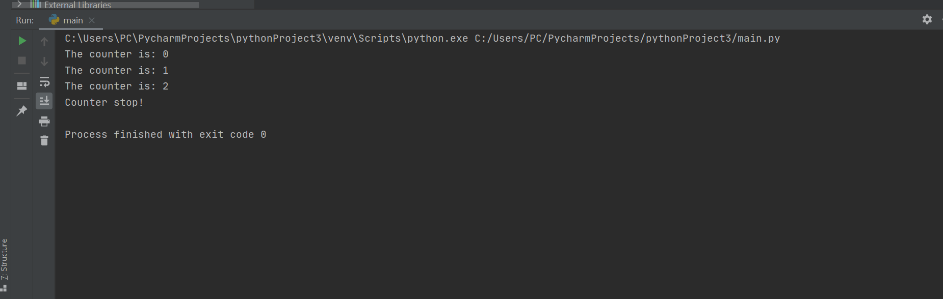
- For loop
Iterate over items, lists and arrays in any automatic sequence to execute the given block statement [1].
a = ['d', 'm', 'r']
for index in range(len(a)):
print ('Alphabets:', a[index])
print ("End of Program!")
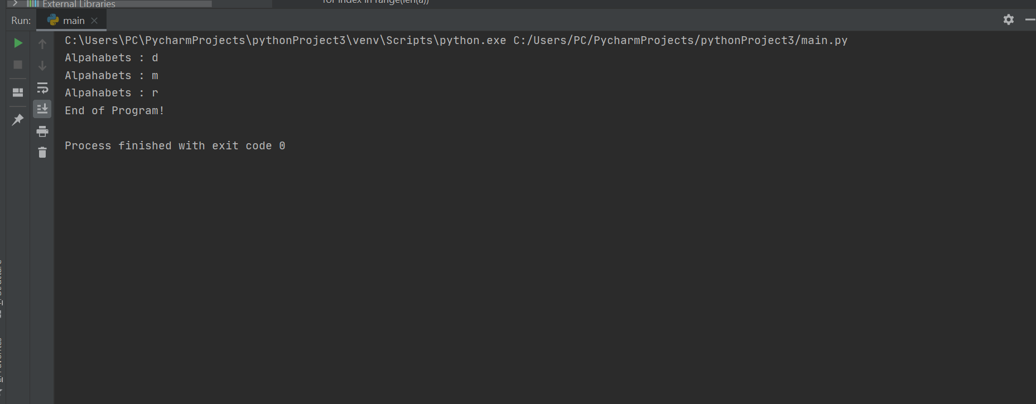
- Nested loops
Using one loop on top of another loop to control the nesting of the loops to execute the given code functionality [4].
i = 2
while (i < 5):
j = 2
while (j <= (i/j)):
if not(i%j):
break
j = j + 1
if (j > i/j):
print (i, " is prime")
i = i + 1
print ("prime number generator!")
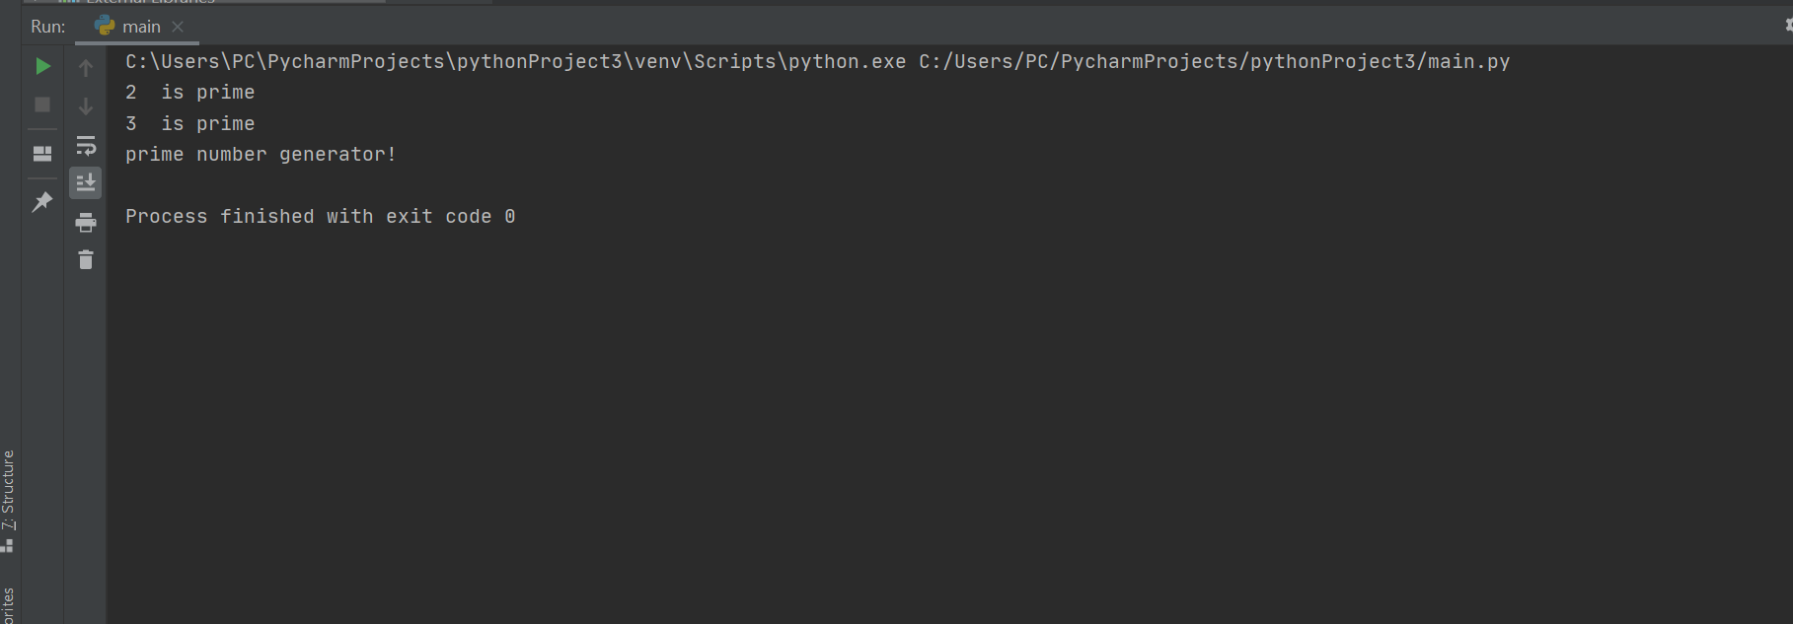

TASK A3
Lists are used to store multiple items within the single variable collections with built-in functionality that stores the data in the form of Tuple, set and dictionaries with different variables and can be created in the form of a listings [2].
mylist = ["a", "b", "c"]
print(mylist)
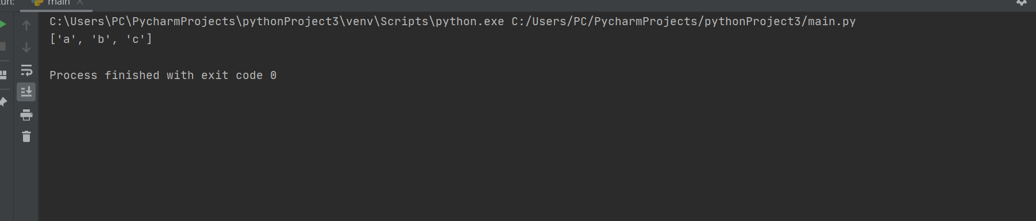
Multidimensional lists
list1 = ["a", "b", "b"]
list2 = [1, 2, 3, 3, 3]
list3 = [True, False, False]
print(list1)
print(list2)
print(list3)
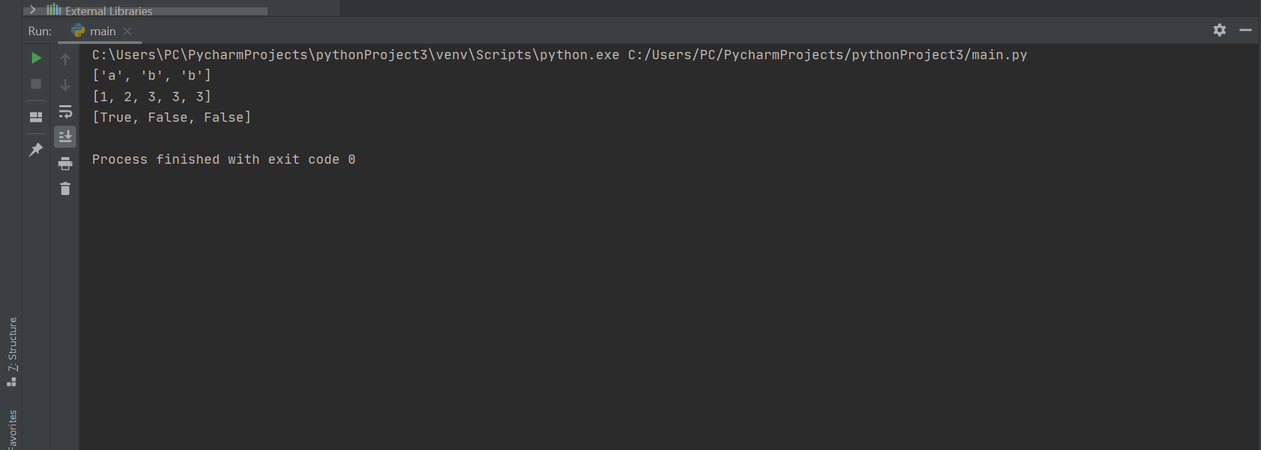

PART B

Exercise 1
The variables to be used in the program includes:
- Char customer_name = input ("Customer Name:")
- Int customer_quantity = int (input ("Enter Quantity: "))
- int customer_price = float (input ("Enter price: "))
- float total_cost = customer_quantity*customer_price
The pseudocode flow chart for the program includes the following:
- Enter the name of the customer name
- Enter the quantity of the customer
- Check and validate the quantity (if the quantity is greater than 0)
- Enter the price
- Check and validate the price (if the price is greater than 0)
- Calculate the total cost (price * quantity)
- Display the results for:
- Customer name
- Quantity for the item
- Price for the item
- The total cost values
#Show how variables can contain different types of values by using three variables to hold a customer name and details
Char customer_name = input ("Customer Name:")
Int customer_quantity = int (input ("Enter Quantity: "))
#validate the quantity of the customer input identity
while (customer_quantity <= 0):
print ("The quantity must be above zero.")
customer_quantity = int (input ("Input another quantity again "))
int customer_price = float (input ("Enter price: "))
while (customer_price <= 0):
print ("The price must be above zero.")
customer_price = int (input ("Input another price again"))
float total_cost = customer_quantity*customer_price
#print all details of screen
print ("Customer Name: “, customer_name)
print ("Quantity: “, customer_quantity)
print ("Price: “, customer_price)
print ("Total Cost: “, total_cost)
test validation
- Test case 1
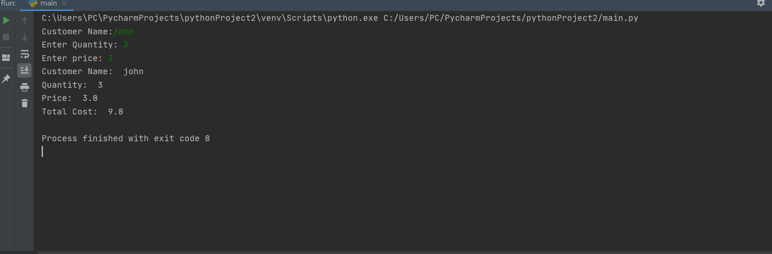
Test case 2
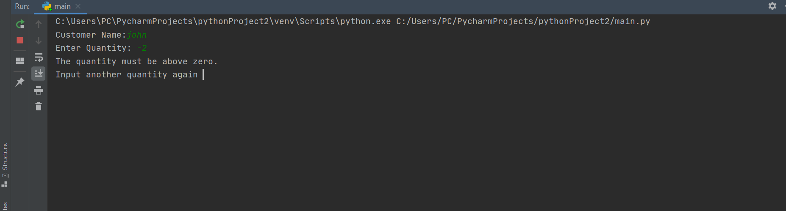
Test case 3
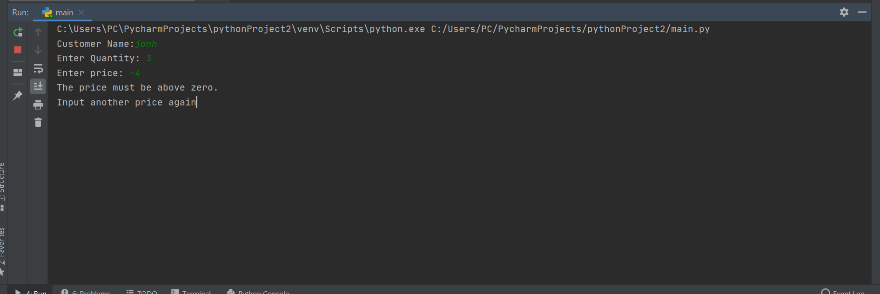

Exercise 2
The pseudocode flow chart for the program includes the following:
- Create a function defArea
- Input radius of the outer circle
- Calculate the area of the radius of the outer circle
- Create function 2 defArea2
- Input the radius of the inner circle
- Calculate the area of the radius of the inner circle
- Calculate the difference between the two-circle function to calculate the area of the shaded circle
- Test controls for:
- Test for numbers that’s less than 0 (radius for inner circle less than 0)
- Radius of the outer circle less than 0
- Radius of inner circle greater than radius of the outer circle
# Python program to find Area of a circle
def findArea(r):
PI = 3.14159265359
return PI * (r*r);
def findArea2(r2):
PI = 3.14159265359
return PI * (r2*r2);
# Driver method
num=float (input ("Enter the radius of the outer circle:"))
num2=float (input ("Enter the radius of the inner circle:"))
if (num <=0):
print ("Radius for the outer circle must be zero and above.")
if (num2 <=0):
print ("Radius for the inner circle must be zero and above.")
elif (num <=num2):
print ("Radius for the outer circle must greater than that of inner circle")
elif (num >=0):
print ("Area is %.6f" % (findArea(num)-findArea(num2)));
testing the controls within the Python Program Exercise two
test control 1
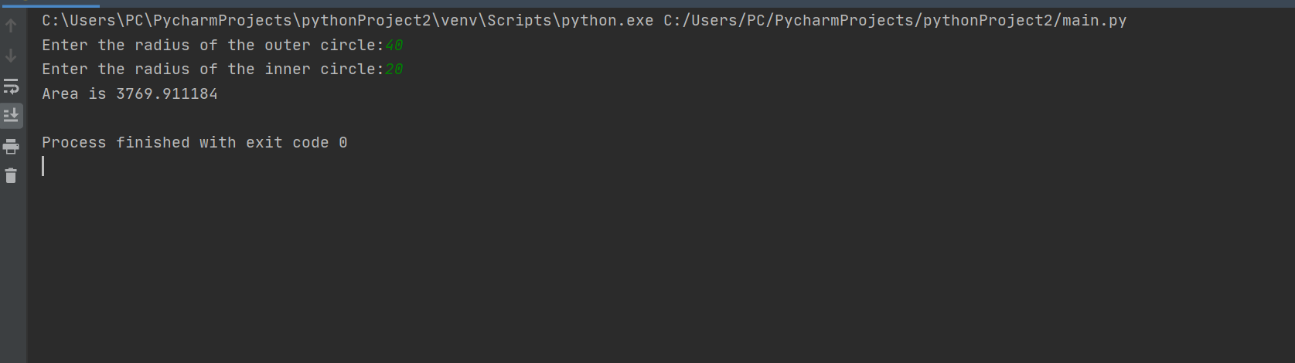
Control to validate the outer circle
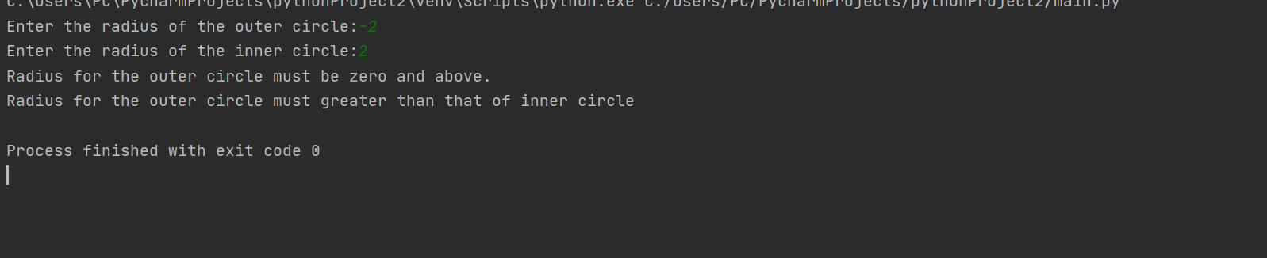
Control to validate the inner circle
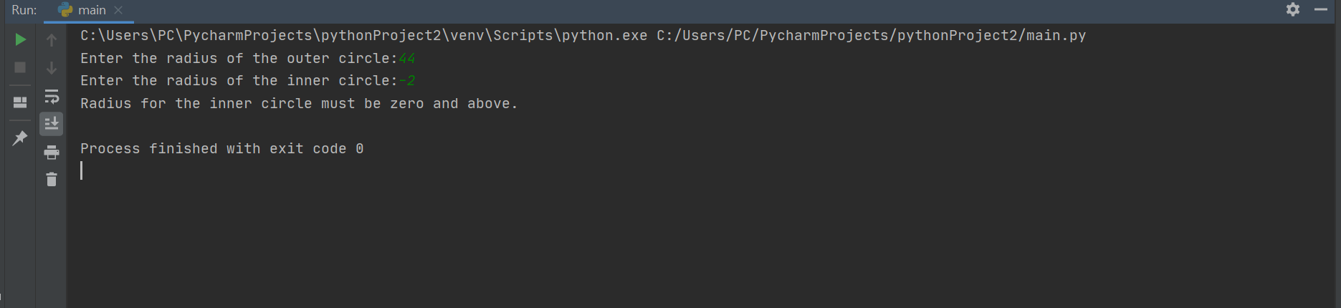

Exercise 3
Pseudocode for the implementation of the program
- The user enters the names of the five staff
- The names of the five staff and their salary details
- Prompt the user to enter the staff details (names of the five staff and their salary details)
- The details are inserted in the array list with their salary scope for each of the members (in both the first and second array list for the members in the IT department – in the details insert the array list (names + salary details of the employees in the IT department).
- Calculate the total salary for the names of the five staff
- Calculate the increment for the five staff
# creating an empty list
employee_names = []
employee_salary = []
# number of elements as input
n = 5
salary = 0
increment = 0
# iterating till the range
for i in range (0, n):
employee_names.append(input("Enter staff name: \n"))
employee_salary.append(float(input ("Enter Salary: \n")))
while(employee_salary[i] <= 0):
print("Salary must be greater than zero.")
employee_salary.append(float(input("Enter Salary: \n")))
salary = salary + employee_salary[i]
increment = increment + employee_salary[j] + 0.1*employee_salary[j]
print("Total salary: ",salary)
print ("Total salary amount with 10% increase: “, increment)
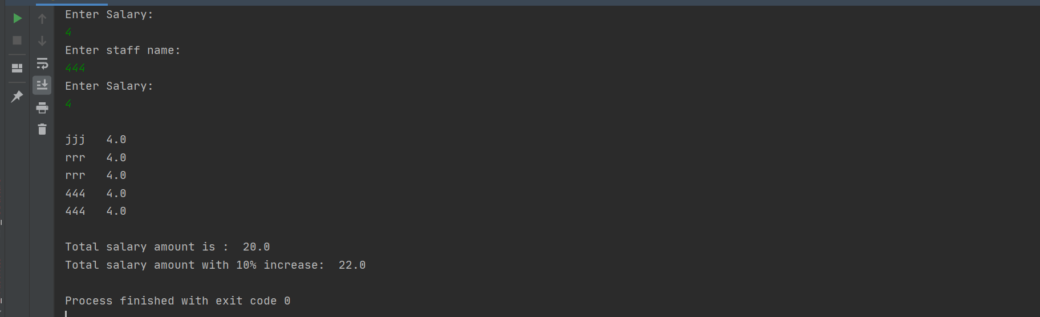
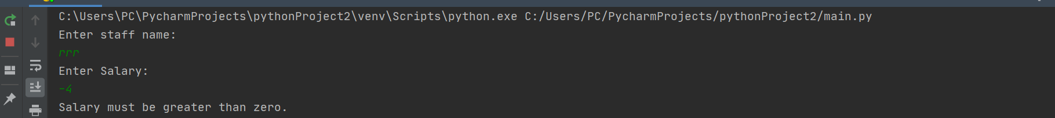

Exercise 4
Pseudocode for the spinning game for the random numbers
- Input the user to check the user defined inputs? Input yes
- Generate the random number of variables and attributes in the given spinning game
- Click the spinning game to generate random numbers
- Generate the three random numbers and check the following conditions:
- Any two combination of same number = 5 points
- Three numbers combination (with the exception of 9) = 15 points
- Any combination of the number 9s = 200 points
- Three nines plays a big jackpot = 2000 points.
import random
# generate random numbers from 0 to 999
def spinning_game(random_number) :
random_number = random.randint(000, 999)
f = [int(x) for x in str(random_number)]
choice = "Yes"
user_choice_input = input("Spin? ")
points = 0
print(random_number)
if (f[0] != f[1] and f[0] != f[2] and f[1] != f[2]) :
print("You lose, your points are ", points)
user_choice_input = input("Spin? ")

if (f[0] == f[1] and f[1] != f[2] and f[1] != 9 or f[1] == f[2] and f[2] != f[0] and f[1] != 9 or f[0] == f[2] and
f[1] != f[2] and f[0] != 9) :
points = points + 5
print("You win, your points are ", points)
user_choice_input = input("Spin? ")

if (f[0] == f[1] and f[1] == f[2] and f[0] != 9) :
points = points + 15
print("You win, your points are ", points)
user_choice_input = input("Spin? ")

if (f[0] == f[1] and f[1] != f[2] and f[0] == 9 or f[1] == f[2] and f[2] != f[0] and f[1] == 9 or f[0] == f[2] and
f[1] != f[2] and f[0] == 9) :
points = points + 200
print("You win, your points are ", points)
user_choice = input("Spin? ")

if (f[0] == f[1] and f[1] == f[2] and f[2] == 9) :
points = points + 2000
print("You win, your points are ", points)
user_choice = input("Spin? ")
random_number = random.randint(100, 999) # generate a random 3 digit number
a = [int(x) for x in str(random_number)] # convert the number into a list of individual digits
if (points! = 0):
print ("You win, your points are ", points)
else:
print ("You lose, your points are ", points)
# Press the green button in the gutter to run the script.
if __name__ == '__main__':
spinning_game ('spinning game')

Test controls
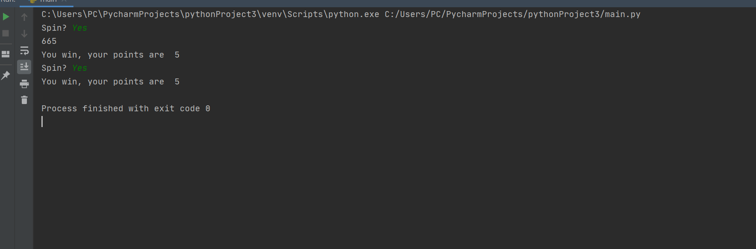
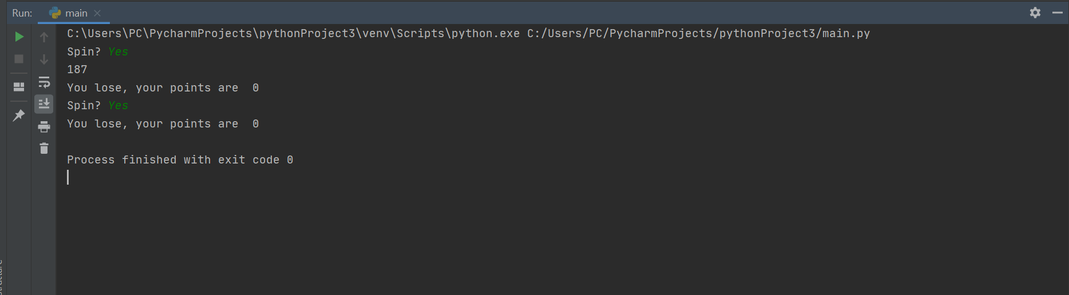
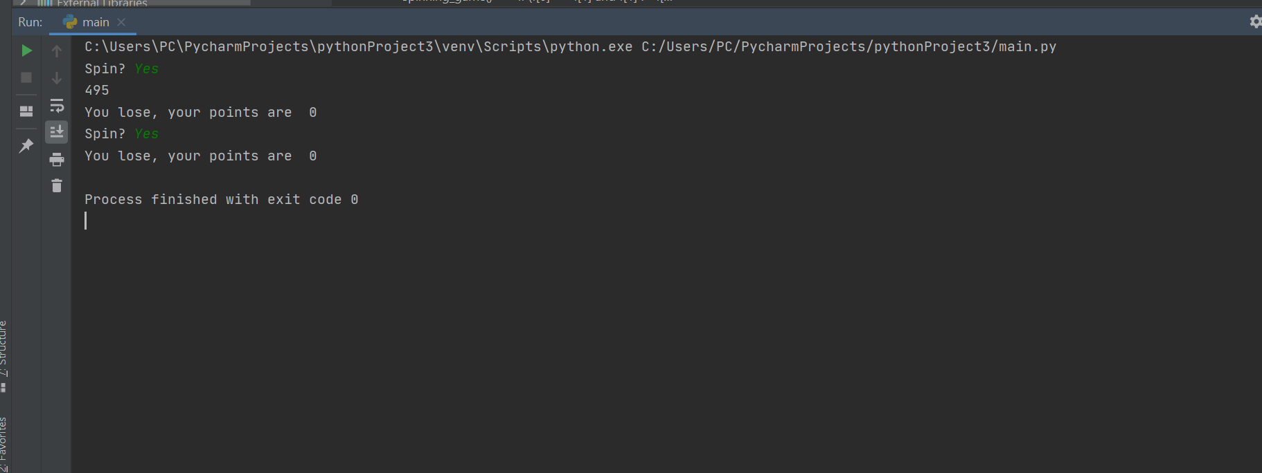
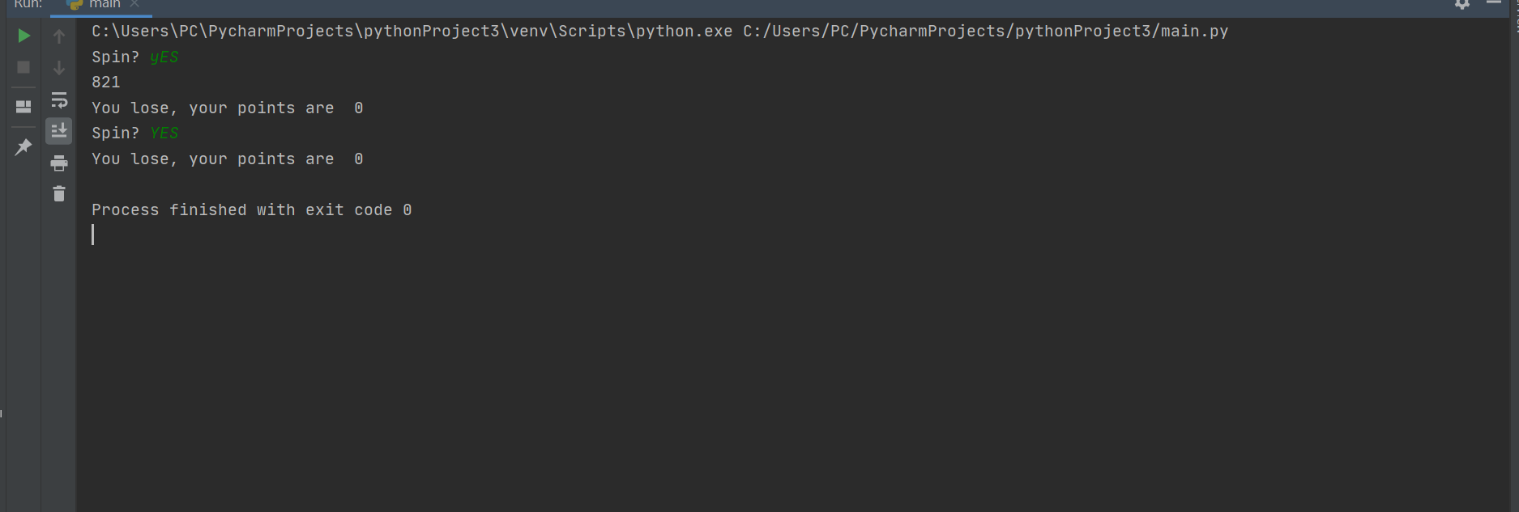

References
[1]F. Gibbs, "Installing Python Modules with pip", The Programming Historian, no. 2, 2013. Available: 10.46430/phen0029.
[2]W. Turkel and A. Crymble, "Manipulating Strings in Python", The Programming Historian, no. 1, 2012. Available: 10.46430/phen0013.
[3]M. Dawson, Python programming for the absolute beginner. Boston, MA: Course Technology Cengage Learning, 2010.
[4]K. Marwa, Python Programming. US: Tritech Digital Media, 2018.

