Reading 1: The power of pink: Men who wear shirts of that colour earn £1,000 a year more than those who don’t
Daily Mail David Baker, Friday, Nov 23 2012
- Men who wear pink also tend to be confident and get more compliments from female colleagues
- Research also found men in white are most punctual, while those in blue have the least work romances

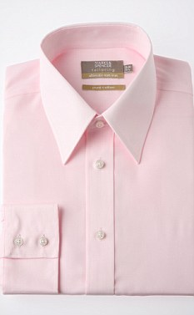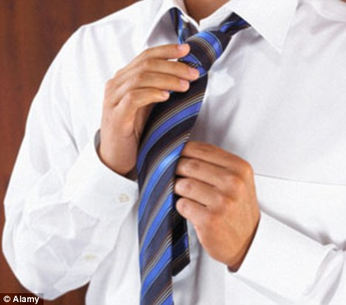
Confidence: Men wearing pink are also said to be more confident characters and are more likely to get compliments from female colleagues
Punctual: Men who opt to wear white shirts to work tend to be the most punctual, research suggests
Men who wear pink shirts to work earn more and are better qualified than those who favour traditional colours such as white or blue, it has emerged.
Researchers also found men who wear pink are more likely to get compliments from female colleagues and are more confident characters in the office.
A typical pink shirt wearer earns £1,000 more a year than those who opt for other colours, the poll of 1,500 male office workers found.
One in four men feels more attractive in a pink shirt and those who frequently wear purple or lilac have the most office romances, while those who prefer blue have the least.
Men who wear pink are also twice as likely to have a Master's degree than those who favour white shirts, with one in ten pink shirt wearers having a PHD.
Stephanie Thiers-Ratcliffe, International Marketing Manager for Cotton USA, which commissioned the study, said: 'You can tell a lot about someone by the colour they wear.
'Pink is a colour more men have been embracing recently and it's encouraging that they are not afraid to experiment with brighter colours.
'We spend most of our days at work and it's good for company standards, our own confidence and work ethic to remain smart, but that doesn't mean you have to be boring.
'Men appear loyal to cotton when it comes to fabrics, but with colours and styles of shirts, men can experiment just as much as women can.
'Colour aside, clothing material is also an important factor for what you wear to work.'
The report also found men who favour shirts with green tones are the most likely to be late for work, whilst white shirt fans are the most punctual, the survey found.
And if you are trying for a promotion then it's best to dress in a purple shirt, it emerged.
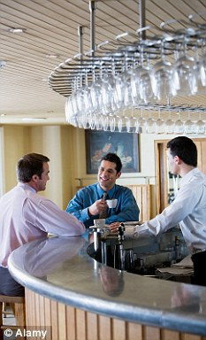
In the last five years men who are likely to wear purple shirts have had the most pay rises, so it's no wonder that one in twenty of them drive a car that's worth £20,000 or more.
Pink shirt wearers on the other hand are more likely to have a low carbon footprint as half of them insist on taking public transport to work.
One in twenty of those polled said there was rivalry between the male male members of staff over who looks the best and well over half said they like to make an effort with their image.
Surprisingly 42 per cent of men said they ironed their own shirts but a flash one in 20 pays someone to do it for them.

The colour of money: Pink shirt wearers apparently earn £1,000 more than those who wear other colours according to a poll
Over a quarter have their shirts ironed for them by their wife or girlfriend, although 13 per cent still rely on mum to press their clothes.
More than half of men polled said ironing shirts was an irritating job, with the average man spending 24 minutes every week on making their shirts crease free.
Stephanie Thiers-Ratcliffe added: 'A crease free shirt is crucial to looking smart and professional, but ironing can be a laborious task - making easy iron 100 per cent cotton items increasingly popular.'
http://www.dailymail.co.uk/news/article-2236652/Men-wear-pink-shirts-earn-1-000-year-dont.html

