Certificate of Higher Education in Skills for the Workplace


Problem Solving and Decision Making

Module Code: BMSW4004
Student Name: Filipe Selvatici
Student ID: 1921657
Word Count: 1936

Contents
Understand the Problem 2
Business Structure 3
JD Wetherspoon’s Fishbone Diagram 4
Solution planning: Develop Alternatives 5
Implement the Decision and Monitor Progress 6
Possible Solutions 6
Alternate Solution Generations 7
Evaluation of best alternatives: 200 7
Approaches to Implement the English Course 9
Monitoring and Control 11
Referencing: 13
Appendix 15

Introduction
The pub chain JD Weatherspoon employs 43,000 people all over the United Kingdom (UK) (J D Wetherspoon 2021). It has a larger quantity of non-English employees. I was one of them. In 2017, around 24% of Europeans were working in the hospitality business in London (Lunn, F. 2017). JD Weatherspoon holds 8.8% of the UK pubs market share(Seymour, A. 2019).

There was an issue at the operational level in my JD Elephant and Castle branch. An average of 5 out of 10 employees could not perform properly due to the language barrier. Causing stress and frustration between the customers and the more qualified staff. Only one staff could translate for the others.

When the translator was off, the whole shift was a nightmare. Imagine 5 staff sitting and waiting for guidance from the manager that could not talk to them. Also, some of the employees enjoyed the fact that they could not do anything extra, because the manager would rather ask the English speaker staff to do it. This did not stop business such as pubs, restaurant, and hotels from keeping constantly searching for an immigrant’s workforce due to their cheaper labor(Lunn, F. 2017). This report will present that will benefit both sides, employee, and employers.

Business Structure
The chain has around 10 to 20 employees per shift depending on size and busiest period of the year:
- 1 manager
- 1 assistant manager
- 4 bartenders
- 1 glass collector
- 3 chefs
- 2 kitchen assistants
- 4 cleaners
- 2 securities

At that time, JD Elephant and Castle branch had:

Filipe’s JD Wetherspoon Branch
Role | Quantity | Language skill level
Manager | 1 | English Fluent(Eng-F)
Assistant manager | 1 | English Fluent(Eng-F)
Bartenders | 4 | Broken English(B-Eng)
Glass collectors | 2 | Non-English speaker(Non-Eng)
Chefs | 3 | Broken English(B-Eng)
Kitchen assistant | 2 | Broken English(B-Eng)
Cleaners | 4 | Non-English speaker(Non-Eng)
Securities | 2 | English Fluent(Eng-F)
Total | 19 | 6 Non-Eng, 4 Eng-F and 9 B-Eng
Table 1: Filipe’s JD Wetherspoon Branch

Three business models techniques will be used to scope, research, and solution for the problem:

- Fishbone Diagram: Presenting the consequences of the problem.
- SWOT Analysis: Investigated the potential areas for improvement.
- Kurt Lewin’s Model of Change Management: Putting the ideas into practice.

JD Wetherspoon’s Fishbone Diagram
The Fishbone Diagram will present a more consistently breaking down of the problem. There are two diagrams, first a draft and second an official diagram.

Diagram 1: First Draft
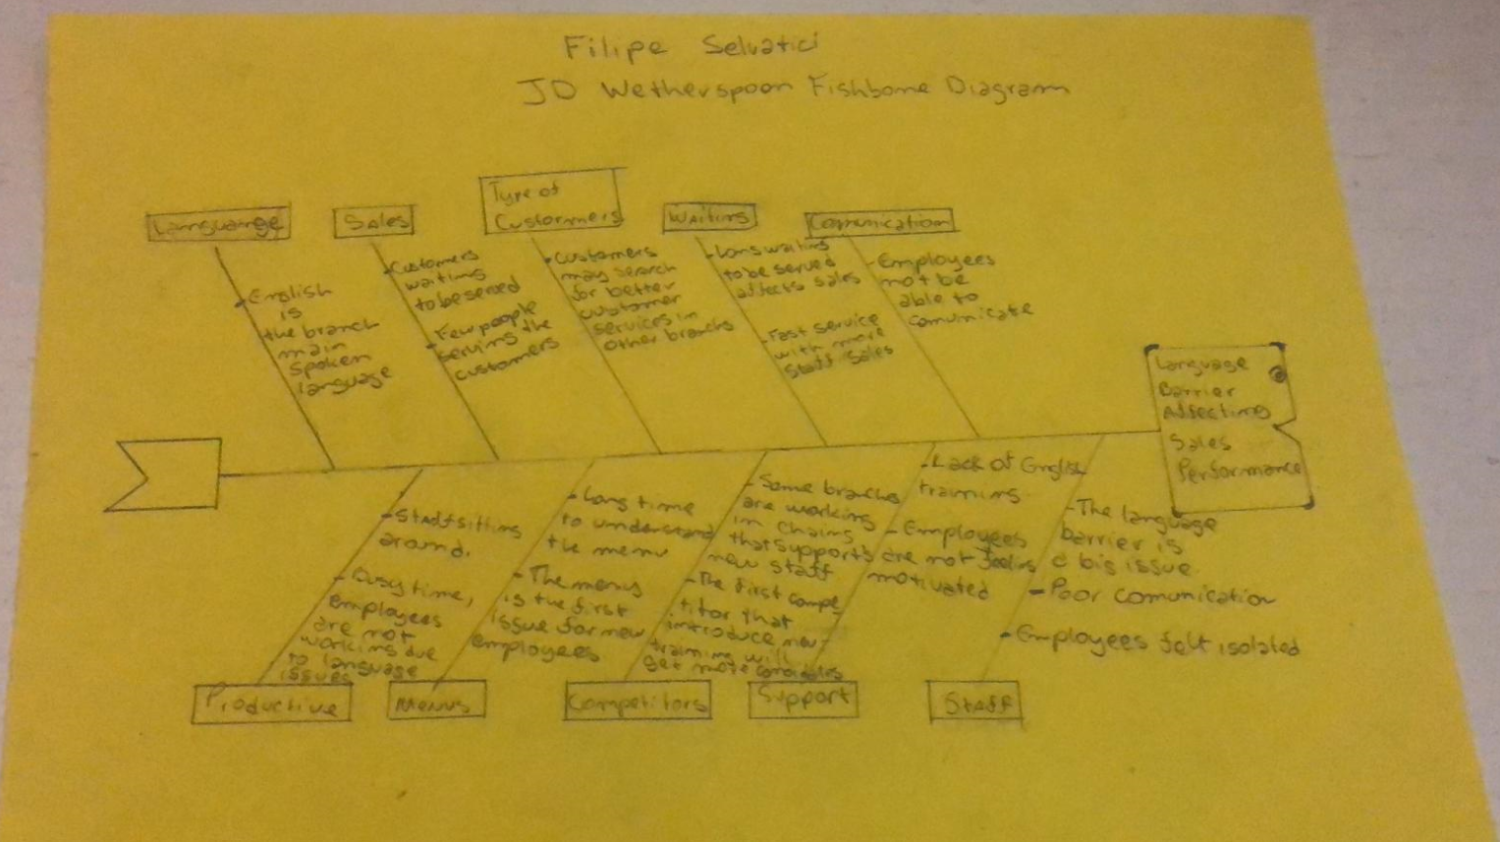

Diagram 2:Official
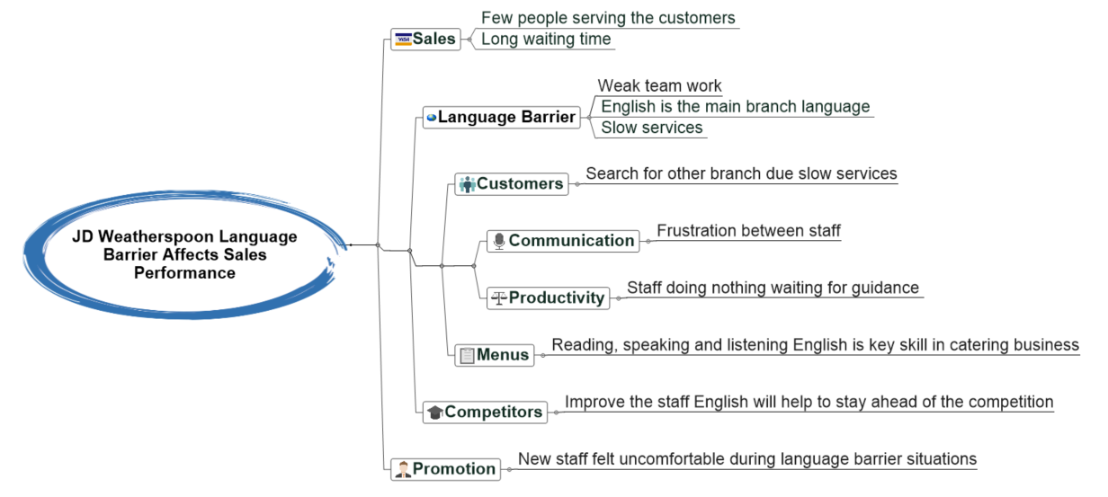

Solution planning: Develop Alternatives.

Applying the SWOT analysis to improve the language barrier issue:
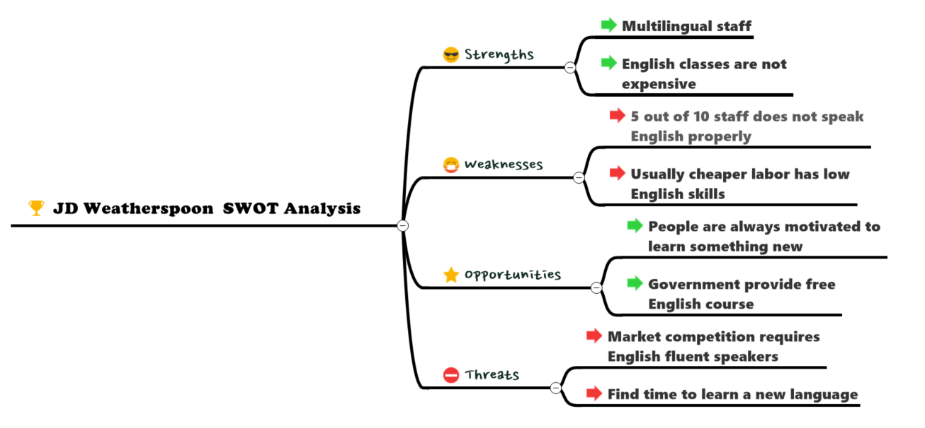

Diagram: JD Weatherspoon SWOT analysis.

Support the employee's language barrier is something that takes time, however, should not be ignored. In a working environment, people need to express their opinion and frustration in aim improve the company performance, making them feel motivated. Improve employee's communication skill is key for any organisation(Murdoch, A. 2015).

Implement the Decision and Monitor Progress

Kurt Lewin’s Model of Change Management

This model consists of the following three steps:

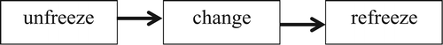

Unfreezing: is the idea of eliminating the individual old behavior that could eventually cause some sort of damage to the company. Present a new clear company policy. Signup everyone for an English test and enroll each staff accordingly to a minimum English standard required.

Changing: compulsory online English training. Break the routine, interact with the old staff the new staff. Bonus for the most dedicated employee in other to keep them motivated.

Refreezing: make the new rules practical and consistent, create checklists to tracking the changes daily. Managers must remind the employees that the company rules will benefit everyone.

Possible Solutions
Suppose if 20% of the total 45,000 employees working for JD Weatherspoon’s are currently having a language barrier challenge, then a total of 9,000 employees are maybe affecting the company operations(J D Wetherspoon 2021).

According to Rampton (2015), there are 10 ways to help with the language barrier in the working environment. From the 10 ways, 5 of them can be used in the case of JD Wetherspoon:

- NARROW YOUR MARKET: seek more qualified staff.
- SHOW RESPECT BY KNOWING WHICH LANGUAGE IS SPOKEN: the branches should keep a list of the variety of languages spoken by the staff.
- CONDUCT SURVEYS: ask questions related to the daily work routine.
- USE VISUAL METHODS OF COMMUNICATION: Create signs for the staff to be able to expand their English vocabulary. Add information in multiple languages to be fair with everyone.
- SEEK CLARIFICATION: never assume that a non-English speaker has clearly understood the instructions for the task or request given by the manager (Rampton 2015).

Alternate Solution Generations
First alternative: Fire the Staff
If the people are not aimed to learn English in a country that has its base language as English. Then they should consider moving out. Organisations are not people parents. They should take the initiative to change and start learning as soon they stepped into the country. It is not a question of discrimination; people should respect the local language and learn at least the basic words.

Second alternative: Hire a Translator
During busy hours hire an assistant supervisor for the no English speakers. Clustering the pub chains by a foreign language, then hire a translator that could work in different branches in a certain area, one week in branch A and another in branch B.

Use the only person able to translate is not practically possible, they had shift duties to be done. Example: full-time Brazilian Portuguese could not translate for everyone during the busiest period.

Evaluation of best alternatives:
Apply the PMI technique will help to avoid what is called an “intelligence trap”. During decision-making, ideas tend to be biased. This technique will help to make self-control and not just accept the decision idea but also evaluate if that is the best idea for the case. This helps to narrow the thoughts of an idea such as making an English course compulsory for the staff that does not speak English.
Compulsory English Course:
Plus | Minus | Interesting/Implications
Rate 1 to 5 | Rate 1 to 5 | Rate 1 to 5
Improve Communication(+2) | Cost(-5) | Increase communication between staff(+5)
Opens employment opportunity(+3) | Not enough skill(-3) | Stop language barrier(+5)
Improve Sales(+5) | Time consuming(-3) | Increase profit(+3)
Variety of shift support(+4) | Not everyone on board(-2) | Staff will not do the course
Extra skill(+1) |  | Staff will leave the job after learning English(-5)
Total +15 | Total -13 | Total +8
Table 2: Plan for an English course

Results:

- +15 (Plus)
- -13 (Minus)
- +8 (Interesting / Implications)
- Total = +10

The results concluded that implementing an English course at JD Wetherspoon’s will improve the employee's performance, it will stop the language barrier. There are some implications such as cost and time-consuming. However, the company will gain better employees and will be able to increase sales due to the extra skill provided.

Approaches to Implement the English Course

English is a language that can be learned according to each need and desire. This project must be for a universal group of people and not a specific group. For this implementation, there will be two approaches, an action-orientated plan and project milestones.

- This will be an action-oriented plan which will consist of the following:

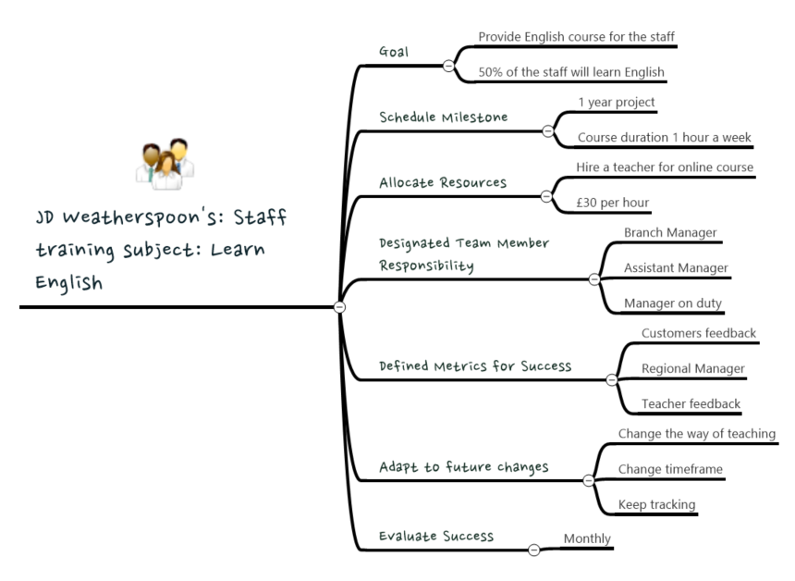
Figure 1: Strategy Plan

Now that the project has an accelerated plan, it is time to implement some of the ideas to the project milestones. For example, the project time, goal, allocated resources, and evaluation success will be the topics to be added to the timeframe required to start and complete the project.

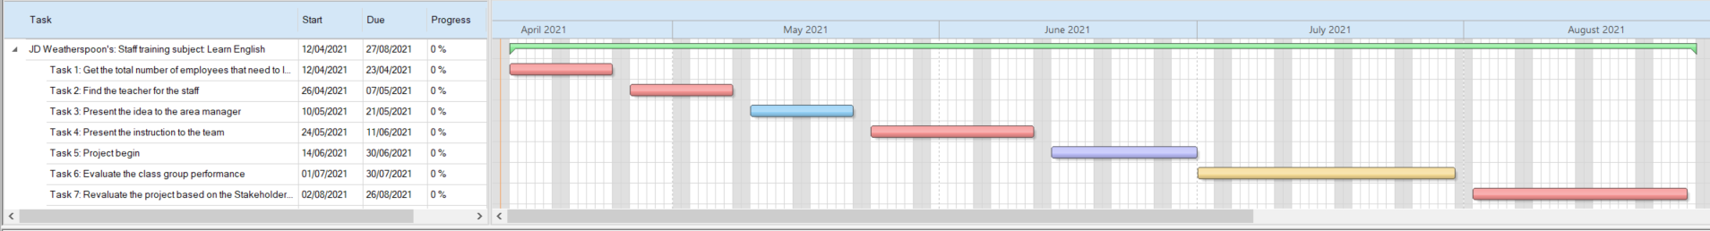
- Project milestones:
Table 3: Milestone

The whole project takes six months however it will be braked into two steps, five months of implementation and another month of the evaluation based on previous experience. Furthermore, repeat the hole process with better solutions and techniques based on the previous project.

Suppose the project has started today April 2021, then it would finish by the end of August 2021. Then make adaptations and retry for another five months, finally select the best approach for both periods and solidified implementation for the whole year.

This is an enumerated priority schedule for the project tasks. Notice that the priority is measured between 1 to 5:
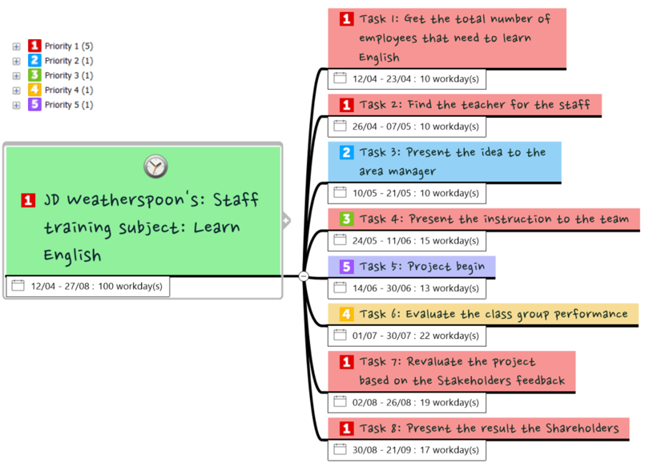
Figure 2: Milestone

Monitoring and Control
Rampton 2015 suggested that managers should create daily questions to keep tracking of any type of work environment in the learning process. He suggested that managers should question the shift routine, using the following questions:
- What have you done since the last shift?
- What are you working on now?
- What will you do next?

Three Steps Used for Behavior Control

- Establish standards: Ideally, branch managers will have to monitor through an app. Once a week they will have a basic English test done in the branch through an iPad. They should pass in at least 50% of the questions.

- Concurrent Control: One-to-one meetings are very efficient also. Talking directly and observing if there are some improvements to the employee's language skills. Also, in time if the employee behavior does not change to a more confident way, then a flag will be raised.

- Feedback Control: Switch tasks from time to time, they could help serve tables or prepare cocktails. Practical training will help them to interact with the other employees including the customer too. After the other employees could give the feedback to the managers.

Communicate to the Stakeholders.

In 1984, Freemen wrote the book “Strategic management: a stakeholder approach” which defined stakeholders as a group of individuals that will support the company with each specific part in the business, it could be internal and external individuals such as customers, suppliers, employees, the community, and others (Freeman, R. Edward 1984).

COMMUNICATIONS MANAGEMENT PLAN FOR JD Wetherspoon’s
ID | STAKEHOLDER | INFORMATION | METHOD | TIMING OR FREQUENCY | SENDER | ASSUMPTIONS | CONSTRAINTS
S001 | Managers | Project management and supervision | Fishbone Diagram  SWOT Analysis  Kurt Lewin’s Model of Change Management | Monthly | Project Manager | Team leads will provide verbal updates via meetings. | Minimum of 1 hour of training a week.
S002 | Cleaners | The trained team, improve language skill | Online learning | To align with start-up, test, and prep for launch. | Project Manager | None. | Impact on career progression
S003 | Glass collectors | The trained team, improve language skill | Online learning | To align with start-up, test, and prep for launch. | Project Manager | None. | Impact on career progression
S003 | Teacher | Deliver the language skill | Zoon software | Dates TBC | Change Manager | All team at the same level | Flexible teaching hours
S004 | Customers | Improve communication and sales | Direct contact with the manager | Dates TBC | Change Manager | Assumes 60% of feedbacks given by customers will be positive. | Feedback must be review by all team
Table 4: COMMUNICATIONS MANAGEMENT PLAN FOR JD Wetherspoon’s

This action plan can be adapted accordingly to the project development. Dealing with those stakeholders has challenges, adaptations to the process cannot be ignored.

Recommendations

One of the biggest examples is the culture clashing which sometimes can be related to the language barrier(Habs, C. 2020 ). The law of supply and demand has proven that non-qualified people will be always treated as the last resource. I would recommend that companies such as JD Wetherspoon’s should specify clearly in the job advertisements that new candidates must have at least basic English. If so, offering to take part in an English training through the company under the circumstances that they will have to sign up for a minimal 12-month contract.

Conclusion

Government laws have pointed out that organisations should adapt to the current population culture and working extra hard to minimise daily basis issues such as Gossip, Harassment, Ethnic Discrimination, Performance issues and Communication Problems(Good Therapy 2019). This report proves that J D Wetherspoon will strength from it and I am learning gradually to become a great manager.

Referencing:
Websites:
- Glassdoor (2021) J D Wetherspoon ‘shift patterns’ Reviews. Available at: https://www.glassdoor.co.uk/Reviews/J-D-Wetherspoon-shift-patterns-Reviews-EI_IE10905.0,15_KH16,30.htm (Accessed: 11 April 2021).

Articles:
- Cummings, S., Bridgman, T. and Brown, K. G. (2016) ‘Unfreezing change as three steps: Rethinking Kurt Lewin’s legacy for change management, Human Relations, 69(1), pp. 33–60. DOI: 10.1177/0018726715577707.
- Foundations of Western Culture (2021) ‘Labor Laws – Foundations of Western Culture’. Available at: http://foundations.uwgb.org/labor-laws/ (Accessed: 29 March 2021).
- Good Therapy (2019) ‘Workplace Issue’.’ Available at https://www.goodtherapy.org/learn-about-therapy/issues/workplace-issues (Accessed: 27 March 2021).
- J D Wetherspoon (2021) ‘People - J D Wetherspoon’ . Available at: https://www.jdwetherspoon.com/investors-home/bsr/people (Accessed: 2 April 2021).
- Seymour, A. (2019) ‘UK’s four largest pub groups hold 25.5% of the market’, Foodservice Equipment Journal, 23 October. Available at: https://www.foodserviceequipmentjournal.com/data-crunch-uks-four-largest-pub-groups-hold-25-5-of-the-market/ (Accessed: 2 April 2021).
Journal:
- Lunn, F. (2017) ‘Labour migration in the hospitality sector’, p. 59.
- McDaniel, B. (2018) ‘Challenges and Solutions Of The Catering Industry’ , Caterease, 5 February. Available at: https://www.caterease.com/challenges-solutions-catering-industry/ (Accessed: 5 April 2021).

Books:
- Freeman, R. Edward (1984)” Strategic Management: A Stakeholder Approach”, Boston: Pitman.

Citations:

- Habs, C. (2020 ) Cultural & Language Barriers in the Workforce, Small Business – Chron Available at: https://smallbusiness.chron.com/cultural-language-barriers-workforce-11928.html (Accessed: 29 March 2021).
- Rampton, J. (2015) 10 Tips For Overcoming The Language Barrier When Expanding Overseas, Fast Company. Available at: https://www.fastcompany.com/3043336/10-tips-for-overcoming-the-language-barrier-when-expanding-overseas (Accessed: 6 April 2021).
- Singha, D. (2016) ‘How Businesses Can Deal With Language Barriers’ Business 2 Community. Available at: https://www.business2community.com/marketing/businesses-can-deal-language-barriers-01679524 (Accessed: 6 April 2021).

Appendix

Role Play Unsatisfied Employee and Manager Consultant

Employee: I am a very unsatisfied employee in my current work situation, and I would like to share some of the following problems for you to address as a management consultant.

Q1 – Employee: There is no work-life balance in this job and as a result, I am finding it very difficult to address my personal and family matters. What do you suggest as a management consultant to improve the work-life balance in my current situation?
Answer
- Manager consultant: I understand your situation and I could offer you the following options:
- Work Remotely is an option that we can offer you which will allow you to be flexible with your working hours and work locations.
- We could allow you to have a Flexible Overtime Hour. Keep in mind that October and December are the busiest period of the year. We can offer you fixed overtime hours: work until 8 PM or 9 PM maximum.

Q2 – Employee: I must work for long hours and as a result, I feel exhausted and tired. There is a lot of stress and burnout in the job and my productivity goes down. What do you suggest as a management consultant to improve the work situation?
Answer
- Manager consultant: When was your last vacation?
- Employee: 2 years ago!
- Manager consultant: This may be the source of the problem.
- Manager consultant: in this case, I would encourage you to take some Vacation Time. I can offer you 3 weeks’ vacation this time. However next time take at least 2 weeks of vacation a year.

Q3 - Employee: I am being underpaid and even not paid for the long hours of work time. What do you recommend as a management consultant to solve this problem of wages and salary?
Answer

- Manager consultant: I cannot promise anything related to wages right now as we are going through a pandemic. According to Rosario (2021), the unemployment rates have increased from 5% to 6.9% in the past year due to the pandemic effect (Rozario 2021).
- Manager consultant: According to BBC News, The Chancellor of the Exchequer Rishi Sunak said that the government will only cover 80% of employees’ wages. Now people are getting paid less. After the pandemic, we can come back with this topic (BBC 2021).

Q4 - Employee: Some of the employees have language barrier issues. What do you suggest as a management consultant to improve office communication?
Answer
- Manager consultant: We are already aware of these issues. Future training will be provided to the employees.
- Manager consultant: Where is the most critical communication issue?
- Employee: In the technical words!
- Manager consultant: I would suggest you use Plain Language. Avoid communicating deeply technically with the other co-workers.
Q5 - Employee: Finally, my supervisor is always busy. I cannot find any time to discuss the company related issues with him. What is the best approach to fix these issues between him and me?
Answer
- Manager consultant: In this, I will have to step in and take actions. It is his duties to take care of his team. I will not accept any excuses. I schedule a one-to-one meeting with him right after our conversation. Do worry your name will be disclosed.

End

References

- BBC (2021) ‘Labour market update for London – January 2021 – London Datastore’. Available at: https://data.london.gov.uk/briefings/labour-market-update-for-london-january-2021/ (Accessed: 18 April 2021).
- Rozario, D. (2021) Labour market update for London – January 2021 – London Datastore. Available at: https://data.london.gov.uk/briefings/labour-market-update-for-london-january-2021/ (Accessed: 18 April 2021).

