UWTSD: Advanced Physics of Ordnance, Munitions and Explosives
Name: Andrew R Hurley Jnr
Student No. 1906810
Date: 09/11/2021
Module: ACDA5015
Lecturer: Professor Kelvin Donne
Assignment Title: Advanced Physics of OME
Task:
Using FEA and relevant sources, critically analyse shaped charges via a literature review.

Abstract

In this report ABAQUS is used to solve FEA simulations for a Shaped charge.

Each simulation varies in how the model is meshed, Lagrangian and Eulerian methods are discussed for meshing along with material properties being adjusted for a theoretically better output.

This experiment shows that it is possible to simulate a shaped charge using ABAQUS with adequate results, though meshing models to be finer for more precise measurements does increase difficulty and time for simulation processing.

Contents
1 Abstract 1
2 Contents 2
3 Introduction 3
3.1 Explosively Formed Projectiles 3
3.2 Finite Element Analysis 5
3.3 Meshing 5
3.4 Material properties 6
4 Simulations 7
4.1 Coarse Mesh 7
4.2 Re-mesh number 1 8
4.3 Re-mesh number 2 9
5 Results 11
5.1 Coarse mesh Simulation 11
5.2 2nd Simulation 11
5.3 3rd Simulation 12
6 Discussion 12
6.1 Coarse Mesh 12
6.2 2nd Simulation 13
6.3 3rd Simulation 13
7 Conclusion 14
8 Works Cited 15
9 Annex 16
9.1 Coarse Mesh Pre-Set Material Properties 16

Introduction

Explosively Formed Projectiles

Shaped charges are a part of a wider family of explosive systems named “Explosively Formed Projectiles” (EFP’s). These systems primarily use a combination of explosive and liner that when initiated, form a projectile that has the capability to punch through large quantities of material accurately [1].

EFP’s are very optimisable to suit situational needs, the liner can be adjusted in diameter and angle, for jet length and size. The shape too can be changed from cone to dome for a different formation of projectile.
Cones offer a molten jet that can penetrate deeper into material with a smaller radii cavity. Whereas domes offer a large slug that does not penetrate deep into material (respective to the jet) but does leave a large radii cavity [2].

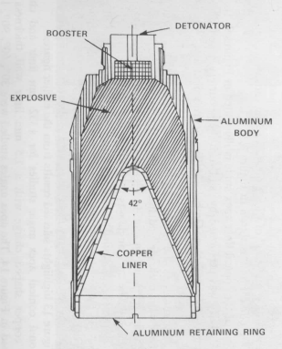
The EFP being used during simulations is loosely based on a standard shaped charge design (Aseltine 1980 [3] – See Figure 1 below).
Figure 1 – Aseltine 1980 example of shaped charge design.
Ex, Fundamentals of Shaped Charges [3]

The formation of a shaped-charge jet is well known and understood theoretically, Figure 2 below shows the formation of the liner jet from t=0 to approximately t=9μs.
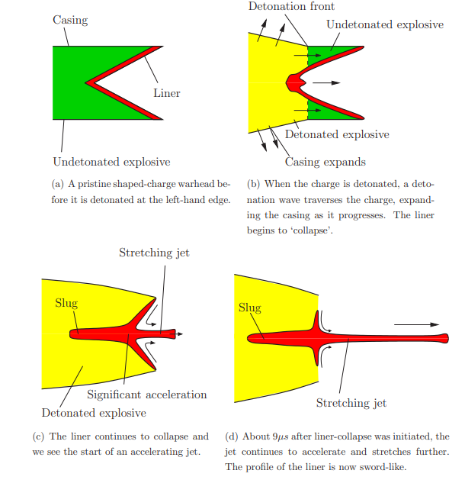
(Figure 2 – A sequence of evets in shaped-charge jet formation – Ex, Penetration of a Shaped Charge [4])

Finite Element Analysis

ABAQUS finite element analysis software is a simulation package that offers solutions for sophisticated engineering problems covering a vast spectrum of industrial applications. Using FEA software, simulations can be made quickly and efficiently with the ability to edit, monitor, diagnose and visualise the analyses [5].

To begin the simulations of shaped charges used a Lagrangian or a Eulerian mesh throughout the model, with a reasonable pre-set mesh distribution.
The Lagrangian approach uses a mesh that tracks the nodes of the material, each node is a material particle and can be evaluated for deformation. The software will focus on calculating the trajectory of each particle, whereas Eulerian meshes, the software will approach this by looking at the concentration of particles and will calculate the overall diffusion [6].

Meshing

Meshes are made up of elements which contain nodes that represent the shape of the geometry. The ‘finer’ a mesh, the more accurate the analysis will be as the model will be segmented into smaller prisms/cuboids, each of these segments will be calculated and analysed and will be used to visualise the simulation.

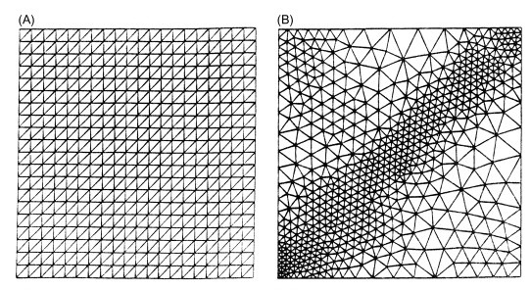
Meshing does not need to be uniform across the model, thought-out intelligent meshing is required for optimised simulating. Placing finer meshes in places of interest on the model and coarser meshes on areas on the model that are not of interest will capture more precise and accurate information that is desired (See figure 3 below), it will also lessen the simulation run time compared to a uniform fine mesh on a whole model [7].
Figure 3 -
A; Uniform Mesh,
B; Non-Uniform mesh (Fine mesh bottom left to top right diagonal).
Ex, Adiabatic Shear Localization

[8]

Material properties

For ABAQUS to simulate the detonation and jet formation process accurately in lieu of the real world, the material properties assigned to all the parts in the assembly need to be taken from credible sources with realistic values.

For the casing, Steel 1055 is being used, being a medium-carbon steel, it provides high durability and lower ductility than that of low carbon steel, without the brittleness seen in a high carbon steel.

Properties:
Density | 7870 kg/m³
Modulus of Elasticity | 205 GPa
Bulk Modulus | 160 GPa
Poissons Ratio | 0.29
Shear Modulus | 80.0 GPa
U Tensile Strength | 660 MPa
Y Tensile Strength | 560 MPa

(Ex, MatWeb [9]; [10], [11], [12])

For the liner, Copper C10100 is an oxygen free copper, as copper is a ductile workable material, using it for the liner material enables deformation into a jet under the detonation’s heat and pressure.

Properties:
Density | 8825 kg/m³
Modulus of Elasticity | 115 GPa
Bulk Modulus | 123 GPa
Poissons Ratio | 0.31
Shear Modulus | 44.0 GPa
U Tensile Strength | 338 MPa
Y Tensile Strength | 197 MPa

(Ex, MatWeb [13]; [14], [15], [16])

For the explosive, TNT will be used via JWL equations in the simulation. The JWL (Jones-Wilkins-Lee) Equation of state is used most often for the products and reactants of a high explosive [17].

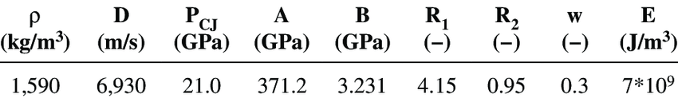
The material properties and JWL parameters of TNT are as follows in Figure 4:
(Figure 4 - The material properties and JWL parameters of TNT [18])

Simulations

Coarse Mesh

The first simulation run was a pre-made coarse meshed model with basic material properties for the steel casing and copper liner.
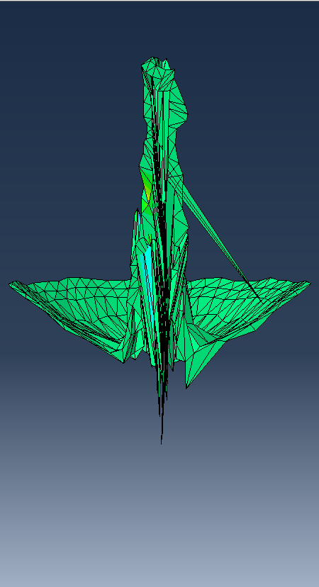
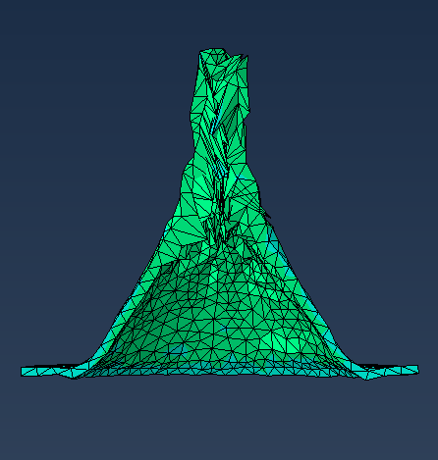
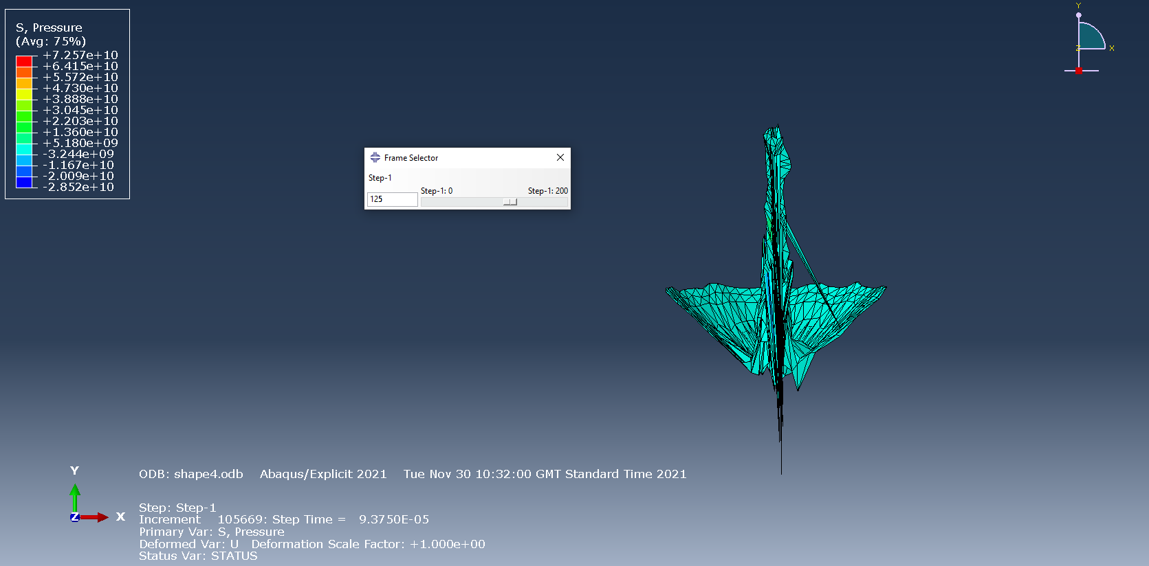
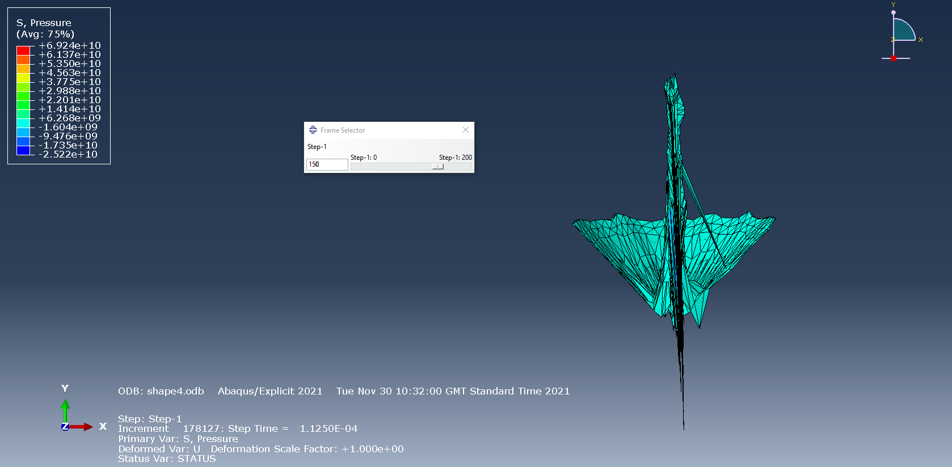
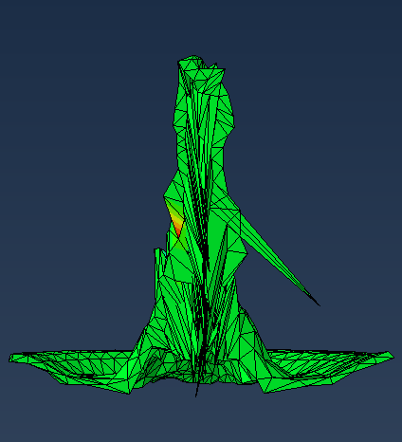
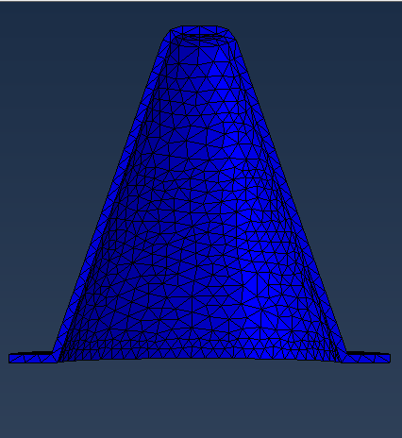

Re-mesh number 1
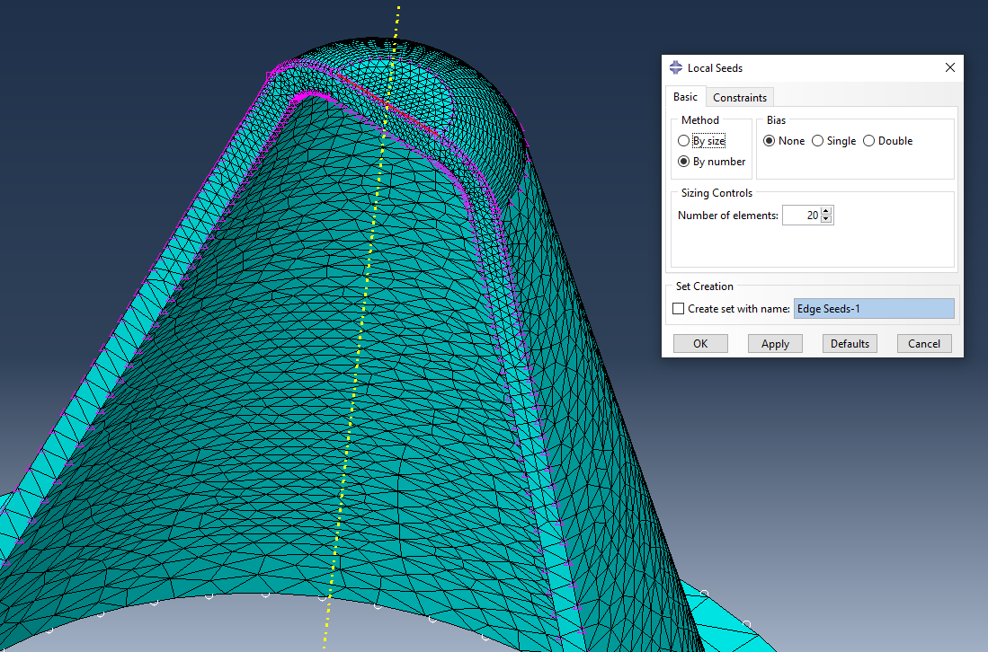

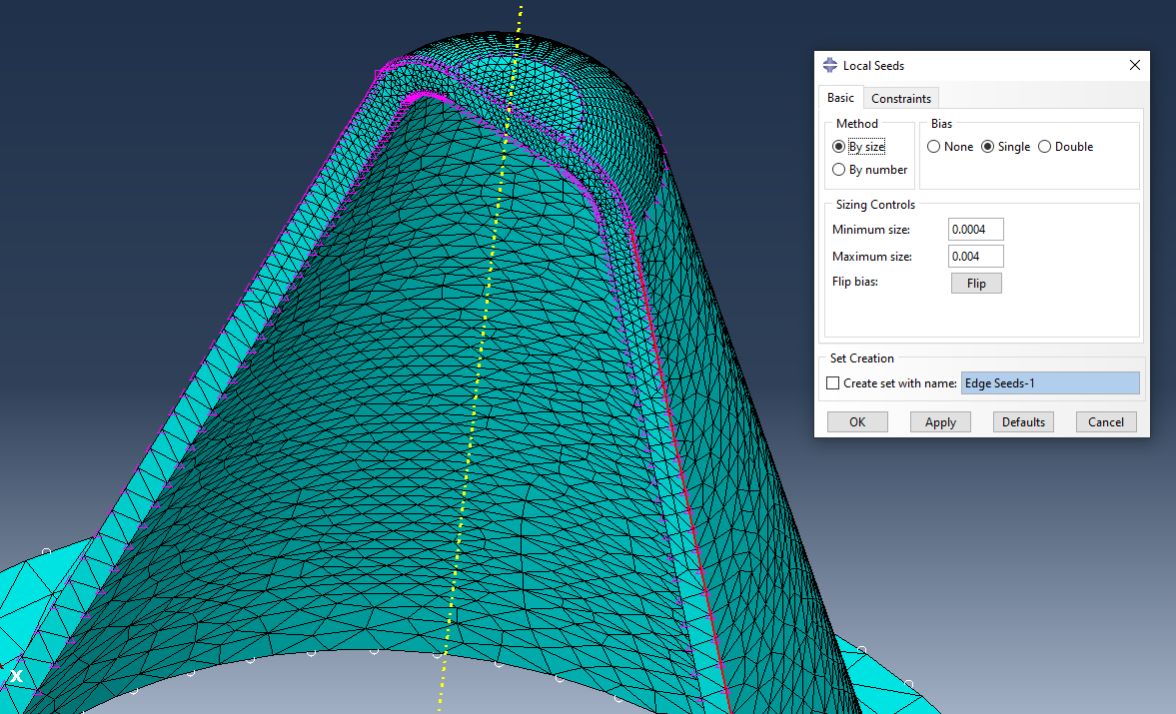

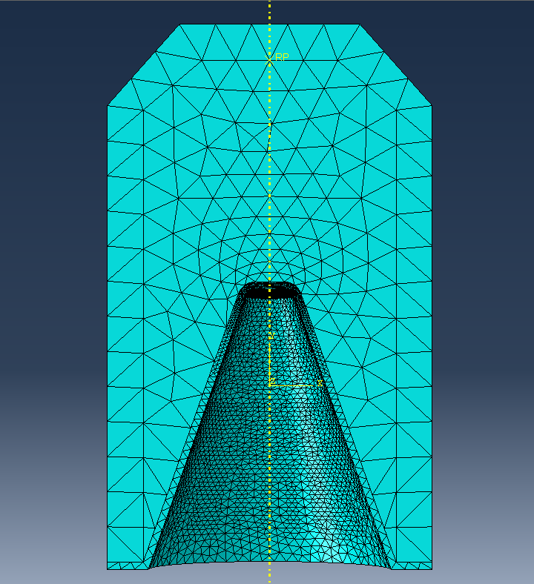

Re-mesh number 2
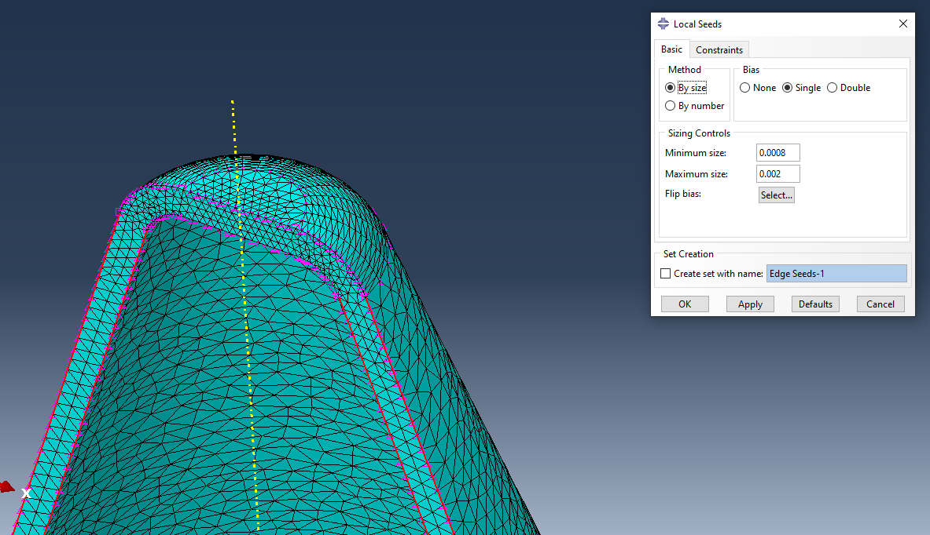

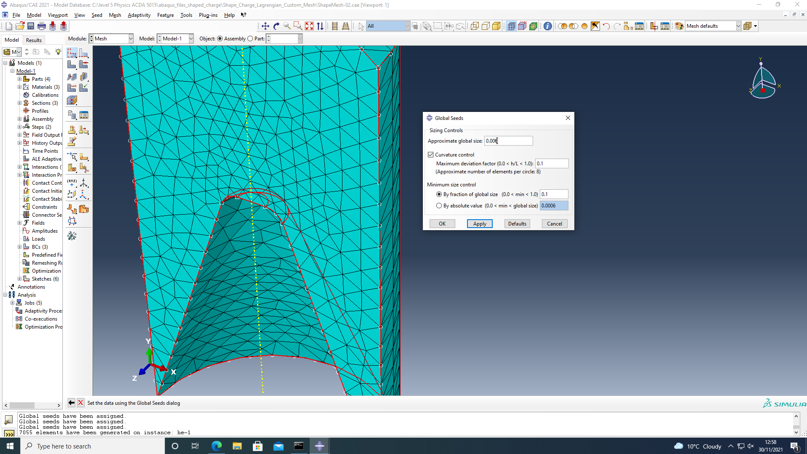

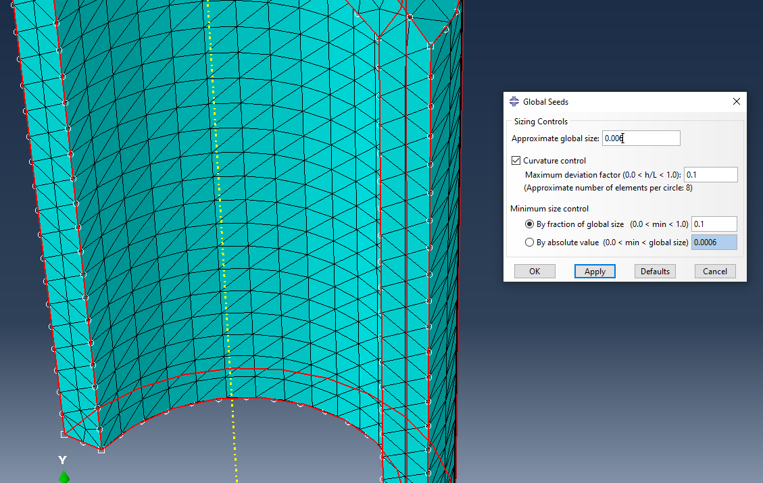

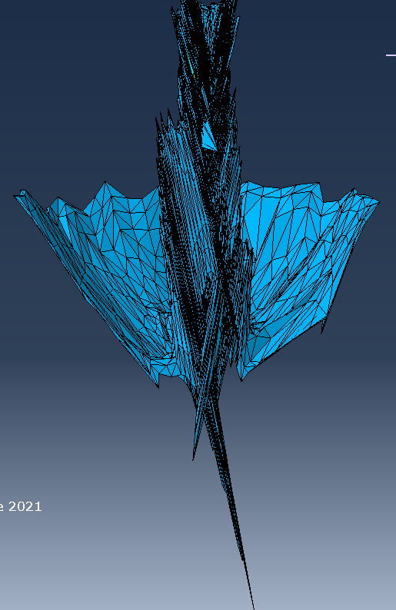
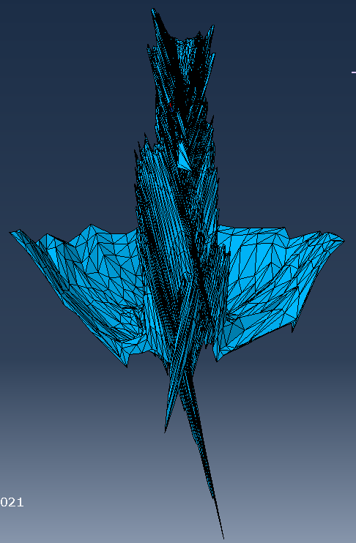
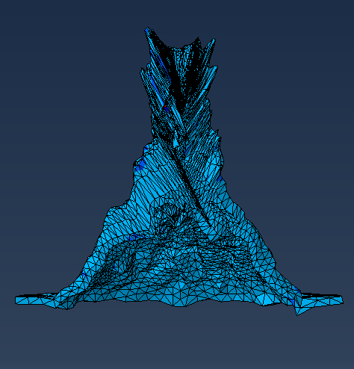
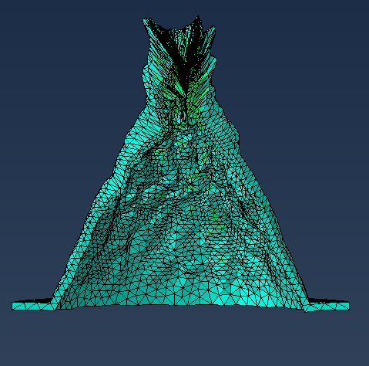
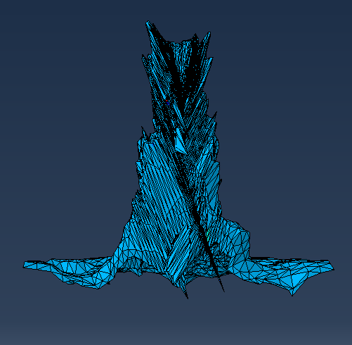
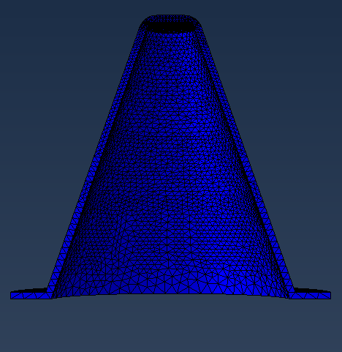

Results

Coarse mesh Simulation
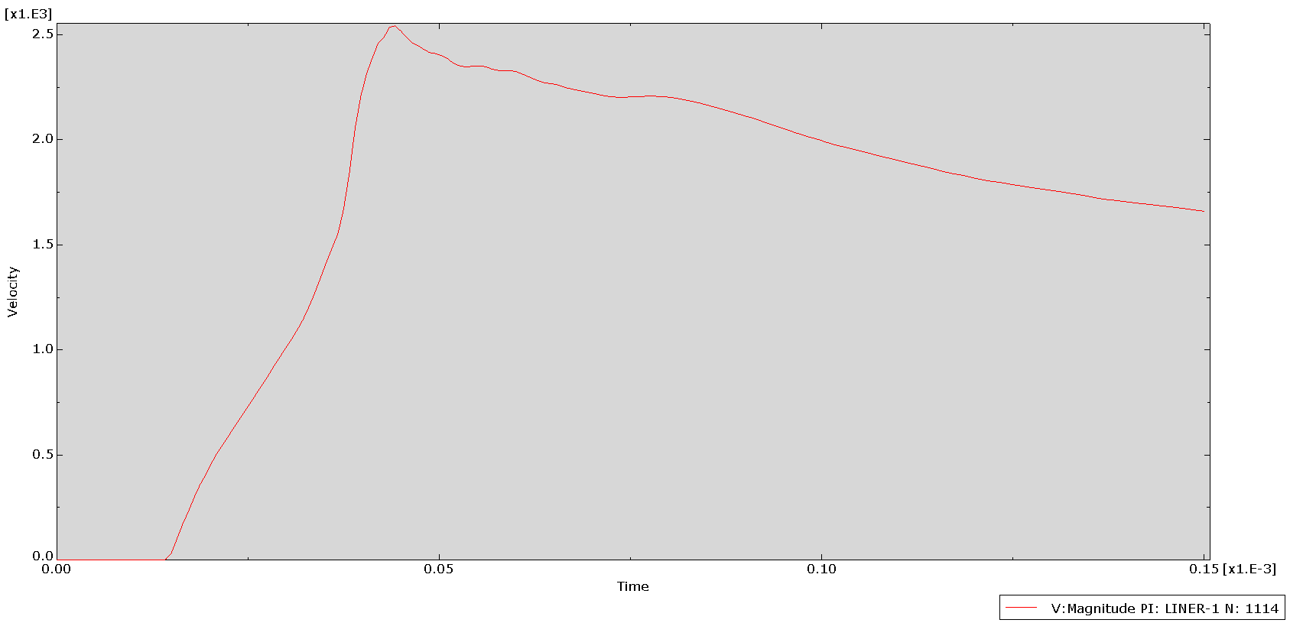

(Coarse Mesh Velocity vs time graph for single element)

2nd Simulation
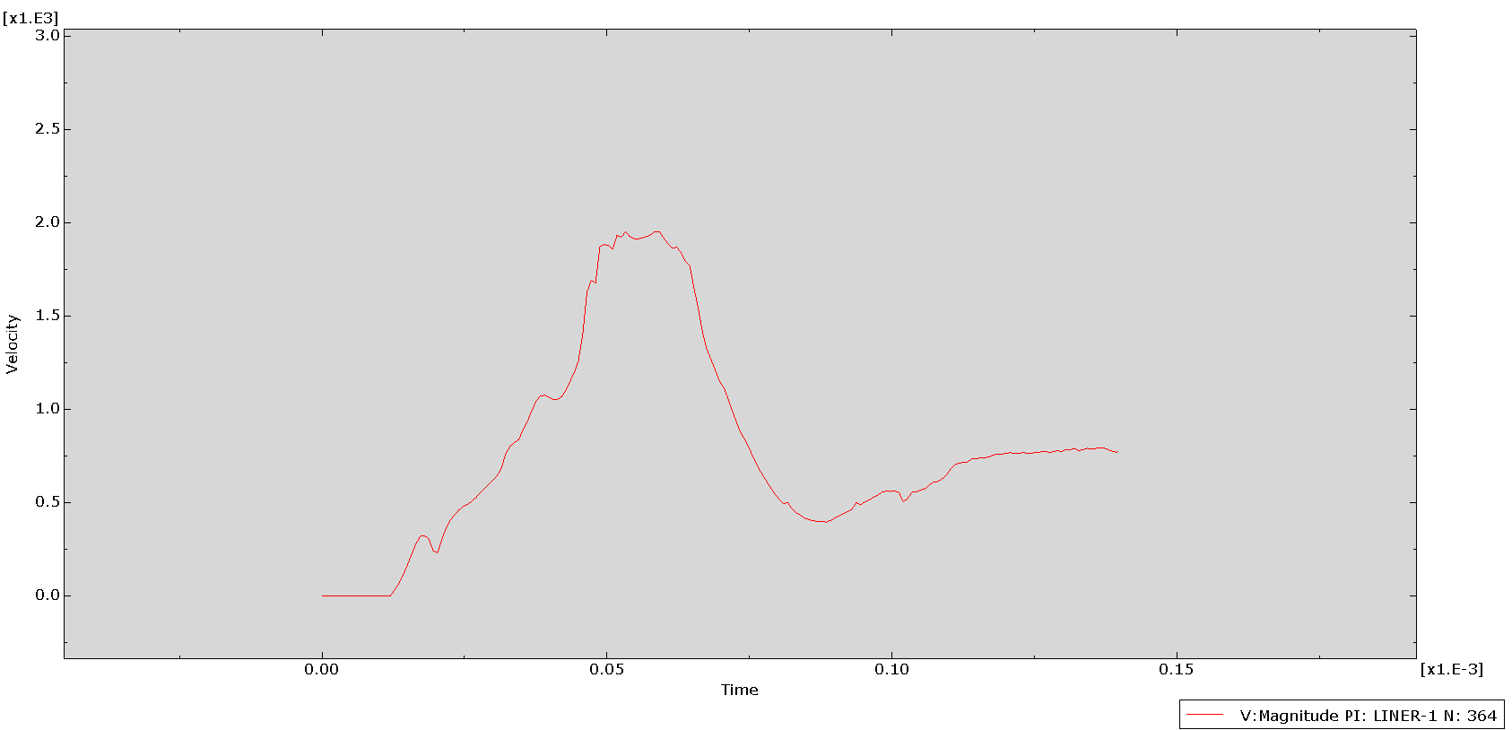
(1st Re-Mesh velocity vs time graph for single element)

3rd Simulation

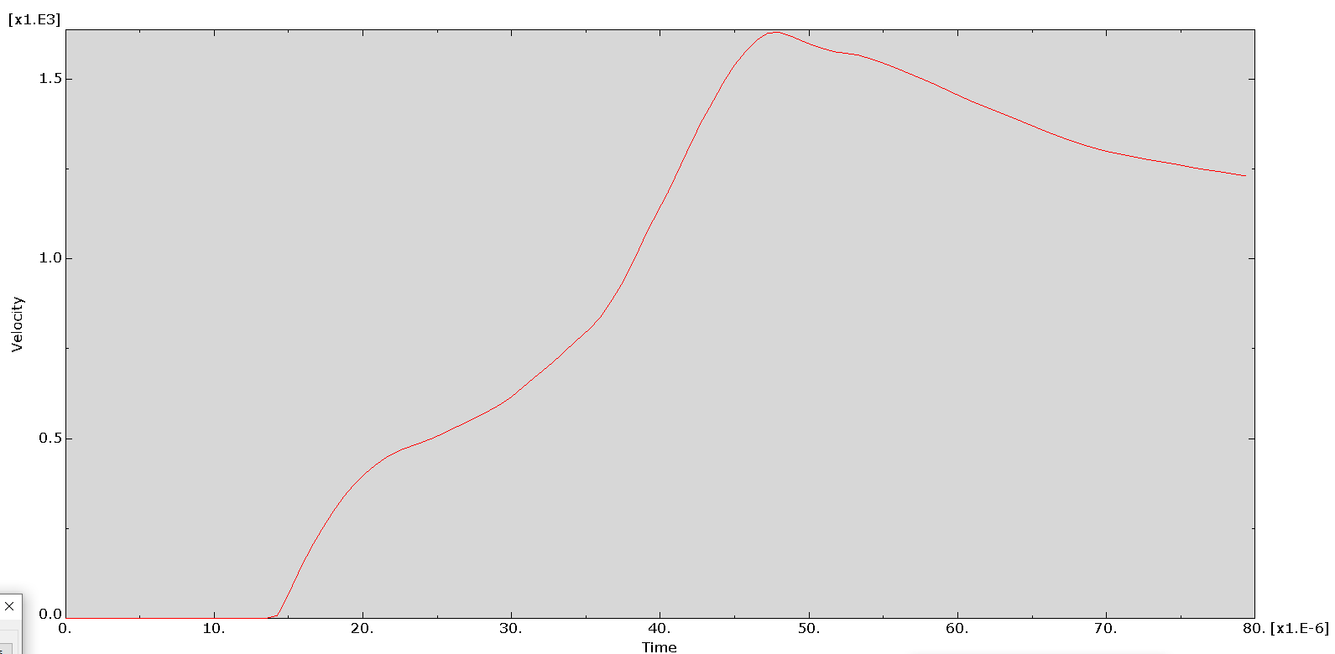
(2nd re-mesh velocity vs time graph for single element)

Discussion

Coarse Mesh

The coarse mesh is the simplest of the simulations as it has a lower number of elements to simulate and as such is less work for the software to process and complete. It also has simplified material properties. (Compared to what was discussed in 3.4)

The simulation shows a jet being formed as expected from the copper jet and the graph shows a near constant acceleration until it peaks at 0.044 milliseconds at a velocity of 2500ms⁻¹.

After the peak there is a near constant deceleration, though it is far lower than the acceleration seen between t=0.013ms and t=0.044ms.

The instant acceleration estimated from the graph between t=0.013ms and t=0.044ms;
(0.013,0), (0.044, 2500)
m = (2500 – 0) / (0.044 – 0.013)
m = 2500/0.000031
m = 80,645,161 ms⁻²

Some sources suggest that the acceleration of a shaped charge can reach up to 250,000,000 ms⁻², so an acceleration of 80million meters per second, every second, is not unreasonable [19].

The deceleration of the shaped charge is also acceptably constant so using the same method, it can be worked out to;
(0.044, 2500), (0.15, 1625)
m = (1625 – 2500) / (0.15 – 0.044)
m = -875/0.000106
m = -8,254,716 ms⁻²

The deceleration is 10.2% of the acceleration seen at the start of the simulation, so it can be assumed it would take another one millisecond for all energy to be lost if deceleration remained constant.

2nd Simulation

The second simulation was a re-meshed version of the coarse mesh prior, focusing on creating a finer mesh around the conical liner as this is an area of interest, due to it being the material that makes up the jet. Around the point of the cone was a “seed by number” set to a “number of elements” of 20, and a single bias along the long vertices set to 0.0004 to 0.004.

The simulation was a failure due to multiple critical errors during the processing. When viewing the simulation progress, multiple elements were being stretched beyond what was capable and therefore crashing the simulation. The graph (5.2.1) immediately provides information that something has gone wrong.

The graph shape is not the rapid velocity increase and slow decrease that would be expected from an explosive charge impulse.

3rd Simulation

The 3rd simulation was an update to the 2nd (3.2) where the fine mesh was made coarser to hasten the simulation processing time. The casing and HE fill mesh were made a little finer by a small increase in the hopes of providing a more accurate simulation overall rather than just focussing on the liner. The material properties shown in 3.4 were also implemented which should give a more defined simulation with real world

The graph (5.3.1) is of a similar shape to the coarse simulation graph 5.1.1, however this simulation failed part-way through its run-time, so the time base only reaches 80μs rather than the 150μs set as a result.

The simulation 4.3.4 shows a jet forming although non-uniform in comparison to the coarse mesh 4.1.2. An issue that continuously arose when creating finer meshes was where the casing and fill being less fine created stretched elements that would press through the fine meshed liner distorting and creating voids. This could be a reason as to why the liner has off angle elements protruding.

The instant acceleration estimated from the graph between t=0.014ms and t=0.047ms;
(0.014,0), (0.047, 1643)
m = (1643 – 0) / (0.047 – 0.014)
m = 1643 / 0.000033
m = 49,787,879 ms⁻²

The estimated deceleration between t=0.0485ms and t=0.08ms;
(0.0485, 1643), (0.8, 1233)
m = (1233 – 1643) / (0.08 – 0.0485)
m = -410 / 0.0000315
m = -13,015,873 ms⁻²

The deceleration of this system is 26.1% of the initial acceleration, therefore this shaped charge would lose its energy after another 126μs if deceleration remained constant.

Compared to the coarse mesh this system has considerably less initial energy put into the shaped charge. This is apparent by the lower peak velocity and increased deceleration to zero velocity.
The reasons for this could be due to the new material properties that were defined for this simulation; it could also be simulation error or human error in the measurements of the time and velocity for the graph.

Conclusion

In this experiment, it has been determined that you can use FEA simulation software to model and simulate a shaped charge.

The coarse meshed model has an expected outcome for its results, whereas the two further simulations which change the mesh and materials do not. The 3rd simulation 4.3 does follow suit with results that are adequate and follow the norm, however the values for velocity do appear to be low.

As a means to adjust this and check for error, it is recommended that each simulation be run 3-5 times and have the results compared and made into a mean average of results (excluding any obvious anomalies). Doing this would check the simulation for repeatability.

It is also recommended that when creating fine meshing, use a small section of the model, as it is cylindrical, and then copy and rotate the section around for a ‘full’ simulation. This would drastically reduce the simulation run time and the chance for critical element errors which caused a few simulation abortions during this experiment.

Works Cited

[1] | W. C. K. Y. ChengWanga, “Penetration of shaped charge into layered and spaced concrete targets,” International Journal of Impact Engineering, vol. 112, no. 1, pp. 193-206, 2018.
[2] | W. H. F. Q. L. J. L. B. K. X. Hu F, “Impact performance of explosively formed projectile (EFP) into concrete targets,” International Journal of Impact Engineering, vol. 109, no. 1, pp. 150-166, 2017.
[3] | J. A. Z. W.P.Walters, Fundamentals of Shaped Charges, New York: John Wiley & Sons, 1989.
[4] | C. Poole, “Penetration of a Shaped Charge,” Corpus Christi College, Oxford, 2005.
[5] | Dassault Systemes, “ABAQUS/CAE,” Dassault Systemes, [Online]. Available: https://www.3ds.com/products-services/simulia/products/abaqus/abaquscae/. [Accessed 10 11 2021].
[6] | M. M. M. S. M.S.Saidi, “Comparison between Lagrangian and Eulerian approaches in predicting motion of micron-sized particles in lamniar flows,” Atmospheric Environment, vol. 89, no. 1, pp. 199-206, 2014.
[7] | B. L. a. Y. Z. J. Fan, “Finite Element Analysis of Crankshaft by ABAQUS,” in Second International Conference on Digital Manufacturing & Automation, Zhangjiajie, Conference Publish Services, 2011, pp. 545-548.
[8] | R. C. B. D. Batra, “Analysis of Adiabatic Shear Bands by Numerical Methods,” in Adiabatic Shear Localisation (Second Edition), Amsterdam, Elsevier, 2012, pp. 173-214.
[9] | MatWeb, “AISI 1055 Steel,” MatWeb, 2021. [Online]. Available: http://www.matweb.com/search/DataSheet.aspx?MatGUID=e2e2ef9bf34d449eb5f9862ae630bc1c. [Accessed 17 11 2021].
[10] | J. Davis, ASM Specialty Handbook - Carbon and Allow Steels, Ohio: ASM International, 1996.
[11] | M. Handbook, Vol.1 - Properties and Selection: Irons, Steels, and High-Performance Alloys (10th Edition), ASM International, 1990.
[12] | P. Harvey, “Engineering Properties of Steels,” American Society for Metals, Ohio, 1982.
[13] | MatWeb, “Copper UNS-C10100,” MatWeb, 2021. [Online]. Available: http://www.matweb.com/search/DataSheet.aspx?MatGUID=25cdd9bd3ebb4941be91cb0bee4cc661. [Accessed 17 11 2021].
[14] | M. Bauccio, ASM Engineered Materials Reference Book, Ohio: ASM International, 1994.
[15] | ASM International, ASM Specialty handbook - Copper and Copper Alloys, Ohio: ASM International, 2001.
[16] | M. F. A. Norman A Waterman, The Materials Selector (2nd Edition), London, UK: Chapman & Hall, 2997.
[17] | R. Menikoff, “JWL Equation of State,” Los Almos National Library, United States, 2016.
[18] | J. P. Jovan Trajkovski, “Blast resistant trash receptacles with blast loading redirection - comparative analyses,” International Journal of Computational Methods and Experimental Measurements, vol. V4, no. 3, pp. 201-212, 2016.
[19] | GlobalSecurity, “Shaped Charge,” GlobalSecurity.org, 2000-2021. [Online]. Available: https://www.globalsecurity.org/military/systems/munitions/bullets2-shaped-charge.htm. [Accessed 2022 01 09].

Annex

Coarse Mesh Pre-Set Material Properties


