
Master of Business Administration

LCMB7023-Human Capital Management
Lecturer: Gladius Kulothungan

Student Name: Md Kausar Hosen
Student ID: 2406152

Word Count: 2472
Submission Date: 17 th December 2025
Table of Contents
Introduction 1
Question 1: Technological Advancements Reshaping Labour Markets 1
Technology and Labour Market Transformation 1
Implications for Human Resource Management 2
Implications for International Human Resource Management: Microsoft 3
Critical Evaluation of Strategic HRM Outcomes 3
Question 2: Demographic and Geopolitical Factors Influencing Employment Markets 4
Demographic Factors 4
Geopolitical Factors 4
HR Challenges in Practice: The NHS 5
Question 3: Addressing Skills Gaps and Talent Shortages through Strategic HRM 5
Nature of Skills Shortages 5
Strategic HRM Responses 6
Critical Evaluation of HR Strategies 6
Question 4: Reflective Report Using Gibbs’ Reflective Cycle 7
Conclusion 10
References 11

Introduction
Globalisation, intensive technological development and high rate of demographic shift have been causing radical change in the global labour markets. The presence of artificial intelligence, online platforms and distance working paradigms has led to the reorganisation of labour, and the ageing population, migration stress, and geopolitical instability are all changing labour supply and demand worldwide (ILO, 2025; OECD, 2023). People management has in this respect, become a strategy and not a functional activity. The management of employment relations that should be strategically aimed at achieving organisational goals may be called Human Resource Management (HRM), but International Human Resource Management (IHRM) may be applied to national boundaries and encompasses diverse institutional, cultural and regulatory environments (Farndale et al., 2021).
The focus of the report is to critically examine how the national and international labour market forces influenced the HRM and the IHRM strategies. The report examines technological change, demographic and geopolitical pressure and skills shortage using Microsoft, UK National Health Service (NHS) and evidence provided by the International Labour Organisation (ILO), and then concludes with a reflective evaluation of personal preparedness to work globally.

Question 1: Technological Advancements Reshaping Labour Markets

Technology and Labour Market Transformation
The current technological developments, especially artificial intelligence (AI), automation and online platforms, are transforming the labour markets through changing the job structures and not destroying jobs. Recent studies show that AI is the main redesigner of jobs, as it automates mundane cognitive and manual labor, at the same time putting more strain on advanced digital, analytical and problem-solving skills (Autor et al., 2022). ILO (2025) claims that such change increases labour market polarisation, which is disproportionately disadvantaging low- and medium-skilled workers and favoring highly skilled professionals. Digital labour platforms also increase the opportunities of cross-border employment but also disaggregate employment relations and undermine the traditional job security, which provokes employment precarity and inequality (De Stefano et al., 2020). Therefore, there is the productivity gain as well as massive social and distributional risks created by technology-driven labour markets.

Implications for Human Resource Management
As a reaction to such changes, HRM is becoming more and more demanded to take a strategic orientation towards workforce planning and skills development. The recruitment systems powered by AI are more efficient and predictive, but empirical research reveals that AI-based decision-making can replicate historical biases based on training data, which negate the idea of fairness and diversity goals (Bogen and Rieke, 2022).
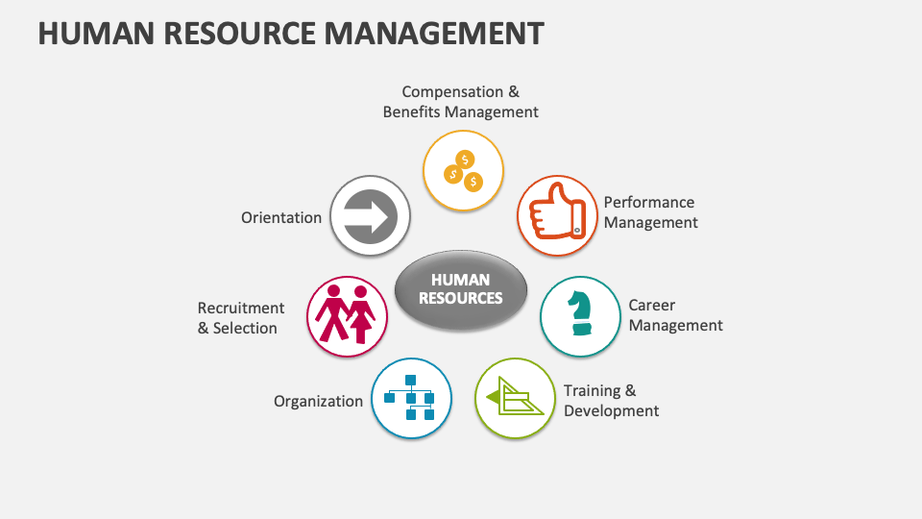
Figure 1: Human Resource Management (Collidu, 2024)

Digital monitoring performance management systems improve the measurement of output, but also increase the ethical and legal issues of monitoring employees, their privacy, and transparency (Tambe et al., 2020). Therefore, HR practitioners have to find a balance between technological optimisation and ethical governance systems to maintain employee trust and organisational legitimacy in technology-driven environments.

Implications for International Human Resource Management: Microsoft
To counteract these changes, HRM is now being demanded to be strategically oriented towards workforce planning and skills development. Efficiency and predictive accuracy are enhanced with AI-enabled recruitment systems, but empirical research shows that algorithmic decision-making can recreate historical bias in training data, compromising the goals of fairness and diversity (Bogen and Rieke, 2022). Digital monitoring performance management systems improve the measurement of output, but also increase the ethical and legal issues of monitoring employees, their privacy, and transparency (Tambe et al., 2020). Therefore, HR practitioners have to find a balance between technological optimisation and ethical governance systems to maintain employee trust and organisational legitimacy in technology-driven environments.

Critical Evaluation of Strategic HRM Outcomes
In general, AI and digital technologies enhance strategic HRM, allowing decision-making based on data and integrating global talent. They however require ethical implementation to be effective, regulatory sensitivity and long-term human capital investment. In their absence, the adoption of technology is likely to worsen inequality and undermine trust within the workforce, and thus, negatively affect long-term organisational sustainability instead of supporting it (ILO, 2025).

Question 2: Demographic and Geopolitical Factors Influencing Employment Markets

Demographic Factors
Demographic change is a structural limitation to the employment markets, especially in the developed economies, over the long term. Low fertility and rising life expectancy has decreased the working age population and at the same time raised dependency ratios creating greater competition in the labour markets across the sectors. According to Eurostat (2024), the working-age population in the EU is currently declining since 2013, which restricts the supply of labour regardless of the recruitment methods of the organisation. The high replacement demand is also created by ageing workforces, especially in the healthcare and the services to the population, where retirements exceed the number of new entrants into the labour market (Bloom et al., 2022).
Migration in the past has helped in reducing demographic pressures through supplementing domestic labour markets, but there is an increasing inequality in skills mobility. The highly skilled workers are mobile all over the world, whereas the shortages are in the highly needed but less appealing jobs, such as care and support jobs (Papademetriou and Sumption, 2021). These population trends limit organisational choice, by shrinking recruitment options and raising reliance on external labour markets, decreasing the range of solutions within the organisational sphere of HR alone.

Geopolitical Factors
The geopolitical changes also heighten the instability of labour market by transforming the migration regimes and labour mobility trends. Immigration policy modifications in developed economies have brought about more stringent visa conditions and compliance expenses and diminished access to the international source of labour (Sumption, 2023). Moreover, education systems have been broken, skilled labor and global talent pipelines have been interrupted by global conflicts and political upheaval, especially in the technology and healthcare industries (UNHCR, 2024).
Long-term workforce planning is also compromised by geopolitical uncertainty as organisations find it difficult to forecast labour supply in more and more fragmented regulatory settings. Skills mismatches are further increased by trade tensions and geopolitical realignments, as they deter cross-border mobility and the transfer of knowledge and limit organisational flexibility in talent sourcing (Rodrik, 2021).

HR Challenges in Practice: The NHS
The National Health Service (NHS) provides a good example of how HR decision-making is constrained by demographic and geopolitical forces. The ongoing workforce deficits are driven by the growing needs in the service delivery process that is caused by the ageing population and the lack of capacity to train in the country and the decreasing foreign labour flows (Health Foundation, 2023). This has resulted in acute staffing issues within the NHS despite the mass recruiting activities. The causes of retention like burnout and turnover related to stress are augmented by the prolonged workload intensity, instead of the failures of HR policy design. The global recruitment is a policy that is mandatory yet constrained by moral provisions and legislative controls that limit the freedom of the managers in human resource planning. Consequently, the external demographic and geopolitical factors affect the HR performance of the NHS primarily, which means that the problems of labour markets are flexible to structural constraints, but not internal inefficiency.

Question 3: Addressing Skills Gaps and Talent Shortages through Strategic HRM

Nature of Skills Shortages
There are differences in skills shortages in different sectors because of structural and cyclical forces that determine labour supply and demand. The high rate of digitalisation and the proliferation of artificial intelligence in the technology industry has created persistent demand in high levels of digital, data and cyber security capabilities, which education and training systems are continually unable to meet (McKinsey Global Institute, 2023). These deficiencies are mostly structural, which is a long process of skills formation as opposed to short-run economic cycles. Conversely, healthcare shortages, especially in nursing and care professions, are demographic ageing-led, emotionally taxing and limited training pipelines-driven (The King’s Fund, 2022). The structural shortages exist even when the economy is slowing down, and the cyclical shortages vary with the labour market conditions, requiring differentiated HR strategies but not the same ones across the board.

Strategic HRM Responses
Strategic HRM aims at solving skills gaps by means of long term capability building in line with organisational goals. Other organisations, including Microsoft, have focused on massive up skilling and reskilling programs, integrating lifelong learning into the workforce plan to achieve flexibility in highly evolving technology contexts (Microsoft, 2025). Development of talent pipeline (e.g., graduate programmes, apprenticeships and collaboration with educational institutions) helps to sustain the supply of skills, as well as to decrease costs of recruitment in the long run. Employer branding also improves attraction through creating signals of development and organisational purpose in competitive labour markets. International recruitment in industries where there is an acute shortage like in healthcare is one of the critical strategies that can be used to fill an immediate workforce gap as domestic training capacity increases.

Critical Evaluation of HR Strategies
HR interventions have major trade-offs that restricted their effectiveness as a standalone intervention despite their strategic value. Up skilling and reskilling programs demand significant financial resources and time, as well as raising the retention risk since the employees can leave the company once they have developed highly mobile skills (CIPD, 2023). The long-term resiliency of talent pipelines is maximized, but short-term shortages are ignored because of long training lead times. International recruitment will reduce the short-term labour shortages but also introduce ethical issues associated with the loss of labour in the home countries and dependency on migrant labour in the long-term (World Health Organization, 2023). Also, employer branding efforts can positively influence attraction, but do not address the root cause of job quality problems, like workload levels, burnout, and lack of progression, especially in healthcare environments.
As a result, as much as strategic HRM can help to alleviate skills gaps and promote organisational flexibility, it cannot completely eliminate structurally fixed labour market constraints without action on a policy level and systematic investment in education and workforce planning. This demonstrates the constraints of organisational agency and the rationale of co-ordinated labour market and HR policies.

Question 4: Reflective Report Using Gibbs’ Reflective Cycle
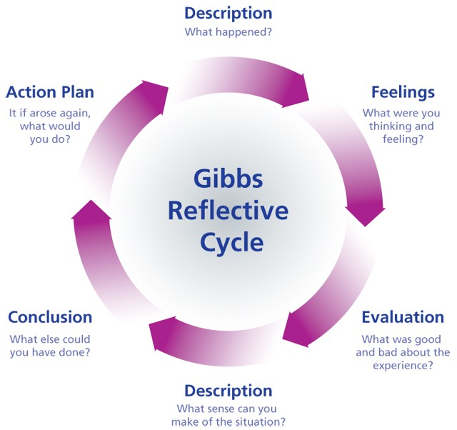
Figure 2: Gibbs’ Reflective Cycle (smartuser, 2023)
Description
This reflective report assesses my ability to work successfully in a global and technology-focused professional setting. The reflection is informed by my recent postgraduate learning experience, which entailed virtual teamwork, multicultural teamwork and autonomous skill building. These experiences are the realities of the modern global workplaces, where digital technologies and cross-cultural interaction are the part of the performance. This analysis is organized around Gibbs reflective cycle that allows making a systematic connection between experience, learning and future development as a professional (Gibbs, 2020). They are cultural awareness, technology capability, communication, teamwork, leadership and self-directed learning.
Feelings
Initially, I was sure about my ability to communicate with culturally different peers and take part in discussions speaking the common working language, English. Nevertheless, I also felt unsure when facing other norms of communication especially indirect feedback, and decision-making styles. Equally, I felt secure in using the familiar digital tools, but I felt fear when I had to use new technologies on my own without systematic instructions. These attitudes demonstrated a certain degree of current competence as well as recognition of the areas of skills deficiency that may influence my performance in the global professional environment.
Evaluation
There are a number of areas that performed well in my performance. I was culturally open because I changed my communicative style and actively listened to other points of view. It has been found that cultural awareness increases collaboration through the reduction of misunderstanding and enhancing trust in multicultural teams (Ang et al., 2020). I was also involved in beneficial virtual teamwork, organising the work using the online collaboration systems, so that there was no misunderstanding of tasks and timelines.
But restrictions were also present. I sometimes did not want to discuss any minor disagreements directly, especially online, which could lead to an unresolved tension. Secondly, I was not much strategic in my use of digital tools, but more task-driven to enhance long-term capability. These are the weaknesses that curtailed my possible contribution to the team effectiveness and leadership.
Analysis
These experiences demonstrate how the demands in globalised and digitised workplaces are becoming more complex. Cross-cultural competence is not just about tolerance but also entails constant reflection and behavioural change (Minkov and Kaasa, 2021). My aversion to conflict is typical of most multicultural teams in which fear of misunderstanding may prevent effective communication. Building trust in conflict management is thus a requisite of working well in the international partnership.
Technological capability is also very important. Digital fluency is also becoming directly associated with employability because organisations are increasingly dependent on virtual working, data-driven operation and fast innovation (Bessen, 2022). Although I have functional digital competencies, my reactive learning style limits my strategic capability to use technology. Self-directed learning and leadership are interrelated because proactive learning helps people to exercise initiative and independence in complex situations (CIPD, 2023). Learning activities will be inefficient without a structured development strategy.
Conclusion
As a reflection, my main strength areas are cultural adaptability, underlying digital competence and collaborative teamwork, which are the reasons that help me engage successfully in international settings. There are however some weaknesses in proactive technology learning and structured professional development planning and confident conflict management. Such deficiencies are not signs of a weakness but the failure to focus on strategy and intentional practice. It is important to note these limitations in order to match my skill set with the requirements of postgraduate level jobs in international labour markets.

Action Plan
To this, I have come up with a specific action plan to improve my employability. To enhance cultural intelligence and skills of resolving conflicts, I will first undergo a certified course in cross-cultural communication in six months. Second, I will reserve monthly time to learn more about the advanced functionality of digital collaboration and productivity tools that are applicable to my area, which facilitates continuous technological adjustment. Third, I will develop a systematic professional growth plan that would be in line with my career goals, which would be revised after every three months to check the progress. These SMART objectives will help to convert thinking into action and contribute to a long-term professional development in international and technology-savvy workplaces (Jackson, 2021).

Conclusion
This report has established that technological development, demographic upheaval and geopolitical insecurity are reshaping the global labour markets, and all of them bring considerable limitations to organisational decision-making. The ageing population, migration barriers and geopolitical instability increase labour shortages, especially in essential sectors, AI and digitalisation are altering work and skills demands and are worsening the situation. Strategic HRM is thus critical towards facilitating organisations to undertake a response to the same by way of long-term workforce planning, skills development and ethical talent management. The reflective analysis also shows that individual preparedness to work globally relies on cultural flexibility, digital and lifelong learning and it supports the significance of strategic HRM on organisational and personal levels.

References
Ang, S., Rockstuhl, T. and Van Dyne, L. (2020) ‘Cultural intelligence’, Annual Review of Organizational Psychology and Organizational Behavior, 7, pp. 1–28.
Autor, D., Mindell, D. and Reynolds, E. (2022) The work of the future: Building better jobs in an age of intelligent machines. Cambridge, MA: MIT Press.
Bessen, J.E. (2022) Learning by doing: The real connection between innovation, wages, and wealth. New Haven, CT: Yale University Press.
Bloom, D.E., Kuhn, M. and Prettner, K. (2022) ‘Population aging and macroeconomic outcomes’, Handbook of the Economics of Population Aging, 1, pp. 3–56.
Bogen, M. and Rieke, A. (2022) ‘Help wanted: An examination of hiring algorithms, equity, and bias’, Journal of Business Ethics, 180(2), pp. 1–15.
Chartered Institute of Personnel and Development (CIPD) (2023) Learning at work 2023: Building a learning culture. London: CIPD. Available at:
https://www.cipd.org/uk/knowledge/reports/learning-at-work/. [Accessed 1 Dec. 2025].
Chartered Institute of Personnel and Development (CIPD) (2023) Professional development: Skills for sustainable employability. London: CIPD. Available at:
https://www.cipd.org/uk/knowledge/guides/professional-development-factsheet/. [Accessed 1 Dec. 2025].
Collidu (2024). Human Resource Management. [online] Collidu.com. Available at: https://www.collidu.com/presentation-human-resource-management [Accessed 1 Dec. 2025].
De Stefano, V., Aloisi, A. and Countouris, N. (2020) ‘Platform work and the employment relationship’, Comparative Labor Law and Policy Journal, 41(3), pp. 471–504.
Eurostat (2024) Population structure and ageing. Luxembourg: European Commission. Available at: https://ec.europa.eu/eurostat/statistics-explained/index.php?title=Population_structure_and_ageing. [Accessed 2 Dec. 2025].
Farndale, E., Scullion, H. and Sparrow, P. (2021) Global talent management. 2nd edn. London: Routledge.
Gibbs, G. (2020) Learning by doing: A guide to teaching and learning methods. Oxford: Oxford Brookes University. Available at:
https://www.brookes.ac.uk/getmedia/fd64b8c4-0f3e-4d7c-9d6c-9b2f6c3e3a4f/learning-by-doing-graham-gibbs.pdf. [Accessed 2 Dec. 2025].
Health Foundation (2023) Closing the gap: Key areas for action on the health and care workforce. London: The Health Foundation. Available at:
https://www.health.org.uk/publications/reports/closing-the-gap-key-areas-for-action-on-the-health-and-care-workforce. [Accessed 2 Dec. 2025].
International Labour Organization (ILO) (2025) World employment and social outlook: Trends 2025. Geneva: ILO. Available at:
https://www.ilo.org/global/research/global-reports/weso/2025/lang--en/index.htm. [Accessed 2 Dec. 2025].
Jackson, D. (2021) ‘Employability skill development in higher education’, Education + Training, 63(3), pp. 367–381.
King’s Fund (2022) The NHS workforce: Our position. London: The King’s Fund. Available at:
https://www.kingsfund.org.uk/projects/positions/nhs-workforce. [Accessed 5 Dec. 2025].
McKinsey Global Institute (2023) Generative AI and the future of work in advanced economies. New York: McKinsey & Company. Available at:
https://www.mckinsey.com/mgi/our-research/generative-ai-and-the-future-of-work-in-advanced-economies. [Accessed 5 Dec. 2025].
Microsoft (2025) Global workforce and skills development report. Redmond, WA: Microsoft. Available at:
https://www.microsoft.com/en-us/worklab/work-trend-index. [Accessed 5 Dec. 2025].
Minkov, M. and Kaasa, A. (2021) Cross-cultural analysis: The science and art of comparing the world’s modern societies and their cultures. 2nd edn. London: SAGE Publications.
Organisation for Economic Co-operation and Development (OECD) (2021) The future of work after COVID-19. Paris: OECD Publishing. Available at:
https://www.oecd.org/employment/the-future-of-work-after-covid-19.pdf. [Accessed 5 Dec. 2025].
Organisation for Economic Co-operation and Development (OECD) (2023) Labour market trends and policies. Paris: OECD Publishing. Available at:
https://www.oecd.org/employment/labour-market-trends-and-policies-2023.pdf. [Accessed 5 Dec. 2025].
Papademetriou, D.G. and Sumption, M. (2021) Rethinking points systems and employer-sponsored visas. Washington, DC: Migration Policy Institute. Available at:
https://www.migrationpolicy.org/research/rethinking-points-systems-employer-sponsored-visas.
[Accessed 9 Dec. 2025].
Rodrik, D. (2021) The globalization paradox: Democracy and the future of the world economy. New York: W.W. Norton & Company.
smartuser (2023). Reflective Practice–A Key to Improvement - British School. [online] British School. Available at: https://www.british-school.org/reflective-practice-a-key-to-improvement/ [Accessed 9 Dec. 2025].
Sumption, M. (2023) Immigration after Brexit: Managing trade-offs. Oxford: The Migration Observatory. Available at:
https://migrationobservatory.ox.ac.uk/resources/reports/immigration-after-brexit-managing-trade-offs/. [Accessed 9 Dec. 2025].
Tambe, P., Cappelli, P. and Yakubovich, V. (2020) ‘Artificial intelligence in human resources management: Challenges and a path forward’, California Management Review, 62(2), pp. 15–42.
United Nations High Commissioner for Refugees (UNHCR) (2024) Global trends: Forced displacement in 2023. Geneva: UNHCR. Available at:
https://www.unhcr.org/global-trends-report-2023. [Accessed 9 Dec. 2025].
World Health Organization (2023) Global health workforce stock and distribution. Geneva: WHO. Available at:
https://www.who.int/data/gho/data/themes/topics/health-workforce. [Accessed 9 Dec. 2025].

