6a Selection in Python (2) – if/elif/else statements

1. Write a program to allow the user to enter their age. If their age is between 18-30, print a message on the screen. If they are outside this age group, print a different message.

Don't forget to test your program on the boundaries!

Sample output:

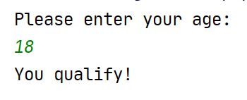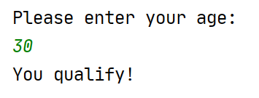

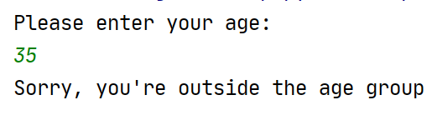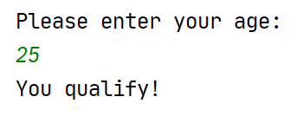

2.a) Write a program that allows the user to enter two pizza toppings. Print a message on the screen to state whether the user has chosen Hawaiian pizza (ham and pineapple!) or not. (Note: the user will enter everything in lower case)

Sample output:

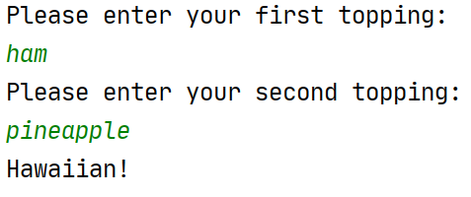

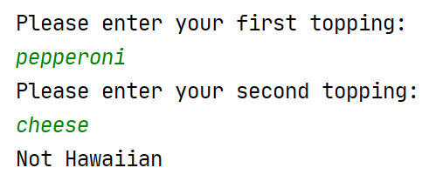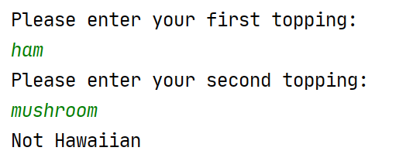

2b Remember, the user could enter pineapple first and then ham, or vice versa, so you will need to check both combinations. Adjust your program so you check both ways:

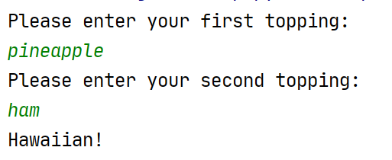

3a. Write a program which allows the user to input a date in a form similar to the following:

9 February 2021

Print the date on the screen, showing the contraction for the day (eg 1st 4th 22nd)

Sample output:

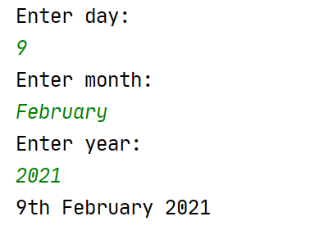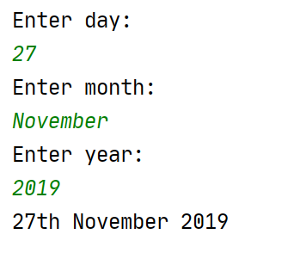

Hint:
st = 1st 21st 31st
nd = 2nd 22nd
rd = 3rd 23rd
th = the rest!
4. Write a calculator which looks something like the below. Think about the variable types in advance and decide how to cast your variables (Remember, if you don't cast, Python will consider the inputs to be strings!)

Sample output:

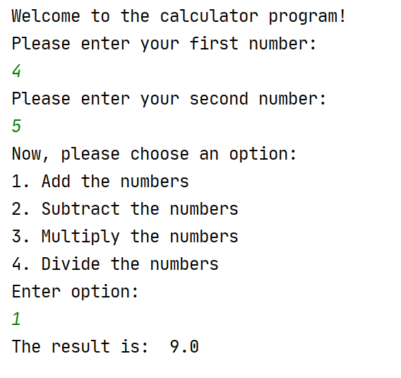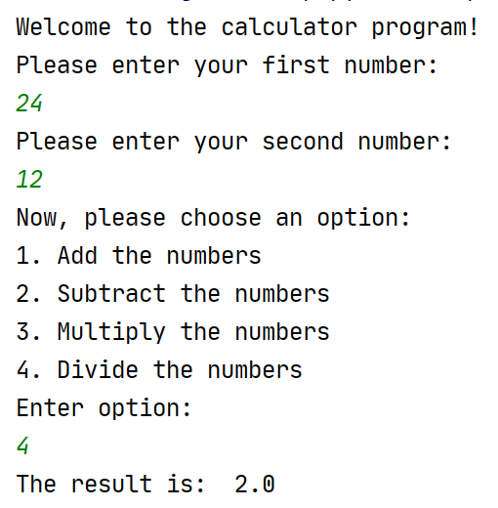

Remember to test your calculator thoroughly, making sure it works for all options (and invalid ones too!)

EXTRA 5a. Ask the user to guess what my favourite number is (for the purposes of this program, my favourite number is 15) Tell the user whether they guessed right or wrong.

(Note: one guess only, but the user can re-run the program to try again if they want)

Sample output:

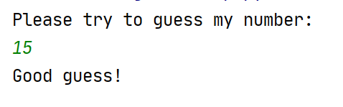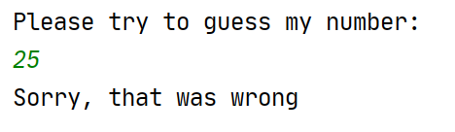

5b Extend the game from 5a so that instead of the player being told they are wrong, they get told if they are warm or cold. You can consider "warm" to be a guess within 5 of my favourite number.

Sample output:



