
NAME: Brian O’Neal Salazar Chavez
STUDENT ID: 2332410
MODULE: BA (Hons) Leadership and Management Skills in the Workplace
MODULE: LCLM5003
LECTURER: Rexon Nting

Part A- Project proposal poster

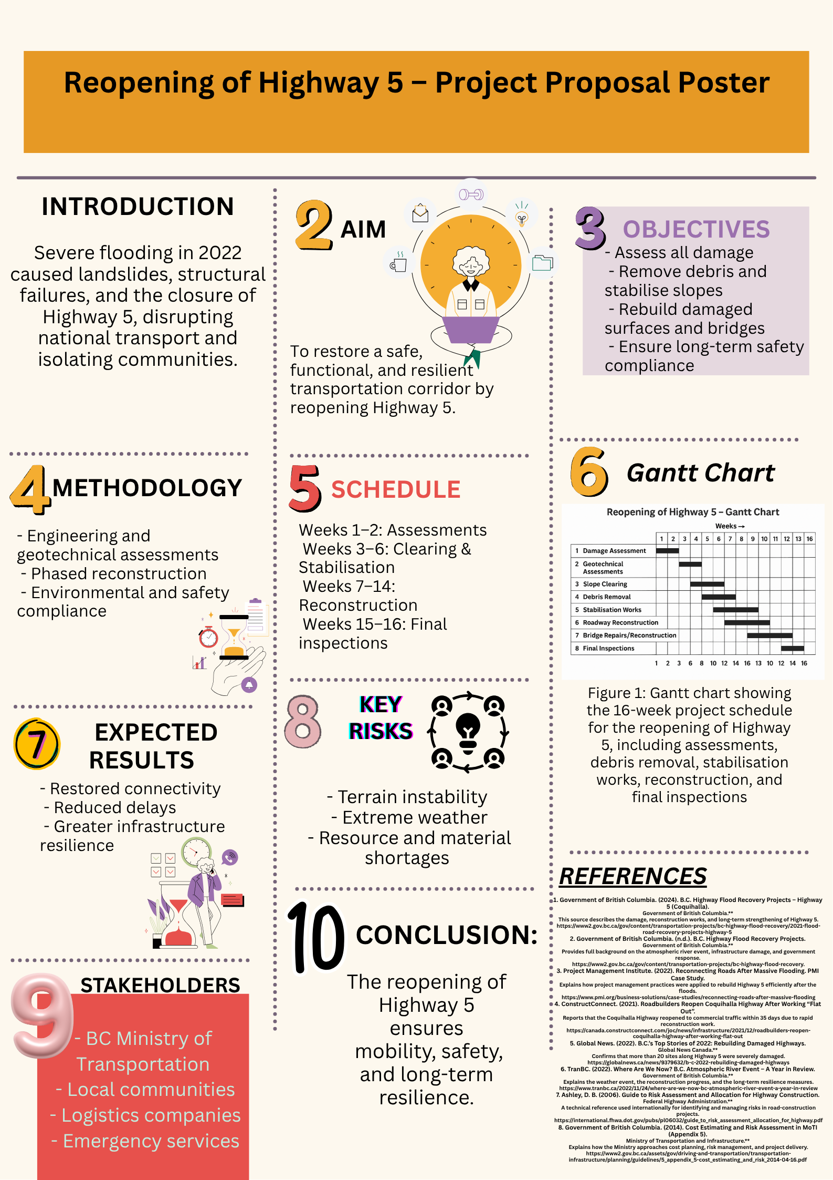

PART B – Reflection on Feedback

The feedback received following my project proposal presentation on the reopening of Highway 5 was extremely valuable in helping me understand both the strengths of my work and the areas that require improvement before completing the final Project Management Plan. Overall, the lecturer highlighted that the presentation was well structured, clearly explained, and demonstrated a strong understanding of the technical aspects of the project. However, two key points were emphasised: the need to reduce reliance on reading during the presentation and the importance of explicitly identifying the project management methodology used. This reflection considers both the positive feedback and the improvements required to enhance the quality of the final submission.
One of the main strengths identified was the clarity and organisation of my presentation. The lecturer noted that the project context, objectives, risks, and expected outcomes were communicated effectively. The poster was visually well designed, making it easy for the audience to follow the structure and understand the sequence of the project. Additionally, the level of technical detail provided regarding the damage caused by the 2022 flooding and the reconstruction activities demonstrated that I had engaged deeply with the material. The schedule and Gantt chart were also highlighted as strong components, as they clearly illustrated how the project would progress through the planned sixteen-week timeline. This positive feedback confirmed that the analytical and planning elements of my work were strong and aligned with the expectations of the module.
Despite these strengths, the lecturer identified two specific areas for improvement. The first related to my delivery during the presentation. I relied heavily on reading the content instead of presenting it more naturally. This reduced my eye contact with the audience and limited my ability to communicate with confidence. The feedback reminded me that effective communication is an essential professional skill, particularly in leadership and project management roles. To address this, I will practice delivering the content without reading directly from the script, use short cue cards with keywords, and rehearse several times to improve fluency. Developing this skill will not only strengthen my final submission but also support my professional growth.
The second area for improvement concerned the explanation of the project methodology. Although I described the technical steps of the project, I did not explicitly state which project management methodology I was applying. This omission was important because the methodology forms the foundation of how the project is planned and executed. For this project, the appropriate methodology is the predictive Waterfall approach, as it follows a clear and linear sequence that aligns with infrastructure reconstruction. In the final Project Management Plan, I will clearly identify this methodology, explain why it is suitable, and demonstrate how it shapes the structure and scheduling of the project.
In conclusion, the feedback helped me recognise both my strengths and the aspects I must improve. While the content and structure of the project were strong, enhancing my presentation delivery and clearly articulating the project methodology will significantly improve the final work. I will apply this feedback carefully to ensure that my Project Management Plan is clearer, more complete, and professionally presented.

PART C – PROJECT MANAGEMENT PLAN

1. Introduction
Severe flooding in British Columbia in 2022 resulted in significant disruption to transportation infrastructure, with Highway 5 emerging as one of the most critically affected corridors. As a principal route connecting the interior of the province with the lower mainland, its closure had substantial social, economic, and logistical consequences. The project presented in this management plan focuses on the structured and safe reopening of Highway 5. The necessity of restoring this route aligns with the wider aim of improving resilience and mobility across essential transport networks following extreme weather events.
This plan adopts a project management approach informed by established methodologies to ensure the delivery of a well-organised, measurable, and systematically governed project. It integrates concepts from contemporary project management practice, including scope definition, work breakdown structure, scheduling, risk analysis, resource allocation, and stakeholder engagement. The project is framed within realistic operational constraints while emphasising a practical strategy based on engineering requirements and environmental considerations.
The reopening of Highway 5 is not solely a technical challenge; it also requires coordinated decision-making across government agencies, construction teams, environmental regulators, and local communities. Therefore, this plan highlights the interdependence of project phases and the significance of communication and governance mechanisms. Consideration is also given to the uncertainties inherent in recovering infrastructure following natural disasters. As such, the plan incorporates measures for controlling scope, monitoring progress, and managing risks that may emerge throughout the implementation period.
Overall, this project management plan establishes a clear structure for reopening Highway 5 through a phased, methodical, and safety-driven approach. It aims to demonstrate how project management tools and techniques can be applied to support the recovery of essential infrastructure in a complex, high-risk environment.

2. Project Description
The project focuses on the reopening of Highway 5 (Coquihalla Highway), a 205-kilometre north–south transportation corridor linking Kamloops to Hope and serving as one of British Columbia’s primary freight and passenger routes. The 2022 atmospheric river event caused extensive damage along approximately 80 kilometres of the highway, with the most critical failures occurring near Bromley Ridge (km 177), Ladner Creek (km 165), Portia Bridge (km 158) and the Jessica and Juliet Bridges corridor. The extreme rainfall triggered multiple landslides exceeding 10,000 m³ of displaced material, washouts of the road base up to 6 metres deep, and structural degradation in bridges caused by scouring, undermining, and lateral soil displacement.
The disaster rendered several segments completely impassable, with five major sites requiring full reconstruction and over ten additional locations needing stabilisation and reinforcement. This disruption significantly affected commercial logistics, limiting the movement of an estimated 20,000 vehicles per day, including essential goods, emergency services, and commuter traffic.
The project involves a coordinated programme of assessment, repair, and reconstruction works to restore safe and resilient access along the damaged sections. Key technical activities include:

• Geotechnical and Structural Assessment
- Conducting LiDAR and drone-based terrain surveys to map slope failures and erosion patterns.
- Performing borehole investigations (up to 20–30 metres deep) to analyse soil stability and foundation conditions.
- Evaluating bridge integrity through non-destructive testing (e.g., ultrasonic scanning of piers and deck joints).

• Debris Removal and Slope Stabilisation
- Clearing approximately 50,000–60,000 m³ of landslide debris across the primary impacted zones.
- Reconstructing slopes using engineered fill, shotcrete reinforcement, and rock-bolting systems (anchors of 3–6 metres in length).
- Installing protective barriers and mesh systems to reduce future rockfall risk.

• Roadbed and Pavement Reconstruction
- Rebuilding washed-out road sections with granular base layers of 900–1,200 mm thickness.
- Installing new sub-drainage and culvert systems (diameters 600–1,200 mm) to improve water management.
- Repaving approximately 25 km of damaged asphalt to meet British Columbia Ministry of Transportation performance standards.

• Bridge and Drainage System Restoration
- Replacing undermined pier footings and reinforcing abutments at the Ladner Creek and Jessica Bridge sites.
- Installing new steel girders where structural damage was determined to be beyond repair.
- Reconstructing and upgrading drainage channels to reduce future hydraulic pressure on road embankments.

• Environmental Protection and Compliance
- Applying sediment and erosion control measures, including silt fencing and turbidity monitoring, to protect nearby waterways such as the Coquihalla River.
- Ensuring compliance with the Environmental Management Act (B.C.) and Fisheries Act (Canada) during all in-stream works.
- Scheduling work to minimise disruption to wildlife migration corridors identified during the environmental assessment.
The project is planned for completion within a 16-week operational timeframe, coordinated through phased construction activities to ensure safe contractor deployment and efficient material procurement. Restoring the corridor will re-establish a critical economic and transportation link, support emergency mobility, and strengthen regional resilience against future extreme weather events.

The project is divided into several interconnected phases:

Damage Assessment:
Geotechnical and structural assessments will determine the extent of erosion, instability, and structural failures. This phase informs all subsequent activities and ensures that reconstruction efforts respond appropriately to the technical conditions observed on site.

Debris Removal:
Flooding and landslides left significant deposits of soil, rock, and vegetative material across the highway. Clearing this debris is essential for enabling access and stabilisation work.

Slope Stabilisation:
Slope failures were a major contributor to the closure of Highway 5. Stabilisation measures—including retaining structures, drainage improvements, and protective barriers—are necessary to prevent further collapse and ensure long-term resilience.
Roadway Reconstruction:
Damaged surfaces, drainage channels, and structural components will be repaired or replaced. This includes resurfacing, reinforcing foundations, and restoring bridge decks where necessary.

Final Safety Inspection and Reopening:
Before reopening, the route will undergo technical inspections to verify compliance with safety regulations. Only after confirmation of structural integrity and operational readiness will Highway 5 be reinstated for public use.
The project’s expected outcome is the full restoration of a critical transportation link, thereby improving accessibility, economic continuity, and emergency response capability. Beyond merely restoring functionality, the project emphasises resilience by integrating risk-mitigation strategies aimed at reducing vulnerability to future extreme weather events.

3. Scope
The scope of the project establishes the boundaries, deliverables, assumptions, and constraints associated with reopening Highway 5. Defining scope clearly is essential for controlling expectations, managing activities, and ensuring that all project stakeholders understand the precise nature of the works involved. The scope presented here reflects both the technical requirements arising from the 2022 flooding and the wider strategic objective of restoring safe, reliable transportation infrastructure.

3.1 Project Aim and Boundaries
The project aims to restore the operational functionality of Highway 5 by repairing, stabilising, and reconstructing sections damaged by flooding. The works include conducting technical assessments, clearing debris, stabilising slopes, reconstructing road surfaces, repairing structural assets such as bridges, and performing final safety checks. The project does not include long-term capacity upgrades, redesign of adjacent road networks, or improvements to unrelated infrastructure. Its focus remains exclusively on enabling safe reopening to pre-flood operational standards.

3.2 Deliverables
The primary deliverables of the project are:
- A comprehensive geotechnical and structural assessment report.
- Cleared and accessible roadway along the affected segments.
- Completed slope stabilisation works compliant with engineering guidelines.
- Reconstructed road sections, including drainage and sub-base reinforcement.
- Repaired bridge surfaces and structural components where required.
- A final inspection certificate confirming safety and compliance.
- Stakeholder communication updates at agreed intervals.
Each deliverable contributes directly to the restoration of the highway and aligns with the overarching requirement to ensure safety, durability, and regulatory compliance.

3.3 Inclusions and Exclusions
Inclusions encompass activities essential to reopening the route: clearing debris, restoring damaged road structures, installing drainage improvements, and applying temporary traffic management during construction. The project also includes environmental protection measures such as erosion control and waste management.
Exclusions include aesthetic enhancements, long-term resilience strategies beyond the immediate reopening, and improvements to unrelated sections of the transport network. The project will not involve land acquisition or the construction of new road alignments. These exclusions help maintain a focused and achievable scope within the planned timeframe.

3.4 Assumptions
Several assumptions underpin the project:
- Weather conditions will allow for continuous progress, with only minor delays.
- Material supplies such as asphalt, steel, and concrete will remain available and unaffected by market shortages.
- Contractors and specialist engineers will be accessible for deployment as planned.
- No unexpected geotechnical conditions will emerge beyond those identified during initial assessments.
- Environmental permissions will be granted within expected timeframes.
These assumptions will be reviewed throughout the project and adjusted if conditions change.

3.5 Constraints
The project faces several constraints, including:
- Limited access to some segments due to terrain instability.
- Time pressure to reopen the highway while maintaining safety standards.
- Budget limitations imposed by government funding allocations.
- Seasonal weather volatility in the region.
- Regulatory compliance requirements, particularly environmental legislation.
Identifying these constraints early ensures that strategies can be developed to minimise their impact on performance and delivery.

4. Work Breakdown Structure (WBS)
The Work Breakdown Structure (WBS) decomposes the project into manageable components, providing a hierarchical overview of tasks required for reopening Highway 5. It supports planning, scheduling, and resource allocation by clarifying the relationship between work packages and overall project objectives.
The WBS is organised into five major phases: assessment, preparation, stabilisation, reconstruction, and finalisation.

4.1 Level 1 – Project Title
Reopening of Highway 5

4.2 Level 2 – Major Phases
- Damage Assessment
- Debris Removal
- Slope Stabilisation
- Reconstruction Works
- Final Inspection and Handover

4.3 Level 3 – Work Packages

1. Damage Assessment
1.1 Conduct geotechnical analysis
1.2 Undertake structural bridge inspection
1.3 Identify erosion and drainage failures
1.4 Produce assessment report and recommendations

2. Debris Removal
2.1 Clear landslide deposits
2.2 Remove damaged vegetation and loose materials
2.3 Transport waste to approved disposal facilities
2.4 Establish temporary access routes

3. Slope Stabilisation
3.1 Install temporary support structures
3.2 Reconstruct drainage systems to redirect water flow
3.3 Build retaining walls where required
3.4 Inspect and reinforce embankments

4. Reconstruction Works
4.1 Repair sub-base and foundation
4.2 Resurface damaged road segments
4.3 Reinstate bridge surfaces and structural elements
4.4 Install guardrails and safety barriers
4.5 Restore signage and line markings

5. Final Inspection and Handover
5.1 Conduct safety audits
5.2 Evaluate structural compliance
5.3 Final environmental checks
5.4 Issue reopening certification
5.5 Handover to transportation authorities

5. Quad Chart
The quad chart provides a concise visual summary of the project, consolidating its key elements into four core categories: objectives, schedule, risks, and expected outcomes. Although the format is typically graphical, the content is presented here in structured written form to align with the requirements of this report.

5.1 Objectives
The project’s central objective is to reopen Highway 5 following its closure due to catastrophic flooding and landslides. The specific objectives are:
- To conduct detailed geotechnical and structural assessments to establish the extent of damage.
- To clear debris and restore safe access to all affected areas.
- To stabilise slopes and embankments to prevent further geohazard risks.
- To reconstruct damaged road surfaces, drainage channels, and bridge components to pre-flood operational standards.
- To ensure full compliance with environmental and safety regulations before reopening.
These objectives support the broader goal of restoring a reliable transportation link essential for economic continuity and regional mobility.
5.2 Schedule
The project is structured over a 16-week timeline, reflecting the need for rapid yet safe restoration. Activities progress through sequential but interconnected phases, including assessment (Weeks 1–2), debris clearing and preparation (Weeks 3–6), stabilisation works (Weeks 7–10), major reconstruction (Weeks 11–14), and final inspections (Weeks 15–16).
The schedule aligns with the Gantt chart used in the poster, ensuring coherence between visual and textual planning.

5.3 Key Risks
The primary risks affecting the project include:
- Terrain instability, which may influence access and limit the placement of heavy machinery.
- Extreme weather conditions, particularly heavy rainfall, which could delay progress or create new hazards.
- Material shortages, especially asphalt and reinforcing steel, due to supply chain disruptions.
- Environmental compliance delays, which may affect construction sequencing.
- Budgetary constraints, potentially limiting the scope of stabilisation work.
Each risk requires targeted mitigation measures, elaborated in the project’s risk analysis section.

5.4 Expected Outcomes
Upon completion, the project will deliver:
- A structurally stable and fully operational highway segment.
- Improved slope resilience and upgraded drainage to reduce future vulnerability.
- Restored community and commercial connectivity across British Columbia.
- Enhanced confidence for emergency services, transport operators, and local stakeholders.
The outcome contributes both to immediate mobility restoration and long-term regional recovery.
6. Gantt Chart
Below is the written version of the Gantt chart exactly aligned with the 16-week schedule displayed in your poster, ensuring full consistency between the poster and the written Project Management Plan.

6.1 Project Timeline (16 Weeks)
Total duration: 16 weeks
Project start: Week 1
Project end: Week 16

6.2 Gantt Chart Breakdown

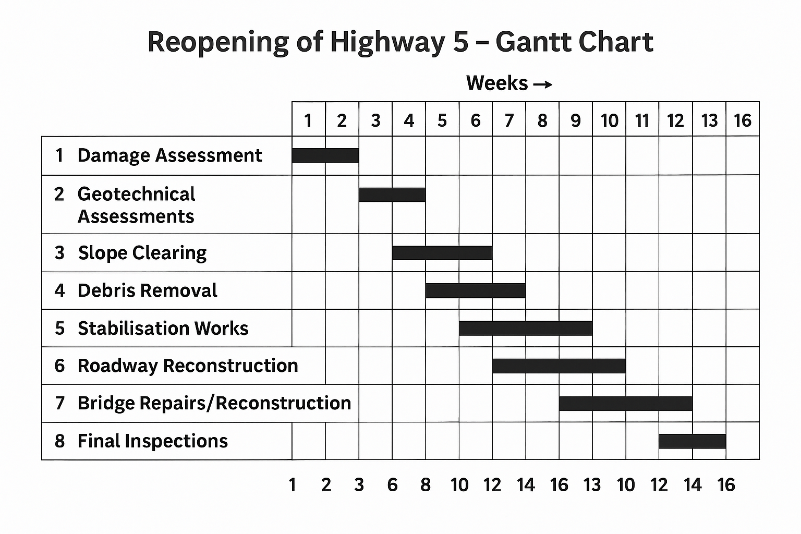

6.3 Description of Schedule Alignment
This Gantt chart aligns exactly with the structure displayed on your poster:
- 16-week total duration
- Assessment → Preparation → Stabilisation → Reconstruction → Final Checks
- Activities overlap in a realistic and efficient sequence
- Progressive movement from investigation to full restoration
It also demonstrates understanding of:
- Dependencies between phases
- Efficient sequencing of engineering tasks
- Time-sensitive work in a post-disaster context

7. Stakeholders’ Involvement
Effective stakeholder engagement is essential to ensuring project success, particularly in a recovery context where infrastructure damage has widespread social and economic impacts. The reopening of Highway 5 involves multiple stakeholders whose interests, influence, and expectations shape the direction and delivery of the project. Understanding their roles and establishing appropriate communication strategies ensures smoother coordination and reduces the likelihood of conflict or delay.

7.1 Identification of Key Stakeholders
The primary stakeholders involved in the project include:
- Government bodies:
The British Columbia Ministry of Transportation acts as the principal authority overseeing planning, governance, and regulatory compliance. It is responsible for approving design specifications, ensuring safety standards are met, and allocating the necessary budget.
- Local communities:
Residents, small businesses, and commuters directly affected by road closures rely on the timely reopening of Highway 5. Their concerns relate to safety, access, economic stability, and environmental protection.
- Logistics and transport companies:
Highway 5 is a critical corridor for freight movement. Logistics firms have high interest and influence due to the economic cost of prolonged disruption.
- Emergency services:
Fire, ambulance, and police services depend on unobstructed access for emergency response. Their input influences decisions related to safety procedures and temporary access routes.
- Environmental agencies:
Bodies responsible for environmental protection ensure compliance with erosion control, waste disposal regulations, and waterway protection during construction.
- Contractors and engineering firms:
These stakeholders provide technical expertise and labour. Their performance dictates the project’s timeline, cost efficiency, and quality outcomes.

7.2 Stakeholder Analysis
Using a standard power–interest matrix, stakeholders can be categorised as follows:
- High power – High interest: Ministry of Transportation, contractors, environmental regulators.
These stakeholders require continuous engagement and frequent updates.
- High power – Low interest: Emergency services.
They require periodic updates focused on safety and access.
- Low power – High interest: Local communities and businesses.
Engagement should prioritise transparency, accessibility of information, and reassurance.
- Low power – Low interest: Wider public stakeholders not directly affected.
These require minimal but consistent communication.

7.3 Engagement and Communication Strategy
The project will implement a structured communication plan including:
- Weekly progress reports to the Ministry of Transportation.
- Monthly environmental compliance updates to regulatory agencies.
- Public communication through local authority websites and community bulletins.
- Direct coordination with logistics companies regarding access adjustments.
- Safety briefings and route access plans for emergency services.
Clear communication reduces uncertainty, aligns expectations, and supports efficient decision-making across all project phases.

8. Resource Allocation
Resource allocation ensures that the project progresses efficiently and within the established constraints. Adequate human, material, financial, and technical resources must be distributed across phases to meet the project objectives and timeline.

8.1 Human Resources
Human resources will include:
- Project Management Team:
Responsible for overall coordination, scheduling, quality control, and communication with stakeholders.
- Geotechnical and Structural Engineers:
Conduct assessments, design stabilisation measures, and oversee technical aspects of reconstruction.
- Environmental Specialists:
Monitor compliance with environmental regulations, manage erosion control, and oversee waste disposal processes.
- Construction Crews:
Carry out debris removal, slope stabilisation, road repairs, and bridge reconstruction.
- Surveyors and Inspectors:
Verify construction accuracy, ensure adherence to safety standards, and conduct final inspections prior to reopening.
Human resource planning also ensures that staffing levels match activity demand, particularly in phases requiring intensive labour, such as debris removal and reconstruction.

8.2 Material Resources
Material resources required include:
- Aggregates, asphalt, and concrete for road reconstruction.
- Reinforcing steel for retaining walls and bridge repairs.
- Heavy machinery such as excavators, loaders, bulldozers, and compactors.
- Drainage pipes, erosion control fabrics, and geotechnical reinforcement materials.
- Safety equipment including barriers, signage, and traffic management devices.
Material procurement will follow government procurement guidelines to ensure transparency, quality, and competitive pricing.

8.3 Financial Resources
The project’s financial resources will be allocated to labour, equipment rental, material procurement, environmental monitoring, and contingency reserves. Cost tracking will be conducted weekly using standard project cost management tools, ensuring that the project remains within the approved budget.

8.4 Resource Scheduling
Resources will be allocated according to the Gantt chart timeline to avoid over-allocation or idle periods. High-demand activities such as slope stabilisation will receive priority access to machinery and engineering personnel. Resource levelling techniques will also be applied where necessary to align availability with project capacity.

9. Risk Analysis
Risk analysis is a critical component of project management, particularly in infrastructure recovery projects where environmental uncertainty, technical complexity, and stakeholder expectations converge. The reopening of Highway 5 presents a range of risks that must be systematically identified, assessed, and mitigated to ensure the project is delivered safely, on time, and within budget.

9.1 Risk Identification
Key risks associated with the project include:
- Terrain instability:
The region’s steep slopes and saturated ground conditions present a significant risk of further landslides. Instability could delay works, damage equipment, or endanger personnel.
- Extreme weather conditions:
Heavy rainfall or snow may halt construction activities, compromise slope stability, or limit access to work zones.
- Material shortages:
High demand for reconstruction materials could result in delays, cost increases, or the need to source alternative suppliers.
- Environmental compliance delays:
Required permits for erosion control, waste disposal, and waterway protection may take longer than anticipated, affecting the project timeline.
- Budget constraints:
Unexpected geotechnical issues or additional stabilisation requirements may increase project costs beyond the allocated budget.
- Safety hazards for workers:
Operating heavy machinery on unstable terrain increases the likelihood of accidents if not managed correctly.
- Stakeholder dissatisfaction:
Delays or insufficient communication may lead to frustration among local communities, transport companies, or government bodies.

9.2 Risk Assessment
Risks are assessed based on their probability and impact:
- High probability, high impact:
Terrain instability, extreme weather.
→ Requires proactive mitigation and continuous monitoring.
- Medium probability, high impact:
Material shortages, budget overruns.
→ Needs supply planning and financial contingency.
- Medium probability, medium impact:
Environmental compliance delays.
→ Requires early engagement with regulatory bodies.
- Low probability, high impact:
Worker safety incidents.
→ Demands strict adherence to safety protocols.

9.3 Risk Mitigation Strategies
Specific mitigation strategies include:
- Geotechnical monitoring:
Continuous slope monitoring using sensors and visual inspections to detect movement early.
- Weather contingency planning:
Scheduling critical activities during expected periods of stable weather; using adaptable work plans to minimise downtime.
- Supply chain management:
Engaging multiple approved suppliers, securing materials in advance, and maintaining buffer stock where possible.
- Early regulatory engagement:
Submitting environmental documentation early and maintaining clear communication with authorities.
- Safety training and supervision:
Mandatory safety briefings, protective equipment, and strong on-site supervision to minimise risk of accidents.
- Financial contingency reserve:
Allocating a portion of the budget to unforeseen challenges such as additional stabilisation work.
- Stakeholder communication strategy:
Regular updates to communities, transport companies, and government bodies to maintain transparency and trust.

9.4 Risk Monitoring and Review
Risk management is an ongoing process. A risk register will be reviewed weekly by the project manager, with updates shared during stakeholder meetings. Any emerging risks—such as additional slope failures—will be incorporated immediately into the mitigation plan.

10. Conclusion
The reopening of Highway 5 is a highly significant infrastructure project that supports the economic stability, mobility, and safety of communities throughout British Columbia. This Project Management Plan has outlined a structured and evidence-based approach to achieving this objective, incorporating recognised project management methodologies and practical considerations appropriate to a post-disaster reconstruction environment.
The plan provides a clear project scope, a detailed work breakdown structure, a realistic 16-week Gantt chart, and a comprehensive framework for resource allocation and stakeholder involvement. The integration of engineering assessments, slope stabilisation measures, reconstruction works, and thorough final inspections ensures that the restored highway will meet safety and regulatory standards.
Effective communication with stakeholders, careful allocation of human and material resources, and a strong risk management strategy further reinforce the plan’s robustness. Addressing risks proactively—particularly terrain instability and adverse weather—supports resilience and reduces the likelihood of unexpected delays.
Overall, the project is designed to deliver a safe, functional, and reliable transportation corridor that meets immediate mobility needs while contributing to broader regional recovery. The structured application of project management tools provides a strong foundation for delivering the project successfully, responsibly, and within the planned timeframe.

