INDEPENDENT PROJECT - Exhibition – 10%

Student Name: | Farley Staines
Title of Project: | Visualisation Tool for Motorsports Data
Supervisor: | Dr Nik Whitehead
2nd marker: | Mark Huntly
Course: | - Applied Computing  - CNC  ☒ DIS  - Software Dev  - Games Dev  - Web Dev  - Electrical and Electronic

Exhibition
1. Poster: Clarity of Technical Description |  /40
2. Poster: Quality of Visual Display |  /40
3. Questionnaire/other materials
TOTAL |  /80 = 90%


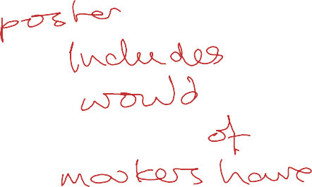



Comments:

