

Program Name – MBA International Business
Student Name- Parth Shaileshbhai Solanki
STUDENT I’D -2429347
Module Name – MARKETING MANAGEMENT
Module Code – LCMB7024
Lecturer- Dr Haoran Liu
Word Count – 2630

Submission Date – 28 March

Analysis of Pioneer and Follower Advantages and Product Life Cycle Strategies
Table of Contents
Introduction 3
Section 1: Advantages of Pioneering 3
Section 2: Advantages of Following 5
Section 3: Product Life Cycle Strategies for Pioneers 6
Section 4: Product Life Cycle Strategies for Followers 8
Conclusion 9
References 11

Introduction
When it comes to market entry with new products or technologies, companies need to make no better strategic decision than when to enter the market. This is a fundamental choice: Do we venture into a blank field or play on someone else’s farm in an established player’s backyard? The impact of this choice on a firm’s ability to compete, resource allocation, and ultimately sustainable existence is gigantic. Market pioneers might enter uncharted territory and have the prospect of attaining huge first-mover advantages, but they also run great risks. For their part, followers penetrate pre-existing markets, levering off the experience of predecessors' blunders and of having a harder sell in an increasingly crowded market. This strategic choice is meaningful beyond just when the company chooses to enter the market; it drives matters of marketing strategy core to a company, such as product development priorities, pricing models, distribution channels, and promotional approaches.
In this essay, we assert that if the strengths and the ‘internal’ capabilities of the company are aligned with market conditions, the strategy, and the goals the combination produces the outcome that we term ‘leveraged pioneer’ and ‘leveraged follower’ and that these yield remarkable success when properly positioned within a company. Apple’s unprecedented rise in the iPhone shows the importance of pioneering and Samsung’s dominant role in the smartphone market reflects the distinction of second-place followers, which would command much market share and revenue. Both approaches are viable providing their possible technological complexity, market uncertainty, competitive intensity and organizational resources.

Section 1: Advantages of Pioneering
Definition of market pioneers/first-movers
They are called market pioneers, or first movers, organizations that bring to the marketplace new or novel products, services and business models before every other one (Halberstadt et al., 2022). Usually, these companies have poured some money in R&D just to create innovative offerings that cover up customer need gaps or create new markets from scratch. However, market uncertainty brings about great risks for pioneers; they are taking risks, and there is a price to pay for this, but if their innovations prove successful, then the advantages that they gain are immense.
Key Advantages of Pioneering
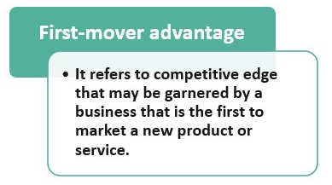
Figure 1: First-mover advantage (Source: Kosha, 2022)
First-Mover Advantage:
First-mover advantage is a term that refers to the set of benefits that are enjoyed by pioneers by way of their being the first ones to market (Chavez, and Chen, 2022). Other key factors include acquiring initial market share leadership, creating early adopter switching costs, as well as securing perks when acquiring a limited resource.
Brand Recognition and Reputation Benefits:
Such a “pioneer identity” allows for a long-lasting consumer association that future market entrants are hard put to replace (Lytle, 2023). In the electric car market, Tesla shows this advantage as with increasing competition the brand is still essentially the only name in mind for premium electric vehicles. Despite the increase in competition, this brand recognition gave this company a remarkable 65% market share in the U.S. electric vehicle segment in 2022 (Hopkins and Lazonick, 2024).
Setting Industry Standards:
According to market pioneers, they tend to set technological standards, user interface conventions, and business practices that not only guide the industry’s development but also influence and clash (Palmer et al., 2022). This powerful competitive advantage is that it allows followers to either comply with established standards or convince consumers to adopt ‘different’ approaches. This is best seen in Apple’s iOS mobile operating system which sets the expectations of what the user experience should be and competitors have to consider this when developing their own. Spotify is another internet company, which pioneered a music streaming subscription model that has quickly become the industry standard, thus leaving most of the competitors, or even new entrants following Spotify’s footsteps when entering the market (Lee, 2025).
Examples of Successful Pioneers:
Several contemporary companies are successfully benefitting from market pioneering:
In 2007, Apple really revolutionized the smartphone industry with the iPhone in 2007 which combines telephony with computing, thereby opening the smartphone to follow the touchscreen smartphone paradigm pioneered by Apple (Blahnik, and Schindelbeck, 2021). Benefiting from Apple's pioneering approach, it has been able to reap about 57% of industry profits whilst having only about 20% of the market share.
Amazon was the retail leader in transforming retail through its pioneering e-commerce platform and remains the leader in cloud computing through Amazon Web Services (Carreno, 2024). Amazon set the bar for customers’ convenience, variety, selection and delivery speed by pioneering online retail at scale and many are still trying to catch up.
Tesla completely turned electric cars on their head, by pioneering the creation of long-range, high-performance, electric cars with premium design elements (Daylan, 2023). Tesla may be a relatively new entrant in the automotive industry, but it has taken an innovative attitude to electric vehicles that has forced traditional automakers to fast-track their own electric vehicle development programs.

Section 2: Advantages of Following
Definition of market followers
Enterprises that follow the market are known as market followers which means that such companies come into a market after some pioneers have done things: opening product categories, proving for market’s viability, and educating consumers (Sulaiman et al., 2024). In contrast, followers copy, instead of creating, new markets, they analyze existing products by searching for improvement points and creating new, competitive products that eliminate pioneer weaknesses and fill uncovered market niches.
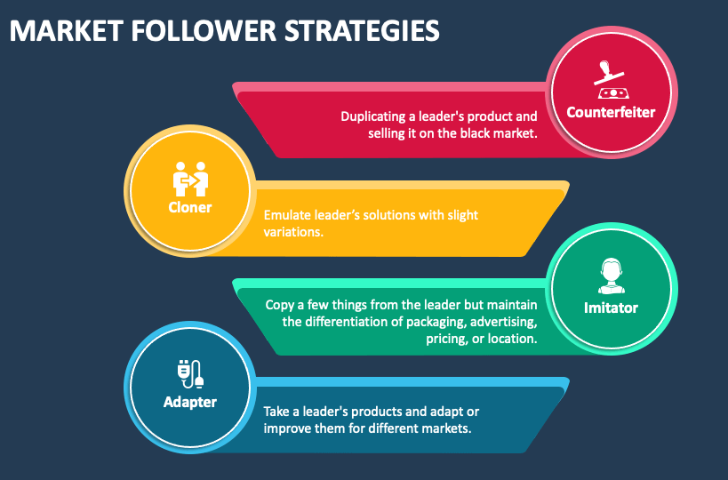
Figure 2: Market follower’s strategies (Source: Cammarano et al., 2023)
Key advantages:
Learning from Pioneers' Mistakes:
The substantial advantage of followers of the market lies in the fact that they can watch the pioneers’ missteps and limitations. However, following this observational learning allows followers to make error-free tagging in product design, market positioning, pricing strategies, and various distribution. Samsung paid attention to early pioneers of smartphones up to the time, like Apple, and discovered the opportunity there in bigger screen sizes and more features that Apple neglected (Cammarano et al., 2023).
Lower R&D Costs:
Typically, pioneers incur much higher research and development expenses than do followers. Followers analyze existent products and allocate their R&D investments to optimize innovation efforts by concentrating on some specific improvements instead of spending resources on the core technology. Microsoft applied this beneficial advantage to the game console market: the company researched what was available in the market and designed its offer in terms of what it considered important to improve.
Reduced Market Uncertainty:
The environments that market followers enter are considerably less uncertain than the ones that pioneers enter. Through the experience of the pioneer, the risk exposure of the follower has been reduced on the dimensions of market size, customer preferences, pricing elasticity and distribution requirements. Its entry into the ridesharing arena after one of its major competitors, Uber, had planted the seeds of the concept demonstrates this advantage, in that Lyft would have been able to compete with greater certainty concerning ones that potentially exist in the marketplace, the nature of any regulatory challenges that may arise, and strategies that would need to be employed to secure drivers and riders (Bednar et al., 2022).
Examples of Successful Followers:
When Apple created the smartphone sector, there was only one player in the game, and Samsung came into the game later, very early in the game Samsung caught quite a good part of the market, gaining market share because they could provide a wide variety of models in terms of price, they had bigger screens, and it had a lot of customization options that Apple was not willing to get into at that time. Samsung will gain an approximate 20% piece of the global smartphone market by 2022, for shipping more units than any other manufacturer (Alam, 2022).
While following Apple into the personal computer operating system arena, Microsoft followed in Apple’s footsteps in achieving a dominating market share using strategic partnerships with hardware manufacturers. Also, Microsoft's Xbox caught onto the momentum the PlayStation had generated with Sony's and Nintendo's gaming consoles by opting for online multiplayer gaming and securing exclusive game titles.

Section 3: Product Life Cycle Strategies for Pioneers
Introduction to product life cycle model
Conceptual framework about the product life cycle model which involves the phases of a product life cycle that is Introductory, Growth, Maturity and Decline. However, this model offers important strategic direction, which should be critically assessed because product trajectories have never been more compressed and non-linear categories. Gradual progression from step to step in defined stages has surrendered to the prevalence of increasingly rapid acceleration in, premature maturation of, and strategic rejuvenation from, these steps.
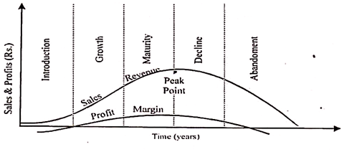
Figure 3: Product life cycle (Source: Gerling, and Krautkrämer, 2021)
Growth stage strategies for pioneers:
Pioneers launch these critical strategies during the growth stage when they face fast-growing sales velocity, face new or emerging competition and attempt to capitalize on their early position while erecting barriers to other competitors.
Rapid Market Penetration
At growth stages, pioneering companies choose to undertake market penetration levels aggressively to get a hold of the market first before competitive gains enter the picture. Rapid growth by young, ride-sharing pioneer Uber is a typical example of the approach: The start-up opened in 65 countries in its first six years, operating at a loss to gain a foothold in a market, before turning profitable. This strategy enables the pioneers to instantiate network effects and economies of scale thus creating very challenging barriers to subsequent market entry.
Brand Reinforcement:
Pioneers invest heavily in building brand during growth stages to associate the brand and the category continuously in consumers’ minds. This strategy is evident in the way GoPro marketed during its growth stage as the company produced massive user generated content campaigns that forced them to be synonymous with the definitive action camera (Gerling, and Krautkrämer, 2021). Pioneers also create cognitive barriers that followers must overcome to get consideration by establishing this strong category association.
Implemented Strategies by Pioneer Companies:
As a streaming video pioneer, Netflix is a comprehensive product lifecycle management company. During the growth stages, the company was driven to make a quick international expansion and bid for content licensing agreements before the competition entered the market. When the streaming market developed, Netflix decided to begin producing original content and had a more refined segmentation strategy of delivering tailored content recommendations to users based on their viewing history (Ahmed, and Abdulkareem, 2023). With exclusive content and technical improvements that keep it looking like offering value to the viewer, the company keeps defending itself against followers through innovation and technology that continues to counter increasing competition from services like Disney+, HBO Max, etc.
Like Apple, the iPhone case shows how the management of an iPhone through its lifecycle can be used to implement good pioneering strategies. During the growth period, Apple’s strategy was based on patent protection, branding, and ecosystem development (Shabdanov, 2023). However, as smartphones matured, Apple had more sophisticated product line extensions (i.e., Pro, Max, SE models, etc.), addressing various price points and user needs.

Section 4: Product Life Cycle Strategies for Followers
Growth Stage Strategies for Followers
During market growth phases, follower companies apply different strategic approaches which are focused on the differentiation, cost advantage and the targeted market positions that can offer alternative viable offerings compared to pioneer offerings.
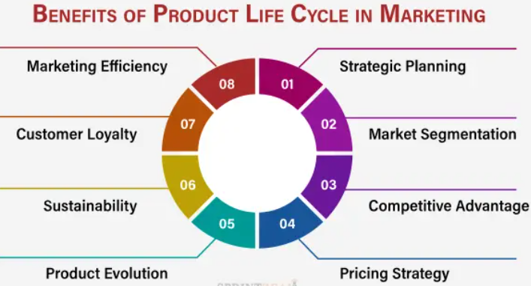
Figure 4: Product life cycle for followers (Source: Li, 2024)
Differentiation from Pioneers:
Successful followers find ways to create clear points of differentiation that address Pittsburgh and pioneer limitations or unserved market needs. This is exactly what OnePlus has done in the smartphone market, offering premium specifications in the mid-market price range, thereby establishing itself as a 'flagship killer', a place to lure tech-savvy consumers who do not want a product with a premium price tag.
Cost Leadership:
Many also take advantage of the later market entry to gain cost advantage through manufacturing efficiencies, supply chain optimization and R&D reduction. For consumer electronics, Xiaomi shows this approach by developing high-quality smartphones, televisions, and smart home devices at a fraction of the price of the pioneers (Li, 2024). This leader provides the cost so that followers can attract price-sensitive segments that will refuse pioneer offerings due to the unreasonableness of price.
Market Niche Focus:
This means that followers target markets where pioneers have approached them broadly. In the streaming device market, Roku follows this strategy and is completely dedicated to inexpensive, user-friendly streaming hardware while competitors such as Apple have tried broader, high-priced strategy. However, allowing Apple, Google, and Amazon to enter the streaming device market while Roku took a focused approach, it still achieved 39% of the streaming device market share in 2023 (Coelho, 2023).
Improved Product Features:
Follower companies analyze Pioneer offerings by looking for opportunities to improve its functionality, usability and also performance. An early example of this is Samsung's early Galaxy Note smartphones for which the screen was more than twice as big as with iPhone and it had a stylus. Followers address specific feature limitations of a pioneer product and propose compelling value propositions to the segment that cares about these capabilities the most.
Implemented Strategies by Follower Companies:
Samsung’s comprehensive approach how to tackle the smartphone market is best manifested through their use of their products for both the early product innovation phase as well as the squeegee phase of the product life cycle. Samsung became differentiated during the growth stages with larger screens, removable batteries and larger storage options than that already present on Apple's iPhone (Hamatake, 2024). They used manufacturing scale advantages to get cost efficiencies while vigorously marketing these differentiating points. When the smartphone market matured, Samsung did a sophisticated segmentation based on its Galaxy S, Note, A, and M series that addressed different price points and user requirements (Hamatake, 2024). This company is still looking for some segments that are untapped while it is developing foldable smartphones that open another premium category.
Microsoft’s Xbox strategy is an example of an effective follower approach in the game console market. What helped Microsoft stand out, entering after Sony had defined the category, was superior online gaming features, and savvy acquisitions of the strategic game studios. In the case of market maturity, when there has been no innovation in the market space and rules, they implement innovative business models such as Xbox Game Pass that provide access to hundreds of games and create recurring revenue streams and platform stickiness.

Conclusion
This is an analysis of pioneer and follower strategies that shows both have the potential to bring market success when appropriately coupled with organizational capabilities, market conditions, and strategic objectives. Companies like Apple, Amazon and Tesla, for example, leverage such advantages as brand recognition, brand setting, premium pricing and learning curve benefits to gain a lead. For example, followers lower R&D costs, reduce market uncertainty, gain improvement opportunities, and reduce customer education costs as in Samsung, Microsoft, and Zara.
Correct product life cycle management is critical to determine which approach will succeed or fail. Growth stage strategies must be implemented by pioneers to first perform rapid market penetration, brand reinforcement, patent protection, and continuous innovation and then maturity stage strategies with product line extensions, market segmentation and protecting against followers. Growth strategies are implemented by successful followers based on differentiation, cost leadership and niche focus, then maturity with price competition, service excellence and process innovation.
The strategic choice of pioneering versus following is optimal under several contextual factors. In situations characterized by a strong patent protection potential, significant learning curve benefits, as well as high customer switching costs it significantly pays off to pioneer. Organizations that have many resources, including R&D capabilities, risk tolerance, and market education resources, also succeed in pioneering. On the contrary, the approach indicated by the following applies when this market uncertainty is high, there is rapid technological evolution, pioneer offerings have clear limitations, or when the organization has high operational efficiency and strong marketing capabilities but modest R&D resources.

References
Ahmed, A. and Abdulkareem, A.M., 2023. Big data analytics in the entertainment Industry: audience behavior analysis, content recommendation, and Revenue maximization. Reviews of Contemporary Business Analytics, 6(1), pp.88-102.
Alam, S., 2022. Reviewing the global smartphone industry strategic implication in response to COVID-19 situation. International Journal of Interactive Mobile Technologies, 15(14).
Bednar, V., Qarri, A. and Shaban, R., 2022. Study of Competition Issues in Data-Driven Markets in Canada. Ottawa: Vivic Research for Innovation, Science and Economic Development Canada. January. Online at https://vivicresearch. ca/work/study-of-competition-issues-in-data-driven-markets-in-canada.
Blahnik, V. and Schindelbeck, O., 2021. Smartphone imaging technology and its applications. Advanced Optical Technologies, 10(3), pp.145-232.
Cammarano, A., Varriale, V., Michelino, F. and Caputo, M., 2023. Employing online big data and patent statistics to examine the relationship between end Product's perceived quality and Components' technological features. Technology in Society, 73, p.102231.
Carreno, A.M., 2024. Analyzing Amazon's Evolution from an Online Bookstore to a Global Tech Giant.
Chavez, D.E. and Chen, H., 2022. First-mover advantages and innovation success: A contingency approach. Journal of Business & Industrial Marketing, 37(6), pp.1169-1181.
Coelho, C.D.A.S., 2023. User Experience, Business Models, and Emerging Technologies Within the Video Streaming Platforms Industry.
Daylan, A., 2023. Examining the Disruptive Innovation Theory by Analysing Tesla, Inc.
Gerling, W. and Krautkrämer, F., 2021. Versatile Camcorders. Looking at the GoPro Movement (Vol. 2). Kulturverlag Kadmos.
Halberstadt, J., Kollhoff, S., Kraus, S. and Dhir, A., 2022. Early bird or early worm? First-mover (dis) advantages and the success of web-based social enterprises. Technological Forecasting and Social Change, 181, p.121784.
Hamatake, J., 2024. The Complexity of Choosing Sustainable Smartphone Options in the Face of Planned Obsolescence: An Exploratory Study of Smartphone Consumer Behaviour.
Hopkins, M. and Lazonick, W., 2024. Tesla as a Global Competitor: Strategic Control in the EV Transition. Institute for New Economic Thinking Working Paper Series, (225).
Kosha M., 2025. First Mover Advantage. [Online] Available at: https://www.wallstreetmojo.com/first-mover-advantages/
Lee, B.K., 2025. Digital Product Management: Strategic Planning and Market Opportunity. CRC Press.
Li, R., 2024. The Future Development Prospects of Xiaomi Corporation: Based on Financial Analysis and Comparison. Advances in Economics, Management and Political Sciences, 98, pp.110-117.
Lytle, M., 2023. Subduing the Wolf: Utah Pioneer Identity and the War on Wolves Between 1852 and 2020.
Palmer, M., Toral, I., Truong, Y. and Lowe, F., 2022. Institutional pioneers and articulation work in digital platform infrastructure-building. Journal of Business Research, 142, pp.930-945.
Shabdanov, B., 2023. STRATEGIC ANALYSIS REPORT ON APPLE INC. Journal of Entrepreneurship & Innovation, 15(15).
Sulaiman, M.A.B.A., Asad, M., Awain, A.M.S.B., Asif, M.U. and Shanfari, K.S.A., 2024. Entrepreneurial marketing and performance: contingent role of market turbulence. Discover Sustainability, 5(1), p.492.

