
Skills for the Workplace
Module Assignment Submission
Student Name: | Christy Leigh Mainwaring
Student Number: | 2006768
Module No: | BMSK4006
Module Title: | Part 1 Business Plan

Statement of Confirmation of Authenticity
By the act of making this submission, the student declares that this is the work of the student named above. The work has not, in whole or in part, been knowingly presented elsewhere for assessment, or where assessment has been built on a previous assessment, this has been identified. Where materials have been used from other sources it has been properly acknowledged. If this statement is untrue, the student acknowledges that an assessment offence has been committed.
Attention is drawn to the plagiarism and unfair practice policies of both the University and of ILM.

Table of Contents
Title Page 3
Executive Summary 4
Business/Industry Overview 4
Market Analysis and Competition 5
Sales and Marketing Plan 5
Product or Service Offerings 5
Pricing Strategy 5
Sales and Distribution 5
Advertising and Promotion 5
Ownership and Management Plan 6
Operating Plan 6
Financial Plan 6
Appendices 7

Business Name: Sweet Surprise Wales
Date: (official start date 20th of Feb 2021).
Business Address: 56 Ynys Las, Llwynhendy, Llanelli, Dyfed, SA14 9BT
Phone: 07307611926
Website: Instagram and Facebook page (SweetSurpriseWales).

Executive Summary

Who and what is Sweet Surprise Wales I hear you say? We are a company that believes in the passion and joy that brings confectionary to people. On a cold and miserable day in February, I had the brilliant idea of going to Tesco to buy myself a bag of pick n’ mix sweets, sadly to see that due to COVID, they had to close it down. Sad to see that happen, I had the bright idea of well, what if I buy these sweets in bulk, and send them out to the people who I love, my friends and family. Sending these sweets to them, I will see their faces brighten up to what I was about to give them. So, then I thought, let’s see if I can sell these sweets and what competition do I have out there. I was shocked to see that shops that sell sweets had to close down due to COVID, and that the nearest place selling pick n’ mix sweets were now based in Cardiff, miles away from Llanelli. I have a reliable source where I have my shipment of sweets weekly and have a fantastic relationship with them now. One of the main things I wanted to ensure that the packaging would be eco-friendly. Having looked high and low for different sources of packaging in the market I came across the brilliant and bright packaging that I use for the sweet bags currently. I am a one-man band currently, and am working in my very own home producing a high standard of product. My mission with Sweet Surprise Wales is that it will only grow larger in size. On the way I would like to bring in a employee, and eventually have a unit somewhere around Llanelli selling these wonderful bags of sweets. Going into the financial side of things, I do currently have a loan from the Welsh government that support small businesses such as mine. Having done some sales in the last few months, my predictions a year from now that the business will be worth £124k. The brilliant thing about my business is that it caters to the young and older generation. In the pipeline I am currently talking to my supplier to cater for special dietary requirements such as GF and Vegan sweets.

Business/Industry Overview

Sweet Surprise Wales was established in 2021 in hope to bring a little bit of joy in people’s lives. At the height of a lockdown, there is nothing better than to dig into a big bag of pick n’ mix sweets to remind you of the good old days when Covid didn’t exist. This company is catered to all ages. To the 60+ enjoying rhubarb and custard sweets, to the little ones enjoying a sugar rush from the Haribo’s range, there really is something for everyone to smile about with Sweet Surprise Wales.

In this business we have a very small team, me. As the sole trader I have the hands-on approach to all the business. I sort all the paperwork, the money logistics to the delivery of the sweets themselves. If there is anything that you need to know, I have all the answers. Eventually I do see the business progressing by employing someone to join the team by bagging the sweets and delivering them as well. With being the sole trader, I do not pay anyone, and I have entitled myself to any earnings of the sweets. In my business plan you will be able to see how much profit I make in the sweet bags further on.

As a sweet company we have fallen into the hospitality industry. This industry is very wide with people owning restaurants, to the people baking birthday cakes in their own homes. Sweet Surprise is a company that has the same traits as what a big restaurant in London would aim to do. To bring quality service to customers to bring the best satisfaction as possible. I have 10+ years of experience in the hospitality industry. I have the qualifications and skills that other sweet companies do not possess that will give customers wanting more and more. I know from experience that the hospitality industry can be extremely competitive. I have noticed that due to COVID-19 that other people have had the same idea as me during the lockdown. The gap in their market is that they do not have the qualifications and traits that Sweet Surprise has.

A key focus I wanted to come out in my business is that it is a Welsh brand. Being a Welsh speaker, I have decided to incorporate the language in each post that I do on Instagram and Facebook. This differs from the other companies as their sole focus is to just display their products on social media. I want my customers to know that it is a small but passionate Welsh business.

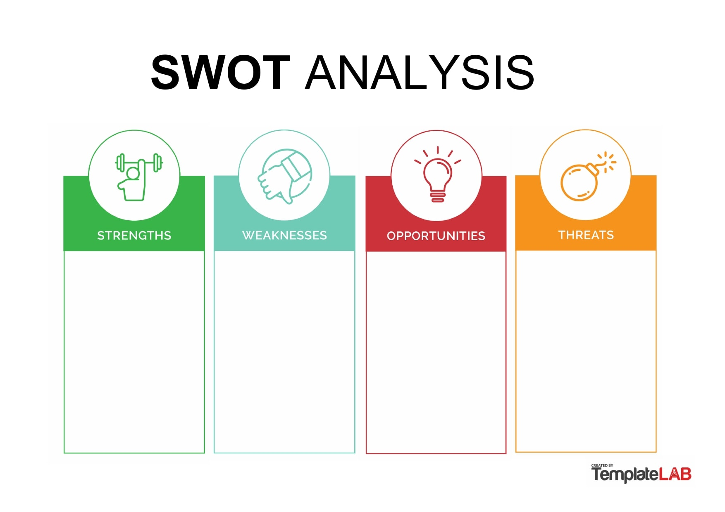
Other people might have the same idea.
Could have a lot of competition.
Since opening we have had offers for supplying other stores with our sweets.
We are a positive, skilled company with ambition and drive.
A number of people already following our social media pages.
Need more assistance with marketing.
The business isn’t a year old yet. People might fray away from that.
Need more reviews.

Market Analysis and Competition

Many people during lockdown have decided to do their own sweet businesses up, I will have to stand out to the rest to achieve the best sales in my area. The modern consumer usually has their own phone in their pockets. The 21st century has made shopping easier. Having thousands of different products available has made us spoilt for choice! According to an article written by M, Djordjevic (Jan 19th, 2021) “experts expect online sales projections to hit $145.8 billion by 2023”. Shop such as Topshop the last year has now decided to only trade online.

I have decided to start up with social media. I have created a Instagram and Facebook page to sell my sweets. With a predicted estimate of “2.85 billion people using Facebook in 2021” H, Tankovska (May 21st, 2021) my best bet to sell my product successfully is through social media.

Below is a link to the Facebook and Instagram page for SweetSurpriseWales.

https://www.facebook.com/sweetsurprisewales https://www.instagram.com/sweetsurprisewales/

Having done my research I have come across many sweet companies such as KandyKing, We pick you mix and more. I knew from the start that there is such a market for pick and mix sweets. However, I couldn’t find any close in proximity near where I live (Llanelli). I did find a store close to my location called The American candy store. They only sell sweets from America, would their sweets fit in the age category as the 60+? I doubt it. Now I will need to find a supplier to buy my sweets from.

Sales and Marketing Plan

As said previously I will be selling on social media through Facebook and Instagram. However, I have considered that there will be some gaps in my profit due to this. I will consider a graphic designer down the pipeline to create posters and business cards to put in small local shops so that they can discover my social media and website. This will increase my sales to the individuals that do not have access to social media. The group I am targeting right now are in early teens to the 50’s. I would like to increase the age as I do know that there are people in the older age category that would buy from my business.

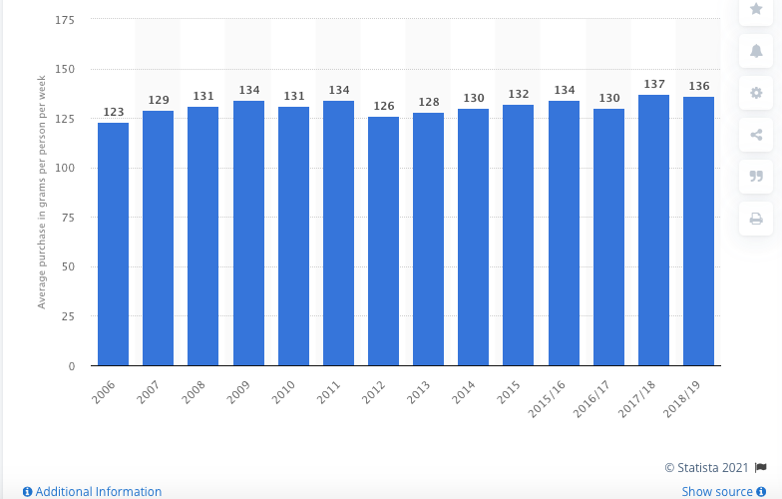
Below is a graph from Statistica of the average purchase per person per week of confectionary in the UK (2006 to 2019). This research was conducted by N, G. Wunsch (December 11th 2020). The graph shows consistency of how sweets and chocolate are always in demand in the UK and that there will always be a market in the industry. In 2018/2019 an average household eat around 136 grams of sweets per week. A 500g bag that we produce would last a household approx. around a three-week turnaround basis, (if they last that long). That’ll average that per month they will need to buy four 500g bags, making them spend £1,080 per household per year.

Product or Service Offerings

Our sweets and service differ from the rest. As a small Welsh business, we stand out as we have experience in the hospitality industry. I have 5+ years’ experience in working in very fast paced environments, where the customers satisfaction is always the key priority. I want to take the wealth of knowledge I have in the industry and spread happiness through sweets and chocolate. I have been doing these sweet bags up for the last few months and nothing brings me more pleasure than seeing smiling faces. I have the skills and knowledge of what it takes to ensure a good practise. Cleanliness and hygiene standards are more now than ever important to the customer. I ensure a clean workplace, the correct PPE, and the right paperwork is shown to the relevant persons. Due to COVID slowing down the prosses of having the health and safety officers out to see the workplace, I am due a check. I am confident that I will achieve a 5-star rating. What I am proud to show is that I am a passionate Welsh speaker, I have not come across a sweet business in Wales that display the same passion as I do. I like to add the language in the posts that I share. It is also a reason as to why I added the “Wales” part in the Sweet Surprise. To show the customer that the product that they choose to buy is from Wales.

Pricing Strategy

To price my product properly I had to research all different companies that supplied the sweets that I wanted to sell. Below is the amount I had to pay to have a full stock of sweets. For a business like mine I must consider the price of shipping and tax. Tax for sweets have gone considerably higher the last 10 years due to the sugar tax fee they charge on top now. Now that I know how much the product cost, I will now have to find different packaging solutions to make the sweets have the “WOW factor”. I found the best packaging for my business. I also wanted my business to be as eco-friendly as possible, so to have recyclable packaging meant a lot from the very first thought of Sweet Surprise. The price for the packaging bags are £106.68, but with tax added makes it £128.02. So with the sweets and the packaging the overall cost for myself would be £297.61.

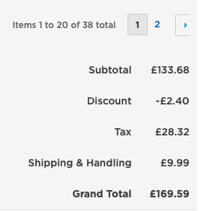
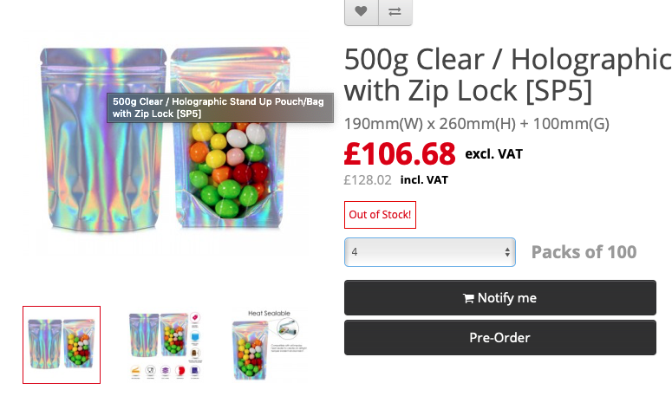

Packaging = £128.02 (including VAT)

Divide by 100 = £1.28 per bag.

Sweets = £169.59 (including VAT)

By weight to make profit there would be an estimate of £4/5 worth of sweets in each bag.

That makes the total cost of the product £6.28. To ensure profit is made I will charge for the sweet bags £10.

Sales and Distribution

With the product and pricing shown, how will they go to the customer I hear you ask. Well as I have a clean driving license with years of experience, I will be delivering the sweets, also providing postal. There is an option for the customer to come and collect their sweets from the business premisses. On average I have to fill my car up around £35 in petrol a week. With collection it is free. The cost of sending out the sweets will cost the customer an extra £3.40 on top of the sweets themselves. The bags that the sweets are wrapped in are airtight and travel safe. I have sent out many bags out, even to someone in Italy, and they weren’t damaged. Further down the pipeline I would like to have a unit somewhere to have more storage and a postal man collecting the sweets to be posted daily. Payment methods for the sweets will either be through bank transfer or the simple way, cash.

Advertising and Promotion

I started the business in February in the height of a lockdown. I wanted to start the business with a bang and decided to create a giveaway of the sweets. The giveaway would be on Instagram and Facebook. To enter the competition you had to share, comment three friends on the post, and like the post. This ensured that more and more people would see that the business was fresh and new and something that they definitely would like to engage with. A wonderful thing that Facebook now can do is show how many interactions your posts on Facebook have on your business. On the highest viewed post, I had 8 thousand people looking at the post. With that one post on Facebook I had a total of 48 orders. £480 worth, making it’s a profit of £182.39. Which doesn’t sound like a lot. Put one post became another 15 in that month, making sales double and triple overtime. Social media is what I use currently, when the business will become larger advertisement will increase through ads in new articles and posters in corner shops to increase sales. I have planned for the one year anniversary that I will be dotting around Llanelli small bags of sweets to be found for people, and once found they need to take a picture to be within a chance of winning a big bag of pick and mix sweets.
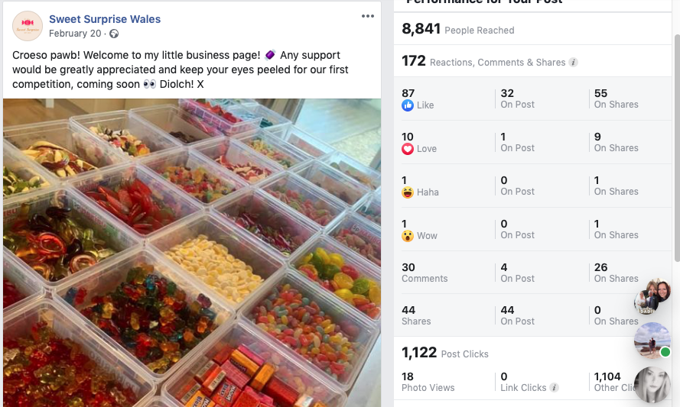

Ownership and Management Plan

I started this idea by myself. I am the sole trader of the business. As time goes on I will want to employ some people to come and pack orders, and deliver them to peoples home. In the cash flow chart there is leeway to employ staff.

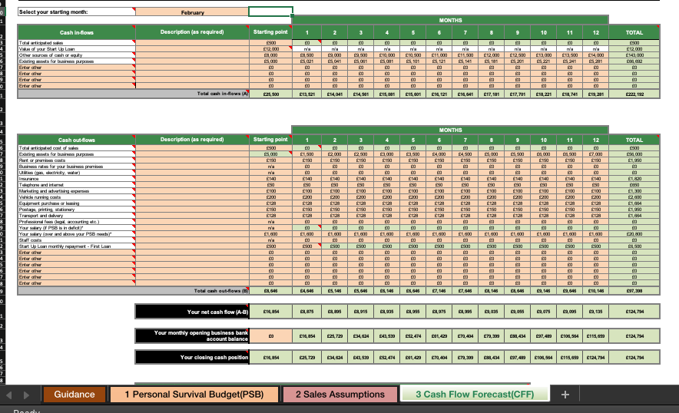
Financial Plan

Above is what I predict that Sweet Surprise wales will earn in a 12 month forecast. In the spreadsheet it covers the costs of which I have to pay, and the loan I have borrowed from the bank. As a sole trader many banks have offered various kind of loans on offer. There are a number of factors that needed to be considered during the application of a loan. Covid-19 had detrimental affects to some businesses throughout the pandemic. The grant that is from Business Wales, which is supported through the government. The grant is paid into the holders account in two lump sums. The government then calculate a total of 80% of the business’ trading profit, they do however cap the money at £7.5k. These grants need to be considered in the National Insurance scheme.

A | Estimated costs | Monthly cost (£)
A | Mortgage/rent | 150
A | Council tax | n/a
A | Gas, electricity and oil | 45
A | Water rates | 30
A | All personal and property insurances | 60
A | Clothing | 30
A | Food and housekeeping | 200
A | Telephone | 33
A | Hire charges (TV, DVD etc.) | 20
A | Subscriptions (clubs, magazines etc.) | 10
A | Entertainment (meals and drinks) | 50
A | Car tax, insurance, service and maintenance | 60
A | Children's expenditure and presents | n/a
A | Credit card, loan and other personal debt repayments | n/a
A | National Insurance | 170
B | Total costs (£) | £858.00
C | Estimated income | Monthly income (£)
C | Income from family/partner | 2400
C | Part time job | n/a
C | Working tax credit | n/a
C | Child benefits | n/a
C | Other benefits | n/a
D | Total income (£) | £0.00
E | Total survival income required (£) | £858.00

Appendices

C, Mainwaring (February 19th 2021) {online Facebook and Instagram page} https://www.facebook.com/sweetsurprisewales https://www.instagram.com/sweetsurprisewales/
H, Tankovska (May 21st, 2021) {online article} Monthly Active users on Facebook https://www.statista.com/statistics/264810/number-of-monthly-active-facebook-users-worldwide/ accessed on 27th of June 2021.

N, G. Wunsch (Dec, 11th 2020) {online graph} Weekly Household Consumption of Confectionery in the UK. https://www.statista.com/statistics/284521/weekly-household-consumption-of-confectionery-in-the-united-kingdom-uk/ accessed on 28th of June 2021.

M, Djordjevic (Jan 19th, 2021) {online article} Online shopping Vs In-store Shopping https://savemycent.com/statistics-on-online-shopping-vs-in-store-shopping/ accessed on 27th of June 2021.
Welsh Government {online article} Support for the Self Employed. https://businesswales.gov.wales/coronavirus-advice/support/support-self-employed accessed on 29th of June 2021.

Christy Leigh Mainwaring
23 Lletty Road! Llanelli, Dyfed, SA14 6BN
Phone: 07397 379455! E-Mail: christyleeigh@gmail.com

Experience

I was a part time waitress in busy restaurant. My duties included preparing and serving food, taking customer orders, preparing their bills and cleaning. As I dealt a lot with customers I have gained excellent
communication skills, am friendly, courteous and polite at all times as it is an important part of my role to ensure that the customer has a first class and pleasurable dining experience. I am able to work on my own and as part of a busy team.
During my work experience while at school I worked in a bakery for a week. I gained many skills such as time keeping, customer service, insuring orders were correct and prepared in a timely fashion, checking the diary on a daily basis as well as ensuring the ingredients were weighed accurately. I used my creative skills in decorating the cakes, which gained many compliments. I was also responsible for creating a window display to reflect the Easter period which I thoroughly enjoyed and improved my creative skills.
I have gained three years of experience working within a busy reception at a beauty salon. During this time it as challenging at times, during any mix up’s of over booking around Christmas time for example. This challenged me, and it put me in a position where everyone needed to act as a team. My duties also included producing a display for clients to come in and sample products. I also gathered a skill in this industry to take card payments and cash. During my time as a receptionist, the importance to have a clean area for clients to come in was very critical for them, and myself. I do believe I work better under pressure, and even better when there’s a clean and tidy environment.
I was also a part of a small team in a call centre based in Swansea. My duties included to take calls, ensure that all paperwork was organized. There were times that customers were very challenging on the phone, but my communication skills did improve during the time I was there.

Education

NVQ Beauty Therapy and Holistic Therapy – Level 1, 2 and 3. I have completed a few workshops as well. This includes my Dermologica triaining, in sales as well. I have also gained experience with a makeup and nail course.
I have also gained my qualification in Humanities and Social Scienes. During this access course I have gained qualifications in physiology, sociology, history, law and maths.

Maes Yr Yrfa 2008-2013
Drama - B
Art - C
English Language - C
English Literature - C
Welsh - C
Communication – Level 1

Communication- Dual Language – Level 1 & Level 2
Application of Number – Level 1 and 2
Information and communication technology – Level 1 & Level 2
Welsh Baccalaureate - Pass

Skills

Communication – dealing with internal and external customers through verbal and written form in order to ensure optimum business performance.

Problem solving- resolving queries in a methodical manner independently and with internal and external sources to find appropriate resolutions, efficiencies and high level of quality.

Team Player- enjoy sharing knowledge and encouraging development of others to achieve specific team goals.

Planning and organizing – refined planning and organizational skills that balance work, team support and general responsibilities in a timely and professional manner

Software skills - good working knowledge of office software Microsoft Word, Power Point and Excel. Inspiration, Sibelius and garage band. I am experienced at using the Mac operating system as well as Windows.

