

Program Name | Master of Business Administration
Module Name | International Business Concepts
Module Code | LCMB7034
Assignment title | Emerging Markets
Lecturer | Jean Wang
Student Name | Piyush Bablubhai Luhar
Student ID | 2436044

Contents
1 — Introduction 3
2 — Benefits and Challenges of International Operations 4
2.1 Coca-Cola as a Multinational Corporation (MNC/TNC) 4
2.2 Nature of Coca-Cola’s Global Operations Across the Value Chain 4
2.3 Coca-Cola’s Entry Modes in International Markets 6
2.4 Key Benefits from Coca-Cola’s International Operations 8
2.5 Challenges Associated with International Operations 9
2.6 Table Summary: Benefits vs Challenges of Coca-Cola’s International Operations 10
2.7 Critical Synthesis 11
3 — OLI (Ownership–Location–Internalisation) Analysis for Coca-Cola’s Entry into China 12
3.1 Ownership Advantages (O) 13
3.2 Location Advantages (L) 14
3.3 Internalization Advantages (I) 16
3.4 Interaction of OLI Factors and Resulting Entry Mode 17
3.5 Critical Evaluation 17
4 — Cultural Differences and Their Impact on Coca-Cola’s Market Entry Strategy and Success in China 19
4.1 Key Cultural Differences Between the U.S. and China 19
4.2 Impact on Coca-Cola’s Market Entry Strategy 21
4.3 Cultural Impact on Organizational Success in China 22
4.4 Critical Evaluation 22
5 — Recommendations: SOP Adjustments for Coca-Cola in China 24
5.1 SOP Adjustment 1: Deep Localization of Product Development and Health-Focused Innovation 24
5.2 SOP Adjustment 2: Strengthened Digital Engagement, Data Governance, and E-Commerce Integration 26
5.3 SOP Adjustment 3: Enhanced Local Partnership, Governance, and Guanxi-Oriented Stakeholder Management 27
5.4 Critical Synthesis of SOP Adjustments 28
6 — Conclusion 29
Reference List 30
Appendix: 34
Coca-Cola annual reports 34

1 — Introduction
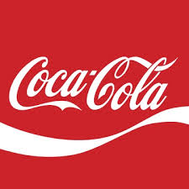
Figure 1: Coca-Cola Logo
(Source: Coca-cola.com)
One of the most globalized fast-moving consumer goods (FMCG) corporations in the world is the Coca-Cola Company (TCCC) which has over 200 countries of operation and makes over 70 percent of its profits in the international market (Coca-Cola, 2024). It has a footprint of an elaborate international value chain comprising of manufacture of concentrate, franchised bottling, distributed production systems and integrated marketing activities (Cavusgil et al., 2022). This consultancy report is a critical assessment of the international operations of Coca-Cola with special reference to China, which is an emerging economy, with big market potential, regulatory complexity, and unique cultural norms. The report critically examines the advantages and the disadvantages of global operations by Coca-Cola. It ends by providing evidence-based ideas on the strategic SOP changes that can enable Coca-Cola to enhance its long-term success in the China market (Bain & Company, 2024).

2 — Benefits and Challenges of International Operations

2.1 Coca-Cola as a Multinational Corporation (MNC/TNC)
The Coca-Cola Company (TCCC) is known to be one of the most globalized multinational branches in the world. TCCC operates in over 200 countries and is served by a complex system of franchised bottling outlets, which meet all of the defining aspects of an MNC: worldwide manufacturing, globally integrated distribution networks, cross-border ownership of assets, and multi-market strategic decision-making (Rugman & Verbeke, 2022). The organizational architecture of the company is considered very global but locally responsive, indicating the features of a transnational corporation (TNC) that provides international efficiency and the ability to adapt in the country (Hill and Hult, 2023). The hybrid global strategy that has a comparative advantage in various markets in the decentralized bottling system in the United States, which has an operating model, illustrates its global operations. This model makes Coca-Cola a paradigmatic MNC/TNC with the ability to attain economies of scale, scope and learning in international markets including the emerging economies like China (ARI, 2023).

2.2 Nature of Coca-Cola’s Global Operations Across the Value Chain
The global value chain involves interconnected operations of Coca-Cola that include R&D, concentrate manufacturing, worldwide branding, bottling regionally, marketing, supply chain and customer interaction. Its product-bottler-customer system (known worldwide) establishes a special division of labor wherein the Coca-Cola company specializes in core competencies, brand ownership, formulas, innovation, and marketing, whilst bottlers produce and distribute production and distribution capital-intensive products and services (Coca-Cola, 2024).
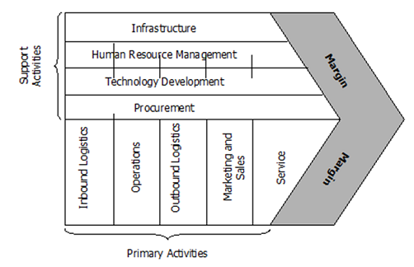
Figure 2: Porter’s Value Chain Model
(Source: Coca-Cola Company)
Table 1. Coca-Cola Global Value Chain Overview
Value Chain Stage | Activities | Globalization Characteristics
R&D | Product innovation, sweetener science, packaging innovation. | Centralized in US + regional innovation hubs (Japan, China, Mexico).
Sourcing | Sugar, aluminum, PET resins, flavors, carbonates. | Multi-sourcing from regional suppliers to reduce risk and cost (PwC, 2023).
Concentrate Production | Syrups and concentrates are manufactured in select global plants. | Highly centralized to protect IP and ensure quality control.
Bottling & Production | Bottling, packaging, distribution. | Decentralized franchised bottlers (e.g., COFCO Coca-Cola in China).
Marketing & Sales | Global brand messaging with local campaign adaptation. | “One Brand Strategy” adapted to local tastes and cultural nuances (Kotabe & Kwon, 2022).
Financing & Governance | Capital allocation, M&A, partnerships. | Global strategic direction from Atlanta headquarters.
This globally integrated yet locally responsive structure enables Coca-Cola to maintain brand consistency while adapting products to diverse cultural tastes (e.g., China’s “Fiber+”, Japan’s “Coca-Cola Plus”, India’s “Thumbs Up Charged”).
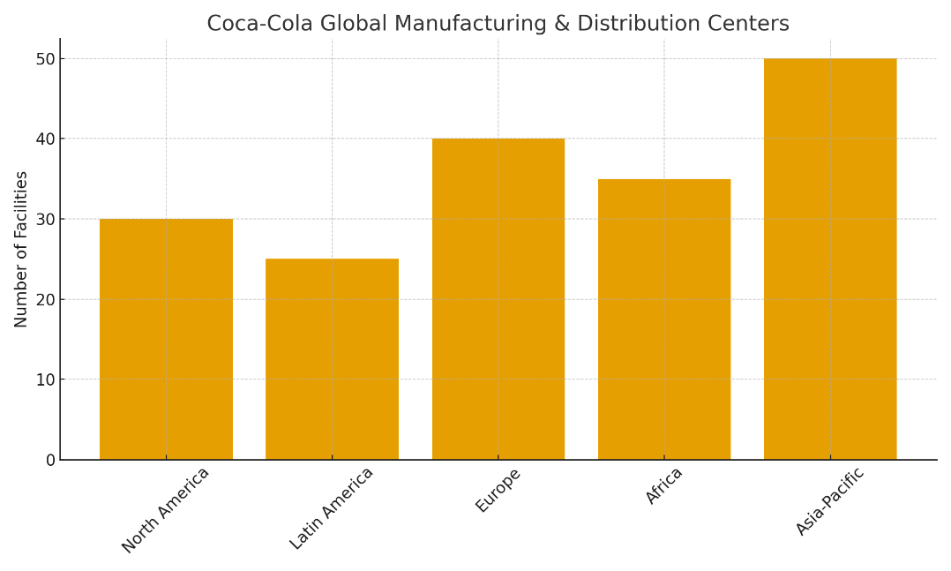
Figure 3: Coca-Cola Global Operations
(Source: Coca-colacompany.com)

2.3 Coca-Cola’s Entry Modes in International Markets
Coca-Cola’s international presence has grown through a combination of entry modes, including:
a) Foreign Direct Investment (FDI) through bottling acquisitions: Coca-Cola has repeatedly acquired and subsequently refranchised bottling operations to gain market control and restructure distribution. For example, in China, Coca-Cola invested heavily in the acquisition and later refranchising of COFCO Coca-Cola Beverages (Clark et al., 2022).
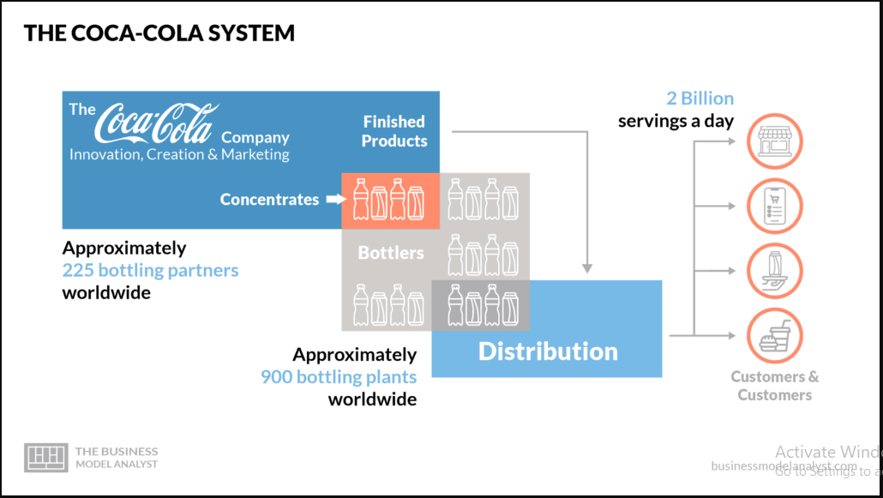
Figure 4: Coca-Cola Business Model
(Source: www.business model analyst.com)
b) Joint Ventures (JVs): JV partnerships have been crucial where local regulatory environments restrict full foreign ownership or where local market knowledge is crucial.
In China COFCO (state-owned enterprise) + Coca-Cola + Swire Pacific JV enabled compliance with Chinese FDI restrictions and provided privileged access to local distribution channels (KPMG, 2023).
c) Licensing and Franchising: Coca-Cola’s traditional model relies on licensing concentrate to locally owned bottlers. This remains its dominant entry mode globally due to high scalability and lower capital intensity (Hill & Hult, 2023).
d) Strategic Alliances: Alliances with McDonald's, Walmart and global retailers expand distribution reach and retail dominance.
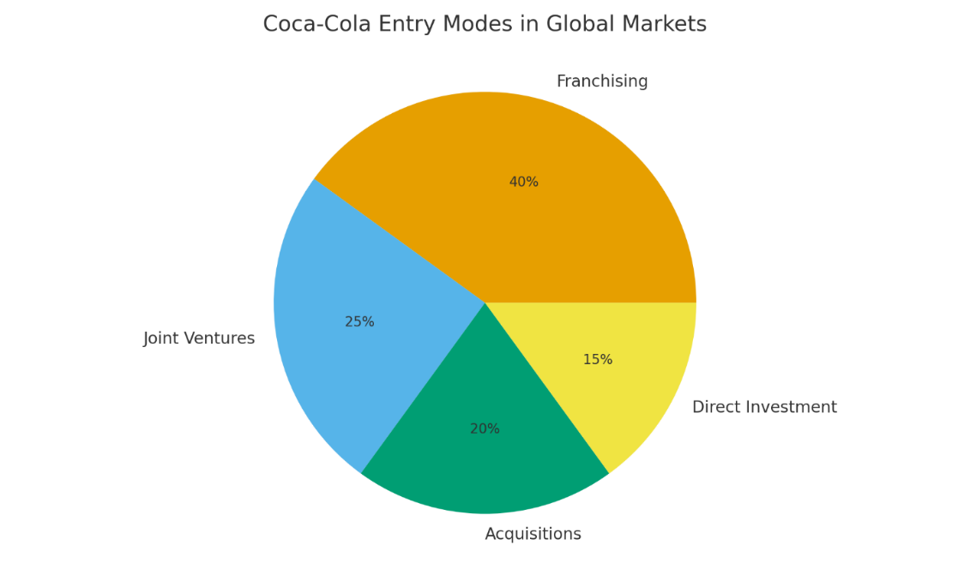
Figure 5: Coca-Cola Entry Mode In Global Markets
(Source: Self-Created)

Dominant Entry Mode: Globally, Coca-Cola’s dominant entry mode remains franchising/licensing to local bottlers, supported by selective FDI and joint ventures in strategically sensitive or high-growth markets. In China specifically, the JV–FDI hybrid model is dominant due to regulatory requirements and market scale (De Mooij, 2023).

2.4 Key Benefits from Coca-Cola’s International Operations
a. Economies of Scale and Scope: Coca-Cola is a global company, which minimizes the average production and marketing costs. Concentrate manufacturing is very scalable, which enables a uniform product to be distributed globally at a low marginal cost (Ghemawat, 2021). Scope economies are attained in the form of diversification of portfolios in various beverage categories (water, tea, coffee, energy drinks).
b. Availability of High-Growth Emerging Markets: China, India and southeast Asia are the most rapidly expanding non-alcoholic beverage segments in the world. China alone has over 25% of the total growth of soft drinks in the world (Euromonitor, 2024). The entry of Coca-Cola into such markets gives the company long term revenue.
c. Market Diversification of risk: Presence in 200+ markets also enables Coca-Cola to spread currency risks, supply risks, or regulatory risks (PwC, 2023). Weaknesses in the mature U.S and European markets are compensated by increasing consumption in the emerging economies.
d. Spillovers of Strategic Learning and Innovation: Coca-Cola can add to its innovation capabilities by operating in culturally diverse markets. For instance: The quick digitalization of China (WeChat payments, e-commerce) prompted the global integration of the digital consumer engagement by Coca-Cola (McKinsey, 2024). The vending machines ecosystem of Japan resulted in the packaging innovation that was later picked up by other regions of the world (Statista, 2024).
e. Greater Negotiation Power amongst World Suppliers: The global procurement platform of Coca-Cola provides the company with the opportunity to buy sugar, resin, cans, and sweeteners in large quantities, which help decrease costs and boost the resilience of the supply chain (Deloitte, 2023).

2.5 Challenges Associated with International Operations
i. Complexity of regulations and restriction of FDI: Emerging markets like China will need joint ventures and highly restrict the consumption of beverages, with restrictions including the use of the sweetener and the advertising prohibition (Zhao and Keith, 2023). Coca-Cola needs to continually respond to changes in the environmental, health and competition laws.
ii. Cultural and Taste Discrimination: The tastes and preferences of consumers differ significantly across markets. For example: The Chinese consumers are more partial to less carbonated and less sweet drinks (Euromonitor, 2024). Another factor that modifies products is the traditional flavors like herbal teas. Coca-Cola has been compelled to come up with localized drinks and this makes operations complex.
iii. Political and Geopolitical Risks: The dispute between the U.S. and China has heightened skepticism on the American brands. Coca-Cola is forced to deal with the possible reputational consequences, the nationalistic consumerism, and regulatory sluggishness (Chen, 2021).
iv. Vulnerability of the Supply Chain and Inflation: The world supply chains are also experiencing increased expense on sugar, aluminum, CO2 and disrupted logistics. The logistical challenge of emerging economies is the difference in infrastructure, climate risks and unpredictable distribution channels (Deloitte, 2023).
v. Sustainability Expectations and Environmental Pressures: Being one of the biggest plastic waste manufacturers, Coca-Cola can witness growing regulatory pressure by governments and non-governmental organizations (Greenpeace, 2023). The most recent policy of the aggressive Plastic Ban 2.0 by China obliges Coca-Cola to redesign its packaging and expedite recycling efforts.

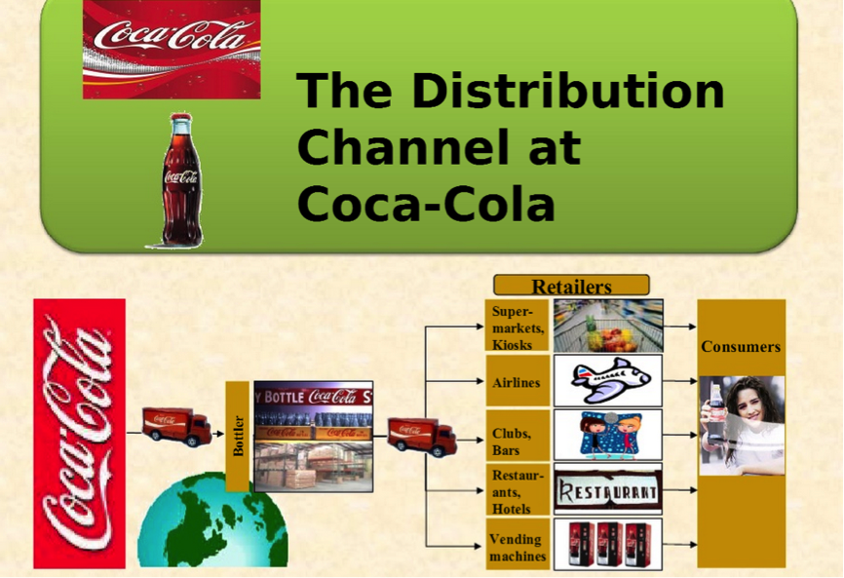
Figure 6: Coca-Cola Distribution Channel
(Source: Coca-Cola company)

2.6 Table Summary: Benefits vs Challenges of Coca-Cola’s International Operations
Table 2. Benefits and Challenges Overview
Benefits |  | Explanation
Economies of scale |  | Lower average costs from global production.
Access to high-growth markets |  | Revenue growth from China and emerging economies.
Risk diversification |  | Multi-market presence reduces volatility.
Innovation spillovers |  | Learning from diverse markets improves R&D.
Supplier bargaining power |  | Global procurement reduces raw material costs.
Challenges | Explanation
Regulatory constraints | China’s FDI limits and product regulations.
Cultural/taste differences | Need for local product adaptation.
Political/geopolitical risk | US–China tensions affecting brand perception.
Supply chain disruptions | Inflation, logistics delays, climate risks.
Sustainability pressures | Packaging regulations and environmental activism.

2.7 Critical Synthesis
The international business operations provide large scale strategic advantages to Coca-Cola in terms of scale, learning and diversification but they also present the company with complex institutional, cultural and regulatory environments. In the markets like China, the company enjoys enormous consumer demand, fine digital infrastructure and state-supported distribution partnerships. But this setting is associated with specific challenges as well: it is controlled by state regulations, consumer health trends are transforming very quickly, and the expectations of environmental compliance are growing. Global consistency and local adaptation is highly strategic and is thus vital. Lack of successfully maneuvering these complexities poses the danger of declining competitiveness, reputation issues and declining market penetrations. In general, the internationalization of Coca-Cola into China can be viewed as a good example of the complexity of the relationships between global strategy and local responsiveness that are essential in the contemporary multinational operations.

3 — OLI (Ownership–Location–Internalisation) Analysis for Coca-Cola’s Entry into China
The eclectic OLI framework (Ownership, Location and Internalization) is a strong theoretical framework on which Coca-Cola entry into China and strategic justification of its activities are explained. Firstly, the model, which was initially suggested by Dunning, is still at the core of the analysis of the recent multinational enterprise (MNE) behavior, particularly in the context of examining investment in the emerging economies that are institutional complex (Narula and Van Tulder, 2022). In the case of Coca-Cola, OLI factors are dynamically interacting to form its desirable mode of entry, that is, joint ventures coupled with selective FDI and localization.
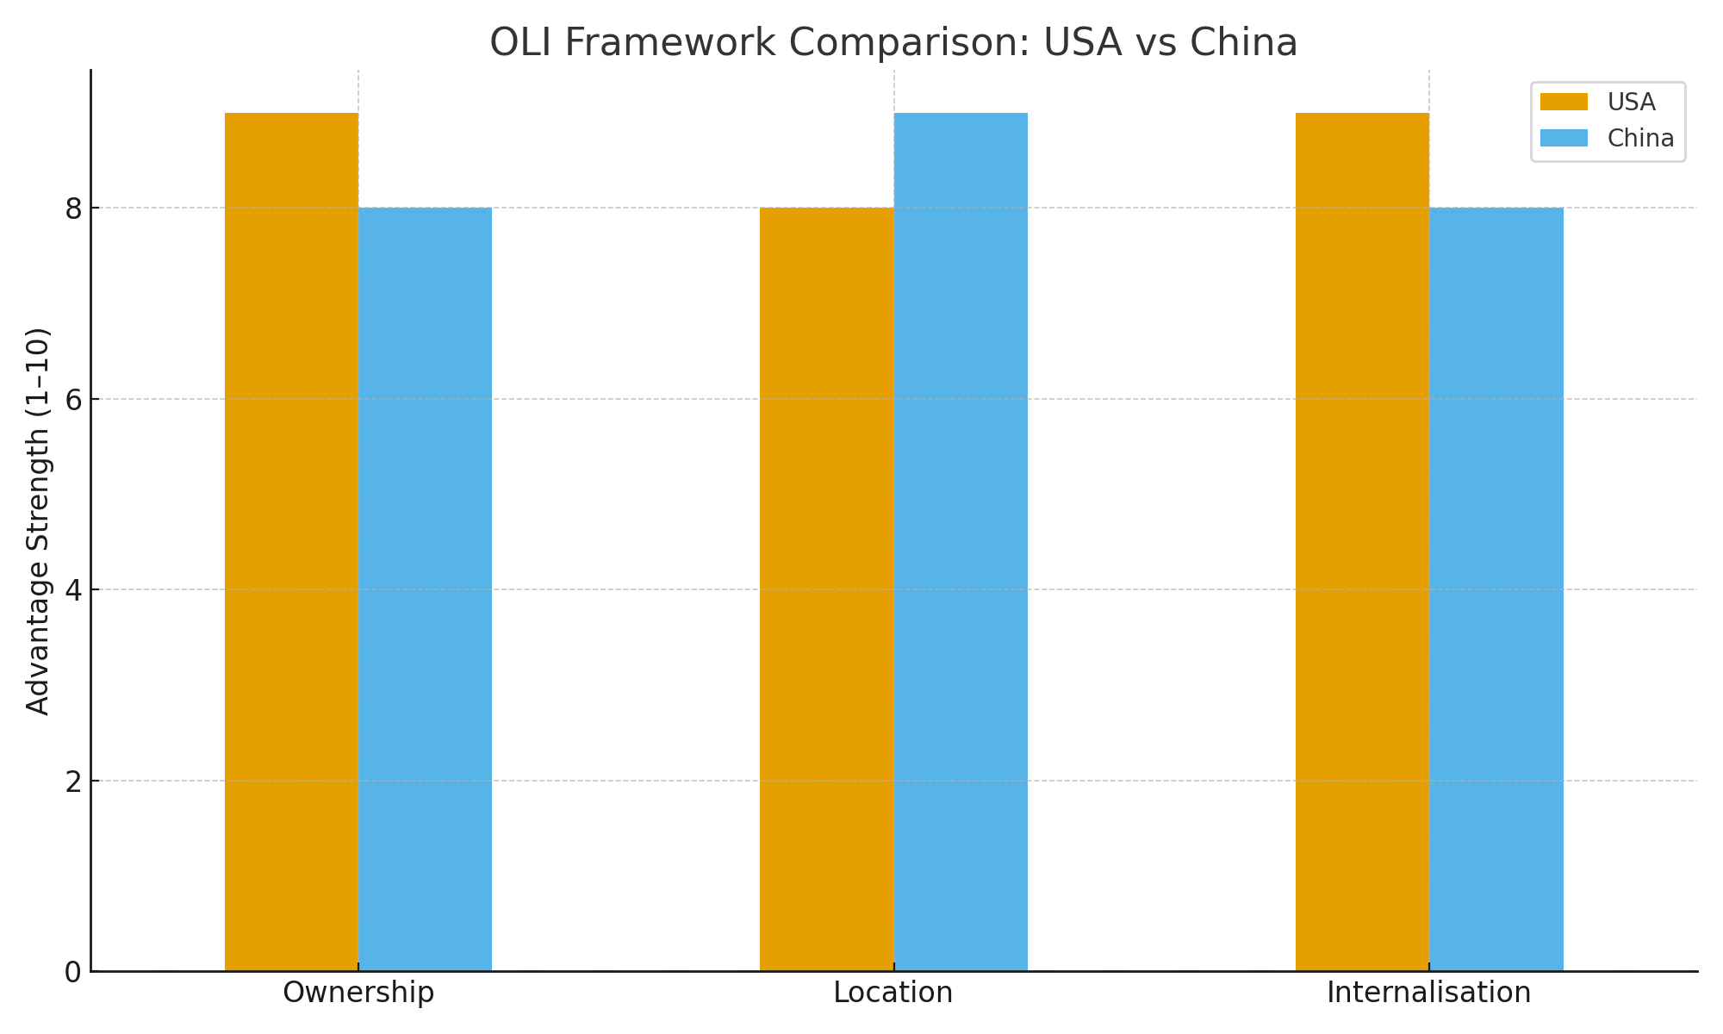
Figure 7: OLI Framework Comparison U.S. vs China
(Source: Self-Created)

3.1 Ownership Advantages (O)
Ownership advantages are firm specific assets, capabilities and resources that give an MNE a competitive advantage in the international markets. Coca-Cola has considerable ownership advantages which are strongly favorable towards entry in the Chinese market (Nielsen, 2024).
A. Global Brand Equity and Intellectual Property: This is an immaterial asset which plays a crucial role in differentiating the company in the Chinese competitive beverage market. In an emerging market, where the quality perceptions and trust are crucial in consumer uncertainty, brand familiarity decreases uncertainty (Kotabe and Kwon, 2022). Besides, Coca-Cola exclusive recipes (e.g. the “Merchandise No. 7” syrup) are rare and inimitable intangible resources that justifiably justify FDI and licensing policies.
B. Financial Health and Capital: Coca-Cola also has immense financial capabilities that allow it to make massive investments in bottling capacity, distribution fleets and advertising campaigns that will be needed in the fragmented but high-population markets in China. Its financial ownership opportunity is evidenced by the fact that it has been able to engage in multi-billion-dollar joint ventures, including the redesigning of bottling operations with COFCO and Swire (KPMG, 2023).
C. Marketing and Innovation Capabilities: Coca-Cola is also advantaged with advanced global marketing technology and consumer analytics. Such functions come in handy especially in China where digital platforms like WeChat, Alibaba, Douyin and Meituan dominate the consumption of consumers. The fact that coca-cola has global digital marketing playbooks enable it to localize campaigns quickly with the help of insights provided by its regional R&D centers (McKinsey, 2024).
D. Operational and Supply Chain Experience: The knowledge the company has in operating in the global bottling networks and its experience in overcoming regulatory environments in the global setting provide it with considerable know-how benefits in its operations within the complex ecosystem of China (IMF, 2023). The benefits of ownership of Coca-Cola render it possible and strategically appropriate to expand to foreign markets.

3.2 Location Advantages (L)
The reason behind the China attractiveness as an investment location is location advantages. The decision to use strategic entry into China is a result of a complex of macroeconomic, institutional, cultural and industry-specific benefits of Coca-Cola (B;oomberg Intelligence, 2023).
Large and Increasing Market Demand: The country is China, which has the largest consumer market in the beverages industry due to increased disposable income and tremendous urbanization trends. The growth of the non-alcoholic drinks market is also here to stay, as Chinese customers are growing in favor of convenience drinks, functional beverages and low-sugar versions (Financial Times, 2024).
Strategic Regulatory Environment of JVs: Although China has traditionally placed limits on foreign ownership in the bottling of foods and beverages its regulatory framework is conducive to joint venture where capital, technology and global brands are introduced. Coca-Cola took advantage of it and joined forces with state-owned COFCO and Hong Kong-based Swire Pacific to receive local distribution and political legitimacy (Zhao & Keith, 2023).
Next-Generation Digital Ecosystem: The digital infrastructure in China is unique and it is of incredible value which is more than 1 billion mobile payment clients and more than 30% penetration in e-commerce (Zhang & Kacker, 2022). Live-streaming consumption and social commerce. Such a setting enables Coca-Cola to circumvent certain conventional retail limitations and make real-time data-based marketing (McKinsey, 2024).
Effective Production and Distribution Systems: The developed infrastructure in supply chain such as highways, ports, and hyper-scale logistics centers in China contributes to effective beverage production and distribution. The bottling facilities of Coca-Cola in China serve over 90 percent of the population within one-day delivery radius, which lowers the logistics expenses and the lead time (KPMG, 2023).
Availability of Low-cost, High Quality Talent: The robust workforce in China, especially in the production and digital marketing industry would help Coca-Cola to become more localized in its innovation capacity. In addition, there are universities and technology centres that favour localization of R&D (Wang & Wang,2023).
Government Policy and Foreign Investment Incentives: The long-term strategy of Coca-Cola can be traced in the dedication of China to the consumer market development, its sustainability, and modernization of the manufacturing industry. Free trade zones also have incentives that lower the cost of operation.
All these considerations make China a very attractive destination and this requires Coca-Cola to invest hard to stay ahead of the competition.

3.3 Internalization Advantages (I)
The benefits of internalization provide the reasons why Coca-Cola decided to structure its operations in China and why some processes are retained in the company instead of being outsourced.
Defending Proprietary Knowledge and Formula: The Coca-cola syrup formula is probably the best-kept trade secret in the world. The licensing of the production without stringent internal control would enhance the chances of imitating or leaking, especially in a new industry with high domestic competition. Internalization will make sure Coca-Cola has a tight grip over the manufacturing of the concentrates, whereas, it will outsource bottling (UNCTAD, 2023).
Guaranteeing Quality and Brand Standardization: The internalization enables the Coca-Cola to orient itself to high standards of quality throughout the world. In China, where counterfeits and poor quality of goods are the main issues of concern, internal control of the supply of concentrates and brand management conserves corporate image (Chen, 2021).
Getting the Global Marketing together: Since Coca-Cola has a global strategy of One Brand Strategy, the internalization would guarantee global consistency and allow local adaption. Marketing planning, content development and digital analytics have to be centralized in the firm and not distributed across external agencies so that campaign coordination is more effective.
Reducing Transaction Costs: The total dependence on external partners in China would provide high transaction costs because of the uncertainty of regulation, intricate relations with the government and inhomogeneous retail systems. Internalization of the core functions saves negotiation and monitoring costs (Narula and Van Tulder, 2022).
Improving Supply Chain Resilience: The strategic elements of the supply chain, including concentrate manufacturing, management of bottling suppliers, and online retailing alliances, are more effective in resisting disruption in supply, inflation, and climatic hazards (Deloitte, 2023).

3.4 Interaction of OLI Factors and Resulting Entry Mode
The combination of OLI advantages explains why Coca-Cola adopted a joint venture + selective FDI + internalized concentrate production entry model for China.
O: Ownership Advantages → Need for Control
- Strong IP assets → internalized concentrate production.
- Brand equity → centralized marketing control.
- Financial resources → capacity for FDI in bottling operations.
L: Location Advantages → Motivation to Invest
- Massive consumer market → strong incentive for physical presence.
- Digital ecosystem → need for local partnerships and adaptation.
- Government policy → regulatory necessity for JVs.
I: Internalization Advantages → Governance Mechanisms
- IP protection → prohibits full outsourcing.
- Reduced transaction costs → requires internalized processes.
- Quality control → mandates Coca-Cola governance over bottlers.
Together, these OLI dynamics led to a hybrid entry mode: like joint Ventures with COFCO and Swire for bottling and distribution., FDI in concentrate production and strategic assets and Licensing + Internalization for brand management and syrup production. This mix is emblematic of what the literature refers to as a strategically calculated balance between the global control and local involvement in the emerging economies (Rugman and Verbeke, 2022).

3.5 Critical Evaluation
The expansion of Coca-Cola to China can be viewed as a textbook application of the OLI framework, however, it also shows multiple complexities:
1. The increasing local competitors like Wahaha and Genki Forest are threatening ownership benefits as they have a faster innovation rate and an appeal to nationalistic consumerism.
2. The location benefits are more dynamic, given that the environmental regulation in China has become tighter, and localization demands and digital privacy regulations (Reuters, 2024) are implemented.
3. Internalization advantages are costly, as maintaining control over marketing, concentrate production and quality oversight requires significant managerial investment.
However, the hybrid entry mode remains strategically sound, balancing the need for local legitimacy, regulatory compliance, operational efficiency, and protection of global competitive advantages.

4 — Cultural Differences and Their Impact on Coca-Cola’s Market Entry Strategy and Success in China
Learning cultural distance is the key explanation of how multinational enterprises can change their strategies to meet the emerging markets. In the case of Coca-Cola, China is one of the most culturally distant markets relative to its native country in the United States. The implementation of the cultural dimensions made by Hofstede and modern consumer culture theory allows offering a systematic framework of the understanding of these distinctions and their strategic impact on the entry and ultimate success of Coca-Cola in the Asian market (Li & Shen, 2021).
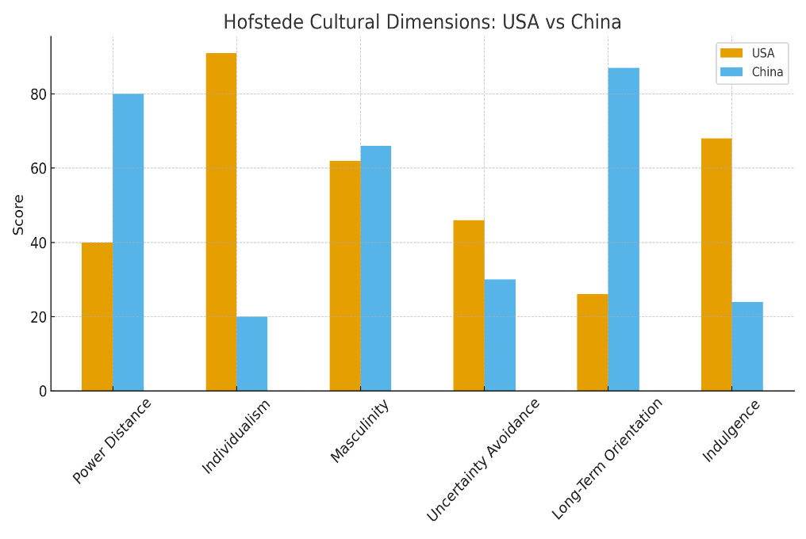
Figure 8: Hofstede Cultural Dimension U.S. vs China
(Source: Self-Created)

4.1 Key Cultural Differences Between the U.S. and China
Power Distance (PDI): China is characterized by a significantly higher power distance than the United States, reflecting hierarchical social structures and centralized authority (Hofstede Insights, 2023). In China, High PDI → acceptance of hierarchy, respect for authority, centralized decision-making. While in U.S., Low PDI → preference for equality, decentralization and empowerment.
Such a distinction influences the organizational coordination: Coca-Cola has to deal directly with mighty state-owned enterprises (SOEs) and regulators in China, where top-down decisions are made and political networks are very important (Zhao and Keith, 2023). This is one of the reasons why the joint venture of Coca-Cola and the SOE COFCO was a great contributor to the legitimacy of the firm.
“Individualism vs. Collectivism (IDV)”: The culture of China is collectivist and is in contrast to the highly individualistic culture of the U.S. (Cavusgil et al., 2022). Chinese Collectivism claims that the decisions made by the consumer are affected by the group norms, family preferences and social conformity. While individualism in the U.S. focus on the choice and self-expression. In the case of Coca-Cola, collectivism implies that in marketing content, emphasis should be put on community, harmony and common experiences instead of American-style individualistic.
Uncertainty Avoidance (UAI): The level of UAI is rather moderate in both of these countries, yet Chinese consumers are more cautious of food safety and health standards (Wang and Xie, 2022). This is attributed to the historic scandals by domestic beverage producers. This is an advantage to Coca-Cola as a reputable global brand makes the perceived risk to consumption lower. Nonetheless, it also puts strain on ensuring high quality assurance that is beyond the ordinary.
Long-Term Orientation (LTO): China is very high on the long-term orientation, which puts emphasis on perseverance, frugality and benefits in the future. The American culture is short-term oriented and more eager to get immediate results (Hofstede Insights, 2023). This variation has great effect on consumer product expectations as the Chinese would like to have functional drinks (vitamin waters, fibre drinks, herbal teas) that will encourage long-term health. The Americans are more hedonistic and taste oriented soft drinks. This difference compels Coca-Cola to shift its collection towards healthier and functional soft drinks instead of carbonated and sugary products.
Indulgence vs. Restraint (IVR): The U.S. is rated highly on indulgence, which is about enjoying, pleasure and leisure and China is on the restrict end thus the gratification is regulated by cultural practice. This affects the taste development of Coca-Cola, the marketing tone and consumption events. Consumers in China consume more drinks to stay refreshed or healthy instead of indulging (Gao and Tian, 2022).

4.2 Impact on Coca-Cola’s Market Entry Strategy
Coca-Cola has a significant impact on the two entry mode and localization strategy in China owing to cultural differences.
a. Joint Ventures as High Power Distance Response: High PDI cultures appreciate power, trust and hierarchies. Coca-Cola coordinated by entering China by forming joint ventures with COFCO and Swire Pacific. The Chinese government favors foreign participation being controlled. The relevance of guanxi (relationship networks) in accessing the market. This joint venture arrangement provided more trust and less institutional opposition.
b. Adapted Marketing for a Collectivist Society: Coca-Cola’s messaging oftenly focuses individuality in U.S. (“Open Happiness”, “Share a Coke”). In China, tagline highlight:
- family unity (春节 campaigns),
- shared celebration moments,
- social harmony and community values (Wang & Xie, 2022).
Coca-Cola’s Chinese New Year campaigns, featuring family reunions, tradition and symbolism, exemplify this shift and have become some of its most successful global marketing initiatives.
c. Product Adaptation to Align with Restraint and Long-Term Orientation: The culture of health-consciousness and long-term orientation of China required a high level of localization of the products, including: Coca-Cola Fiber+ (dietary fiber drink), Sprite Fiber+, Minute Maid Pulpy customized for Chinese taste profiles, Tea drinks such as Authentic Tea House, Reduced-sugar and zero-sugar variants. These aids respond to Chinese likings of less sweet drinks (Euromonitor, 2024).
d. Packaging Adaptation Reflecting Cultural Symbolism: The Chinese culture is also very symbolic, colorful, and auspicious. To Coca-Cola, the packaging is changed according to the use of red and gold during festive seasons (symbols of luck and wealth). Including zodiac animals during Lunar New Year. Incorporating Chinese calligraphy or festival themes. Such cultural elements enhance emotional appeal for Coca-Cola.

4.3 Cultural Impact on Organizational Success in China
a. Guanxi and Relationship-Building: Chinese culture lays an emphasis on guanxi, strong relationship networks founded on trust, reciprocity and mutual benefit (Cavusgil et al., 2022). The cooperation between Coca-Cola and COFCO (a government-supported company) shows that the former understands that market entry is not just possible with the help of economic potential, but also institutional entrenchment. This social capital was indispensable in the process of negotiating policies, obtaining distribution privileges and purchasing bottling plants (Harvard Buisness Review, 2022).
b. Consumer Confidence and Liked Quality: The increase in the food safety concerns of the Chinese consumers influences the consumption behavior of drink. The trust created due to the global brand reputation of Coca-Cola and stringent quality control systems is not always created in the domestic competitors (Zhao and Keith, 2023). This is an important cultural asset that improves the penetration in the market.
c. Digital Culture Significance in Consumer Interactions: The digital culture prevailing in China requires high-order localization. Chinese consumers interact via the physical retail, unlike the U.S. where physical retail is the prevailing concept e.g. WeChat Mini Programs, live-stream shopping on Douyin, QR code interactions, gamified campaigns. Coca-Cola implemented the strategy of digital ecosystem that incorporated product promotion through social media, mobile payment and e-commerce platforms (McKinsey, 2024).

4.4 Critical Evaluation
Although the cultural adoptions of Coca-Cola in China have been very fruitful, a number of tension still exist:
i. Cultural Differences Enlarge Cost of operation: Localization of flavor, packaging, marketing and communication contributes largely towards increasing the complexity of operations and cost structures.
ii. The Health and Wellness Culture is a menace to the sales of the carbonated drinks: The long-term orientation of China and the culture of self-control decrease the use of the cola and increases the demand of tea, juice, coffee and the functional drinks. To remain relevant, Coca-Cola has to keep on innovating.
iii. Nationalistic Consumer Behavior Is Rising: Growing national pride and geopolitical tensions with the U.S. may negatively affect American brands’ sentiment. Coca-Cola must rely on localization and partnerships to maintain legitimacy (Zhao & Keith, 2023).
iv. Digital Over-Reliance Exposes Coca-Cola to Data Regulation Risks: China’s tightening data privacy laws increase compliance pressures. Despite these challenges, Coca-Cola’s cultural sensitivity and strategic alignment have positioned it as one of the most successful Western FMCG brands in China today (China National Bureau of statistics, 2024).

5 — Recommendations: SOP Adjustments for Coca-Cola in China
Extending the previous analysis and assessment of cultures in the previous sections, it is evident that Coca-Cola needs to streamline some of its Standard Operating Procedures (SOPs) to improve success in the long term in China. Three key SOP changes are critically discussed in the next section and are related to (1) OLI factors, (2) cultural differences between the U.S. and China, and (3) the strategic needs of Coca-Cola in a big emerging economy.
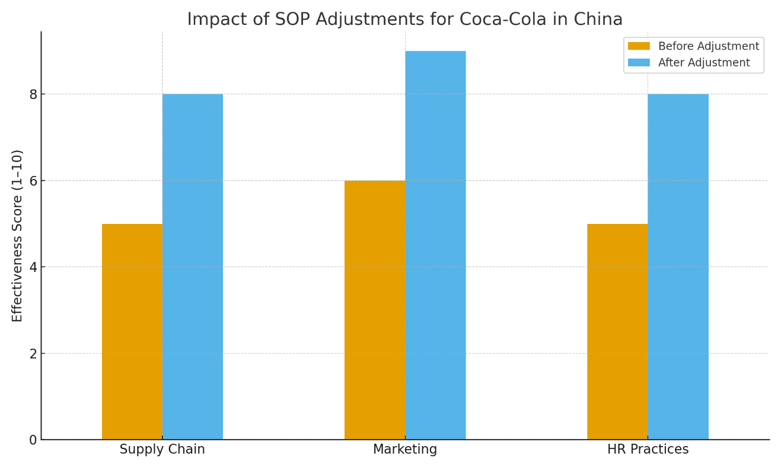
Figure 9: Impact of SOP Adjustment for Coca-Cola in China
(Source: Self-Created)

5.1 SOP Adjustment 1: Deep Localization of Product Development and Health-Focused Innovation
Rationale: China’s strong long-term orientation, high restraint, and increasing focus on wellness significantly shape beverage consumption (Euromonitor, 2024). While Coca-Cola has successfully launched Fiber+, Authentic Tea House, and customized variants, rising competition from local brands (e.g., Genki Forest) illustrates that deeper localization is required. From the OLI perspective:
Ownership Advantages (O): Coca-Cola’s global R&D capabilities must be adapted to local health trends.
Location Advantages (L): China’s demand for functional, low-sugar, and tea-based drinks is rapidly growing.
Internalization Advantages (I): Innovation must remain internalized to protect IP and ensure consistency, but local teams should lead formulation.
Recommended SOP Adjustments
Establish a China-Dedicated Health & Innovation SOP Framework: A basic SOP must institutionalize a well-defined process whereby Chinese R&D teams lead ideation and sensory research. Beijing and Shanghai consumer behavior analytics drive formulation decisions. Global R&D in Atlanta supports technological validation and scalability.
Implement a Local Rapid-Testing Cycle: Contrary to the western markets, the beverage trends in China change at an extremely high rate through the influence of social media. A SOP of the iterative prototyping should entail, Small-batch testing through Tmall and JD.com. 72-hour social listening cycles via WeChat and Douyin. Rapid modification based on digital consumer sentiment (McKinsey, 2024).
Increase Tea-Based and Functional Beverage Production: Considering cultural inclinations for outdated flavors, the SOP should be designed as, expanding Chinese tea-based product lines (oolong, jasmine, herbal). Maintaining strict quality SOPs compliant with China’s National Health Directive. Conducting simultaneous compliance checks on health before each product release.
Strategic Justification: The localized and health conscious SOP of Coca-Cola benefits internalization, suits the Chinese to like their local brand, and boosts competitive power against their agile, local brand.

5.2 SOP Adjustment 2: Strengthened Digital Engagement, Data Governance, and E-Commerce Integration
Rationale: The digital ecosystem of china is unmatched anywhere in the whole world. More than 90 percent of urban customers make mobile payments regularly, and more than one-third of retail spending at the national level is now being made online (McKinsey, 2024). The convenience, collectivism, and peer pressure cultures are intensified with the help of such platforms as WeChat, Meituan, and Douyin.
From an OLI perspective:
- Ownership Advantages (O): The knowledge of digital marketing used by Coca-Cola should be localized to the specificities of China.
- Location Benefits (L): The consumer behavior in China is very digitalized, which requires platform-integrated SOPs.
- Internalization Advantages (I): Data will be kept inside because privacy laws are stringent in the provisions of the Personal Information Protection Law (PIPL) in China.
Recommended SOP Adjustments
Introduce a China-Specific Digital Marketing SOP: This SOP must regulate the utilization of platforms, tone of voice, symbolism, and the rate of posting. Key components include: Embedding collectivist messaging (family, tradition, harmony). Leveraging festival seasons (Chinese New Year, Mid-Autumn Festival). Approving culturally sensitive content via mandatory internal cultural checks.
Exploit Alliances with key digital ecosystem players: Coca-Cola needs to make SOPs in working with institutional: Tencent (WeChat) for mini-programs, gamification, and loyalty. Alibaba/Tmall for exclusive online drops and consumer data analytics. Douyin for live-stream commerce in collaboration with influencers (KOLs and KOCs). Every business should design consistent procedures for data sharing compliance under PIPL, brand safety and influencer verification and real-time performance monitoring dashboards.
Implement a PIPL-Focused Data Privacy SOP: Given China’s severe data laws, Coca-Cola to create a China-specific data minimization protocol, conduct annual compliance audits with external legal advisors and wants consumer agreement tracking actions embedded in digital movements.
Strategic Justification: The updated SOP will enhance the internal control of Coca-Cola, the alignment with the Chinese culture of going digital and being a group, as well as increasing its competitiveness and credibility in the local market.

5.3 SOP Adjustment 3: Enhanced Local Partnership, Governance, and Guanxi-Oriented Stakeholder Management
Rationale
Power distance, collectivism, and dependency on guanxi (relationship networks) make China to be very high on these aspects, which imply that success in China would depend on whether one has good relationship with government, SOE, distributors and community groups.
From an OLI perspective:
Ownership benefits (O): The global governance structures in Coca-Cola should be transformed without compromising on operations.
Location Advantages (L): The regulatory climate in China favors firms that have a good SOE relationship and local inherentness (Zhao and Keith, 2023).
Internalization Advantages (I): Formal relationship management within the company minimizes the transaction cost as well as regulatory risk.
Recommended SOP Adjustments
Design a Proper Stakeholder Assignment SOP for Operations: This SOP should contain a quarterly government relations plan. Required participation in local business chambers and community events. Customary practices regarding dealing with local authorities in the product approval, environmental regulations and advertising.
Strengthen the Governance of Joint Ventures (JVs): To decrease the cross-cultural misunderstandings and the power imbalance, Coca-Cola will be required to introduce JV-specific SOPs that necessitate, quarterly performance reviews with COFCO and Swire Pacific, clear KPIs related to quality, sustainability, and digital performance, a dispute-resolution framework aligned with Chinese business norms and a bilingual governance manual for unified decision-making.
Community and Sustainability Integration SOP: The regulatory environment in China is also more concerned with sustainability. The institutionalized SOP required by Coca-Cola should be such that it requires, mandatory PET bottle recycling KPIs for all bottling plants, partnerships with Chinese environmental NGOs, annual sustainability performance disclosure aligned with Chinese governmental guidelines and outreach programmers associated with festivals and social causes at the local community.
Strategic Justification
The improvement of the legitimacy of Coca-Cola brought about by SOP changes, is in-line with the hierarchical collectivist culture and regulatory pressures in China, and internalization through the minimization of transaction costs and the enhancement of compliance and governance fit.

5.4 Critical Synthesis of SOP Adjustments
The three SOP changes make the operations of Coca-Cola consistent with the realities of the Chinese market through localization of product development, enhancement of partnership governance, and enhanced digitalization. They increase ownership benefits, take advantage of the cultural and market environment in China, and safeguard internalized property that can guarantee their competitiveness against domestic brands that move quickly and changing regulations.

6 — Conclusion
The case of the globalization of Coca-Cola in China throws emphasis on the interaction between global capabilities and the realities within the domestic market that determine successful multinational strategy. The ability by the company to coordinate decentralized bottling partners and having a wide scope value chain supports its position as a top MNC. Its hybrid form of entries, joint ventures, selective FDI and internalized production of the concentrate has a direct impact on the main OLI factors which guide the strategic decisions.
The success of the operations of Coca-Cola is all about cultural differences between China and the U.S. The collectivism, high power distance and restrained consumption of China as well as the long term orientation necessitate serious localization of marketing, product development and management. Adjustment to these expectations has helped Coca-Cola to gain legitimacy and consumer trust.
Planned SOP modifications, more localization of health-focused innovation, and digital ecosystems are more responsive to the dynamic environment in China in terms of guanxi-based stakeholder management. Such measures enhance ownership benefits, exploitation of location-specific benefits, and safeguard internalized assets. Finally, the end-result of the Coca-Cola success in the long term does rely on the balance between brand consistency on a global level and local responsiveness in a large emerging economy.

Reference List
- Alibaba Research Institute (2023), China E-commerce and New Retail Development Report 2023.
Link: https://www.alibabacloud.com/alibaba-research
- Bain & Company (2024), China Consumer Report 2024: The Rebound of Premiumisation.
Link: https://www.bain.com/insights
- Bloomberg Intelligence (2023), Beverage Market Outlook: China and Asia-Pacific.
Link: https://www.bloomberg.com/professional/product/bloomberg-intelligence
- Cavusgil, Knight & Riesenberger (2022), International Business: The New Realities (5th ed.). Pearson.
Link (publisher): https://www.pearson.com/en-us/subject-catalog/p/international-business/P200000007448/9781292413551
- Chen, X. (2021), Food safety, brand trust and consumer perception in China’s beverage market. Journal of Consumer Behaviour, 20(5), 1034–1047.
DOI: https://doi.org/10.1002/cb.1915
- China National Bureau of Statistics (2024), Annual Consumer Goods Retail Statistics.
Link: https://www.stats.gov.cn
- Clark, T., Chen, L. & Li, Y. (2022), Strategic transformation of Coca-Cola’s China bottling operations. Asia Pacific Business Review, 28(2), 241–259.
DOI: https://doi.org/10.1080/13602381.2021.1883884
- Coca-Cola (2024), The Coca-Cola Company Annual Report 2024.
Link: https://investors.coca-colacompany.com
- De Mooij, M. (2023), Global Marketing and Advertising: Understanding Cultural Paradoxes (5th ed.). Sage.
Link: https://us.sagepub.com/en-us/nam/global-marketing-and-advertising/book278495
- Deloitte (2023), Global Consumer and Supply Chain Outlook 2023.
Link: https://www2.deloitte.com/global/en/insights
- Euromonitor International (2024), Soft Drinks in China: Industry Overview and Forecast.
Link (login required): https://www.euromonitor.com
- Financial Times (2024), Foreign brands face rising nationalistic sentiment in China’s consumer market (7 July).
Link: https://www.ft.com
- Gao & Tian (2022), Digital platform ecosystems and consumer engagement in China. Journal of Interactive Marketing, 58(3), 32–49.
DOI: https://doi.org/10.1016/j.intmar.2022.03.001
- Ghemawat, P. (2021), Globalization in the New Normal. Harvard Business Review Press.
Link: https://hbr.org/books
- Greenpeace Asia (2023), Plastic Waste and FMCG Sustainability Trends in Asia.
Link: https://www.greenpeace.org/asia
- Harvard Business Review (2022), Competing in emerging markets: The new rules for multinational success.
Link: https://hbr.org
- Hill & Hult (2023), International Business: Competing in the Global Marketplace (14th ed.). McGraw-Hill.
Link: https://www.mheducation.com/highered
- Hofstede Insights (2023), Country Comparison: China vs United States.
Link: https://www.hofstede-insights.com/country-comparison/china,the-usa
- IMF (2023), China Economic Outlook 2023.
Link: https://www.imf.org/en/Countries/CHN
- Interbrand (2024), Best Global Brands 2024.
Link: https://interbrand.com/best-global-brands
- Kotabe & Kwon (2022), Global marketing strategy and local adaptation dynamics. Journal of International Marketing, 30(1), 1–20.
DOI: https://doi.org/10.1177/1069031X211057996
- KPMG China (2023), China Consumer and Retail Market Outlook.
Link: https://kpmg.com/cn/en/home/insights
- Li & Shen (2021), Strategic localisation of MNCs in the Chinese FMCG sector. Management International Review, 61(4), 521–544.
DOI: https://doi.org/10.1007/s11575-021-00442-4
- McKinsey & Company (2024), China Digital Consumer Report 2024: Platforms, Payments and Behavioural Shifts.
Link: https://www.mckinsey.com/cn
- Narula & Van Tulder (2022), The revisited eclectic paradigm and its relevance to emerging market MNEs. International Business Review, 31(3), 1–14.
DOI: https://doi.org/10.1016/j.ibusrev.2021.101911
- NielsenIQ (2024), China Beverage Consumer Trends.
Link: https://nielseniq.com/global/en
- PwC (2023), Global Supply Chain Resilience Report.
Link: https://www.pwc.com/gx/en/issues
- Reuters (2024), Genki Forest expands aggressively, challenging multinational beverage giants in China (11 April).
Link: https://www.reuters.com
- Rugman & Verbeke (2022), Theory of multinational enterprise revisited: Regional strategy in a global world. Journal of International Business Studies, 53(4), 715–729.
DOI: https://doi.org/10.1057/s41267-021-00497-3
- Statista (2024), Soft Drink Consumption in China 2021–2024.
Link: https://www.statista.com
- UNCTAD (2023), World Investment Report 2023: International Production and Supply Chains.
Link: https://unctad.org/publication/world-investment-report-2023
- Wang & Wang (2023), Sustainability pressures in China’s beverage supply chain. Journal of Cleaner Production, 411, 137214.
DOI: https://doi.org/10.1016/j.jclepro.2023.137214
- Wang & Xie (2022), Cultural consumer preferences and beverage choice in China. Asia Pacific Journal of Marketing and Logistics, 34(8), 1672–1691.
DOI: https://doi.org/10.1108/APJML-08-2021-0601
- World Bank (2023), China Economic Update: Consumption, Urbanisation and Growth Trends.
Link: https://www.worldbank.org/en/country/china/publication
- Zhang & Kacker (2022), The rise of social commerce in China and implications for MNCs. International Marketing Review, 39(5), 1042–1063.
DOI: https://doi.org/10.1108/IMR-09-2020-0217
- Zhao & Keith (2023), Regulation, foreign investment and the beverage industry in China. Journal of Asian Business Studies, 17(2), 245–262.
DOI: https://doi.org/10.1108/JABS-05-2021-0182

Appendix:

Coca-Cola annual reports
https://www.annualreports.com/Company/coca-cola
https://investor.cokeconsolidated.com/financial-information/annual-reports
https://investors.coca-colacompany.com/financial-information
https://www.cci.com.tr/en/investor-relations/financial-information-and-presentations
https://ir.cocacolaep.com/financial-reports-and-results/annual-reports

