

Programme: Master of Business Administration
Module Name: Marketing Management
Module code: LCMB7024
Module Lecturer:Taonga Kaonga Sobere-Snithers
“Title: Sustainability-Driven Growth Strategy: A Marketing Environment Analysis of BHP”
Student Name:Kirti Kalpeshkumar Patel
Student ID: 2537200

Table of Contents
Introduction 3
Task 1: Marketing Environment Analysis 3
2.1 Description of Marketing Environment 3
2.2 Natural Environment Actor 3
2.3 Customer Actor 6
2.4 Summary of Environmental Analysis 8
Task 2: Strategic Growth and Competitive Positioning 8
3.1 Introduction to Ansoff Matrix 8
3.2 Evaluation of Growth Options 9
3.3 Recommended Growth Strategy: Product Development 10
3.4 Achieving Competitive Advantage Through a Lower-Carbon Business Model 11
3.5 Strategic Conclusion 13
Task 3: Critical Reflection on AI Usage 13
4.1 Tool Disclosure 13
4.2 Critical Evaluation of AI Output 14
4.3 Contribution Analysis 14
4.4 Ethical and Professional Reflection 15
Conclusion 15
Reference 16

Introduction
BHP Group Ltd (Broken Hill Proprietary Company Limited) is a global resource company that is engaged in the production of essential commodities through underground mines to produce iron ore, metallurgical coal, copper, and potash (Global Data, 2026). This report evaluates the external marketing environment affecting the chosen company, BHP, as it shifts towards a low-carbon business strategy, focusing on the natural environment and customers. The growth opportunities were assessed using the Ansoff Matrix to develop a sustainable competitive advantage and to export to its customers worldwide.

Task 1: Marketing Environment Analysis

2.1 Description of Marketing Environment
The marketing environment encompasses internal and external influences affecting an organization’s capacity to create value and sustain profitable customer relationships. The external marketing environment is composed of micro and macro environments, as suggested by (Gini and Agala, 2023). The micro environment includes customers, suppliers, intermediaries, and competitors, which have a direct impact on the performance of the organization. On the other hand, the macro environment involves political, economic, social, technological, environmental, and legal environments.

2.2 Natural Environment Actor
Climate Change and Decarbonisation Pressure
From the operations, BHP aims to reach net-zero operational GHG emissions by 2050 and has invested in clean energy and emissions-reduction technologies. For example, BHP is developing lower-carbon steel-making technology, including steel-making with hydrogen and carbon capture, by working with dominant steel makers in China, Japan and South Korea. (BHP, 2026)
These new low-carbon technologies require substantial amounts of capital, and the commercial viability of green steel is technically unproven and also costly. According to Gozlugol, and Ringe, (2022), the mining industry is operating under an old, carbon-intensive business model, and all the promises made about cutting climate change emissions from above are unlikely to materialize on time. Thus, the mining industry is also presented with financial and operational risks, while potentially having opportunities for climate-change strategic management.
Environmental Regulations and Sustainability Expectations
The EU's Carbon Border Adjustment Mechanism (CBAM) helps to create environmental changes in the competitive market for the resource-intensive sectors (OECD, 2025). The environmental regulatory changes include the implementation of carbon pricing and emissions trading schemes. The effect of the Paris Agreement and Carbon taxes on the marketing environment of BHP is directly increasing the need for low-carbon product offerings. As an example, European steel manufacturers will be able to source from importers the used raw material as evidence for preferring low-embedded-carbon suppliers to secure the supply chains, which could have become more competitive (Ellersdorfer et al., 2024). Due to this BHP invested in its environment reporting systems and sustainability schemes.
However, Coase(2025), states compliance will have a positive impact on the cost of production. These strategies have thus put high pressure on costs and could possibly endanger the competitiveness of cost-intensive domestic firms, while regulations allow for differentiation strategies in a global context with higher cost pressure.
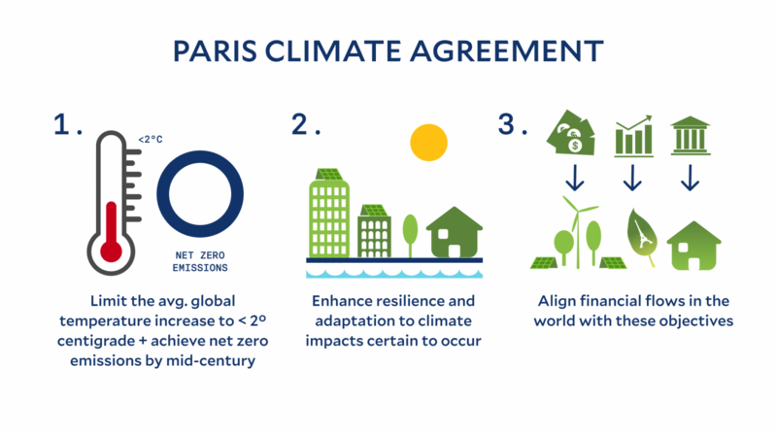
Figure 1: Paris Climate Agreement
(Source: YALE, 2021)
Growing Demand for Minerals Supporting the Green Transition
The renewable sources of energy and increased electrification will drive up significantly the demand for many of the commodities, such as nickel and copper, in particular in BHP's portfolio worldwide. Also, critical minerals will play an integral role in the production of EV's, renewable generation, battery storage, and electricity transmission. Based on IEA (2024) study, the demand for minerals could be over double by 2040, while they follow a net-zero-emissions pathway. This presents a great opportunity to leverage BHP's business model with sustainable trends, thus growing the anticipated demand for products.
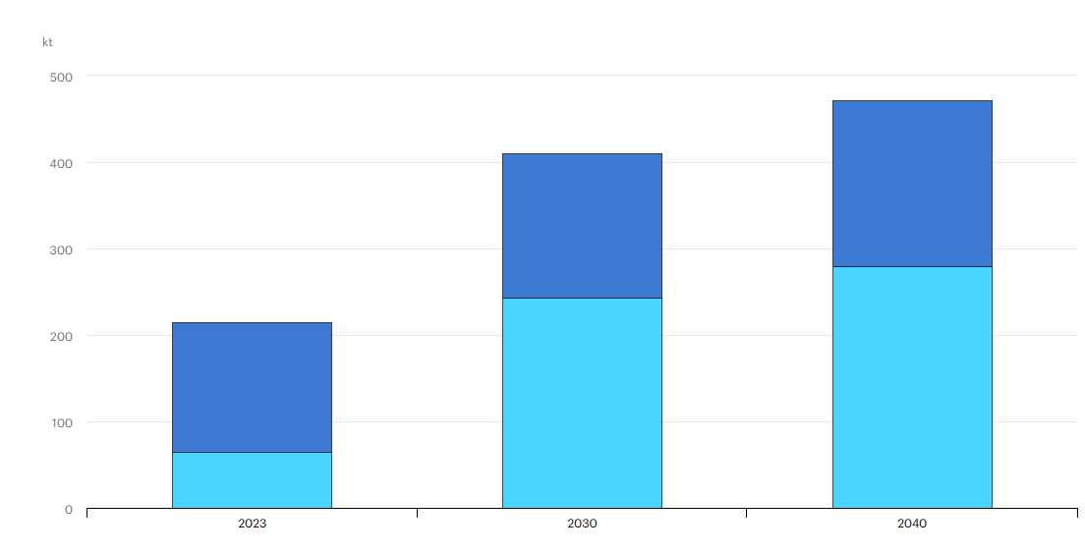
Figure 2: Global cobalt demand in the Net Zero Scenario, 2023-2040
(Source: IEA, 2024)
However, mining operations create an impact on the environment due to the use of land, water, and air, as well as other lives and greenhouse gases (Gopinathan et al., 2023). Therefore, a long-term winning competitive advantage would be in balancing resource consumption with conservation and the concerns of other stakeholders.

2.3 Customer Actor
Due to environmental pressures, customer expectations are an external environmental marketing actor that is relevant in BHP's transition towards lower carbon products. Lepistö et al., (2024) define external stakeholders, such as customers for the organization, who cannot survive without their satisfaction with the products.
Rising Demand for Sustainable Supply Chains
The customers for BHP involve steel makers, automotive manufacturers, the construction industry, and the general manufacturing industry. Most of these industries face growing demands for a reduction in carbon emissions throughout their supply chain from governments, investors, and customers. For example, the global auto manufacturers Volvo and Mercedes-Benz have ambitious sustainability targets to produce automobiles with lower-carbon inputs that will replace 70% by 2025 (Peng et al., 2023). This can lead to demands for lower carbon inputs to the steel producers from the customers. Hence, the mining and metal extraction company, such as BHP, needs to work with the steel customers along the entire value chain.
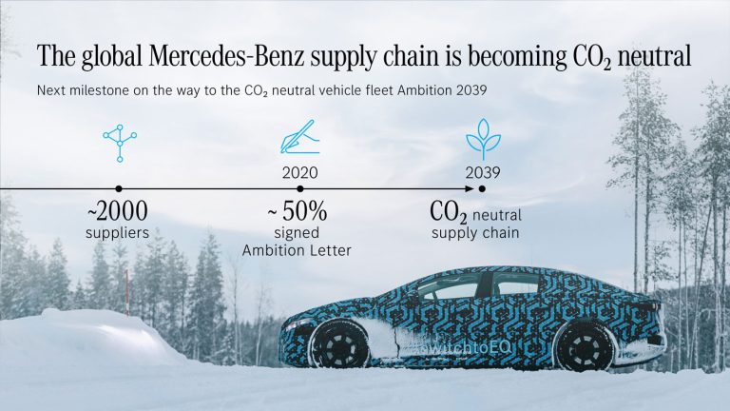
Figure 3: Global supply chain becoming CO2 neutral
(Source: Zero Carbon Charge, 2022)
Therefore, BHP is aware of this trend with some large steel producers and is exploring technologies that can reduce emissions from steel production. This helps to build customer loyalty and move the industry.
Critical Evaluation of Customer Influence
Despite the growth in demand for sustainable products, customer requirements are often multi-dimensional and conflicting. Although cost, reliability and quality are often still considered by industrial customers as a result of the environmental aspect, willingness to pay for a cheaper carbon-free alternative is not a given in many market segments (Yadav et al. 2026).
However, customers are likely to be more willing to accept environmentally friendly supply chains with increased concern toward environmental impact but only if customers believe the value of the product justifies the higher cost (Wang et al. 2022). Besides, price sensitivity may bring unprofitable outcomes in ultra-competitive markets like construction and manufacturing, as pointed out by Warraich, and Siddiq, (2025).
Therefore, customer impact constitutes a source of both opportunity and difficulty for BHP. While demand for sustainable supply chains fuels the shift to lower-carbon products, the ultimate adoption of BHP's new strategy rests on the market's ability to perceive sustainable practices as creating value.

2.4 Summary of Environmental Analysis
From the analysis, it can be determined that it is the Natural Environment factor that is the greatest external factor for the transition to lower carbon products at BHP. Issues of climate change and the scarcity of resources have prompted the company, as well as the expectations from various stakeholders, to decrease emissions and take on responsible practices within the Natural Environment. Moreover, the environment that has driven this transition more rapidly is the Regulatory and Political Environment due to factors such as increasing strict environmental controls, policies toward emission reduction, and sustainability reporting initiatives.

Task 2: Strategic Growth and Competitive Positioning

3.1 Introduction to Ansoff Matrix
The Ansoff Matrix helps organisations to discover strategies consisting of four strategies, such as market penetration, product development, market development, and diversification. This matrix focuses on growth options by considering new or existing products and markets, which allows companies to develop strategies suited to their business environment. However, BHP faces increasing pressure from the growing regulations concerning the environment, climate change, and customer needs.

3.2 Evaluation of Growth Options
Ansoff Growth Strategy | Suitability for BHP | Justification
Market Penetration | Medium | The strategy offers limited support for the transition towards lower-carbon products.
Market Development | High | It helps in entering new geographical markets or targeting emerging renewable energy for BHP's products
Product Development | Very High | It helps to develop lower-carbon minerals and sustainable mining technologies directly supports BHP's decarbonisation objectives.
Diversification | Medium | It involves substantial investment, high risk, and may divert resources from core sustainability priorities.
Table 1: Ansoff Growth Strategy
(Source: Self-developed)
Market penetration seeks to expand sales of existing products to existing markets. BHP can achieve deepened relationships with existing customers by optimizing the efficiency of existing operations (Kusuma and Furinto, 2022). However, market penetration will fail to meet growing sustainability concerns and required product innovation, and will also likely be insufficient to assist BHP in achieving lower carbon operations.
Market Development refers to re-positioning current products to alternative geographies or market segments (Ebepu et al., 2024). While market development may lead to revenue growth, it fails to adequately address increasing environmental concerns and stakeholder pressure for mining sustainability (Ebepu et al., 2024). Additional markets expose BHP to higher levels of regulatory complexity and political risks.
The product development is to explore the possibility of a new product in the existing market. The emphasis is much in line with the sustainability objectives of BHP, because the focus will be placed on the development of low-carbon minerals, sustainable mining solutions, and a green supply chain for existing clients (Gasimov et al., 2025). Hence, innovative new products can be found, and more attention will be given to green products.
Diversification means creating new products and selling them in new markets, and is the highest-risk growth option. It does have good long-term prospects, and the investment needs to be huge due to significant uncertainties (Razak, 2022). The already-significant challenges of decarbonisation mean that resources could be diverted away from BHP's core sustainability agenda. Therefore, Product development is the most appropriate strategic option to serve environmental and business interests.

Figure 4: Ansoff Matrix
(Source: Self-developed)

3.3 Recommended Growth Strategy: Product Development
In the analysis of the Ansoff Matrix, it can be recommended that product development seems the most suitable strategy for the BHP industry, as it directly leads to achieving their goal to move toward a lower carbon business. As a customer-oriented company, it utilizes its relationship with customers, where BHP is likely to create a low-carbon iron ore solution and innovative mining technology by applying a product development strategy (BHP, 2026). It has a low impact on the environment and responsibly sourced critical minerals that would be needed for new renewable energy systems, along with electric vehicles.
Moreover, the strategy is also consistent with rising customer desire for more sustainable supply chains. For instance, with a target for reducing carbon emissions themselves, steel makers are targeting the procurement of low-emission feedstocks (Xinyu et al., 2025). BHP is adding value for its current customers and also building a foundation for future leadership globally, by building green steel alliances, implementing renewable power, and focusing on low-emission technology (BHP, 2024).
Therefore, the benefits gained from long-term growth opportunities, such as addressing the changing environmental expectations and remaining, while product development requires substantial investment of capital and ingenuity that is relevant in the global market.

3.4 Achieving Competitive Advantage Through a Lower-Carbon Business Model
BHP can develop a competitive advantage by focusing on a differentiation strategy were sustainability leadership is its point of difference. Salieiev (2024) states that differentiation is the act of creating important points in product or service offerings in which customers will assign values. For the mining sector, the new products will focus on providing a lower carbon footprint and more ethical sources that highlight sources of competitive differentiation.
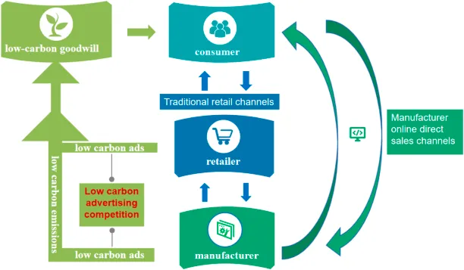
Figure 5: Lower-Carbon Good will
(Source: Xie et al., 2023)
BHP could position itself as a distinct offering with the help of renewable energy, emissions reduction technology, sustainable mining practices, and give disclosure of environmental (Amegboleza, and Ülkü, 2025). These provide business reputation benefits and solidify customer relationships who require sustainable business partners. As such, the partnership BHP formed with steel manufacturers on reducing value chain emissions moves them from a raw material supplier to a strategic partner for sustainability.
The differentiation based on sustainability has to be developed continuously by innovation, since its competitors, such as Rio Tinto and Vale, are also investing considerably in low-carbon solutions (Chua, 2024). Consequently, R&D, operating efficiency, and demonstrably environmental performance have to be continuously tracked and investment to maintain its advantage over competitors.

3.5 Strategic Conclusion
According to the Ansoff matrix, the growth strategy that makes sense for BHP as it moves to a lower-carbon business model is the “product development” strategy. In comparison to market penetration, market development, and diversification, product development is the most suitable growth strategy for meeting the sustainable objective and adapting to market needs. It offers growth in developing lower carbon products and investing in green technologies and sustainable supply chains, which helps to reinforce the market position of BHP while meeting pressure in terms of environmental regulation and demand. Therefore, product development is aligned with differentiation based on a leading position in sustainability.

Task 3: Critical Reflection on AI Usage

4.1 Tool Disclosure
AI was deployed to support research activities when producing this report. Generative AI systems, such as ChatGPT, which help to study alternative viewpoints about the environmental considerations and strategic growth strategy relevant to the mining sector (Bukar et al., 2024). The systems were not employed in the writing of the final report but in research and editing efforts by following university guidance on the use of AI. Moreover, research also involved exploring information in university databases such as Google Scholar, Scopus, and company sustainability reports, which could be confirmed and cited with other academic research. This tool is basically used to boost efficiency when collecting background information.(ChatGPT : https://chatgpt.com/)
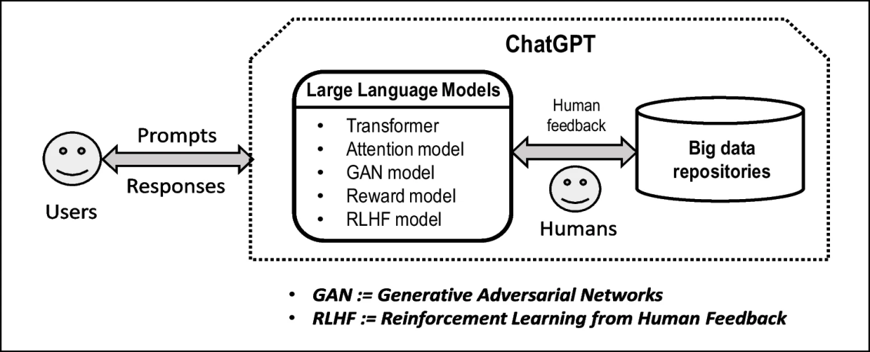
Figure 6: Generative Artificial Intelligence
(Source: Storey et al., 2024)

4.2 Critical Evaluation of AI Output
Adel and Alani, (2025) reported that several limitations were encountered in this phase, including the threat of hallucinations by using AI tools to conduct research, in which an AI will generate false facts, unsupported claims, or unfeasible reference links. To avoid this from happening, all information received from the AI's responses has been compared with relevant journal articles, BHP's official documents, industry-based reports, or other organisational websites, and where any conflict was present, the report either included a correction or eliminated that data. Also, statistical figures and sustainability assertions have been corroborated with more recently published articles so that the figures included are factually correct and current (Kautish et al., 2024). This has demonstrated that even when using an AI tool, human intelligence is still required.

4.3 Contribution Analysis
It was useful in helping to establish the related concepts that should be looked into, as well as in summarising background details and potential areas of investigation. However, the evidence analysed was by myself, and the final theories selected were my own for a critical examination of the BHP's marketing environment, and the evaluation of strategic growth alternatives. It was possible to construct the report in line with the requirements of the assignment and academic advice obtained through the module. All the arguments put forward, conclusions, and recommendations are the result of my own evaluation of evidence derived from academic and industry-based research.

4.4 Ethical and Professional Reflection
The expanded adoption of AI in marketing analysis generates several ethical and professional concerns. Some ethical issues with AI include academic integrity, since AI could hinder the ability to learn, as well as needing an explicit definition of how it can be used (Qadhi et al., 2024). Another ethical concern is the possibility of bias from the AI system and how this bias would affect the final output based on the quality of the data input. For marketing professionals to view these results as factual or unbiased, they will need to be skeptical of all AI-driven outputs. Accountable professionals may use AI to speed up their decision-making process, but ultimately will still be responsible for their use of AI. Through this activity, I learned that AI can serve as an effective research assistant in analysis when properly and ethically utilized, and what is required by human interpretation.

Conclusion
In this report, it can be concluded that the External environment that is influencing BHP to move toward lower-carbon product are Natural environment and regulation. The most appropriate growth strategy for BHP under the Ansoff Matrix in response to these external forces was product development. For BHP to thrive as a company on its own and through long-term sustainability, it will have to commit to investment in sustainable innovation and differentiation through environmental leadership.

Reference
Adel, A. and Alani, N., (2025). ‘Can generative AI reliably synthesise literature? exploring hallucination issues in ChatGPT.’ AI & SOCIETY, pp.1-14. https://link.springer.com/content/pdf/10.1007/s00146-025-02406-7.pdf (Accessed: 6th June, 2026).
Amegboleza, A.A. and Ülkü, M.A., (2025). ‘Sustainable energy transition for the mining industry: a bibliometric analysis of trends and emerging research pathways.’ Sustainability, 17(5), p.2292. https://www.mdpi.com/2071-1050/17/5/2292 (Accessed: 6th June, 2026).
BHP, (2024), Pathways towards steelmaking decarbonisation, Available At: https://www.bhp.com/news/bhp-insights/2024/10/pathways-towards-steelmaking-decarbonisation (Accessed: 6th June, 2026).
BHP, (2026), BHP - Climate Change 2018, Available At: https://www.bhp.com/-/media/documents/environment/2019/190121_bhpcdpresponseclimatechange2018.pdf?la=en#:~:text=Carbon%20capture%20and%20storage%20(CCS),uses%20both%20or%20iron%20ore (Accessed: 6th June, 2026).
BHP, (2026), BHP partners with China Baowu to address the challenges of climate change, Available At: bhp.com/news/media-centre/releases/2020/11/bhp-partners-with-china-baowu-to-address-the-challenges-of-climate-change#:~:text=The%20five-year%20partnership%20will%20focus,intensity%20reduction%20in%20integrated%20steelmaking. (Accessed: 6th June, 2026).
Bukar, U.A., Sayeed, M.S., Razak, S.F.A., Yogarayan, S. and Sneesl, R., (2024). ‘Decision-making framework for the utilization of generative artificial intelligence in education: A case study of ChatGPT.’ IEEE Access, 12, pp.95368-95389. https://ieeexplore.ieee.org/iel8/6287639/6514899/10589404.pdf (Accessed: 6th June, 2026).
Chua, K.P., (2024). ‘Integrating Sustainable Innovation into Corporate Strategy: A Comparative Analysis of Multinational Enterprises.’ International Journal of Public Administration, Management and Economic Development, 9(2), pp.123-138. https://www.ijpamed.eu/index.php/journal/article/download/203/180 (Accessed: 6th June, 2026).
Coase, R.H., (2025). ‘The institutional structure of production.’ In Handbook of New Institutional Economics (pp. 37-46). Cham: Springer Nature Switzerland. https://link.springer.com/content/pdf/10.1007/978-3-031-50810-3_3.pdf (Accessed: 6th June, 2026).
Ebepu, O.O., Aniebonam, E.E., Waheed, O.O. and Asamoah, F., (2024). ‘Advanced market analysis and United States business growth: Identifying emerging opportunities for sustainable profitability.’ International Journal for Multidisciplinary Research, 7(1), pp.1-14. https://www.researchgate.net/profile/Ebuka-Aniebonam/publication/388076067_Advanced_Market_Analysis_and_United_States_Business_Growth_Identifying_Emerging_Opportunities_for_Sustainable_Profitability/links/67899fb475d4ab477e4859f3/Advanced-Market-Analysis-and-United-States-Business-Growth-Identifying-Emerging-Opportunities-for-Sustainable-Profitability.pdf
Ellersdorfer, P., Wang, C., Saydam, S., Canbulat, I., MacGill, I. and Daiyan, R., (2024). ‘Unlocking new export opportunities: An open-source framework for assessing green iron and steel supply chains.’ International Journal of Hydrogen Energy, 92, pp.1366-1374. https://www.sciencedirect.com/science/article/pii/S0360319924043611 (Accessed: 6th June, 2026).
Gasimov, F., Williams, R.A. and Krishanan, M.G., 2025). ‘Key pathways towards sustainable processing of critical minerals.’ Minerals Engineering, 233, p.109644. https://www.sciencedirect.com/science/article/pii/S0892687525004728
Gini, K.B. and Agala, H.O., (2023). ‘The Impact of Macro-Environmental Factors on Business Performance.’ International Journal of Research and Innovation in Social Science, 7(11), pp.1837-1843. https://www.researchgate.net/profile/Kiyentei-Gini/publication/376792903_The_Impact_of_Macro-Environmental_Factors_on_Business_Performance/links/6588b2f30bb2c7472b09d265/The-Impact-of-Macro-Environmental-Factors-on-Business-Performance.pdf (Accessed: 6th June, 2026).
Global Data, (2026), BHP Group Ltd - Company Profile, Available At: https://www.globaldata.com/company-profile/bhp/#:~:text=BHP%20Group%20Ltd%20(BHP)%20is,metallurgical%20coal%2C%20copper%2C%20and%20potash. (Accessed: 6th June, 2026).
Gopinathan, P., Subramani, T., Barbosa, S. and Yuvaraj, D., (2023). ‘Environmental impact and health risk assessment due to coal mining and utilization.’ Environmental Geochemistry and Health, 45(10), pp.6915-6922. https://link.springer.com/content/pdf/10.1007/s10653-023-01744-z.pdf (Accessed: 6th June, 2026).
Gozlugol, A.A. and Ringe, W.G., (2022). ‘Net-zero transition and divestments of carbon-intensive assets.’ UC Davis L. Rev., 56, p.1963. https://www.econstor.eu/bitstream/10419/271517/1/1847124054.pdf (Accessed: 6th June, 2026).
IEA, (2024), Outlook for key minerals, Available At: https://www.iea.org/reports/global-critical-minerals-outlook-2024/outlook-for-key-minerals (Accessed: 6th June, 2026).
Kautish, P., Thaichon, P. and Soni, P., (2024). ‘Environmental values and sustainability: Mediating role of nature connectedness, and love for nature toward vegan food consumption.’ Journal of Consumer Behaviour, 23(3), pp.1130-1145. https://onlinelibrary.wiley.com/doi/pdfdirect/10.1002/cb.2267 (Accessed: 6th June, 2026).
Kusuma, N.C. and Furinto, A., (2022). ‘Tapping the New Source of Growth: New Marketing Strategy for a Heavy Equipment Distributor in the Nickel-Mining Sector.’ International Journal of Current Science Research and Review, 5(4), pp.1211-1225. https://www.academia.edu/download/91627670/44-25-2022.pdf
Lepistö, K., Saunila, M. and Ukko, J., (2024). ‘Enhancing customer satisfaction, personnel satisfaction and company reputation with total quality management: combining traditional and new views.’ Benchmarking: An International Journal, 31(1), pp.75-97. https://www.emerald.com/bij/article-pdf/31/1/75/9456153/bij-12-2021-0749.pdf (Accessed: 6th June, 2026).
OECD, (2025), EU Carbon Border Adjustment Mechanism: What is it, how does it work and what are the effects?, Available At: https://www.oecd.org/en/blogs/2025/03/eu-carbon-border-adjustment-mechanism-what-is-it-how-does-it-work-and-what-are-the-effects.html (Accessed: 6th June, 2026).
Peng, J., Shi, X. and Tong, X., (2023). ‘Extended producer responsibility for low carbon transition in automobile industry.’ Circular Economy, 2(2), p.100036. https://www.sciencedirect.com/science/article/pii/S2773167723000134 (Accessed: 6th June, 2026).
Qadhi, S.M., Alduais, A., Chaaban, Y. and Khraisheh, M., (2024). ‘Generative AI, research ethics, and higher education research: Insights from a scientometric analysis.’ Information, 15(6), p.325. https://www.mdpi.com/2078-2489/15/6/325 (Accessed: 6th June, 2026).
Razak, I., (2022). ‘Product diversification: Marketing management strategy for business growth.’ Jurnal Ekonomi, 11(03), pp.2162-2167. https://ejournal.seaninstitute.or.id/index.php/Ekonomi/article/download/3995/3173
Salieiev, I., (2024). ‘Organization of processes for complex mining and processing of mineral raw materials from coal mines in the context of the concept of sustainable development.’ Mining of Mineral Deposits, 18(1), pp.54-66. https://pdfs.semanticscholar.org/c137/0f4c7908b87b7e6df9a004cce06fc599b2db.pdf (Accessed: 6th June, 2026).
Storey, V.C., Yue, W.T., Zhao, J.L. and Lukyanenko, R., (2025). ‘Generative artificial intelligence: Evolving technology, growing societal impact, and opportunities for information systems research.’ Information Systems Frontiers, pp.1-22. https://link.springer.com/content/pdf/10.1007/s10796-025-10581-7.pdf (Accessed: 6th June, 2026).
Wang, M., Kumar, V., Ruan, X., Saad, M., Garza-Reyes, J.A. and Kumar, A., (2022). ‘Sustainability concerns on consumers’ attitude towards short food supply chains: An empirical investigation.’ Operations Management Research, 15(1), pp.76-92. https://link.springer.com/content/pdf/10.1007/s12063-021-00188-x.pdf (Accessed: 6th June, 2026).
Warraich, A.H. and Siddiq, F.N., (2025). ‘Blue Ocean Strategy: Creating Uncontested Market Space.’ International Journal of Modern Research in Management, 2(01), pp.23-33. https://ijournalmrm.com/index.php/IJMRM/article/download/14/14 (Accessed: 6th June, 2026).
Xie, D.R., Qin, Q., Xie, J.M., He, X.J. and Jiang, M.T., (2023). ‘Coordination contracts and numerical analysis of low-carbon competitive supply chains under the influence of low-carbon goodwill.’ Frontiers in Environmental Science, 11, p.1260667. https://www.frontiersin.org/journals/environmental-science/articles/10.3389/fenvs.2023.1260667/pdf (Accessed: 6th June, 2026).
Xinyu, T., Pekka, K. and Ismo, H., (2025). ‘A design and modeling approach for resource-constrained internet of things devices.’ Design Automation for Embedded Systems, 29(3), p.4. https://link.springer.com/content/pdf/10.1007/s10617-025-09294-6.pdf
Yadav, D., Dwivedi, A., Lu, X., Vishwakarma, C.B., Jing, D., Dansena, P. and Kumar, R.R., (2026). ‘A systematic multi-criteria framework for selecting hydrogen production methods.’ International Journal of Green Energy, 23(8), pp.1691-1708. https://www.researchgate.net/profile/Xinlong-Lu/publication/400794983_A_systematic_multi-criteria_framework_for_selecting_hydrogen_production_methods/links/69abca4ebff9750ad9c8fa02/A-systematic-multi-criteria-framework-for-selecting-hydrogen-production-methods.pdf
YALE, (2021), Yale Experts Explain The Paris Climate Agreement, Available At: https://sustainability.yale.edu/explainers/yale-experts-explain-paris-climate-agreement (Accessed: 6th June, 2026).
Zero Carbon Charge, (2022), Mercedes-Benz Next Milestone Ambition 2039 – Global supply chain becoming CO2 neutral, Available At: https://charge.co.za/mercedes-benz-next-milestone-ambition-2039-global-supply-chain-becoming-co2-neutral/ (Accessed: 6th June, 2026).

