Effective Team Working and Communication
(BMSW4002_LON)
Valentina Garzon Gomez (2111132)
2023

Table of Contents
1.0 Introduction 2
2.0 Communication skills 3
3.0 Three Models of Communication 4
3.1 Shannon and Weaver model of communication: 4
3.1.1 Pedro and Maria case study 5
3.2 Schramm’s Model of Communication: 5
3.3 Berlo’s Model of Communication: 6
4.0 Poor communication in the workplace and how to improve 7
4.1 Poor communication examples 8
4.1.1 Max the Multitasker Case Study 8
4.2 How to improve communication in the workplace 8
5.0 Conclusion: 9
References 10

Introduction

Communication is an exchange of thoughts, ideas, views, emotions and expressions from one person or more than one, to another individual. Communication is more than just words, it is cultural aspects, perceptions, knowledge, attitudes, experiences, and skills than we can show and perceive. Every day we need to communicate with our parents, colleagues, friends, classmates, partners, so it is really important that we try to implement good communication skills, so we will be able to express our thoughts and feelings.

During this module I learnt how important communication is and now at work I can communicate very well with my colleagues and with the customers. In this report I wrote all the knowledge I acquired during the classes.

2.0 Communication skills

Having good communication skills is vital in all aspects of our lives.
We need to communicate effectively not only in our workplace but with friends, families and new people we meet.

Knowing how to communicate properly at work has a huge impact, because we need to share and receive information. Nowadays we have many methods to communicate and transfer information such as phones, computers, tablets, etc… so having good communication skills is essential.

We use verbal and non-verbal communication to express ourselves: verbal communication are the words we use to communicate a message and non-verbal communication are the things we communicate by body language and signals. Nonverbal communication helps us understand what the person is saying and what they mean with the message or how they feel about it.

Clarity is indispensable for oral communication, involving structuring your thoughts logically and using the right words to give the message as effectively as possible (Kurtuy, 2023).
For example I work in a restaurant and having good oral communication is essential because I have to be clear with the costumers to provide a good service and I also need to communicate with my team clearly and efficiently.

Written communication skills are important: you will always have to write emails or messages to your colleagues, give a report to your boss and communicate with customers.

Being a good listener is an important skill. First, we need to know the differences between hearing and listening: hearing is the physical ability to detect sounds, listening requires your attention to understand the meaning of those messages. The HURIER model defines listening in six parts: hearing, understanding, remembering, interpreting, evaluating and responding. (Quintanilla, 2020, p.54).

Being able to give feedback is equally important, it is tied with the will to learn and the ability to adapt and accept constructive criticism. Other fundamental factors that are important for an effective communication are respect, confidence and honesty (Careerblog, 2021). Having values when communicating will make us look professional and make others respect us.

3.0 Three Models of Communication

During class we have seen the different models which help us understand how the communication process unfurls and how there can be misunderstandings when we give a message to an individual.

3.1 Shannon and Weaver model of communication:

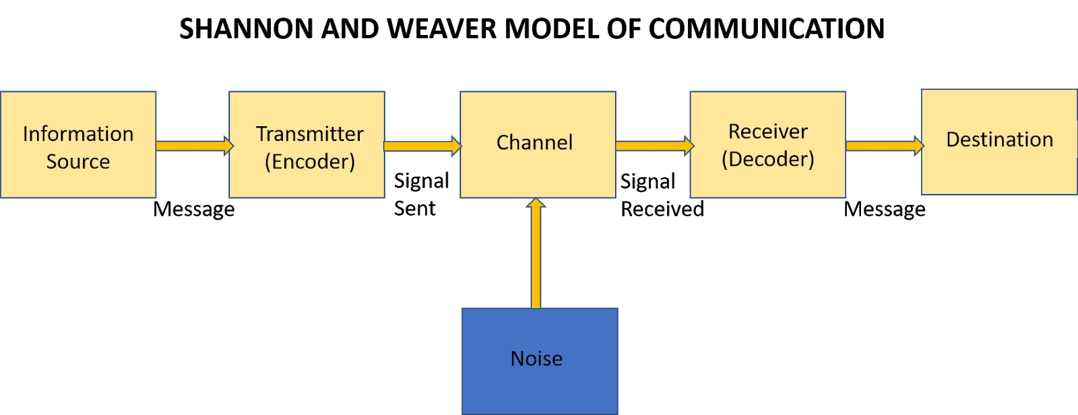
Figure 1. Shannon and Weaver’s Model of Communication (Sis Michelle, 2018).

This model was created in 1948 for Claude Shannon, a mathematician and Warren Weaver, a scientist. The model has been modified and developed over the years, adapting to technological advances; it was inspired by “machine translation” which is how the first technologies like computers, radios, and televisions transfer information (Regan, 2021).

The source is where the message begins: here we have the person, group or organisation that wants to communicate something. The transmitter takes the message and encodes it, turning it into a signal. The channel is the system we use to send this signal to the desired recipient via different means such as email or text, for example. Noise is any factor that can disrupt or distort the communication and interfere with the signal, causing misunderstandings between the source and the receiver and altering the transmission flow between them. When the signal arrives to the desired destination it must be decoded: the signal is converted into a message. The decoder can be an equipment, a software, a machine or an individual. Finally the receiver has the message and they will interpret it however they see fit (Communication Theory, 2020).

3.1.1 Pedro and Maria case study

During class we read a case study which lead us to better understand how important the channel is in the process of communication: Maria called her husband Pedro and asked him to bring a chicken home while on his way back from work, but where he works there is a lot of noise and he was not able to hear what Maria asked him, so he came back home and he immediately went to the kitchen to meet Maria because that was what he understood. Shannon and Weaver model helped us understand why there was this confusion, how important the channel is and how noise can affect the signal, altering communication. (Moodle uwtsd, n.d).

This is a good Model to apply to have good communication and we can also apply it for face-to-face communication, but it works best for communicating via technological device. It is still missing a really important step in communication which is feedback after the receiver gets the message, which is why a message can be easily misunderstood.

3.2 Schramm’s Model of Communication:

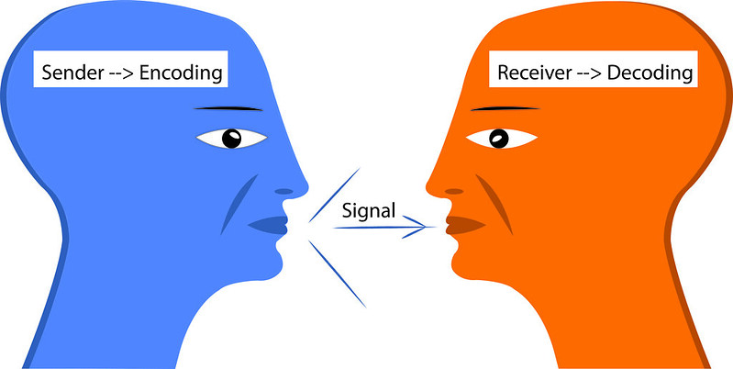
Figure 2. Schramm Model. (LibreTexts, 2023).

The Schramm communication model was created in 1954 by Wilbur Schramm. He was considered one of the first founders in communication studies. The Schramm communication model consist in a cyclical process of two parts, an encoder and a decoder (Cuofano, 2023).

The source is the person who wants to send the message, this person has to provide a clear message in order for the receiver to be able to easily understand it. The sender is in charge of encoding which is the process of converting languages, expressions, or symbols into a message. Different channels can be used to transmit a message such as verbally, in writing, or via technological devices. Now the receiver is tasked with decoding the message and understand what the sender wanted to transmit.

For a successful communication using this model, it is important the receiver gives feedback to the sender, confirming that the message has been received and understood or if it is necessary, ask for clarification. This feedback will lead to a new cycle of communication where the receiver now will be the sender (Cuofano, 2023).

3.3 Berlo’s Model of Communication:

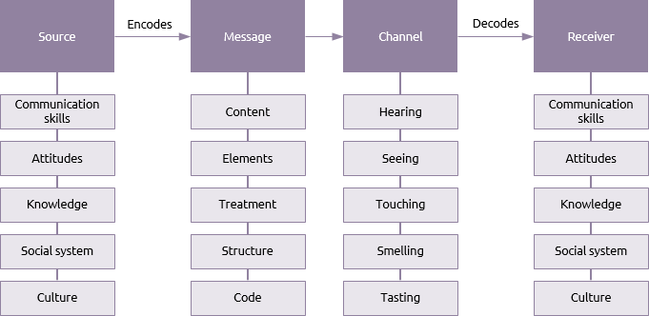
Figure 3. Berlo. (Praxis, 2014).

Berlo’s Model of Communication was developed in 1960 by David Berlo. He designed the SMCR communication model which refers to: sender, message, channel and receiver which are important fundamentals for any communication process. Berlo invented this model based on the Shannon-Weaver Communication Model and he described some factors that make communication more effective (Kobiruzzaman, 2021).

The source is the person who creates a message they want to transfer to the receiver. These factors will influence the message: communication skills (effective speak, read, write and listening), attitude (negative or positive), knowledge (having knowledge about the subject of the message he wants to communicate), social system (Values, beliefs, laws, religion, etc) and culture; (being careful with the different cultures, not saying something offensive).

The message is created by thoughts and is converted into words. Any message includes elements such as content, element, treatment, structure and code.

The channel is the method of how the information goes from the sender to the receiver. Now it is common that we use technological devices as a channel to transfer a message, but in general communication the five senses of a human being are the channels that will help us to communicate with each other.

The receiver will get the message and will try to understand what the sender wants to communicate and then will be able to give feedback. The receiver must also use the help of the sender factors such as communication skills, attitude, knowledge, social systems and culture to receive the message effectively. (businesstopia in communication, 2018).

From my point of view this is the clearer model of communication for companies and individual to use for effective communication. It is realistic and easy to understand even for those who need to improve communication skills.

4.0 Poor communication in the workplace and how to improve

I have been working in hospitality for almost 4 years and I have seen many mistakes that we make when communicating that lead me to think about solutions and how important it is to improve communication skills. In a restaurant there are different departments which are the kitchen, the bar, reception and the department I work in as a waitress, front of house. It is essential that we communicate between departments to provide the best experience and services to our customers.

4.1 Poor communication examples

At work we have different kind of events and services that we provide for our customers, so an example of bad communication I can give is when the reception team does not communicate with the managers letting them know which events we have, the exact time it will start, etc… this situation creates chaos at work, because if we are not ready nothing will work and are not going to provide a good service. Another case of bad communication in my workplace is when the kitchen and front of house team do not communicate with each other: we must know if we are running out of any dish from the menu or if any specials are on for that day. It is our job to communicate and listen carefully so we provide the right information to our customers; it has happened before that we communicated poorly and made mistakes that have caused customers to give bad feedback.

As a waitress I must have good communication with customers: since the moment they arrive to the table it is important for me to apply all my communication skills, I must listen carefully, notice body language to understand if everything is going well, speaking clearly about any allergies, menu changes, specials and important information I need to provide.

4.1.1 Max the Multitasker Case Study

This case study was a good example of how important it is to organize our time and apply good communication skills. Max has his own business organizing events, he was working alone and it was impossible for him to have proper communication with his clients: he was trying to do many things at the same time and when his client Tamara called him to ask for an important change on her event, he was not applying active listening and for this reason he was not able to fulfil her needs causing him to lose a client.

4.2 How to improve communication in the workplace

Good communication skills In the workplace begin with working as a team and cooperating. The most important aspects to improve communication in the workplace are: Active listening; understanding that we communicate in different ways; doing briefings every day at work so we are informed of new events; giving and asking for feedback; having appropriate body language and knowing all the roles in the team (Post University, 2020).

5.0 Conclusion:

Communication skills are vital for everyone’s success in life and career as they allow you to interact with people effectively and make your presence felt during a conversation or a meeting. Being able to communicate in a team helps you building trust with your colleagues, strengthening your professional relationships, boosting teamwork, developing a sense of belonging and becoming more productive. Personally I have learned and grown thanks to all the knowledge acquired through this module, now feel more confident and self-reliant.

References

Regan, J (2021) The Shannon Weaver Model of Communication. Available at: https://www.stockton.ac.uk/media/3546/the-shannon-weaver-model-of-communication-theory-script.pdf (Accessed: 25/04/2023).

Communication Theory, (2020) Shannon and Weaver Mode of Communication. Available at: https://www.communicationtheory.org/shannon-and-weaver-model-of-communication/ (Accessed: 25/04/2023).

Figure 1. Michelle, S. (2018) Shannon and Weaver’s Model of Communication. Available at: https://michellemathiasfsp.blogspot.com/2018/11/shannon-and-weavers-model-of.html
(Accessed: 25/04/2023).

Moodle uwtsd, (n.d) Case Study: Maria and Pedro (to be applied to Shannon and Weaver). Available at: Moodle University of Wales Trinity Saint David.

Figure 2. LibreTexts, (2023) Models of interpersonal Communication. Available at: https://batch.libretexts.org/print/url=https://socialsci.libretexts.org/Bookshelves/Communication/Interpersonal_Communication/Interpersonal_Communication_-_A_Mindful_Approach_to_Relationships_%28Wrench_et_al.%29/02%3A_Overview_of_Interpersonal_Communication/2.04%3A_Models_of_Interpersonal_Communication.pdf (Accessed: 25/04/2023).

Cuofano, G. (2023) Schramm Communication Model. Available at: https://fourweekmba.com/schramm-communication-model/ (Accessed: 25/04/2023).

Figure 3. Praxis, (2014) Berlo. Available at: https://www.praxisframework.org/en/library/berlo (Accessed: 25/04/2023).

Kobiruzzaman, M. (2021) David Berlo’s SMCR Model of Communication Examples & Explanation. Available at: https://newsmoor.com/smcr-model-of-communication-david-berlos-smcr-model-of-communication-example/ (Accessed: 25/04/2023).

Businesstopia in Communication. (2018) Berlo’s SMCR Model of Communication. Available at: https://www.businesstopia.net/communication/berlo-model-communication (Accessed: 25/04/2023).

Kurtuy, A. (2023) Top 11 Communication Skills (For Your Life & Career). Available at: https://novoresume.com/career-blog/communication-skills (Accessed: 26/04/2023).

Quintanilla, K. M. (2020) Business and professional communication: KEYS for workplace excellence. 4th edn. Los Angeles: SAGE.

Quintanilla, K. M. & Wahl, S.T in Maund, A, Shriek, M and Tinkler, A, (n.d) Case Study: Max the multitasker. Available at: Moodle University of Wales Trinity Saint David.

Post University. (2020) The Key to Succeeding at Work: Improving Communication in the Workplace. Available at: https://post.edu/blog/7-tips-for-developing-superior-workplace-communication-skills/ (Accessed: 26/04/2023).

