

Task 1 – Reading Task Template
Upload your photo of your A3 in-class notes here:
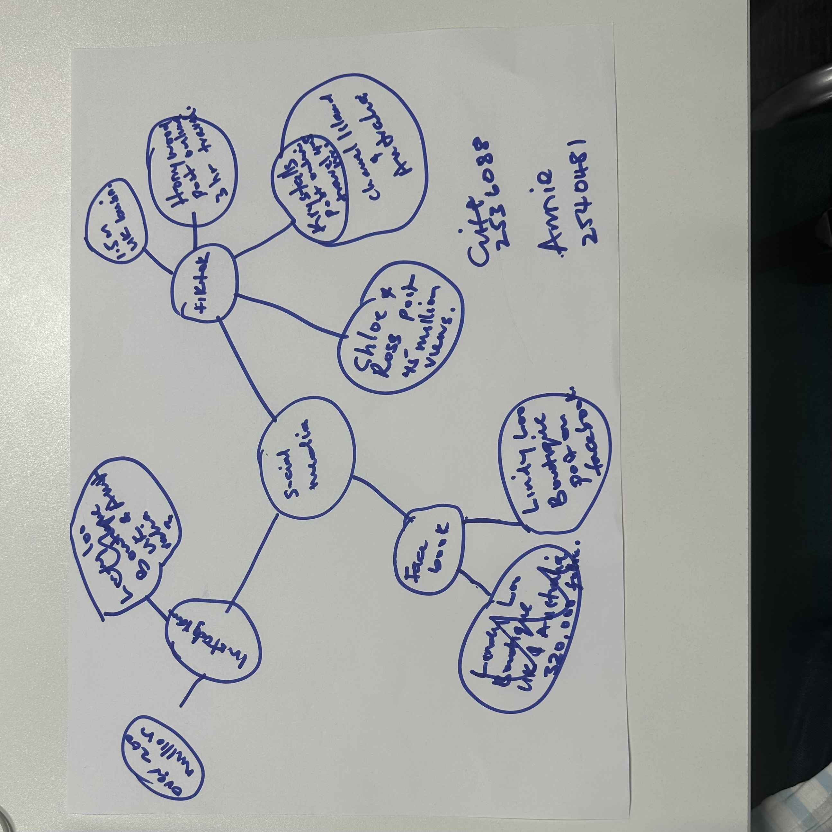

1. Answer these questions using the sentence starters below
a. What is the main idea of the text?
The main idea is that sharing business information online has proved positive to business growth.
b. What are two key points?
One key point is posting business online is positive way of advertisement that brings in success.
Another key point is that people are willing to travel from far and wide to buy your products when there are proven reviews for an instance likes are a way people approve business online.
c. What part of the text did you find most important? Why?
The most important part is if you post it, they will come. The reason this is important is that without posting it online, people might not know what kind of business you do and that will limit the amount of people that do business with you. Posting with a positive altitude helps as well.
d. Was anything unclear or difficult to understand?
Nothing was unclear to me as online business growth has increased rapidly in recent years.
e. How did your group help you understand the text better?
My group helped me by explaining that the more awareness and good service we create in business the better it will pay off in the end and also the use of different platforms helped as well.
3. One sentence reflection
Question: What did you find challenging about this task?
The hardest part was drawing the diagram to show how social media influence business growth.

