University of Wales Trinity Saint Davids
Thermo-fluid Mechanics
ACMA 5011

Submission date 19/01/2026
Luke John (2320124)
Contents
Table of Figures 2
Part 1 3
1) 3
i) 3
ii) 3
iii) 3
2) 4
3) 5
i) 5
ii) 5
iii) 5
iiii) 5
4) 6
5) 6
6) 7
7) 7
8) 7
Part 2 8
Carnot’s Heat Engine concept 8
Carnot Cycle 9
Heat Pumps and Refrigerators 10
Part C 11
(i) 11
(ii) 12
(iii) 13

Table of Figures
Figure 1 Carnot Heat Engine (Parker, 2025) 8
Figure 2 Carnot Cycle (Mehul Bagaria, 2022) 9
Figure 3 Refrigerator System (Yan, 2022) 10

Part 1

1)

i)
Given that
$$P=1.5×{10}^{6} pa$$
$V=8×{10}^{-3} m^{3}$
$$R=8.31.{mol}^{-1}K^{-1}$$
$$T=127℃ or 127+273=400K$$
Then, using the ideal gas equation. $PV=nRT$ where n= number of moles, so$n=\frac{PV}{RT}=\frac{1.5×{10}^{6}×8×{10}^{-3}}{8.31×400}=3.61 moles$

ii)
Given that $N_{A}=6.023×{10}^{23}$ This is the number of molecules/particles in one mole.
$$3.61×6.023×{10}^{23}=2.174303×{10}^{24} molecules$$

iii)
$$n=\frac{mass}{moler mass} ≈ n×moler mass=mass$$
Molar mass is given as $32g$ so.
$3.61×32×{10}^{-3}=115.52×{10}^{-3} or 115.52g$
$\frac{115.52}{2.174303×{10}^{24}}=5.313×{10}^{-23}g$ Mass of one molecule of gas.

2)
In this ideal gas equation, the tube joining the two bulbs isn’t considered, as its volume is negligible and the mass of gas within the system is fixed.
B
273K
A
273K

Initially
VA=$2×{10}^{-3} M^{3}$ VB=$1×{10}^{-3} M^{3}$
PA=$1×{10}^{5} Pa$ PB=$1×{10}^{5} Pa$
TA= 273 K TB= 273 K
B
273K
A
500K

After heat
VA= $2×{10}^{-3} M^{3}$ VB=$1×{10}^{-3}M^{3}$
PA= P PB= P
TA= 500 K TB= 273 K

$$\left[\frac{PA×VA}{TA}\right]+\left[\frac{PB×VB}{TB}\right]=P\left[\frac{VA}{TA}+\frac{VB}{TB}\right]$$

$$\left[\frac{1×{10}^{5}×2{×10}^{-3}}{273}\right]+\left[\frac{1×{10}^{5}×1{×10}^{-3}}{273}\right]=P\left[\frac{2{×10}^{-3}}{500}+\frac{1×{10}^{-3}}{273}\right]$$

$$\left[\frac{2{×10}^{-3}}{500}+\frac{1×{10}^{-3}}{273}\right]=7.663×{10}^{-6}$$

$$P=\frac{300}{273×7.663{×10}^{-6}}$$

$$P=143.40{×10}^{3}$$

3)
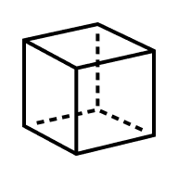

i)
Distance = Speed x Time
$$2l=u_{1}×t$$
$$2×1=500×t$$
$$t=\frac{2}{500}=4×{10}^{-3} or 0.004 Seconds$$

ii)
Momentum = mass x Velocity
Initial Momentum = $Mu_{1}=5×{10}^{-26}×500=2.5×{10}^{-23} kgms^{-1}$
Final Momentum =$-Mu_{1}=-5×{10}^{-26}×500=-2.5×{10}^{-23} kgms^{-1}$
Change in momentum = $Mu_{1}-(-Mu_{1})≈2Mu_{1}=2×2.5×{10}^{-23}$
$$=5× {10}^{-23} kgms^{-1}$$

iii)
$$Force= \frac{Change in Momentum}{Time Between Collisions}=\frac{5×{10}^{-23}}{4×{10}^{-3}}=1.25×{10}^{-20}N$$
As 1/3 of the molecules are assumed to collide on each face.
1/3 of molecules = $9×{10}^{24}÷3=3×{10}^{24}$
Total force experienced on one face = $1.25×{10}^{-20}×3×{10}^{24}=37.5×{10}^{3} or 37.5 KN$

iiii)
$$Pressure One Face of the Box=\frac{force}{area}=\frac{37.5×{10}^{3}}{1^{2}}=37.5×{10}^{3} or 37.5 KPa$$

4)
As the mass of gas is fixed and the temperature is constant Boyle's law can be used, which states $p_{1 }v_{1}=p_{2}v_{2}$
$$2×{10}^{6}pa×v_{1}=p_{2}×\frac{v_{2}}{3}$$
$$p_{2}=6×{10}^{6}pa$$
In adiabatic processes, no heat enters or leaves the system. From the first law of thermodynamics, it can be shown that under such circumstances. $pv^{γ}=constant$
$$p_{2}v_{2}^{γ}=p_{3}v_{3}^{γ}$$
$$6×{10}^{6}×{(\frac{v_{2}}{3})}^{1.3}=p_{3}×{(v_{3})}^{1.3}$$
$$6×{10}^{6}×\frac{v_{2}^{1.3}}{3^{1.3}}=p_{3}×{v_{3}}^{1.3}$$
$$\frac{6×{10}^{6}}{3^{1.3}}=p_{3}$$
$$p_{3}=1.44 Mpa$$

5)
The First Law of Thermodynamics states that energy is conserved $∆Q=∆U+∆W$. Therefore, the change in internal energy is $∆U=∆Q-∆W$
$$∆U=800-375=425 J$$

6)
$η_{Carnot}=(\frac{T_{1-T_{2}}}{T_{1}}) ×100\%$
- $\left(\frac{100×500}{1000}\right)×100\%=50\%$

- $\left(\frac{T×300}{T}\right)×100\%=50\%$

$$\frac{1}{2}=\left(\frac{T-300}{T}\right)$$

$$T=2\left(T-300\right)$$

$$T=2T-600$$

$$600=2T-T$$

$$T=600K$$

7)
The maximum efficiency of a Carnot heat engine is given by
$η_{Carnot}=\frac{work done over one cycle}{heat taken in at high temp} ≈ η=\frac{Q_{1}-Q_{2}}{Q_{1}}×100\%$
$$η_{Carnot}=\frac{10,000-2,000}{10,000}×100\%=80\%$$

8)
The formula for entropy is given as $∆S=\int_{1}^{2}{\frac{∆Q}{T}}$
$$∆S=\int_{373K}^{573K}{mc_{w}\frac{dT}{T}}$$
$$∆S=mc_{w}\int_{373K}^{573K}{\frac{dT}{T}}$$
$$∆S=10×4.20×{10}^{3}×(lnT)_{373K}^{573K}$$
$$∆S=42×{10}^{3}×\ln\left(573\right)-\ln\left(373\right)$$
$∆S=42×{10}^{3}×\ln\left(\frac{573}{373}\right)JK^{-1}$

Part 2

Carnot’s Heat Engine concept
At the start of the 19th century, research into the efficiency and work that could be produced by a steam engine was a critical technological problem. Due to the misconception of heat, many theories arose, such as air engines could outperform steam due to the fact that they avoided the latent heat of vaporisation. In 1824, Sadi Carnot resolved this problem with a unifying principle. This is an abstract heat engine that absorbs heat at $Q_{H}$ from a hot reservoir at a temperature $T_{H}$. This then produces useful work (W) and rejects heat. $Q_{C}$ to a colder reservoir at a temperature $T_{C}$ As seen in Figure 1, the formula for work done is $W=Q_{H}-Q_{C}.$ Carnot realised that without a cold reservoir, continuous operation was impossible, no matter the engine design or the working substance used. Carnot’s crucial insight was that the heat engine should be reversible and be able to convert work done to heat and restore the high-temperature reservoir to its original heat. From this, he formulated his principle: no heat engine operating between two temperatures can be more efficient than a reversible one working between the same temperatures. A consequence of Carnot’s principle is that all heat engines have the same efficiency. Therefore, the efficiency is a universal function of the temperatures of the heat reservoirs alone. This is demonstrated by$η=\frac{T_{H}-T_{C}}{T_{H}}=1-\frac{T_{C}}{T_{H}}$ (Jaynes and John, 1996). This is in line with the first law of thermodynamics, which states that the net work done is equal to the net heat transferred. This gives the mathematical efficiency of any thermodynamic cycle.
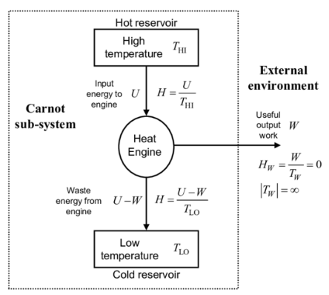
QC
QH
Figure 1 Carnot Heat Engine (Parker, 2025)

Carnot Cycle
The Carnot cycle works on two processes: isothermal and isentropic. Isothermal means the temperature in the process remains constant. Isentropic: This is an ideal theoretical thermodynamic process in which the entropy remains constant. It is both adiabatic (no heat transferred across boundaries) and reversible (frictionless with no internal irreversibility) (Mehul Bagaria, 2022). In Figure 2, the 4 stages of the Carnot cycle are shown. 1-2 isothermal expansion at this stage, the working fluid is introduced to the hot reservoir. The gas expands as heat is slowly absorbed from QH. The temperature remains constant, and the absorbed heat is entirely converted into heat. 2-3 isentropic expansion. At this stage, the system is thermally insulated, and no heat is transferred. The gas continues to expand, doing work using its internal energy. The temperature drops from $T_{H}$ to $T_{C}$ and the entropy remains constant. 3-4 isothermal compression, the working fluid comes in contact with the cold reservoir. At this point, the gas is compressed slowly. Heat $Q_{C}$ is rejected to the cold reservoir, and the temperature remains constant. 4-1 isentropic compression, this is the final stage of the cycle. At this stage, the system is thermally insulated again, and external work is done on the gas. The temperature rises back from $T_{C}$ to${ T}_{H}$ The entropy remains constant.
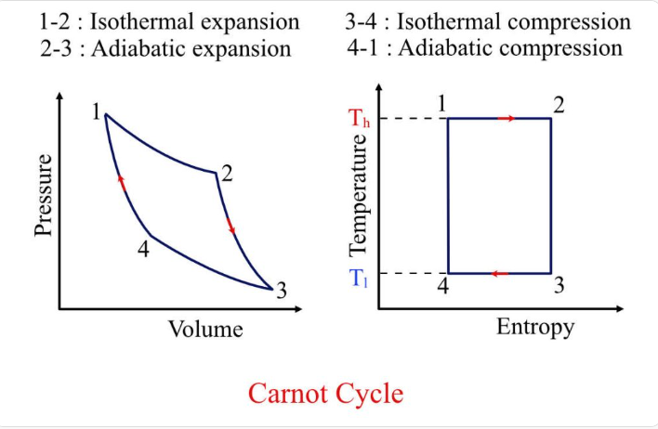
Figure 2 Carnot Cycle (Mehul Bagaria, 2022)
In reality, a heat engine cannot be reversible. This is due to internal and external irreversibilities such as friction. In Carnot’s heat engine, the pistons are frictionless, whereas in reality, there is friction throughout the system, causing losses. Another reason is bypass heat leak, where heat is lost from the system by radiation and air transfer, as Carnot's system relies on adiabatic processes. Turbulence is created within the working liquid and gases of actual heat engines; the amount produced will vary, unlike Carnot’s engine, in which entropy is constant. Real heat engines have non-quasi-static compression and expansion processes, in which the system changes rapidly between states. This process causes pressure and temperature changes, which also produce a large amount of entropy within the system (Chen, Li and Sun, 2007).
All these irreversibilities also mean that real engines cannot achieve the same efficiency as Carnot’s engine. This is a direct result of the second law of thermodynamics. The second law states: the total entropy of an isolated system can never decrease. $ΔS >0$. As Carnot’s engine is isentropic, the entropy is constant. $∆S=0$. The heat lost or dumped in a Carnot engine represents the minimum amount. It is far higher in real engines; this is why Carnot’s engine represents the upper end of efficiency according to the second law (Zhou et al., 2004).

Heat Pumps and Refrigerators
When the Carnot cycle is reversed, the same system acts as a heat pump or refrigerator. Instead of taking heat from a hot reservoir and rejecting it into the cold, heat is taken from the cold reservoir and rejected into the hot. This is achieved by adding work to the system, as shown in Figure 3, unlike the Carnot heat engine, which produces work. In heat pumps and refrigerators, the work is provided by a compressor driven by an electric motor. This compresses the working fluid, and as a result, the pressure and temperature of the working fluid are increased. This then allows the fluid to reject heat to the hot reservoir. This does not violate the second law of thermodynamics, as the heat is forced to flow from cold to hot by adding external work. Entropy is also created within the system, keeping it below its ideal Carnot limits. Another apparent contradiction is that heat pumps and refrigerators are evaluated by their coefficient of performance (COP), which can exceed 1 or unity. For refrigerators, the is given as $COP=\frac{Q_{C}}{W}$ and for heat pumps, this is given as $COP=\frac{Q_{H}}{W}$. This is because these systems move heat rather than convert it into work, so they don’t violate the first law of thermodynamics (Çengel, Boles and Mehmet Kanoglu, 2020).
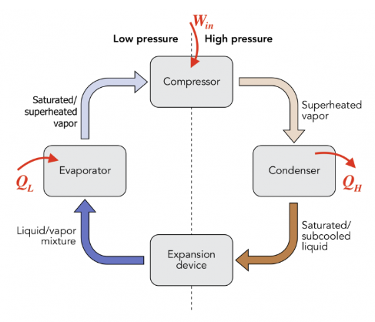
Figure 3 Refrigerator System (Yan, 2022)

Part C

(i)
An ideal gas is a theoretical model. In this model, the volume of the gas molecules is negligible compared to the volume occupied by the gas. The force of attraction and repulsion between the individual gas molecules and the container is also assumed to be negligible. For an ideal gas, the gas molecules undergo perfectly elastic collisions with each other and the container. This means that no energy is lost during a collision. The motion of the particles is random and constant, obeying Newton's laws. The mathematical equation for an ideal gas is $PV=nRT$. This accurately describes gas behaviour at high temperature and low pressure.
Were
P = pressure
V = volume
n = number of moles
R = universal gas constant
T = absolute temperature (K)
It can be modified to the Van Der Waals equation, which is $\left(P+\frac{{an}^{2}}{V^{2}}\right)\left(V-nb\right)=nRT.$ This introduces two corrective terms, each addresses a physical limitation of the ideal gas model. First is $+\frac{{an}^{2}}{V^{2}}$ The pressure correction term, in real gases, the attractive intermolecular forces reduce the force that molecules collide with the container walls. As a result, the pressure measured is lower than that predicted by the ideal gas law. a = the strength of the intermolecular attractions. The stronger the attraction, the higher the value of a. Such as in easily liquefiable gases. The second is the volume corrective term $-nb$. This is because gas molecules occupy a finite volume, which reduces the space available for the molecules to move. The ideal gas law considers molecules as point masses with negligible volume. This term subtracts from the volume in the ideal gas equation. The b represents the excluded volume per mole relative to molecular size. At low pressure and high temperature Van Der Waals equation reduces to the ideal gas equation $PV=nRT$ as $\frac{{an}^{2}}{V^{2}}=0$ and $nb=0$ At high pressure and low temperature, the Van der Waals corrections become significant, providing greater accuracy (Moran et al., 2018).

(ii)
The ideal gas model is a consequence of the assumptions made in kinetic theory. Due to the assumption that gases are large numbers of point molecules that are in constant random motion. They have a negligible molecular volume with no intermolecular forces that experience perfectly elastic collisions. Kinetic theory gives a microscopic explanation for the macroscopic behaviours of an ideal gas. Kinetic theory states that gas pressure is caused by continual elastic collisions of the molecules with the container walls (Lower, 2015). The average pressure caused by the force of these collisions is given by
$$P=\frac{1}{3}\frac{Nm}{V}\left(c^{2}\right)$$
The number of molecules is given by N, and their mass is m, finally ($c^{2})$ is the mean square molecular speed.
The ideal gas equation relates to temperature, volume and pressure on the macroscopic scale. It is given as $PV=NkT$. To relate this to the kinetic theory for pressure, it needs to be rearranged.
$$P=\frac{NkT}{V}$$
Where k is the Boltzmann constant. Since both equations represent the same pressure, they can be set as equal. $\frac{1}{3}\frac{Nm}{V}\left(c^{2}\right)=\frac{NkT}{V}$ This then becomes $m\left(c^{2}\right)=3kT$ after removing the like terms and fractions.
Using kinetic theory, the average kinetic energy of the molecules moving at speed c is given as $\left(E_{k}\right)=\frac{1}{2}m\left(c_{2}\right)$. When combined with what was derived earlier, we get $\left(E_{k}\right)=\frac{1}{2}(3kT)$. The factor 3 arises from the fact that molecular motion happens in three independent spatial directions, each contributes $\frac{1}{2}kT$ to the average kinetic energy. The final equation is.
$$\left(E_{k}\right)=\frac{3}{2}kT$$
This shows that in an ideal gas, temperature is a direct measure of molecular kinetic energy, and the absence of intermolecular forces ensures that the internal energy depends only on temperature. This does not depend on gas type and applies to all ideal gases. This states that as the temperature rose, so would the kinetic energy, which also means that at absolute zero (0 K), there would be absolutely no molecular motion at all (Moran et al., 2018).

(iii)
At constant pressure, the relationship between the root-mean-square (rms) speed of molecules in an ideal gas and the gas density can be derived from kinetic theory. According to kinetic theory the pressure of an ideal gas is expressed as.
$$P=\frac{1}{3}ρc_{rms}^{2}$$
Where P is the pressure, $ρ$ is the density and $c_{rms}^{2}$ is the root-mean-square molecular speed. To rearrange this equation to give the $c_{rms}$ would be.
$$c_{rms}= \sqrt{\frac{3P}{ρ}}$$
This equation shows that for a system that is at constant pressure, the rms speed is inversely proportional to the square root of the density of the gas $c_{rms}∝\frac{1}{√ρ}$. Under the same pressure conditions, gases with lower densities have higher molecular speeds, and gases with higher densities have lower molecular speeds. This relationship can also be linked to the molar mass of an ideal gas. For this, the rms is given by.
$$c_{rms}=\sqrt{\frac{3RT}{M}}$$
In this equation, R is the universal gas constant, T is the absolute temperature, and M is the Molar mass. At a constant temperature, this gives $c_{rms}∝\frac{1}{√M}$. This demonstrates that the rms is inversely proportional to the square root of the Molar mass. As the density of an ideal gas is given by $ρ=\frac{PM}{RT}$ Density is directly proportional to Molar mass at constant pressure and temperature. Demonstrating the inverse relationship between rms speed and density.
This leads to Graham's Law, which states that the rate of diffusion/effusion of a gas is inversely proportional to the square root of its Molar mass, or equivalently, its density.
$$r∝\frac{1}{√M}\sim r∝\frac{1}{√ρ}$$
For two gases at the same temperature and pressure, this would be.
$$\frac{r_{1}}{r_{2}}=\sqrt{\frac{M_{2}}{M_{1}}}=\sqrt{\frac{ρ_{2}}{ρ_{1}}}$$
This principle is used for gas separation, where gases with lighter molecules diffuse or effuse more rapidly through a porous barrier. This allows a partial separation based on molecular mass. The gas that emerges on the other side is enriched with the lighter component, while the gas left behind is enriched with the heavier one. A single diffusion or effusion stage only produces a small amount of separation. But if repeated, it can significantly increase the concentration difference between the mixtures (Çengel, Boles and Mehmet Kanoglu, 2020).

References List
ÇengelY.A., Boles, M.A. and Mehmet Kanoglu (2020). Thermodynamics: an engineering approach. Singapore: Mcgraw-Hill Education.
Chen, L., Li, J. and Sun, F. (2007). Generalized irreversible heat-engine experiencing a complex heat-transfer law. Applied Energy, [online] 85(1), pp.52–60. doi:https://doi.org/10.1016/j.apenergy.2007.06.001.
Jaynes, E. and John, S. (1996). THE EVOLUTION OF CARNOT’S PRINCIPLE*. [online] 7, p.1996. Available at: https://bayes.wustl.edu/etj/articles/ccarnot.pdf?utm [Accessed 2 Jan. 2026].
Lower, S. (2015). Basics of Kinetic Molecular Theory. [online] Chemistry LibreTexts. Available at: https://chem.libretexts.org/Bookshelves/Physical_and_Theoretical_Chemistry_Textbook_Maps/Supplemental_Modules_%28Physical_and_Theoretical_Chemistry%29/Physical_Properties_of_Matter/States_of_Matter/Properties_of_Gases/Kinetic_Theory_of_Gases/Basics_of_Kinetic_Molecular_Theory [Accessed 12 Jan. 2026].
Mehul Bagaria (2022). Carnot Efficiency | Formula, Derivation & Explanation - eigenplus. [online] eigenplus. Available at: https://www.eigenplus.com/carnot-efficiency-formula-derivation-explanation/?utm [Accessed 4 Jan. 2026].
Moran, M.J., Shapiro, H.N., Boettner, D.D. and Bailey, M.B. (2018). Fundamentals of engineering thermodynamics. 9th ed. Hoboken, Nj: John Wiley & Sons, Inc.
Parker, M.C. (2025). Differential temperature Carnot heat analysis shows that computing machines are thermodynamically irreversible. [online] Researchgate.net. Available at: https://www.researchgate.net/publication/222011943_Differential_temperature_Carnot_heat_analysis_shows_that_computing_machines_are_thermodynamically_irreversible [Accessed 2 Jan. 2026].
Yan, C.Y. (2022). 6.2 Refrigerator and heat pump. pressbooks.bccampus.ca. [online] Available at: https://pressbooks.bccampus.ca/thermo1/chapter/6-2-refrigerator-and-heat-pump/ [Accessed 7 Jan. 2026].
Zhou, S., Chen, L., Sun, F. and Wu, C. (2004). Optimal performance of a generalized irreversible Carnot-engine. Applied Energy, [online] 81(4), pp.376–387. doi:https://doi.org/10.1016/j.apenergy.2004.09.009.

