

Module: Quality Assurance and Service Improvements
Module code: LCHS7006
Lecturer: Shepherd Ziko
Assignment Title: Component 2Service Improvement Reports
Student Name:- Patel Jayminkumar Vishnubhai
Student ID :- 2432127

Table of Contents
Introduction 3
Background to the Case Study 3
Identified Quality Issue 3
Aim, Scope and Research Questions 3
Evidence Base and Sources 4
Main Body 4
Integration of key theoretical concepts and rationale for selection 4
Root Cause Analysis using the Fishbone (Ishikawa) Framework 6
5 Whys analysis of a representative harm case 7
Application of the Donabedian model 8
SWOT Analysis of Mid Staffordshire NHS Foundation Trust 9
PESTLE Analysis and its Impact 10
Recommendations and Implementation Strategy Informed by Six Sigma 11
Conclusion 12
Reference List 14

Introduction

Background to the Case Study
The threat to health care quality failures in the United Kingdom was centred on Mid Staffordshire NHS Foundation Trust (While, 2015). During 2005 through 2009, Stafford Hospital patients were being subjected to negligence and unsafe care that was prevalent (BBC, 2013). The following investigations estimated that between 400 and 1,200 additional patients expired than would otherwise have been anticipated given the size and case mix of the hospital (Theguardian, 2015). The case is a significant issue of public health quality as it showed how institutional lapses due to leadership, governance, and care provision issues resulting massive damage in a publicly funded health sector (Dyer, 2011). The incident happened in the National Health Service, a body that is an eminency to deliver safe, equitable, and high-quality care, and the consequences are therefore very critical at a national level.

Identified Quality Issue
The major quality problem in Mid Staffordshire involved cases of lack of basic standards of care persisted (Dixon-Woods, 2024). Patients had no proper assistance with daily chores care providing, hygiene was not considered, and pain and distress were often overlooked. The level of staffing was not sufficient with overstretched working hours for existing staffs. Staffing requirements were often neglected with hiring of inexperienced or unaware staffs (Martin et al., 2023). Patient and family complaints were ignored on several occasions, with performance targets and financial balance being given precedence over patient safety. Such failures were the direct cause of preventable patient injuries, health outcome worsening, and unnecessary death (Francis, 2013). The Francis Inquiry made a conclusion that poor care was not caused by singular individual mistakes but was a symptom of serious organisational and cultural issues throughout the Trust.

Aim, Scope and Research Questions
Aim
The purpose of this report is to critically discuss quality failure at Mid Staffordshire NHS Foundation Trust, and to suggest an evidence-based service improvement plan that can be applied in health and social care organisations in the United Kingdom.
Scope
The report is going to cover the analysis of the organisational structure, care processes and care outcomes associated with patient safety and quality.
Research Question
The report aims to answer three main research questions;
- What was the root causes of the quality failures within the Mid Staffordshire?
- How do an inadequate leadership, governance and care process lead to patient harm?
- What best quality improvement strategy that would help in averting such failures in NHS organisations?

Evidence Base and Sources
The report is a product of strong and valid evidence. The first is the public inquiry conducted by Robert Francis, which gives a detailed result of failures in care, breakdown in governance and regulatory control. Theoretical analysis is supported by using peer-reviewed academic literature on the topic of healthcare quality, patient safety culture and organisational failure (Connors et al., 2021). The improvement recommendations are informed by regulatory and policy recommendations provided by NHS England, the Care Quality Commission and the Department of Health and Social Care (NHS England, 2015). Collectively, these sources will make the analysis credible, contextually relevant and in accordance with the standards of the UK health system.

Main Body

Integration of key theoretical concepts and rationale for selection
This section brings together the main theoretical concepts that have been employed in the analysis of the quality failure at Mid Staffordshire NHS Foundation Trust and gives a clear explanation as to why it has been selected. Healthcare quality management theories, safety culture, governance and leadership theories are key to the explanation of large-scale failure in an organisation in the context of health and social care (Yang et al., 2025; Naz et al., 2022). These frameworks are prevalent in NHS research and policy nowadays and can thus be used to analyse a nationally high-profile case.
The Structure, Process and Outcome model by Donabedian is noted as the main quality framework since it allows applying a systematic analysis of the impact of organisational arrangements on the care delivery and patient outcomes (Tossaint-Schoenmakers et al., 2021; McCullough et al., 2023). Recent literature stresses that the model is still very pertinent to evaluate NHS quality failures because it is the direct connection between staffing, infrastructure and governance with clinical processes and outcomes, including mortality and patient harm. Poor care processes and unacceptable outcomes, such as a staffing shortage and weak governance, are structural weak points, which in the Mid Staffordshire case were translated into an explanatory power of the model (Umoren et al., 2024; Bellass et al., 2024).
The theory of safety culture is also incorporated due to its explanations of how unsafe behaviour is made normalised in healthcare organisations (Kaya et al., 2023; Maben et al., 2023). Recent sources of literature emphasise the fact that lack of psychological safety, ineffective reporting of incidents and fear of blame are closely linked to patient neglect and avoidable harm in the NHS hospitals (Cooper et al., 2017; Woo and Avery, 2021). It has been demonstrated that these factors are present at Mid Staffordshire, because employee issues lacked activism and patient complaints were disregarded (Rafferty and Leary, 2023; Martin, Chew and Dixon-Woods, 2021). The safety culture theory can thus be used to explain why warning signs were not taken into immediate action (Hald et al., 2025; Van Daelet al., 2021).
Theories of governance and leadership roles are critical to describe accountability failures at the board level. The literature since 2018 shows that NHS organisations whose clinical leadership is weak and target-oriented governance are more prone to deteriorating the quality of care (Vaughn et al., 2019; Al Anwer Ashour, Banakhar and Elseesy, 2022). Empathic and accommodating leadership paradigms are the opposite of the command-and-control style that can be seen in the Mid Staffordshire (Lynas, 2015; England.nhs.uk, 2017). This critical assessment indicates that there is no greater theory that can be used to postulate the failure alone. Rather, it can be seen that the integration of the quality management, safety culture and governance theories offers an evidence-based and holistic approach to the case analysis and educating the efficient service enhancement.

Root Cause Analysis using the Fishbone (Ishikawa) Framework
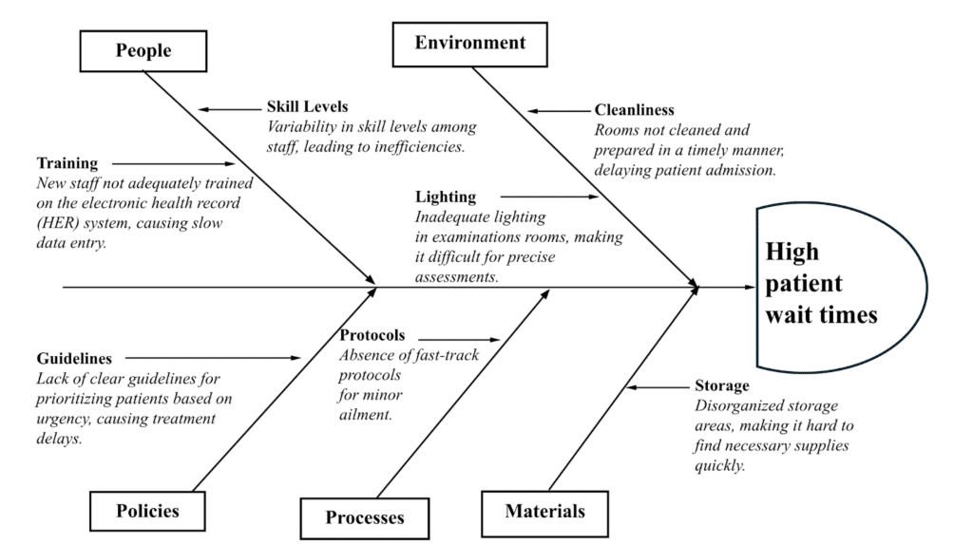
Figure 1: Fishbone Diagram
(Source: Yardley et al., 2022)
The Fishbone analysis identifies the quality failure at Mid Staffordshire as not being the result of an individual factor but a series of lacks relating to the organisation. The ability of the Trust to provide safe care was also minimised by chronic understaffing and a poor skill mix under the People category (Yardley et al., 2022; Ramsey et al., 2022). The Francis Inquiry evidence proves that nurses often had to handle the surplus patient load, which resulted in the failure to provide care and timely address the needs of patients (Martin and O’Hara, 2025; Blakeway, 2024).
These risks were further aggravated by failed processes. Basic nursing tasks, including taking care of patients (feeding and drinking), were not prioritised as care processes and were not monitored systematically (Robb and Bailey, 2025; Ireton, 2025). The procedures of incident reporting and complaints were weak, and numerous damages were done, but no corrective measures were taken.
Causes of policy are a strategic conflict between patient safety and organisational priorities. The Trust was focused on reaching the foundation trust status and attaining national performance targets, which did not encourage investment in staffing and quality improvement (Ham, 2022; Lapsley, 2022). This policy emphasis undermined the safety and quality agenda at the operational levels.
Poor hygiene conditions and overcrowded wards predisposed patients to vulnerability, especially the elderly patients (Jones et al., 2022; Brouwers, 2023). Such pressures increased the workload of the staff and lowered the capacity to provide compassionate care.
Failure in governance is the most severe root cause. The board did not read mortality signs well and acted upon internal and external red flags. Unsafe practices were allowed to continue due to the lack of accountability and weak clinical leadership (Spring et al., 2024; Chambers and Taylor, 2021). The Fishbone analysis reveals that the failure of the Mid Staffordshire was endemic, and the failure across people, process, policy and environment was fuelled by the weaknesses in governance.

Five Whys analysis of a representative harm case
One of the harm cases that were repeatedly found in the Francis Inquiry was the case of elderly patients who were severely dehydrated and malnourished at the time of admission to Stafford hospital (BBC, 2013a; Theguardian, 2011). This injury was chosen as poor hydration and nutrition were some of the most commonly mentioned failures and straightforwardly led to patient decline and preventable mortality.

Why level | Question asked | Evidence-based explanation aligned to the case
Why 1 | Why did the patient experience dehydration and malnutrition | The patient was not regularly assisted with eating and drinking, and fluid intake was not monitored on the ward (Theguardian, 2011a; Francis, 2013b)
Why 2 | Why was assistance with nutrition and hydration not provided | Nurses and healthcare assistants were responsible for excessive numbers of patients, and essential care tasks were deprioritised (Campbell, 2013)
Why 3 | Why were staff responsible for unsafe workloads | Registered nurse staffing levels were persistently below safe standards, and wards relied heavily on untrained support staff (Griffiths et al., 2020; Ball, 2020)
Why 4 | Why we’re staffing levels allowed to remain unsafe | Senior management focused on financial control and meeting national performance targets, limiting recruitment and agency use (Anandacivaet al., 2018; García-Lacalleet al., 2020)
Why 5 | Why were financial targets prioritised over patient safety | Governance and leadership systems failed to embed safety and quality as core objectives, and board oversight of care standards was ineffective (Moffatt-Bruce et al., 2018; Leggat and Balding, 2019)
Table 1: 5-Why Framework
(Source: Griffiths et al., 2020)
This discussion shows that what the clinical harm was of concern was not immediate clinical harm but rather strategic, governance failure. Staffing shortage was one of the foreseeable consequences of organisational choices prioritising financial targets over basic standards of care. The 5 Whys analysis shows a clear correlation between frontline patient harm and leadership priorities and governance failures that support the idea that a system-level quality improvement is necessary, as opposed to individual corrective measures.

Application of the Donabedian model
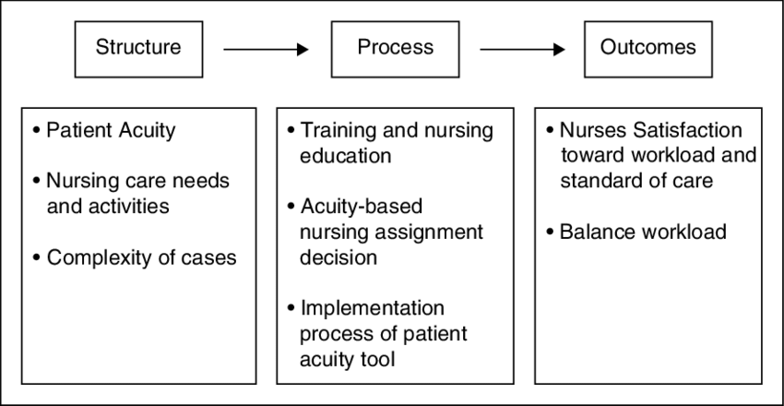
Figure 2: Donabedian's quality framework
(Source: Al-Dweik, G. and Ahmad, 2019)
The Donabedian model offers a definite pattern of investigating the quality failure in Mid Staffordshire NHS Foundation Trust through the organisational conditions that affected the care delivery and patient results (Ham, 2023). This model is especially topical as it is common in the NHS to assess the quality of service and patient safety.
Structure is the organisational foundation to provide safe care, such as staffing, leadership, resources and governance systems. Structural weaknesses could be observed at Mid Staffordshire. The nurse staffing was also consistently inadequate, and an inappropriate skill mix was observed in most wards (Lawless et al., 2019; BBC, 2013c). There was poor clinical leadership, and governance arrangements were not designed to focus on patient safety. The members of the board were not adequately qualified in clinical skills and did not adequately question mortality rates and quality measures. Such weaknesses in the structure diminished the ability of the Trust to provide safe and compassionate care.
Process is associated with the care delivery to patients. At Mid Staffordshire, the basic level of care processes was not met. Patients had not been regularly aided in eating, drinking or toileting, and vital signs had not been regularly checked or increased when patients became worse (Theguardian, 2009; Kapur, 2014). The procedures of complaints and incident reporting were not effective in that bad care was continuously reported without being rectified. There was a restricted flow of information between the staff and management; hence, learning through mistakes was not possible.
Outcome focuses attention on the consequences of patient and organisational care. The consequences of the Mid Staffordshire incident were both preventable patient injuries, unnecessary deaths that ranged between 400 and 1,200, and loss of dignity and trust (NHS.uk, 2019; BBC, 2019). The reputational harm was not confined to the Trust alone, but also helped in national changes to regulate the NHS. All in all, the Donabedian model shows clearly how structural and process malfunctions in Mid Staffordshire directly caused unacceptable patient outcomes.

SWOT Analysis of Mid Staffordshire NHS Foundation Trust
Strengths | Weaknesses
Established NHS funding and national care framework | Chronic nurse understaffing and poor skill mix
Access to national clinical guidelines and standards | Weak governance and limited clinical leadership
Availability of external regulatory oversight | Poor incident reporting and complaints handling
Opportunities | Threats
National patient safety reforms following the Francis Inquiry | Rising demand from an ageing population
Learning from high-performing NHS trusts with strong safety records | Persistent NHS workforce shortages
Strengthened Care Quality Commission inspection regime | Financial pressures and budget constraints
Table 2: SWOT Analysis
(Source: NHS.uk, 2019)
This SWOT analysis reveals that, though Mid Staffordshire was working in a robust national healthcare system, the organisation was crippled by internal organisational weaknesses that severely weakened its performance in providing safe care. Growth opportunities were realised because of changes in the country and national reforms, yet the external workforce and financial demands remained a threat.

PESTLE Analysis and its Impact
Factor | Impact on service quality at Mid Staffordshire
Political | Strong national emphasis on performance targets influenced management priorities
Economic | Tight financial controls led to staffing reductions and limited investment
Social | A high proportion of elderly patients has increased vulnerability and care complexity ( Springet al., 2024)
Technological | Limited use of real-time patient monitoring reduced the early detection of deterioration (Robb and Bailey, 2025)
Legal | Weak regulatory enforcement before reforms delayed intervention
Environmental | Overcrowded wards and poor physical conditions affected infection control and dignity (Bolouset al., 2023)
Table 3: PESTEL Analysis
(Source: NHS.uk, 2019)

The PESTEL analysis shows the interaction of the external system pressures and internal weaknesses. Cost control over patient safety was stimulated by political and economic factors, whereas social changes stimulated the growth of service demand. There were technological barriers to risk detection, and loopholes in the regulations diminished responsibility. These combined to increase organisational deficiencies and the extent of damage witnessed at Mid Staffordshire.

Recommendations and Implementation Strategy Informed by Six Sigma
Leadership and governance reform through Six Sigma
Patient safety and quality must be officially stated as the main strategic goals of the organisation as part of the Define stage of the Six Sigma. The governance systems on the board need to be reorganised, adding quantifiable indicators of quality like mortality rates, nurse staffing adherence, and serious incident trends (Ahmed et al., 2024; Jain et al., 2023). Measure phase: The measure phase requires the review of dashboards with standardised measures every month by a strengthened quality committee with clinical representation. The Analyse stage implies the systematic review of the variation in results in wards, which allows the discovery of the worsening quality early. During the Improve phase, the leadership development programmes on accountability and compassionate leadership are to be used. The Control phase assures sustainability by ensuring that it has regular external benchmarking and regulatory reporting.
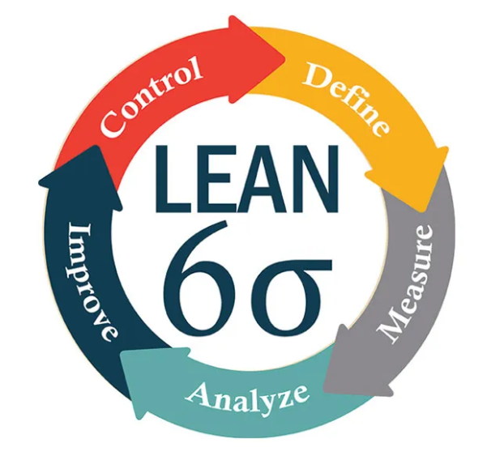
Figure 3: Six Sigma
(Source: TQMI, 2017)
Staffing and workforce planning using Six Sigma
The failures of staffing revealed during the Fishbone and 5 Whys analyses may be resolved by using workforce planning based on Six Sigma. During the Define phase, the safe staffing levels are set in consideration of the acuity of the patients as quality critical. The Measure step implies constant control of the nurse-to-patient ratios, mix of skills and sickness levels of staff (Antony et al., 2023; Jackson, 2022). Root causes of staffing fluctuation are determined during analysis, including rota inefficiency and delays in recruitment (Shah et al., 2023). Flexible staffing models and safeguarded escalation practices are some of the areas of improvement. The control mechanisms entail automatic staffing notifications and board-level audit to guarantee continued compliance.
Incident reporting and duty of candour through Six Sigma
Six Sigma favours the establishment of credible system reporting of incidents through minimisation of variation in a process, as well as underreporting caused by fear. The define phase explains the reason behind reporting as organisational learning and not as blame. Measure is concerned with frequency reporting and investigative time, and learning implementation rates (Robinson et al., 2022; Elsharkawy et al., 2025). The barriers to reporting and prolonged investigation are identified in the analysis. Among the things that can be improved is that the reporting processes can be streamlined and the learning reviews structured. Control is used to provide consistency in the form of an audit cycle and open feedback to staff and patients.
Redesign of care processes using Six Sigma
Analysis of Donabedian's process reveals that there are basic care failures, which can be decreased with the help of the Six Sigma process redesign. Define will define hydration, nutrition and observation reliability as quality characteristics that are critical (Russ et al., 2023; Blythe and Ross, 2022). Measure records the rates of compliance and patient harm. Variation in the care delivery across wards and shifts is identified through analysis. Some of the improvements involve workflows that are based on a checklist and standardised care bundles. A continuous check and corrective action, where variation recurs during the continuous check, brings about a measure of control.
Measurement, evaluation and sustainability
Sustainable improvement is based on a Six Sigma control plan. Outcome metrics, such as the harm rate and patient experience score, are measured alongside process measures, such as staffing compliance and compliance with care bundles (Kaplan et al., 2021; Pannunzio et al., 2024). Measures that are to be balanced, like staff turnover and workload, are followed to avoid the unintended effect. The implementation should be done in phases and with the assistance of a committed quality improvement team to make sure that the improvements are integrated into the governance systems. These recommendations are structured and sustainable measures of ensuring that future quality failures are not experienced in NHS organisations due to the constant application of Six Sigma principles.

Conclusion
The Mid Staffordshire NHS Foundation Trust failure analysis illustrates that the tragedy was not a single clinical oversight but rather the product of profound systemic vulnerabilities in organisational structure, care processes and governance. The combination of the Donabedian model, Fishbone and 5 Whys analyses demonstrates that chronic understaffing, ineffective leadership, ineffective incident reporting, and the misaligned organisational focus, based on performance targets instead of patient safety, were all the direct causes of preventable harm and loss of life. These internal weak points were further fuelled by external pressures, and an unsafe culture had normalised neglect and silenced early warning bells.
The analysis of the theories on the safety culture, quality management, and leadership under consideration proves that a significant enhancement is impossible to achieve without structural change, behaviour redesign, and regular functioning. Six Sigma offers an evidence-based, strong method of accomplishing this, and has a structured method of defining, measuring, analysing, enhancing, and managing critical factors that affect care quality. The implementation of safe staffing guidelines, improved governance, redesign of fundamental care processes, and encouraging open reporting of incidents can reduce the variation, improve accountability, and maintain good-quality care in NHS organisations.

Reference List
Ahmed, S., Hawarna, S., Alqasmi, I., Mohiuddin, M., Rahman, M.K. and Ashrafi, D.M., (2024). Role of Lean Six Sigma approach for enhancing the patient safety and quality improvement in the hospitals. International Journal of Healthcare Management, 17(1), pp.52-62.
Al Anwer Ashour, H.M., Banakhar, M.A. and Elseesy, N.A.E. (2022). Clinical leadership behaviors among critical care nurses in private and governmental hospital: A cross-sectional survey. International Journal of Nursing Sciences, 9(3), pp.357–363. doi:https://doi.org/10.1016/j.ijnss.2022.06.017.
Al-Dweik, G. and Ahmad, M., (2019). Matching Nursing Assignment to Patients' Acuity Level: The Road to Nurses' Satisfaction. Journal of Nursing Measurement, 27(1).
Anandaciva, S., Ward, D., Randhawa, M. and Edge, R., (2018). Leadership in today’s NHS. The Kings Fund NHS Providers, pp.1-84.
Antony, J., Lancastle, J., McDermott, O., Bhat, S., Parida, R. and Cudney, E.A., (2023). An evaluation of Lean and Six Sigma methodologies in the national health service. International Journal of Quality & Reliability Management, 40(1), pp.25-52.
Ball, J., (2020). Analysing the implementation and effects of safe staffing policies in acute hospitals. Nursing Management, 27(3).
BBC (2013a). Francis inquiry into Stafford Hospital cost government £6m. BBC News. [online] 18 Jul. Available at: https://www.bbc.com/news/uk-politics-23355195.
BBC (2013b). Stafford Hospital: the scandal that shames the NHS. BBC News. [online] 4 Feb. Available at: https://www.bbc.com/news/health-21244190.
BBC (2013c). Wards dangerously understaffed, say nurses in survey. BBC News. [online] 2 Feb. Available at: https://www.bbc.com/news/health-21310735.
BBC (2019). Stafford Hospital scandal: The real story behind Channel 4’s The Cure. BBC News. [online] 19 Dec. Available at: https://www.bbc.com/news/uk-england-stoke-staffordshire-50836324.
Bellass, S., Canvin, K., Farragher, T., McLintock, K., Wright, N., Hearty, P., Seanor, N., Cunningham, M., Foy, R. and Sheard, L., (2024). Understanding and improving the quality of primary care for people in prison: a mixed-methods study. Health and Social Care Delivery Research, 12(46), pp.1-329.
Blakeway, S., (2024). Primary care organisational culture and climate impact upon Paramedics. South West Clinical School Journal, 4(01), p.6.
Blythe, N. and Ross, S., (2022). Strategies to reduce waiting times for elective care. London: King's Fund.
Bolous, N.S., Graetz, D.E., Ashrafian, H., Barlow, J., Bhakta, N., Sounderajah, V. and Dowdeswell, B., 2023. Harnessing a clinician-led governance model to overcome healthcare tribalism and drive innovation: a case study of Northumbria NHS Foundation Trust. Journal of Health Organization and Management, 37(9), pp.1-16.
Brouwers, J., (2023). FINANCIAL IMPACT OF QUALITY INITIATIVES AND MANAGEMENT. Exploring the future of hospital quality management and policy in Flanders, p.107.
Campbell, D. (2013). Nurses must spend a year on basic care. [online] the Guardian. Available at: https://www.theguardian.com/society/2013/mar/26/nurses-basic-care-training.
Chambers, N. and Taylor, J., (2021). Organising care around patients: Stories from the frontline of the NHS (p. 239). Manchester University Press.
Connors, E.H., Douglas, S., Jensen-Doss, A., Landes, S.J., Lewis, C.C., McLeod, B.D., Stanick, C. and Lyon, A.R., (2021). What gets measured gets done: How mental health agencies can leverage measurement-based care for better patient care, clinician supports, and organizational goals. Administration and Policy in Mental Health and Mental Health Services Research, 48(2), pp.250-265.
Cooper, J., Edwards, A., Williams, H., Sheikh, A., Parry, G., Hibbert, P., Butlin, A., Donaldson, L. and Carson-Stevens, A. (2017). Nature of Blame in Patient Safety Incident Reports: Mixed Methods Analysis of a National Database. The Annals of Family Medicine, [online] 15(5), pp.455–461. doi:https://doi.org/10.1370/afm.2123.
Dixon-Woods, M., (2024). Report to the Thirlwall Inquiry: addressing Part C of the Terms of Reference. Expert report), 28.
Dyer, C. (2011). Head of Healthcare Commission excised figures on excess deaths from Mid Staffordshire report. BMJ, 342(may06 2), pp.d2900–d2900. doi:https://doi.org/10.1136/bmj.d2900.
Elsharkawy, N.B., Alruwaili, A.N., Elsayed Ramadan, O.M., Alruwaili, M.M., Alhaiti, A. and Abdelaziz, E.M., (2025). Barriers to reporting workplace violence: a qualitative study of nurses’ perceptions in tertiary care settings. BMC nursing, 24(1), p.395.
England.nhs.uk (2017). Culture and Leadership Programme Phase 2 Phase 2: Design collaboration trust respect innovation courage compassion. [online] Available at: https://www.england.nhs.uk/wp-content/uploads/2021/08/Design-phase-guide.pdf.
Francis, R. (2013a). The Mid Staffordshire NHS Foundation Trust Public Inquiry Report of the Mid Staffordshire NHS Foundation Trust Public Inquiry Volume 1: Analysis of evidence and lessons learned (part 1). [online] Available at: https://assets.publishing.service.gov.uk/media/5a7c9bec40f0b65b3de09fde/0898_i.pdf.
Francis, R. (2013b). The Mid Staffordshire NHS Foundation Trust Public Inquiry Report of the Mid Staffordshire NHS Foundation Trust Public Inquiry Volume 3: Present and future Annexes. [online] Available at: https://assets.publishing.service.gov.uk/media/5a757141e5274a1622e21d13/0898_iii.pdf.
García-Lacalle, J., Royo, S. and Yetano, A., (2020). Stewards in an “Odd” kingdom: Performance and remuneration of the boards of directors of NHS foundation trusts. International Public Management Journal, 23(6), pp.770-797.
Griffiths, P., Saville, C., Ball, J.E., Ball, J., Chable, R., Dimech, A., Jones, J., Jeffrey, Y., Pattison, N., Saucedo, A.R. and Saucedo, A., 2020. The Safer Nursing Care Tool as a guide to nurse staffing requirements on hospital wards: observational and modelling study. Health and Social Care Delivery Research, 8(16), pp.1-162.
Ham, C., (2022). Governing the health and care system in England.
Ham, C., 2023. Improving health and care at scale. NHS Confederation, pp.2023-11.
Ireton, E., (2025). Framing, implementing, and monitoring public inquiry recommendations: a contextual briefing.
Jackson, C., (2022). Torbay and South Devon NHS Foundation Trust Integrated Workforce Education Strategy Report-Key Findings and Recommendations.
Jain, A.R.V.I.N.D., Sharma, R.E.E.N.A. and Jamali, M.C., (2023). Lean and six sigma in healthcare: examining the impact on patient safety and quality of care. Seybold Report, 18, pp.2680-2695.
Jones, A., Maben, J., Adams, M., Mannion, R., Banks, C., Blake, J., Job, K. and Kelly, D., (2022). Implementation of'freedom to speak up guardians' in NHS acute and mental health trusts in England: the FTSUG mixed-methods study. Health and Social Care Delivery Research, 10(23), pp.1-124.
Kaplan, R.S., Jehi, L., Ko, C.Y., Pusic, A. and Witkowski, M., (2021). Health care measurements that improve patient outcomes. NEJM Catalyst Innovations in Care Delivery, 2(2).
Kapur, N. (2014). Mid Staffordshire Hospital Report - The British Psychological Society. [online] www.bps.org.uk. Available at: https://www.bps.org.uk/psychologist/mid-staffordshire-hospital-report.
Kaya, G.K., Ustebay, S., Nixon, J., Pilbeam, C. and Sujan, M., (2023). Exploring the impact of safety culture on incident reporting: Lessons learned from machine learning analysis of NHS England staff survey and incident data. Safety science, 166, p.106260.
Lapsley, I., 2022. Whatever happened to new public management?. Financial Accountability and Management, 38(4), pp.471-482.
Lawless, J., Couch, R., Griffiths, P., Burton, C. and Ball, J. (2019). Towards safe nurse staffing in England’s National Health Service: Progress and pitfalls of policy evolution. Health Policy, [online] 123(6). doi:https://doi.org/10.1016/j.healthpol.2019.03.011.
Leggat, S.G. and Balding, C., (2019). Bridging existing governance gaps: five evidence-based actions that boards can take to pursue high quality care. Australian Health Review, 43(2), pp.126-132.
Lynas, K. (2015). The leadership response to the Francis report. Future Hospital Journal, [online] 2(3), pp.203–208. doi:https://doi.org/10.7861/futurehosp.2-3-203.
Maben, J., Aunger, J.A., Abrams, R., Wright, J.M., Pearson, M., Westbrook, J.I., Jones, A. and Mannion, R., (2023). Interventions to address unprofessional behaviours between staff in acute care: what works for whom and why? A realist review. BMC medicine, 21(1), p.403. Hald, E.J., Gillespie, A. and Reader, T.W., 2025. Problems in dealing with problems: How breakdowns in corrective culture lead to institutional failure. British Journal of Management, 36(1), pp.73-90.
Martin, G. and O’Hara, J., (2025). Hope over experience? Patient and staff voice in the NHS after the Dash review. bmj, 390.
Martin, G., Stanford, S. and Dixon-Woods, M., (2023). A decade after Francis: is the NHS safer and more open?. bmj, 380.
Martin, G.P., Chew, S. and Dixon-Woods, M. (2021). Why do systems for responding to concerns and complaints so often fail patients, families and healthcare staff? A qualitative study. Social Science & Medicine, 287, p.114375. doi:https://doi.org/10.1016/j.socscimed.2021.114375.
McCullough, K., Andrew, L., Genoni, A., Dunham, M., Whitehead, L. and Porock, D., (2023). An examination of primary health care nursing service evaluation using the Donabedian model: A systematic review. Research in nursing & health, 46(1), pp.159-176.
Moffatt-Bruce, S., Clark, S., DiMaio, M. and Fann, J., (2018). Leadership oversight for patient safety Programs: an essential element. The Annals of thoracic surgery, 105(2), pp.351-356.
Naz, S., Saleem, S., Islam, Z.S., Bhamani, S. and Sheikh, L., (2022). Obstetric triage improvement process using the Donabedian model of quality care: a quality improvement initiative. BMJ Open Quality, 11(2), p.e001483.
NHS England (2015). NHS England» Care Quality Commission. [online] England.nhs.uk. Available at: https://www.england.nhs.uk/ourwork/part-rel/cqc/.
Nhs.uk (2019). Learning from the tragedy at Mid Staffordshire Hospital. [online] Available at: https://www.sth.nhs.uk/clientfiles/File/GoodHealth_0613_intranet.pdf.
Pannunzio, V., Morales Ornelas, H.C., Gurung, P., van Kooten, R., Snelders, D., van Os, H., Wouters, M., Tollenaar, R., Atsma, D. and Kleinsmann, M., (2024). Patient and staff experience of remote patient monitoring—what to measure and how: systematic review. Journal of Medical Internet Research, 26, p.e48463.
Rafferty, A.M. and Leary, A. (2023). Nursing notes on a scandal. Future Healthcare Journal, 10(1), pp.3–6.
Ramsey, S.M., Brooks, J., Briggs, M. and Hallett, C.E., (2022). Corporatising compassion? A contemporary history study of English NHS Trusts' nursing strategy documents. Nursing Inquiry, 29(4), p.e12486.
Robb, M.L. and Bailey, J., (2025). The politics of whistleblowing and the fight to cure the NHS: an interview with Julie Bailey. The Journal of Adult Protection.
Robinson, S., White, W., Wilkes, J. and Wilkinson, C., (2022). Improving culture of care through maximising learning from observations and events: Addressing what is at fault. Laboratory Animals, 56(2), pp.135-146.
Russ, S.J., Green, J., de Winter, L., Herrington, E., Hughes-Hallett, A., Taylor, J.M. and Sevdalis, N., 2023. An introduction to quality improvement. Journal of Clinical Urology, p.20514158221075405.
Shah, P., Dharmarajah, K., Chapman, A., Jamieson, K. and Macaulay, C., (2023). 648 The Good, The Bad and the Rota–solving workforce challenges and promoting flexible working through clinician-led innovative rostering technology.
Spring, C., Castro-Sánchez, E. and Wells, M., (2024). ‘The Emperor's new clothes?’Healthcare professionals’ perceptions of the nursing associate role in two UK National Health Service hospitals: A qualitative interview study. International Journal of Nursing Studies Advances, 7, p.100211.
Theguardian (2009). Hospital condemned over deaths after ‘appalling’ failures in care. The Guardian. [online] 17 Mar. Available at: https://www.theguardian.com/society/2009/mar/17/mid-staffordshire-nhs-trust.
Theguardian (2011a). Half of hospitals ‘failing to feed elderly patients properly’. The Guardian. [online] 8 Oct. Available at: https://www.theguardian.com/society/2011/oct/08/half-hospitals-not-feeding-elderly.
Theguardian (2011b). Neglect and indignity: Stafford hospital inquiry damns NHS failings. The Guardian. [online] 1 Dec. Available at: https://www.theguardian.com/society/2011/dec/01/stafford-hospital-inquiry-nhs-failings.
Theguardian (2015). Mid Staffs NHS trust charged over deaths of four patients. The Guardian. [online] 15 Oct. Available at: https://www.theguardian.com/society/2015/oct/15/mid-staffs-nhs-trust-charged-over-deaths-of-four-patients.
Tossaint-Schoenmakers, R., Versluis, A., Chavannes, N., Talboom-Kamp, E. and Kasteleyn, M., (2021). The challenge of integrating eHealth into health care: systematic literature review of the Donabedian model of structure, process, and outcome. Journal of medical Internet research, 23(5), p.e27180.
TQMI 2017. Transform Your Goals with Lean Six Sigma: Proven Powerful Methods. [online] TQMI. Available at: https://www.tqmi.com/blogs/lean-six-sigma-goals/ [Accessed 10 Dec. 2025].
Umoren, O.D., Olukotun, S.T.A., Kehinde, V.V., Okonkwo, C.J., Gbadebo, A.J. and Alani, O.A., (2024). Enhancing the acute ward's care quality through a safer staffing approach. Journal of Health, Applied Sciences and Management, 8(1), pp.96-105.
Van Dael, J., Gillespie, A., Reader, T., Smalley, K., Papadimitriou, D., Glampson, B., Marshall, D. and Mayer, E. (2021). Getting the whole story: Integrating patient complaints and staff reports of unsafe care. Journal of Health Services Research & Policy, 27(1), pp.41–49. doi:https://doi.org/10.1177/13558196211029323.
Vaughn, V.M., Saint, S., Krein, S.L., Forman, J.H., Meddings, J., Ameling, J., Winter, S., Townsend, W. and Chopra, V. (2019). Characteristics of healthcare organisations struggling to improve quality: results from a systematic review of qualitative studies. BMJ Quality & Safety, [online] 28(1), pp.74–84. doi:https://doi.org/10.1136/bmjqs-2017-007573.
While, A. (2015). Can We Learn from the Mid-Staffordshire Inquiry or Is It Always Someone Else’s problem? London Journal of Primary Care, [online] 7(2), pp.23–24. doi:https://doi.org/10.1080/17571472.2015.11493431.
Woo, M.W.J. and Avery, M.J. (2021). Nurses’ experiences in voluntary error reporting: An integrative literature review. International Journal of Nursing Sciences, [online] 8(4), pp.453–469. doi:https://doi.org/10.1016/j.ijnss.2021.07.004.
Yang, J., Liu, F., Yang, C., Wei, J., Ma, Y., Xu, L., Xie, J. and Wang, J., (2025). Application of Donabedian Three‐Dimensional Model in Outpatient Care Quality: A Scoping Review. Journal of Nursing Management, 2025(1), p.6893336.
Yardley, S., Williams, H., Bowie, P., Edwards, A., Noble, S., Donaldson, L. and Carson-Stevens, A., (2022). Which human factors design issues are influencing system performance in out-of-hours community palliative care? Integration of realist approaches with an established systems analysis framework to develop mid-range programme theory. BMJ open, 12(1), p.e048045.

