Assignment 2

Kristen Buller 2005063

Contents
1.Understanding NTFS and Share Permissions 2
1.1NTFS 2
1.2 5
1.3 6
2.1 7
GPO 1 7
GPO 2 9
GPO 3: 11
GPO 4 12
GPO 5 13
Task 2 14
1. 14
2. 15
3. 19
4. 22
Filter 1 22
Filter 2 23
Filter 3: 25
Task 3 27
Password Principles 27
Failover clustering 29
Network Policy 31
References 32

1.Understanding NTFS and Share Permissions

1.1NTFS

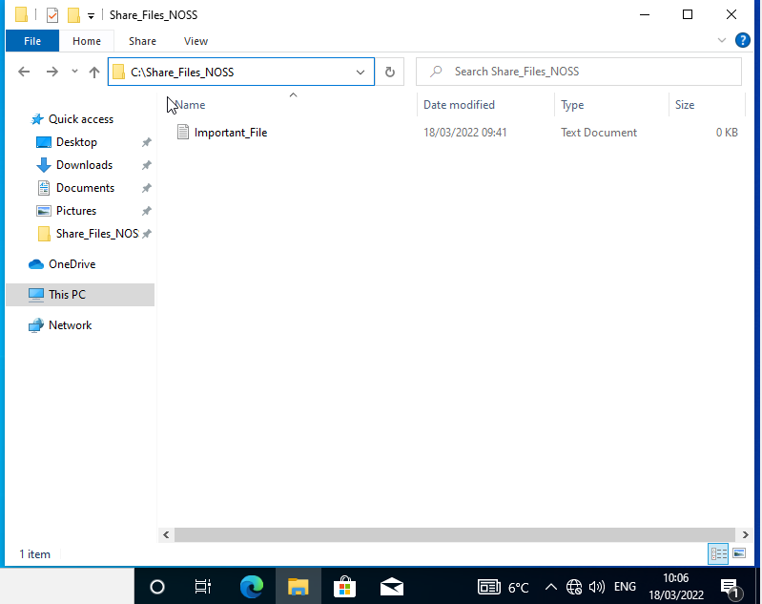
The text file has been created in share_files_noss, I will now set the permissions.
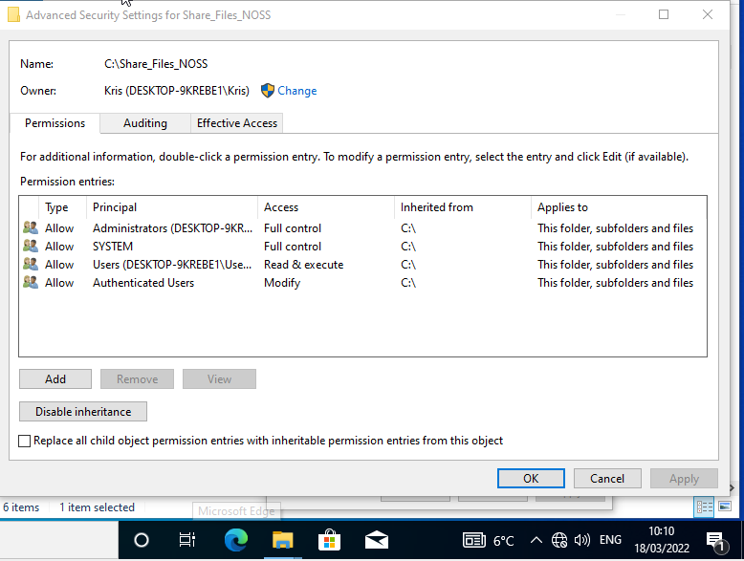
Inside the advance security settings for the folder, it shows who has access to the folder.
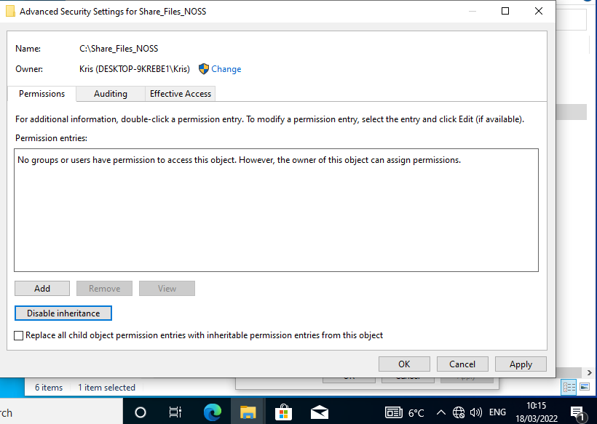
AFTER

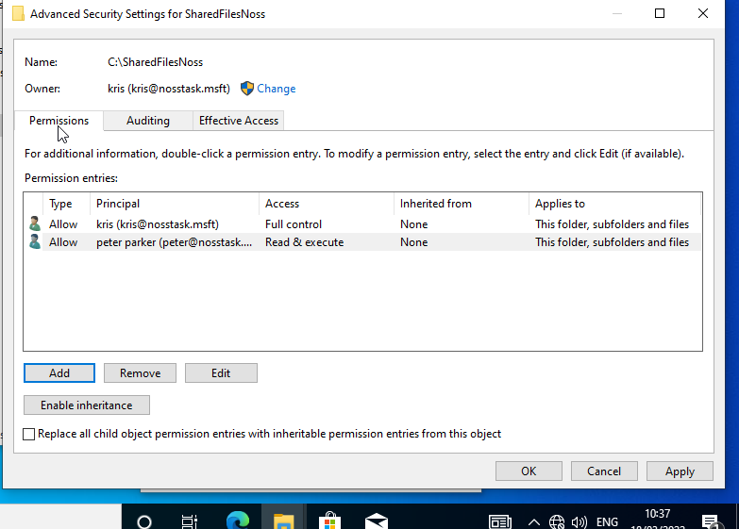
The advance security settings has been set. Two users have been added, Kris has full control meaning they can save in this folder. While peter parker only has read & execute meaning that user account will not be allowed to save in that folder.
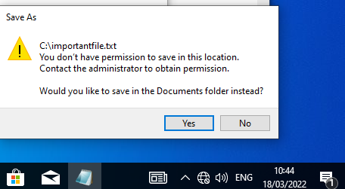
Permission in c:/ denied when attempting to save in this folder.

1.2

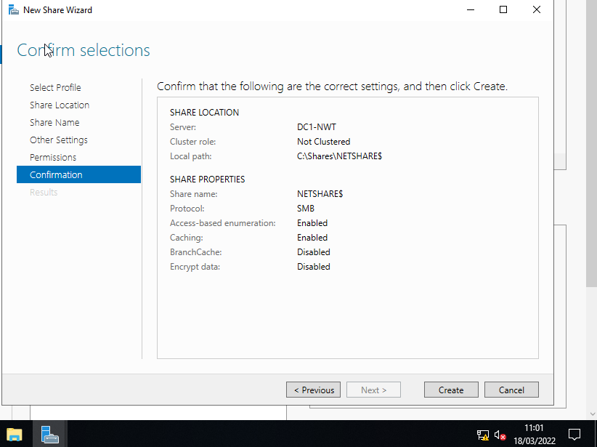
Shared location has been configured. The network file share has been crated on the server.

1.3
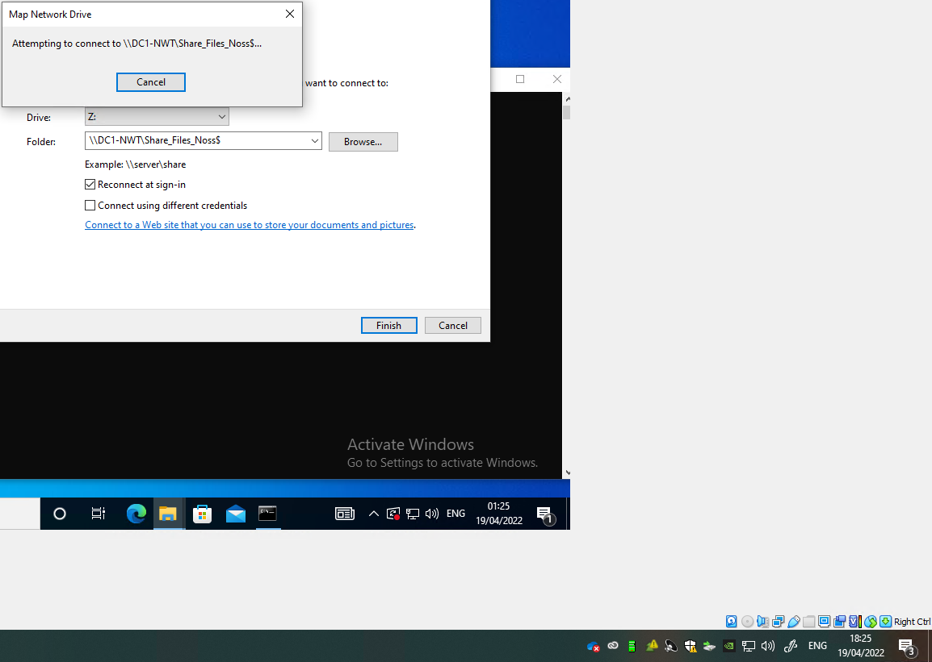
Accessing the file server over the network.

2.1

GPO 1
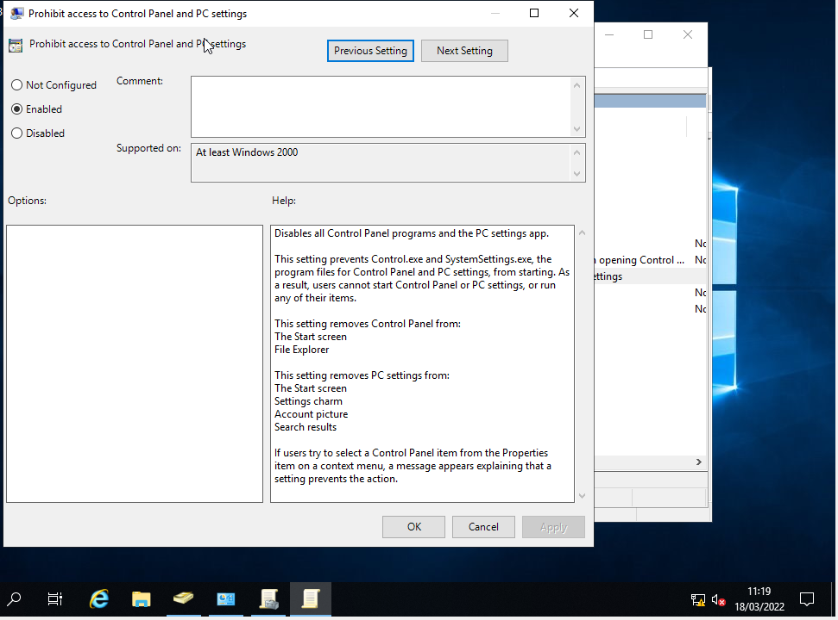
Prohibit access to control panel via pc settings. Enabling this will prevent the user from accessing the control panel and pc settings. Control panel will be removed from the start screen and file explorer.

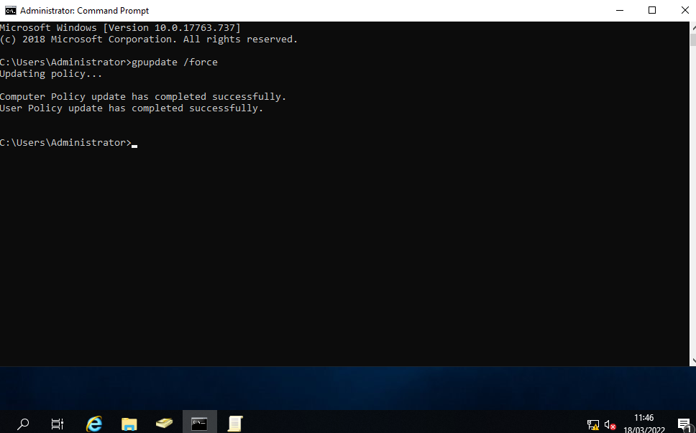
By entering command prompt and typing in /force I am updating the user accounts policies, meaning the prohibit access control panel and pc settings policy has successful been added to the user account. Group policy update will force the domain to update and accept any new policies that have been created on the domain.

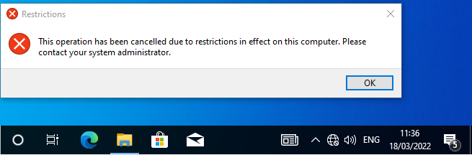
An error message has been displayed when the user attempts to access the control panel. Some admins would want to do this to prevent the user from browsing or changing important things from the control panel.

GPO 2
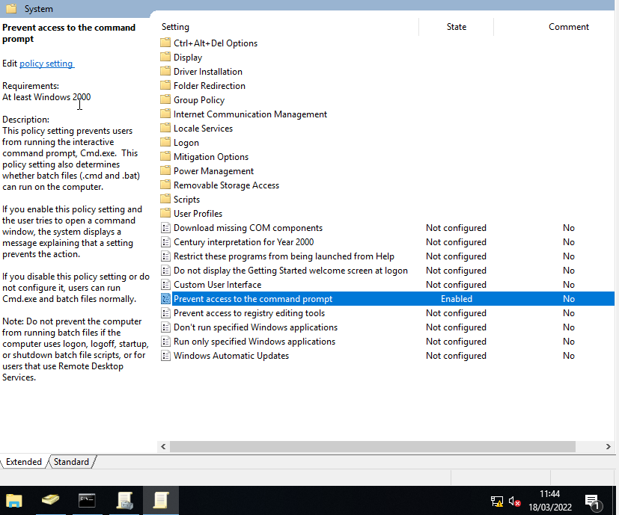
Enabling the prevent access to the command prompt policy.

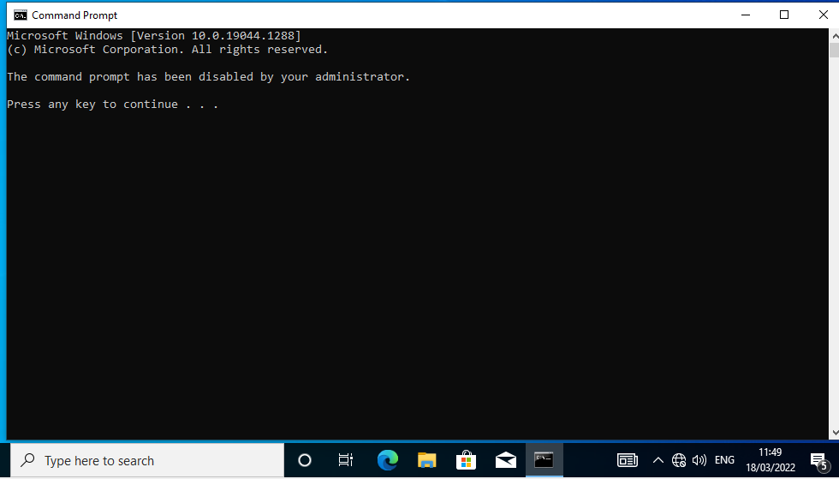
Evidence that user cannot perform commands through the command prompt. If they press any key, they will be removed from command prompt.

GPO 3:
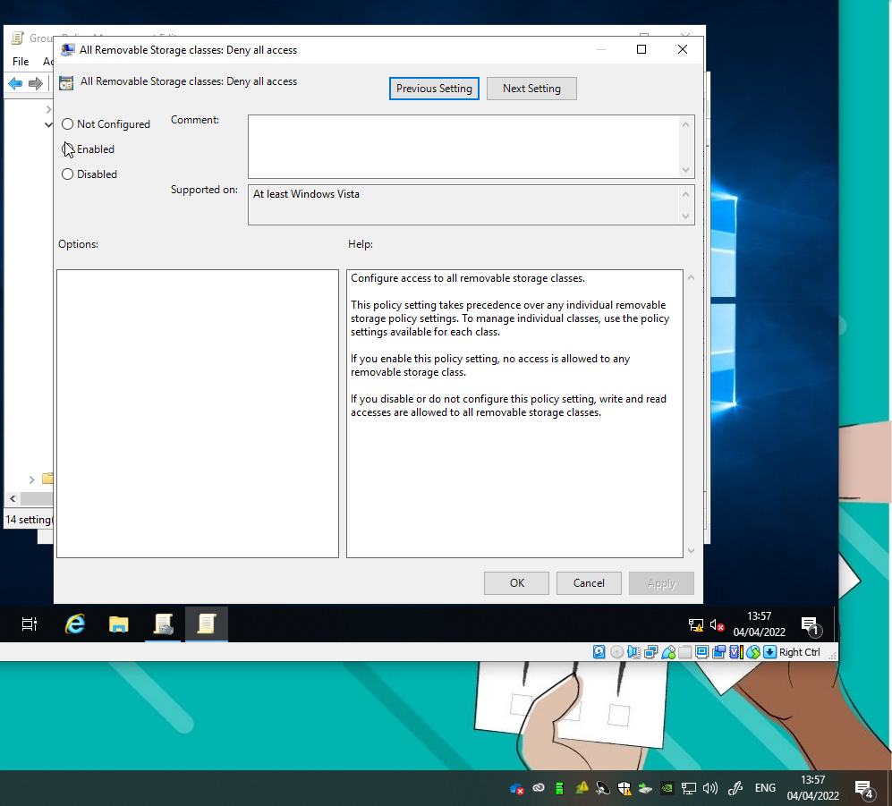
New policy added prevents those from accessing removable storage class.

GPO 4
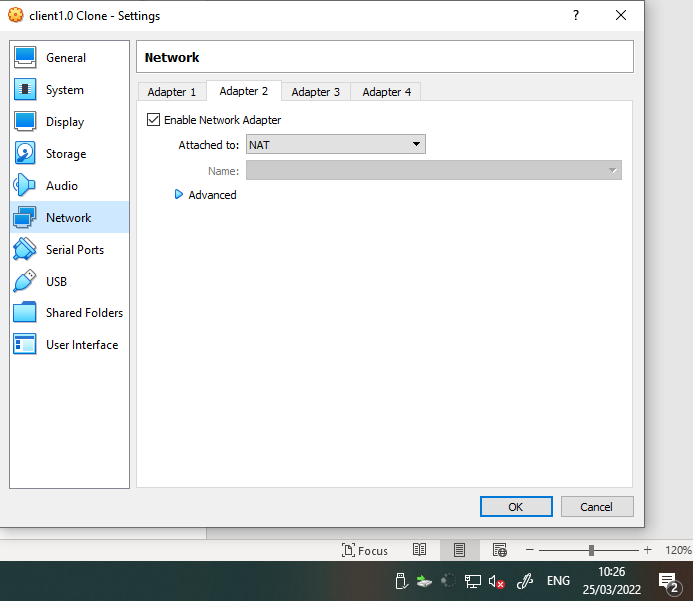
Granting internet access to the client through the VM this is so I can access the internet to download software.

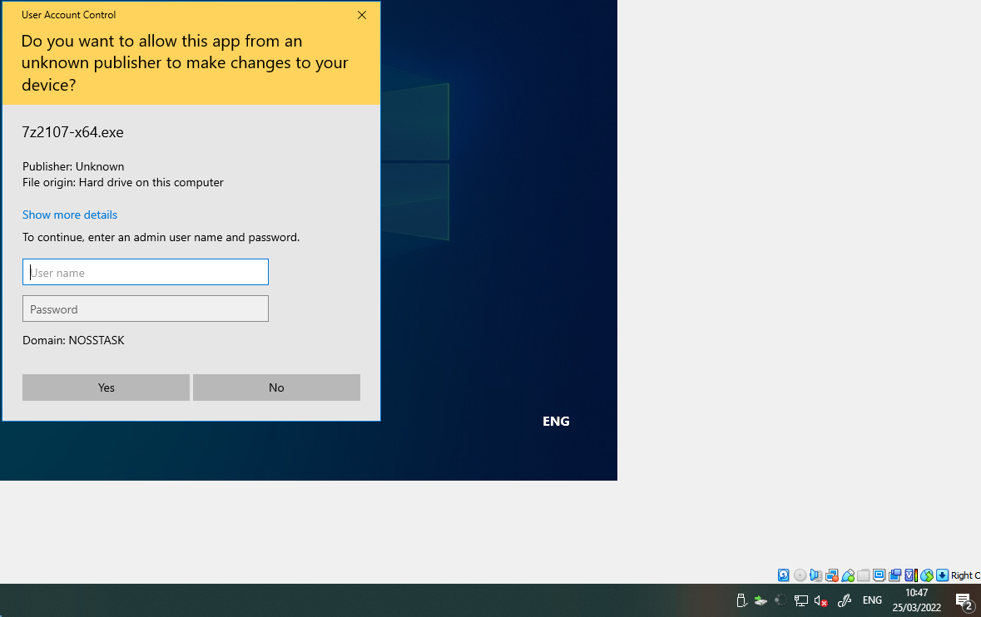
Install of software did not work. It requires administrator username and password to proceed. This shows that this user account has a policy which prevents them from downloading programs from the internet.

GPO 5
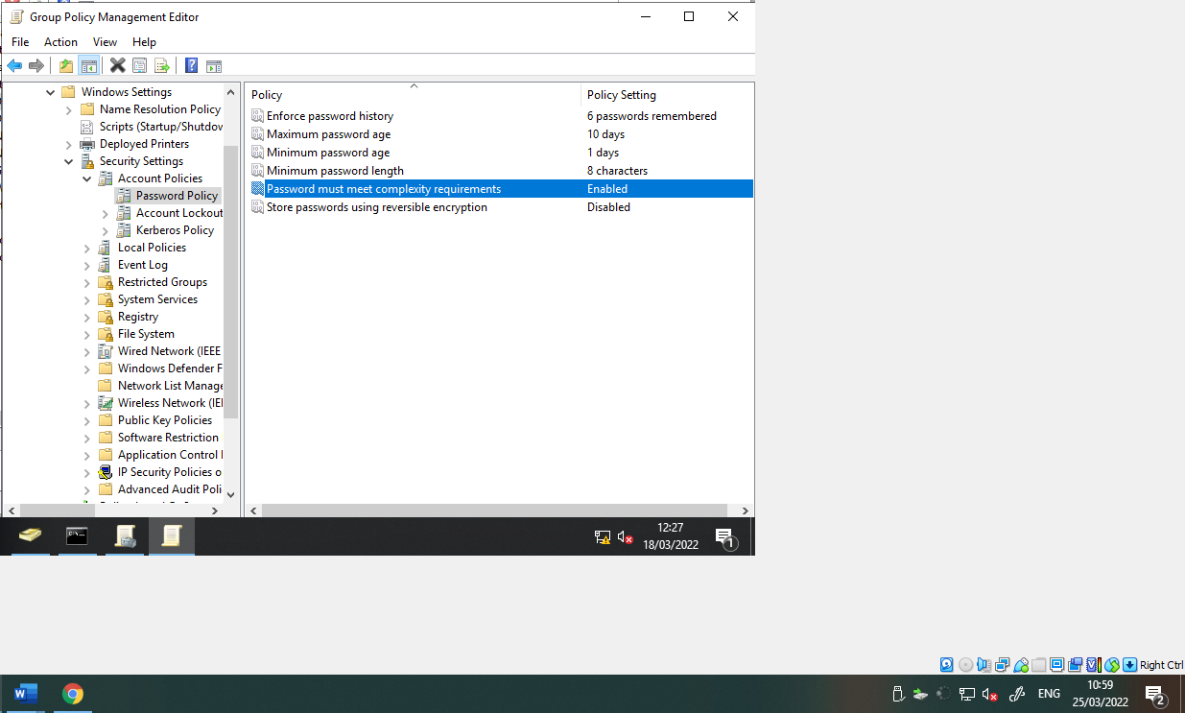
Setting password policy ensures user account must match policy requirements. Certain organisations will want to require staff/students to set a complex password to keep user accounts safe from hacking.

Task 2

1.
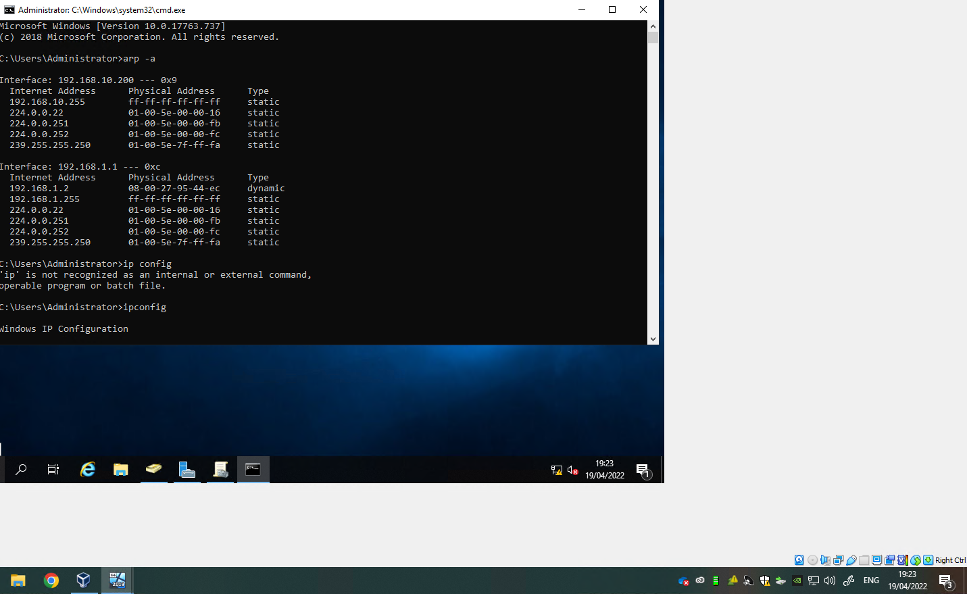
By typing in the ARP -A command in command prompt this displays the NIC MAC address on the machine

2.
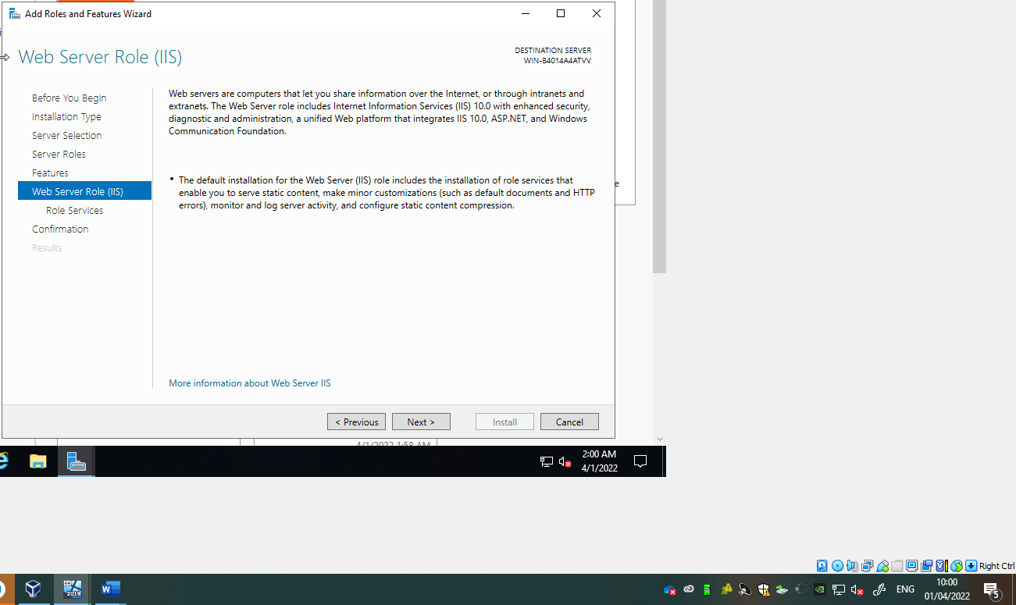
Installing the FTP server role.

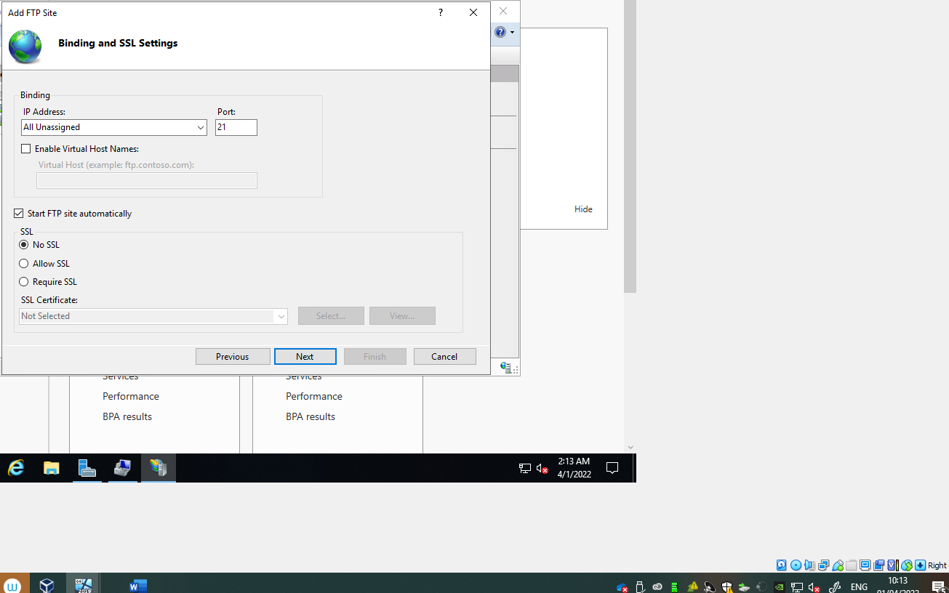
The destination port will always be 21. Consistency is important as thousands of people will attempt to connect to this service so it’s vital that it’s bound to a port.
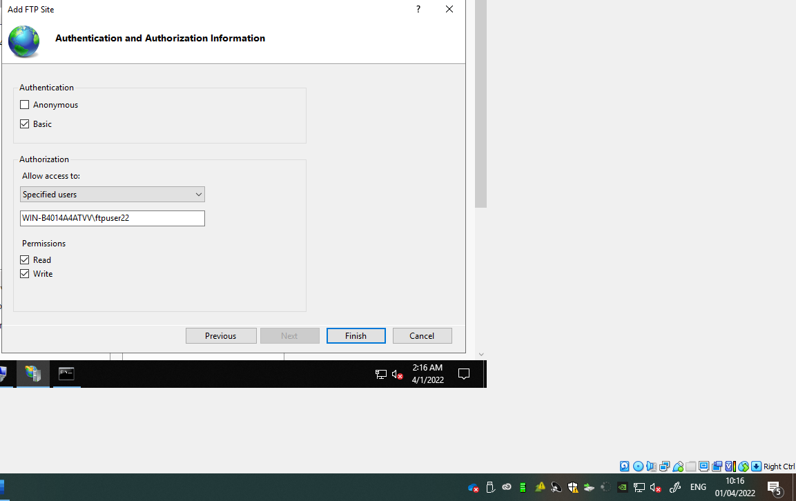
Adding the FTP site, I have specified the user, my hostname, and ftpuser22 the username. Read and write permission have also been checked.

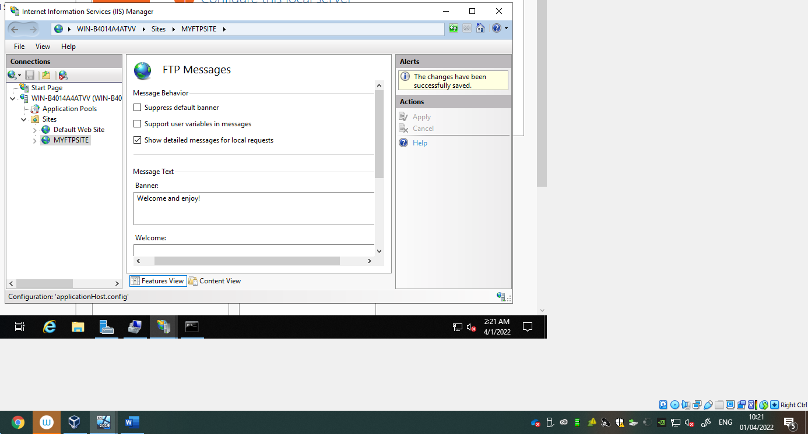
Setting up a banner for my FTP site. When a user attempts to access the FTP they will be greeted by a welcome message.

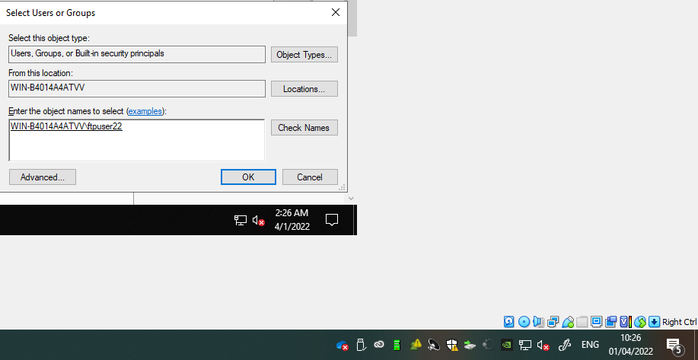
Searching for the local user that was created, proves that user lives on this server. It has been resolved.

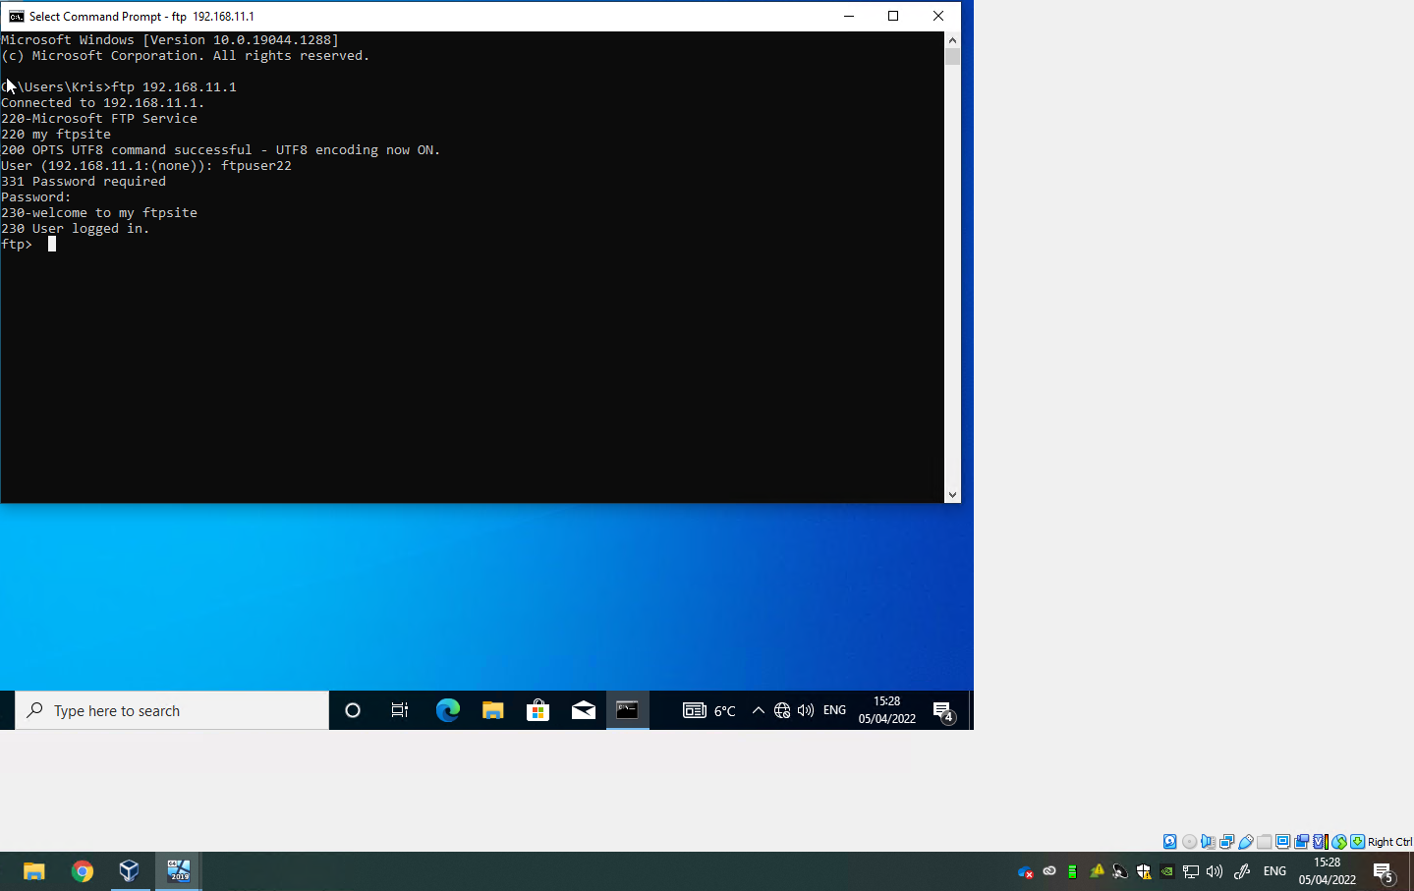
User has logged in the FTP server 192.168.11.1.
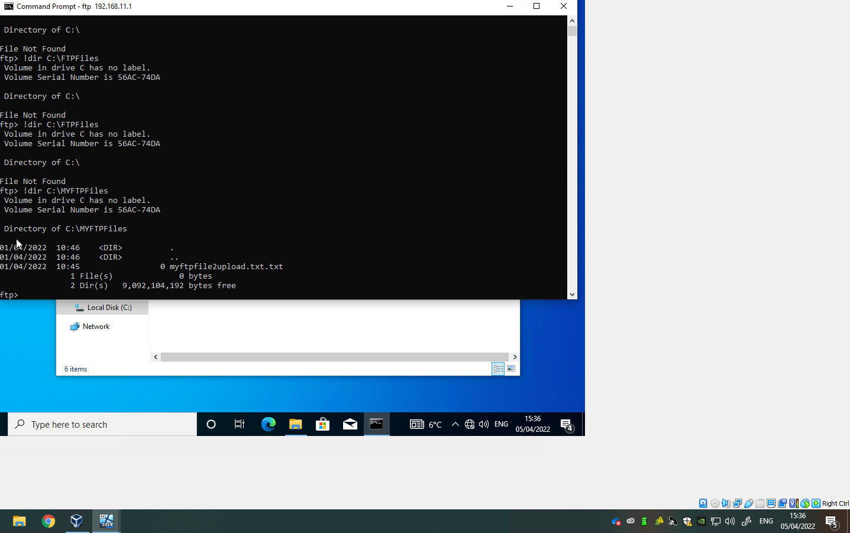
Connecting the FTP service from server 2 to client1. This allows client1 to upload and send files to server2 through FTP service.
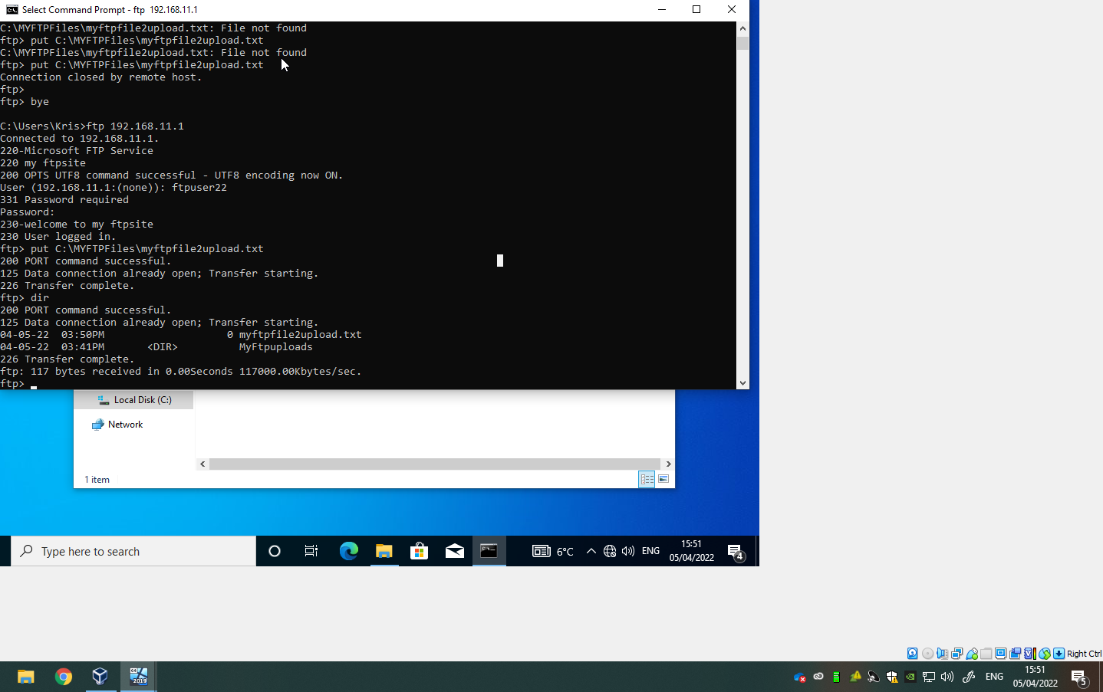
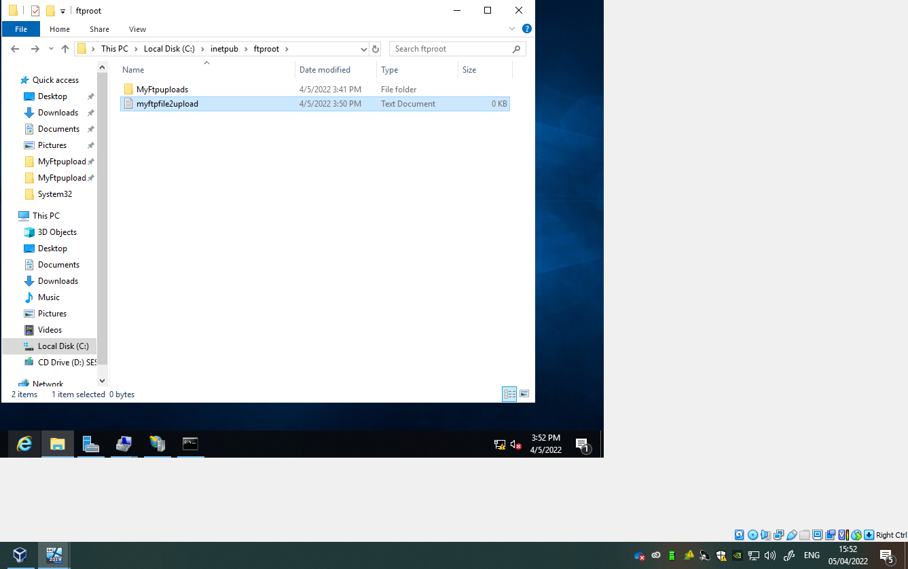
File has been copied from client2 to server 2

3.
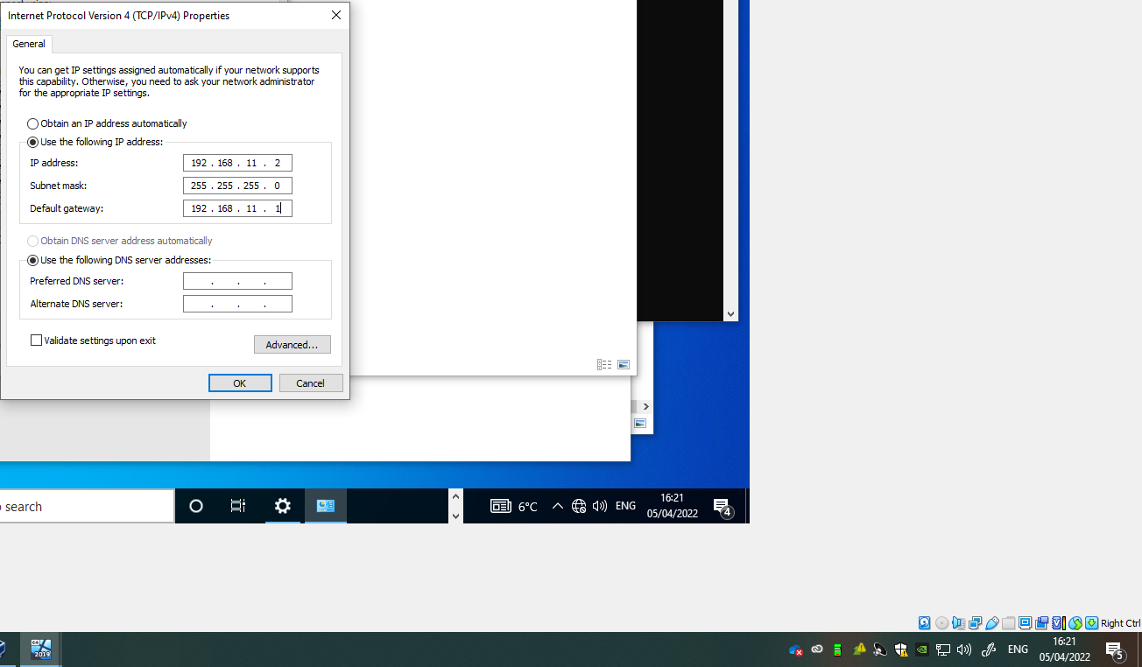
Setting the default gateway, the gateway allows for two network adapters to connect to the local subnet and to an outside network, allowing for communication without directly pining an IP address.
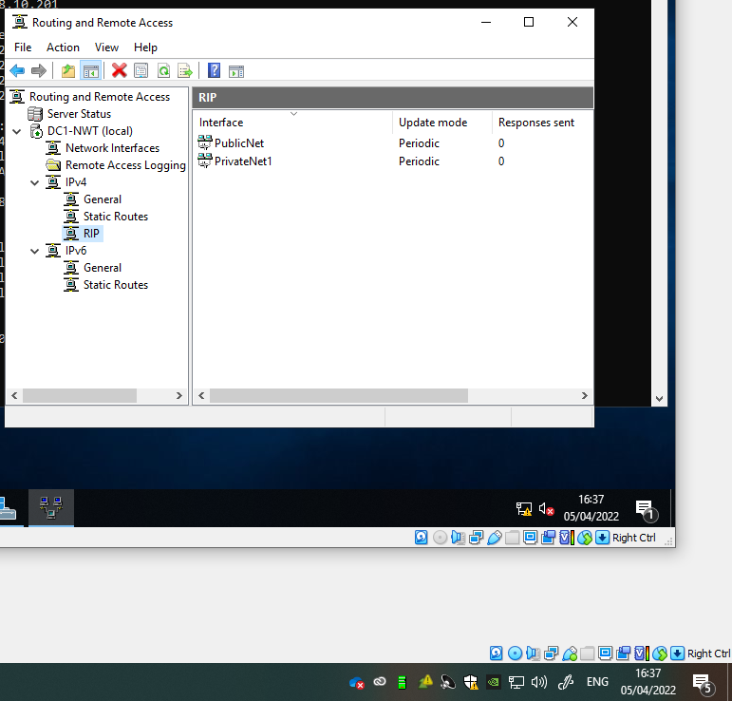
Once RIP is installed on the servers, I added PublicNet and PrivateNet1 to the servers so they could communicate with each other.

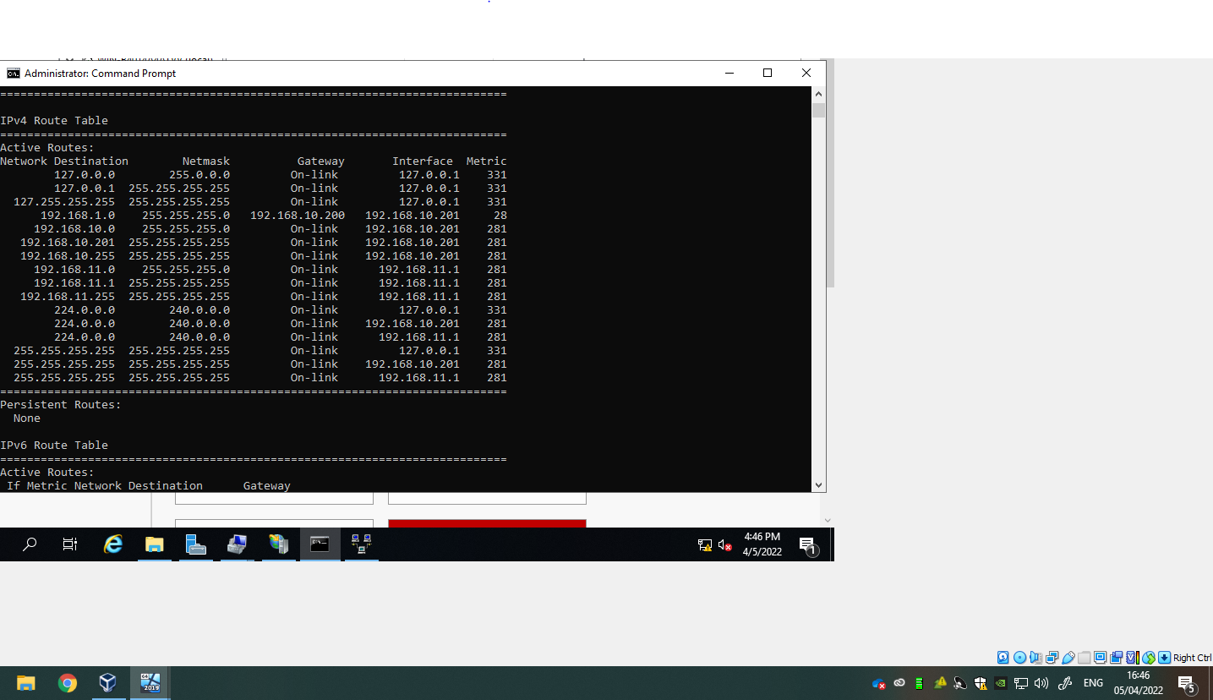
The IPv4 route table shows the gateway for 192.168.1.0, which allows connection to another network 192.168.10.200
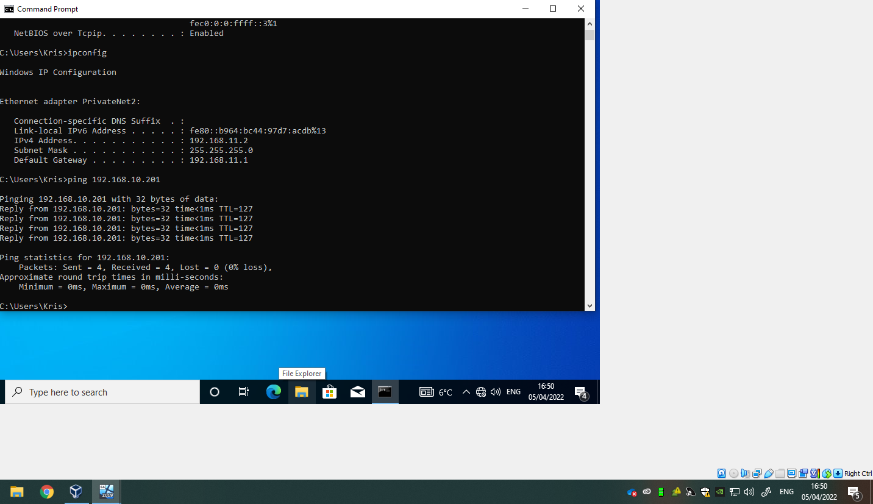
Default gateway specified to client 2 can connect to other pcs. WAN created over the PublicNet.

4.

Filter 1
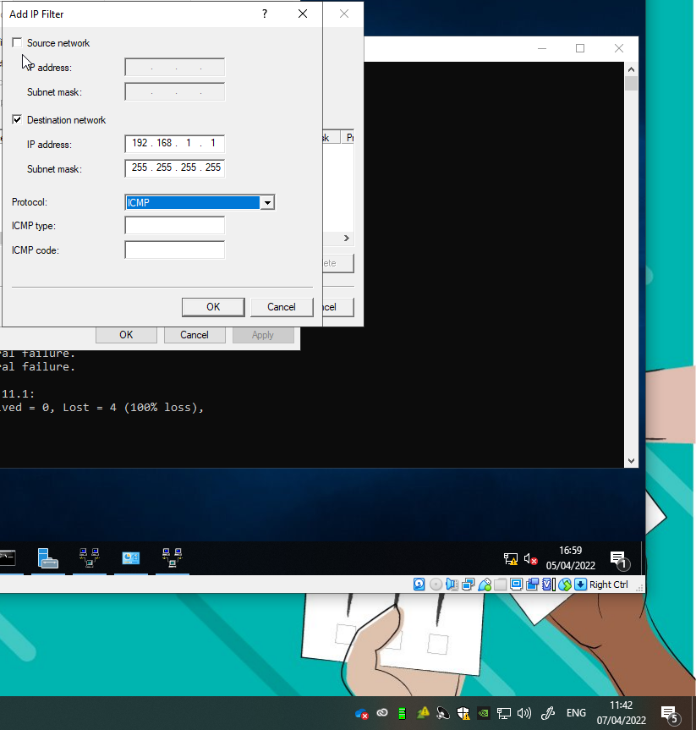
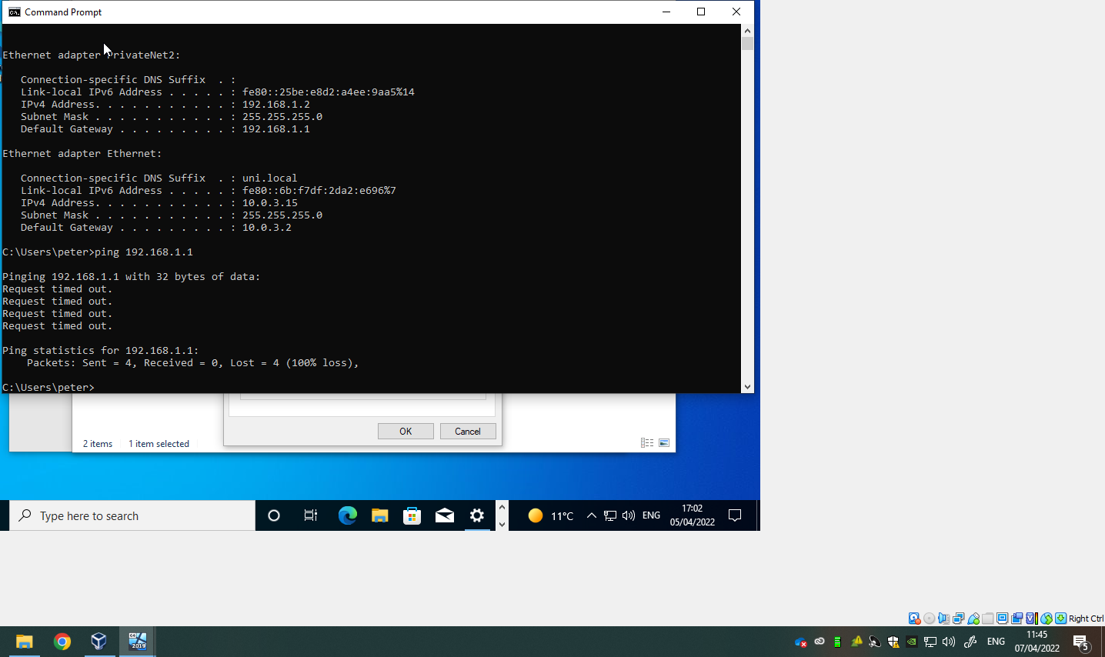
I added an inbound filter to 192.168.1.1 to server 1 router firewall, this denied all pings from privatenet1 from pining the server.

Filter 2
Restricting access on the FTP service from running on server2 to hosts only on the privatenet2.
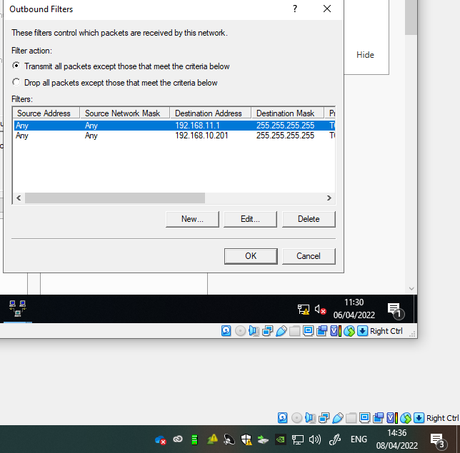
2.0
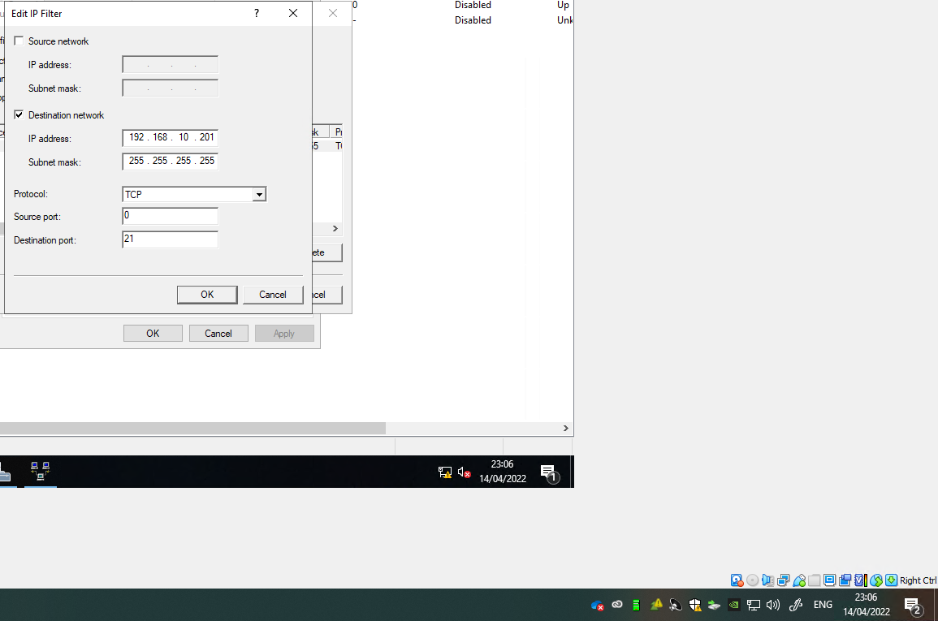

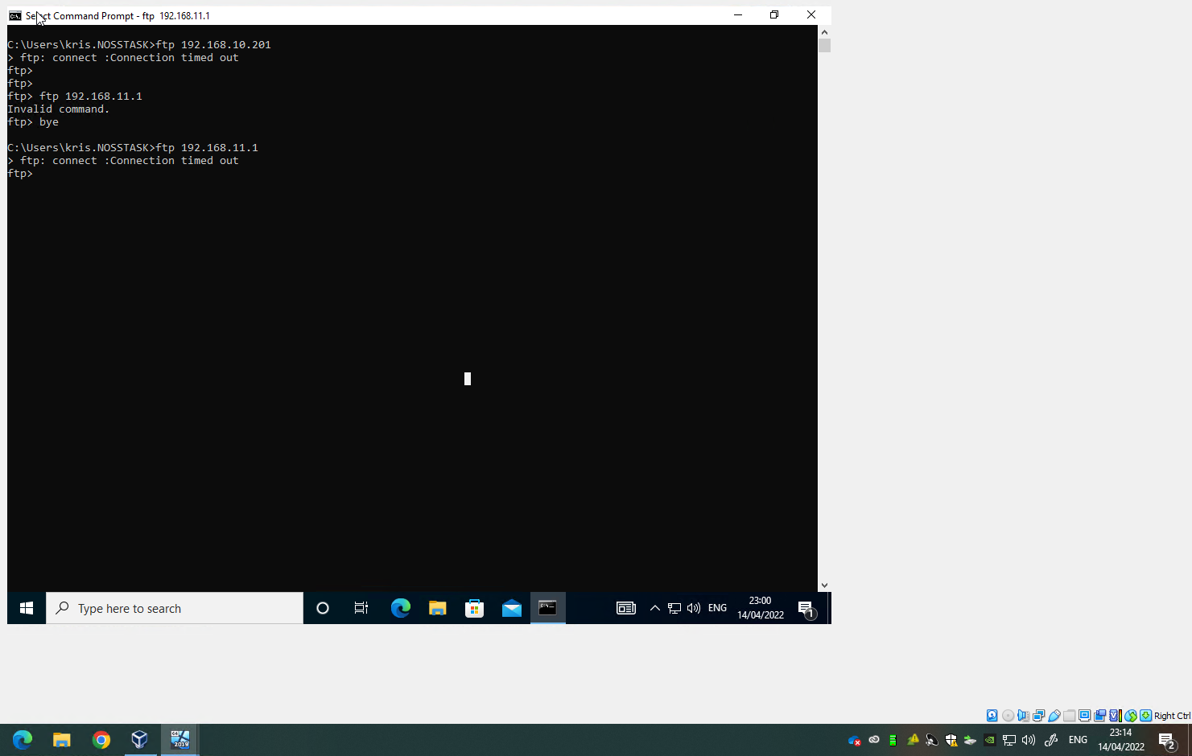
Restricting access to server 2’s FTP server on the client 1.

Filter 3:
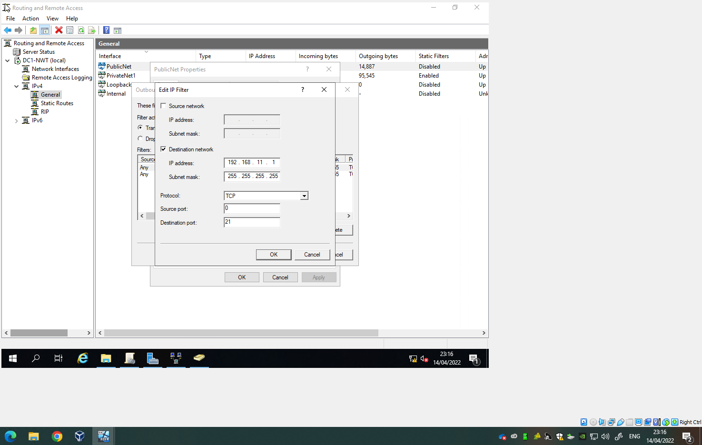

Allow specific hosts in private net1 access to the ftpservice.
Don’t allow specific hosts in privatenet1 getting access to the ftpservice.

Task 3

Password Principles
Passwords are considered to be not only the most common but most important practice when it comes to securing data. Still to this day passwords are considered by many experts to be the best way to protect confidential information and to ensure only the intended user gets access to their account. The below image is an example of a Windows 10 Administrator setting up a password policy to ensure that all users on that network follow the same password policy. Back in the early days of the internet and windows, password policies were non-existent. This means that when a user would enter a password, the password could be as simple as 123, this is because there was no policy set up in which would present a user with an error message telling them that they must meet the certain criteria when it came to creating the password to proceed. In this Windows example an admin can prevent the user from using a password previously used before, they can set how regularly the user must change their password. The character length in which the user must meet, if an admin was to set the character length to 12 then the user must have a password containing characters of more than 12. Using characters like letters, numbers and symbols drastically improves the security of a user’s account. [4] 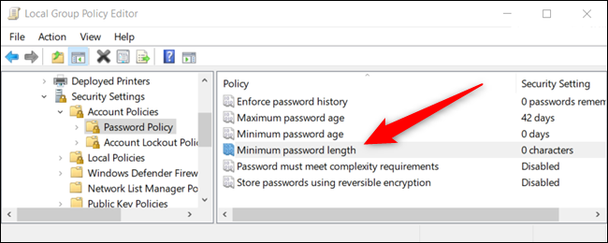
The importance of ensuring that users accounts are protected is incredibly important to organisations. Back in 2011 the world saw one of the biggest data breaches in history. Sony’s PlayStation Network was breached with up to 77million user account names, and passwords exposed. Sony was heavily criticised at time for failing to update the company’s security policy, in which cost Sony hundreds of millions in pounds in damages. When users finally were able to log back on to their PSN accounts three weeks later, they were requested to change their password immediately before they could log in. Sony set a password policy to ensure all users change their passwords before logging in, also Sony added more policies like minimum password length, characters, numbers and capitals. These were made mandatory when it came to creating a password. Despite Sony drastically improving their password security, there were many things that were missing like Multi-Factor Authentication, it would take Sony five years for them to finally follow Microsoft by adding this authentication. [2]
Multi-factor authentication is quickly becoming one of the most popular ways in which users/organisations will look to protect their accounts. There are many different examples of multi-factor authentication one is an authenticator app, for example if a user was to create a user account and enter in their username and password, they would be prompt to link this account to an app authenticator. Mobile phones are unique, a user would know immediately if their mobile phone was missing, and majority of the time a hacker will be hundreds of miles away so they cannot touch a mobile phone. Once the app authenticator and the user account are linked the user will be prompt by the webpage to approve a sign in on their phone if they agree to this, they will gain access to the user account. Other ways to do this without downloading an app, would be to provide a mobile phone number, and the webpage will send out a code in which the user will enter to gain access to their account. Typically, a bank would use this method to ensure that a criminal hasn’t gained access to someone’s credit card details criminally.
CAPTCHAs which have been around for a long time have been used on the internet during the early days. The image below is an example of what a CAPCHA will look like, typically when a hacker attempts to gain access to your account, you’re not the only person in which they are attempting to hack. Hackers have a database of thousands of different passwords in which will go through each and every password to attempt to crack your account. However what CAPTCHA does is after you enter a password it will prompt you with a question, these questions are typically simple for the average person. However, for a hacker if they are going through thousands of passwords every minute it’s almost impossible for the hacker to do this every time as it will become incredibly tedious and a waste of time. This is because computers are not humans, they don’t process the basic understanding of certain situations these CAPCHAs must be done by humans. [1]

Lastly pass phrases are something that is highly recommended when it comes to creating a password. Many users will struggle to come up with an idea of what password they should use. This results in users creating password that they will remember, that could be their name, or their favourite TV show. This however isn’t good as these passwords can be easily guessed. So, by using a passphrase, the password will be a line of random letters that will make no sense at all. However, the user has thought of a phrase in which they will remember and each first letter of the phrase will be turned into a password. For example, “My Name Is Bill Gates I Am the Founder of Microsoft” the pass phrase of this memorable sentence will look like this “MNIBGIATFOM”. [3]

Failover clustering
Failover clustering is a feature which can be added from “Add Roles and Features Wizard. The feature allows for computers to work together each computer is connected physically through cables and software. Availability and scalability are drastically increased. Think of one of the cluster servers as a Node, if one of the nodes fail then others nodes will take over these will be tasked to provide a service. Nodes will be monitored constantly this is to ensure that each node is working properly, if a node isn’t communicating then it will be restarted or moved to another node. [6]
Availability in Failover Clustering is so important. When a user is using a service like, email, logon, internet, proxy, firewall these services all require a failover cluster. It’s vital that these services are available 24/7. So, by having multiple computers hosting the service, if one of those computers has a fault and stops working then the other computers on the service will take over and complete the process. The failover cluster is a feature which was added to Windows Server 2022, Windows Server 2019 and Windows Server 2016. As I mentioned before there is constant communication between the nodes, when two or more nodes are combined these forms a cluster this cluster will host a service. While both communicate constantly, both the cluster and the node will be monitored to find any faults. It’s important that these faults are detected early as most of the time these nodes will be removed from the cluster to restart and passed to another node to continue the process. [7] [8]
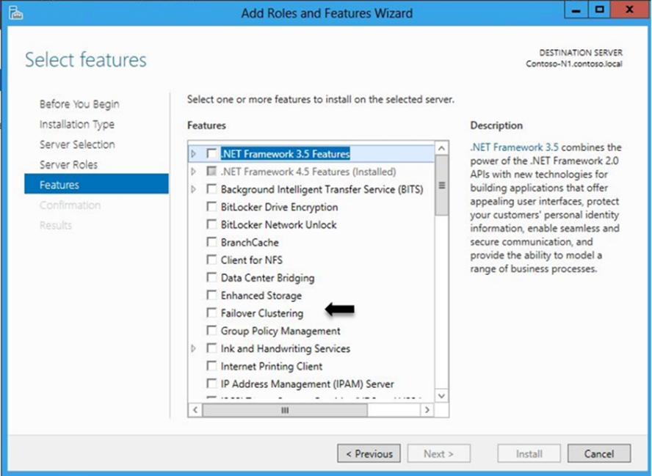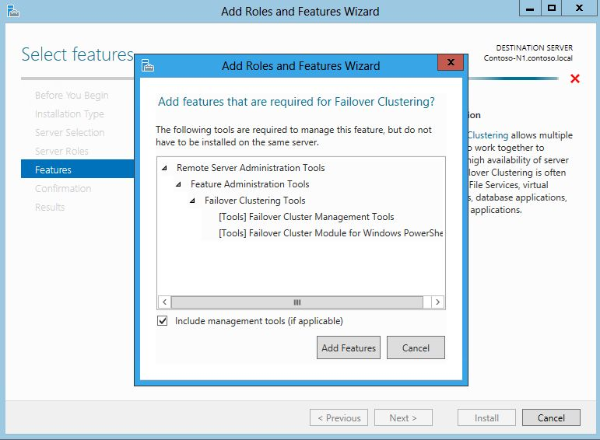
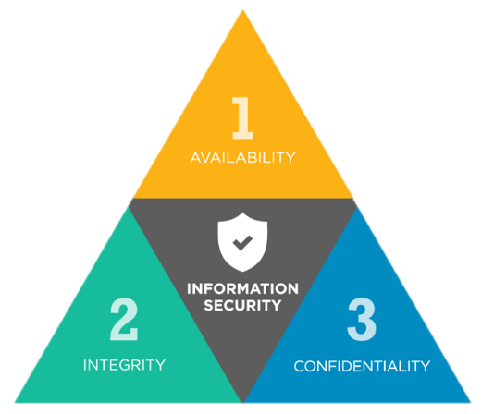
Failover clustering would use the CIA triad. CIA is known as Confidentiality, integrity and availability. Confidentiality is important when a user is accessing a service it’s vital that their personal information is kept safe and secure. When a user browses online, there IP address needs to be pinged to access the web, so it’s the responsibility of the internet service to keep this information secure using tools like cryptography to encrypt passwords, IP address, personal information goes a long way in protecting a user who is accessing the failover cluster services.
Integrity is important as it helps to prevent modification of information by hackers. It ensures that data has not been tampered with, when a computer and a node are communicating between each other, that node is producing a service, so it’s vital that the service the user is using is correct, authentic and reliable.
Lastly and most importantly is availability, to any organisation which is producing a service it’s absolutely vital that that service is available 24/7 to maximise profits and success. In the case of failover cluster, this is a Windows Server feature which was added to offer a service to benefit users. This service must provide reliable access to software, programs, the web without any disruption. So, if one node was to go down, the failover cluster would restart that node and give another node the task in offering that service. DDOS attacks can also affect the availability that’s why some services may offer VPNs to protect users from having that IP address stolen and misused.. [5]

Network Policy
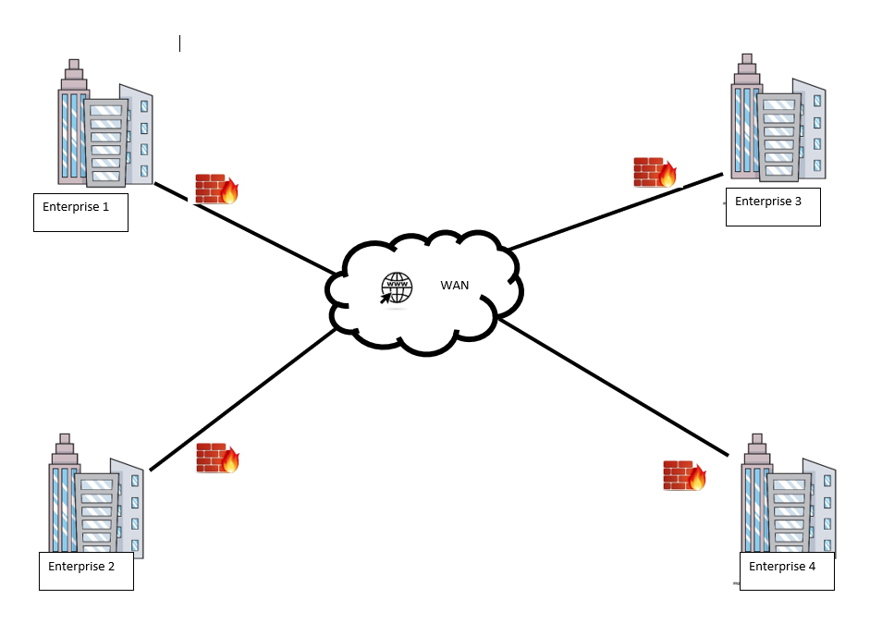
The topology I have used is a WAN topology. The cloud/internet will connect each enterprise across the nation to each other. Each enterprise has a LAN topology which means they can share data between each other, get access to applications services etc. For enterprises to communicate with each other over the LAN, they can be physically connected through a cable but most likely wireless through the internet. A firewall is set up on each router before packets are sent to the internet through the WAN. This is to ensure that the router can detect bad packets and intercept any malicious attempts to gain access to the network. Typically, a network would be built on a Type 2 Hypervisor. For an organisation it’s vital when setting up the networks that the appropriate networks are set up to connect each enterprise to the network, for example adapters will be created to set up Internal Networks so IP address can be created to allow communication between different computers/servers on the network. For example, Enterprise 1 would have an IP address of 192.168.10.101 while enterprise 2 would have an IP address of 192.168.20.100.
Each enterprise will have its own IT team set up, the admin will be in charge of the active directory domain services, the administrator will have the power to set up user accounts for each computer located on the LAN. Each user will be set up with a username, password personal information and certain privileges. An example of those privileges would be can they download certain software; can they get access to certain folders/directories. Setting rules for each user group allows for the administrator to have good control of the network, and ensure that only the relevant users have access to resources that they are intended to.
GPOs are another way in which an administrator can keep the network safe. By setting up policies for the network and its users, the admin can ensure that there are rules that users must obey, meaning users who don’t have the necessary privileges can’t access certain areas of a network. This is a great safety feature as it protects the enterprise from inside interference.
Regular updates of the security policy is very important to ensure the safety of an enterprise. Ensure that every employee which gains access to the network, signs a document that says they understand the rules and regulations of that enterprise. Continually monitoring and innovating will ensure the security of the enterprise. Install anti-virus software, ensuring that firewalls are turned on, ensuring that Windows systems are continually installed would be policies that an enterprise would enforce to ensure security.
Setting up password policies for employees is something that would be considered by an admin team. Ensure that the user changes there passwords as soon as they access their user account. Enforcing a policy which requires employees to meet certain password criteria. Regular password changes. Multi-factor authentication can also be added to add another layer of security, this is another policy which can be added by the enterprise. [9]

References
[1], Grimes, R. A. , Hacking Multifactor Authentication, Hacking Multifactor Authentication - Google Books, 2020
[2], Tom Phillips, Great PSN hack, Five years ago today, Sony admitted the great PSN hack | Eurogamer.net, 2016
[3], Australian government ,Creating Strong Passphrases, PROTECT - Creating Strong Passphrases (October 2021).pdf (cyber.gov.au), 2021
[4], Brady Gavin, How-to geek, How to Set a Minimum Password Length in Windows 10 (howtogeek.com)
[5], Debbie Walkowski, F5.com, What Is The CIA Triad? (f5.com), 2019
[6], Microsoft, Failover Clustering, Failover Clustering | Microsoft Docs, 2022
[7], Gavin Wright, Failover Clustering, What is Windows Server Failover Clustering (WSFC)? (techtarget.com), 2022
[8], Jacqueline Emigh, Failover clustering, What is Failover Clustering? | ServerWatch, 2019
[9], Luke Irwin, IT governance, IT Governance Blog: 5 essential information security policies, 2020

