UNIVERSITY OF WALES TRINITY SAINT DAVID

INDIVIDUAL ASSIGNMNENT

REPORT

MANAGEMENT ECONOMICS
LCBB 5003

Name: Anca-Diana Gog
Student Number: 1918426
Module Lecturer’s Name: Muno Zuwirai

May 2022

Contents
Introduction 2
Profit Maximization Analysis 2
Market structures 3
Market share 6
Recommendations 7
Conclusion 8
References 9

Introduction
The purpose of this report is to analyse and apply the Profit Maximization Theory, business environment, business objectives, market structure and stakeholder issues in light of Allan Scheepers’s statement. This report will discuss and evaluate various issues considered by management in decision making by ASI management. At the end this report will present recommendations for ASI’s management.
All Supplies Incorporated (ASI) is the largest consumer goods retailer in UK with a long retail tradition, currently controlling 43% of the market share. The business has a huge network of stores across UK and has huge retail shops and massive parking lots, fuel forecourts and in-shop restaurants. In addition to stocking known premium brands and ranges, ASI has links with manufacturers who produce some products exclusively for ASI. Those products are branded under ASI’s name and brand.

Profit Maximization Analysis
The main objective of any rationale business is assumed to be profit maximization.
“The firm’s profit maximization level of output occurs when the additional revenue from selling an extra unit just equals the extra cost of producing it, that is, when MR = MC” (Samuleson & Marks, 2015, p. 34). In this statement Marginal Revenue (MR) is “the amount of additional revenue that comes with a unit increase in output and sales” (Samuelson & Marks, 2015, p. 34) and the Marginal Cost (MC) is “the additional cost of producing an extra unit of output” (Samuelson & Marks, 2015, p. 34). Therefore, the Marginal Profit is the difference between marginal revenue and marginal cost. Put in a graphic representation, the profit maximization looks like this:
Figure 1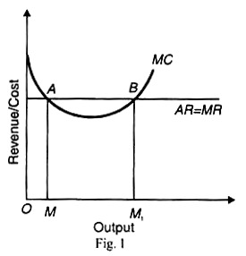 (Kwatiah, 2022)
M and M1 represent the quantity, MC is marginal cost, AR is average revenue and MR is marginal revenue.
Differently put, every extra unit ASI produces generates a change in profit from the extra revenue it gains from that unit of its cost of production. Profits are usually maximized when the marginal profit is zero.
ASI’s decision problem is to determine the profit maximization price and output for its products and services. The decision has to focus on the difference between the revenues and costs. In order to increase profits, the difference has to be as high as possible. If the decision consists in increasing the quantity and sales, the profit would increase only if the extra revenue earned outstrips the extra cost.
The profit maximization theory is best appliable in a perfect competition, which in real world is very rare. “The theory of perfect competition illustrates an extreme form of capitalism. Firms have no power whatsoever to affect the price of the product. The price they face is that determined by the interaction of demand and supply in the whole market” (Sloman & Jones, 2020, p. 187). This means that the firms are price takers, they don’t have the power to change the price of a certain product or service; the price is determined by the demand and supply on the market. Also, there is freedom to enter and exit the market. The product that all firms produce is homogenous, so there is no need for branding or advertising. All the parts involved in the process have perfect knowledge of the market, meaning firms, suppliers and customers all know the prices, the costs of production, the technology used in production and the market opportunities. As said before, these are unrealistic conditions, and few industries meet these conditions.

Market structures
There are different market structures. In the next section of this report will present and analyse monopoly, monopolistic competition and oligopoly and show how these apply to ASI.
In a monopoly market structure “there is only one firm prevailing in a particular industry. However, from a regulatory view, monopoly power exists when a single firm controls 25% or more of a particular market” (Prateek, 2022). In a monopoly market there is a lack of substitutes, the barriers to entry are high, the firm is the industry, there is no competition, therefore the firm decides the price so the profits can be maintained high on the long run.
Monopolistic competition is when “there are a lot of firms competing, but where each firm does, nevertheless, have some degree of marker power; each firm has some discretion as to what price to charge for its products because they are differentiated from those of other firms” (Sloman & Jones, 2020, p. 187). In a monopolistic competition, even if there is a larger number of firms, their decision making is not affected at a high level by competition because of the differentiated products, meaning each firm has a small market share. Entering the market is very easy, every firm is free to start a business in this market. Example of monopolistic competition would be restaurants, builders, petrol stations etc.
These market structures don’t come under the perfect competition conditions. These firms are not price takers, they affect the prices in the market, the information is most of the times incomplete, the products are not homogenous, they are differentiated.
ASI’s market structure doesn’t come under the perfect competition conditions either, as most of the firms in the market. But ASI’s market structure is different, it can be defined as an oligopoly. “Oligopoly occurs when just a few firms between them share a large proportion of the industry… One of the key differences between oligopolies is in the degree of product differentiation. Much of the competition between such oligopolists is in terms to the marketing of their particular brand. Marketing practices may differ considerably from one industry to another” (Sloman & Jones, 2020, p. 187). It is not simple to enter such a market, due to factors such as the size of the industry or legislation. The firms in an oligopoly market are interdependent, meaning that the decision the competitors make will affect the firm, as well as the decisions that the firm makes will affect the competitors. Even if ASI has the higher market share, the decisions of the competitors would affect its profits or position on the market.
First, the question is what can stop ASI from maximising profits.
In a perfect competition market, there is an equilibrium between the demand and supply, there are no surpluses or shortages and the market functions efficiently. The demand and supply give the price; therefore, a decrease of the supply will lead to an increase in price. Also, an increase in the demand will lead to higher prices.
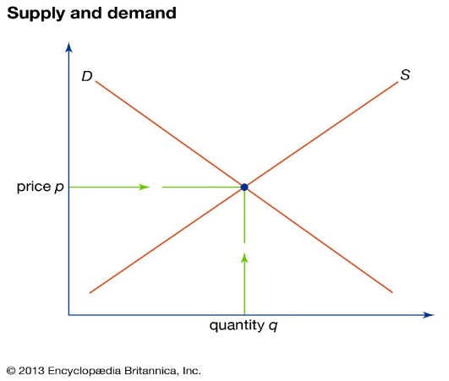
Figure 2
ASI is operating in an oligopoly market structure, which is not a perfect competition, where the competitors’ reaction to a change of price depends on whether it is lowered or raised. At the slightest change of price, the demand curve will change as well due to the elasticity of demand.
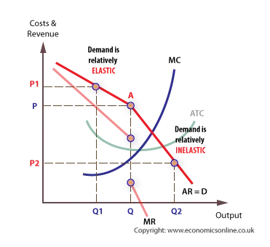
Figure 3. http://www.economicsonline.co.uk/Business_economics/Oligopoly.html
As shown in Figure 3, in an oligopoly market structure, companies have difficulties in creating price strategies. “Where a firm decides to lower its price, other firms will follow as demand is relatively inelastic, and all firms will lose revenue at the lower price. The market will see the equilibrium price and quantity remain stable despite small changes in the marginal cost as firms are unwilling to change their price due to these losses in revenue” (Dale, 2016)
For example, if an airline decides to increase the prices of the tickets the competitors will not do the same thing, they will keep their prices not changed and the result for the airline will be loss of revenue because the demand curve is relatively elastic. The competitors don’t have to follow the change in price, and they will keep their competitive advantage. If the same airline company would decrease the prices, the competitors will have to adjust and decrease the prices. In each situation the airline company will face a loss in revenue, therefore profit, as well as a loss in market share, the demand curve is inelastic in this situation.
Figure 3 shows that even if marginal cost MC increases, the price doesn’t change significantly, it stays close to the original due to the elasticity of demand. The profit maximization theory states that when MC=MR the profits will be maximized. No matter where the MC position is on the graph the effect on price is minimum, price will remain at P.

Market share
Another issue for maximizing profit is the market share. Even is right now ASI is controlling the market share, the competitive advantage can change. In UK market share there have been some changes in the last decade for example.
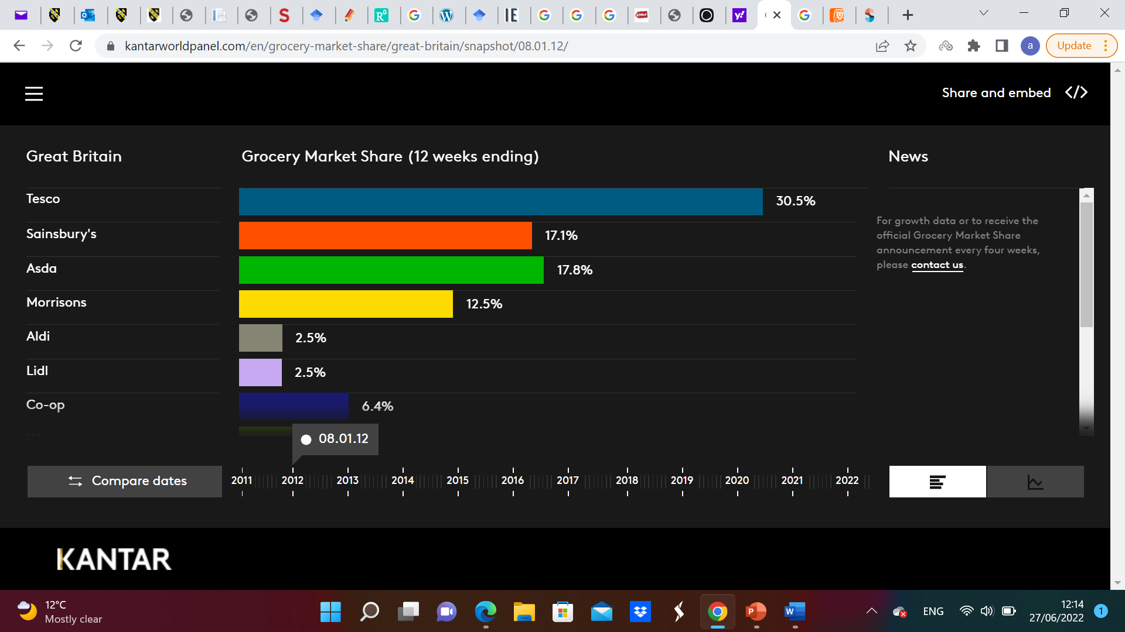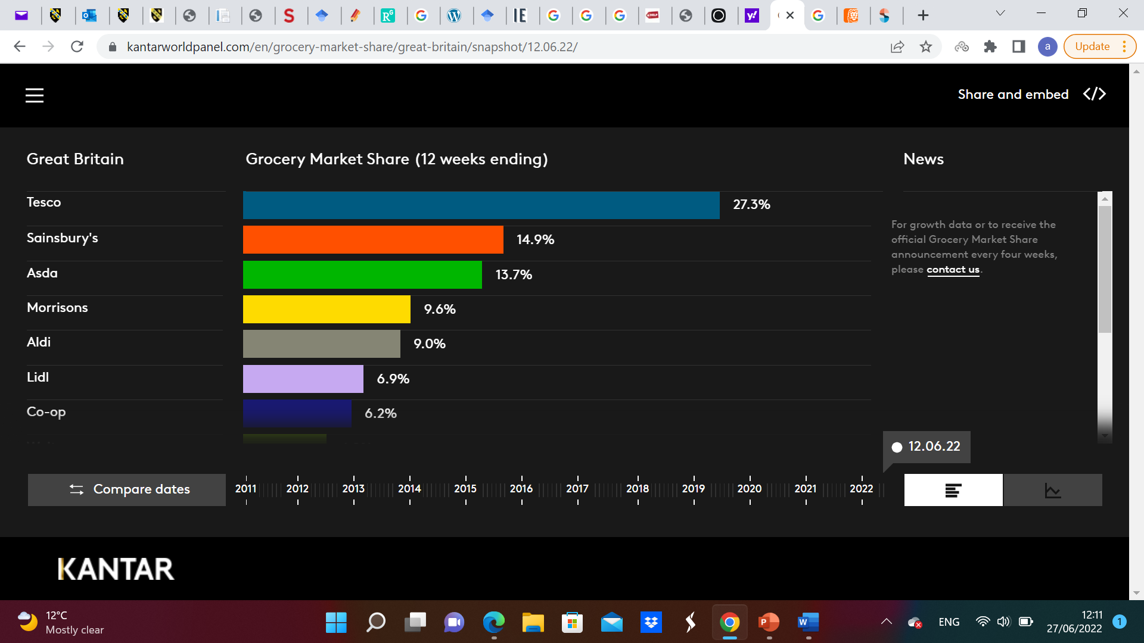
Figure 4 Figure 5
https://www.kantarworldpanel.com/en/grocery-market-share/great-britain/snapshot/05.02.12/
Even if Tesco controls the market, we can see that other competitor have considerably increased their market share over the last few years. For example, Aldi, which is quite a new competitor in UK market share had 2.5% market share in 2012, when Tesco had 30.5% market share. Now, Aldi increased the 9% and Tesco recorded a decrease, having just 27.3% market share, which means part of Tesco’s market share shifted to Aldi or other competitors (Kantar, 2022). Even if Tesco still controls the market share, the decrease or stagnation of market share will affect profit being maximized.
An impediment for profit maximization is represented by the reduced buying power of customers. Energy bills increase, interest rate increase, inflation and COVID – 19 are the main factors that are causing a fall in consumer spending. “Inflation is set to stay above 6% for most of 2022, and that means consumer spending will struggle to avoid a downturn later this year. The Bank of England is still squarely focused on curtailing higher inflation, though we think policymakers will hold off on further hikes once the bank rate reaches 1% in May and growth risks build” (Smith , 2022). The external factors such as the war in Ukraine is causing a major disruption which associated with the increased energy prices have a negative effect on the consumers’ buying power. COVID – 19 is one of the factors that influenced the buying power and habits in the past two years, and it still does. First the customer’s buying habits changed, and a large part of their shopping is done online. If the retail companies don’t adapt to this shift in patterns, their revenues from sales will be affected. Except from the medical crisis, COVID – 19 produced a major crisis on the economic and social levels. “The economic and social consequences of a crisis, such as rising unemployment, a freezing of wages and pensions at a certain level, as inflation rises, rising commodity prices and declining purchasing power, leas to major changes in the purchasing and consumption behaviour of the population […] In face of an economic crisis, the orientation of consumers towards a new simplicity, towards frugality in consumption, determines a better awareness of the value of the money, pushing consumers to accept compromises in terms of value for money, brand or personal comfort” (Duralia, 2020, p. 6).

Recommendations
There are, however, some strategies that can be applied so that ASI can achieve its objective – profit maximization.
ASI must strategize business growth. The company has reached its point of expansion and has to find additional options to maximize the profits. “Growth is a must for business to survive in developing industries. Businesses need to be in a continuous change and development process in order to make progress” (Durmaz & Ilhan, 2015). There are two types of growth strategies: organic and inorganic or integration. Organic growth refers to the company growing from inside, without any external intervention. This includes strategies such as intensive growth, market penetration, product development or diversification. Inorganic growth strategies are strategic partnerships or as an alternative, merger and acquisition. Using this strategies, the growth can be horizontal, vertical, or conglomeration (Durmaz & Ilhan, 2015).
A strategy ASI can use is the backward vertical integration, which is merging with a company in the supply chain. “Backward integration allows a manufacturer to seize a stronger control over its quality of material supply and, thereby, its quality of final products” (Lin, et al., 2013). A convincing example is Tesco’s merger with Booker Group in 2018. Booker is UK’s leading wholesaler. Tesco, as well as ASI is UK’s larger retailer; Booker was the largest company in the supply chain of the small retailers. By merging, Tesco has become a major supplier to those retailers, “serving 125,000 independent convenience stores as well as 468,000 restaurants and pubs” (Riley, 2017). After the merger Tesco announced “rising in sales for the 10th quarter in a raw in the three months to 26th May, in a sign its takeover of wholesaler Booker is paying off. The supermarket reported 1.8 per cent growth in group sales, with UK and Ireland sales up 3.5 per cent” (Morrison, 2018).
Another strategy that will improve ASI profit gain is merging with a competitor. This is quite difficult to achieve due to legislation. For example, if Tesco were to merge with Asda, which is one of the major competitors, they will have the competitive advantage. The costs will be significantly reduced because they would have the advantage of bulk buying, and this would generate more profits. But this merger can’t be done without an approval from the Competition Commission because there is a high risk of the two companies to become a monopoly, which will change the oligopoly market structure, meaning the two companies will control the market and the other retailers will disappear from the market.
ASI can also take into consideration international expansion. With the use of PESTEL analysis and Porter’s Five Forces the company can identify potential international markets to expand. PESTEL analysis is used to identify the macro factors: political, social, technological, environmental, and legal that offer an overview of the market and how those factors impact on Aldi. Porter’s Five Forces is used to analyse the competition on the market and the attractiveness of the retail sector, as well as the analysis of the buyers’ power, supplier power substitutes and the threat of new entrants. Aldi is a German company but they are operating in UK and USA. Another example is Walmart, which is a US company and they are operating in UK and South Africa, which is a growing economy.

Conclusion
Profit maximization is the primary objective to any company. Profit reflects the company’s efficiency, in a market controlling company, such as ASI it is a major source of internal finance. Therefore, the company adopts strategies that improve sales and increase the profits. The profit is usually maximized when the marginal profit is zero. ASI is not a company that is operating under perfect competition, no companies are. It is an oligopoly, meaning that the market structure in which it operates comprises a few companies sharing the largest part of an industry. The main characteristics of this market structure is product differentiation, and they are price givers, meaning that the price is not only determined by the supply and demand.
Taking into consideration Allan Scheepers’s statement, this report showed that increasing price is not a suitable strategy anymore. It might have been in the beginning years of the company, when it was the only retail company on the market, with no competitor. Nowadays, it the company increases prices the competition won’t follow, they will maintain their prices and the company will lose competitive advantage, therefore sales will drop, and the profit will become lose. However, there are other strategies that can be used for the company growth and profit maximization, such as backward vertical integration, merger with a competitor or expanding internationally.

References
Dale, D., 2016. Predatory Pricing - Are we doing it right?. [Online]
Available at: https://www.researchgate.net/publication/309358641_Predatory_Pricing_-_Are_we_doing_it_right/download
[Accessed 27 June 2022].
Duralia, O., 2020. The Impact of the Current Crisis Generated by the COVID-19 Pandemic on Consumer Behaviour. Studies in Business and Economics , 15(2), pp. 86-99.
Durmaz, Y. & Ilhan, A., 2015. Growth Strategies in Business and a Theoretical Approach. International Journal of Business and Management, 10(4), pp. 210-214.
Kantar, 2022. Kantar World Panel. [Online]
Available at: https://www.kantarworldpanel.com/en/grocery-market-share/great-britain/snapshot/08.01.12/
[Accessed 27 June 2022].
Kwatiah, N., 2022. Economics Discussion. [Online]
Available at: https://www.economicsdiscussion.net/profit/profit-maximisation/profit-maximisation-theory-with-diagram/18741
[Accessed 23 June 2022].
Lin, Y.-T., Parlakturk, A. K. & Swaminathan, J. M., 2013. Vertical Integration under Competition: Forward, Backward, or No Integration?. Production and Operations Management, 23(1), pp. 19-35.Morrison, C., 2018. Tesco's Booker takeover pays off as sales rise. Independent, 15 June.
Prateek, A., 2022. Inteligent Economist. [Online]
Available at: https://www.intelligenteconomist.com/monopoly-market-structure/
[Accessed 23 June 2022].
Riley, G., 2017. Explore Economics. [Online]
Available at: https://www.tutor2u.net/economics/blog/tesco-buys-booker-to-become-biggest-uk-food-firm#:~:text=A%20classic%20example%20here%20of,and%20logistics%20business%20Booker%20Group.&text=The%20takeover%20is%20Tesco's%20first,the%20UK's%20largest%20supermarket%20
[Accessed 1 July 2022].
Samuelson, W. F. & Marks, S. G., 2015. Managerial Economics. Eighth ed. Hoboken: Wiley.
Sloman, J. & Jones, E., 2020. Essential Economics for a Business. Sixth ed. Harlow: Pearson.
Smith , J., 2022. UK consumer spending set to fall amid cost of living crunch. [Online]
Available at: https://think.ing.com/articles/uk-consumer-spending-set-to-fall-amid-cost-of-living-
crunch
[Accessed 27 June 2022].

