

Dissertation (LCMB7020)
THE IMPACT OF TALENT MANAGEMENT STRATEGIES ON EMPLOYEE RETENTION - A CASE STUDY OF NHS

Student name: clerina perara
Student Number: 2215774
Lecturer: Gladius David kulothungan


Master’s Degrees by Examination and Dissertation
Declaration Form.
1. This work has not previously been accepted in substance for any degree and is not being concurrently submitted in candidature for any degree.
Signed…clerina perara….………………………………………………………………………...
Date ……26-09-2023…………………………………………………………………………...
2. This dissertation is being submitted in partial fulfilment of the requirements for the degree of Master in Business Administration.
Signed ……clerina perara……………………………………………………………………….
Date …………26-09-2023………………………………………………………..…………...
3. This dissertation is the result of my own independent work/investigation, except where otherwise stated.
Other sources are acknowledged by footnotes giving explicit references.
A bibliography is appended.
Signed candidate: ……clerina perara………………………………………….……………….
Date: ………26-09-2023…………………………………………….……………………….

4. I hereby give consent for my dissertation, if accepted, to be available for photocopying, inter- library loan, and for deposit in the University’s digital repository
Signed (candidate)……clerina perara………………………………….………….…………...
Date…………26-09-2023……………………………………….…………….……………..
Supervisor’s Declaration.
I am satisfied that this work is the result of the student’s own efforts.
Signed: … Gladius David kulothungan ………………………………………………..
Date: ……26-09-2023………………………………………………………………………...

University of Wales: Trinity Saint David

E-Thesis Deposit Agreement

Details of the Work
I would like to deposit the following item in the digital repository maintained by the University, and/or in any other repository authorized for use by the University:

Title
The impact of talent management strategies on employee retention -A case study on NHS

This item is a product of my own research endeavours and is covered by the agreement below in which the item is referred to as “the Work”. It is identical in content to that deposited in the Learning Resources Centre, subject to point 4 below.

I agree that the University of Wales: Trinity Saint David may electronically store, copy or translate the Work to any approved medium or format for the purpose of future preservation and accessibility. The University is not under any obligation to reproduce or display the Work in the same formats or resolutions in which it was originally deposited.

UW: TSD Digital Repository
I understand that work deposited in the digital repository will be accessible to a wide variety of people and institutions, including automated agents and search engines via the World Wide Web.

I understand that once the Work is deposited, the item and its metadata may be incorporated into public access catalogues or services, such as national databases of electronic theses.

I agree as follows:
- That I am the author or have the authority of the author/s to make this agreement and do hereby give the University of Wales: Trinity Saint David the right to make available the Work in the way described above.
- That the electronic copy of the Work deposited in the digital repository and covered by this agreement, is identical in content to the paper copy of the Work.
- That I have exercised reasonable care to ensure that the Work is original, and to the best of my knowledge, does not breach any laws including those relating to defamation, libel and copyright.
- That I have, in instances where the intellectual property of other authors or copyright holders is included in the Work, gained explicit permission for the inclusion of that material in the Work, and in the electronic form of the Work as accessed through the open access digital repository, or that I have identified and removed that material for which adequate permission has not been obtained and which will be inaccessible via the digital repository
- That University of Wales: Trinity Saint David does not hold any obligation to take legal action on behalf of the Depositor, or other rights holders, in the event of a breach of intellectual property rights, or any other right, in the material deposited.
- That I undertake to indemnify the University of Wales: Trinity Saint David against all actions, suits, proceedings, claims, demands and costs occasioned by the University in consequence of any breach of this agreement

Signature

Clerina perara

Date 26/09/2023

Acknowledgement
I would like to take this opportunity to express my gratitude and thanks to my professors and my supervisor who helped me immensely to complete this research. I would also like to thank my classmates and cohort members for their support throughout the process of this research.

I am also grateful to the survey participants, who generously contributed their time, without which this research would not have been possible.

A special thanks go to my partner for his support and understanding throughout my academic journey. His encouragement and trust in my abilities have been a constant source of strength and motivation.

Finally, I want to express my appreciation to the University of Wales Trinity Saint David for providing me with the necessary resources to conduct this dissertation.

Abstract
Talent management is a strategic approach to recruit, select, retain, and attract qualified. Talented and skilled employees in an organisation. National Health Service is a government funded healthcare organisation in the UK. Recently this organisation is facing staff shortage issues due to improper growth opportunities, work pressure, and other factors. The aim of this study is to analyse the impact of talent management strategies on employee retention of NHS. Literature review accounts for the evaluation of the existing findings. Thereby, the driven context of talent management ways for Indian public health sector and NHS measures work division, distribution of responsibility, taking care of employee’s mental health and recruiting new employees.
Different pieces of literature have addressed the influence of employee management/ talent management on employee retention. From these literature pieces, it has been found that employee management solely depends on the effectiveness of Strategic Human Resource Management (SHRM) practices. There are different strategies for tackling with the challenges of talent management. However, these SHRM practices have been found to face challenges regarding financial, legal, and organisational contexts. These identified contexts have been found to be influenced by both internal and external organisational attributes. Literature pieces covering employee retention also suggested an adequate amount of influence of these internal and external factors.
Employee retention has been found to be positively influenced by employee satisfaction levels. NHS, both in these regards has been found to have successfully identified areas that require improvement to cater to changing healthcare needs. The organization becomes powerful with the help of skilled employees. The talent management process helps in achieving the organizational goal through staff retention process. In order to increase the revenue of any organization employee retention has a significant role. In a healthcare organization talented doctors and skilled staff are essential part.
Research strategy has been mixed choice as both survey and interview is conduct to derive the real time and authentic data of NHS employees. Primary data collection has been used in which both interview and survey has been done. Transcript and statistical analysis have been conducted to breakdown information that are gathered through primary data collection.
Conclusion part has efficiently helped in summarising overall data that are gathered regarding talent management process. This section also helped in development of knowledge related to effective impact that can be earned through development of necessary talent management process within NHS. Objective meeting also aided in understanding the key objectives that are met through gaining of data in both literature review and data analysis section. It has been found that most of the information that are being gained have helped in meeting research objectives. The future scope, strategic recommendations and major limitations are also elucidated in this research.

Table of Contents
Chapter 1: Introduction 10
1.1 Introduction 10
1.2 Background 10
1.3 Rationale 13
1.4 Research aim and objectives puja 14
1.5 Significance of the study 15
1.6 Study structure 16
1.7 Summary 17
Chapter 2: Literature Review 17
2.1 Introduction 17
2.2 Identifying the ways of talent management in employee retention in an organization 18
2.3 Determining the impact of talent management on staff retention 21
2.4 Evaluating the challenges regarding management and employee retention 24
2.5 Strategies for mitigating challenges associated with talent management 28
2.6 Conceptual Framework 32
2.7 Theoretical Framework 32
2.8 Literature gap 34
2.9 Summary 35
Chapter 3: Methodology 36
3.1 Introduction 36
3.2. Research Philosophy 37
3.3 Research Approach 37
3.4 Methodological choice 38
3.4.1 Research Strategy 38
3.4.2 Research Design 39
3.5 Time horizon 41
3.6 Data collection technique 41
3.7 Sampling Method 42
3.8 Data Analysis Technique 43
3.9 Ethics 43
3.10 Summary 43
Chapter 4 Findings and Discussion 44
4.1 Introduction 44
4.2 How the data answers to research questions (Grouping the answers to each research question) 44
4.3 Discussion of the findings and learning from the findings related to the research 46
4.4 Summary 50
Chapter 5: Conclusion and Recommendation 51
5.1 Overall Conclusion 51
5.2 Linking with Objectives 53
5.3 Future Scope 55
5.4 Research Limitation 55
5.5 Recommendation 56
Reference List 57
Appendices 67

List of Figures
Figure 1.1: Model of talent management process 11
Figure 1.2: Factors that affect employee turnover in an organisation 12
Figure 1.3: Structure of the study 16
Figure 2.1: Density and population size of healthcare workers/employees 18
Figure 2.2: Growth in the Indian healthcare sector 20
Figure 2.3: Reskilling average in the healthcare sector 20
Figure 2.4: Organizational performance depending on talent management 23
Figure 2.5: Identified Human Resource areas to improve in NHS 25
Figure 2.6: Number of Nurses leaving NHS 27
Figure 2.7: Strategies for mitigating challenges with talent management 29
Figure 2.8: Conceptual framework measuring IV and DV 32
Figure 2.9: Maslow’s Hierarchy of Needs 33
Figure 3.1: Saunders’s Research Onion 36
Figure 3.2: Inductive research approach 38
Figure 3.3: Descriptive research design 40

List of Tables
Table 4.1: Aligning derived data with research question 46

Chapter 1: Introduction

1.1 Introduction
The term talent management refers to the methodologically arranged, strategic method of obtaining appropriate talent onboard and helping individuals grow their capabilities within the organisational context. According to Hongal and Kinange (2020), talent management includes the identification of vacant areas, and talent gaps, recruiting appropriate candidates, developing required capabilities, training employees, and motivating them to achieve business goals. Employees are a crucial part of an organisation and an organisation must retain skilled employees. As opined by Ali et al., (2019), retention of skilled and talented employees is important because it has a positive impact on organisational performance that is directly linked with organisational success. Therefore, the appropriate strategy needs to be implemented in an organisation to retain talented employees and obtain organisational success. The purpose of this study is to investigate the effect of talent management strategies on the retention of employees in “National Health Service”. NHS is a government-maintained health care and medical service for all individuals living in the UK. The researcher is going to observe whether the talent management strategies of NHS are effective in retaining employees or not. This chapter of the research is going to cover the scientific background, rationale for conducting this research, aim, objectives, research question and overall structure of the study.

1.2 Background
Talent management is a founder of human resources management and it is important to achieve organisational goals and gain sustainable competitive advantages. According to Hongal and Kinange (2020), along with enhancing competition in the global market and increasing challenges in attracting and managing skilled employees, talent management has become the most valuable part of various organisations. Critical analysis reveals that talent management is a cylindrical process instead of a linear progression of various events to manage talents.
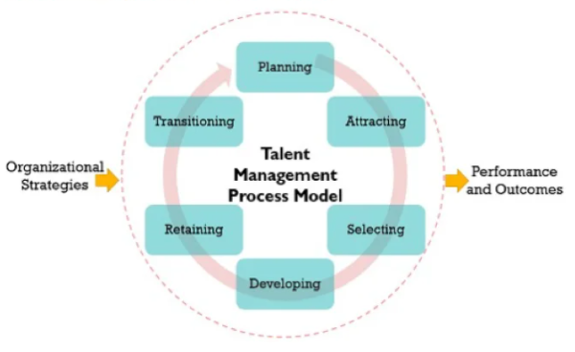

Figure 1.1: Model of talent management process
(Source: Spiceworks.com, 2023)
The above image depicts the first stage of talent management is planning which involves the identification of areas in which gaps are present. Based on the identification, in this planning stage HR managers develop a proper plan to start the recruitment process (Kaliannan et al., 2023). The next stage of talent management is attracting. In this stage, human resource managers decide whether talent will be attracted from internal or external sources (Jooss et al., 2023). Based on that proper advertisement has been created to attract talent. The third stage is selection in which talent managers design tests, group discussions and interviews to select appropriate candidates for the vacant position in the organisation (Mohammed et al., 2020). After the selection developing stage was followed by talent managers. In this stage selected employees get proper training to contribute to the success of the organisation. The next stage is retaining which includes appropriate increments, promotions, and growth opportunities. In this stage, talent managers provide various benefits and opportunities to employees to remain in the organisation (Hongal and Kinange, 2020). A critical evaluation of research by Al Aina and Atan (2020), reveals that there is a positive and significant relationship between employee retention and talent management. Therefore, it can be understood that the talent management process involves talented and skilled employee retention.
Considering employee retention in NHS a Statista report reveals that there is a decreased level of enthusiasm observed among NHS staff over the last decade. This situation has created a staff shortage situation in the NHS (Statista.com, 2023). Critical analysis of different journals helps to understand that most organisations have faced employee retention issues because of poor career growth opportunities and inadequate benefits and compensation.
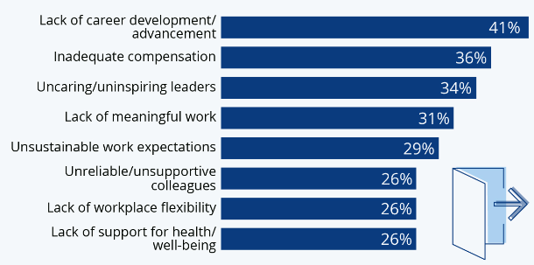

Figure 1.2: Factors that affect employee turnover in an organisation
(Source: Statista.com, 2023)
The above image shows that career advancement and inadequate compensation are two factors that motivate employees to quit an organisation. However, uncaring leaders, lack of health support, poor flexibility in the workplace, unsupportive colleagues, and lack of meaningful work are the factors that affect employee turnover. In order to retain talented employees in NHS or other organisations the talent management team must provide opportunities, compensation, flexibility, and a better workplace culture to employees (Mitosis et al. 2021). NHS is the largest employer in the world, and in the year 2022, it has employed almost 384122 caregivers and 136235 doctors. Hence, overall, 1.3 million people are employed in the workforce of the NHS (Statista.com, 2023). The staff expenditure of the NHS has increased by 62.5 billion pounds. Within years 2020 to 2021, the staff expenditure of the NHS represented only 44% of its entire expense, which indicates a decrease from the previous year. This situation has created a challenging situation for NHS to retain and recruit staff. It can be obtained that improper staff management is a factor that decreases staff retention in the NHS.
Regarding, talent management strategies and their effect on employee retention Chanana and Sangeeta (2021) have claimed that giving better training opportunities to employees can motivate them to remain with an organisation. It can be considered as an example that Google runs a mentorship program in which Career Guru connects with employees to provide guidance about skills needed to complete available roles in Google (Sriram and Devagiri, 2023). In addition to this, the “Googler-to-Googler program” (G2G) of Google is another appropriate example in which the company has provided training and skill-growing opportunities to retain employees (Linkedin.com, 2023). Critical analysis also helps to identify that Amazon has developed “Leadership Principles” to empower and retain talent within the organisation. This largest technology organisation has developed various leadership principles that aim to increase productivity and develop employees (Kamberaj, 2020). These principles enable the organisation to create effective leaders that are needed to manage and organise best performance personnel, and exceptional talent.
Therefore, talent management strategies are crucial to retain and attract qualified, skilled, and talented employees within the workforce. The primary target of talent management is to make sure that organisations have an engaged and competent workforce that is capable of driving organisational success and achieving overall business objectives. In the difficult situation of the NHS regarding staff shortage, appropriate talent management strategies can allow the organisation to maintain its performance and provide appropriate services to patients.

1.3 Rationale
In the era of globalisation, it becomes easy for organisations to grow businesses in the international market. However, increasing globalisation has increased the rate of competition and the difficult situation of retaining global talent. Simpson et al., (2021) have stated that the recent business environment has been characterised by rapid changes and growing complexity. The increasing instability of the global market, changes in the demographics of the workforce, and changes in technology have developed an intense war for managing talent. This VUCA environment has created human capital management as a top priority of the organisation (Porkodi, 2022). Furthermore, firms are seeking to implement effective practices of talent management that can assist in the identification, retention, and development of highly skilled and qualified employees.
In recent times talent management has been an issue in the UK because Brexit as well as the Covid 19 pandemic has negatively affected the business situation. Both consecutive situations have created an unstable socio-political environment in the United Kingdom. The exit from Britain from the European Union creates political and economic uncertainties in the UK. This situation has aggravated the challenges of retaining and attracting talent (Musakuro and de Klerk, 2021). It is essential for businesses operating in the UK to develop and adopt effective strategies of talent management to retain valuable employees. Organisations also need to make sure the growth and continuity of their business operation through talent management practices.
Talent management is an issue for NHS because the COVID-19 pandemic has negatively affected the health and well-being of healthcare workers. Due to poor health and well-being practices followed by NHS in the surge of pandemic cases, various healthcare employees have left their jobs (Creese et al., 2021). It has been also observed that despite the growing recognition of talent management, proper research regarding talent management in NHS is limited. Furthermore, researchers have neglected the particular challenges that NHS faced in managing talents and relevant practices that affect employee retention.
This study aims to contribute to the existing literature and primary sources to explore the effect of talent management practices on employee retention in the NHS. The result of this research is going to contribute to a better understanding of the mechanisms through which talent management strategies of NHS motivate the retention of doctors and staff within the organisation. Moreover, the result of this report is going to provide valuable insight to practitioners working in various areas of NHS. It is going to also provide information about the process of designing and implementing effective strategies for talent management to increase employee retention.

1.4 Research aim and objectives puja
Aim
The prime goal of the research paper is to assess the impact of talent management strategies on employee retention in the context of the NHS
Research objectives
● To analyse the ways of talent management in employee retention of an organisation in the context of NHS
● To evaluate the impact of talent management on staff retention based on the case study of the NHS
● To critically evaluate challenges regarding management and employee retention in the context of NHS
● To elucidate strategies for mitigating challenges associated with talent management and employee retention from the NHS
Research questions
RQ1. What are the ways of talent management in employee retention of an organisation in the context of the NHS?
RQ2. What are the impacts of talent management on staff retention based on the case study of the NHS?
RQ3. What are the challenges regarding management and employee retention in the context of the NHS?
RQ4. What are the strategies for mitigating challenges associated with talent management and employee retention from the NHS?

1.5 Significance of the study
This study has a significant role in understanding the impact of different talent management strategies. The influence associated with the strategies on employee retention can be understood with the help of this research. This research enables the students to understand the key role of talent management in an organization. The research is significant to the students of management who are in need to know various strategies that can help in employee retention. In the current context the researcher gathers data depending on the objectives and helps in mitigating the challenges associated with the management and employee retention. This study is important for the students to understand the key challenges that may create issues in the employee retention process.
This current study helps one in understanding the importance of employee retention in an organization and also the ways that can help in increasing the employee retention rate. The current context has helped in identifying major talent management strategies that can be fruitful for the betterment of an organization. The data has been gathered on determining the impact of various talent management strategies that enables the organization in accelerating staff retention processes. This study is also significant as it helps in identifying the key challenges that can harm the process of employee retention and talent management process. The effective strategies that can mitigate the challenges associated with talent management and employee retention process has been included for the enhancement of the study and also helps in further research for gaining knowledge about talent management and employee retention in an organization.

1.6 Study structure
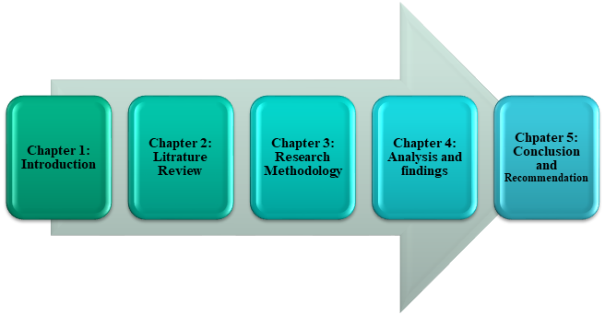

Figure 1.3: Structure of the study
(Source: Self-developed)

1.7 Summary
It can be summarized from the whole chapter that talent management is the key element to grow the capabilities of the employees through application of strategic methods. In order to achieve the organizational goals, the employees should get proper training and motivation. An appropriate strategy is needed for the retainment of talented and skilled employees. The organization becomes powerful when it has a good number of talented employees. In order to keep pace with the competitive organization talented employees are the most essential part for the betterment of the organization. The talent management process is important for obtaining skilled employees. Career advancement and the lack of compensation are the major factors that help the employees to quit an organization and make the organization weak. The talent management strategies play a crucial role in order to drive organizational goals and ultimately helps in achieving the strategic goals set by the organization. In order to derive best performance and exceptional talent the organizations should have effective leadership. In order to attract skilled and talented staff talent management is a key element. In a healthcare organization talent management strategy can help in improving the situation of staff shortage and can avail higher levels of services to the patients.

Chapter 2: Literature Review

2.1 Introduction
The piece of academic writing facilitating the insight of research is conceptualised as a literature review. In terms of significance following chapter enables the researcher to understand the context of the topic based on previous research. Critical evaluation of the findings is also an important part, which allows the readers to get hold of the published topic. From a broader perspective perceiving a literature review in the existing research limits the duplicity of work and allows the researcher to find individual ways of presenting new thoughts and knowledge. Besides the evaluation of familiar research, the chapter gives a scope to explore and extend the analysis of the subject. For reference, the preferred study is based on talent management strategies to assess the impact on employee retention. However, there are several existing studies giving the idea of following context but this research will aim to focus on a wider ground by highlighting ways of talent management, impact, challenges of management and mitigation.

2.2 Identifying the ways of talent management in employee retention in an organization
Concerning the idea of talent management is associated with the employer's way of handling recruitment and aiding the development of the workforce for the long-term productivity of an organisation. Referencing the study of Bibi (2019) the implications of the following context help with the higher performance of employees and motivate the working morale of the individuals in the work environment. The scholar has also argued that talent management enables healthy competition among co-workers allowing them to explore existing opportunities and talent. In other words, the concept of talent management aligns with the identification of recruitment and holding on the employees, driving the success factor of the company (Helmold and Samara, 2019). Implementation of the management is indifferent based on the working scenarios, industry, recruitment, and field. For example, healthcare sectors like NHS refer to the concept because of quick response and cost-effective shifts in the validation and compliance standard.
As per the latest data, it has been witnessed that there are 65.1 million health workers on the global front, which is categorised as 12.7 million medical doctors, 2.2 million midwives, 29.1 million nurses and 14.9 million relatable occupations (Boniol et al., 2022). Apparently, the fact is also true that by 2030 there will be a shortage of 18 million workers owing to income equitability and disparity, whereas talent management still getting the priority.
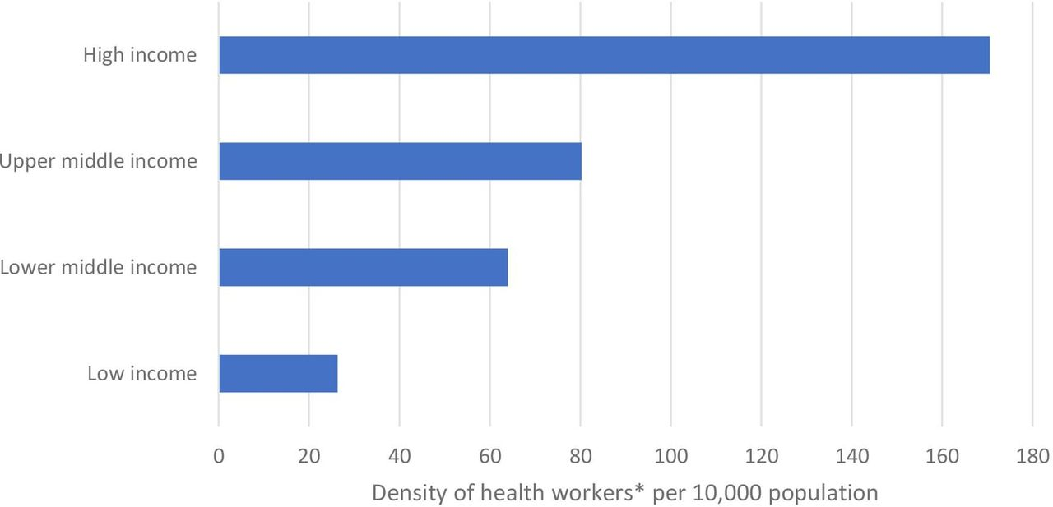

Figure 2.1: Density and population size of healthcare workers/employees
(Source: Boniol et al., 2022)
The aforementioned graph represents the density and population size of the health workers per 10,000 population. Assessment of the data clearly proposes an inequality in the worker's population in the lower-income, lower-middle-income, upper-middle income and high-income (Boniol et al., 2022). The high-income population has a 6.5-strike rate of health workers density than the low-income or upper-income. Therefore, it is important to manage the talent to hold on to the employees and upskill their insights to get beneficial results. Inlining with this, the Indian public healthcare sector, which is still in its developing phase believes in pivoting the positions within the concerned organisation (Gallardo-Gallardo et al., 2020). The concerned healthcare system has been divided into two significant parts diagnostics and administrative. Doctors and nurses are conveniently allocated to high-priority responsibilities, whereas the administrative section is handled by “The Ministry of Health and Family Welfare” (Krishnan and Nair, 2021). Time and over the administrative staff are being trained to make them compatible with the high-tech environment, whereas in terms of high-quality management new laws and regulations are introduced.
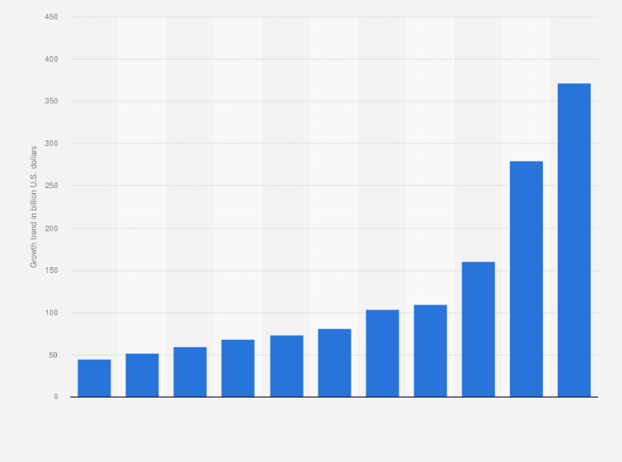

Figure 2.2: Growth in the Indian healthcare sector
(Source: Statista.com, 2021)
In response to the presented graphical representation, it can be witnessed that India has significantly grown in the healthcare sector. This is because over the past few years or significantly the forecasted growth of the staffing members in the “Indian public health care sector,” has risen up to 16.28 % (Statista.com, 2021). It can be hereby concluded that India is among the few countries to successfully conduct talent management as they divide the work pressure among the employees according to their job position and experience. On the other hand, taking the reference of NHS, there has been a significant skill gap among the employees leading to agility, lower production, higher employee attrition and limited innovation impacting talent management (Goldacre et al., 2020). The healthcare sector of the UK has also confronted the aftermath of Brexit policy as there is a huge drop in the number of nurses and doctors from EU healthcare professionals. Making the situation worse the existing healthcare employees in the NHS were to reskill their insights to compete with the new surge of demands from the patients and different parts of the world.
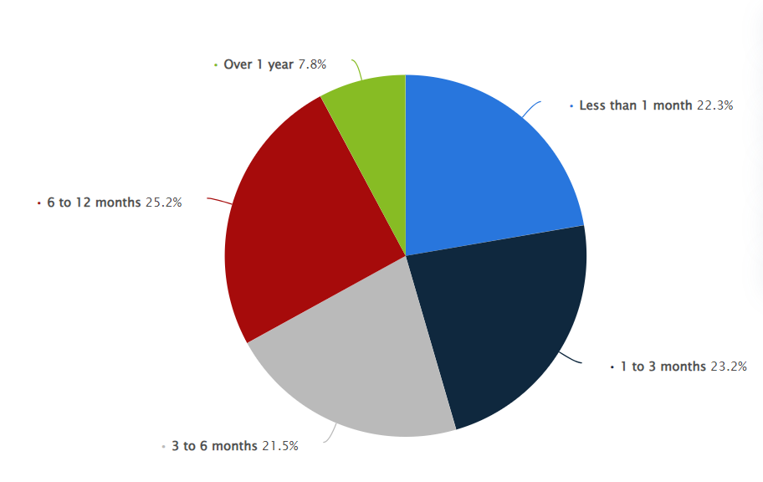

Figure 2.3: Reskilling average in the healthcare sector
(Source: Statista.com, 2020)
Referring to the following data, it is pretty much evident that reskilling of staff in the given sector is not easy as 25.2% of the population ought to take 6 to 12 months, whereas 23.2% of employees are to take 1 to 3 months’ time for reskilling. In-depth understanding evaluates that 21.5% of healthcare staff are supposed to take 3 to 6 months of reskilling time and 7.8% are to take over 1 year (Statista.com, 2020). There is only 22.3% of the population who are supposedly scheduling only 1 month for the skill gap. Aligning the same with the NHS setup, the health sector has invested a lot in talent management in terms of recovering the skill gap. Firstly, the shortfall in the number of employees in the NHS has been fulfilled by recruitment. The preferred sector has aimed to help recover the skill gap by adding 488,000 by 2031 (Holt, 2022). In this context, Al Aina and Atan (2020) have opined that the best of talent management is hiring new employees as the process motivates other employees and includes new talent in the field. Alongside this, the problem of reskilling the employees for more than 1 year can also be resolved.
Furthermore, the entry of new doctors and nurses into the NHS also creates a gap in experience, which is being addressed by NHS’s interim People Plan setting out patients and people's ever-growing demand while providing the staff with flexible working scenarios. The best way of talent management for the mentioned organisation is to make the culture inclusive, healthy, and compassionate (Holt, 2022). This not only satisfies the demand of the patient with quality care but aids the engagement of employees enabling a better work-life balance. One of the most significant parts of NHS talent management is focusing on the mental and physical conditioning of the employees, which attracts the attention of Gen Z talent. There is a measurement of two years long traumatic experience management for the employees of NHS to combat the impact of the pandemic outbreak (Holt, 2022). This helps the concerned organisation to embrace employee retention at different levels.

2.3 Determining the impact of talent management on staff retention
Talent management is the process through which the employers recruit employees and develop a productive workforce with the help of various strategies. According to the study of Al Aina and Atan (2020), in an organization retention of employees leads to boost the productivity level and also helps in promoting employee engagement which plays a crucial role in increasing the revenue of the organization. The strategies of talent management help in minimization of turnovers of the employees of an organization through retention. In the healthcare organization employee retention plays a significant role by providing skilled and talented staff, productive doctors, practitioners and nurses.
Hiring new employees can be expensive for an organization. In the requirement process a huge amount of money is spent. As per the view of Kurdi and Alshurideh (2020), employee retention enables the manager of an organization to prevent the expenditure for hiring new employees. Organizations that follow talent management strategies get a wider chance to retain their skilled employees and can save the organizations from the loss of productivity. According to the research of Masri and Abubakr (2019), the process of talent management allows the organization to develop the skills of their employees in order to meet the goals of the organization with better performances. In a healthcare organization such as the NHS, employee retention plays a key role for the betterment of the organization and also to achieve strategic goals.
It is important for employees to feel motivated towards their work in the workplace. As per the study of Kurdi et al., (2020), timely increment, getting a bonus on special occasions helps in retaining the staff of any organization. The employees feel energetic and motivated to accomplish their jobs when they feel entirely satisfied with their jobs (Claus, 2019). In a healthcare organization health insurance policy can make the staff feel secure as they can get proper health facilities through effective insurance policies. A proper healthcare facility for the staff in their need works as a mental and physical support for the staff and the employees feel positive about their work and helps in planning for working there for a longer period of time.
A proper training for the employees with a regular interval boosts the skill and working culture of the employees. The employees of an organization feel satisfied and secure when they get training for performing better in their further jobs (Gallardo-Gallardo et al., 2020). The growth of the skills of the employees of any organization such as the NHS depends on different training for developing the work culture in the organization. Both the experienced and fresher employees can enrich their skill and talent through effective and progressive training provided by the organization. The proper training campaign with a regular interval enhances the skill as well as makes the employees feel valuable and promotes the working culture to become productive.
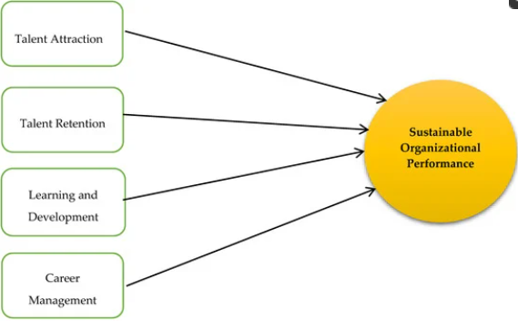

Figure 2.4: Organizational performance depending on talent management
(Source: Created by learner)

A proper leave policy is another key that influences the employees to retain. The organizations that offer a flexible policy to their employees helps in feeling that the organization values their employees and also it helps in maintaining work-life balance. The policy of the organization increases the level of loyalty of their employees and keeps their staff to feel motivated towards their work. According to the view of Stamolampros et al., (2019), the employee of any organization should not feel excessive work pressure which may hamper their personal life as well as lead to feel unmotivated towards their work. In order to make the employees feel motivated toward the work the management must recruit employees on the basis of amount of work at a regular interval which may lead the employees to feel energetic and helps in maintaining a relaxed and worry-free atmosphere in the working place (Hamouche, 2021). Employees with excess workload can damage the entire working capacity of the employees which ultimately turns into the massive loss of the organization and failure of meeting the goals of the organization.
Talent management boosts employee satisfaction and a satisfied workforce is the best asset for any organization and the NHS is not an exception. When an organization becomes able to maintain a satisfied workforce the rate of employee turnover is reduced and that increases productivity level. Talent management helps to make employees engaged, motivated, and enthusiastic to provide their best effort to the organization (Kurniawaty et al., 2019). As a result, the productivity level in an organization improves rapidly. Proper increment policy, fair employee appraisal, and indiscriminate working culture help to generate a sense of value for employees and that helps to retain them in the organization.
Social exchange theory can enhance the benefit of an organization and also enable it to achieve strategic goals. This theory is based on the concept of relationship between two parties for the cost related benefit. Major elements of this theory are trust and commitment. According to social exchange theory the employees get in touch with their employers which is needed in order to achieve the organizational goal. In order to meet the ultimate goal of any large organization such as the NHS, it is important to get in touch with the employees for the management (Sepahvand and Bagherzadeh Khodashahri, 2021). A relationship of trust among the employees makes a better working culture which ultimately results in the achievement of organizational goals.
Adaptation of talent management in an organization creates a greater chance for staff retention. In order to satisfy the valuable employees, the organization can implement strategies that can be fruitful for the staff retention process as well as make a good benefit for the entire organization. Talent management adaptation is the key that ultimately results in achieving the goals through valuable staff retention. The organizations which have more skilled and talented staff are more prone to achieve the organizational goals (Riyanto et al., 2021). It is important to make the employees feel secure and keep motivated towards their work which can be possible only by implementing effective talent management strategies in an organization. A fair pay and its regularity can boost the engagement of the employees. The regular increment and providing bonus help the employees to feel valued which enables them to work to achieve the goals of the organization. So that, a proper talent management strategy can be implemented in a workforce for employee retention and also to achieve the strategic goals of an organization.

2.4 Evaluating the challenges regarding management and employee retention
Employee management from an organisational perspective can be referred to as “Human Resource Management (HRM)” which defines the management of human resources of an organisation. Employee management can depend on both internal and external environmental attributes of an organisation. According to Hamouche (2021), due to the wake of COVID-19, organisations irrespective of operational industries and size have faced challenges in around 8 organisational aspects. The “Strategic HRM (SHRM)” has faced challenges during COVID-19 with respect to the vertical or horizontal interrelations between different organisational strategies and HRM functions. Due to the spread of COVID-19, healthcare industries have faced SHRM issues relating to “personal”, “legal” and “organisational” contexts (Yusefi et al., 2022). Personal challenges in this context can be identified to cater to insufficient knowledge and awareness among employees, their psychological conditions, increase in workload and reduced job satisfaction levels. Similarly, legal challenges in this regard instigated a lack of continuously supportive governmental protocols, inappropriate teleworking approaches and a lack of alternative regulations for managing SHRM.
Healthcare organisations in the organisational context have faced a lack of financial resources, a lack of appropriate organisational culture implementation and inefficient distribution of human resources. According to Collings et al., (2021), SHRM defines the direction of human resource planning and deployment concerning organisational needs and requirements to meet organisational goals. Considering the challenges in healthcare, the inability of SHRM to encompass decision determinants related to HR practices amidst COVID-19 can be evaluated. Changes in work culture and the introduction of new job profiles have created a sufficient number of challenges to healthcare organisations in maintaining their respective HRM practices.
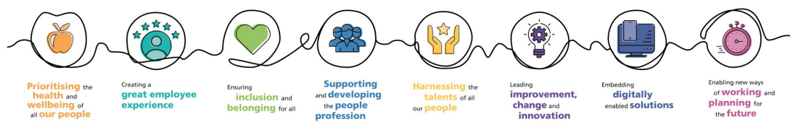

Figure 2.5: Identified Human Resource areas to improve in NHS
(Source: England.nhs.uk, 2021)
Concerning the SHRM challenges, NHS can also be derived to acknowledge the impact of COVID-19 and its associated challenges. NHS has taken different approaches to mitigate these challenges. Based on the identified approaches, it can be evaluated that NHS has primarily identified three distinctive SHRM challenges which are “Change in work culture with respect to healthcare needs”, “Changing innovation and expectations” and “Inefficient workforce supply management” (England.nhs.uk, 2021). There has been an increase in demand for healthcare services in the UK due to the ageing population and complex healthcare news. NHS, in this regard, has identified the need for change in work culture with respect to these changing healthcare needs. NHS further identified the requirement for integrating an agile approach to cater to changing expectations and innovation. NHS has identified that the agile approach can help provide sufficient training to its employees and thus can be beneficial in managing human capital. Due to the complexity of the talent acquisition practices in NHS and the aftermath of COVID-19, a significant amount of lack in the growth of the workforce can be identified. NHS has acknowledged this challenge by focusing on managing workforce supply with respect to the rising healthcare demands.
Alongside HRM, organisations all around the world face challenges regarding employee retention based on their changing organisational culture and structure. Employee retention can be identified to be dependent on employee satisfaction which in turn can change based on four distinctive factors which include “sustainable work environment”, “effective and sustainable talent acquisition”, “effective and sustainable communication” and “sustainable growth opportunities” (Ghani et al., 2022). Organisational work culture can incur changes based on external and internal environmental changes. Different external attributes like political, legal, economic, social, technological, and environmental can influence the work culture of an organisation. Changes in the existing work culture can instigate changes in employee satisfaction levels. Similarly, organisations which are unable to provide “sustainable growth opportunities” and “effective and sustainable communication” can face lowered employee satisfaction that can result in higher employee retention.
Employee satisfaction can also depend on the talent acquisition practices of an organisation. Inappropriate planning of the “talent development process” of an organisation can be identified as a major challenge which can lead to higher employee retention rates (Mahadi et al., 2020). Considering this, the talent acquisition practices can be evaluated to help in determining employee engagement, retention, and turnover to a near-accurate extent. “Effective and sustainable talent acquisition” practices thus can be determined to help increase employee satisfaction. Overall, all these challenges relate to employee satisfaction and meeting employee satisfaction requires appropriate decision-making practices to identify employee needs. According to Ali and Anwar, (2021), recognition, reward, incentive, and compensation can help to motivate employees to an extent that they can achieve sustainable job satisfaction levels. These identified motivational factors can be evaluated to focus on the individual needs of the employees. Organisations failing to meet the needs of employees thus can be determined to face challenges in increasing employee retention.
The healthcare industry from a global perspective can be observed to acknowledge employee retention as a growing challenge with respect to the increasing demand for patient care. Employee engagement can have a positively significant influence on employee retention (Khalid and Nawab, 2018). Based on this, it can be evaluated that the lack of employee engagement in the healthcare industry can be referred to as a challenge in increasing employee retention. Employee engagement in healthcare can further be evaluated to depend more on external factors than internal organisational attributes. Reaction to long-term stress has been identified to result in lower employee engagement and higher employee turnover among staff and clinicians (Willard-Grace et al., 2019). Depending on this, it can be evaluated that a lack of personal accomplishment and personalisation for a long time can incur stress among employees which can result in reduced employee engagement and thus reduced employee retention.
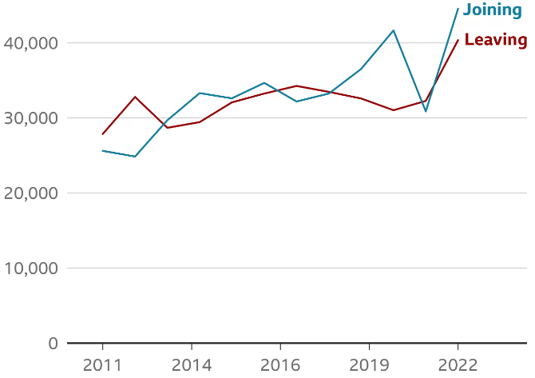

Figure 2.6: Number of Nurses leaving NHS
(Source: Bbc.com, 2022)
This above representation defines the employee turnover at NHS due to the COVID-19 outbreak. A considerable number of employees can be identified to leave NHS during the represented timeline. The spread of COVID-19 has created challenges for NHS in maintaining its employee retention capabilities. NHS workforce has been identified to have more frontline workers actively leaving due to COVID-19 (O'Hara et al., 2022). Based on this, it can also be identified that the worsening of staffing capabilities and the work culture in NHS have become the main reasons behind the higher employee turnover.
NHS, in this regard, can be observed to acknowledge these challenges by addressing them in the “NHS People Plan”. NHS can further be seen to focus on improving work culture to an extent where staff can feel supported and happy at work towards achieving individual ambitions in the respective workplace (Nhsemployers.org, 2022). Based on this approach taken by NHS, it can be evaluated that NHS is focusing on the identification of employee needs in an attempt to increase employee satisfaction levels through higher employee engagement. The plan to achieve higher employee satisfaction levels by NHS can thus be determined to address employee retention in the respective workplace.

2.5 Strategies for mitigating challenges associated with talent management
Strategic challenge mitigation and management is an immensely relevant concept for impacting the talent management scenario. This further helps in robust employee retention mechanism and propels the organizational leverage for better outcomes and development. A meticulously curated talent management strategy helps in mitigating the challenges associated in this domain (Rinaldy, Pahira and Lativah, 2023). Such challenges if not treated properly have the inherent potential to disrupt the organizational portfolio of human resources leading to greater adversities and atrocities for the organization.
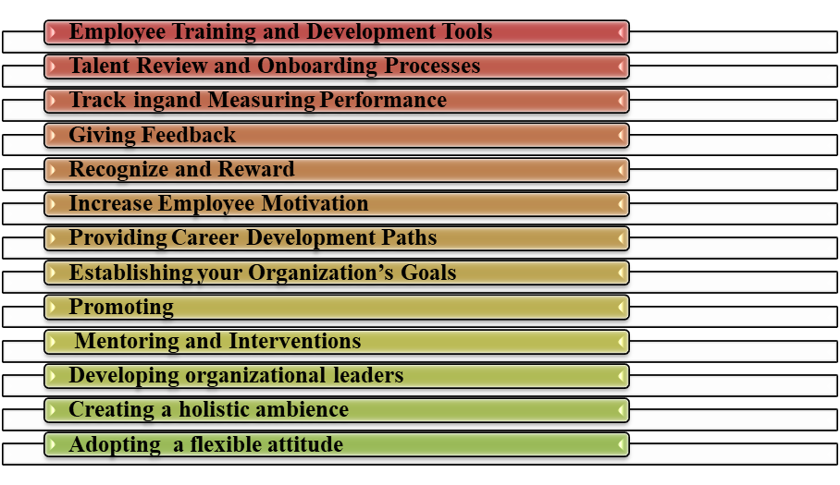

Figure 2.7: Strategies for mitigating challenges with talent management
(Source: Self-developed)
There are various strategies that can be immensely impactful for mitigating the challenges associated with talent management in the organization. Organizations can effectively deploy employee training and development tools for amplifying that training prepositions of the workforce (Refer to Figure 2.7). Sustaining strategic investment in team training tools can help to identify the learner’s perspective and analyse the performance gap and probability. As per the view of Lukowski et al., (2020), deploying training tools can help to address the need of skilled professionals. The system of immediate recurring feedback to overcome those gaps can also help to align the core strategies of the workers. It also helps to save a great deal of time, efforts, resources of the company and can deploy a 360-learning platform for consistent upscaling of the workers. Training deployment through the advance technology integration can help to reduce the employee turnover and can also balance the layoff tendency (Mahlasela and Chinyamurindi, 2020). It can also promote more holistic employee engagement and amplify the productivity parameters. The overall team functionality challenges can also be strategically dealt with the help of new training workers. The vast skill gap lying unaddressed is one of the significant challenges that is encountered across the domain of talent management. Such challenges can also be dealt with by investing in proper training options of the employees.
Strategic investment for effective talent review and the boarding process can also be categorically improved. Filtering out the new fresh talent incorporated into the workforce is important. A good hiring practice is one of the important parameters that propels organizational success and development (Pessach et al., 2020). It can help to tackle the challenge of employee mismanagement by hiring the best resources for the organization by filtering out the employees. Investing proper technology for tracking and measuring the performance parameters is also a dominant trend of mitigating the challenges associated with talent management. Tracking KPIs can also promote more insight to the correct weakness and address the challenges effectively. Likewise, time trackers can be effective in identifying productivity among the workforce (Kim et al., 2019). Improving the communication mechanism is one of the strategy parameters of improving the organizational output. Giving proper feedback of the employees and necessary guidance of overcoming the deviation in the performance is also an important strategy for addressing the challenges of talent management. As per the view of Collings et al., (2021), rewarding and recognising the contribution of the workforces is also an important strategy that addresses the challenges of talent management. Providing reward and recognition improves the motivation capacities of the work force and help them to retain effectively into the organization and their by supporting greater contribution to the output generation.
Organizations have to play an important role in addressing the motivational aspects of the employees to categorically deal with the associated challenges of talent management. According to the view of Varma (2018), focusing on employee motivation can also help the companies to align the workforce to the core goals and objectives of the organizations. It can reduce the tendencies of absenteeism and improve the team building for greater risk management. Focusing on employee development through providing a perfect career development plan and path can make the employees feel much more engaged as they are engaged in viewing the development that they can be a part of by contributing to the organization outcomes. According to the evidence of Oluwaseun (2020), this is related to employee satisfaction, productivity and leads to better performance. Properly establishing the organizational goals and objectives can also make the employees much more cautious about the performance parameters and their expected behavior from them.
Proper mentoring and intervention on suitable time duration also help to improve the collaboration, communication skills. As per the view of Rissman et al., (2020), this can also help in reinforcing accomplishment and improve the decision making and time management capabilities. Hence, challenges pertaining to management can be effectively dealt with. Only focusing on training and development of the work forces are not enough. The organizational leaders and departmental managers have also been trained properly so that necessary leadership styles can be deployed across the team setup. According to the view of Mourão (2018), such leadership can impact aspects of professional development. It can help to manage the talent effectively and address the challenges lying in this domain. Equipping the leaders with the necessary tools and directional capabilities is also important for talent management skills.
The entire organizational culture and environment also needs to be framed properly so as to address complaints, grievances of every work force effectively. As per the view of Xu et al., (2021), positive organizational culture helps in effective talent management. This provides the scope of amplification of the core skill sets that automatically mangoes the challenges lying in the domain of talent management. Through such strong organizational culture, a holistic development can be promoted for talent incorporation. Flexible working attitude with the help of technology can also be a strategic game changer in this domain for managing the Talent on a seamlessly remote mode. Hence through these impactful strategies the overall challenges lying across the talent management can be effectively dealt with.

2.6 Conceptual Framework
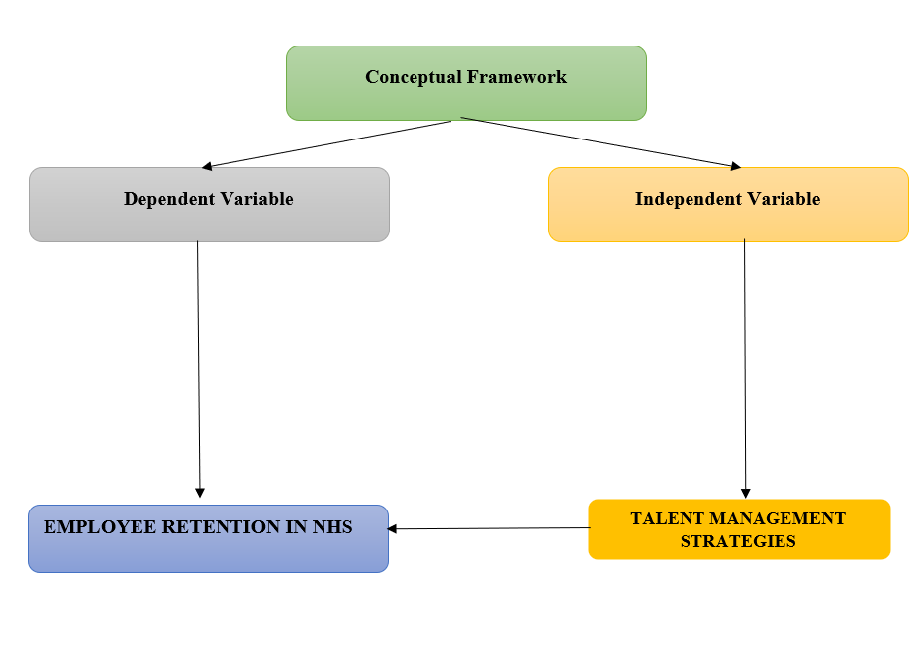

Figure 2.8: Conceptual framework measuring IV and DV
(Source: Self-developed)

2.7 Theoretical Framework
Strategic Human Resource Management (SHRM): SHRM can be referred to as a framework which provides suitability evaluation capabilities to an organisation regarding its people management and development. Appropriate SHRM practices can help an organisation in various aspects including “efficient human resource allocation”, “identifying and addressing employee surpluses”, “employee selection procedure” and “taking the proper approach to cater to employee shortages” (Greer, 2021). SHRM practices can help to properly utilise the human resources of an organisation by appropriately allocating them. SHRM practices while doing so can further help in promoting flexibility, cross-functional teams, non-union basis work culture and cross-functional training programs. These aspects covered by SHRM practices can lead to efficient and productive teamwork. Employee surpluses like retention, redeployment, retirement, employment policies and downsizing can also be properly managed with the help of appropriate SHRM practices.
Talent acquisition in an organisation also plays a huge role in achieving sustainable SHRM practices. Proper implementation of SHRM practices can help to evaluate and identify the validity and reliability of talent acquisition, present a proper analysis of the job role and responsibilities, and implement different testing attributes to interviews. These aspects covered by SHRM practices can contribute to a better organisational work culture that includes proper talent. SHRM practices have also been identified to help in reducing employee shortages ((Greer, 2021)). Concerning this, SHRM practices provide an organisation with the ability to address and implement strategic changes in recruiting, promoting inclusion and diversity, flexible labour management and outsourcing capabilities.
Maslow’s Hierarchy of Needs: Employees of an organisation can have individual needs which align with the organisational achievements. According to “Maslow’s hierarchy of needs”, there are five different categories of needs that include “self-actualisation”, “esteem”, “love and belonging”, “safety needs” and “psychological needs” (Hopper, 2020). This theory further depicts that satisfied lower-level needs can instigate the urge to attain higher-level needs with respect to this hierarchical model.
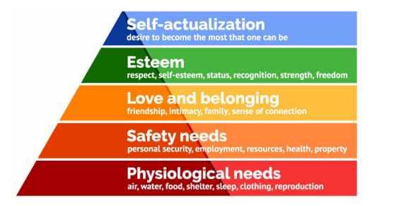

Figure 2.9: Maslow’s Hierarchy of Needs
(Source: Hopper, 2020)
This above representation defines the identified needs according to Maslow's hierarchical model. Considering this representation, it can be identified that the "psychological needs" represent the basic needs that any individual wants to attain to live happily. Considering the completion of these needs, individuals can go up with respect to this model. "Safety needs" primarily address a safe environment, "Love and belonging" mainly represent the feeling of belongingness and love, "Esteem" revolves around the desire to feel good about ourselves and "Self-actualisation" refers to the needs responsible for the feeling of achieving full potential. These needs can be beneficial for organisations in the identification and evaluation of employee needs. Organisations capable of meeting these needs or providing opportunities to employees to meet these needs can have highly motivated employees.

2.8 Literature gap
Following closely evaluating the prior research upon this subject, it happened to be discovered that, although reflecting the theoretical effects of talent management tactics on employee retention, there does not exist an established relationship. Additionally, the earlier literature presents a range of contextual information. The empirical along with statistical findings underlying the earlier research studies that were published are thus effectively missing in the current investigation. The literature research then discovered an additional gap, this one related to core ideas about any real-world use of talent management tactics for employee retention. After that, there did not exist much discussion in earlier literature about the relationship between employing talent management practices and employee retention.
Moreover, taking the reference of a case analysis of the NHS, earlier research has discussed the influence of talent management regarding staff retention; nevertheless, data needed to quantify the effect is lacking. In the overall context surrounding the NHS, the literature has discussed issues with management as well as employee retention; nevertheless, this part omitted to depict theoretical understanding, creating a gap towards establishing fresh knowledge. Further, the absence of effective opposing abstracted perspectives causes a gap within the literature information on NHS initiatives for addressing problems with talent management and staff retention.

2.9 Summary
The conclusion driven through the above discussion states that talent management is significant for employee retention in the healthcare sector. This is because the following context is aligned with staffing motivation, innovation, recruitment, and high morale. In terms of Indian and UK healthcare organisations talent management is measured through the distribution of responsibility, flexibility, reskilling, and new hiring. Focusing on the impact of the following measures, talent management helps with productivity, high retention, positive work culture, and stable mental and physical health of the staff. However, the healthcare sector also faces challenges in terms of talent management, which has surged because of the pandemic outbreak as well. The mitigation strategies suggested for the same are encouraging employees, improving team collaboration, risk management and upgrading communication skills.

Chapter 3: Methodology

3.1 Introduction
The methodology chapter has intended to explain the reason behind selecting certain methods and the reason behind the selection of layers of Saunder’s research onion. In addition to this, this section has put effort into presenting the reliability and validity of the entire study. Therefore, this chapter has briefly outlined the method selected for conducting this dissertation that meets the objective and this scope. Additionally, this chapter has seemed to show a direct link between the research topic with the methods used to arrive at the findings of the investigation. However, this section of the study has deliberated to present the chosen approaches' justifications and drawbacks.
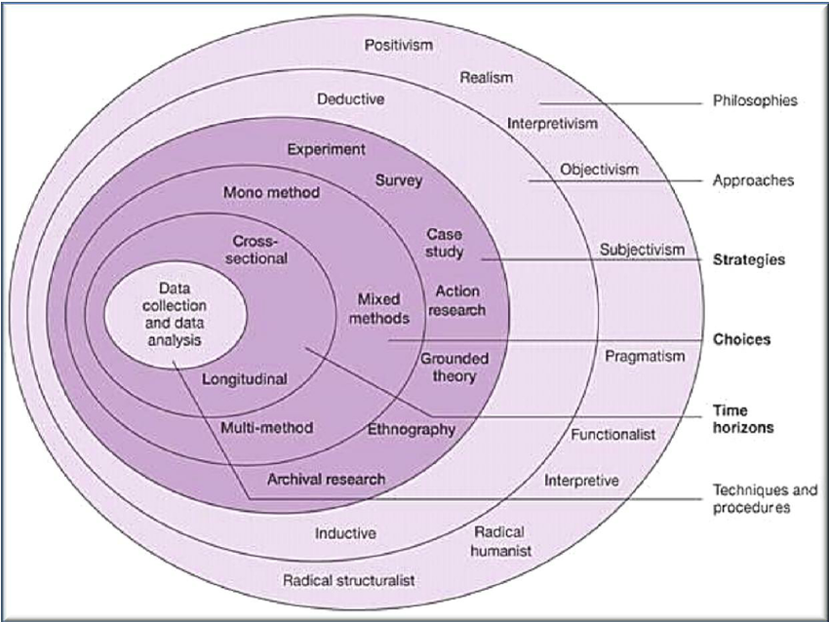

Figure 3.1: Saunders’s Research Onion
(Source: Wisenthige, 2023)

3.2. Research Philosophy
The term research philosophy refers to the framework that directs the process of conducting research based on ideas about reality and the nature of the knowledge. Saliya (2023) has defined research philosophy as the group of fundamental beliefs that guide the design as well as execution of the research study. Various research philosophies provide various processes to understand scientific research. Researchers have also mentioned that philosophy in a study includes an opinion related to the way research is going to be carried out, the way data is going to be collected and the way information is analysed and evaluated for this research. There are four different types of research philosophies that are used in scientific research. Interpretivism, pragmatism, realism, and positivism are four types of research philosophies (Muhaise et al. 2020). In this context, to understand the effect of talent management on employee retention the researcher has selected the Positivism research philosophy.
Positivism philosophy includes a philosophical situation which indicates that knowledge regarding social phenomenon depends on factors that can be measured, observed, and recorded in a similar way as in natural science (Nickerson, 2022). Therefore, here positivist philosophical selection has allowed the researcher to gain knowledge about the talent management factors that help the NHS retain talent in its workforce. The selection of this philosophy is justified for this research because it covers a broad range of situations regarding talent management in a limited time. Therefore, various factors regarding talent management have been covered within this research.

3.3 Research Approach
Depending on the identified research aim and objectives, the Inductive research approach has been chosen for this research. An Inductive research approach primarily focuses on observations and based on the results, it provides a theoretical perspective (Research-methodology.net, 2023). This research approach thus identifies and evaluates the patterns present in the gathered data which then provides a clear understanding of what to record as observations. Focusing on this research approach has helped to integrate flexibility in this research. Due to the integration of flexibility in this research, several instances where modifications to research techniques needed have been properly satisfied. This research approach further helped in presenting a holistic point of view with respect to the diverse range of collected data. Patterns in observations concerning this holistic view in this research have increased the chances of generating new ideas and theories. The ability to generate new ideas in this research further helped to properly interpret gathered data and draw sufficient conclusions that cater to the research objectives.
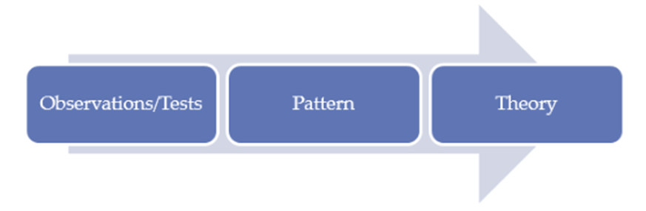

Figure 3.2: Inductive research approach
(Source: Research-methodology.net, 2023)
This above graphical representation shows three major stages of an Inductive research approach. According to this representation, data gathered for this research provided a clear idea of patterns through observations. These patterns in later parts of this research helped to identify associated theories. Following the Inductive research approach, the researcher has also been able to identify probabilities present within the collected data. This further helped in incorporating the correlations between employee management and employee retention. This research approach has also helped the researcher to accumulate patterns from collected data which resulted in a better understanding of related areas of this research. In accordance with the above-selected research approach, the researcher has used it to critically analyse every aspect of employee talent management and how it affects employee retention inside a company. In addition to this, this technique has been utilised to collect and interpret appropriate data to thoroughly examine difficulties surrounding management and personnel retention in the healthcare context of NHS.

3.4 Methodological choice

3.4.1 Research Strategy
The research Strategy not only supports the study that was conducted, but it additionally addresses all of the significant decisions that were taken during the dissertation writing process. In accordance with Saliya (2023), a research strategy provides a piece of equipment that enables researchers to successfully carry out investigations efficiently throughout the schedule in addition to delivering high-quality conclusions and thorough reporting. Nevertheless, selecting an effective research method helps to remain focused on ways to investigate or analyse a fascinating subject (Mishra and Alok, 2022). There are certainly different types of research strategies including qualitative, survey, focus group, action research, interview, and case study. For the existing research, the survey and interview strategy have been chosen to gather, analyse and carry out the information.
Considering the methodological choice in terms of “survey,” and “interview,” the researcher has been able to collect authentic and real-time data from the participants. This is because both strategy choices are an extensive form of research process that helps to generate data by collecting data from significant individuals while asking them relevant questions (Sileyew, 2019). Referring to the gathering of data, there are different ways through which a researcher can collect data such as face-to-face interviews, telephonic conversations, and online forms. The researcher has chosen Google Forms and telephonic medium for the significant research to conduct the survey as well as interviews among individuals associated with the NHS. This has helped the readers to get an in-depth insight into the NHS's present scenario regarding talent management. Accordingly, on one side survey has helped to explore the range of age groups, genders, and experiences of the NHS workers, whereas interviews account for responsibility, challenges, and talent management ways. Overall, the mixed type of research strategy has been impactful in gaining knowledge regarding the subject area.

3.4.2 Research Design
Concentrating on research design, the investigation must select an effective research design that can produce a successful study output. Various kinds of study designs exist, including exploratory and descriptive designs (Asenahabi, 2019). Hereby, the researcher of this study has deliberately considered a “Descriptive design” for the study. In the perspective described by Roush (2023), descriptive design is frequently employed by investigators to analyse and record the scope and complexity of an issue, spot emerging patterns and trends, along with serve as a foundation for further investigation. The outcomes of descriptive research may be used to guide programme design, policy creation, and decision-making processes. Descriptive research, according to Pagola (2023), nevertheless, just offers a picture of what is happening now and lacks the ability to demonstrate causal relationship linkages.
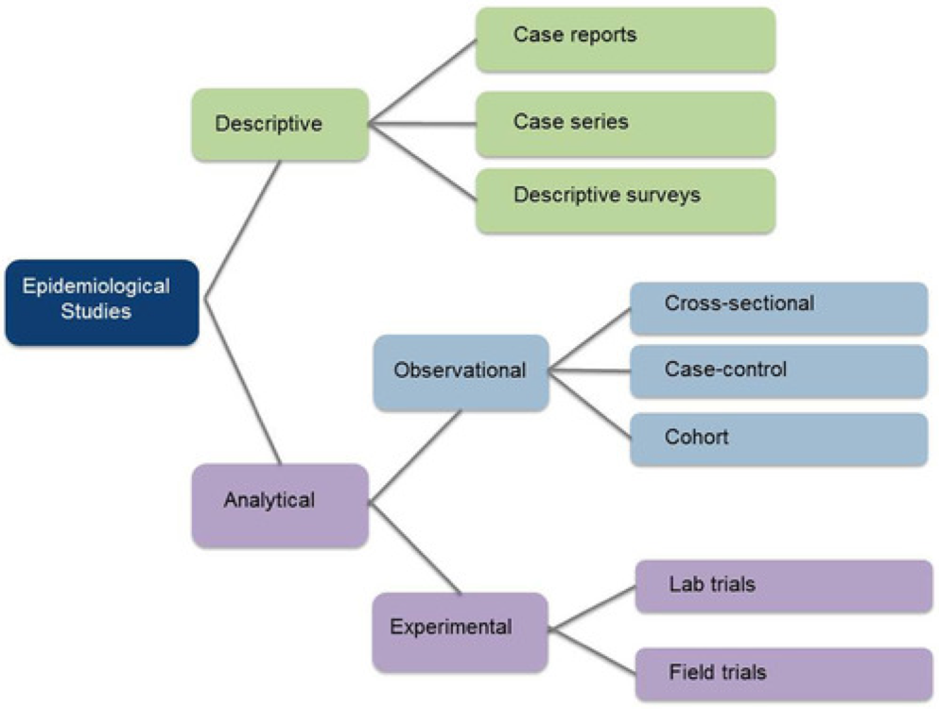

Figure 3.3: Descriptive research design
(Source: Created by the learner)
The importance of staff oversight had been critically examined. The investigator used a descriptive design to characterise every single one of the personnel with relation to facts such as how employees may be inspired and how talent management can occur. As a consequence, the descriptive design encourages further development of the current study. Thus, the observation framed by the exploration of primary data has been supported by this descriptive research design. To evaluate management as well as staff retention issues seriously within the framework of the NHS, the researcher has used descriptive design. The same descriptive design has been employed to clarify tactics for easing difficulties regarding talent management including NHS staff retention.

3.5 Time horizon
A time horizon, whereby is often referred to by the term planning horizon, comprises a set point at a later date during which particular activities can be assessed or taken to have concluded. As per Boliboev and Mirzaeva (2022), the amount of time span (that is, a period of weeks or deliberately months) towards the near future through which plans have been made is commonly referred to as a planning horizon. In this research study, the research’s planned horizon is displayed in the table [Refer to Appendix 1].

3.6 Data collection technique
Data collection is the process of gathering and developing information, facts, and details from various sources for research and analysis. It is a crucial step in the research process to collect data that is directly aligned with the research's objectives, and it can incorporate a variety of approaches such as surveys, interviews, observations, document reviews, experiments, and more (Stanislo, 2023). This step is a significant part of a study for making sure that the data collected is accurate and relevant, which further helps the researcher to develop solid findings and well-informed conclusions. In this study, the "Primary Mixed-Method" process for data collection has been chosen. This is a useful approach for gaining a thorough understanding of the study’s topic. It brilliantly combines qualitative and quantitative methods with the help of both interviews and surveys respectively, which allows the researcher to reach even a more accurate conclusion and study outcomes (Creswell and Hirose, 2019). In fact, interviews and surveys enable the researcher to understand particular circumstances and challenges within the NHS. The study can address specific difficulties and complexities connected to talent management that might not be evident from secondary data sources by connecting directly with individuals who work in this healthcare system.
The qualitative aspect of this method focuses on understanding key participants' experiences, perspectives, and narratives such as NHS employees. It helps the researcher to determine the 'why' and 'how' behind their thoughts and actions, offering light on the individual side and opinion of talent management strategies and employee retention. The quantitative side, on the other hand, provides numerical facts and statistics that provide a broader view and assist in the identification of trends, patterns, and statistical links which support the research objectives. The research aims to give a thorough and well-rounded understanding of the influence of talent management methods on staff retention within the NHS by employing a "Primary Mixed-Method" data-gathering approach.

3.7 Sampling Method
Choosing an effective sample method is critical for producing relevant study results. The researcher has chosen a "Purposive sampling" strategy for this study, which aligns with the eligibility requirements specified in the data collecting section. This method was chosen above alternatives such as probability sampling and random sampling because of its better alignment with the study’s objectives. According to Campbell et al. (2020), Purposive sampling involves the researcher purposefully selecting participants who have specialised knowledge and experience relating to the research issue, in this example, a doctor and an NHS caretaker for interview, as well as an online survey of 30 NHS staff. Interviewing a doctor and a care assistant is effective to obtain in depth insight of talent management practice in the NHS. On the other hand, conducting surveys over 30 employees could also provide knowledge about staff retention and employee management in the NHS.
The researcher has chosen a purposive sampling strategy because it carefully selects individuals with relevant insights into talent management strategies and employee retention within the NHS. It is critical to recognise that with this technique, participant selection is purpose-driven and that the researcher's own beliefs and judgements could influence the sample (Berndt, 2020). However, given the nature of this study, which mostly incorporates primary data about talent management in the NHS, purposive sampling is thought to be the best strategy for gathering relevant information. Additionally, carefully selecting participants based on specific criteria like in purposive sampling can help reduce potential sampling bias which ensures that the sample is more representative of the target population's key characteristics. All other sampling strategies were judged to be irrelevant to this study.

3.8 Data Analysis Technique
Presenting accurate and trustworthy data is generally the goal of data analysis throughout the research. Following data collection, the researcher must go on to data analysis, which treats all of the data critically. This study has purposely developed an interview transcript and has conducted an overall interview based on research questions. After gaining data through interview transcript analysis had been used to breakdown gathered information and extract key parts that are related to each research question. Transcript analysis helped in creating discussion regarding information that is being gathered (Nasheeda et al., 2019). This study also explored core methods that are used by NHS for talent management, similarly also aided in gaining knowledge associated with challenges that are also faced by NHS while conducting talent management. It has been found that along with transcript analysis, statistical analysis has also been used as surveys have been conducted. Statistical analysis helped in breaking down information that is related to statistical data that are gathered through surveys. Therefore, the data analysis has been considered with effective combination and contrast of interview and survey data.

3.9 Ethics
Confidentiality along with the investigator's function as a data-gathering tool are ethical concerns in qualitative research. Therefore, the researcher has considered the “General Data Protection Act 2018” for maintaining ethical consideration throughout the study. The purpose of this study's ethical consideration intended to preserve the researcher's goal of increasing the study's validity and legal significance.

3.10 Summary
In summarising this chapter, it can be stated that the researcher has carefully selected the research philosophy, approach, design, data collection technique and analysis method. In addition to this, to maintain the Ethics of the study along with deriving the desired result from the finding the researcher has opted for corrective methods and considerations.

Chapter 4 Findings and Discussion

4.1 Introduction
The findings are the crucial part of research that enables the researcher to effectively analyse collected data and answer research questions. Both primary qualitative and quantitative data obtained through survey and interview have been analysed and interpreted result in this section.

4.2 How the data answers to research questions (Grouping the answers to each research question)
Research Question | Answers of Interview | Data derived from Survey questions
RQ1. What are the ways of talent management in employee retention of an organisation in the context of the NHS? | According to a doctor of the NHS supportive co-workers and effective team members are factors that provide motivation. Therefore, talent management strategies that can employ effective and supportive teams can retain employees.  Succession planning, coaching, and development programmes are used by NHS to manage talent within the organisation.  In addition to this interviewee also mentioned that NHS promotes an inclusive significant approach to talent management. NHS also employed education and training to new joiners to enhance their skill. | Talent acquisition plan, recruitment of the right talent, individual development plan, skill development opportunities and continuous training are the ways to employee retention through talent management.
RQ2. What are the impacts of talent management on staff retention based on the case study of the NHS? | According to the interviewee, determined and effective talent management strategies have a significant effect on increasing retention rates of employees. It is based on the existing capabilities and potential of the company and deals with present and future business requirements. Including motivation and retention in a particular way can help NHS to retain employees. Moreover, bonuses, rewards, and flexible working schedules are effective in retaining employees. | Survey analysis reveals that talent management has a significant positive effect on employee retention. Succession planning, motivation, recognition, and benefits are retaining employees in NHS.
RQ 3: What are the challenges regarding management and employee retention in the context of the NHS? | There is a certain lack of adequate skilled employees which leads to a high workload. In adequate training opportunities, the doctor has to perform their designated duties in addition to providing training. On the contrary, the healthcare worker identified the challenge of a lower scope of career advancement assistance and feedback. In addition, there is poor support from the HR department, therefore leading to a skill gap. | There is sufficient scope for the talent acquisition plan of NHS to improve. It faces the challenge of low individual development scope, continuous training facilities and succession planning. Moreover, the pay is not optimally competitive that power motivation. Lastly, the employees are not adequately appreciated and recognised.
RQ4: What are the strategies for mitigating challenges associated with talent management and employee retention from the NHS? | The usage of strategies like rewards, employee bonuses, and flexible working hours are beneficial in increasing employee retention. Additionally, it has also been found that the inclusion of education and training as a part of talent management after joining NHS helps to gain a clear understanding of the roles and deliver superior care. In addition, the development of a supportive and positive environment as a part of talent management is assistive in the retention of employees. | The presence of scope for individual development and skill development is required to increase motivation. Succession planning, along with competitive pay and benefits for the employees also help in employee retention. Lastly, providing the employees with due recognition and appreciation for their work helps improve retention.

Table 4.1: Aligning derived data with research question
(Source: Self-created)

4.3 Discussion of the findings and learning from the findings related to the research
From the survey results and interview results it can be learned that effective talent management strategies are followed by the NHS. A strong agreeability is observed from the participants in terms of NHS talent management process transparency, and its ability to retain diversity within the organisation. The survey response also illustrates a certain degree of satisfaction with the talent management approach deployed by NHS, even though they also agree strongly towards the presence of scope for improvement. The aspect of the talent acquisition plan is directly related to employee retention, as it has been supported by 93.3% of the survey participants. Additionally, 93.3% of survey participants agree that the talent management adopted by NHS is relevant in the present context and 93.3% of participants agree that the talent management adopted by NHS is relevant in the present context. Survey response reveals that in the presence of an optimal talent acquisition plan, employee motivation is increased, which positively influences the desire to leave NHS, as expressed by the survey participants. From these findings, it can be learned that talent management approaches adopted by NHS have a significant impact on the retention of skilled and talented employees. However, it has been identified that the existing talent management strategies have several shortcomings that need effective strategies to enhance employee retention.
Researchers have identified that continuous training helps employees to learn new skills that not only help employees to complete their responsibilities but also help in improving their career opportunities. The survey response supports it as participants feel that there is a strong interrelation between employee retention with individual development scope, even though the presence of this scope in NHS is moderately limited. Career pathing is one of the important ways to enhance employee engagement and satisfaction within an organisation. According to the assistant NHS staff, “the talent management strategies of NHS offer training and education after joining the employees”. In contrast, survey response bends the scale towards recruitment of the appropriate talent, rather than employee training or better talent management. This education and training not only help staff to understand their responsibilities but also increase their skills to advance careers in the field of healthcare. Survey participants agree that they have encountered adequate skill development opportunities in NHS, and also helps to understand that skill development is related to organisational profitability and retention of talent. In contrast, the interview response, contradicts the finding, by stating that the individual has encountered challenges pertaining to “support from HR” so as to “advance my skills to grow my career”. From this context, it can be learned that there is a need for optimal support from the NHS HR department to support the employees in skill and career development which in turn boosts retention.
In this context, these views can be aligned with the findings of Mikkonen et al., (2019), where the researcher also agreed that continuous education and training are crucial for staff retention, managing reputation, decreasing medical malpractice, and better patient outcomes. On the other hand, the doctor has said that as a talent management strategy, NHS has employed development programmes, succession planning and coaching for employees that provide them with enhanced opportunities to grow in their respective careers. The survey response also indicates that the participants strongly agree that succession planning is a key determinant in talent management so that employees are able to enhance their skills and prepare themselves for challenging roles. Okwakpam (2019) has mentioned that to increase employee retention it is crucial for an organisation to involve and communicate with every participant at the time of succession planning. Therefore, effective talent management strategies that provide career growth opportunities and training to employees are effective in retaining employees in NHS. these finds lead to the learning that continuous training not only contributes to retention but also prepares employees for succession planning, thereby optimising talent management.
It has been also observed survey respondents have agreed that the NHS has employed continuous training facilities for employees that create learning opportunities for employees. On the other hand, stated that effective talent management strategies including flexible work schedules, benefits and recognition positively motivate employees and increase their retention within the organisation. According to the doctor, “talent management strategy of NHS must include retention and motivation as a significant way to appoint talented candidates within the workplace”. Almohtaseb et al., (2020) have claimed that the motivation of employees is the key to retaining them in an organisation. Moreover, the assistant staffs have also agreed that NHS has effectively employed strategies for talent management by providing bonuses, flexible working and rewards that create motivation among employees to work collaboratively and also create a “high-performance culture” within the organisation. Al Aina and Atan (2020) have also agreed that the talent management department needs to appreciate and recognise employees for their work to retain them in an organisation. Thus, talent management has a significant effect on employee retention. It has been learned from findings that development plans, succession planning and talent acquisition plans are effective strategies for talent management to decrease employee turnover rate.
NHS encounters several challenges in maintaining its talent management plan so that they are able to recruit the right talent within the organisation. Through the interview process, a deeper understanding of the challenges is comprehended. Both the survey and interview identify that adequate training is needed to be included within the talent management program so that employees gain a scope to improve themselves and take up more challenging roles within the organisation. The presence of HR support has been identified to be a challenge from the interview response, whereas, the survey states otherwise, emphasising that the NHS HR department actively assists in talent management and skill development. Retaining and attracting top talent as well as maintaining inclusion and diversity are the major challenges faced by global organisations (Cherubini et al., 2022). As opined by the doctor of the NHS, “There are several challenges in NHS including overworked employees and staff shortages”. This is a shortcoming of the talent management strategies of the organisation that can increase the employee turnover rate. Oliver (2022) has also agreed that due to understaffing conditions, the existing staff of the NHS are facing high workloads and work stress. Whereas, the assistant staff has mentioned a challenge faced regarding the talent management of NHS. According to the assistant staff, “the talent management strategies of NHS lack gaining and providing feedback to employees on their performance and gaps in the performance”. Through the survey response, it can be comprehended that attempts towards equitable talent management for every employee, even though the aspect of feedback is required to be improved as it contributes towards talent management. Moreover, it can also be learned that there is a deficiency of support from the HR departments that need improvement. Another prominent challenge within the talent management aspect is the scope for gaining necessary feedback that helps to understand skills and motivate individuals towards learning.
The pay received by employees has a significant impact on motivation and their intention to retain themselves within the organisation. The participants involved in the survey unanimously agree that competitive pay is a significant strategic approach within the talent management approach adopted by NHS, and it is related to their desire to retain themselves within NHS. In this respect, it can be analysed that improvement of pay structure in the talent management approach so that employees are motivated further, leading to retention. According to the assistant staff, “The talent management strategies include rewards, bonuses, flexible working schedules and others”. According to the research by, Amushila and Bussin (2021), competitive compensation, reading and recognising employees are the effective strategies to retain talent in an organisation. Participants of the survey also agree that they have received adequate recognition within NHS and that it is aligned with the 3R approach consisting of recognition, reward, and respect, and it has positively influenced their desire for retention and high care quality. These strategies help working professionals to work better. Kurdi and Alshurideh (2020) have argued that a positive work environment and career growth opportunities are crucial strategies for talent management that increase employee retention. In addition to pay, which acts as an external motivating factor, the scope to improve one's skill provides intrinsic motivation to employees and boosts their intention towards working for the organisational success and its growth. Furthermore, it has been learned that training also allows employees to undertake more challenging roles thereby having a scope to improve their career prospects, which assists in retention.

4.4 Summary
It can be summarized from this chapter that talent management has a significant positive effect on retaining employees and talent in an organisation. Considering the perspectives of doctors and carers of NHS it has been obtained that NHS is providing training, education, recognition, and other benefits as a strategy of talent management to retain employees within the organisation.

Chapter 5: Conclusion and Recommendation

5.1 Overall Conclusion
It can be concluded from overall study that employees are a crucial part of an organisation. Due to this reason companies need to take certain aspects into consideration so that proper talents are recruited and they are handled properly. This study has extracted accurate data that properly explained the impact of using talent management strategies on overall employee retention of a firm. It has been summarised that employee retention needs to be an organisation’s core goal so that it is able to keep talented as well as productive workers within a firm. Enhanced management of talented and productive employees helps an organisation to reach its goals and meet its vision successfully.
This study concluded the need of using talent management actions within the NHS so that talent acquisition can be done successfully. It has been summarised that the National Health Service needs to have proper talents in their organisation so that they are able to treat their patients properly. It has been concluded that framing of necessary strategies regarding talent management can help this organisation to recruit efficient healthcare workers that are going to provide accurate treatment. It is summarised that objectives, aims that were framed all were properly discussed within this study to develop accurate data. Objectives mostly helped in gaining data related to talent management methods, impact of talent management and challenges that were encountered while conducting it. Research questions or objectives that were framed mostly concluded all the major methods that paved the path for better talent hunting and gathering within the NHS. Similarly, it was also concluded from literature analysis that some authors mentioned that one prime technique that the NHS can use for talent management is to check the skill set of an individual before recruiting.
Checking the skill set of an individual before recruiting helps in understanding whether that person is suitable in contributing its potential for meeting NHS’s goals as well as objectives. Another author also summarised after recruiting to maintain employee retention it is also important to provide training to all the talents so that they are able to enhance their skills more. This study through its literature review further summarised the factor that a strong talent management process efficiently helped in improving productivity of business operations. Necessary research methods like primary data collection, statistical, transcript analysis was further incorporated to gather more information and improve research quality.
The findings section of this study has summarised the exact ways of talent management that are being used by the NHS to handle its employee retention. It can be summarised from the interview that incorporation of proper talent handling plans, recruitment of right talent and development of individual development plans for each employee largely helped in talent management. Incorporation of individual plans massively opens up scope for efficient skill development that also leads to efficient employee retention through talent management within the organisation. A concrete plan of talent handling massively helps the NHS to understand the type of talents that they need to meet its organisation's needs. Another major aspect that has been concluded is related to the effect of using the talent management process within the NHS. Based on interview responses it is concluded that implementation of talent management has helped in increasing employee retention. This is because motivation helps in development of a focused mindset within individuals and it drives them to work more efficiently. Another major impact that has been recognised is that talent management plan helps in recognising hard work that is put forward by all health workers within the NHS. This recognition massively helps in development of work performance as workers feel rewarded and they are able to put forward more work for the NHS.
Study has also concluded that challenges are also faced by the NHS while handling the talent management process and also handling employee retention. It summarised that individual level development occurs at a very minimal rate as talent management does not largely emphasise in enhancing individual skills. It is also found that the continuous training process is also not present within the NHS which also poses issues for employees to enhance their skills. Lack of training also hinders maintenance of talent thus negatively impacting employee retention as derived from interview. Sometimes the NHS has also been failing in recognising their employees which as a result also appreciated the employee retention process as employees prefer to work in an environment that appreciates their effort. Another major information that has been gathered are regarding strategies that are being used to minimise challenges. It has been found that motivation needs to be increased and due to this reason, the NHS has come up with a necessary motivation plan so that overall development can be done successfully.
Interviews helped in gaining some core knowledge regarding NHS activities, however, survey responses were also gathered to further enhance knowledge associated with the talent management process. It has been summarised that the majority of NHS workers are young talents as they are working for less than 1 year and they are aware of employee retention strategies that are being used to handle talents of the organisation. However, the majority of responses have also shown agreement to this factor that the NHS's talent management approach massively helps in development of motivation among workers. Similarly, more than 93.3% of doctors, workers have also mentioned that implementation of talent acquisition process also helps in improving employee retention. On other hand, it has been also considered that recruiting the right talent is the most common method of handling employee retention through effective talent management. Survey responses also concluded that overall talent management processes of the NHS are satisfactory as they help in efficient talent handling. Continuous development process is also needed to be handled as majority of workers have agreed to that factor. Based on overall findings it has been understood that incorporation of a strong talent management process helps in better handling of new employees. Efficient employee handing also paves the path for effective business operations.

5.2 Linking with Objectives
Objective 1: “To analyse the ways of talent management in employee retention of an organisation in the context of NHS”
Objective has been framed to gain knowledge related to methods that can be used to maintain employee retention and also develop talent management processes efficiently. Based on this objective necessary information is gathered within findings and literature review. It has been found that with implementation of a strong talent acquisition plan organisations like the NHS can handle its work productivity. Interview findings also mentioned that within this talent management plan a proper requirement process has been developed so that it helps in individual skill enhancement within the NHS. Objective has been met through findings and literature review part as both of them explained methods like extensive training that also helps in development of talent management. Improved talent management aids in increasing employee retention, hence meeting this objective helps in understanding core methods of talent management and how it contributes to improved employee satisfaction.
Objective 2: “To evaluate the impact of talent management on staff retention based on the case study of the NHS”
Objective has been developed to gain reliable information related to the overall impact of talent management on the overall staff retention process. Meeting this objective majorly helps in development of information related to the effect of talent management on overall employee satisfaction development. Development of this objective also aimed at understanding overall upliftment of business efficiency that took place as a result of staff management. Improved staff management majorly helps in development of business operations. Similarly, it has also been found that this objective has been discussed in the literature review and finding’s part. Discussion in both of LR and finding’s part has helped in analysis that through this management process NHS are able to improve potential of its employees. Similarly, improvement in employees’ potential leads to efficient development of NHS operations. Meeting this objective helped in understanding all core positive impacts that lead to better business operations.
Objective 3: “To critically evaluate challenges regarding management and employee retention in the context of NHS”
Objective has been developed to analyse core challenges that are posing a threat during incorporation of talent management procedures. Meeting this objective helped in gaining knowledge related to core issues that can be identified during the process of talent management easily. Literature review and findings section aided in understanding that challenges like lack of individual development plan can easily diminish progress of skill upliftment within an individual. Similarly, sometimes due to unclear goals talent management becomes confusing, hence implementation of proper goals is required so that overall talent management process can be done accurately. It has also been found information related to challenges helped in understanding core places that need to be changed.
Objective 4: “To elucidate strategies for mitigating challenges associated with talent management and employee retention from the NHS”
This objective has been developed to gain information related to strategies that can be used to improve current issues that are being faced during the talent management process. Similarly, implementation of this objective also helps in development of ideas related to strategies like building of individual level development plans to bring self-upliftment. Literature review and data analysis par both have gathered sufficient knowledge related to core strategies that can help in development of operations through mending challenges.

5.3 Future Scope
This research has been meticulously framed and developed on understanding the overall impact of talent management strategy for employee retention with major emphasis on the case study of NHS. In the future this study can be of great importance and significance as there is justified scope lying in front of the study. The findings of the study will help in addressing the diversified needs and specification on the aspects of employee retention and talent management. In the future this study can form the base of more exploratory research lying in the domain of employee retention and talent management. It can also guide the policy maker and industrial management to be aware about the plethora of challenges that are critically encountered in the domain of retaining the employees and supporting organizational development. This research in the future can provide a comprehensive idea about the changing trends of talent management in the present scenario and the modes of employee retention through understanding their respective demands and specifications. Prominent organizations can take ideas in the future from this research and can reframe and recalibrate the organizational policy and can improve the employee motivation aspects. The modes of preparing the future workforce through integration of technological inclusions, training support can also be effectively ideated by analysing the findings of this research. Hence in the future vast scope lies with this research.

5.4 Research Limitation
This research has been developed on the basis of primary data; hence, the practical scenario has been explored in this research effectively. However, the use of primary data has led to huge depletion of the research budget and has proved to be an immensely costly affair. The data collection in this research has also been a time-consuming affair. The process of testing validity research has also been a costly affair. The number of sources explored is also limited considering the vastness of the research domain. Hence the same is also a limiting factor to arrive at the accurate precision of the research findings. Incorporating relevant secondary data would have helped to gain tremendous access to a variety of data in limited time to amplify the analytical horizons of the research. This could have supported more holistic research outcomes in this research.

5.5 Recommendation
There lies vast scope of massive improvement in the research in the future. It can be recommended to improve the number of sources of gathering the data to project a more realistic view in the data sets. This could also amplify the relevance of the research finding and could be used actively in decision scenarios. The number of literatures analysed in this research can also be improved for more explorative research. This could also be successfully analysed to understand the deviation between the future research and the present research. Theoretical scenarios illustrated in this research could be more prominently explored. Likewise, the strategic Human Resource Management has been effectively used to ideate the development form of flexibility, incorporation cross functional team management. It can be recommended to use this theory for linking the employee retention capacities more effectively. Maslow's need hierarchy theory categorically depicts the different classes of needs that are fulfilled by organization to motivate the employees. It can be recommended to analyse the nexus of this theory with talent management for better outcomes generation.

Reference List
Al Aina, R. and Atan, T., (2020). The impact of implementing talent management practices on sustainable organizational performance. Sustainability, 12(20), p.8372.
Ali, B.J. and Anwar, G., (2021). An empirical study of employees’ motivation and its influence job satisfaction. Ali, BJ, & Anwar, G.(2021). An Empirical Study of Employees’ Motivation and its Influence Job Satisfaction. International Journal of Engineering, Business and Management, 5(2), pp.21-30.
Ali, Z., Bashir, M. and Mehreen, A., (2019). Managing organizational effectiveness through talent management and career development: The mediating role of employee engagement. Journal of Management Sciences, 6(1), pp.62-78.
Almohtaseb, A.A., Shaheen, H.A.K., Alomari, K.M. and Yousef, M.A., (2020). Impact of talent management on organizational performance: The moderating role of an effective performance management system. International Journal of Business and management, 15(4), pp.11-24.
Amushila, J. and Bussin, M.H., (2021). The effect of talent management practices on employee retention at the Namibia University of Science and Technology: administration middle-level staff. SA Journal of Human Resource Management, 19, p.11.
Asenahabi, B.M., (2019). Basics of research design: A guide to selecting appropriate research design. International Journal of Contemporary Applied Researches, 6(5), pp.76-89.
Aspers, P. and Corte, U., (2019). What is qualitative in qualitative research. Qualitative sociology, 42, pp.139-160.
Bbc.com, (2022). Record number of nurses quitting the NHS (Online) Available at: https://www.bbc.com/news/health-63080462 [Accessed on 12th October 2023]
Berndt, A.E., 2020. Sampling methods. Journal of Human Lactation, 36(2), pp.224-226.
Bibi, M., (2019). Impact of talent management practices on employee performance: an empirical study among healthcare employees. SEISENSE Journal of Management, 2(1), pp.22-32.
Boliboev, A.A. and Mirzaeva, S.N., (2022). METHODS OF PLANNING PRODUCTION PROCESSES. Gospodarka i Innowacje., 24, pp.961-964.
Boniol, M., Kunjumen, T., Nair, T.S., Siyam, A., Campbell, J. and Diallo, K., (2022). The global health workforce stock and distribution in 2020 and 2030: a threat to equity and ‘universal’health coverage?. BMJ global health, 7(6), p.e009316.
Braun, V., Clarke, V., Boulton, E., Davey, L. and McEvoy, C., 2021. The online survey as a qualitative research tool. International journal of social research methodology, 24(6), pp.641-654.
Campbell, S., Greenwood, M., Prior, S., Shearer, T., Walkem, K., Young, S., Bywaters, D. and Walker, K., 2020. Purposive sampling: complex or simple? Research case examples. Journal of research in Nursing, 25(8), pp.652-661.
Chanana, N. and Sangeeta, (2021). Employee engagement practices during COVID‐19 lockdown. Journal of public affairs, 21(4), p.e2508.
Cherubini, F., Newman, N. and Nielsen, R., (2020). Changing newsrooms 2020: addressing diversity and nurturing talent at a time of unprecedented change.
Claus, L., (2019). HR disruption—Time already to reinvent talent management. BRQ Business Research Quarterly, 22(3), pp.207-215.
Collings, D.G., McMackin, J., Nyberg, A.J. and Wright, P.M., (2021) Strategic human resource management and COVID‐19: Emerging challenges and research opportunities. Journal of Management Studies, 58(5), p.1378.
Creese, J., Byrne, J.P., Conway, E., Barrett, E., Prihodova, L. and Humphries, N., (2021). “We all really need to just take a breath”: composite narratives of hospital doctors’ well-being during the COVID-19 pandemic. International Journal of Environmental Research and Public Health, 18(4), p.2051.
Creswell, J.W. and Hirose, M., 2019. Mixed methods and survey research in family medicine and community health. Family medicine and community health, 7(2).
England.nhs.uk, (2021). The future of NHS human resources and organisational development (Online) Available at: https://www.england.nhs.uk/wp-content/uploads/2021/11/B0659_The-future-of-NHS-human-resources-and-organisational-development-report_22112021.pdf [Accessed on 12th October 2023]
Gallardo-Gallardo, E., Thunnissen, M. and Scullion, H., (2020). Talent management: context matters. The International Journal of Human Resource Management, 31(4), pp.457-473.
Ghani, B., Zada, M., Memon, K.R., Ullah, R., Khattak, A., Han, H., Ariza-Montes, A. and Araya-Castillo, L., (2022). Challenges and strategies for employee retention in the hospitality industry: A review. Sustainability, 14(5), p.2885.
Gobo, G., (2023). Mixed methods and their pragmatic approach: Is there a risk of being entangled in a positivist epistemology and methodology? Limits, pitfalls and consequences of a bricolage methodology. In Forum: Qualitative Social Research (Vol. 24, No. 1, pp. 1-26). Institut für Qualitative Forschung, Internationale Akademie Berlin gGmbH.
Goldacre, B., Bardsley, M., Benson, T., Cheema, K., Chinn, R., Coughlan, E., Dougan, S., Farr, M., Hawkins, L., Jonas, A. and Kinnear, A., (2020). Bringing NHS data analysis into the 21st century. Journal of the Royal Society of Medicine, 113(10), pp.383-388.
Greer, C.R., (2021). Strategic human resource management. Pearson Custom Publishing.
Hamouche, S., (2021). Human resource management and the COVID-19 crisis: Implications, challenges, opportunities, and future organizational directions. Journal of Management & Organization, pp.1-16.
Helmold, M. and Samara, W., (2019). Progress in performance management. Springer International Publishing.
Holt, C., (2022). How the healthcare sector can attract and retain staff to avoid a widening skills gap. Available at: https://www.peoplemanagement.co.uk/article/1751716/healthcare-sector-attract-retain-staff-widening-skills-gap [Accessed on: 13-10-2023]
Hongal, P. and Kinange, U., (2020). A study on talent management and its impact on organization performance-an empirical review. International Journal of Engineering and Management Research, 10.
Hopper, E., (2020). Maslow’s hierarchy of needs explained. ThoughtCo, ThoughtCo, 24, pp.1-3.
Jooss, S., Lenz, J. and Burbach, R., (2023). Beyond competing for talent: an integrative framework for coopetition in talent management in SMEs. International Journal of Contemporary Hospitality Management, 35(8), pp.2691-2707.
Kaliannan, M., Darmalinggam, D., Dorasamy, M. and Abraham, M., (2023). Inclusive talent development as a key talent management approach: A systematic literature review. Human Resource Management Review, 33(1), p.100926.
Kamberaj, B., (2020). The Importance of Organizational Learning As Imperative for the Use of Information Technology in E-Commerce. Available at SSRN 3594083.
Khalid, K. and Nawab, S., (2018). Employee participation and employee retention in view of compensation. Sage Open, 8(4), p.2158244018810067.
Kim, Y.-H., Choe, E.K., Lee, B. and Seo, J. (2019). Understanding Personal Productivity. Proceedings of the 2019 CHI Conference on Human Factors in Computing Systems - CHI ’19. [online] doi:https://doi.org/10.1145/3290605.3300845.
Krishnan, G.A. and Nair, A.K., (2021). Primary health-care innovations with superior allusion to family health centers. Indian Journal of Community Medicine, 46(1), pp.149-152.
Kurdi, B. and Alshurideh, M., (2020). Employee retention and organizational performance: Evidence from banking industry. Management Science Letters, 10(16), pp.3981-3990.
Kurdi, B., Alshurideh, M. and Alnaser, A., (2020). The impact of employee satisfaction on customer satisfaction: Theoretical and empirical underpinning. Management Science Letters, 10(15), pp.3561-3570.
Kurniawaty, K., Ramly, M. and Ramlawati, R., (2019). The effect of work environment, stress, and job satisfaction on employee turnover intention. Management science letters, 9(6), pp.877-886.
Lichtman, M., (2023). Qualitative research in education: A user's guide. Routledge.
Linkedin.com (2023) Talent management training program of Google Available at: https://www.linkedin.com/pulse/why-its-worth-installing-coaching-culture-your-aldona-ole%C5%84kiewicz#:~:text=Google's%20%22G2G%22%20(Googler%2D,and%20personal%20growth%20among%20employees. [Accessed on 20-09-2023]
Lukowski, F., Baum, M. and Mohr, S. (2020). Technology, tasks and training – evidence on the provision of employer-provided training in times of technological change in Germany. Studies in Continuing Education, [online] pp.1–22. doi:https://doi.org/10.1080/0158037x.2020.1759525.
Mahadi, N., Woo, N.M., Baskaran, S. and Yaakop, A.Y., (2020). Determinant factors for employee retention: Should I stay. International Journal of Academic Research in Business and Social Sciences, 10(4), pp.201-213.
Mahlasela, S. and Chinyamurindi, W.T. (2020). Technology‐related factors and their influence on turnover intentions: A case of government employees in South Africa. The Electronic Journal of Information Systems in Developing Countries, 86(3). doi:https://doi.org/10.1002/isd2.12126.
Masri, N.E. and Abubakr, S.U.L.I.M.A.N., (2019). Talent management, employee recognition and performance in the research institutions. Studies in Business & Economics, 14(1).
Mbanaso, U.M., Abrahams, L. and Okafor, K.C., (2023). Research Philosophy, Design and Methodology. In Research Techniques for Computer Science, Information Systems and Cybersecurity (pp. 81-113). Cham: Springer Nature Switzerland.
Mikkonen, K., Koskinen, M., Koskinen, C., Koivula, M., Koskimäki, M., Lähteenmäki, M. L., ... & Kääriäinen, M. (2019). Qualitative study of social and healthcare educators’ perceptions of their competence in education. Health & Social Care in the Community, 27(6), 1555-1563.
Mishra, S.B. and Alok, S., (2022). Handbook of research methodology.
Mitosis, K.D., Lamnisos, D. and Talias, M.A., (2021). Talent management in healthcare: A systematic qualitative review. Sustainability, 13(8), p.4469.
Mohammed, A.A., Baig, A.H. and Gururajan, R., (2020). An examination of talent management processes in Australian higher education. International Journal of Productivity and Performance Management, 69(6), pp.1271-1299.
Mourão, L. (2018). The Role of Leadership in the Professional Development of Subordinates. Leadership. [online] doi:https://doi.org/10.5772/intechopen.76056.
Muhaise, H., Ejiri, A.H., Muwanga-Zake, J.W.F. and Kareyo, M., (2020). The Research Philosophy Dilemma for Postgraduate Student Researchers. International Journal of Research and Scientific Innovation, 7(4), pp.2321-2705.
Musakuro, R.N. and de Klerk, F., (2021). Academic talent: Perceived challenges to talent management in the South African higher education sector. SA Journal of Human Resource Management, 19, p.1394.
Nasheeda, A., Abdullah, H.B., Krauss, S.E. and Ahmed, N.B., (2019). Transforming transcripts into stories: A multimethod approach to narrative analysis. International Journal of Qualitative Methods, 18, p.1609406919856797.
Nhsemployers.org, (2022). Improving staff retention (Online) Available at: https://www.nhsemployers.org/publications/improving-staff-retention [Accessed on 12th October 2023]
Nickerson, C., (2022). Positivism in sociology: definition, theory & examples. Simply Psychology.
O'Hara, R., Weyman, A., Glendinning, R., Roy, D., Coster, J. and Nolan, P., (2022), July. Should I stay or should I go? NHS staff retention in a post-COVID-19 world…. In HSR Conference 15th 2022 Shefffield.
Okwakpam, J. A. (2019). Effective succession planning: A roadmap to employee retention. Kuwait Chapter of the Arabian Journal of Business and Management Review, 8(2), 1-10.
Oliver, D., (2022). David Oliver: Politicians’ abject failure to tackle the existential crisis in the NHS. bmj, 378.
Oluwaseun, O.O. (2020). EMPLOYEE TRAINING AND DEVELOPMENT AS A MODEL FOR ORGANIZATIONAL SUCCESS. International Journal of Engineering Technologies and Management Research, [online] 5(3), pp.181–189. doi:https://doi.org/10.29121/ijetmr.v5.i3.2018.190.
Pagola, S., (2023). Outstanding advantages, current drawbacks, and significant recent developments in mechanochemistry: A perspective view. Crystals, 13(1), p.124.
Pessach, D., Singer, G., Avrahami, D., Chalutz Ben-Gal, H., Shmueli, E. and Ben-Gal, I. (2020). Employees recruitment: A prescriptive analytics approach via machine learning and mathematical programming. Decision Support Systems, [online] 134(1), p.113290. doi:https://doi.org/10.1016/j.dss.2020.113290.
Porkodi, S., (2022). Imperative Strategic Enhancement on Human Resource Management Functions in VUCA Business Environment–HR Leader Perspective. International Journal for Research in Engineering Application & Management (IJREAM), 8(6), pp.61-67.
Research-methodology.net, (2023). Inductive Approach (Inductive Reasoning) (Online) Available at: https://research-methodology.net/research-methodology/research-approach/inductive-approach-2/ [Accessed on 12th October 2023]
Rinaldy, R., Pahira, S.H. and Lativah, E. (2023). Talent Management Strategies to Face the Challenges of Changing Workforce Demographics. American Journal of Economic and Management Business (AJEMB), 2(8), pp.310–315. doi:https://doi.org/10.58631/ajemb.v2i8.53.
Rissman, J., Bataille, C., Masanet, E., Aden, N., Morrow III, W.R., Zhou, N., Elliott, N., Dell, R., Heeren, N., Huckestein, B. and Cresko, J., (2020) Technologies and policies to decarbonize global industry: Review and assessment of mitigation drivers through 2070. Applied energy, 266, p.114848.
Riyanto, S., Endri, E. and Herlisha, N., (2021). Effect of work motivation and job satisfaction on employee performance: Mediating role of employee engagement. Problems and Perspectives in Management, 19(3), p.162.
Roush, K., (2023). A nurse's step-by-step guide to writing a dissertation or scholarly project. Sigma Theta Tau.
Savin-Baden, M. and Major, C.H., (2023). Qualitative research: The essential guide to theory and practice. Taylor & Francis.
Sepahvand, R. and Bagherzadeh Khodashahri, R., (2021). Strategic human resource management practices and employee retention: A study of the moderating role of job engagement. Iranian Journal of Management Studies, 14(2), pp.437-468.
Sileyew, K.J., (2019). Research design and methodology. Cyberspace, pp.1-12.
Simpson, N.P., Mach, K.J., Constable, A., Hess, J., Hogarth, R., Howden, M., Lawrence, J., Lempert, R.J., Muccione, V., Mackey, B. and New, M.G., (2021). A framework for complex climate change risk assessment. One Earth, 4(4), pp.489-501.
Spiceworks.com (2023) Model of talent management Available at: https://www.spiceworks.com/hr/talent-management/articles/what-is-talent-management/ [Accessed on 17-10-2023]
Sriram, G. and Devagiri, A., (2023). Scalable Mentoring Programs—The Key to Entrepreneurship Development: A Little Bit of Structure Goes a Long Way. In Diversity and Inclusion in the Start-Up Ecosystem (pp. 107-131). Singapore: Springer Nature Singapore.
Stamolampros, P., Korfiatis, N., Chalvatzis, K. and Buhalis, D., (2019). Job satisfaction and employee turnover determinants in high contact services: Insights from Employees’ Online reviews. Tourism Management, 75, pp.130-147.
Stanislo, K.J., 2023. Data Collection: Time to revisit the WHY, WHAT, and HOW. NASN School Nurse, p.1942602X231199932.
Statista.com (2023) Factors causing employee turnover Available at: https://www.statista.com/chart/27830/reasons-for-quitting-previous-job/#:~:text=At%20the%20top%20of%20the,being%20uncaring%20or%20uninspiring%20leaders. [Accessed on 20-09-2023]
Statista.com (2023) Lack of enthusiasm among NHS staff Available at: https://www.statista.com/statistics/883005/enthusiasm-at-work-nhs-england/ [Accessed on 20-09-2023]
Statista.com (2023) Staff retaining issues of NHS Available at: https://www.statista.com/topics/9575/nhs-staff-shortage/#topicOverview [Accessed on 20-09-2023]
Statista.com., (2020). Expected average reskilling needs in the health and healthcare sector worldwide as of 2020, by duration. Available at: https://www.statista.com/statistics/1239261/health-sector-reskilling-needs/ [Accessed on: 13-10-2023]
Statista.com., (2021). Growth trend in Indian healthcare sector from 2008 to 2017, with a forecast for 2020 and 2022. Available at: https://www.statista.com/statistics/1343672/india-growth-trend-in-healthcare-sector/ [Accessed on: 12-10-2023]
Varma, C. (2018). MPORTANCE OF EMPLOYEE MOTIVATION & JOB SATISFACTION FOR ORGANIZATIONAL PERFORMANCE.
Willard-Grace, R., Knox, M., Huang, B., Hammer, H., Kivlahan, C. and Grumbach, K., (2019). Burnout and health care workforce turnover. The Annals of Family Medicine, 17(1), pp.36-41.
Wisenthige, K., (2023). Research Design. In Social Research Methodology and Publishing Results: A Guide to Non-Native English Speakers (pp. 74-93). IGI Global.
Xu, K., Wang, C., Li, Z., Wu, S. and Wang, J., (2021) Salt mitigation strategies of solar‐driven interfacial desalination. Advanced Functional Materials, 31(8), p.2007855.
Yusefi, A.R., Sharifi, M., Nasabi, N.S., Rezabeigi Davarani, E. and Bastani, P., (2022). Health human resources challenges during COVID-19 pandemic; evidence of a qualitative study in a developing country. PloS one, 17(1), p.e0262887.

Appendices
Appendix 1: Time horizon
Activities | August 2023 |  |  |  | September 2023 |  |  |  | October 2023
Week numbers | 1 | 2 | 3 | 4 | 1 | 2 | 3 | 4 | 1 | 2 | 3 | 4
Approval of the research proposal with study’s aim and objectives
Project initiation by drafting introduction (topic’s background, rationale and problem)
Developing literature review
Drafting research methodology
Collecting survey response
Conducting interview
Proceeding with data analysis
Interpretation of the findings
Drafting discussion and conclusion from findings
Final submission of the dissertation
(Source: Self-created)

Appendix 2: Survey Responses
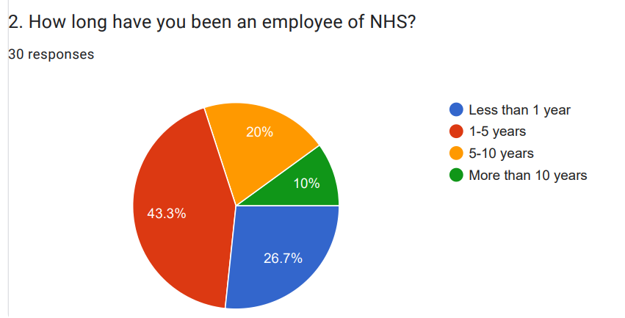
Figure 1: Survey response to Question 2
(Source: Self-Created)
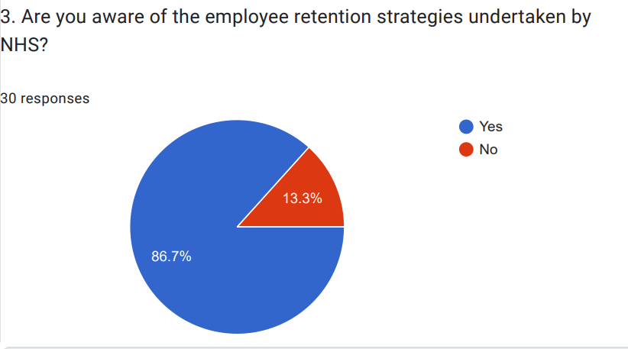
Figure 2: Survey response to Question 3
(Source: Self-Created)
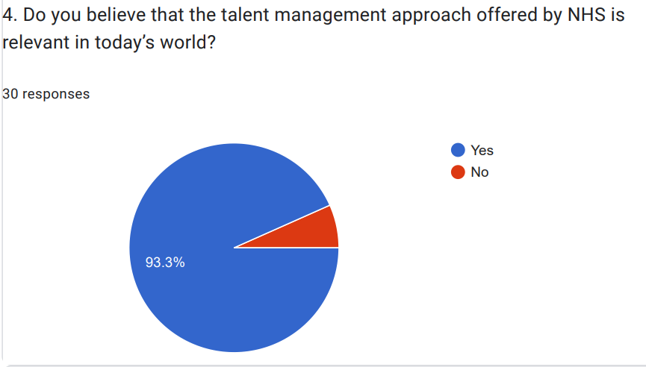
Figure 3: Survey response to Question 4
(Source: Self-Created)
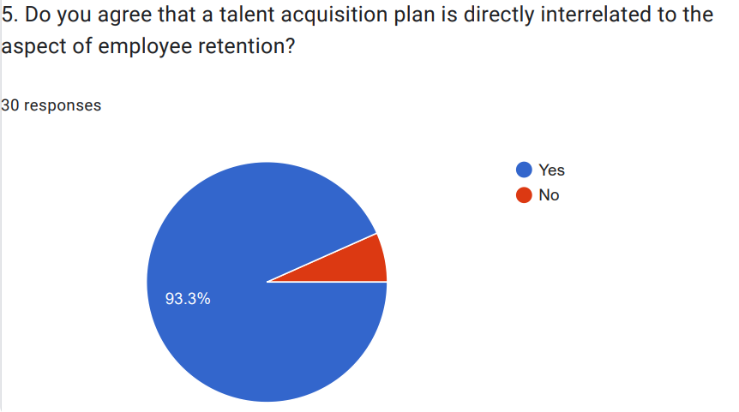
Figure 4: Survey response to Question 5
(Source: Self-Created)
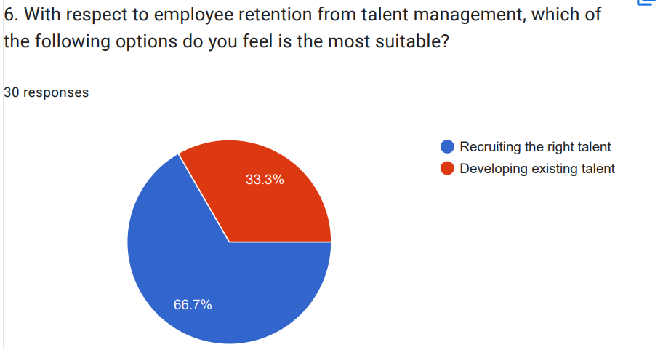
Figure 5: Survey response to Question 6
(Source: Self-Created)
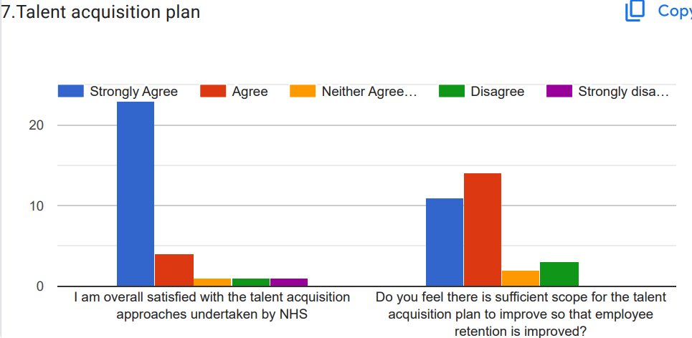
Figure 6: Survey response to Question 7
(Source: Self-Created)
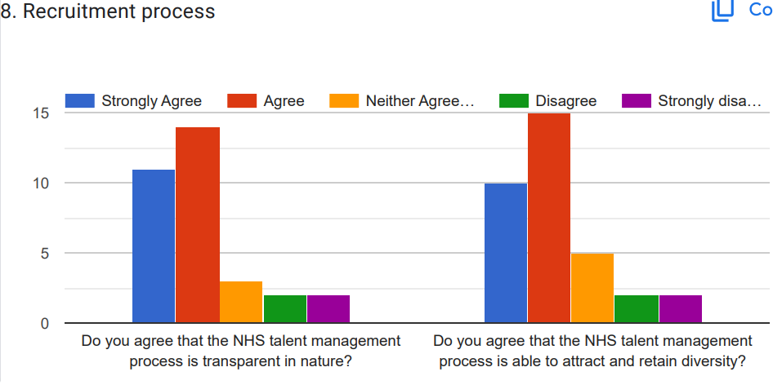
Figure 7: Survey response to Question 8
(Source: Self-Created)
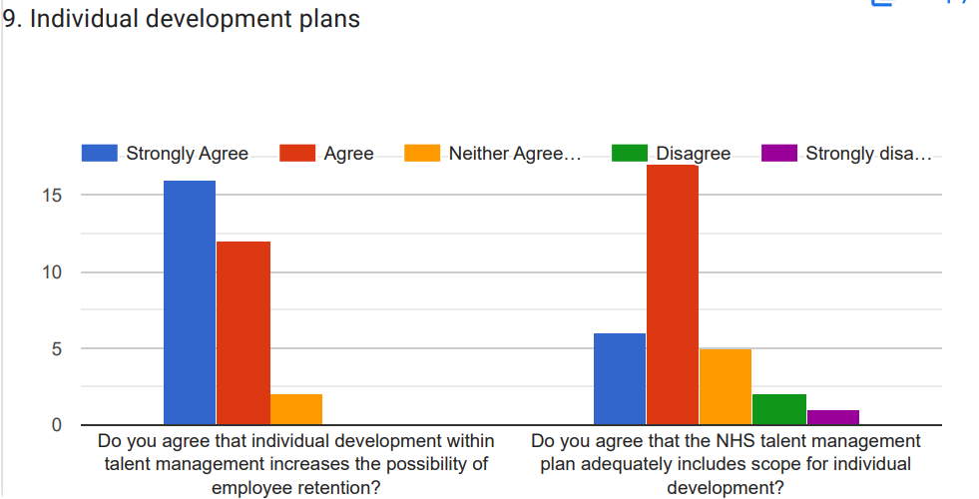
Figure 8: Survey response to Question 9
(Source: Self-Created)
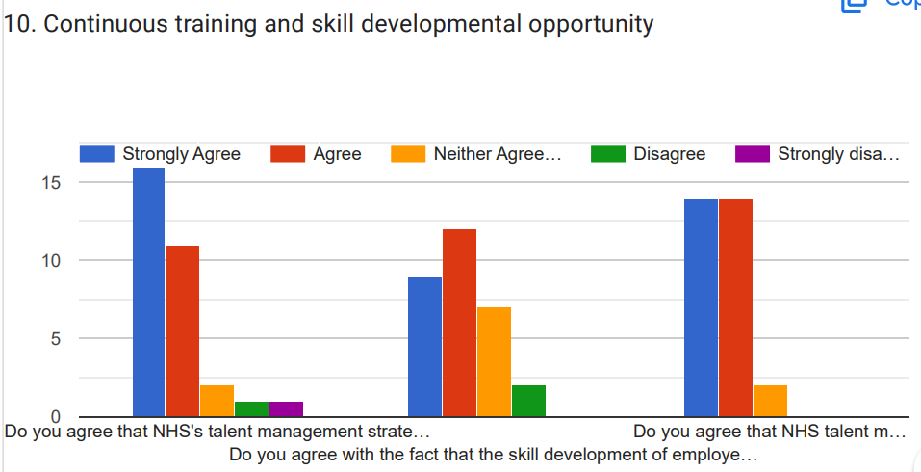
Figure 9: Survey response to Question 10
(Source: Self-Created)
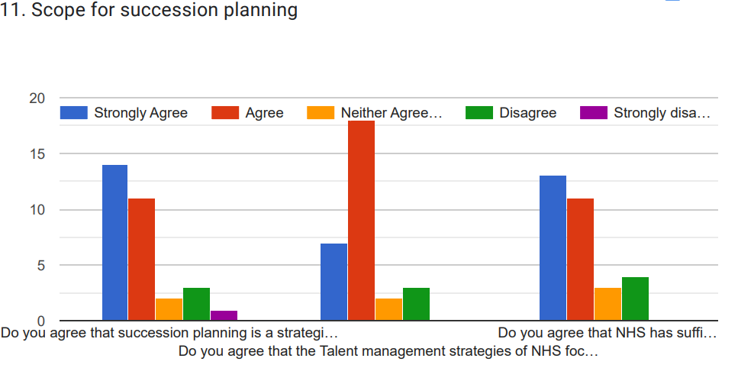
Figure 10: Survey response to Question 11
(Source: Self-Created)
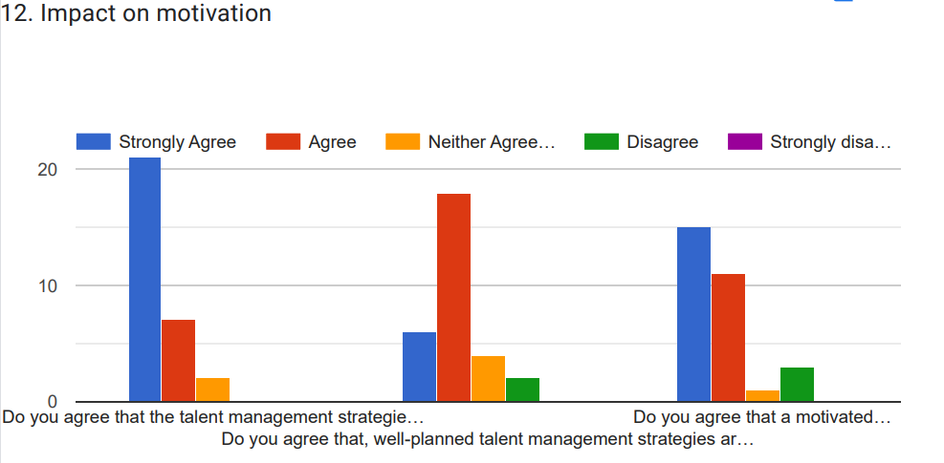
Figure 11: Survey response to Question 12
(Source: Self-Created)
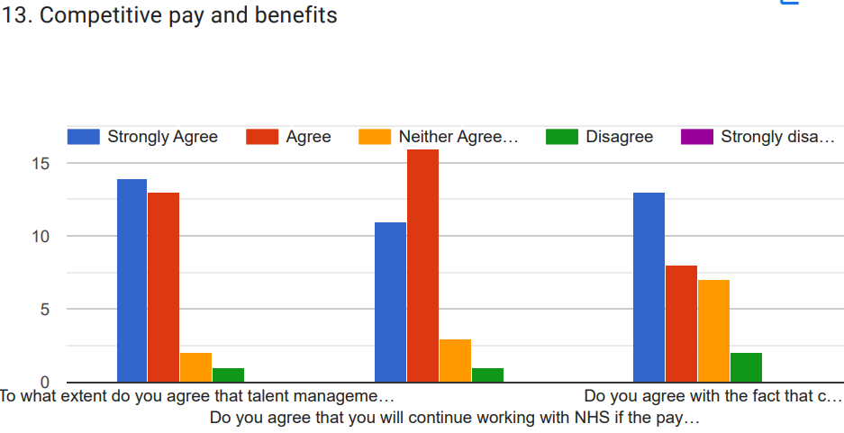
Figure 12: Survey response to Question 13
(Source: Self-Created)
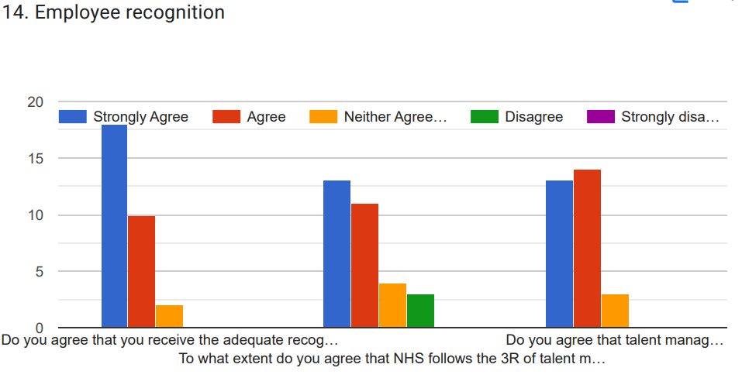
Figure 4.13: Survey response to Question 14
(Source: Self-Created)
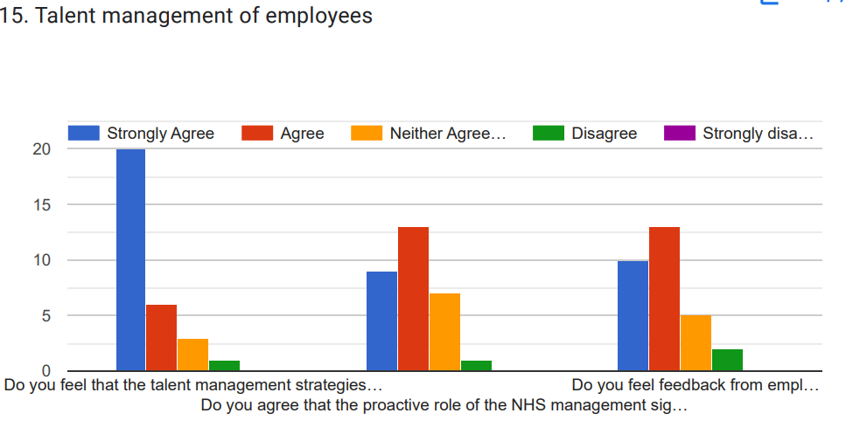
Figure 4.14: Survey response to Question 15
(Source: Self-Created)

Appendix 3: Interview transcript
Interview with care assistant-NHS staff
Sr No. | : Question | Answer
1 | Hi, I am grateful to have this opportunity to talk to you. I hope you are well. | Hello, it is my pleasure to communicate with you. I am grateful to help you by answering the questions. I am ready to answer you today.
2. | For how long, have you been working as an NHS staff? | I have been working in this organisation in the UK for the last 3 years. I have been always encouraged to become a care assistant since I saw my mom become a healthcare staff. This is why, I have always been interested in serving people in the healthcare field. I am so happy to get this chance and pursue my career in this field further.
3. | What has attracted you to the care profession? | I think the main thing that has attracted me to this profession is the need to help people who are in need. Since my mother was also a nurse and a healthcare professional that really inspired me to follow her steps and pursue this career.
4. | What are your daily liabilities in NHS staff and in which department you are working? | I am working in the care department in NHS. Being a care assistant, my primary liabilities involve taking care of patients and helping patients with their personal needs like cleaning, washing, eating and others. I also tend to make reports on the health and wellbeing of people like blood pressure, temperature and others.
5. | Could you please share how you handle your work under pressure? | Sure, why not? I think I tend to focus on my roles and responsibilities first. In addition, I always pay attention to meeting the needs of my patients and prioritise their needs first. Since it is my responsibility and nobility to take care of the patients, that is why I do not care about pressure. I tend to take care of them and do my duty with all my potential.
6. | Could you please answer about your professional background and how that led to this role? | I have done diploma in high school that has helped me to start my career before graduation in the healthcare field. I have taken courses while in high school and prepared my career to become a care assistant. I have done courses in social studies, biology and mathematics.
7. | What is your understanding of maintaining the confidentiality of the patient's data in the NHS organisation? | I feel and believe that confidentiality is significant. Since I was taught in social studies medical reports and data of a patient should not be disclosed to anyone except the patient and his family members. It can affect the patient and the treatment quality can be reduced. This is why, being a care assistant, I try to keep the personal conversations with the patients to myself and not share the details with anyone in terms of address and phone numbers. According to Keshta and Odeh (2021), confidentiality is known to be a good care practice and must be taken in a serious way.
8. | What do you think, you are suitable for this role in NHS? | I think that I hold several required skills and competencies that make me compatible with this job in NHS. The skills and features I hold include caring, kind, friendly, and willing to take care of patients and carry out their personal tasks. In addition, I am also able to follow the rules and processes imposed by NHS to deliver care and do my duty. However, I am also able to work in a team and respect the cross-cultural working environment.
9. | Could you please share any scenario of teamwork with cross-cultural people to meet the better needs of the patients? | Sure. One example I can give regarding better teamwork with different people includes handling a complicated case of a patient after surgery operations. In the post-surgery period, the patient required good care and proper observations as well as time-to-time medications from doctors and nurses in order to become better. In that scenario, I have collaboratively worked with doctors, nurses and other healthcare givers to report the health and well-being of the patient. This helped them to deliver the best treatment to the patient in the post-surgery period.
10. | Do you think that talent management strategies are implemented in NHS? If implemented then share how these strategies retain employees. | Yes, I have found that the HR department in the NHS organisation has implemented talent management strategies to manage the talents of the healthcare professionals. In addition, the talent management strategies of NHS offer training and education after joining the employees. This helps the healthcare workers even me to understand my roles and liabilities and also advance my skills to grow my career in the healthcare field. This is how the employees become motivated to remain in NHS for a longer time. However, I have also faced challenges regarding this strategy. For example, the talent management strategies of NHS lack gaining and providing feedback to employees on their performance and gaps in the performance. This is why, I felt a little lack of support from the HR department in NHS.
11. | In your opinion, do you think that the talent management strategies are effective in NHS? | Yes, surely, I think the strategies of talent management are effective. The talent management strategies include rewards, bonuses, flexible working schedules and others (Davidescu et al., 2020). These strategies help us as working professionals in NHS to work in a high-performance culture and develop strong employer collaboration. I feel that the bonus and reward structure is effective in NHS in encouraging me as a care assistant to serve better to patients better beyond my duties.
12. | Fine. This is all for today and I have asked so many questions to you. Thank you so much for answering all my questions with so much calm and patience.  I am grateful to have your time today. | It is my pleasure that I have answered all of the questions successfully. If you further need any assistance or help from me, you can contact me at any time. I will be happy to help you.
Table 1: Table representing the interview transcript with care assistant
(Source: self-created)
Interview with Doctor
Sr. No. | Question | Answer
1. | Hi! Thank you for giving me time to ask you something about your current experience working with the NHS | Hello! It is my kind gladness to chat with you. It is a great opportunity for me that I would be a small part of your dissertation. I assure you that I will fully cooperate with you by providing all answers with my best possibility
2. | How long have you been working in the healthcare field and What is your motivation for doing the job in the healthcare sector? | Well! Thank you for asking this question. As I have been working in this health care field as a doctor for 7 years. From my childhood, I was wishing to become a doctor because it is a novel profession. I also mention that my father was a reputed heart specialist and my mother was a reputed gynaecologist. Those two people are the most inspirational and motivational objects of my life. Hence, I am very grateful to provide quality services to my patients.
3. | As a doctor, kindly share a few words with me What is your key responsibility to work within the NHS? | Look, I am a heart specialist doctor and my responsibility is huge as most the person believe that doctors are part of God. Many patients come to me with great hope, that they think I can decrease their disease. So, it is a huge responsibility to me. I am doing my duty more than 10 to 12 hours including the night duties. Most of the time I am working in the emergency section. On the other hand, sometimes I need to collaborate with the medical team to formulate treatment plans. In addition, I play a role in mentoring and training junior doctors, confirming they deliver high-quality service and maintain the hospital’s protocols.
4. | Kindly share your educational background and what motivates you to do better service to the common people | I completed my Bachelor of Science in Medicine in 2011, then I pursued a master's degree and completed it by 2014, I have completed my MBBS degree by 2020. I have gathered many kinds of experiences during this time. I meet several types of patients both rich and poor and they give me the special strength to work hard to harder every day. Throughout my professional career, I have had the opportunity to work with effective team members and most supportive co-workers. I personally feel that all those things provide me great motivation to do better service to the common people.
5. | What kind of challenges do you face since the beginning of working within NHS? | I personally believe, there are several challenges including NHS including overworked employees and staff shortages. In addition, sometimes some patients party behave badly to the doctors, those are the challenges that obstruct the daily life job and effective work. In addition, I personally believe time management is another key challenge for doing a job within NHS.
6. | What kind of talent management strategy has been used by NHS? | I can identify that, several types of talent management strategies have been used by NHS such as coaching, development programmes, succession planning and others. However, during my tenure, I can identify that NHS promote a significant and inclusive approach to talent management as well as it confirms that every staff member and must regularly follow talent conservation.
7. | Do you think all the talent management strategies are effective or not? | I think all these talent management strategies are effective and important for enhancing the employee retention rate within NHS. Moreover, I also realize that, NHS needs to enhance its overall talent management strategy with full of effect and determination.
8. | What is the impact of talent management strategy on employee retention rate? | I personally believe that talent management strategy provides a direct effect on employee retention rate. I think that talent management mostly depends on the company's potential and existing capabilities as well as it deals with its future and present business requirements. I think that the "talent management strategy" of NHS must include retention and motivation as a significant way to appoint talented candidates within the workplace.
9. | How do you manage both your professional and personal life being a doctor of NHS? | Frankly speaking, I can try to maintain both my personal and professional life. As I have 2 children both are very small and my wife is a professor. In that case, I can tell you my wife is very supportive as she always encourages me to do my individual work. With the help of my wife and parents, I manage both my personal and professional life.
10. | In your experience, how does a supportive environment and a positive work culture contribute to talent retention? | Look, in every organization, a supportive and positive working environment is very important. From this perspective I can tell you that I am very lucky that I get very cooperative co-workers and get a very positive working environment since my joining date. I can get full support from my co-worker when I face any challenges within the workplace.
11. | How do you manage your daily life stress and similarly maintain your well-being? | I always make sure to maintain a healthy life with the help of healthy food, free hand exercise and others. When I get any free time, I use to read story books and do some free hand exercise to maintain a healthy life and remove the daily stress. Hence, my father used to tell me that exercise and playing is the most important factor for removing daily stress.
12. | Do you think, each other collaboration is necessary for providing better quality service to patients?  Thank you so much for your kind cooperation and for giving answers very effectively! And thank you for giving me your valuable time | Of course, I feel that each other cooperation and collaboration is very important for doing an effective job within the workplace. In addition, I also believe that it gives me a significant help to maintain a healthy work life.  Thank you! It is my pleasure and honour to chat with you. Thank you once again

Table 2: Table representing the interview transcript with doctor
(Source: Self-created)

