

Market Research Analysis Report:

K8 Water Ionizer

Business Development

Digital Skills for Personal Development and Business Growth (BMSW4008_CARD)

Student Name: Alexandra Zara
Student ID: 2329733
Lecturer: Philippa Fitzgerald
Date of Submission: 20.06.2025
AI Acknowledgement
I confirm that I have not presented any AI generated materials as my own work.
I confirm that I have copies of my drafts, notes, and other resources I used, which I may be asked to provide in evidence.

Table of Contents
TASK 1 3
1. Executive Summary 3
2. Key Survey Findings and Business Significance 3
2.1 Water Quality as Primary Health 3
2.2 Multifunctionality and Technology Adoption 4
2.3 Price Expectations and Market Positioning 6
2.4 Scientific Validation Requirements 7
3. Business Concept 8
4. Audience Segmentation Process 11
5. SEO Strategy Implementation 13
6. Website Design 14
7. Marketing Development 15
8. Conclusions 15
TASK 2 16
Excel in Small Business Management 16
A Strategic Tool for Digital Transformation 16
References – task 1 18
References – task 2 19

TASK 1

Executive Summary

This analysis report examines how complex market research shaped the development of the K8 Water Ionizer business, from initial concept trough website creation and marketing strategy implementation. Through systematic survey analysis, key-consumer insights were indentified and directly translated into strategic business decision, resulting in the successful launch of k8water.weebly.com. The research revealed critical market dynamics that fundamentally influenced product positioning, pricing strategy, and digital marketing approach.

Key Survey Findings and Business Significance

2.1 Water Quality as Primary Health

The most significant finding emerged from survey question 6, where 50% ( 20 individuals ) of respondents rated water quality as “extremely important” to their health and wellness (fig.01) and (fig.02), with an additional 20% ( 8 individuals ) rating it “very important”.

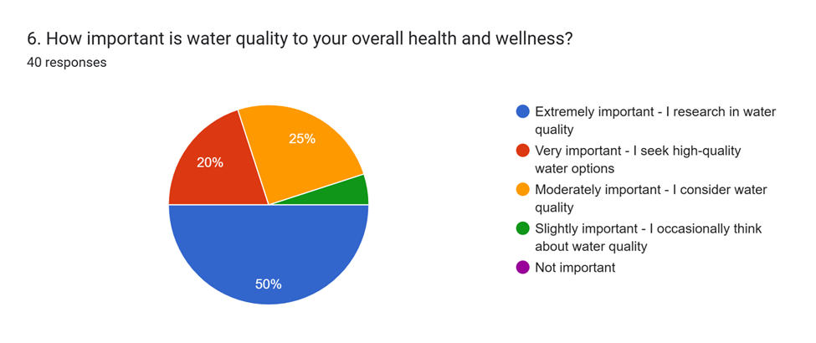

(fig.01)

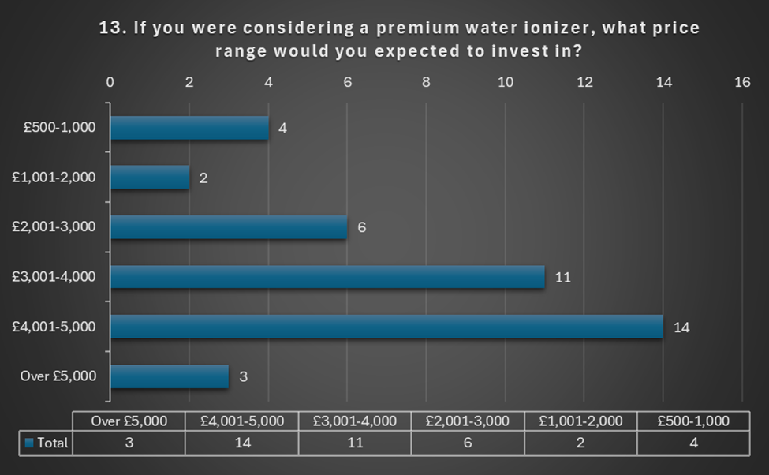

This more then 70% prioritization of water quality validated the core business premise and directly influenced website messaging strategy (Dadwal, 2020). The finding contradicted assumptions that price would be the primary concern, instead revealing health consciousness as the dominant purchasing motivator. This insight drove the decision to lead whit health benefits rather than cost savings on the website homepage. The research demonstrated that consumers view water ionizers as health investments rather than convenience products, fundamentally shaping the K8`spositioning as a wellness appliance rather then a basic filtration system.

2.2 Multifunctionality and Technology Adoption

Survey question 10 revealed that 47.5% of respondents ( 19 individuals ) found ionization technology creating multiple water types “extremely appealing”, with 42.5%
( 17 individuals ), rating it “very appealing”. (fig.03) and (fig.04)

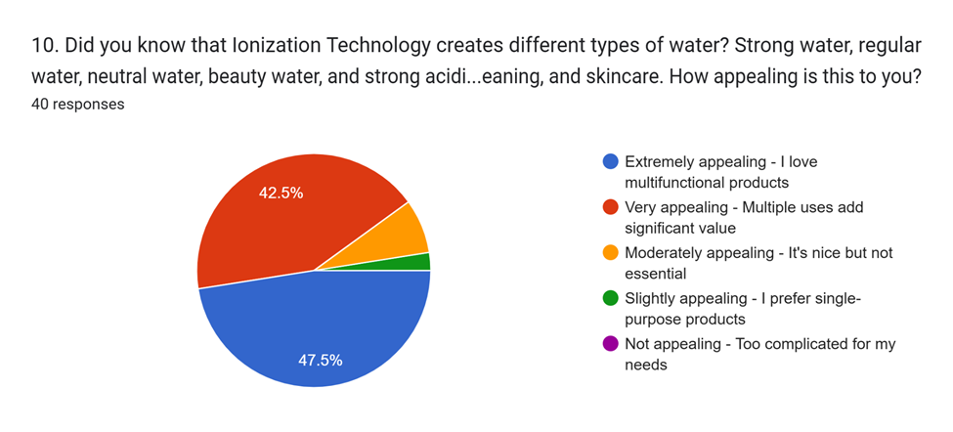

(fig.03
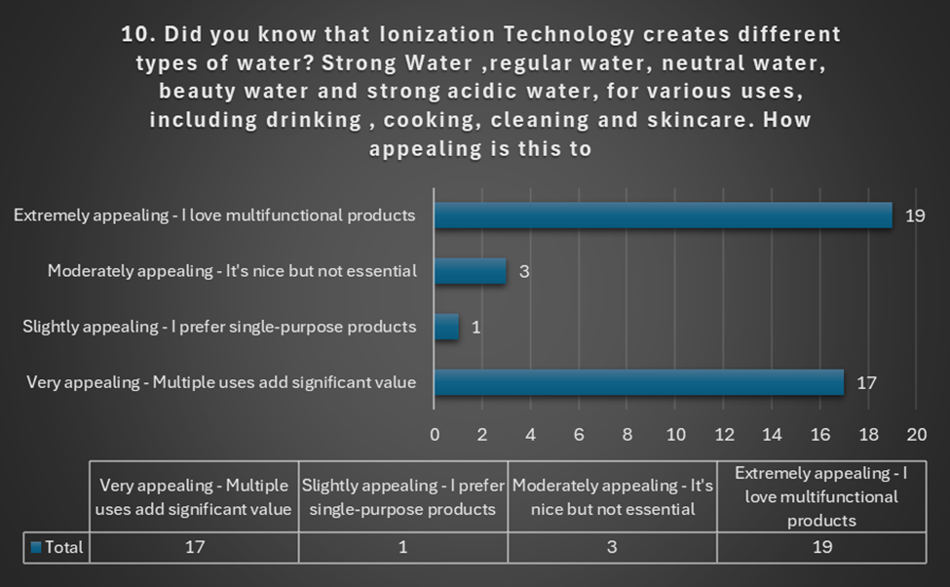

(fig.04)

This 90% positive responses to multifunctionality became central to the K8`s value proposition (Soltanifar et al.,2021). The strong preference for versatile products indicated sophisticated consumer understanding of water ionization technology, supporting a premium positioning strategy. This finding directly influenced website design, with prominent sections dedicated to explain the five water types ( drinking, cooking, cleaning, beauty, acidic )and their specific application. The multifunctionality became a key differentiator in marketing materials, addressing consumer desire for comprehensive solutions rather than single-purpose appliances.

2.3 Price Expectations and Market Positioning

Analysis of question 13 revealed that 62.5% of respondents ( 25 individuals ) expected to invest £3,001 - £5,000 in a premium water ionizer, with 35% ( 14 individuals ) specifically targeting the £4,001 - £5,000 range. (fig.05) and (fig.06)

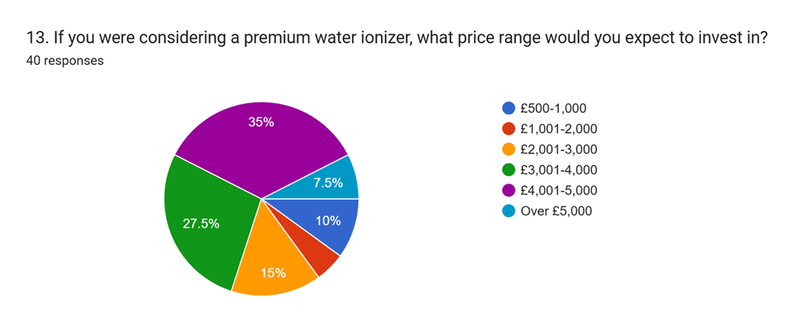

(fig.05)

(fig.06)
This price tolerance exceeded initial expectations and validated premium positioning strategy. The willingness to invest significantly in water treatment systems indicated a mature market ready for high-value solutions (Pinto & Guarda, 2020). These findings supported the K8`s £3,500 - £4,500 pricing strategy and influenced the prominent display of financing options, presented on the website. The research demonstrated that price sensitivity was secondary to value perception, enabling confidence in premium pricing approaches.

2.4 Scientific Validation Requirements

Question 14 identified that 77.5% of the participators, required “scientific studies proving health benefits” as their primary purchase motivator. (fig.07

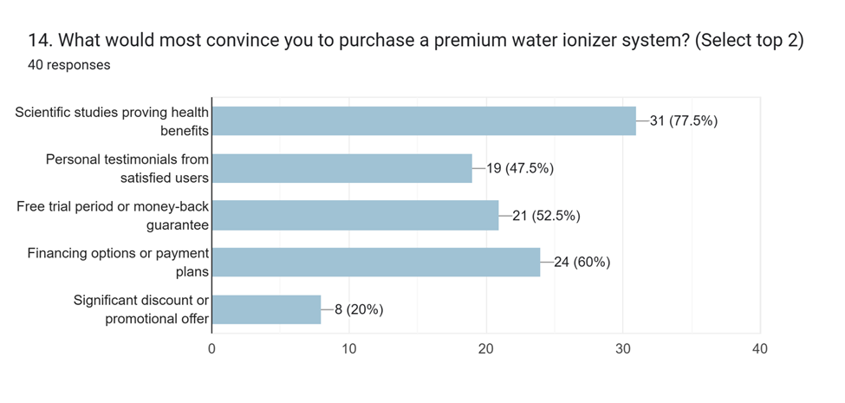

(fig.07)
This demand for evidence-based marketing fundamentally shaped content strategy and website architecture (Bencsik, 2017). The finding revealed that consumers approach water ionizer purchases with scepticism, requiring substantial proof before investment. This insight drove the creation of dedicated research sections on the website, emphasis on integration of scientific marketing purchase hesitation.

Business Concept

The initial business concept focused broadly on water treatment solutions within an evergreen market. However, survey insights revealed specific consumer preferences that refined the approach significantly. The research demonstrated that consumers prefer premium, multifunctional health appliances rather than basic water filters, leading to the K8 Water Ionizer selection over generic alternatives.
Survey data showing 47.5% ( 19 individuals ) of respondents consuming 2-3 liters of water daily (fig.08) and (fig09),

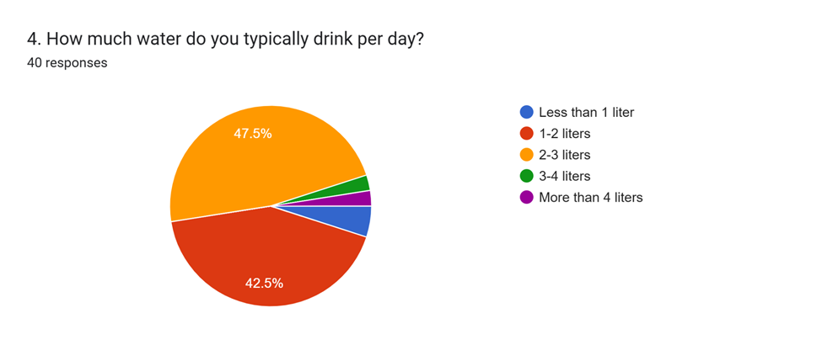
(fig.08)

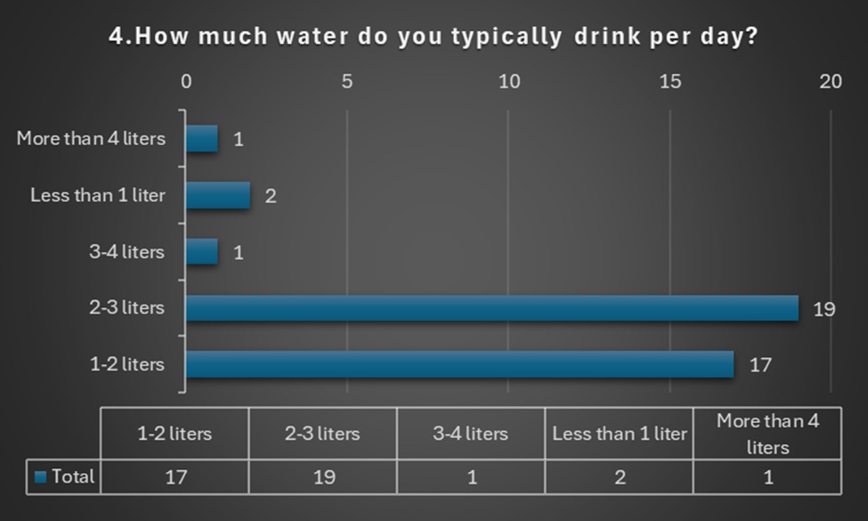

(fig.09)
combined with 55% ( 22 individuals ) homeownership rates (fig.10) and (fig.11),

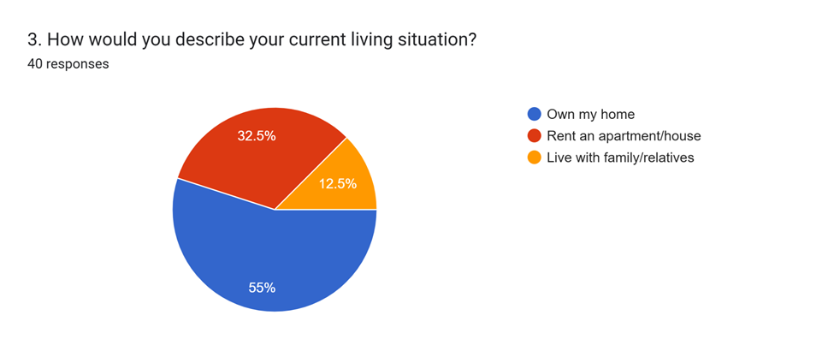

(fig.10)

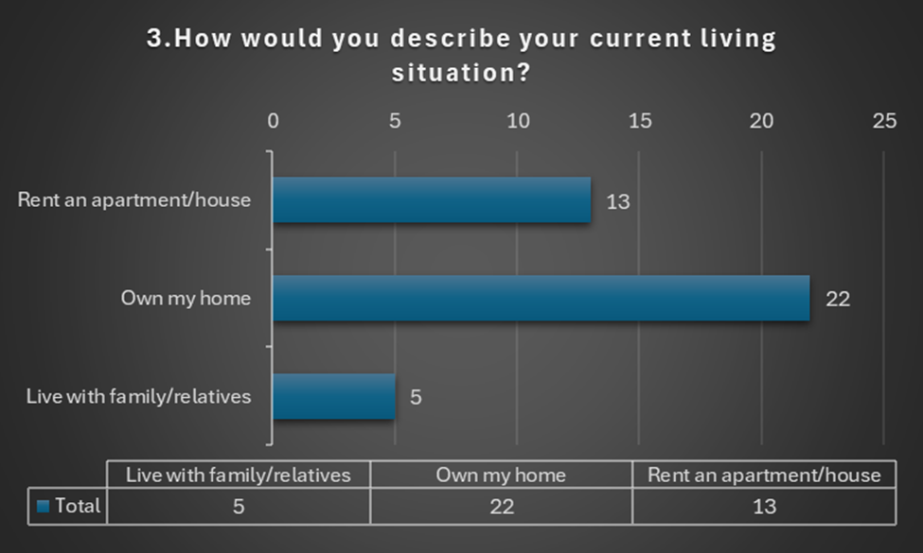

(fig.11)
Validated the target market`s suitability for permanent ionization systems.
These insights confirmed market readiness for significant investment in water treatment technology (Byrd, 2021). The evolution from general water treatment to specific ionization technology reflected survey findings about consumer sophistication and willingness to invest in advanced solutions. This refinement enabled focused marketing and precise target in connection to audience identification.

Audience Segmentation Process

The research identified three distinct customer types, based on demographic and psychographic analysis. The primary segment, “Health-Conscious Homeowners” ( 35-44 age group, £40-60k income ), represented 42.5% ( 17 individuals Each cat. )of responses and became the core target for the market. (fig.12 to 15)

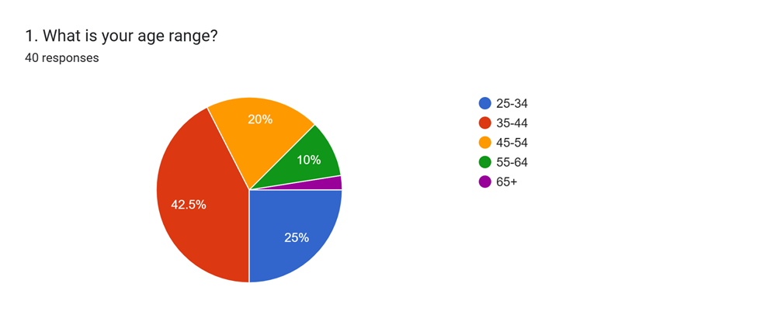

(fig.12)
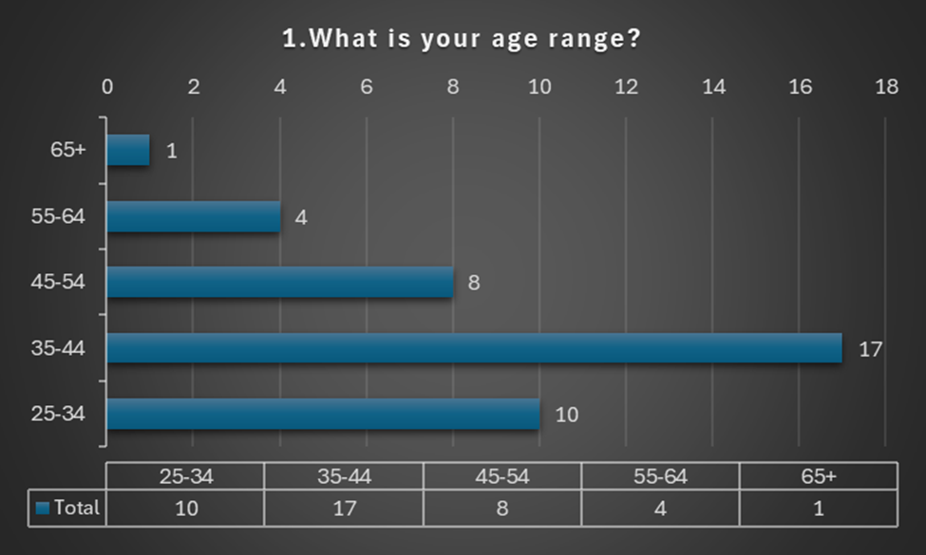

(fig.13)
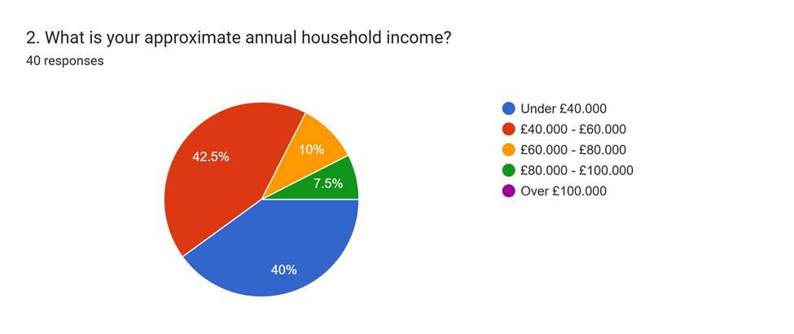

(fig.14)

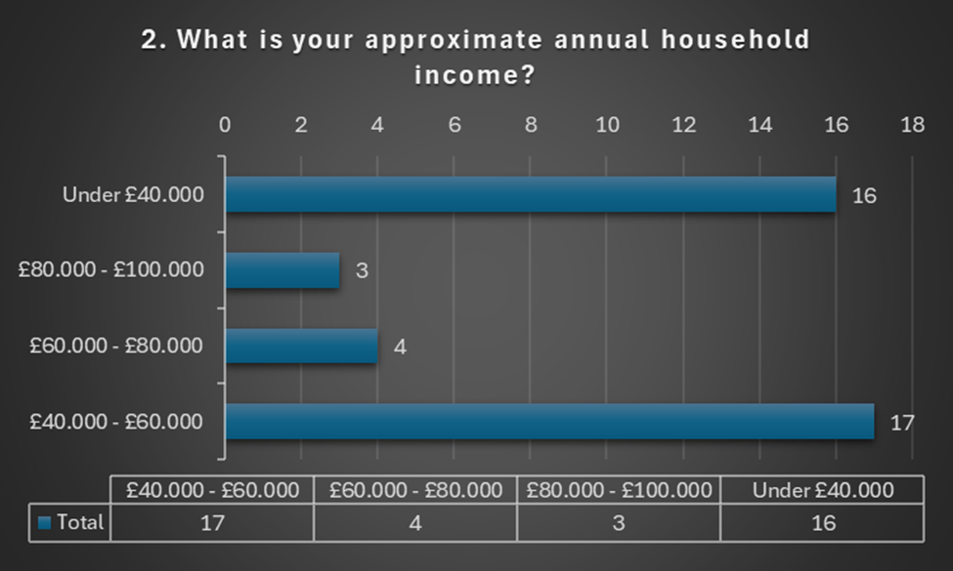

(fig.15)
This group demonstrated high health awareness, homeownership for permanent installation, and moderate income enabling premium purchases. The secondary “Wellness Enthusiast” segment ( 25-35 age group ) comprised 25% of responses, representing emerging consumers with rising incomes and technology adoption preferences. The premium “Affluent Health Investor” segment ( 45+ age group, £60k+ income ) showed highest spending willingness but represented a smaller market share (Sandhu, 2020). This segmentation process enabled targeted strategies, with scientific health benefits emphasized for all category while price sensitivity varied by income levels. This directly influenced website content creation and marketing material development.

SEO Strategy Implementation

The SEO strategy emerged directly from survey insights about consumer search behaviour and priorities. Primary keywords focused on “Water Ionizer UK” and “Alkaline Water Machine” based on product interest patterns. Local optimization, targeting “Water Ionizer Cardiff or /and London, etc, is reflecting the 70% homeowner demographic requiring local installation services.
Health-focused keywords like “water benefits” and “ionized water health” addressed the majority of those prioritizing water quality. Content strategy development included “Scientific Studies on Ionized Water” articles targeting the ones requiring evidence-based information (Reedy & Parker, 2017). The technical SEO implementation emphasized fast loading times and mobile optimization, recognizing that health-conscious consumers research extensively before premium purchases. Local SEO optimization reflected survey findings about homeowner installation requirements and geographic service limitations.

Website Design

Survey insights directly shaped website architecture and user experience design. The homepage features health benefits and scientific validation, responding to the related audience. Multifunctionality explanations address positive response to versatile water types. Pricing transparency and financing options reflect ( £3,001-£5,000 ) audience price expectations from 62.5% of respondents. The website structure follows the customer journey mapped from survey data, progressing from problem awareness through solution education to purchase decision support. This approach reflects the complex research behaviour demonstrated by the target audience.

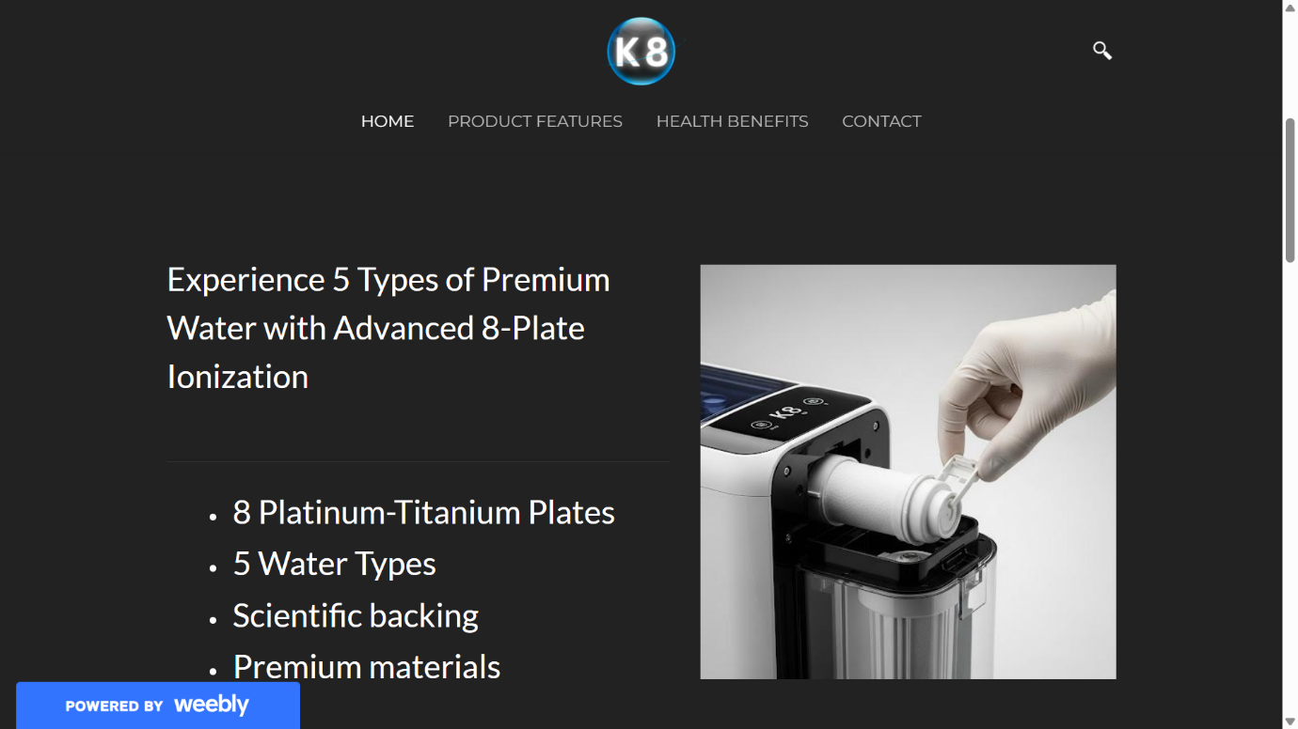
(Source By Author, 2025)
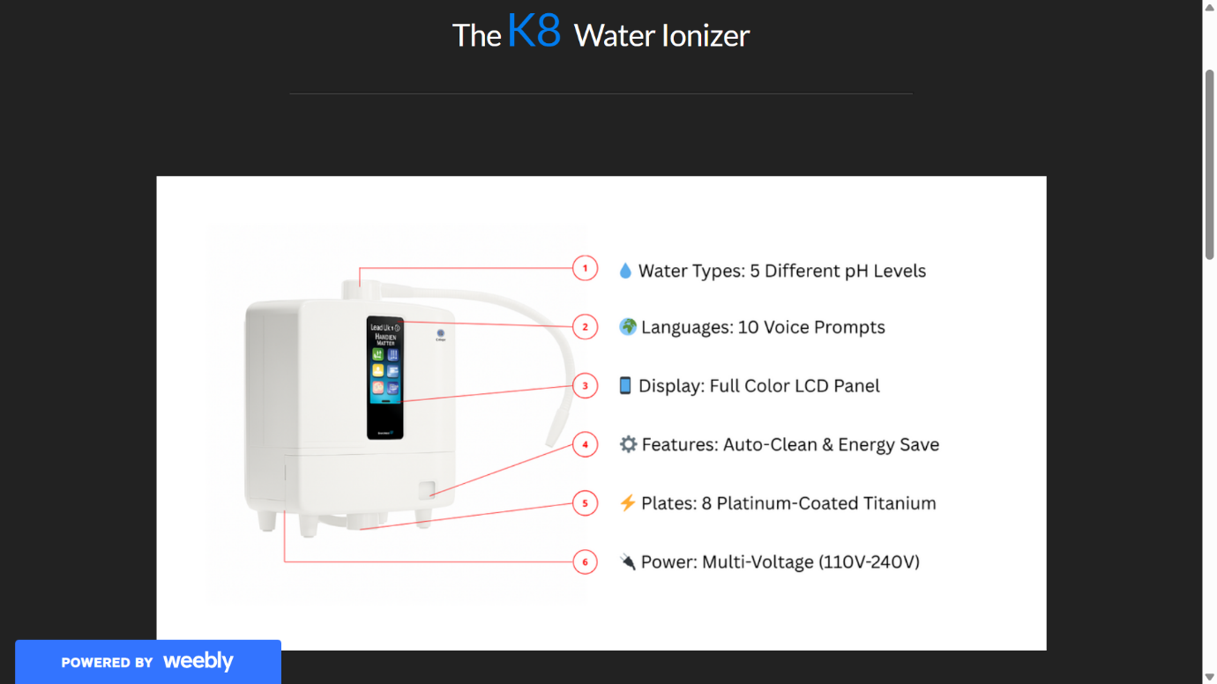
(Source By Author, 2025)
Website Link - http://k8water.weebly.com

7. Marketing Development

Marketing materials helped the development by integrating survey insights with visual communication strategies. Comparison data emphasized long-term cost savings, addressing audience concerned about value versus bottled water. Scientific credibility materials responded to the demand for evidence-based marketing. Customer journey mapping reflected the decision-making process revealed through survey analysis, emphasizing key touchpoints like research validation and risk mitigation (Paulus & Nijstad,2003). The visual design strategy maintained consistency between survey insights and brand presentation, ensuring alignment between consumer preferences and marketing communication.

8. Conclusions

The complex market research process, have successfully identified critical consumer insights that fundamentally shaped the K8 Water Ionizer business development. The systematic approach from survey design through data analysis and strategic implementation demonstrated clear connections between consumer preferences and business decisions. The research validated premium market positioning while identifying specific requirements for successful market achievements. Future developments should continue leveraging these insights while monitoring evolving consumer preferences in the health and wellness, of water treatment market. The methodology established through this research process provides a foundation for ongoing market analysis and strategic refinement, ensuring continued alignment between consumer needs and business offerings in the dynamic health technology marketplace.

TASK 2

Excel in Small Business Management

A Strategic Tool for Digital Transformation

In today’s increasingly data-driven economy, the ability to manage, interpret and present data effectively is essential for small businesses (McAfee and Brynjolfsson, 2012). Microsoft Excel remains one of the most widely used digital tools for this purpose. As a spreadsheet software, Excel empowers businesses to handle everything from financial forecasting to inventory management with accuracy and efficiency (US Chamber of Commerce, 2024). For a start up like K8 Water, which promotes hydration and wellness through alkaline water solutions, Excel offers strategic advantages in managing operations, budgeting and scaling sustainably.
Excel plays a foundational role in digital literacy and competency within enterprises (Spante et al., 2018). Spreadsheet proficiency is considered a core skill for business professionals, particularly in financial and operational decision-making (Southern Oregon University, 2022). At K8 Water, Excel is crucial in tracking monthly income streams, such as sales and services, against expenses like rent, wages and marketing. This facilitates accurate financial forecasting and enables informed decisions based on profit and loss trends.
One of Excel`s greatest strength lies is its versatility. For instance, K8 Water`s 12 month financial projection spreadsheet, created using basic formulas like =SUM() for totals and many others for net profit, helps visualize how seasonal trends affect income and expenses (Quicken, n.d). Such real time supports in planning and strategic adaptation is related to small enterprises. With minimal training, K8 Water`s team can simulate different pricing strategies, inventory changes, or cost adjusting agile business practices.
Excel`s built in tools for data visualization enhance both internal and external communications (Microsoft Corporation, 2025). K8 Water uses bar charts to illustrate income vs. expenses across months. These visuals not only make data easier to interpret but also support investor presentations and business reports. Visual aids foster transparency and build stakeholder confidence, particularly in competitive wellness markets. In the broader context of the digital era, Excel integrates seamlessly with other Microsoft applications and cloud platforms, which promotes efficiency and collaboration (Teng, 2022). Integration is a key driver of digital transformation. By linking Excel spreadsheets to OneDrive or SharePoint, K8 Water staff can access, edit and share financial data remotely, facilitating flexible work arrangements and real time updates.
Moreover, Excel enhances data accuracy and reduces human error through automated formulas and validation features (Unito, 2025). Small businesses like K8 Water often with limited stuff, proves that automation is critical for efficiency. Excel`s conditional formatting and data validation ensure consistent entries, which is crucial for budgeting and compliance. Even minor spreadsheets errors can have major business consequences, especially in resource constrained environments (Fallon, 2024).
Another significant benefit of Excel is its support for growth planning. As K8 Water expands its online presence and explores new distribution channels, Excel can be used to analyse customer data, forecast demand and budget for digital marketing. The software also supports advanced tools such as pivot tables and basic macros, enabling deeper analytics without the cost of enterprise systems (Microsoft Corporation, n.d.)
Despite its many advantages, Excel has limitations, especially when managing large datasets or complex relational databases. For K8 Water, this might become an issue, only when customer volume grows exponentially. Over reliance on manual updates and lack of version control can also lead to data discrepancies (Camms, a Riskonnect Company, 2023). Therefore, it is recommended that Excel be used in connection with cloud based accounting tools like QuickBooks or inventory system to maintain scalability and accuracy.
To address these limitations, K8 Water is also exploring Excel training programs and best practices for data security. Embedding spreadsheet literacy within the company culture will ensure that employees are equipped to use Excel effectively. Training also aligns with enterprise education goals, fostering digital resilience and adaptability.
In conclusion, Excel remains an essential digital tool for small businesses navigating the modern economy. For K8 Water, Excel`s capabilities in budgeting, forecasting, visualization and automation provide a low cost yet powerful platform for operational management. When integrated whit broader digital strategies and complemented by training, Excel not only supports current business needs but also prepares the company for future challenges. As digital transformation continues to shape the business landscape, mastering Excel will remain a key driver of entrepreneurial success.

References – task 1

Bencsik, A. (ed.) (2017) Knowledge Management Initiatives and Strategies in Small and Medium Enterprises. Hershey, PA: IGI Global. Available at: https://www.igi-global.com/gateway/book/159580 (Accessed on 02 June 2025)
Byrd, L.S. (ed.) (2021) Cultivating Entrepreneurial Changemakers Through Digital Media Education. Hershey, PA: IGI Global. Available at: https://www.igi-global.com/gateway/book/253259 (Accessed on 05 June 2025)
Dadwal, S.S. (ed.) (2020) Handbook of Research on Innovations in Technology and Marketing for the Connected Consumer. Hershey, PA: IGI Global. Available at: https://www.igi-global.com/gateway/book/226306 (Accessed on 04 June 2025)
Paulus, P. and Nijstad, B. (eds.) (2003) Group Creativity: Innovation through Collaboration. Oxford: Oxford University Press. Available at: https://academic.oup.com/book/27143 (Accessed on 01 June 2025)
Pinto, F.M. and Guarda, T. (eds.) (2020) Digital Marketing Strategies and Models for Competitive Business. Hershey, PA: IGI Global. Available at: https://www.igi-global.com/gateway/book/239390 (Accessed on 02 June 2025)
Reedy, K. and Parker, J. (eds.) (2017) Digital Literacy Unpacked. London: Facet Publishing. Available at: ProQuest eBook Central https://ebookcentral.proquest.com/lib/trinity/detail.action?docID=5490897 (Accessed on 01 June 2025)
Sandhu, K. (ed.) (2020) Digital Transformation and Innovative Services for Business and Learning. Hershey, PA: IGI Global. Available at: https://www.igi-global.com/gateway/book/245338 (Accessed on 03 June 2025)
Soltanifar, M., Hughes, M. and Göcke, L. (2021) Digital Entrepreneurship. Cham: Springer. Available at: https://link.springer.com/book/10.1007/978-3-030-53914-6 (Accessed on 03 June 2025)

References – task 2

Camms, a Riskonnect Company, 2023. How to Automate any Spreadsheet-based Business Process and Bring it Online. Camms Group Blog. Published c. 2 years ago. Available at: https://cammsgroup.com/blog/how-to-automate-any-spreadsheet-based-business-process-and-bring-it-online/ (Accessed on 01 June 2025)
Fallon, N., 2024. The Best Spreadsheet Software: Features, Uses, and Programs. Business.com. [online] Updated 2 December 2024. Available at: https://www.business.com/articles/best-spreadsheet-software/ (Accessed on 30 May 2025)
Quicken, n.d. Visualize business income and expense trends with graphs. Quicken Windows Help. Available at: https://info.quicken.com/win/see-my-income-and-expenses-as-a-graph-business (Accessed on 30 May 2025)
Microsoft Corporation, n.d. Learn to use Power Query and Power Pivot in Excel. Available at: https://support.microsoft.com/en-gb/office/learn-to-use-power-query-and-power-pivot-in-excel-42d895c2-d1d7-41d0-88da-d1ed7ecc102d (Accessed on 06 June 2025)
Microsoft Corporation, 2025. Collaboration between internal and external individuals. Available at: https://learn.microsoft.com/en-us/viva/insights/advanced/analyst/external-collaboration (Accessed on 06 June 2025)
Southern Oregon University (2022) Using Excel Spreadsheets to Make Business Decisions for Successful Outcomes. Available at: https://online.sou.edu/degrees/business/mba/information-analysis-and-decision-making/excel-spreadsheets-business-decisions/ (Accessed on 07 June 2025)
Spante, M., Hashemi, S.S., Lundin, M. and Algers, A. (2018) 'Digital competence and digital literacy in higher education research: Systematic review of concept use', Cogent Education, 5(1). Available at: https://www.tandfonline.com/doi/full/10.1080/2331186X.2018.1519143 (Accessed on 01 June 2025)

Teng, X. (2022) 'Impact of the Digital Transformation of Small‐ and Medium‐Sized Listed Companies on Performance: Based on a Cost‐Benefit Analysis Framework', Journal of Mathematics. Available at: https://onlinelibrary.wiley.com/doi/10.1155/2022/1504499 (Accessed on 04 June 2025)
Ranatunga, R.V.S.P.K., Priyanath, H.M.S. and Megama, R.G.N., (2020). Digital Literacy, Business Uncertainty & Economic Performance: An Empirical Study of Small Businesses in Sri Lanka. International Journal of Academic Research in Business and Social Sciences, 10(5) Available at: https://www.researchgate.net/publication/341244310_Digital_Literacy_Business_Uncertainty_Economic_Performance_An_Empirical_Study_Of_Small_Businesses_In_Sri_Lanka (Accessed on 08 June 2025)
McAfee, A. and Brynjolfsson, E., (2012). Big data: The management revolution. Harvard Business Review. . Available at: Big Data: The Management Revolution (Accessed on 06 June 2025)
US Chamber of Commerce (2024) How to Create a Financial Projection In Excel. Available at: https://www.uschamber.com/co/run/finance/creating-financial-projections-in-excel (Accessed on 07 June 2025)

