Electronics II (EEE version) (ACDA6001)
Gomer Morgan-Gray
2316794
2026

Abstract
This report presents the covers the design, implementation and evaluation of two different binary multipliers. A Brauns and Wallace tree multiplier were created using VHDL and a Xilinx Artix-7 FPGA. Both designs were created to take an 8-bit input producing a 16-bit output. The study focuses on comparing calculation performance including propagation delay, recourse utilization, and power efficiency.
Through simulation the functionality of both multipliers was verified across a range of test cases. Analysis of the critical path revealed that the Brauns multiplier achieved a propagation delay of 41ns whilst the Wallace managed a delay of 31ns due to its parallel reduction structure. Additionally, the Wallace design demonstrated slightly reduced LUT usage and higher power efficiency per operation.
Despite increased design complexity of the Wallace multiplier, it offers superior performance making it more suitable for high-speed applications, whereas the Brauns multipliers simpler design may be applicable for certain use cases.

Contents
Abstract 2
1 – Introduction 4
2 – Background Research 4
2.1 – Multiplier Architectures 4
2.2 – FPGA 4
2.3 – Critical Path and Propagation Delay 5
2.4 – Applications Of Binary Multipliers 5
3 – Methodology 6
3.1 – Design Approach 6
3.2 – VHDL Implementation 6
4 – Braun Multiplier Design 7
4.1 – Principle of operation 7
4.2 – Block Diagram 7
4.3 – VHDL Implementation 8
5 – Wallace Tree Multiplier Design 10
5.1 – Principles of operation 10
5.2 – Block & Dot Diagram 10
5.3 – VHDL Implementation 12
6 – Results and Analysis 13
6.1 – Propagation delay comparison 13
6.3 – Simulation Results 14
6.4 – LUT & Power Usage 16
6.5 - Evaluation 17
7 – Discussion & Future Recommendations 18
8 – Conclusion 18
References 19

1 – Introduction
This report details the design, simulation and evaluation of the Braun and Wallace tree multipliers. Making use of VHDL and on an Artix-7 FPGA.
A binary multiplier is a digital circuit used to multiply 2 input numbers and provide an output. There are several types of binary multiplier circuit designs, chosen for this analysis in this report is the Braun’s multiplier and the Wallace tree multiplier.
Digital Multipliers serve a core role in current electronic systems, being heavily used in digital signal processing operations such as finite impulse response filters, fast Fourier transforms and are essential for machine learning applications [1].
Due to this fundamental role multipliers serve in these systems efficient multiplication is essential for improving overall system performance. Binary multipliers operate by calculating the partial products of the input numbers then summing the partial products together to determine the final product [2].

2 – Background Research

2.1 – Multiplier Architectures
Binary multiplier designs can be classified into 2 main types: array-based, and tree-based architecture [3]. Array multipliers such as the chosen Brauns make use of a regular structure where partial products are summed in a sequential manner. The regularity of this type of multiplier makes them highly suitable for implementation in hardware, especially when used within an FPGA allowing for predictable routing [4]. However, the main limitation to this style of multiplier is caused by propagation delay from the sequential addition of partial products increasing linearly with the increase in operand size [4], this would lead to a significant performance decrease when frequently used within system.
In contrast to the Braun multiplier, tree-based approaches such as the Wallace multiplier make use of a parallel reduction approach to summing the partial products. This helps to greatly decrease the propagation delay by summing partial products simultaneously [5]. This significantly reduces the critical path, making tree-based multipliers more suitable for high performance applications due to reduced delays. These advantages, however, come at the drawback of increasing design complexity introducing an irregular layout making implementation more difficult.

2.2 – FPGA
A Field Programable Gate Array (FPGA) is a reconfigurable integrated circuit. Unlike Application Specific Integrated Circuits (ASIC), which have a fixed functionality, FPGAs allow for reprogramming, allowing for rapid prototyping, testing and iterative development.
The platform used for this project is the Xilinx Artix-7 FPGA. All FPGAs contain several configurable components, of interest for this project are the look-up Tables (LUTs), These function as a truth table representing the output of 1 or more logic gate [6] [7]. These can then be connected as required to create the full system

2.3 – Critical Path and Propagation Delay
Critical path analysis can be applied to any combinational or sequential logic circuit. The critical path of a circuit is the longest path a signal must travel from input to output. This determines the maximum operating speed of a circuit [7].
Propagation delay is an unavoidable attribute to all electronics circuits and describes the delay a component takes from input to output whilst performing its role [8].
Propagation delay is a result of several factors such as parasitic capacitance: this unavoidable effect requires the input of the logic gate to be charged or discharged to a sufficient level before the inputs state is changed [9]. This effect is worsened due to the output resistance of the previous stage limiting the current available to charge this capacitance [10]. In multiplier circuits these effects are even greater as this delay accumulates across several stages, significantly impacting overall performance.

2.4 – Applications Of Binary Multipliers
Binary multipliers are widely used in many modern digital systems. One primary application is digital signal processing, where multipliers are essential for systems such as filtering, conversion and Fourier transforms [11]. They are also heavily used in image processing, where large volumes of data are required to be processed in real time with low latency.
In addition, multipliers are a fundamental component in cryptography, where they are used in encryption algorithms such as RSA and Elliptic Curve systems [12]. In more recent developments in artificial intelligence multipliers have become increasingly important, particularly in neural network acceleration [13].

3 – Methodology
This section covers the approach taken to design, implement and simulate both the Wallace and Braun multipliers alongside performance evaluation making use of VHDL and the Vivado FPGA Software.

3.1 – Design Approach
The design began with determining requirements for both the Braun and Wallace multiplier. Both multipliers were chosen to make use of an 8-bit unsigned input providing a 16-bit output.
Both are designed to generate the partial products of both inputs making use of and operations then these partial products are summed making use of a combination of half and full adders arranged according to the multiplier’s architecture.

3.2 – VHDL Implementation
A modular approach was taken whilst developing the VHDL Program; this enhances readability, reusability, and scalability. Two reusable modules were created “Full_Adder” and “Half_Adder”. These modules are then instantiated and connected via port mapping allowing for intercommunication with the main module. As both multipliers take the same 8-bit input and provide a 16-bit output, a common constraint file has been made ensuring inputs and outputs are the same for both.
For the Braun multiplier a structured parallel array of adders, where each row corresponds to a stage of partial product calculation is used. This contrasts the Wallace tree multiplier which makes use of weighted sum of all the partial products with the number of partial products being reduced in each stage until only 2 rows remain and are combined with a final ripple adder.

4 – Braun Multiplier Design
The Braun Multiplier is a type of parallel array multiplier, widely used due to its ease of implementation owing to its regular structure, it performs multiplication operations by generating the partial products of the inputs and then summing them in a structured array of adders.

4.1 – Principle of operation
The Braun multiplier functions by generating the partial products of the inputs followed by a sequential addition. For the two inputs A (A₇ to A₀) and B (B₇ to B₀), each bit of one operand is multiplied by each of the other operand making use of AND gates, producing the matrix of partial products.

4.2 – Block Diagram
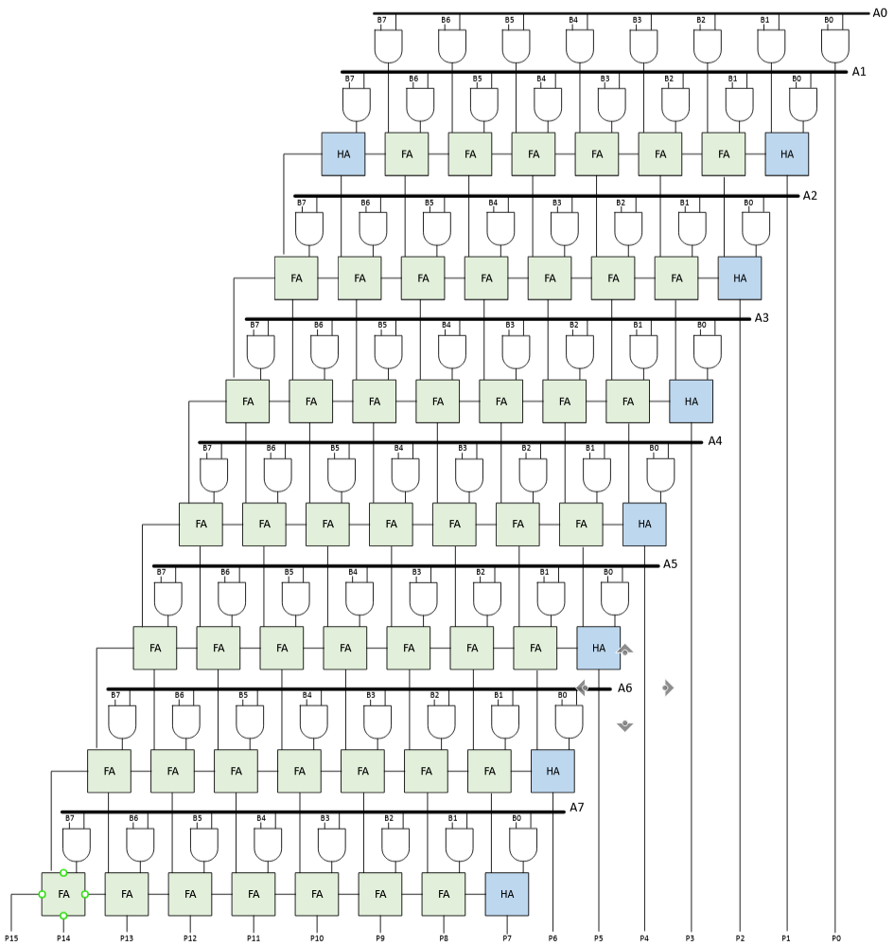
Figure 1 - Brauns Multiplier Block Diagram
Shown in Figure 1 is the block diagram for the 8-bit Brauns multiplier. This diagram shows the key features of this multiplier, primarily the 64 partial product generating AND gates connected to the array of adders. A Mixture of full and half adders are utilized here; the right side of the diagram consists entirely of half adders as there is no carry input from a previous adder.

4.3 – VHDL Implementation
The VHDL implementation has been broken up into several functional sections, this improves development speed, readability and debugging.
The first section shown in Figure 2 is the port configuration for the Top design source file, this defines two 8-bit input vectors “A“ and “B” and defines a 16-bit Output vector “FP”.
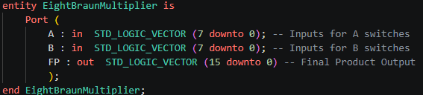
Figure 2 - Brauns VHDL Port Configuration
The next stage shown in Figure 3 defines the necessary intermediate signals, the first set are used for the 64 partial products as the output of the AND gates. The next set of signals are used for each product P0 through P15, each product requires a varying number of partial products as shown in Figure 1.
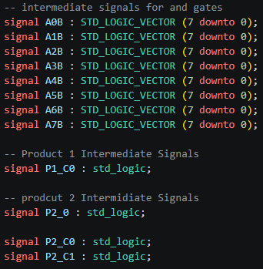
Figure 3 - Brauns VHDL Intermediate Signal Declarations
Shown in Figure 4 is the process of instantiating the half and full adders, this section of code is essential as the half and full adders are used numerous times through the program. This defines the name of the component along with its inputs and outputs.
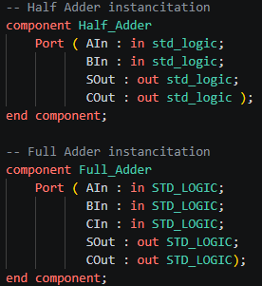
Figure 4 - Brauns VHDL Adder Instantiation
Figure 5 shows the beginning of the architecture section of the VHDL. The first section being the generation of the 64 partial products making use of AND gates. Vectors were used for storing the partial products as it helps improve readability and reduce repeated declarations.
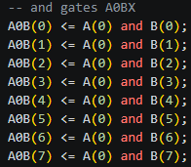
Figure 5 - Brauns VHDL Partial Product AND Gates
The Final section of code shown in Figure 6 is broken up into each individual product P0 through P15 each containing the necessary full and half adders.
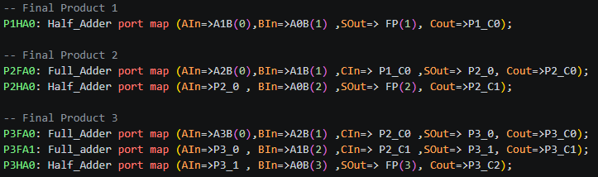
Figure 6 - Brauns VHDL Final Product Generation

5 – Wallace Tree Multiplier Design
The Wallace multiplier is a parallel multiplier architecture that reduces the number of sequential addition stages making use of a treelike structure instead of adding partial products row by row like the Brauns Multiplier.

5.1 – Principles of operation
The operation begins with the generation of partial products using AND gates, similar to the Brauns multiplier. These partial products are then used with several parallel full and half adders to reduce the number of parallel products in each layer. Until ultimately there are only 2 rows of partial products which are summed using a ripple adder.

5.2 – Block & Dot Diagram
Figure 7 illustrates the 4 separate reducing layers and the final ripple adder. Each gray dot represents a partial product firstly beginning with the same 64 as the Brauns multiplier, then being reduced via full adders (highlighted in green) and half adders (highlighted in blue)
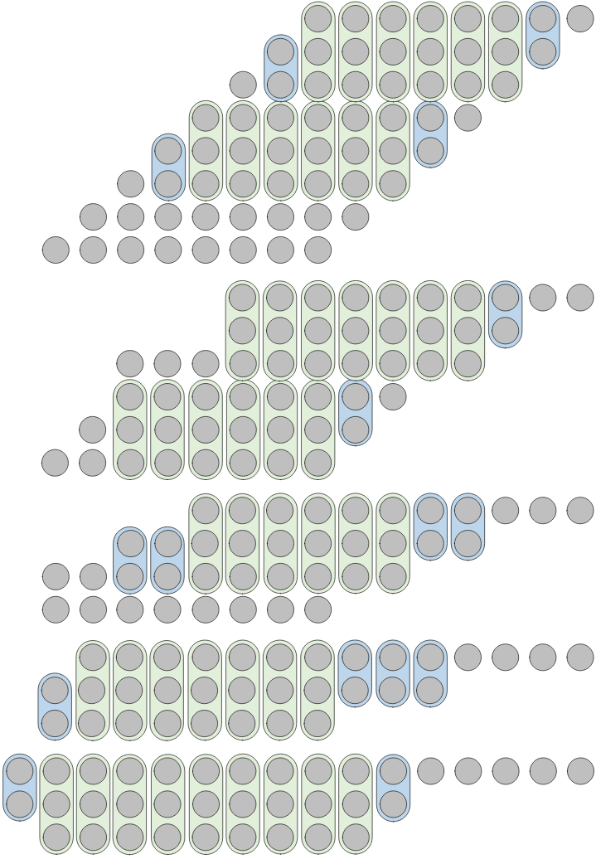
Figure 7 - Wallace Multiplier Dot diagram
The dot diagram was then populated (shown in Figure 8) this allowed for quick integration in VHDL whilst minimizing errors as the structure could be worked out in advance.
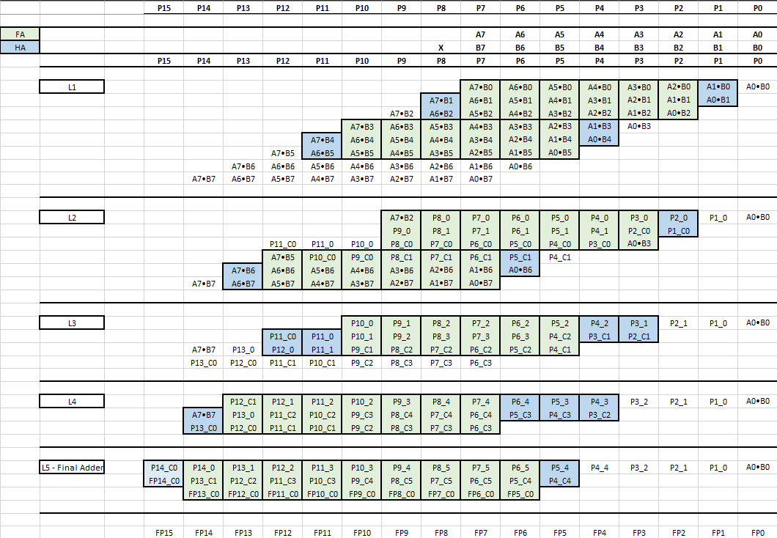
Figure 8 - Wallace Multiplier Populated diagram
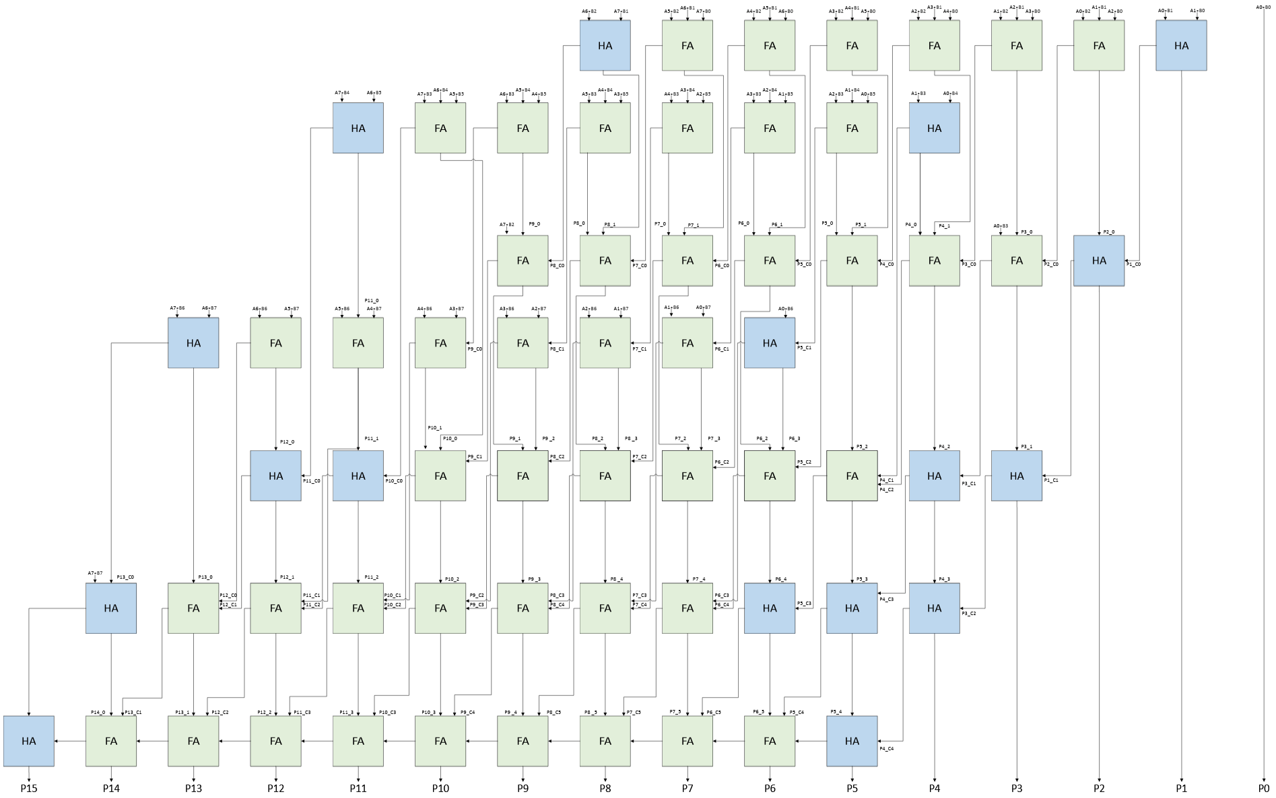
Figure 9 - Wallace Tree Block Diagram

5.3 – VHDL Implementation
The VHDL Implementation of the Wallace Multiplier re-uses several sections of the Brauns multiplier, this improved development speed and improved reliability as copied code sections had already been tested working. Re-used sections included: Port Configuration (Figure 2), Adder Instantiation (Figure 4) and partial product generation (Figure 5), in addition the partial product signal declarations (Figure 3) were re-used however with some alterations as there are different quantities between the two multipliers.
The Majority of alterations to the code where in the final section, where the final products are generated. Shown in Figure 10. This section was organized into each layer as previously set out.
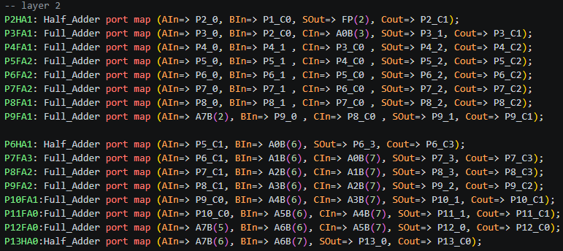
Figure 10 - Final Product Generation

6 – Results and Analysis

6.1 – Propagation delay comparison
The first step in determining the delay of both multiplier types was to identify the critical path as this would show the slowest path a signal must take. Making use of the previously created block diagrams this the critical path could be easily identified and highlighted in red as shown in Figure 11 and Figure 12.
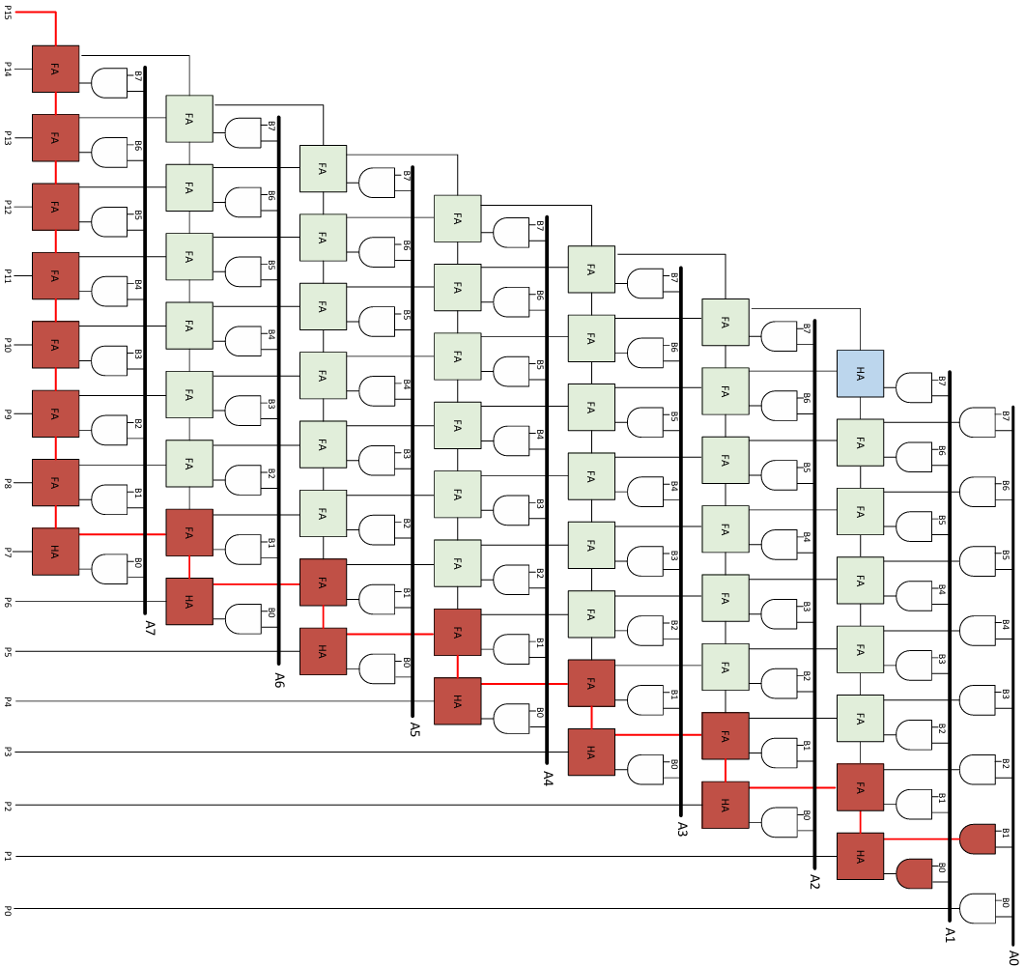
Figure 11 - Brauns Block Diagram Critical Path
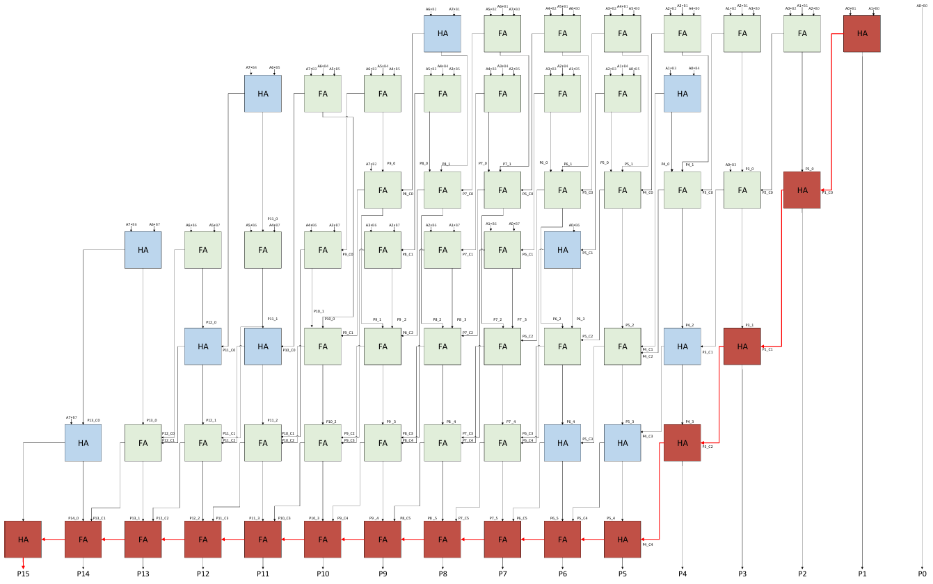
Figure 12 - Wallace Tree Block Diagram Critical Path
With the critical path determined for both multipliers the delay could now be determined for each Half or Full Adder along the critical path 2ns of delay is introduced and for each AND gate 1ns is introduced.
The critical path for the Brauns multiplier contains 20 adders and 1 AND gate. Causing a total delay of (20 x 2 + 1) = 41ns. Comparing this to the Wallace tree containing 15 adders and 1 AND gate causing a delay of (15 x 2 + 1) = 31ns.
This Reduction in propagation delay shown in the Wallace tree allows for operation at higher clock speeds providing a significant performance increase when compared to the Brauns multiplier.

6.3 – Simulation Results
Simulation was performed making use of integrated tools in the Vivado software. A data set consisting of 4 test values was generated as shown in Table 1 consisting of a maximum, high, medium and low value calculation to give a full range to ensure correct operation, inputs A and B where set to the specified constants and the output compared to the correct value.
Table 1 - Multiplier Test Sets
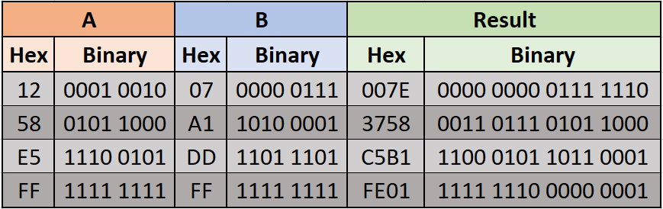
For the first test the expected hex output is 007E as shown in Figure 13 both multipliers calculated the correct value.
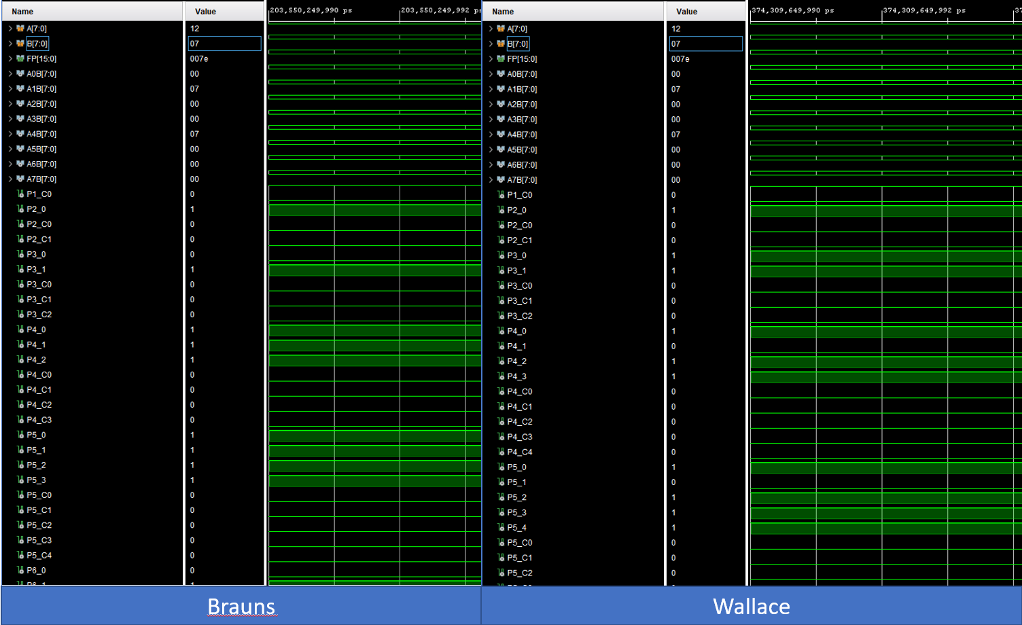
Figure 13 - Brauns and Wallace Simulation Results (Low Value)
Figure 14 shows the medium value test, both multipliers again provided the correct value. It is noted that the intermediate signals differ between the two multipliers, this is expected due to the differences in architecture.
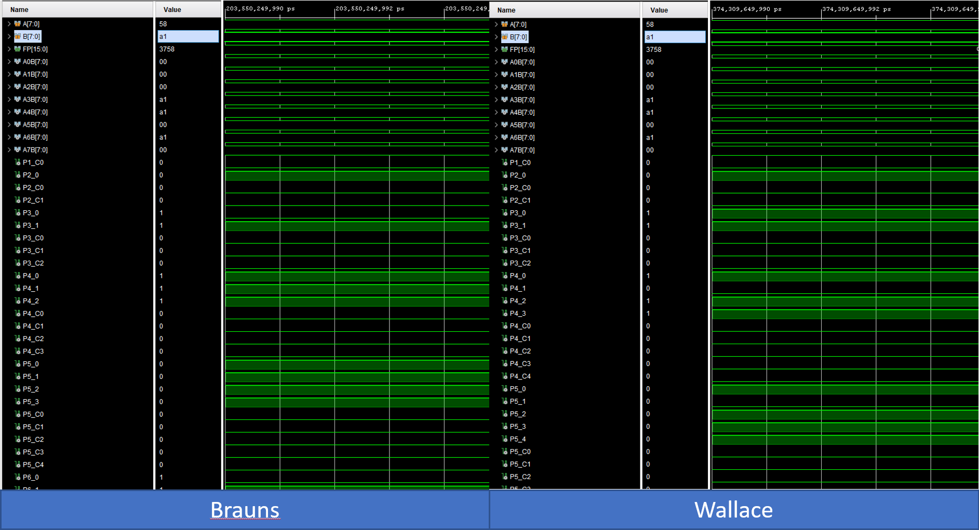
Figure 14 - Brauns and Wallace Simulation Results (Medium Value)
Figure 15 shows the High value test again with the correct value calculated from both multipliers.
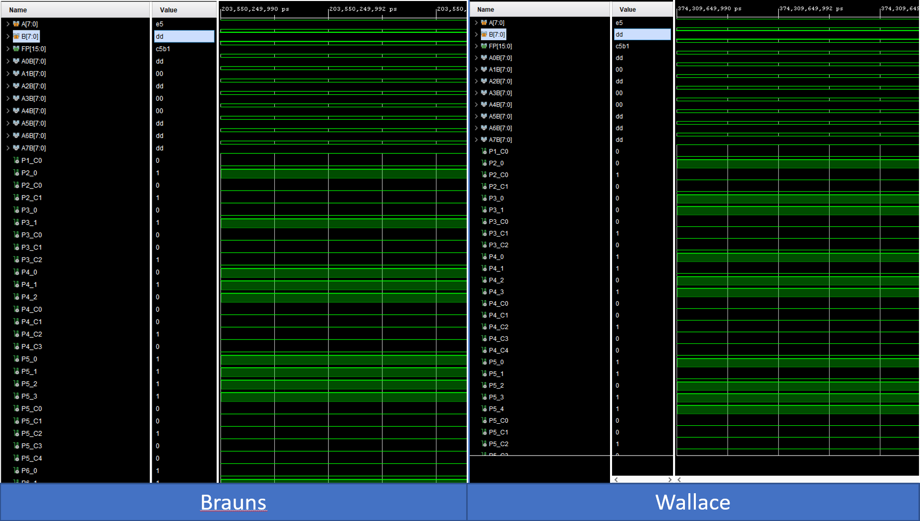
Figure 15 - Brauns and Wallace Simulation Results (High Value)

The final test shown in Figure 16 also provided the correct value form both multipliers.
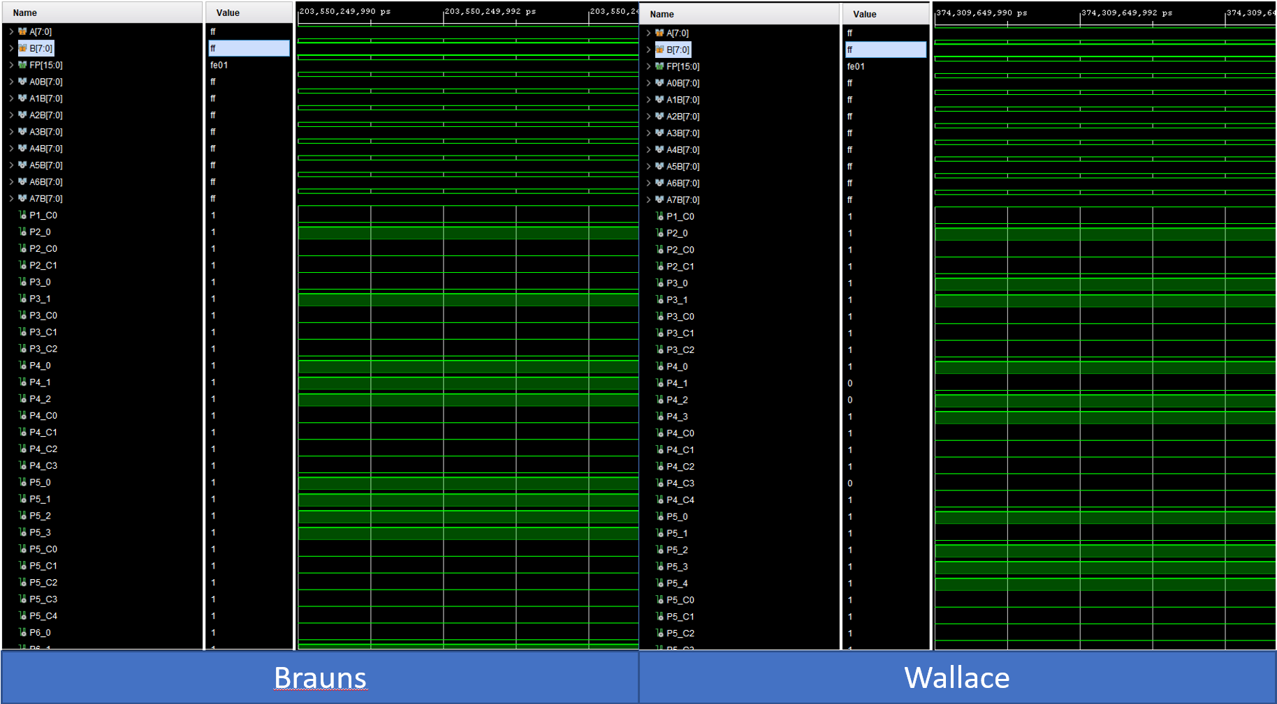
Figure 16 - Brauns and Wallace Simulation Results (Maximum Value)

6.4 – LUT & Power Usage
Vivado provides several features for analyzing the final design including Power and LUT usage. Shown in Figure 17 is the comparison of the used LUT’s from both multipliers, the Wallace is noted as using 4 less LUT’s than the Brauns type. This is an advantage as the lesser the usage the more that is available for other sections of the program, this additionally would reduce the cost if the circuit was developed into an integrated circuit.
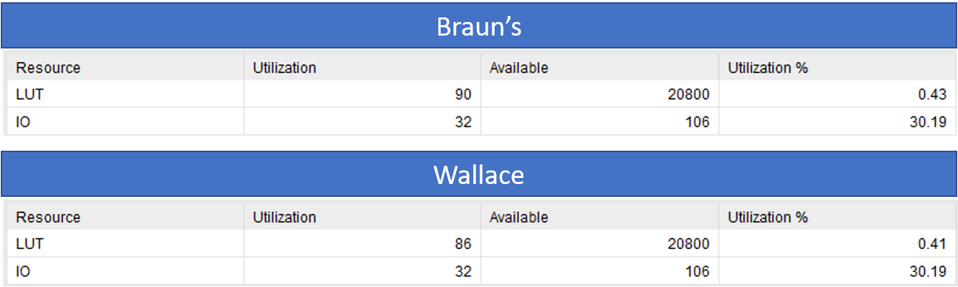
Figure 17 - LUT Comparison Table
Although Vivado reports similar Static power consumption for both designs as shown in Figure 18, this does not capture the fact that the Wallace tree multiplier performs its calculations in a shorter duration, as a result the total power usage used per multiplication operation is lower. This improvement in efficiency makes it more suitable for portable and low power applications.
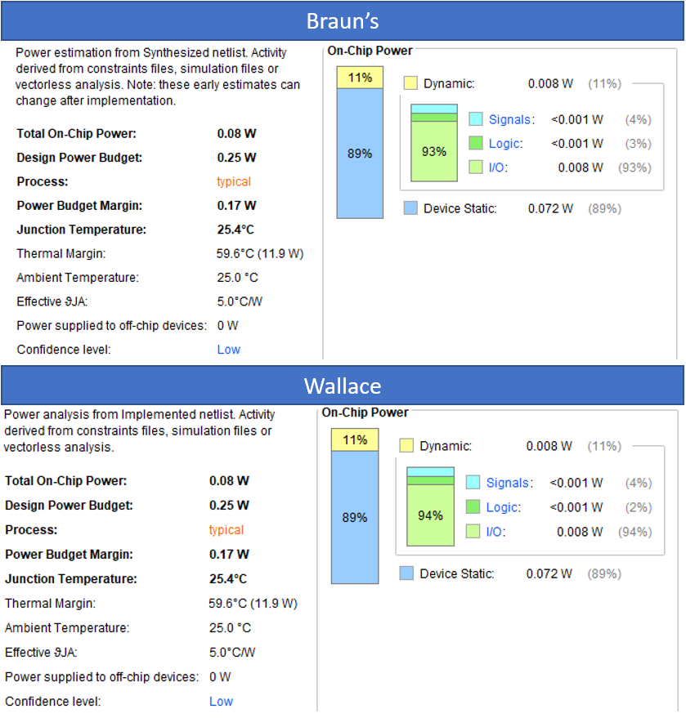
Figure 18 - Multiplier Power Usage Comparison

6.5 - Evaluation
From the results obtained, it is evident that the Wallace multiplier provides superior performance to the Braun multiplier. The calculated critical path delay of 31ns of the Wallace Tree is significantly lower than the 41ns of observed in the Braun multiplier. This improvement has primarily been obtained through the parallel reduction architecture of the parallel products which reduces the number of sequential addition stages.
In contrast, The Brauns multiplier relies on a regular array structure where sequential addition results in a longer critical path and increased delay in operation.
Reviewing the resource utilization, the Wallace tree multiplier demonstrated slightly reduced LUT usage, indicating a more efficient hardware implementation, however this reduction does come at the cost of increased hardware complexity, which may lead to more difficult routing when attempting implementation in hardware.
Although both multipliers demonstrated similar instantaneous power consumption, the improved speed of the Wallace multiplier results in lower overall energy consumption per calculation.
Therefore, the Wallace Multiplier demonstrates suitability for high-performance and energy efficient applications, whereas the Braun multiplier may still be preferred in designs where simplicity and ease of implementation are constraining factors instead of speed.

7 – Discussion & Future Recommendations
Whilst the Wallace tree multiplier gives a good speed improvement over the Brauns multiplier certain applications may require further speed improvements, for this there are several possible additions, one such addition is the carry lookahead adder [14]. This helps to reduce the propagation delay in the carry signal by over 50%, this is done by calculating the carry in parallel [15].
A limitation of the currently tested multipliers is the limitation to unsigned numbers, for certain applications this limitation is not a problem, however if the multiplication of signed numbers is required one possible solution is the Booth multiplier. The booth multiplier operates with a different method to both the Wallace and Brauns multiplier; by examining pairs of bits and performing subtraction and addition operations followed by arithmetic right shifts it can perform multiplication operations with signed numbers in two’s compliment form [16].

8 – Conclusion
This report presented the design, implementation, evaluation and comparison of an 8-bit Brauns and Wallace multiplier making use of VHDL and an Artix-7 FPGA. Both designs successfully performed multiplication calculations across multiple test cases.
Test results displayed a clear performance difference between the two architectures. The Brauns multiplier whilst providing a simple regular structure, exhibited a longer critical path delay of 41ns due to compounding delay as a result of sequential additions of partial products. In contrast the Wallace multiplier improves upon this, reducing the delay to 31ns by making use of parallel reduction.
Although both designs showed similar power consumption, the Wallace multiplier with its faster operation suggests better energy efficiency per operation, however coming at the cost of increased complexity and a less regular design layout.
Overall, the Wallace multiplier is better suited for high performance applications, whilst the Brauns multiplier remains relevant where design simplicity and ease of implementation are priorities.

References

[1] | S. a. S. A. Immareddy, "A survey paper on design and implementation of multipliers for digital system applications," Artificial Intelligence Review, vol. 55, no. 6, pp. 4575-4603, 2022.
[2] | B. H. a. R. WOODS, Digital Logic Design, Newnes, 2003.
[3] | A. G. A. a. Y. Hashim, "Design and Implementation of General Hardware Binary Multiplier (2n x 2n) Bits," Journal of physics. Conference series, vol. 2312, no. 1, 2022.
[4] | S. M. e. al, "Design and Implementation of Braun Multiplier with Different Adder Architectures," in ITM Web of Conferences, 2025 .
[5] | K. Pang, "Architectures for pipelined Wallace tree multiplier-accumulators," in 1990 IEEE International Conference on Computer Design: VLSI in Computers and Processors, Cambridge, MA, USA , 1990.
[6] | M. Parker, Digital signal processing : everything you need to know to get started, Amsterdam : Newnes, 2010.
[7] | A. R. G. S. S. S. a. R. V. P. Premalatha, "Critical path analysis for primary inputs optimization," in IEEE Conference on Information & Communication Technologies, Thuckalay, India, 2013 .
[8] | Z. Lan, "On the propagation delay of CMOS inverters. Applied and Computational Engineering," Applied and Computational Engineering , pp. 163-172, 2024.
[9] | Altium, "Minimize Propagation Delay in Logic Gates: Synchronize Pulse Trains," Altium, 25 1 2021. [Online]. Available: https://resources.altium.com/p/propagation-delay-adjustments-keep-your-pulse-trains-time. [Accessed 16 4 2026].
[10] | E. G. F. Kevin T. Tang, "Delay and noise estimation of CMOS logic gates driving," The VLSI journal , pp. 131-165, 2000.
[11] | Analog Devices, "Guide to Digital Signal Processing (DSP)," Analog Devices, [Online]. Available: https://www.analog.com/en/lp/001/beginners-guide-to-dsp.html. [Accessed 20 4 2026].
[12] | O. a. P. C. a. W. F. a. P. K. Al-Khaleel, "Adaptive Hardware and Systems," A Large Scale Adaptable Multiplier for Cryptographic Applications, pp. 477-484, 2006.
[13] | R. a. K. R. M. a. S. S. a. K. S. a. N. S. George, "Fast approximate booth multiplier for error resilient applications," International Journal of Signal and Imaging Systems Engineering, vol. 13, no. 2, pp. 95-108, 2024.
[14] | Y.-T. P. a. Y.-K. Chen, "The fastest carry lookahead adder," in Proceedings. DELTA 2004. Second IEEE International Workshop on Electronic Design, Test and Applications, Perth, WA, Australia, 2004.
[15] | P. a. M. N. E. Balasubramanian, "High-Speed and Energy-Efficient Carry Look-Ahead Adder," Journal of Low Power Electronics and Applications, vol. 12, no. 3, 2022.
[16] | S.-R. a. W. J.-P. Kuang, "Design of Power-Efficient Configurable Booth Multiplier," IEEE Transactions on Circuits and Systems I: Regular Papers, vol. 57, no. 3, pp. 568-580, 2010.

Table Of Figures
Figure 1 - Brauns Multiplier Block Diagram 7
Figure 2 - Brauns VHDL Port Configuration 8
Figure 3 - Brauns VHDL Intermediate Signal Declarations 8
Figure 4 - Brauns VHDL Adder Instantiation 9
Figure 5 - Brauns VHDL Partial Product AND Gates 9
Figure 6 - Brauns VHDL Final Product Generation 9
Figure 7 - Wallace Multiplier Dot diagram 10
Figure 8 - Wallace Multiplier Populated diagram 11
Figure 9 - Wallace Tree Block Diagram 11
Figure 10 - Final Product Generation 12
Figure 11 - Brauns Block Diagram Critical Path 13
Figure 12 - Wallace Tree Block Diagram Critical Path 13
Figure 13 - Brauns and Wallace Simulation Results (Low Value) 14
Figure 14 - Brauns and Wallace Simulation Results (Medium Value) 15
Figure 15 - Brauns and Wallace Simulation Results (High Value) 15
Figure 16 - Brauns and Wallace Simulation Results (Maximum Value) 16
Figure 17 - LUT Comparison Table 16
Figure 18 - Multiplier Power Usage Comparison 17

