Changemakers Assessment
By Charlotte Morton

Dear Eilir,

Thank you for the 1st Class Honours in my BA Musical theatre degree. After some bumps in the road and a lot of conversations with you and the rest of the teachers I finally did it. I have continually tried to show up and put the right work and attitude into the course. I have had some slips and falls but with your help and the unis help I have kept on track.

I found that some genres in dance to be the subject that sometimes let me down but after coming into the university and working with people that pushed me and knew how to help me, it really helped me improve and gain more confidence. I

have always loved singing and acting through song and getting the right mentoring has helped me improve drastically, I have learnt that not over acting through song sometimes brings out the biggest performance. Building my repertoire has been the most rewarding but also the hardest thing go do. Finding the right song out of thousands for your voice type is hard but building that song to the point you can pull it out and be happy and comfortable is the most rewarding thing.

Acting over the past 2 years has been the most up and down thing, pushing me out of my comfort zone and building more knowledge of the acting world is very interesting. I had little experience with realistic acting, building on that was a struggle but, in the end, I am very proud of the progress I have made.

Overall, the amount of support and growth I have had in this course has been the most overwhelming and rewarding experience I have had so far. It has really helped me see my potential and it excites me to see what else I can do to grow and what the next steps are.

Thanks,
Charlotte Morton

Website:

Link: https://sites.google.com/view/charlottemorton/home or for the live site www.charlottemorton.uk

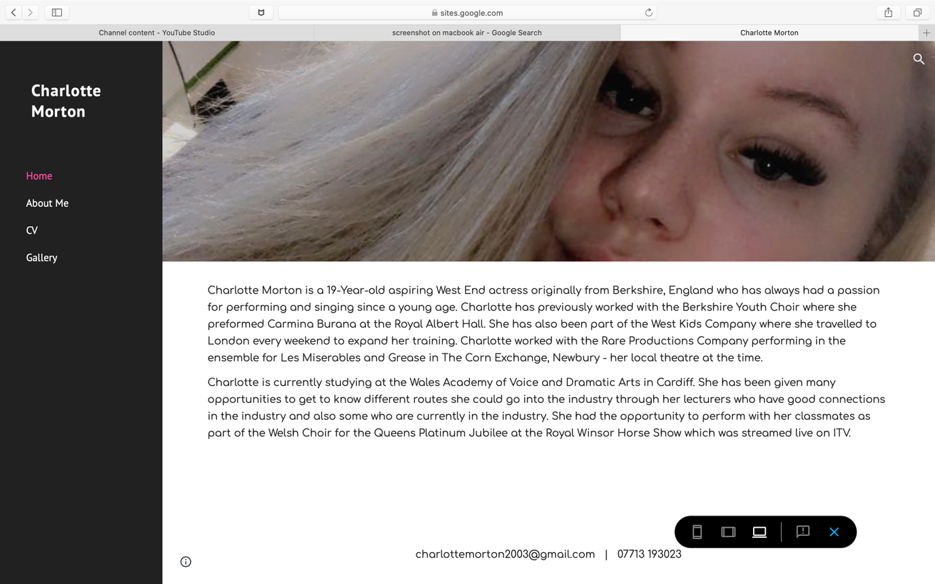

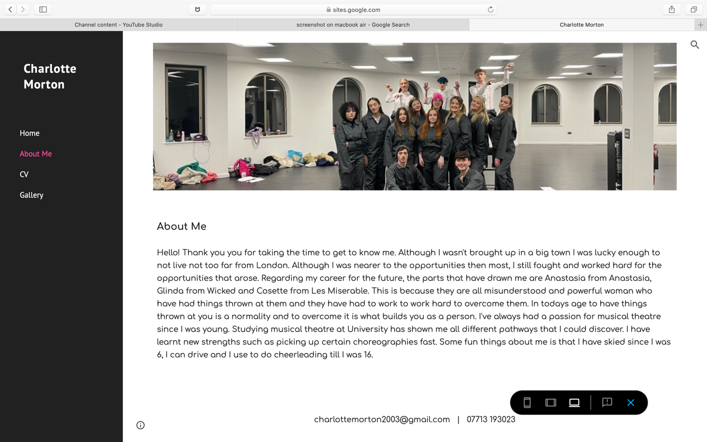
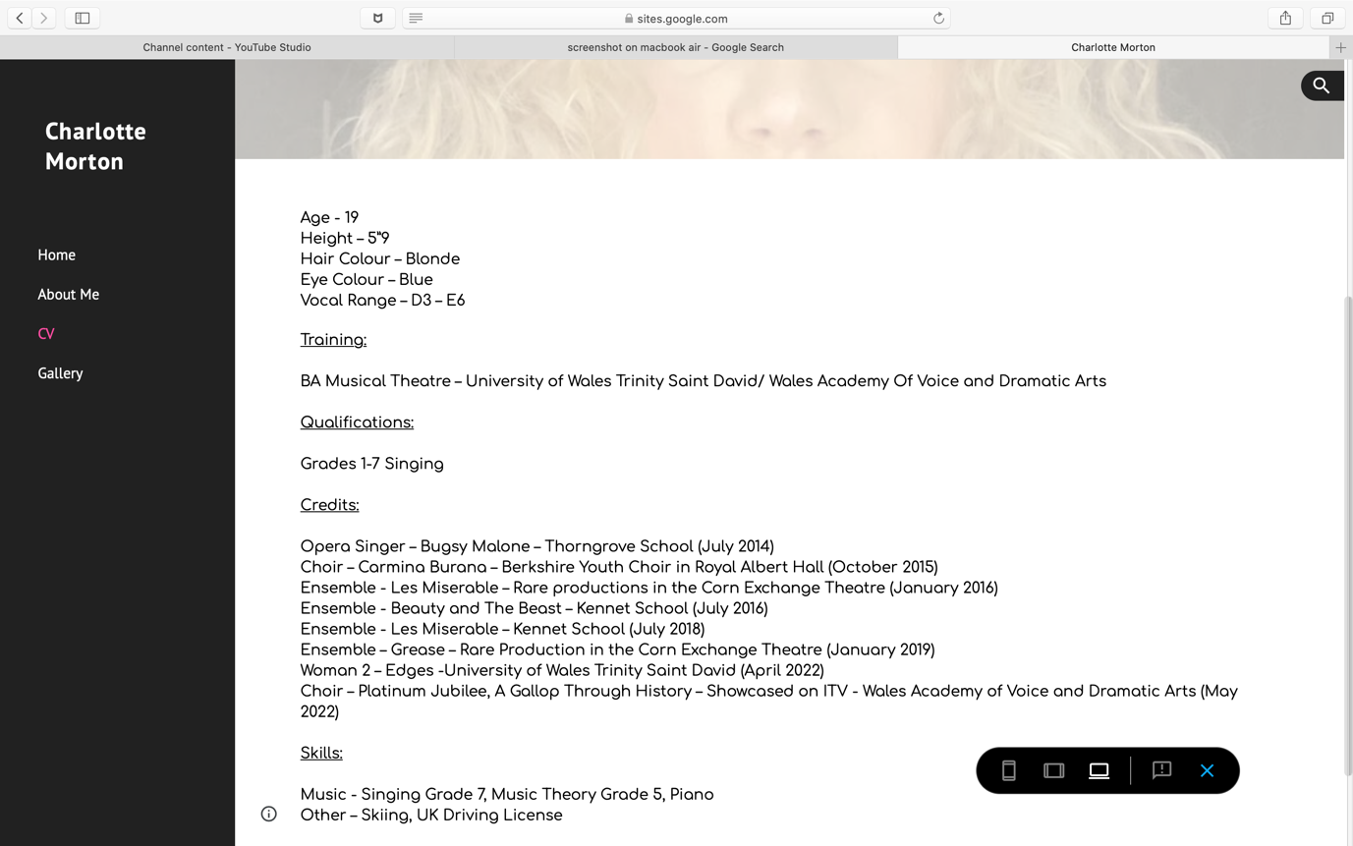

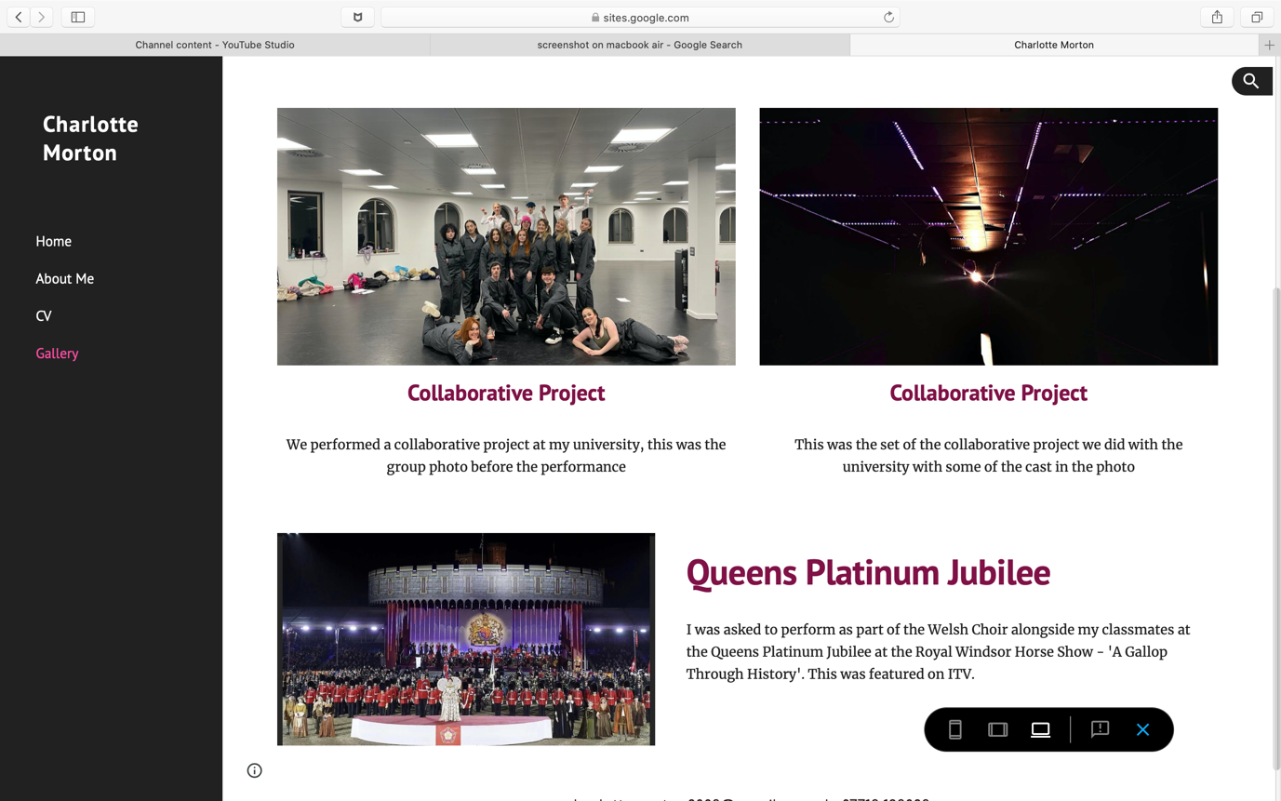

Canva CV:

Link: https://www.canva.com/design/DAFVU542f-w/PzFJUeun2SRUuB_8igEDPQ/view?utm_content=DAFVU542f-w&utm_campaign=designshare&utm_medium=link&utm_source=viewer

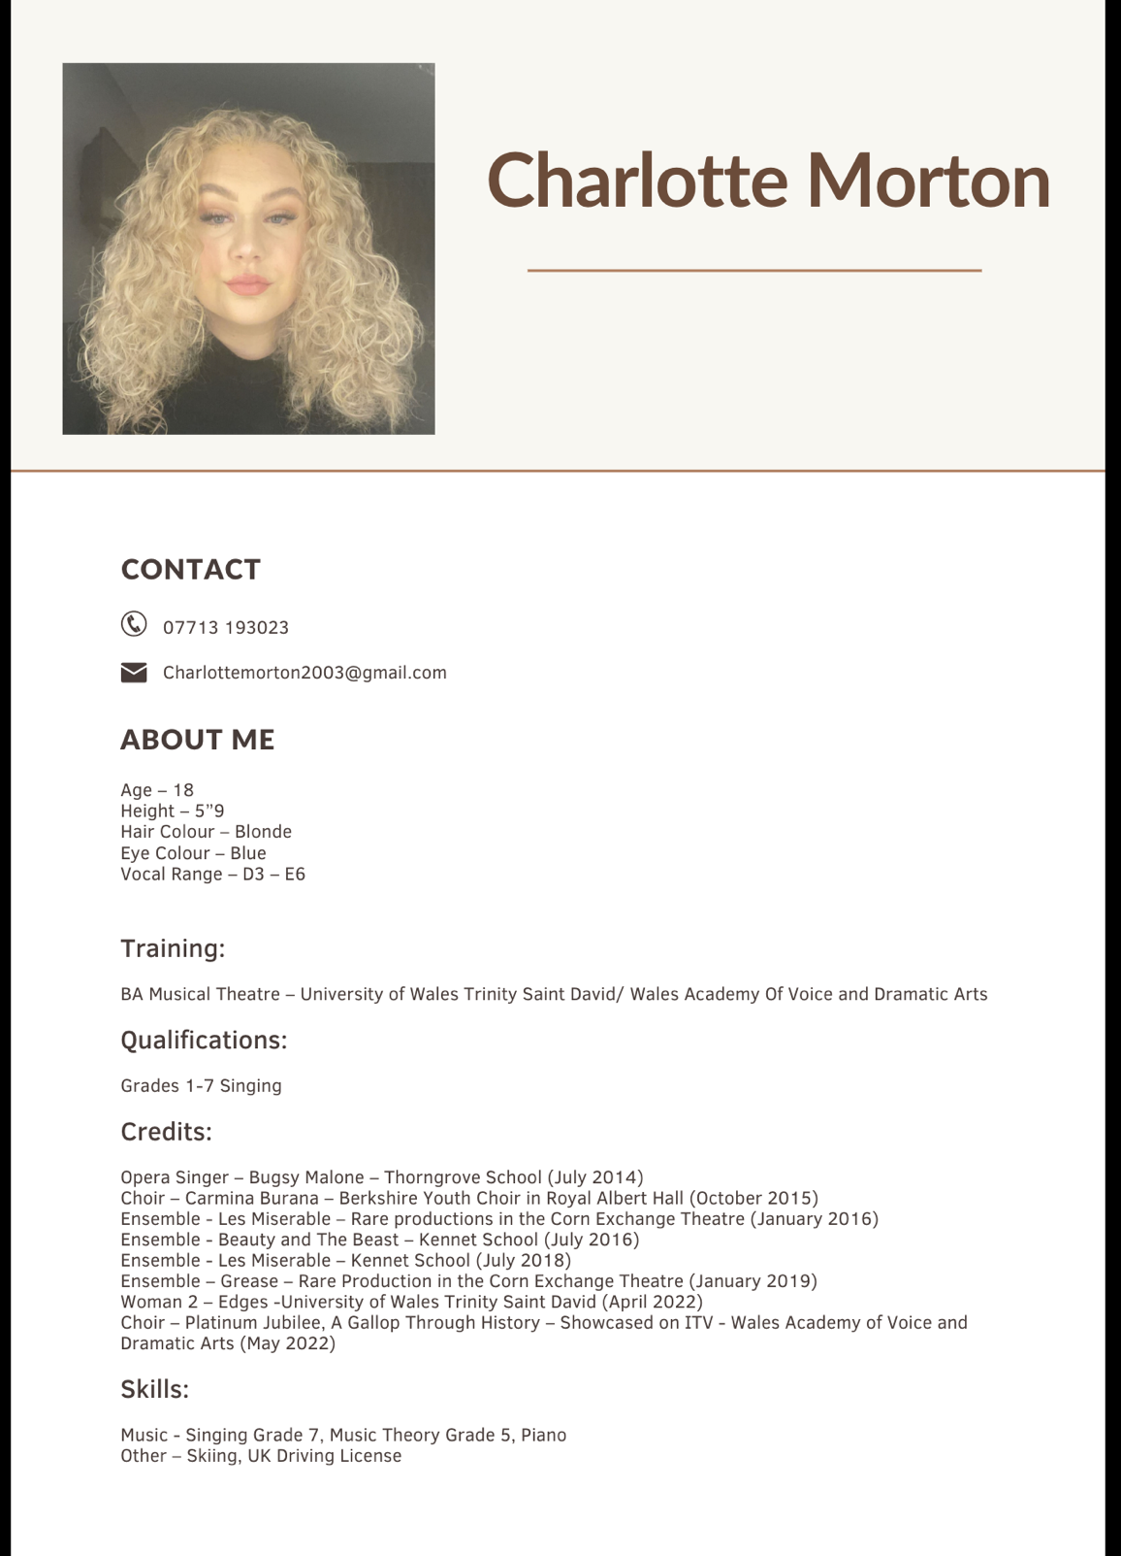

Self tape:

Video Link: https://youtu.be/pInix8qwRY0


