Problem Solving and Decision Making

Student name: Dalanda Diallo

Student number: 2025163

Module code: BMSW4004

Lecturer name: Soban Saqib

Assignment title: Problem solving and Decision Making

Table of contents

- Cover page
- Table of contents
- Introduction, what is complex problem, work life balance
- The problem, Fishbone tool
- Pestle analysis, solutions
- Final solutions, swot analysis, swot analysis table
- Conclusion
- Reference list

Problem Solving and Decision Making

Introduction

The approach of problem solving involves identifying and resolving a gap among a current state and an ideal objective, with the goal means path being obstructed by either known or unknowable barriers. Typically, the circumstance is one that has never been faced before, or at the very lowest, one for which a precise remedy from experience is uncertain. In contrary, decision-making is the process of selecting one of two alternatives to achieve a certain objective. Both issue resolution and decision-making include such steps. In actuality, the terms might be employed in different contexts sometimes (Huitt, W., 1992).
The aim of this report is to define my problem-solving skills and strategies, as well as two alternative answers to a particular workplace development. For this report, I will be using the problem encountered at my current workplace. I will describe the situation and all the potential ramifications and go deeper into the problem to determine what might be at the root of it so I can start building solutions with the skills I have acquired in this module. Once the resolution has been determined, I will devise a strategy for monitoring it to ensure that it is appropriate and that the problem does not repeat.

What is Complex problem?

Through the support of intellectual activity and behaviour, complex problem solving is done to lower the obstacle among a given start point and a desired target phase. Limitations, the start stage, and the desired objective state demonstrate complexity, fluctuate significantly dynamic, and can often be completely invisible. In contrary to addressing simple problems, complicated issues have uncertain exact characteristics of the initial state, planned goal condition, and restrictions at the commencement of the problem solution. When solving complex problems, the problem-solver must effectively engage with the task-dependent environmental factors. Along with information, it necessitates the application of cognitive, emotional, and social resources (Frensch and Funke 1995).
However, complicated problems are any that require for the ability to approach them from numerous, frequently opposing perspectives and could result in various workable solutions.
Complex problems are difficult to explain because different individuals can have different perspectives on the original problem cause, origin, and scope. Complicated problems are often difficult to solve because of their social complexity rather than their sophistication (J., Funke, 2012). According to Middleton, H., 2002, individuals use two different kinds of issue-solving procedures to move around the problem domain. Foremost are algorithms, whose are described as methods that ensure an outcome; an e. g. of an algorithm is a simple prescription. Procedures are typically helpful for issues where it would be feasible to accurately describe every aspect of the issue area. Guidelines, which are referred to as the second plan, are described as methods that increase the likelihood that a situation can be solved but cannot.

Work life balance

Career balancing, also known as organisational stability, is the capacity of an individual to fulfil their duties to their relatives, their employment, and the other commitments, activities, and chores in their agenda. Work life balance includes positions in various facets of life and to add more the relationships among job and family obligations (Delecta, P., 2011). The connection among institutional and cultural locations and times of working and not working in countries where revenue is primarily earned and dispersed through labour markets is what Felstead et al. (2002) refer to as "work-life balance." According to Greenhaus, J.H., and Powell, G.N. (2006) researches have demonstrated the benefits of properly balancing work and family life for both workers and enterprises.

The Problem

Firstly, this paragraph is to discuss about the issues that I am experiencing at my workplace. I will be giving full details of the matter. So, currently there are these two problems that are happening at work. I work in a restaurant as a waitress, Barista, and bartender and it happens that I am underpaid for all the tasks that one has been producing and furthermore, my workplace has lack of staff, and those reasons make some of us have a heavy schedule with no good salary. Secondly, there is not life balance. The restaurant where one is working at is a small restaurant but there are two other branches in west London, and they are all small. Even though one’s restaurant is small sometimes it gets very busy. Thirdly, the restaurant has only three waiters which makes things difficult as sometimes two waiters are off at the same time, so the manager gives me a lot off hours more than what one asked for, since one has a zero-hour contract to add more, having to work for long hours all the week sometimes even when one is off and considering the fact that the end of the month one will not be satisfied about salary, that have a negative affects towards one’s motivation in fact it does not motivates me to go to work which leads me sometimes to call sick for the simple reason that one feels very tired and stressed. I am overload sometimes and have no social life and no time to meet friends. One has informed the manager that one is a student and needs to have a balance between studies and work, not forgetting that one has informed him from the beginning that one would not be able to do massive hours. Furthermore, when someone calls sick, you may be expected to work on your day off which is normal sometimes. The manager tells me that they are looking for waiters, but one has never seen waiters and one wonders why if the management is looking it should not be so challenging to find staff. The company have nobody qualified or someone with the skills to hire the right candidate. So how is the company going to find someone?

Fishbone tool

Heavy scheduled
Lack of staff

Less time for family
overload work
Work Life balance

No motivation Less time for studies

Stressful environment
Less productivity

Pestle analysis

Pestle analysis offers an overall understanding of a company's status and the internal and external environment factors that exist. In this paragraph one will be analysing the problem discussed above by using Pestle analysing tool.

Political: the issue that affected most restaurant was covid-19 that caused the government to put the country in lockdown and as result many people stopped working after that for long time. To add more when lockdown ended many people were not willing to work anymore in hospitality. And that caused lack of staff in most restaurants including mine.

Economic: the lack of staff caused less production at my workplace and with less staff many tasks had to be done the restaurant had to block the booking systems so the staff that was available to work could take care of the customers. According to (Hopson, 2022) Economic expansion impacted 7% of companies in June 2022, including 8% of companies employing 10 or even more staff.

Sociological: lack of time to see my family and see my friends. Furthermore, one has no time to study or have social activities. One does not have time to meet all the other commitments.

Technological: sometimes there is no boundaries between work and one’s private life since even in one’s day off you are expected to see the group messages on WhatsApp coming from the managers or even work-related emails. And causes stress since even at home one’s cannot disconnect from work and is not healthy.

Legal: as there is overload work, sometimes one is expected to do overtime and those overtimes are not always paid somehow and that causes much of frustration in one’s life.

Environmental: finally, lack of work life balance affects me and my service and productivity at work. To add more the atmosphere is stressful for me and my colleagues since everyone complains about the same matters every time. And the communication between colleagues, departments and the management is not great.

Solutions

There are numerous solutions for these problems that would work. These are the few solutions which will be listed below. The fist solution will be to have a conversation with the manager and explain to him all the issues with being underpaid and one’s lack of social life and lack of time to study and the fact that there was no life balance. And explain that for the work that one’s providing and with all the issues that one’s facing, one’s should have a pay rise or reduce the hours. The second solutions would be to request for more holidays rather than 2 weeks. The third solution would be to suggest the manager to discuss the matter with the general manager so he can offer a pay rise and can seek for more staff. The fourth solution would be to enquire a change to the contract for a part time position if the manager agrees to. Finally, the fifth solution was to find a friend that is looking for job with experience refer the friend to the manager and see if there is a possibility to hire the friend so there are enough people covering shifts.

Final solution

Since there are other branches, the solution would be to request a transference or an exchange of staff with one of the other branches and with the permission of the manager that would be granted. This decision will be made if there is not a result with the previous solutions given and this solution will be applied to the mater to see the results. However, if these possible solutions do not give any outcome, then a contract termination may be considered. However, this is not the best solution, and it would be the last and unfortunate solution. To add more, the best solution would be to request more holidays and reduce the hours of work so one can have more time for the family and other commitments.

Swot Analysis
In this paragraph one will discuss about the strength, weakness, Threats, and opportunity of the workplace.
Strengths: The strength is that the restaurant provides a great service everyday furthermore, the manager has a great experience and has knowledge of what must be done and has a lot of patience with new staff.
Weakness: To add more, one of the biggest issues is miscommunication, in fact there’s no good communication between the staff and the staff insights are not considered. The other big issue that all the staff complains about is about the long hours of work, double shift and there is not flexibility even though hospitality should be the most flexible job.
Threats: There is not life balance, no social life and the staff complains not having enough time to fill in their commitments. Furthermore, some of the colleagues have developed stress and anxiety.
Opportunities: the opportunities that someone can encounter sometimes is having a pay rise and without forgetting to mention the training. As a staff you can beneficiate of a great training in how to make coffees, cocktails and how to serve the food at the table. These are good skills that can be obtained and can be applied to one’s next job.

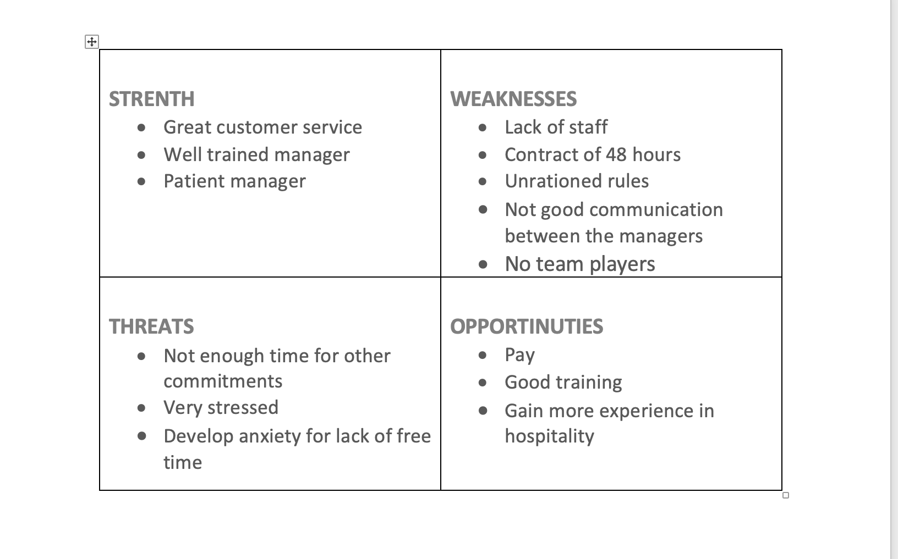
Conclusion

Finally in this report one has discussed about what complex problem is and given details. The report covered a brief definition as well of what is work life balance and without it life can be challenging and can cause mental issues. Furthermore, one has presented the current problem that one is facing in the workplace, and one have analysed the problem with fishbone tool and pestle analysis. One has also given a range of possibilities to the problem presented and has given a final solution that would be applied as last option. This report also includes a swot analysis and a swot analysis table to see the strength, weakness, threats, and the opportunities available in the company. This course made me gain new skills in how to make the right decisions and find the best solutions. One will certainly use it for future studies and work.

References

- Delecta, P., 2011. Work life balance. International journal of current research, 3(4), pp.186-189.

- Gershuny, J., 2003. Changing times: Work and leisure in postindustrial society. Oxford University Press on Demand.
- Greenhaus, J.H., and Powell, G.N. (2006), “When Work and Family Are Allies: A Theory of Work–Family Enrichment”, Academy of Management Review, Vol. 31 No. 1, pp. 72-92.
- Gyllensten, K., Andersson, G. and Muller, H., 2017. Experiences of reduced work hours for nurses and assistant nurses at a surgical department: a qualitative study. BMC nursing, 16(1), pp.1-12.

- Huitt, W., 1992. Problem solving and decision making: Consideration of individual differences using the Myers-Briggs Type Indicator. Journal of Psychological type, 24(1), pp.33-44. https://www.capt.org/jpt/pdfFiles/Huitt_W_Vol_24_33_44.pdf

- Hopson, E. (2022). Business insights and impact on the UK economy - Office for National Statistics. [online] www.ons.gov.uk. Available at:https://www.ons.gov.uk/businessindustryandtrade/business/businessservices/bulletins/businessinsightsandimpactontheukeconomy/4november2021.
- J, Funke., (2012). Complex Problem Solving, ResearchGate, Available at: https://www.researchgate.net/publication/52009574_Complex_Problem_Solving Accessed: 23rd June 2022

- Kim, H.K., 2014. Work-life balance and employees’ performance: The mediating role of affective commitment. Global business and management research: An international journal, 6(1).

- Middleton, H., 2002. Complex problem solving in a workplace setting. International Journal of Educational Research, 37(1), pp.67-84.
- https://www.sciencedirect.com/science/article/pii/S0883035502000228

- Yüksel, İ. (2012). (PDF) Developing a Multi-Criteria Decision-Making Model for PESTEL Analysis. [online] ResearchGate. Available at: https://www.researchgate.net/publication/274863692_Developing_a_Multi-Criteria_Decision_Making_Model_for_PESTEL_Analysis.

