
Skills for the Workplace
Module Assignment Submission
Student Name: | Tracey Harries
Student Number: | 1911014
Module No: | BMSK4003
Module Title: | Digital Skills and Research Methods

Statement of Confirmation of Authenticity
By the act of making this submission, the student declares that this is the work of the student named above. The work has not, in whole or in part, been knowingly presented elsewhere for assessment, or where assessment has been built on a previous assessment, this has been identified. Where materials have been used from other sources it has been properly acknowledged. If this statement is untrue, the student acknowledges that an assessment offence has been committed.
Attention is drawn to the plagiarism and unfair practice policies of both the University and of ILM.
Permission for ILM to use this script
ILM uses learners’ submissions – on an anonymous basis – for assessment standardisation. By submitting, both the centre and the learner agree that ILM may use this script on condition that identifying information is removed. However, if you are unwilling to allow ILM use this script, please refuse by ticking the box: □

Table of Contents
Introduction 4
Part 1 4
1. Modern Technology 4
Old versus new Technology 5
Mobile Applications 5
Cloud Computing 5
Is the Internet safe ? 6
Information Technology 6
1.2 Health Sector 7
Mobile Health 7
Data Sharing 8
Swot Analysis 8
1.3 Data 9
The 5th Industrial Revolution 9
Encryption 10
Blockchain 10
Moore’s Law 10
1.4 Artificial Intelligence 11
Autonomous Robots 11
Emulation 12
1.5 Survey results 12
Part 2 13
2. Social Media 13
Advantages 13
Disadvantages 13
Probing 13
2.2 Marketing 14
Social Media 14
Application Platforms 14
Advertising 15
2.3 Career Prospects 15
Online Profile 15
Employers 15
LinkedIn 16
LinkedIn Profile 16
Conclusion 18
References 18
Bibliography 20
Appendix A 20

Appendix B 21
Appendix C 22
Appendix D 30

Introduction

Digital technology and it’s place not just in the workplace but in society also will be looked at closely during this report, from smartphones being used for almost everything to Artificial Intelligence and future technology. The internet has revolutionized communications and is used in almost everything we do and is now our preferred way of communicating as opposed to writing a letter or making a telephone call having an impact on all levels of education, allowing everyone to share knowledge and develop new ways of learning at any time, anywhere, using any device. Modern technology is in every aspect of life from mobile banking to robotic surgeries, from Satellite Navigation as evidenced in cars and boats to autopilot in aeroplanes.

A survey is conducted into the online social networking websites ( Facebook, Twitter etc ) to determine how we can benefit from using these websites in a positive productive way, from a career perspective to marketing and looking into the advantages and disadvantages of using social media in the workplace, what apps are used and why ?

Part 1

Modern Technology

Technology is hugely important to our lives, love it or hate it technology affects most of what we do today and influences our plans for the future, from using mobile phones to experiencing the benefits of a hearing aid, surfing the internet to turning on Global Positioning Systems (GPS) in our cars. Most things can now be accessed on a mobile device, mobile phones once used for calls, text and taking photos are now used for shopping, banking and even booking a holiday online through developments in mobile technology. According to GSMA Realtime intelligence data (2020) there are now over 9.42 billion mobile connections worldwide with a world population of 7.75 billion. The majority of the mobile market is dominated by the smartphone, (Appendix A) shows the top 10 countries in classified order.

Old versus new Technology

Old technology the technology that has replaced it, i.e. slow dial up internet has been replaced by new high speed fibre optic broadband with instant connection, Mobile phones have replaced landlines. And typewriters replaced by word processors.

Old | New
landline | Mobile phones
Dial up internet | Broadband
Fax machine | Email
Floppy disk | Usb drive
typewriters | Word processor
laptops | Tablets
keyboard | Touch screen

Mobile Applications

Mobile applications are making things easier and quicker (Majumder, S. 2011) being able to shop and bank online with the press of a button, younger generations are being brought up with modern technology being taught in schools from a young age, helping improve skills, using items such as iPad making the learning experience more interesting by using them for research, homework and being able to access online libraries eradicating the need to go and physically get a book (Meredith, R. 2017).

Cloud Computing

On demand computing resources Cloud Computing (The Cloud) “the storing and accessing of data and programs over an internet service” is growing more popular every day, with its effectiveness and efficiency in IT (Information Technology)services more businesses are making the switch, it is continuously evolving adding new services helping businesses to market faster, not needing to invest in hardware, being able to access from any device and data storage are some of the benefits (Bozicevic, V. 2018) According to (IBM, n.d) 75% of existing non-cloud applications will move to the cloud within the next 3 years.

Are there any downsides?

a: Loss of control of data.
b: Cloud computing is network connection dependant to be able to send and retrieve files.
c: Some cloud service providers (CSP) have limited features.

Is security an issue?

a: Cloud Service Providers can also be hacked.
b: Employee negligence.
c: Data loss.

Choosing a Hosted provider can reduce the risk as (SaaS) Software As A Service providers are more popular and targeted more frequently (Mata, W. 2014). Can our information be shared without our knowledge ? Yes it can, The European Union (EU) also known as General Data Protection Regulation (GDPR) states on their website situations where organisations are allowed to collect or reuse personal data without consent, European Union (2019).

a: When it’s in your vital interest, may protect your life.
b: When you have a contract, i.e. employee contract or online purchase contract.
c: Public administrations, i.e. Schools, Hospitals.

Is the Internet safe ?

It is essential that we have up to date anti-virus software installed and running keeping us safe (Porter, K. 2020) spyware can easily be installed without knowing and can monitor our online activity gathering information without our knowledge, while phishing emails will try to steal our sensitive information such as usernames, passwords and credit card details while acting as a trustworthy source, protecting our personal data is imperative. Young children should be monitored closely, keeping them safe from cyberbullying and online predators, parental control tools should be used (Bernal, N. 2019)

Information Technology

Ich
surpasses the c
Information Technology is one of the most significant forces affecting business today, it has the ability to change industries and create new ones, reducing costs and improving productivity (Diggory, K 2018). Systems that connect products, services and transportation through a single online application can increase revenue and is the way most business is currently conducted. Technological innovation is a significant global force, Information Technology (IT) is used extensively to connect business strategies and operations within a corporation, business practices need to be continually updated by technology to build, maintain and enhance a competitive advantage (Berawi, M.A. 2018). The use of the Internet, artificial intelligence, and big data analytics has the potential to transform the way in which goods are manufactured and services are delivered.

Comparing advantages and disadvantages shows us Information Technology is a key component in everyday life, used from small households to vast corporation enterprises but also has significant consequences.

Advantages | Disadvantages
Ease of access to information | Job losses
Improved communication | Increase in loneliness
Time saving | Identity theft
Cost efficiency | Hacked accounts
Health benefits | Advanced weaponry
Increased productivity | Loss of personal touch
Precision | Pollution from machinery

Health Sector

Advanced technology is diagnosing illnesses quicker and more efficiently through the use of Artificial Intelligence, surgeries are being performed effectively with the use of flexible robots mimicking the human hand but with the added advantage of having greater rotation and flexibility, in future years Fifth Generation (5G) the newest generation of mobile networks will enable surgeons to perform robotic operations from different continents. Wearable health and fitness monitors are already here and will start the transformation to save thousands of lives while possibly cutting NHS costs along the way. According to Grand View Research (2017) the health care industry will invest £300bn globally in IOT devices by 2022, from implantable monitoring chips to virtual and augmented reality.

Mobile Health

Mobile health ( MHealth ) is used by most physicians today, using mobile devices and medical applications allows practitioners to instant access to personal health records, improved communication, assisting with diagnostics, medication management and much more from anywhere in the world cutting down on paper use and unnecessary phone calls. On the down side mobile devices can be lost or stolen, vulnerable to hacking, malware or viruses.

Data Sharing

A data sharing revolution within the health sector is imminent, according to Professor Beaumont (2017) “ The best way to treat a patient is to unlock the data and cross reference a patients file with others to gain better insights.” “ Combining data will accelerate the pace at which the healthcare industry operates.”(Gomes-Meana, A. 2017).

While there are many advantages to modern technology, what are the disadvantages?
How would we feel if our information was passed on to third parties perhaps employers or insurers, can we trust doctors with our personal data? How is our data being shared and protected? Implementing robust IT security is crucial while removing personal identifying information where possible will help keep anonymity.

“Protecting patient care in today’s hyper-connected world depends almost entirely on protecting and optimising the network and the services that run through them” (Haggerty, E. 2017). Hospitals and manufacturers need to work together to ensure data remains secure.

Swot Analysis

Undertaking a Swot analysis shows clearly cyber-attacks being the main threat supporting the need for robust security but also shows the opportunity to quicker diagnostics and medical research which can be significant in saving lives.

Strengths | Weaknesses
Improved communication  Ease of access to records  Cost effective | Internet reliant  Venerable to attacks
Opportunity | Threats
Medical research  Quicker diagnostics | Hackers  Malware  Viruses

Data

Data, the oil of the digital era, sitting behind technology data is what makes it all possible, Artificial Intelligence (AI), Robotic Process Automation (RPA), Optical and Intelligent Character Recognition (OCR/ICR) and advanced analytics are transforming organisations across the globe (Read, M. 2019). Data is this new commodity that is used to make major business decisions and is key to helping organisations better understand their customers and the market, being the best insight into customers, analysing browsing and shopping habits advertisements can be targeted towards the customers interests. In 2015, data and analytics specialist (Bernard, M. 2015) said, “I firmly believe that big data and its implications will affect every single business—from Fortune 500 enterprises to mom and pop companies and change how we do business, inside and out”. Should these tech giants be exploiting what they know about us? Are there organisations gathering our data for unknown purposes?

Companies and Governments dip into the data of our lives, tracking what we do, who we know and where we go with increasingly innovative ways, the reason for extracting this data is the value it can generate. People often do not know that their data is being taken and used, data brokers aim to provide their service from the shadows and generates around $200bn in revenue a year (Sadowski, J. 2016). Are we entering a new revolution ?

The 5th Industrial Revolution

With the era of Artificial Intelligence the 5th Industrial Revolution has already begun, combining Artificial Intelligence, Human Intelligence, Blockchain, (IOT) Internet Of Things and more, “AI will help increase human labour productivity, Blockchain will help give access to banking to the unbanked, Robots will help humans align returns on investment (ROI) with purpose”(Gauri, P. 2019). Computational power is increasing daily making unheard of technologies suddenly possible, the new generation will take tasks away from people leaving them in the hands of machines that will learn autonomously without human intervention, (machine Learning) (Naidoo, V. 2019).

Encryption

Security is paramount, with encryption being one of the major steps towards security, scrambling data to make it unreadable without a key to decode it. According to National Cyber Security Alliance (2019) “ 50% of cyber security attacks are targeted at companies with fewer than 2,500 employees” (Read, M. 2019). Smaller companies not investing in the way their data is managed could become obsolete. Will this ensure our data is safe from hackers? According to Google “Quantum Computing (The next generation of supercomputers) will be able to break Encryption within 5 years” (Boland, H. 2020). As hackers develop how can we be sure our data is safe in the future?

Blockchain

Originating as the platform behind Bitcoin, Blockchain can be used for anything that requires a transaction to be recorded securely (Marr, B. 2019) a chain of digital “blocks” that contain transaction records, each block connected to the one before and after it “chain” makes it difficult to tamper with a single record as hacker’s would need to change all the connected blocks linked to go undetected. Not being contained in a central location “blockchains don’t have a single point of failure and cannot be changed from a single computer”( Miles, C. 2017).

Secured through cryptography (Mathematical Encryption Algorithms) network participants have their own private key acting as a personal digital signature, if a record is altered the signature becomes invalid letting the peer network know instantly something is wrong, being distributed across peer to peer networks blockchains are continually updated and kept in sync. “It would require massive amounts of computational power to access every instance (or at least a 51% majority) of a certain blockchain and alter them all at the same time” (Miles, C. 2017).

Moore’s Law

Intel co-founder (Moore, G. 1965) made the observation that the number of transistors on integrated circuits doubles every 2 years, to achieve this chip sizes have shrunk drastically over time while the data volume increases. Since 1965 (Moore’s Law, 1965) has been used in the semi-conductor industry setting targets for research and development. (Moore’s Law, 1965) has helped drive investment towards technological and economical growth benefitting consumers with more powerful electronic gadgets, while indirectly help other innovations in the global economy.

Artificial Intelligence

Artificial Intelligence is already forming a major part in our lives, from touch screens that have given us new ways to communicate with the digital world to automated cars, future Artificial Intelligence will be in every aspect of society supporting and advising us in areas such as work, healthcare, education and science. Research is progressing steadily with the impact on society likely to increase, benefits could be huge, eradicating disease and poverty will be possible. Artificial Intelligence is already augmented into our workplace, with machines that will help us do our job more efficiently. The establishment of shared framework combined with data and processing power has remarkable success in various tasks such as speech recognition, image recognition, machine translation and autonomous vehicles (Hawking, et, al., 2018).

“Artificial Intelligence looks for patterns in data and uses them to predict, prevent or treat disease” Doctor Maruthappu (2017) Software collecting information about patients recovering after surgery will monitor blood pressure and heart rate and learn from observing the same scenario thousands of times, known as machine learning.

Autonomous Robots

Autonomous robots are commonplace in manufacturing and are likely to feature in many other workplaces in the near future. In some places humans have already been replaced by robots or machines, factory workers, checkout cashiers and even bridge tolls are now all automated, it is predicted that 35% of the jobs we all do today could be replaced robots by 2034 (Deloitte 2014). (Appendix B) highlights jobs that are low and high risk of becoming automated throughout London and the UK.

Artificial Intelligence must be controlled, machines with super human intelligence could repeatedly improve their design even further (Good, I. 1965). Would super intelligent Artificial Intelligence be the best or worst thing to happen to humanity? Will Technological Singularity happen and render humans obsolete ? Futurists believe it’s not a case of if but when. According to (Musk, E. 2016) “ Super human Artificial Intelligence is capable of providing incalculable benefits but if deployed incautiously will have adverse effects”. Professor Hawking (2016) states “Alongside the benefits Artificial Intelligence will also bring dangers, like powerful autonomous weapons, or new ways for the few to oppress the many”.

Professor Hawking (2010) believes Philosophy is dead, stating “Philosophy has not kept up with modern developments in science, particularly physics. Scientists have become the bearers of the torch of discovery in our quest for knowledge”(Hawking, S. 2010) If Philosophers haven’t kept up with modern science they have cut themselves off from a secure source of knowledge. (Wolpert, L. n.d.) totally agrees and believes “no scientist would take philosophy seriously”. Philosophers have a fascination for wisdom, a way of thinking about the universe and society, Philosophical achievements are not so clear and indisputable as scientific achievements and Scientists believe philosophy is pointless.

In October 2016 (Stephen Hawking) opened a new centre of Artificial Intelligence Hub in Cambridge (The Leverhulme Centre) aimed at tackling the questions raised by the rapid pace of development in Artificial Intelligence research and dedicated to researching future intelligence computers, (Hawking, et al., 2018) can they emulate human intelligence?

Emulation

Computers are already emulating humans, impersonation technologies are mimicking human behaviour and can be potentially harmful, There are now programs that can generate fake faces and fake digital fingerprints, creating the information needed to fabricate an entire person,
(Rutschman, A. 2019) but it’s not all bad, Artificial Intelligence gave Stephen Hawking the ability to communicate more efficiently by predicting the words he would use the most. Healthcare is also benefitting hugely from it with Artificial Intelligence algorithms used to analyse medical data, treatment, techniques and diagnosis without the use of human input.

Survey results

The results shown at (Appendix C) of a survey conducted recently to ascertain what technology is used in the workplace, clearly email and social media lead the way with Facebook being the most used application, looking further we can see it is used mostly for marketing and networking.

Part 2

Social Media

Designed to connect people and share content such as photos, opinions or events quickly and effectively social media sites have transformed the way we live and do business, retailers use it as part of their marketing strategy and are seeing measurable results (Buffer 2019). As a retailer engaging with customers is important, providing customers with relevant content and involving them will be beneficial, shared posts will give the retailer a larger audience with more followers, shared posts are the new “word of mouth”.

Advantages

While employers use social media to their advantage, using the likes of Facebook and Twitter to advertise has great benefits, cutting costs, increase traffic to your website and targeting a market audience to name a few, also being the quickest way to collect information used by organisations to find new business opportunities (Aguenza, B. 2012). but what are the disadvantages?

Disadvantages

Social media accounts are prone to security breaches (Aguenza, B. 2012). Maintaining a social media presence is a time consuming process spending many hours replying to comments, customers comments can be seen by others and can be malicious putting people off and your brand can be damaged permanently, competitors can create false accounts with the intention of tainting the company.

Probing

Social media such as Facebook and Twitter has given employers an extra opportunity to monitor, spy upon and discipline employees (Upchurch, M.2017). Employers may use tweets and Facebook profiles as pre-screening before an interview, picking up on our identities, recording the number of friends, and probing photographs and “likes” to build up a picture of our social habits, gender, age and skin colour. According to a survey conducted by the US Society for Human Resource Management, (2011) in 2008 34% of companies used social media scans before engaging in recruitment rising to 56% in 2011, figures are expected to continue rising. Further studies have found that social media profiles that exhibit bad behaviour or a liking of alcohol consumption were less likely to be offered a position than those that showed profiles family oriented (Upchurch, M. 2017).

According to (Peacock, 2108) “employers worry that staff are wasting time on websites during the work hours, weakening productivity and increasing security risks to the company by sharing data externally”. As a result employers are banning the use of sites such as Facebook during working hours (Benzie, 2017) Others disagree stating Employee’s using Social Media Sites (SMS) are 9% more productive than those who do not and are more skilled at interacting with others and problem solving, are more efficient workers and more creative (Fahmy, 2009).

Marketing

Once used for being a digital channel for socialising, social media has become one of the most powerful digital marketing tools for brands and business, proving a very cost effective way for promoting and advertising business. According to (Marketing Sherpa, 2019) 95% of adults age 18-34 are more likely to follow a brand via Social Networking. (Smith, K. 2019). Social Media Marketing (SMM) promises profitable success particularly if it’s done correctly, on the other hand (SMM) can be detrimental to a brand bringing unexpected results.

Social Media

What problems can marketing on social media bring to a business? Companies risk negative publicity and without proper management can irreparably damage the reputation of a business.
How can social media help to achieve business goals? Some use it to increase brand awareness others use it to push traffic towards their website increasing sales, it can also create a community and assist in customer support (Buffer, 2019).

Application Platforms

Facebook, Instagram, LinkedIn and Twitter being the most popular platforms today, companies need to listen and engage with customer comments, positive comments gives the opportunity for a polite and pleasant reply while negative comments offers the opportunity for support and correction before a situation worsens (Buffer, 2019). Using analytic tools will give a more in depth look at how social media marketing is performing, detailing if you reach more people this month than last month, How many times your company has been “tagged” or “liked”.

Advertising

Advertising on social media will allow you to reach a wider audience rather than just who follows you, platforms are now so powerful you can specify a target audience based on location, interests, behaviours and more (Smith, K. 2019). The results shown in (Appendix D) displays a chart of social media platforms providing the most sales, noticeably Facebook is by far the most popular platform of choice, it is claimed that Facebook reaches 40 million of the UK’s population through advertising (Digital in the UK, 2019).

Career Prospects

Social media has become a powerful recruitment tool, it has become increasingly popular with employers looking to fill vacancies, According to High Fliers (2019) 94% of employers use social media to promote vacancies. Why? With 67% of the UK population on social media advertising jobs this way is quick, cost effective and an easily accessible way of reaching potential candidates (Knowles, E. 2019).

Online Profile

Learning about our online presence can be fundamental in successful job hunting. Work and Education sections should be filled out adding any life events or achievements, avoid making any negative comments or sharing things that could be observed as unprofessional, being careful what photo’s are uploaded as they are there for all to see. Make your profile interesting sharing your hobbies and interests, showing something you are passionate about and using proper spelling and grammar will be more appealing (Knowles, E 2019).

Employers

Employers will view your profile to establish whether you’re a suitable fit for the company. According to Hubbard (2019) 94% of employers looking at potential candidates social media profiles looked at LinkedIn while 65% looked at Facebook and 55% at Twitter. For example, Viewing Facebook profiles will give the employer an insight into our lifestyle, identity, gender and social habits.

LinkedIn

LinkedIn being a social network for professionals is the easiest way to make same industry connections giving the opportunity to connect with companies and build a network of contacts (Knowles, E. 2019). Profiles should display professional experience, skillset and education background along with interests, hobbies and accomplishments, jobs can be recommended based on your interests and new opportunities can arise.

LinkedIn Profile

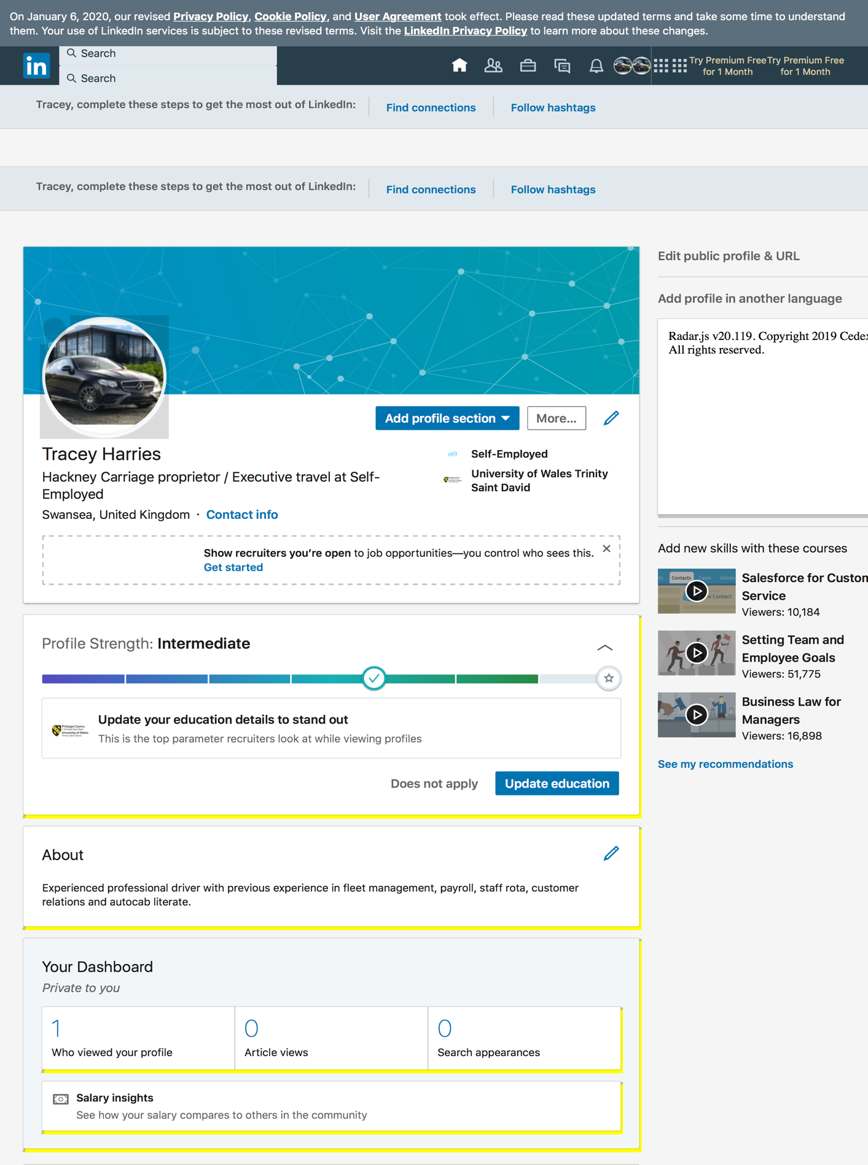

Conclusion

It is obvious digital technology is in every aspect of life personally and professionally, continuously evolving and improving human lives connecting people and businesses globally with ease and transforming how we communicate, shop, recruit and manufacture products. Social media (Facebook, Twitter etc) has become more than a personal platform and is now in every aspect of business from recruitment to advertising and sales. With new emerging technology bringing huge benefits to the health sector and robotics beginning to replace humans in the workplace a new era is dawning, the Artificial Intelligence era, where machine learning merges with reality, with advanced intelligent technology brings a new revolution, the 5th industrial revolution.

References

Majumder, S. (2011). Mobile Application Has Made Our Life Easier. [online] Business 2 Community. Available at: https://www.business2community.com/mobile-apps/mobile-application-has-made-our-life-easier-063349 [Accessed 20 Jan. 2020].

Meredith, R. (2017). iPad 'help improve young pupils' skills'. [online] BBC News. Available at: https://www.bbc.co.uk/news/uk-northern-ireland-40021187 [Accessed 20 Jan. 2020].

Bernal, N. (2019). Online safety for kids: How to protect your children on the internet. [online] The Telegraph. Available at: https://www.telegraph.co.uk/technology/0/online-safety-for-kids-protect-your-child-internet/ [Accessed 20 Jan. 2020].

Porter, K. (2020). Internet scams: What they are and how to avoid them. [online] Us.norton.com. Available at: https://us.norton.com/internetsecurity-online-scams-internet-scams.html [Accessed 20 Jan. 2020].

Van Der Klink, M., Drachsler, H. and Sloep, P. (2011). Technology-enhanced learning in the workplace. [online] Core.ac.uk. Available at: https://core.ac.uk/reader/55536658 [Accessed 30 Dec. 2019].

MED-EL, K. (2018). Technology in the 21st Century. [online] Explore Life. Available at: https://www.explore-life.com/en/articles/technology-in-the-21st-century [Accessed 15 Jan. 2020].

knox (2017). The new technologies transforming healthcare. [online] The Telegraph. Available at: https://www.telegraph.co.uk/business/open-economy/new-technologies-transforming-healthcare/ [Accessed 15 Jan. 2020].

banana, b. (2019). The Impact of Technology in Healthcare | AIMS EDUCATION. [online] AIMS EDUCATION. Available at: https://www.aimseducation.edu/blog/the-impact-of-technology-on-healthcare/ [Accessed 16 Jan. 2020].

FTUI, I. (2018). The Fourth Industrial Revolution: Managing Technology Development for Competitiveness. [online] IJTech - International Journal of Technology. Available at: http://ijtech.eng.ui.ac.id/article/view/1504 [Accessed 18 Jan. 2020].

Deloitte United Kingdom. (2014). Agiletown: the relentless march of technology and London’s response | Deloitte UK. [online] Available at: https://www2.deloitte.com/uk/en/pages/growth/articles/agiletown-the-relentless-march-of-technology-and-londons-response.html [Accessed 18 Jan. 2020].

Hawking, S., Redmayne, E., Thorne, K. and Hawking, L. (2018). Brief answers to the big questions. united states: holder & stoughton, pp.181- 196.

Rutschman, A. (2019). Artificial intelligence can now emulate human behaviours – soon it will be dangerously good. [online] The Conversation. Available at: https://theconversation.com/artificial-intelligence-can-now-emulate-human-behaviors-soon-it-will-be-dangerously-good-114136 [Accessed 20 Jan. 2020].

Read, M. (2019). Data is the most valuable resource on earth. But how and why?. [online] The Vault: Crown Records Management. Available at: https://thevault.crownrms.com/data-valuable-resource/ [Accessed 18 Jan. 2020].

Bhageshpur, K. (2019). Council Post: Data Is The New Oil -- And That's A Good Thing. [online] Forbes.com. Available at: https://www.forbes.com/sites/forbestechcouncil/2019/11/15/data-is-the-new-oil-and-thats-a-good-thing/#af28f4873045 [Accessed 18 Jan. 2020].

Sadowski, J. (2016). Companies are making money from our personal data – but at what cost?. [online] the Guardian. Available at: https:// www.theguardian.com/technology/2016/aug/31/personal-data-corporate-use-google-amazon [Accessed 18 Jan. 2020].

Mulay, A. (2015). Sustaining Moore's law. Morgan & Claypool, Chapter 1.

Upchurch, M. (2017). The internet, social media and the workplace. [online] Core.ac.uk. Available at: https://core.ac.uk/reader/42487572 [Accessed 19 Jan. 2020].

Aguenza, B. (2012). social media and productivity in the workplace. [online] Pdfs.semanticscholar.org. Available at: https://pdfs.semanticscholar.org/2675/378a78c682793b8e9ff235be302b88051233.pdf [Accessed 19 Jan. 2020].

Knowles, E. (2019). Social media and job hunting | Prospects.ac.uk. [online] Prospects.ac.uk. Available at: https://www.prospects.ac.uk/careers-advice/getting-a-job/social-media-and-job-hunting [Accessed 19 Jan. 2020].

Hubbard, E. (2016). How Social Media Affects Your Career Prospects — Interactive Schools. [online] Interactive Schools. Available at: https://blog.interactiveschools.com/blog/how-social-media-affects-your-career-prospects [Accessed 19 Jan. 2020].

Smith, K. (2019). 15 Reasons Why Marketing Through Social Media Should Be Prioritized. [online] Digital Marketing Blog. Available at: https://www.lyfemarketing.com/blog/marketing-through-social-media/ [Accessed 21 Jan. 2020].

Miles, C. (2017). Blockchain security: What keeps your transaction data safe? - Blockchain Pulse: IBM Blockchain Blog. [online] Blockchain Pulse: IBM Blockchain Blog. Available at: https://www.ibm.com/blogs/blockchain/2017/12/blockchain-security-what-keeps-your-transaction-data-safe/ [Accessed 22 Jan. 2020].

Gauri, P. (2019). What the Fifth Industrial Revolution is and why it matters. [online] The European Sting - Critical News & Insights on European Politics, Economy, Foreign Affairs, Business & Technology - europeansting.com. Available at: https://europeansting.com/2019/05/16/what-the-fifth-industrial-revolution-is-and-why-it-matters/ [Accessed 23 Jan. 2020].

Naidoo, V. (2019). The fifth industrial revolution looms. [online] ITWeb. Available at: https://www.itweb.co.za/content/WnxpE74D2jg7V8XL [Accessed 23 Jan. 2020].

Marr, B. (2019). What is Blockchain?. [online] Bernard Marr. Available at: https://www.bernardmarr.com/default.asp?contentID=1389 [Accessed 23 Jan. 2020].

Hawking, S., Mlodinow, L. and West, S. (2010). The grand design. Westminster, Md.: Books on Tape, p.10.

Boland, H. (2020). Quantum computing could end encryption within five years, says Google boss. [online] The Telegraph. Available at: https://www.telegraph.co.uk/technology/2020/01/22/googles-sundar-pichai-quantum-computing-could-end-encryption/ [Accessed 24 Jan. 2020].

Bibliography

Buffer.com. (2019). What is Social Media Marketing?. [online] Available at: https://buffer.com/social-media-marketing [Accessed 21 Jan. 2020].
Ibm.com. (2020). What is cloud computing. [online] Available at: https://www.ibm.com/cloud/learn/cloud-computing [Accessed 19 Jan. 2020].

Avram, M. (2014). advantages and challenges of adopting cloud computing from an enterprise perspective. [online] www.sciencedirect.com.

Your Europe - Citizens. (2019). Data protection and online privacy. [online] Available at: https://europa.eu/youreurope/citizens/consumers/internet-telecoms/data-protection-online-privacy/index_en.htm#shortcut-2 [Accessed 22 Jan. 2020].

Bozicevic, V. (2018). Cloud Computing Benefits: 7 Key Advantages for Your Business. [online] Globaldots.com. Available at: https://www.globaldots.com/blog/cloud-computing-benefits [Accessed 24 Jan. 2020].

Iai.tv. (2020). Hawking vs. Philosophy - Has Science Killed Philosophy?. [online] Available at: https://iai.tv/video/hawking-vs-philosophy [Accessed 24 Jan. 2020].

Appendix A

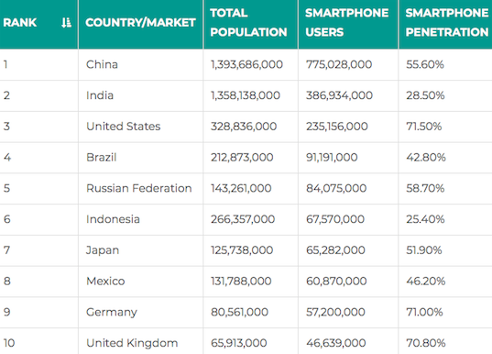

Appendix B

Risk of jobs becoming automated in London and the UK.

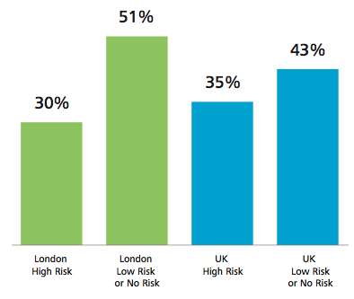

Appendix C

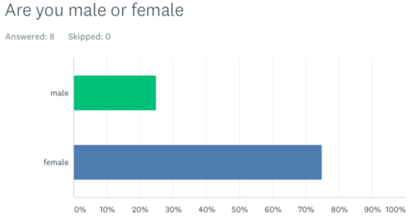
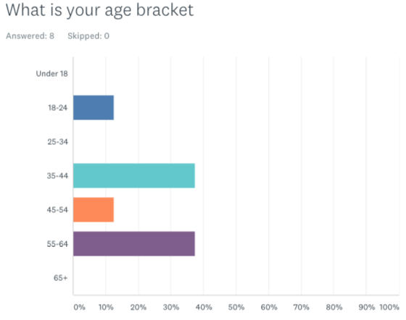

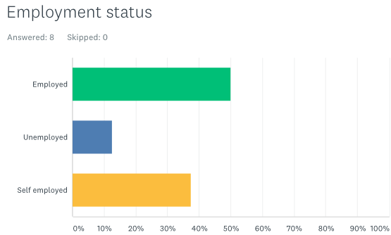
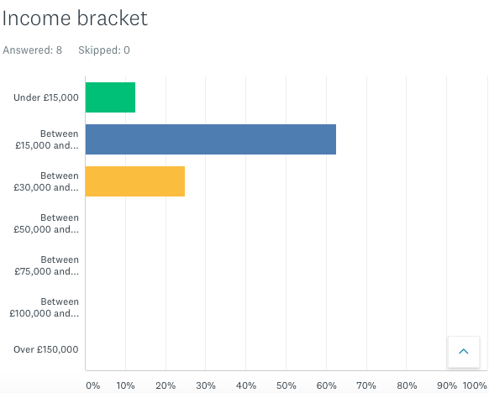
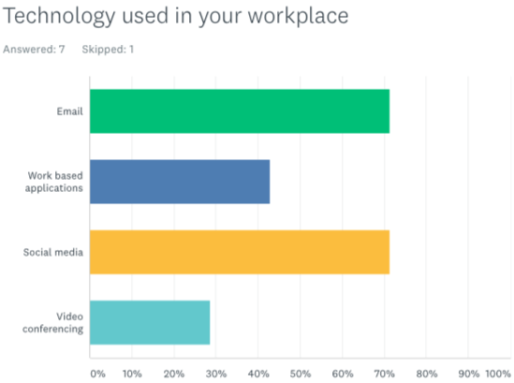
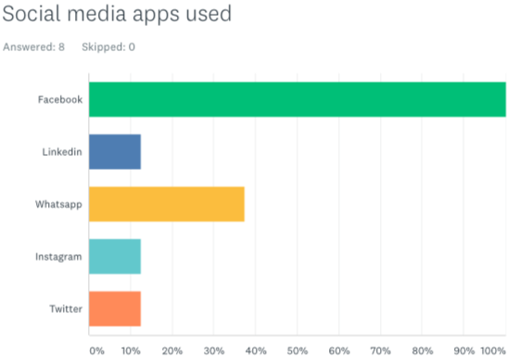
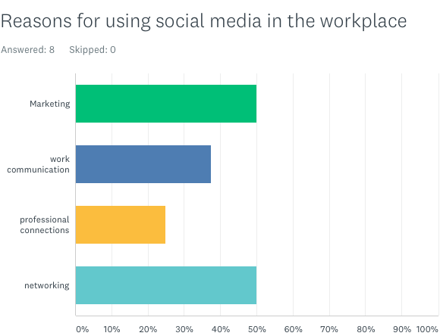
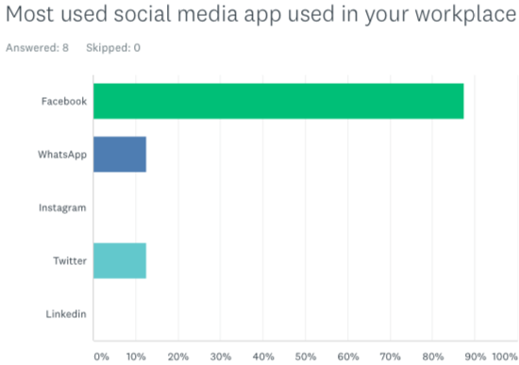

Appendix D

Social media platforms providing the most sales.



