An Evaluation of Marketing
Definition of Marketing “Marketing is the Management process which identifies, anticipates, and supplies customer requirements efficiently and profitably”.
Source: (Blythe,J.and Martin,J,(2019),p02).
The purpose of the essay is to identify the evaluation of marketing. It will cover the marketing mix and how to use that to satisfy customer needs. Will be identifying the factors and trends of the marketing environment and how they effect marketing planning. The marketing mix includes Product, price, place, promotion, people, physical evidence, and process. There are three levels of product * Core, * actual, and *augmented. The marketing environment which includes the digital age, the macro environment, and the microenvironment. The macro environment is including: - political, economic, social, and cultural, technological, legal, and environmental/ecological. There is also consumer behaviour which includes understanding customer behaviour, buyer behaviour and what influences it including social factors, psychological needs. Also, perception in customer behaviour and the learning which describes an individual changes in behaviour and experience. There is also the marketing effort which has a marketing plan. There are two forms of marketing one is traditional and the other is contemporary. There are also six types or markets * consumer, * business, * not for profit, * government, * public sector and * global markets. The evolution of marketing has changed since 1930’s which was just production orientation then in the 1960’s it went to consumer orientation and then in 2010’s when to consumer as a driver so they have changed dramatically over the years.
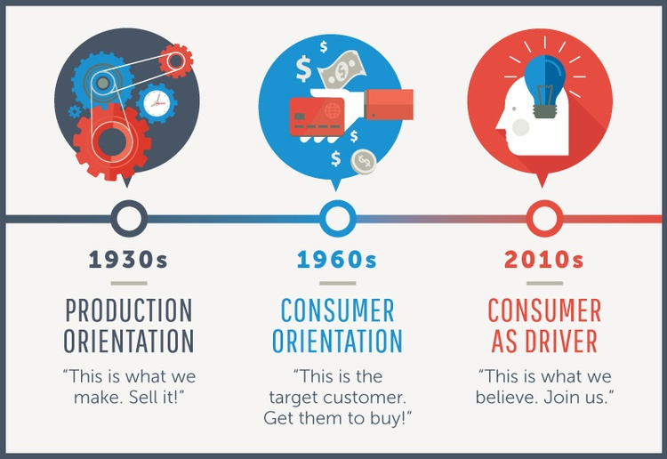
Source:- class slides Marketing Fundamentals
This orientation started at the start of the industrial revolution; everything was handmade. Clothing was produced by tailors with exact measurements or was made at home to the customers specification and to their standards. When sewing machines were introduced the manufacturing process was increased as the speed of making the product was faster and so the cost had decreased, and more goods could be made and sold.
Marketing is responsible for communicating with customers about products offering them respect marketing and unique and separate entity. The band and product managers, researchers and sales representatives which also include advertising and promotion managers. Organisations determined the best opportunities in the marketplace, with its objectives and resources marketers who urge their organisations to target customers carefully and continually or try to exceed their expectations. Organisations must focus and understand what the customers’ needs and wants. Digital marketing efforts the use of an electronic device through the internet, businesses use search engines such as email and social media to contact all there potential and current customers. Phone communication and physical marketing can occur electronically and online. There are endless possibilities for brands on web-based marketing, to be competitive business owners will need to embrace digital marketing. The digital marketing options and strategies can get very creative with a variety of marketing tactics on a small budget. Tools like dashboard to monitors and ROI of campaigns can with traditional promotional content which billboards or whiteboards can give out important and useful advertising.
Macro-environment” is the larger societal forces that affect the microenvironment – demographic, economic, natural, technological, political, and cultural forces”.
Source (Kotler,2017, p69).
The macroenvironment has the big picture the pestle factors are: - Political environment, Economic environment, Social and cultural environment, Technological environment, Legal environment, and Environmental/ecological environment.
Political, which covers tax policies, environmental regulations, trade restrictions and reform, tariffs, political stability and change of government. The tariffs have been changing recently for the worse as petrol and diesel has increased throughout the covid pandemic. The economic has working hours and minimum wage and the cost of living. The social factor has age distribution, career attitudes and health and safety. Technological is when the use of online search engines. The legal factor has had changes to legalisation impacting on the employment industry and access to materials. The environmental is discussing global warming ethnical sourcing and sustainable sources. I have chosen to talk about the Economic factor and the Technological factor.
The economic factor changed in the last couple of months due to covid19, the unemployment rate increased as companies had to close down temporarly or they had to cut employees hours. The employers had to go through the government to apply for furlough for the employees whi they needed to keep on the books. The cost of living changed a bit as everyone was told to work from home which changed the way of communicating with work collegues. ( BBCNEWS.GOV.UK)
The Gini coefficient for household income and benefits has increased by 0.2 percentage points over the last 10 tears. The highest was 107.800 then it was decreased to the lowest of 75,600 due to the pandemic (covid19). It was reduced by four times, the money was after all taxes were taken out, the benefits were increased for a short period of time by giving families on universal credit an extra £20 a week to cover extra additional costs towards childcare as the children wre off school for a long period of time. ( Jennao’neil 28/05/2021) accessed 7/12/21.
The Technological environment has changed since covid as “the whole world has gone to online so marketing has followed to online too. It is the most dramatic force now shaping our destiny”.(kotler2017,p86). Technolog solutions in the health care field these tolls originaly identified that the future of care would be made a lot better and easier, however thses are now viewed as an essential technoloical solution. Technology has accelerated during the pandemic crisis because it can provide distance, safety for all the health care professionals and the patients plus their will be faster results to be reported and visual visits and more.(nurselead,2020oct;18)
According to Bernard Marr” The acceleration of digital technology has transformed everyone to juggling things at home indluding home schooling for the children plus professional work at home. It has changed how businesses have had to operate through customer ordering online, and they had to compete with other marketing organisations”. The engaement with customers was reduced as customers couod no longer go into shops to buy the products they had to order what they required online. To enhance the business process the company had no choice but ti change to technology to compete with others as the data had increased as the hospitality industry had to change to deliveries which included joining delivery companies to have their customers orders fulfilled and to keep the customer base that they had already accomplished. Artificial inteligance has helped out the health care officials with the infection rate as the icu demand was very high during covid19 and all the hospitals were at breaking point even at full capacity. As the customers for all organisations were put through this change of technology development it accelerated their adoption to improve on their digital skills even when helping their children with online schooling as they were given a link to continue with their schooling at home. When the vaccine was introduced the technology used was by scientists in labs if they didn’t have the technology they couldn’t of come up with the right vaccine to help us all in the pandemic as we are all now fully accinated they are working on the booster vaccine to keep us all out of danger.
https://digitalmarketinginstitute.com/blog/the-evolution-of-digital-marketing-30-years-in-the-past-and-future

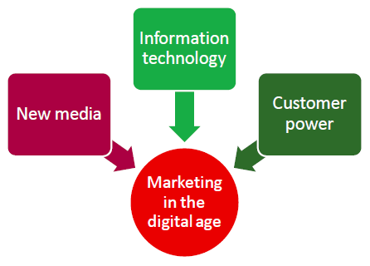
Digital marketing compasses all marketing efforts that use an electonic device or the internet. Businessess use all digital chanels like search engines like social media( youtube) ,email and all other websites to connect with their customers and potential customers. Traditional marketing exisits in ads, phone communication , or physical marketing, digital marketing can occur online and electronically. There are a number of endless possibilities for brand names including email, video, social media or website based opportiunities in the marketing indusrty. Digital marketing is vital for all businesses and brand awareness every brand has its own website to promote how we learn about brands and we expect to rely on it. To be competitive as a business owner you need some digital experience and don’t forget it is always changing. Digital marketing is defined as the use of numerous digital tactics and chanels to connect with all the customer base that you have already which they can spend as much time as they want online the website itself to the business is online branding assets. Online brochures and more marketing campaign supports their overcrching goals to the marketing strategy marketers can support a larger camoaign through free and paid chanels at ther own disposal.
The definition of search engine optimisation is “ in simple terms, it means the process of improving your site to increase its visibility when people search for products or services related to your business”. ( searchengineland.com). Search engines like google and bing use bots to crawl through the pages on the web. It goes from site to site and it collects all the relevant information it needs and puts them in an index, its basically like a giant library to help find exactly what you are looking forat any time of the day. Algorithms analyze the pages taking into account that there are hundreds and maybe thousands of ranking factorsor signals. The SEO success factors considered all the proxies for aspects of the user experience. Search bots estimates how the website has given the searcher what they was searching for. All the activity takes place off page with inbound limks also known as backlinks. The number of publishers that link to you and also the relative ‘authroity’ affect how you ank highly for the keywords that you care about the most. By networking with others and writing guest posts on there webpages they will generate attention which you will earn backlinks. Technical SEO ,is the backend of the website and how the pages are coded.
Pay Per Click (ppc) it is a method which is driving traffic to your own website by a paying publisher everytime that your ad is clicked on. It is a business model where by a company that has placed an advertisement on a website pays a sum of money to the hosts website when a user clicks on the the advertisement. “ so-called’click fraud” is an increasing problem as pay- per- click continues to grow”, it is also known as cost per click (cpc). Ppc is a primary model which is based on keywords for example, in search engines, online ads ( also known as sponsored links) they onlt appear when a keyword is related to the product or service being advertised. They keywords ca result in a higher number of click and then it gives higher profits, it is beneficial for both advertisers amd publishers. For advertisers the model is advantageous as it provides the opportunity for the advertised product or sevice to be given to the specific audience whilst they are searching for the relevant content. Well-designed ppc advertising campaign has a substantial amount of money as the value of each click ( visit) froma customer exceeds the cost to the click paid to the publisher. (coporatefincanceinstitute.com)
Sponsored content,with sponsored content is a long-form or otherwise in-depth asset from a blog post to a video – whose production is funded by a sponsor whose creation is ditribution is handled by a partner, which in turn ensures that the asset closely resembles the non-ad content on its platform. (Alex Cox) ( Brafton.com). Amy piece of sponsored content will have three components which are :- A Sponsor who pays the external partner to produce and distribute the content. A Partner either in media platform (like website) or an influencers account which targets the audience to show where the sponsored content lives, And the third is An Asset which is the actual sponsored post, video, image or a podcast.
The social media platform has main advantages they can communicate directly with their target group. Social medis is increasingly important as all companies use it through facebook, twitter and instagram, direct communication is key as it connects you to potential customers and also your customers that you have already established it is also a success for a business development as people use it as a every day life and it has ever millions of active users. Social media benefits the companies as they will get products sold through facebook and instagram but they can also use ebay. Social media isnt just a trend resposible for a business it is much more a part of society. Social media is a backdrop of digitalization and has a fixed touch point . when we use social media to search for things that we require like gift’s for birthdays or special occations for family member’s, we use places like ebay, amazon and use search engines like google to find them. Socia media is a solid platform for marketing as it helps companies with online customer purchases.( Fluer forster,22.10.2020) accessed (9.12.2021)
Through my findings marketing has changed dranatically through the years, as everything was made by hand at first then once machines were invented tailors could make their products more quickly and the cost would be decreased and more goods were sold. Communication with customers about products and special offers were given by managers and more advertising was made through digital marketing . organisations focused more on the consumer through phone communication and email, brands were also promoted through comoany websites and billboards or whiteboards.nwhilst looking through the macroenvironment (PESTLE) , a lot has changed as a lot of companies had to change the way they communicated with collegues as they had to work from home during the covid pandemic and the way resturants and fast food companies had to use delivery agencies to send food to potential customers. They were also charged per delivery as a percentage was taken off the final cost of the order by the dellivery company. Scoial media was also used a lot during the time for the companies to communicate with the customers through their own websites by changing prices and letting them know what has happening as when they would be re-opening again. The health care professionals had it hard trying to get everyone vaccinated and the government changed everything last minute as to closing shops and resturants by giving them a few days notice. Orgsanisations need to adapt their marketing for the digital world as social media is a marketing tool/ platform in which companies can gain a higher credit through promoting their business with social media. Marketing in organisations is the ultimate role for companies as the growth in database has allowed firms to keep a more accurate information system which they can store all their products and offers more safely. Marketing is changing through the times and companies need to keep up to date with this which using digital methods they can increase sales and promote the business much easier and they will get more new customers even through the doors. The development of marketing has loads of affective way for businesses to change the way they look by changing the structure or look of the interior and the way they communicate with others.

References
Buchanan, David A, Huczynski Andrzej A. (2016) organizational behaviour, 9th edn, Pearson, Harlow.
Blythe, Jim, martin, Jane. (2019). Essentials of marketing, 7th edn. Pearson, Harlow.
Kotler, Phillip, Armstrong Gary, Harris, Lloyd c, Piercy Nigel. (2017). Principles of marketing, 7th edn. Pearson, Harlow. (A)
Kotler, Phillip, Armstrong Gary, Harris, Lloyd c, Piercy Nigel. (2017). Principles of marketing, 7th edn. Pearson, Harlow. (B)
Mullins Laurie j. (2016). Management and organisational behaviour, 11th edn. Pearson, Harlow.
www.brafton.com/blog/content-marketing/sponsored-content/.
https://coporatefinanceinstitue.com/resources/knowledge/ecommerce-saas/pay-per-click-ppc/.
https://dmexco.com/stories/why-social-media-should-be -incoporated-into-your-business-developmemnt/
https:// searchengineland.com/guide/what is seo/.
Marketing fundamentals Rachel Cook/class notes/slides.
Google.com
BBC news.gov.uk

