



Mid and West Wales Fire and Rescue Service

BMMB7013 – Strategic Management

Reshaping the organisation’s strategic direction to discover a new way forward for delivering innovative customer care.

Author: Andrew Morgan 0351590

Executive Summary
Mid and West Wales fire and Rescue Service is the second largest by size in England and Wales. It operates in the public sector and is governed by Welsh Government and central government.
It is currently experiencing challenges in the macro environment, particularly a national pay dispute which threatens industrial action. The On-call sector of the organisation is enduring many challenges with availability due to falling pay and lifestyle changes on the backdrop of the Covid-19 pandemic.
Changes at executive level of the organisation, including a new Chief Fire Officer have changed the strategic direction of the service, partly due to the pandemic and partly due to the changes in legislation of which public sector bodies must abide to.
This strategic analysis will attempt to synthesise both the macro and micro-environment, through three different management tools/frameworks to deliver innovative customer care and ensure future resilience. It will identify key factors that must be considered for strategy implementation.
A conclusion will provide factors to be considered for strategy planning and implementation with recommendations based on the strategic position obtained from this report.

Terms of reference
This report has been commissioned by Chief Fire Officer Roger Thomas, of Mid and West Wales Fire and Rescue Service. The report is to focus on creatively reshaping the organisation’s strategic direction to discover a new way forward for delivering innovative customer care ensuring future resilience and sustainable competitive advantage. This report is to be completed by Andrew Morgan by December 16th, 2022.

Contents Page

Introduction…………………………………………………………………………………………………………………4
What is strategy?...........................................................................................................5
What is Strategic Management?.....................................................................................6
SWOT Analysis………………………………………………………………………………………………………………9
PESTEL Analysis……………………………………………………………………………………………………………15
McKinsey 7’s Model……………………………………………………………………………………………………..20
Conclusion……………………………………………………………………………………………………………………25
Recommendations……………………………………………………………………………………………………….28
References……………………………………………………………………………………………………………………30

Introduction
Mid and West Wales Fire and Rescue Service (FRS) is the largest by size in Wales and England, it covers an area of 4500 square miles, covering almost two thirds of Wales. The Service area has a population of 910,000 people who reside across 431,500 households. The establishment compromises of 58 fire stations, supported with 1351 employees. These are broken down to 400 wholetime firefighters, 709 on-call firefighters, 22 Joint Fire Control Staff and 220 support staff (Mawwfire, 2022, About us). The organisation was formed in 1996 on the amalgamation of West Glamorgan Fire Brigade, Dyfed Fire Brigade and Powys Fire Brigade.
The core of the service is to provide emergency response to fire and special service calls, with 19 stations medical co-responders, and 19 front line appliances out of hospital cardiac arrest responders.
There has been a change of chief fire officer and a restructure of the executives within the last 12 months, bringing new energy and new ideas to improve response throughout the organisation.
This report will focus on reshaping the strategic direction of Mid and West Wales Fire and Rescue Service with a focus on delivering innovative customer care, which will ensure future resilience against a backdrop of the pandemic. A through and detailed strategic analysis will examine the internal and external environments, with critical examination of the strategic options.
In conducting my strategic analysis, I have chosen to use the following strategic management tools, SWOT analysis, PESTEL analysis and the McKinsey 7S Model, I have also considered the use of Porters Five forces but with Mid and West Wales FRS heavily built on culture, the McKinsey model is a slightly better fit to examine the micro-environment of the organisation to evaluate against. Three strategic management tools have been used to give a true reflection of the organisation against the macro and micro-environments, furthermore the option of combining two tools could add further detail to the analysis. This will provide an accurate position of the organisation achieving its strategy and allow a conclusion with recommendations to be produced.
As Mid and West Wales FRS is a not-for-profit organisation, the strategies are not determined to gain competitive advantage. Instead, they are based on providing the best service to the communities in which it serves, whilst complying with all relevant legislations.

What is Strategy?
The term ‘Strategy’ has been defined by several well-known theorists, Johnson, Scholes and Whittington defined strategy as “the direction and scope of an organisation over the long term, which achieves advantage in a changing environment through its configuration of resources and competences with the aim of fulfilling stakeholder expectations (Johnson et al., 2008, P.3). Henry Mintzberg defined strategy as “a pattern in a stream of decisions” (Mintzberg, 1978). Michael Porter said that Strategy is “creating fit among a company’s activities. The success of a strategy depends on doing many things well— not just a few—and integrating among them. If there is no fit among activities, there is no distinctive strategy and little sustainability” (Porter, 1996, p.49)
What is evident from the above that there is no single definition of strategy, the multitude of different definitions have been extremely helpful for strategic leaders to navigate through this complex and challenging path. (Mintzberg, 1978)
Additionally, Henry Mintzberg talks about strategies emerging, a view that not all of strategies are formulated, many emerge through an evolving situation. These strategies are more likely to be fulfilled as opposed to unrealised. (Mintzberg, 1978, p.78). I have seen how many organisations have used emerging strategies through the onset of the Covid-19 pandemic, particularly my own organisation.
Strategy as I see it is understanding where we are now, where we want to be, and how we are going to get there.
The strategic plan for Mid and West Wales FRS is forecast over a five-year period, this is presented through the vision, Mission and Values and the four commitments (Thomas, 2022). This plan incorporates the five ways of working and the sustainable development plan.
What is Strategic Management?
Strategic management is often described as the process an organisation will take to formulise and implement its strategy (Carpenter & Sanders, 2007 P.32). It is the process of which the agreed strategy is brought to fruition. This is done through the formulation of the strategy, the planning involved and the deployment phase (Nickols, 2016 P.32). The key to strategic management is recognising when transformation is needed and having the drive and competence to manage and deliver the process of transformation effectively. (Sadler, 2003 P.23).
Strategic management put simply, is the management of the ‘how we are going to get there’ phase of strategy goals. It manages the key drivers that will allow an organisation to realise its strategy.
There are three main elements of strategic management:
strategic position- evaluate the impact of strategy against the external environment, a realistic appraisal of the capabilities against the expectations.
Strategic choices – the choices for implementing the strategy in both direction of which to take and through method of execution.
Strategy in action – to ensure that the agreed strategy is actioned. (Johnson et al, 2008, pp.12-14)

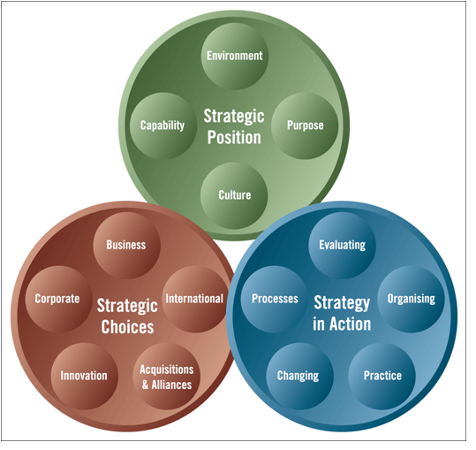

(Johnson et al, 2008 P.12)
To manage the transformation there are several strategic management tools that can help us understand where our organisation is and understand the bigger picture. Many organisations will use these tools to scope the internal and external environments. These may include Porters five forces, SWOT analysis, PESTEL analysis, Ansoff matrix, cultural web and many others.
Mid and West Wales Fire Service utilises an annual business improvement plan for the management of the strategy and the steps in which it will take to achieve such goals. These are broken down into seven improvement and well-being objectives (Thomas, 2022).

Main Body
SWOT Analysis
The Strengths, weaknesses, opportunities and threats (SWOT) analysis will examine the internal and external business environment of Mid and West Wales Fire Service. The SWOT analysis is one of the most straightforward tools in strategic management, created back in the 1960’s and credited to Albert Humphrey, although this is known to be debateable (Teoli et al, 2019). It allows the organisation to critically evaluate its current strategic position to the competition and identify any areas that have the potential to impact on achieving the strategy. Care must be taken to ensure this process does not lead to an over-simplified and misleading analysis (Mullins, 2009, p.541)
I feel it is extremely beneficial for evaluating and generating new strategic options and identifying any action organisations need to take. This management tool has been extensively used over the years and supported by many theorists and found in almost all strategic management books. Some questioned its value back in the late 1990’s (Hill & Westbrook, 1997), however even today, it’s still widely used, proving its effectiveness as a strategic management tool but must not be used alone, other strategic management tools should be considered such as Porter’s Five Forces, PESTEL analysis or Cultural Web to support.
The table below outlines the SWOT analysis findings and has placed the findings in order of priority.

Strengths | Weaknesses
Leading the narrative when things break | Service Delivery
Community Risk Management Planning | Business Continuity Events
Brand | Cyber Attacks, Threats and implications
New ways of working | Regulatory Body Compliance
Celebrating Success | Workforce planning, threats and implications
Opportunities | Threats
Emergency Medical Response | Industrial Action
Joint working co-location hubs | Cost of Living Crisis
 | Changes in government spending

Strengths
One of the main strengths of the organisation is to lead the narrative when things break, this referring to the response against reports published nationally that have identified areas of poor performance or failings by other Fire and Rescue Services or public sector organisations. In November 2022, a cultural report against London Fire Brigade was published “The independent culture review of London Fire Brigade” (Afzal, 2022), uncovering a culture of misogyny, bullying and racism. These extremely unacceptable and damaging findings will cause significant reputational damage to London Fire Brigade, even more so when aired nationally in the press (Sheridan & Mercer, 2022).
Since the publication of this report, the Chief Fire Officer has commissioned an external organisation to undertake a cultural review to begin in the early part of 2023. The findings of the report will be published and will provide a true and accurate reflection of the culture within Mid and West Wales FRS. The response of the Chief Fire Officer demonstrates another example of the Mintzberg theory of ‘emerging strategy’ (Mintzberg, 1987). The organisation has used this strategy for many published reports that need immediate intervention in Service such as, the Manchester Arena Inquiry, Marine Accident Investigation Branch (MAIB) report of the fatal fire service water training exercise and the Grenfell Tower Fire. A working group is generally stood up to action due to the implications they have on the organisation.
Weaknesses
Service delivery across the on-call establishment is the biggest weakness in the organisation and is documented on the Business Risk Register. On-call firefighters provide pivotal fire cover in the community areas in which they serve. Other than a small minority of urban on-call stations which support the wholetime firefighters, these stations are mostly rural in close knit communities. These firefighters are alerted when there is an emergency and respond to the station quickly, often from their main employment. Since 2015 on-call availability across 52 stations, then at 95% has been in steady decline. As of October 2022, availability was down to 83% (Thomas, 2022) and this is having an impact on Service response. As of 13th September 2022, the total number of on-call staff has fallen from 702 to 671 (Business Risk Register Decision Log, 2022). A 100% contract would equate to 120 hours on-call per week and a 75% contract at 90 to 95 hours (Thomas, 2022). There is the additional need to fulfil 3 training hours per week. A combined 100% contract payment and training hours per week totals £5520.32 per annum (£460.03 per month) before any deductions. Call outs would be paid on top of this salary, but these stations are mostly rural with low call activity. The contractual hours have not changed since the early 1990’s and I believe this archaic system is making recruitment extremely challenging and needs urgent review. The chief fire officer has requested to councils to increase the levy by 13% to help plug the shortfall in pay for these firefighters (Scourfield, 2022). As a starting point, I believe the service needs to review the contractual hours considering the changes in people’s lifestyles on the backdrop of a covid-19 pandemic. There is more emphasis on work-life balance and cost of living crisis, the service needs to recognise this.
Opportunities
It is well publicised that the Welsh Ambulance Service Trust (WAST) is enduring significant challenges in meeting targeted response times. Red calls are the most serious category for ambulances to respond to, meaning the person is in imminent danger of death and have a target response time of 8 minutes. Mid and West Wales Fire Service has a co-responder scheme which was began in 1998 and has since expanded to 19 locations throughout the organisation. Over the last 10 years, over 15,000 medical emergencies have been responded to by the organisation (Wales News Online, 2022). This scheme was jointly set up to provide an initial response by specially trained firefighters in a dedicated vehicle. These crews are often more rurally located who may be closer to the scene of an emergency and to provide medical intervention until the arrival of the ambulance crews. In 2016 some trials took place to expand this to frontline appliances, these trials saved many lives and improved outcomes for many others. In November 2022 a statement by the Deputy Minister for Social Partnership - Fire Service training and capacity to broaden the role, outlined scope for firefighters to do more paying particular attention to the NHS (Welsh Parliament, 2022). It was raised by some members of the Senedd, that this contradicts the recently published fire and rescue advisors thematic review on operational training in the fire service (Thematic Review of operational training within the Welsh Fire and Rescue Services, 2022). This additional responsibility could provide lifesaving intervention by already trained firefighters, however there would need to be remuneration for firefighters and a higher degree of training. Trade unions would need consultation on the matter and an agreement from the members to accept any changes to roles. I believe this would only enhance the level of customer care provided to our communities, save lives, and upskill our firefighters to deliver an excellent service.
Threats
One of the biggest threats at present is the looming industrial action by the Fire Brigades Union (FBU), there has been a pay dispute nationally over the proposed offer being well below inflation. The FBU have now entered a ballot stage for members to vote on the fair pay or fire strike campaign (Wrack, 2022). The chief fire officer has a duty of care through the Fire Services Act 2004 and section 22 of the National Framework for Wales, to make provisions for the purpose of firefighting and other statutory requirements. There has been extensive planning by the executive leadership team which has stood up a critical incident team. This team will establish the impact this will have on the service and the number of non-FBU members who will be available to work. To establish how many people are non-FBU members has been challenging as the union subscription is taken via monthly pay deduction, however the data protection Act prevents the Service from accessing that data for any reasons other than pay.
Once final staffing numbers are established, the critical incident team will look what resources they have available to provide essential fire cover to the authority. This will undoubtedly result in a lesser response than business as usual. Strategic locations of resources will be finalised to provide the best service we can. If numbers are not sufficient, then a Military Assistance for Civil Authority (MACA) (2015 to 2020 government policy: Military aid to the civil authorities for activities in the UK, 2016) can be made.
This planning process is having significant impact on day-to-day activities of all involved, even though talks are still on-going, and no final decision has been made whether strike action will occur, this will be decided by FBU members nationally, however this extensive strategic planning still needs to take place for resilience.

PESTEL Analysis
The PESTEL analysis is a tool that is used to evaluate the organisations opportunities and risks in the macro environment. The PESTEL framework was introduced by Francis J. Aguilar, a professor at Harvard Business School, via his book “Scanning the Business Environment” (Heubel, 2022). It focuses on key drivers and key drivers for change, these key drivers explore how the macro environment is likely to change, whilst the key drivers for change will identify the high impact factors that are likely to determine the success or failure of an organisation’s strategy (Johnson et al, pp.55-56). It evaluates the opportunities, challenges and risks in the macro environment to maintain organisational performance and effectiveness (Mullins, 2008 p.86)

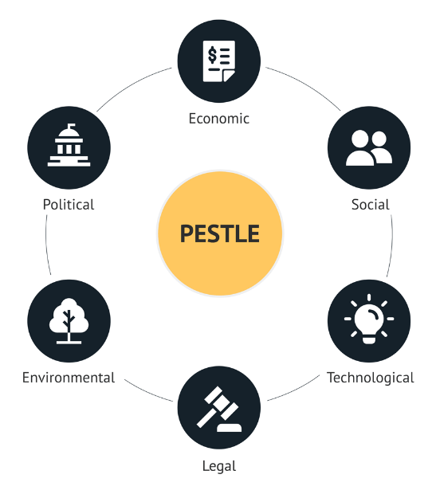
(Heubel, 2022)

The PESTEL analysis provides organisation with an up-to-date position of the external environment, allowing them to respond to any emerging changes as necessary. Failing to utilise this strategic management model could allow other organisations to gain competitive advantage.

Political
One of the biggest political factors is the current government, there have been three prime ministers and chancellors of the exchequer over the last 6 months. This has in my opinion made the conservative party unstable. The Welsh government is funded via the central government, fire and rescue services in Wales being funded by Welsh Government through each authority area crediting the combined fire service’s fund. The chancellor has recently announced plans to fill a £55bn black hole in public finances, with £30bn of cuts by 2027-28 (Andrews, 2022). This could have significant impact over the medium-long term, if cuts or standstill budgets are made to Wales. A general election could of course change this, if there is a change in political party, a labour government is more likely to be supportive of the public services (Mcgrath, 2022). Cuts made to the public sector could have a significant impact to the services and resources available for emergency response.
Economic
The biggest economic factor is the supply-chain shortages, in particular semi-conductor shortage. This is impacting on the Fleet, Engineering and Logistics Department (FELD) that manage all vehicles throughout the organisation. This shortage began in the midst of the Covid-19 pandemic and has been further escalated by the Russian war against Ukraine. Vehicle manufacturers and tier 1 suppliers are unable to procure enough semi-conductor chips which is impacting production (Burkacky et al, 2022). The significant delays have impacted the asset refresh programme where vehicles are replaced, or when leases come to an end. The service has therefore taken the decision to order the vehicles, including fire appliances, for the year ahead programme, on the approval of the fire authority. This has been achieved by horizon scanning, not to predict the future but to assist current decision-makers to produce strategies and plans that are sufficiently flexible and adaptable, to remain robust in a range of possible plausible futures that have been identified within the exercise (Sutherland & Woodroof, 2009). This approach ensures that the standard of fleet is maintained ensuring the service achieves its vision to be a world leader in emergency response.
Social
The analysis of the socio-cultural environment has allowed us to identify the biggest concerns to our organisation. These being:
cost of living crisis
Staff - The impact this is having on staff, in terms of their health and well-being and financial pressures. A recently circulated internal memorandum allowing staff access to help and advice, whilst also supporting agile working to reduce travel costs where possible. Managers have also met to explore additional support for staff who may be struggling from rising interest rates and enduring fuel poverty, some 6.7 million households are suffering from fuel poverty up from 4.5 million a year ago (Graham, 2022). Staff have 24hr access to a confidential counselling line should they require it.
Communities – It has been highlighted through the National Operational Learning internal channels, that instances of fire setting in the home to keep warm have been captured. A recent incident in London had a homeowner set wood on fire in the living room to keep warm, resulting in the house being engulfed in flames (Sky News, 2022). This incident is not isolated and there are fears that these could increase significantly due to the record high fuel costs. The community safety team are working with partner agencies to provide aid to those in need in the communities.
Energy Costs
The energy costs to the organisation are also a concern, energy has been purchased in advance on a fixed term contract to allow stability and a fixed cost for the short term. When this contract is due for renewal, it is likely that costs are going to increase significantly, which will need to be factored in for the financial planning with the fire authority.
Technological
There is a potential threat to a cyber-attack, the current threat level set by the Joint Terrorism Analysis Centre (JTAC) is at substantial. The threat of a cyber-attack is logged on the business risk register as high (Business Risk Register Decision Log, 2022). There have been some internal challenges in ICT with staffing recruitment and retentions, due to the demand and high salaries offered in the private sector. The organisation is working towards Cyber Essentials Plus accreditation, a government backed scheme that will help protect the organisation against a whole range of cyber-attacks (About cyber essentials, 2022) This is essential to protect the data of staff and members of the public as the control room software would have live operational data.
Environmental
The main environmental challenge is achieving the Net zero carbon status by 2030, a document published by the Welsh Government in July 2021 provides an overview of the actions and milestones required to achieve net zero greenhouse gas emissions by 2030, with a vision “By 2030, choosing zero carbon will be routine, culturally embedded and self-regulating across the Welsh public sector” (Net zero carbon status by 2030 - Welsh Government, 2021). The service is making continuous changes to make the organisation greener, the introduction of EV’s, photovoltaic panels, increasing number of charging points across all service locations and many other initiatives. They also have a responsibility under the well-being of future generations (Wales) Act 2015, with one of the seven well-being goals being a “globally responsible Wales”, where they must work to improve the environmental well-being in Wales (Well-being of Future Generations (Wales) act 2015, 2015)
Legal
Changes in the laws have had significant impact on the fire service nationally, the main one being the introduction of the Fire Safety Act 2021. Although not fully implemented, this will supersede the Regulatory Reform (Fire Service) Order 2005. This has been introduced to tighten and improve fire safety regulations further since the Grenfell tower fire in 2017. This has required services to restructure the business fire safety departments, upskill existing staff and recruit further to meet the demands of the changes.
McKinsey 7S Model
The McKinsey 7S Model was developed in the late 1970’s by McKinsey and Co, it was developed to assist executives in dealing with general management problems related to strategic and organisational factors (Channon, D.F. and Caldart, A.A., 2015). The model can be used to examine and solve organisational communication problems, organisational excellence and improve interpersonal relationships (Sing A, 2013). Tom Peters states “I find that the 7-S framework offers a sound approach to combining all of the essential factors that sustain strong organisation” (peters, 2011). The model is made up of the 7S, 3 hard skills (strategy, structure and systems) and should be easily identifiable, the 4 soft skills (shared values, skills, staff and styles) are less feasible (Alshaher, A.A.F., 2013)
This model is suitable for Mid and West Wales FRS as its heavily based on culture, something which the Chief Fire Officer is passionate about, and is focused to protect the strong brand in which he has built over the last 10 months as Chief and during his time as an executive officer prior. The 7S are a natural fit across the organisation so it will give a true reflection of the micro-environment.

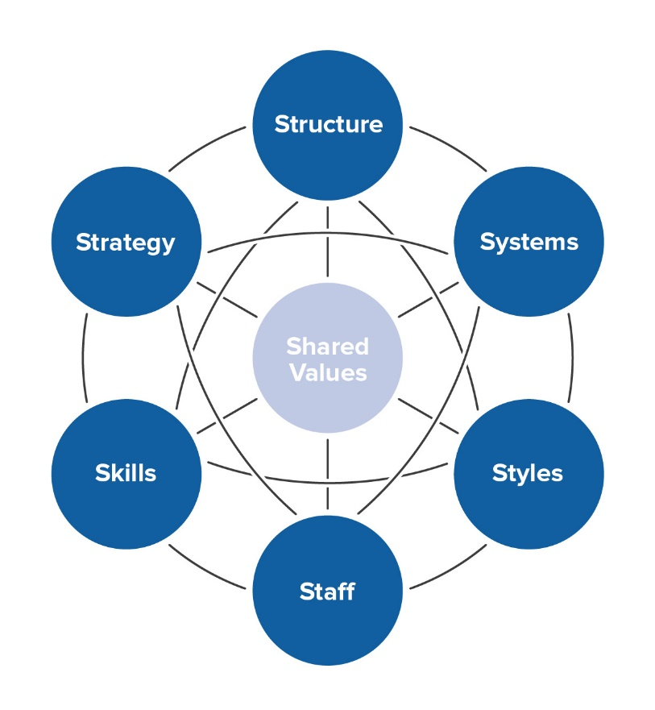
(Peters, 2011)
Strategy
A clear strategy is outlined in the strategic plan 2022-2027, this is through the vision, mission and values. How to achieve the strategy is communicated through the annual business improvement plan 2023-24. It is clearly communicated to all staff ensuring that everyone is on the same level. The organisation is very reactive in responding to change, Michael Porter had a view that “The essence of strategy is choosing what not to do” (The McKinsey 7s model explained with a practical example, 2021).
Structure
The fire service operates a hierarchical structure, operational staff are denoted by rank from Firefighter to Chief Fire Officer. There is structure within non-operational roles through a grading system. Departments are structured through four main directorates: emergency response training delivery, organisational risk, resources and community risk reduction. A recent restructure of directorates has taken place to allow better communication between key departments and improve decision making.
Systems
Many systems are used throughout the organisation, from mobilising systems, training record management, HR management, Operational learning systems and others. Some systems have failed at implementation in recent years and have been costly to the organisation, partly down to the recruitment and retention issues within ICT.
The financial management framework and financial plan poses some risk, there is a risk that some of the key indicators used for financial planning are incorrect:

Key indicators | Resulting in:
Pay Awards | Funding shortfall from local authorities
Inflation Factor | Adverse impact on service delivery
Budget Pressures | Budget overspend
Service Demands | Unaffordable capital plans
Capital Finance Costs | Inflation risking higher than budgeted
Grants

The service will continue to monitor budgets ensuring risks are mitigated as much as possible. This is done through several key strategic groups, they will manage capital assets, facilities, establishment and will continue to monitor the expenditure ensuring compliance with the service budget guidance and financial procedure rules.
Debriefing of corporate projects would allow the capture and loop closure of organisational learning.
Skills
Skill acquisition – Firefighters must undertake an initial 16-week residential recruits course followed by a 24-month development period.
Maintenance of competence - Programme must be followed ensure compliance across all risk critical and core skills.
Specialist skills – Such as rope rescue and water rescue have additional training requirements with professional body – with Continuous Professional Development (CDP) attached.
Staff
There are 1351 members of staff across the organisation, made up of wholetime firefighters, on-call firefighters, control staff and support staff. Succession planning against the retirement profile needs to be considered for continuity. Those due to retire or leave the organisation, can give one month notice, whereas recruitment takes approximately 12 months from application phase to completion of initial training. This can result in organisations relying heavily on overtime to keep appliances available for operational duty. Organisations are only as good as their people, they are what make the cogs turn, we should listen to them, nurture talent, and celebrate success (Branson, 2014).
The introduction of a new agile working policy has assisted with the recruitment and retention of staff, allowing staff to work agile to support a healthy work-life balance, whist maintaining mentorship and talent identification across the organisation.
Styles
The management style throughout the organisation is democratic, decisions are shared to ensure the best possible solutions and to build relationships between management and employees. This is further exaggerated through the public consultation “have your say” campaign, listening to what the people want and expect from the service. The service actively recognises hard work and holds annual celebration of success evening.
Shared Values
The core values of the organisation are to “do the right thing”, “perform with excellence” and “treat people with respect” (Thomas, 2022). These values are filtered through every part of the organisation. Mid and West Wales Fire Service is centred around a positive culture, an external cultural survey commissioned for early 2023. Peter Drucker had a view that “Culture eats strategy for breakfast” (Drucker P, 2016).

Conclusion
As Mid and West Wales Fire and Rescue Service is a public sector, not for profit organisation, there is less focus on competitive advantage. Even though the three fire and rescue services in Wales collaborate in many areas, there is a still competition on providing the best service in Wales.
The SWOT analysis has outlined the strengths, weaknesses, opportunities and threats of the organisation. The service has been pro-active in its response to the London Fire Brigade published cultural report, by commissioning an external review to be undertaken almost immediately. The Chief Fire Officer has staff health, safety, welfare and well-being his top priority, along with the organisations culture. Reputation and branding are held in high regard and the Chief would not want this to be tarnished.
The on-call availability is a weakness that is starting to impact business as usual, this has been in slow decline since 2015 but rapidly accelerated since the Covid-19 pandemic. The changes in people’s lifestyles with more emphasis on work-life balance is making it harder to recruit and retain, ultimately giving the communities a lesser response.
The opportunity to explore into medical response would help alleviate some of the current pressures on WAST, response times are at an all-time low and there is potential scope for the fire service to assist. This could provide Welsh Government with an opportunity to broaden the role and negotiate better pay for firefighters. Firefighters are already trained to a high level in immediate care so this could be implemented swiftly and, with less demand on core activities this could see partial diversification of the organisation.
The looming industrial action is the biggest concern at present, with most firefighters’ members of the of Fire Brigades Union, ballot papers are due to be issued after members rejected the proposed pay offer. Unless the employers can make an improved offer before striking, the service must prepare as best it can for unknown periods without highly skilled firefighters. This is going to have a big impact on the communities in which we serve with a skeleton response at strategic locations.
The PESTEL analysis analyses the macro-economic environment, used alongside the SWOT analysis and McKinsey 7S model. Whist there are threats and challenges, the organisation is well-equipped to deal with these. The continuous horizon scanning has allowed the service to lead the narrative and stay ahead of the curve. Economic factors have had the biggest impact on the organisation with long delays and financial increases on the fleet. The early procurement of vehicles a year in advance has eased pressures, however long waits are still present and costly extended leases are still occurring. Rising fuel costs are of concern, energy purchased in advance is price capped however the renewal rate is likely to see significant increase. members of the public could face rising council tax as the fire service looks to increase the levy from the Fire Authority.
The McKinsey 7S Framework looks at the 7 elements to improve communication problems, organisational excellence and build interpersonal relationships. It evaluates the micro-environment with a focus on the organisational structure. These focus on three hard skill areas and four soft skill areas. It is evident that the organisation is well placed amongst those elements. The 7S need to be aligned and work in harmony with each other, A clear cut strategy communicated to all coupled with a democratic leadership style prevalent throughout the organisation. Software systems are adequate but have room for improvement. The ICT department has endured staffing challenges with some job adverts being open ended due to lack of interest, this has led to some instability and difficulties to introduce and implement new software. A staffing review on grading may plug the gap on salaries between the public and private sector.
Attention must be paid to the financial management framework; rising costs are going to squeeze budgets more than the anticipated 4% inflation for 2022-23. The first phase of securing a 13% increase in the budget has been approved by the Fire Authority, this is essential to cover rising costs and continue to deliver excellent service.
Recommendations
Mid and West Wales FRS needs to continue its focus on the macro environment, the focus over the short term needs to be on the preparedness of potential industrial action. Establishing strategic locations based on operational risks with a view to contact former operational employees, who have left within the last four years to gauge appetite to cover these periods for an agreed payment. There could be a risk of damaging the culture and relationship between employees and management in taking this course, so care must be taken and clearly communicated to all. Strike action is likely to be of high impact to both the organisation and members of the public.
Securing a 13% increase as requested on the service budget should remain a priority, which will provide stability to deal with rising costs from the macro environment and assist with strategy.
Review of the on-call section is also a priority, a review of the contractual hours, pay structure and training to safeguard the future of these firefighters, which the service heavily relies upon. The Community Risk Management Plan (CRMP) will assist with this, ensuring resources are strategically placed to provide the best possible response, crewing models fit the needs of the organisation and training hours are achievable and sufficient.
Seek opportunities for diversification into Emergency Medical Response (EMR) to support WAST whilst safeguarding the future for firefighters in Wales. An agreement would need to be reached between first responders, Welsh Government and trade unions to implement.
Opportunities for collaboration with other public sector bodies in Wales to secure better rates for energy. Current energy is purchased in advanced at a fixed rate and buying in bulk could bring lower costs to all parties.
Strategies need to remain focused on the environmental challenges of achieving a net carbon zero by 2030. The growing demand for renewable energy could bring opportunities to generate income from generated energy across the 58 locations, whilst offsetting this against rising energy costs.
Review of the pay grading structure of the ICT department to better align salaries against the private sector. This may reduce the high turnover of staff this area of the organisation has seen over the last 3 years. Staff recruitment and retention of this department has been extremely challenging, leading to instability, slow product development and failed implementation of projects.

Bibliography
About cyber essentials (2022) NCSC. Available at: https://www.ncsc.gov.uk/cyberessentials/overview
(Accessed: December 7, 2022).
Afzal, N. (2022) Independent Culture Review, London Fire Brigade. Available at: https://www.london-fire.gov.uk/about-us/independent-culture-review/
(Accessed: December 1, 2022).
Alshaher, A.A.F., 2013. The McKinsey 7S model framework for e-learning system readiness assessment. International Journal of Advances in Engineering & Technology, 6(5), p.1948. Available at: Alshaher-libre.pdf (d1wqtxts1xzle7.cloudfront.net)
(Accessed: December 3, 2022).
Andrews, K. (2022) Jeremy Hunt takes the tax burden to post-war high, The Spectator. Available at: https://www.spectator.co.uk/article/jeremy-hunts-austere-autumn-statement/
(Accessed: December 6, 2022).
Branson, H. (2014) An organisation is only as strong as its people..., LinkedIn. Available at: https://www.linkedin.com/pulse/20141204101307-369575369-an-organisation-is-only-as-strong-as-its-people#:~:text=An%20organisation%20is%20only%20as%20strong%20as%20its,at%20Virgin%20Published%20Dec%204%2C%202014%20%2B%20Follow
(Accessed: December 3, 2022).
Burkacky, O. et al. (2022) Semiconductor shortage: How the automotive industry can succeed, McKinsey & Company. McKinsey & Company. Available at: https://www.mckinsey.com/industries/semiconductors/our-insights/semiconductor-shortage-how-the-automotive-industry-can-succeed
(Accessed: November 26, 2022).
Business Risk Register Decision Log (2022) Mid and west Wales Fire Service. Available at: https://midwestwalesfire.moderngov.co.uk/documents/s864/6.%20APPENDIX_2_Risk_Register_Risk%20Assessment%20Matrix.pdf
(Accessed: December 8, 2022).
Carpenter, M.A. and Sanders, W.G. (2007) Strategic management: A Dynamic Perspective, concepts and cases/ Mason A. Carpenter and Wm. Gerard Sanders. second. Upper Saddle River, NJ., New Jersey: Pearson Prentice Hall. P.32
Channon, D.F. and Caldart, A.A., 2015. McKinsey 7S model. Wiley encyclopedia of management, pp.1-1. Available at: McKinsey_7S_model20190814-24867-1nc2oau-libre.pdf (d1wqtxts1xzle7.cloudfront.net)
(Accessed: November 22, 2022)
Drucker, P., 2016. Culture eats strategy for breakfast. Doesn’t it. Available at: PowerPoint Presentation (healthandsafetyindex.com.au)
(Accessed: November 30, 2022)
Peters, T. and Waterman Jr, R.H., 2011. McKinsey 7-S model. Leadership Excellence, 28(10), p.2011. Available at: LE 1110 (futurefocuscoaching.org)
(Accessed: December 6, 2022).
Graham, A. (2022) Energy bills rise to record-high levels as price cap lifted, The Independent. Independent Digital News and Media. Available at: https://www.independent.co.uk/news/uk/home-news/energy-bills-price-cap-today-b2187877.html
(Accessed: December 10, 2022).
Hill, T. and Westbrook, R. (1997) SWOT analysis - time for a product recall: Reuters events: Pharma, SWOT analysis - time for a product recall | Reuters Events | Pharma. Available at: SWOT analysis: It's time for a product recall - ScienceDirect
(Accessed: November 28, 2022).
Heubel, M. (2022) Pestle analysis: The macro-environmental analysis explained, Consulterce. Available at: https://consulterce.com/pestle-analysis/
(Accessed: December 3, 2022).
Johnson, G., Scholes, K. and Whittington, R. (2008) Exploring corporate strategy. Pearson Education UK. P.3
Mawwfire (2022) About Us, Mid and West Wales Fire and Rescue Service. Available at: https://www.mawwfire.gov.uk/eng/about-us/
[Accessed: November 22, 2022].
Mcgrath, D. (2022) Jeremy Hunt warned no 'fat' to cut from public service as he sets out spending plans, The Independent. Independent Digital News and Media. Available at: https://www.independent.co.uk/business/jeremy-hunt-budget-spending-cuts-b2204181.html
(Accessed: December 6, 2022).
Ministry of Defence (2016) 2015 to 2020 government policy: Military aid to the civil authorities for activities in the UK (2016) GOV.UK. Available at: https://www.gov.uk/government/publications/2015-to-2020-government-policy-military-aid-to-the-civil-authorities-for-activities-in-the-uk/2015-to-2020-government-policy-military-aid-to-the-civil-authorities-for-activities-in-the-uk
(Accessed: December 12, 2022).
Mintzberg, H. (1978) ‘Patterns in Strategy Formation’, Management science, 24(9), pp. 934–948. Available at: https://doi.org/10.1287/mnsc.24.9.934.
[Accessed: November 18, 2022]
Mintzberg, H. (1987). The Strategy Concept I: Five Ps for Strategy. California Management Review, 30(1), 11–24. https://doi.org/10.2307/41165263
(Accessed: December 6, 2022).
Mintzberg, H., 1987. Crafting strategy (pp. 71-90). Boston, MA: Harvard Business School Press. Available at: Crafting Strategy.pdf (ximb.ac.in)
[Accessed November 28, 2022]
Mullins, L.J. (2009) Management and organisational behaviour. Eighth. Harlow, UK: Financial Times Prentice Hall. P.541
Net zero carbon status by 2030 - Welsh Government (2021) gov.wales. Available at: https://gov.wales/sites/default/files/publications/2021-07/a-route-map-for-decarbonisation-across-the-welsh-public-sector.pdf
(Accessed: December 7, 2022).
Nickols, F. (2016) Strategy, Strategic Management, strategic planning and strategic thinking - nickols, Nickols.us. Available at: https://nickols.us/~nickols1/strategy_etc.pdf
(Accessed: November 28, 2022).
Porter, M.E., 1996. What is strategy?. Available at: https://www.uniba.it/it/docenti/somma-ernesto/whatisstrategy_porter_96.pdf
[Accessed: November 19, 2022]
Sadler, P. (2003) Strategic management MBA masterclass. second. London, UK: Kogan Page. P.23
Scourfield, A. (2022) Rural Fire Service unsustainable, says mid and West Wales chief, BBC News. BBC. Available at: https://www.bbc.co.uk/news/uk-wales-63821353
(Accessed: December 6, 2022).
Sheridan, R. and Mercer, K. (2022) London fire brigade institutionally misogynist and racist - report, BBC News. BBC. Available at: https://www.bbc.co.uk/news/uk-england-london-63749444
(Accessed: December 7, 2022).
Singh, A., 2013. A Study of Role of McKinsey's 7S Framework in Achieving Organizational Excellence. Organization Development Journal, 31(3), pp. 39-50.
Sky News (2022) Blaze after man Burns Timber to heat home sparks fears energy prices causing surge in fires, Sky News. Sky. Available at: https://news.sky.com/story/blaze-after-man-burns-timber-to-heat-home-sparks-fears-energy-prices-causing-surge-in-fires-12609134
(Accessed: December 9, 2022).
Sutherland, W.J. and Woodroof, H.J. (2009) The need for environmental horizon scanning, Trends in Ecology & Evolution. Elsevier Current Trends. Available at: https://www.sciencedirect.com/science/article/pii/S0169534709001888?casa_token=2KZqwOWpxDQAAAAA%3Atm78EE043-ivNbCUmz1vRl6mYALnZZfGoPaW8L0-PcyZe1DbA0lUQNnG3bXScB2GOpBihXYom2c
(Accessed: December 1, 2022).
Teoli D, Sanvictores T, An J. 2019 SWOT Analysis. In: StatPearls. StatPearls Publishing, Treasure Island (FL); Available at: SWOT Analysis - Abstract - Europe PMC
(accessed: November 18, 2022)
The McKinsey 7s model explained with a practical example (2021) Consultport. Available at: https://consultport.com/consulting-academy/the-mckinsey-7s-model-explained-with-a-practical-example/#:~:text=%E2%80%9CThe%20essence%20of%20strategy%20is%20choosing%20what%20not,A%20Real-Life%20Example%20of%20the%20McKinsey%207S%20Model
(Accessed: December 7, 2022).
Thomas, R., 2022. Strategic Plan [accessed online]. Available at:
Strategic Plan 2022 - 2027 - Mid and West Wales Fire and Rescue Service (mawwfire.gov.uk) [accessed: November 20, 2022]
Thomas, R. (2022) Annual business improvement plan 2022/2023, Mid and West Wales Fire and Rescue Service. Available at: https://www.mawwfire.gov.uk/eng/about-us/our-plans-and-performance/annual-business-improvement-plan-20222023/
(Accessed: November 28, 2022).
Wales News Online (2022) Medical Co-responder champion presented with chief fire officer commendation award, Wales News Online. Available at: https://walesnewsonline.com/medical-co-responder-champion-presented-with-chief-fire-officer-commendation-award/#:~:text=For%20many%20years%2C%20Mid%20and%20West%20Wales%20Fire,was%20introduced%20in%201998%20at%20Reynoldston%20Fire%20Station. (Accessed: December 6, 2022).
Well-being of Future generations (wales) act 2015 (2015) GOV.WALES. Available at: https://gov.wales/well-being-future-generations-act-essentials-html
(Accessed: December 7, 2022).
Welsh Parliament (2022) Plenary 22/11/2022, Welsh Parliament. Available at: https://record.senedd.wales/Plenary/13047#A75972
(Accessed: December 4, 2022).
Wrack, M. (2022) Fair pay or fire strike, Fire Brigades Union. Available at: https://www.fbu.org.uk/campaigns/fair-pay-or-fire-strike
(Accessed: November 29, 2022).

