Introduction.
This chapter presents the analysis of primary data collected by means discussed in the methodology section, using both quantitative and qualitative collection of data. The survey was answered by 25 serving Police Officers. Hartley (2001) concludes that by academic researchers using participants in an organisation to answer surveys that a greater “understanding of the organisational context” can be drawn. The survey link was posted on an open intranet to all current South Wales Police employees and the option to participate was an independent choice. The reason for the survey was set out prior to the link along with the explanation that it was 100% confidential, the survey chose not to ascertain any identifiable details. Data collected was simply the answers, due to the sensitive nature of the topic additionally it offered participants the opportunity to be open without retribution. Furthermore, this chapter will explore themes identified from the data which directly link to the three objectives set out in the research proposal:
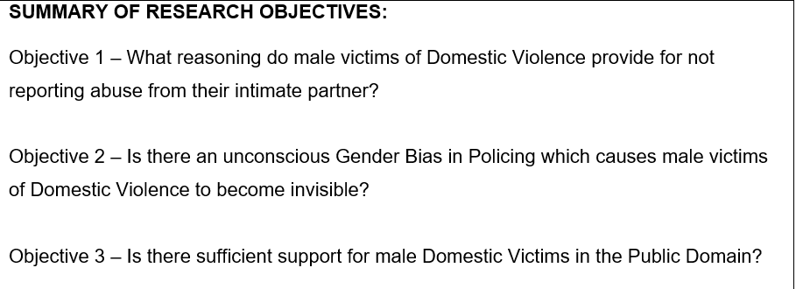
Figure 5.0: Research Objectives set out in the research proposal.

Appendix will include a blank copy of the questions and answer options that were lay out in the survey.

Theme 1: Domestic Violence Support for Male Victims.
Of the participants, 80% stated that they had previously dealt with domestic violence victims who were male gendered and the remaining 20% had not. When asked if they received enough training on dealing with male victims in comparison to female, 64% stated they did not, 24% did and 12% feeling there was an equal training for both genders. Lastly, the final question covering this theme was if the officers felt they had sufficient information to pass on to those male victims. Responses for this set out in question 2 are shown in the graph below, figure 5.1:
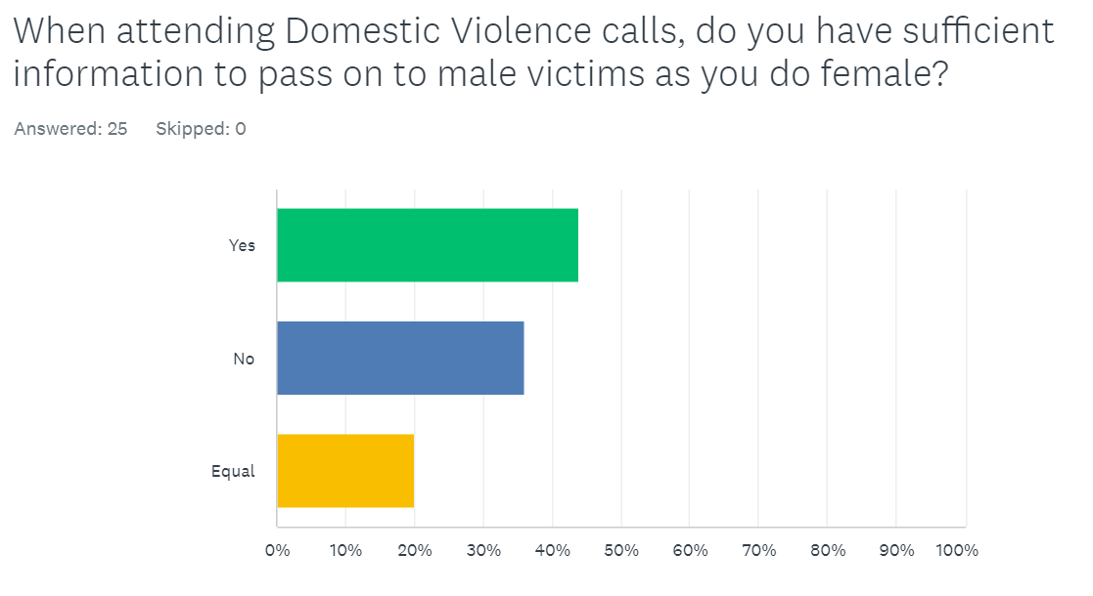
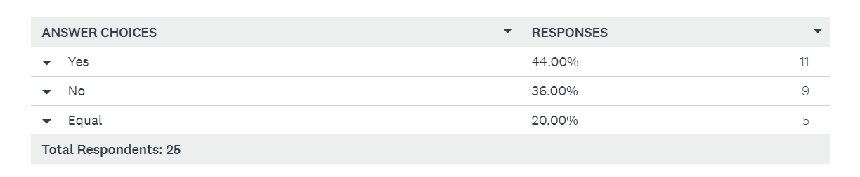Figure 5.1 – Table and graph showing survey participant responses to Question 2.

Reflecting on the data collected, more than half of the participants felt that they did not receive adequate training for assisting male victims of domestic violence as opposed to female. However, they had sufficient knowledge and access to public support information to pass onto those male victims with 64% answering that male targeted support exists for victims. This is supported by the literature provided by the Live Fear Free webpage that all victims of any gender can access their assistance, even though its female targeted on its website, officers should receive training around the charity and hold the knowledge that any gender can use their service. 36% believed that there is not enough information for men, and this may be due to the heavy advertisement for female victims even when support available is for both. From literature, specifically in research conducted solely on support for male DV victims, McCarrick et al (2015) and Huntley et al (2019) discuss this issue of front ended female victim support and the need for more male only support services with enhanced advertisement in addition. It is possible that participants answered in this way due to some having more knowledge of the local services than others.

Theme 2: Existence of Bias on Female to Male DV Victims in Policing.
There was use of qualitative and quantitative data collection surrounding this theme. Two questions were posed in the survey, the first shown in figure 5.2, was a closed response question. As seen in figure 5.2, 56% of participants believe there remains a bias in policing on female to male domestic violence. Furthermore, 12% decided not to provide a response to the question. There is no literature to provide an explanation for the participants choice in declining to answer. Therefore, it could only be an assumption that they either agreed with an existence of bias but did not wish for this to be voiced or did not feel confident in formulating an answer altogether.

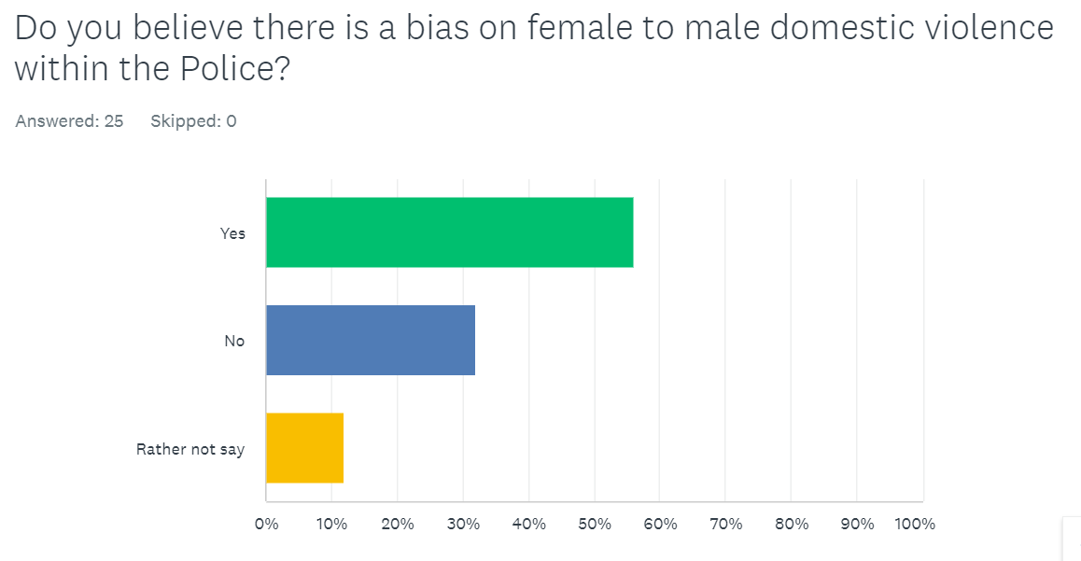
Figure 5.2: Graph of responses from participants to Question 5.

The data is supportive of the conclusion founded by Grady (2002) where there is a consensus that only females can be victims of domestic violence. Drijber et al (2012) and Hines and Douglas (2009) support Grady’s earlier work where male participants explained that police did not take their report of Domestic Violence seriously which has the adverse effect for future reporting. Participants then were asked the question:
“If bias does exist against male victims of domestic abuse, what reasons do you believe there may be for this?”
The question sought for an explanation in an open format. Participants responded similarly with the main discussion being that victims are predominantly female which coincides with the data provided by the Office for National Statistics (2020) (Wales, 2020) which state across England and Wales, 7.6% of DV victims are female and 3.6% male.


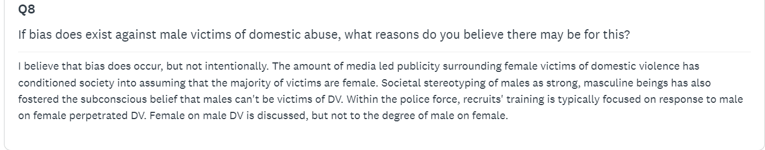
Figure 5.3: Participant number 13’s answer to Question 8.
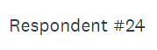
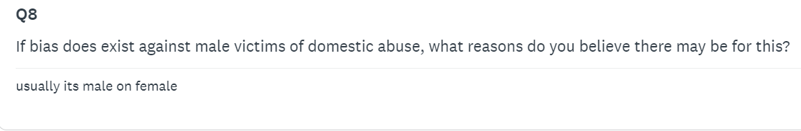
Figure 5.4: Participant number 24’s answer to Question 8.

Theme 3: Underreporting from Male Victims.
To gather data and knowledge from officers, they were offered to formulate answers again in an open format to answer question 7 which asked:
“In your opinion, why would a male victim of female perpetrated Domestic
Violence be deterred from reporting to the Police?”
Participants answered in correlation with repetitive statements and phrases for their explanation. As a result, a word blast diagram was formulated to show these responses as seen in figure 4 below:
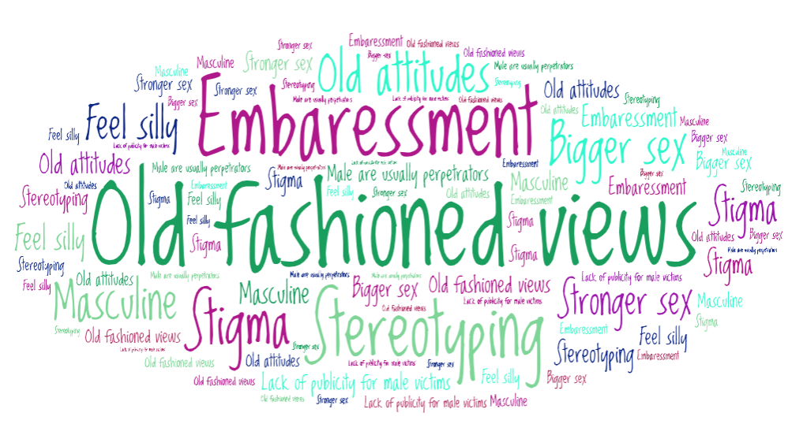
Comparing with the research literature on male victims underreporting, the data collected by participants mirrored the research presented by Huntley et al (2019) and Xu H, (2019). All authors in aggreeance that male victims experience issues of demasculinity and embaressment due to the stigma that male are percieved as the stronger sex compared with the female model. Furthermore, partipants made comment to “old views” which draws compariosn to the work of Ronald F. Levant (1992) and how the role of a traditional male is viewed in society as being both mentally and physically strong.

Conclusion.
Objectives raised in the earlier chapter of the research aims within this essay were matched with themes found from the methodology and findings from the data accompanied in it. Views upheld from the research studied as far back as 1992 were still discussed by participants in this survey response in 2024. It also concludes that bias remains present in the view of male victims of DV and with some rejecting to comment shows that this is still a taboo subject. Current and previous studies maintain that there is still more to do om supporting male victims, as it is conclusive that there are indeed male victims of DV in our society.
Word Count: 1091

Bibliography
Crime survey for England and Wales (2020, November 25th). Office for National Statistics. Domestic abuse victim characteristics, England and Wales: year ending March 2020. Retrieved from:
Domestic abuse victim characteristics, England and Wales - Office for National Statistics (ons.gov.uk)
Accessed on: 3rd October 2024.
Drijber, B.C., Reijnders, U.J.L. & Ceelen, M. (2013) Male Victims of Domestic Violence, (28), 173–178.
Henger, B & Henger, J (2012) The Silent Generation 1925-1945. AuthorHouse, (1) 1-4
Hines, D. A., & Douglas, E. M. (2009). Women’s use of intimate partner violence against men: Prevalence, implications, and consequences. Journal of Aggression, Maltreatment & Trauma, 18(6), 572–586.
Government, W. (2024). Providing help and advice about violence against women, domestic abuse and sexual violence. Retrieved from Live Fear Free: https://www.gov.wales/live-fear-free:
Accessed: 3rd October 2024

Grady, A. (2002). Femaleon-Male Domestiic Violence: Uncommon or ignored? In C. H. Young, New Visions of Crime Victims (pp. 71-95). Portland Oregon: Hart Publishing.

HARTLEY, J., (2001). Employee surveys: Strategic aid or hand-grenade for organisational and cultural change? The International Journal of Public Sector Management, 14(3), 184-204.

Huntley AL, Potter L, Williamson E, et a.l (2019). Help-seeking by male victims of domestic violence and abuse (DVA): a systematic review and qualitative evidence synthesis. BMJ Open. 9(6), 1-13.

Levant, R. F. (1992). Toward the reconstruction of masculinity. Journal of Family Psychology, 379-402.

McCarrick, J.A., Davis-McCabe, C. & Hirst-Winthrop, S. (2015). Men's experiences of the UK Criminal Justice System following female-perpetrated intimate partner violence. Journal of Family Violence, 31(1).

Xu H, Z. W.-J. (2019). The Cinderella Complex: Word embeddings reveal gender stereotypes in movies and books. PLoS ONE.

