MODULE CODE: ECAD4015

STUDENT NAME: Lowri Jones

STUDENT NUMBER: 2400771

AI Acknowledgement

I confirm that I have not used any AI tools in the research and creation of this assignment.
I confirm that I have not presented any AI generated materials as my own work.
I confirm that I have copies of my drafts, notes, and other resources I used, which I may be asked to provide in evidence.

Targets from my previous assignment

Target | How I have addressed it in this work
Some minor typos. It would be beneficial to run a spell check before submission to catch any remaining errors. | Throughout my assignment I have proofread and reread my work to identify and correct any spelling or typographical errors.
Some of your ideas are backed by stronger evidence than others. Aim to be consistent in your approach across the whole assignment. | I have reviewed my assignment to ensure that my ideas are supported with relevant evidence. Strengthening areas where the evidence was weaker by incorporating additional sources and ensuring a balanced approach throughout.
Ensure you are using the latest edition of the Harvard referencing guidelines. | I have ensured that my work adheres to the most recent Harvard referencing guidelines by consulting the latest edition of the Harvard referencing handbook.
Create a community profile for your PTE1 school. Using relevant literature, suggest ways in which the school could make use of its location and community to support pupil learning.

Cross-curricular learning (CCL) is an educational approach that integrates multiple subjects to provide pupils with a holistic, interconnected understanding of knowledge (Barnes, 2015). This method moves beyond isolated subject teaching, encouraging learners to draw connections between different disciplines, thereby fostering a more comprehensive grasp of complex concepts and real-world issues as mentioned by Bechman (Beckmann, 2009).
The significance of CCL in education is vitally important, particularly in cultivating deeper skills and understanding among pupils. Engaging with interconnected subject matter, pupils develop critical thinking, creativity, and problem-solving abilities (Johnson, 2013). This approach mirrors real-life scenarios where challenges are multifaceted and require knowledge from various fields to devise effective solutions. Moreover, CCL promotes the pupils' engagement and motivation by demonstrating the relevance of their studies to everyday life, making learning meaningful and applicable (Sphero, 2021).
In the context of the Curriculum for Wales (CFW), CCL is pivotal in achieving the four purposes outlined as the foundation of the educational framework (Welsh Government, 2022). Them being Ambitious, capable learners, Enterprising, creative contributors, Ethical, informed citizens and Healthy, confident individuals.
The writer understands that CCL supports these four purposes, enabling the pupils to apply knowledge and skills across various contexts, fostering adaptability and resilience. For instance, integrating history and literacy through storytelling not only enhances understanding of historical events but also develops communication skills, thereby contributing to the formation of enterprising and creative contributors (STEM Sports, 2020).
The opportunities presented by CCL are manifold. The writer understands that it allows pupils to make meaningful connections between subjects, enhancing their overall comprehension and retention of information (Barnes, 2015). This method encourages active engagement, as learners see the relevance of their education in real-world contexts, thereby increasing motivation (Johnson, 2013). Additionally, cross-curricular (CC) approaches, support the development of transferable skills such as critical thinking, creativity and problem-solving. For example, floating and sinking activity (see appendix) allows pupils to investigate scientific concepts related to buoyancy while applying mathematical skills in measuring and recording data. This type of activity demonstrates how CCL enhances understanding by linking science, mathematics, and problem-solving in a hands-on context.
However, the writer understands implementing CCL presents challenges. Planning and assessment can be complex, as educators must design cohesive lessons that effectively integrate multiple subjects while meeting curriculum standards (Beckmann, 2009). Ensuring depth in each subject area is crucial to avoid superficial connections that do not enhance learning outcomes. There may also be resistance from educators due to time constraints or a lack of training in interdisciplinary teaching methods as mentioned by Sphero (Sphero, 2021). Successful CCL necessitates strong collaboration among teachers from different disciplines, requiring time and institutional support to develop and implement integrated curricula effectively (STEM Sports, 2020).
The theoretical underpinnings of CCL align with constructivist theories of education, which the writer is aware emphasises the role of learners in actively constructing their own understanding through experience and reflection. Piaget’s theory of cognitive development suggests that learners build knowledge through interactions with their environment, implying that interdisciplinary approaches can provide the diverse contexts necessary for such interactions (Simply Psychology, 2024). Lev Vygotsky’s social constructivism further supports this by highlighting the importance of social interaction and collaboration in learning, elements inherent in CC projects that require cooperative problem-solving and communication (Simply Psychology, 2024).
The writer knows the Literacy, Numeracy, and Digital Competence Framework (LNDCF) is embedded across the CFW, ensuring that these core skills are developed through interdisciplinary approaches rather than isolated subjects (Welsh Government, 2022). The LNDCF follows progression steps, allowing the learners to develop at their own pace while achieving key milestones, providing a structured yet flexible approach to learning, ensuring that children in the foundation phase focus on experiential, play-based learning before transitioning into key stage, where formal subject knowledge deepens. For instance, early literacy development in foundation phase may involve storytelling, phonics, and mark-making, while Key Stage 2 learners engage in structured writing tasks, reading comprehension, and critical analysis (ESTYN, 2023). Similarly, numeracy begins with concrete, hands-on experiences such as counting and measuring in real-life contexts before advancing to problem-solving, data interpretation, and mathematical reasoning in later stages (Welsh Government, 2022).
Literacy is reinforced across subjects, such as storytelling in history, where pupils enhance their reading and writing skills by engaging with historical narratives and constructing their own accounts. Numeracy is integrated into subjects like science, where pupils apply mathematical concepts during experiments, such as measuring and recording data. Digital competence is developed through creating multimedia projects, such as using tablets to document and present research findings in geography (ESTYN, 2022).
Reports by the Welsh Government and ESTYN highlight that best practices in LNDCF integration include CC projects that incorporate these competencies meaningfully. However, areas for improvement include ensuring equitable access to digital resources and providing teacher training to effectively embed digital competence in classroom activities (Welsh Government, 2022).
CC teaching also provides authentic learning experiences, such as project-based learning, where the pupils apply knowledge from multiple disciplines to solve real-world problems (Beckmann, 2009). This approach aligns with the four purposes by developing skills essential for lifelong learning, such as creativity, problem-solving, and teamwork (Welsh Government, 2022).
Another advantage is the transfer of skills between subjects. For example, sustainability projects integrating science, maths, and geography help pupils see connections between ecological awareness, numerical data interpretation, and geographical contexts, making learning more meaningful and engaging (Johnson, 2013).
Despite its benefits, as mentioned the writer understands that CCL presents challenges, including time constraints for teachers to plan and implement effective interdisciplinary lessons (Barnes, 2015). Another concern is ensuring depth rather than superficial links, where lessons risk becoming too generalised without fostering deep subject understanding (ESTYN, 2022). Additionally, successful CC teaching depends on collaborative planning and adequate teacher training, which can be limited due to institutional constraints (Welsh Government, 2022).
Another significant challenge is accommodating the diverse needs of all the pupils within the allocated time. Teachers must balance differentiation strategies to ensure that pupils of varying abilities remain engaged and progress effectively. This requires additional planning time, which may not always be feasible within a standard teaching schedule as mentioned by Estyn report (ESTYN, 2022).
Furthermore, funding limitations can pose obstacles to CC teaching, particularly in terms of acquiring necessary resources, investing in professional development and ensuring access to digital tools. Schools with lower budgets may struggle to implement interdisciplinary learning effectively, leading to disparities in educational opportunities (Welsh Government, 2023). Additionally, research by Darling-Hammond (2021) highlights that funding inequalities can result in a lack of essential teaching materials and reduced opportunities for collaborative planning.
Moreover, digital competence relies on access to technology, and disparities in resources across schools can hinder pupils' ability to fully engage in digitally integrated lessons as stated by Estyn (ESTYN, 2022). Some teachers may also lack the confidence or training to effectively use digital tools in the classroom, reinforcing the need for sustained professional development (Voogt et al., 2018). Schools could invest in teacher training and equitable access to technology. Additionally, integrating structured reflection activities, such as digital journaling, could enhance literacy development alongside digital competence.
Bridging experiences and enhancement days have provided practical insights into CCL for the writer. Observations of interdisciplinary lessons have demonstrated effective strategies, such as see Appendix linking science and numeracy in experiments like the Pirate Ship Experiments floating and sinking.
One of many examples from the writers significant bridging and enrichment day experiences involved an outdoor learning project, where the pupils explored environmental conservation by integrating science understanding ecosystems, numeracy measuring biodiversity, and literacy by writing reports on their findings. This real-world application of knowledge aligned with Vygotsky’s social constructivism, which emphasises the role of social interaction in learning (McLeod, 2024). Similarly, Bruner’s scaffolding theory supports the idea that structured interdisciplinary activities can enhance deeper understanding by building on prior knowledge (Bruner, 1966).
These experiences highlighted the effectiveness of CCL in boosting engagement, fostering independent inquiry and developing critical thinking skills. However, challenges observed included differentiation in mixed-ability groups and ensured that all pupils remained engaged throughout the activity.
A critical reflection on these experiences suggests that successful CC lessons incorporate clear learning objectives, active engagement, and structured assessment methods. Areas for improvement include providing additional teacher support and training to maximise the effectiveness of interdisciplinary teaching.
The writers enhanced provision, as seen in appendix 1, provides a strong CCL opportunity within the CFW, integrating elements of science, numeracy, literacy, and digital competence. Through hands-on engagement with buoyancy and material properties, pupils develop scientific inquiry skills while incorporating numeracy through measurement and prediction. Literacy is enhanced through discussions and reflection exercises, encouraging pupils to articulate their findings effectively. Additionally, digital competence could be embedded by incorporating tablet-based documentation, where the pupils record their observations and present their findings through simple digital presentations.
However, the writer understands that challenges may arise in ensuring equitable access to resources. The writer's school lack sufficient materials and technology to support digital integration effectively. Additionally, differentiation is necessary to accommodate diverse learning needs, ensuring that all pupils can actively participate regardless of ability level. Time constraints may also limit the depth of discussion and reflection, particularly in larger classrooms with varying levels of understanding.
To enhance the activity, the writers lesson could incorporate a more structured digital component, such as using video recording for peer feedback or creating digital graphs of the results. Further scaffolding, such as providing visual aids and simplified explanations for the pupils, could ensure inclusivity ensuring that they gain a deep and meaningful understanding of scientific concepts.
In conclusion, the LNDCF within the CFW is essential in shaping effective teaching and learning practices by embedding core skills across various subjects, rather than treating them in isolation (Welsh Government, 2022). This framework enhances pupils' ability to apply their knowledge in meaningful, real-world contexts, promoting deeper understanding and skill retention. Literacy development across subjects supports effective communication, critical thinking, and engagement in learning, as seen in activities that integrate storytelling with history or report writing with science (ESTYN, 2023). Numeracy, embedded within scientific investigations and geographical analysis, fosters problem-solving and analytical skills, preparing pupils for practical applications of mathematics beyond the classroom (Johnson, 2013). Meanwhile, digital competence ensures that learners are equipped for an increasingly technological world, reinforcing research skills, creativity, and collaboration through digital tools (Voogt et al., 2018).
The integration of LNDCF in CCL not only enhances skill development but also influences the broader educational landscape, impacting assessment strategies, teaching methodologies, and school-wide policies. CC approaches encourage collaboration among educators, requiring well-structured planning and resource allocation to effectively integrate subjects while meeting curriculum objectives (Barnes, 2015). Additionally, they support inclusive education by offering varied entry points for pupils of diverse abilities and learning styles, thereby promoting equity in educational opportunities (Welsh Government, 2023). Furthermore, CCL aligns with the Four Purposes of the CFW by developing ambitious, capable learners who can think critically and apply knowledge in dynamic ways (Welsh Government, 2022).
During the writer's placement, CCL will significantly influence their instructional strategies by promoting a holistic approach to lesson planning and fostering deeper engagement among pupils. The Professional Standards for Teaching and Leadership (PSL) highlight the importance of fostering a culture of collaboration, innovation, and professional learning, which are integral to implementing interdisciplinary approaches (Welsh Government, 2019). Based on this understanding, the writer will follow the PSL. Using the CFW, the writer will base Their teaching on the four purposes. Helping the pupils to become Ambitious, enterprising ethical and healthy individuals. The writer will also incorporating the Welsh language into lesson planning and delivery is a significant component of teaching within the CFW. Integrating Welsh not only fosters a sense of cultural identity and pride in pupils but also supports the development of their bilingual skills, which can enhance cognitive flexibility and communication abilities. This aligns with the four purposes of the CFW, particularly in fostering ambitious and enterprising individuals who can engage with and contribute to their communities in both Welsh and English.
Moreover, drawing on research-based theory and its practical application within lesson planning can significantly improve the effectiveness of instruction. By grounding teaching strategies in well-established educational theory, such as Vygotsky’s social constructivism or Piaget’s stages of cognitive development, the writer can ensure that lessons are tailored to the developmental needs of the pupils while promoting a deeper understanding of the content. Implementing these theories into practice encourages a more engaging, scaffolded learning environment where pupils can build upon prior knowledge, make connections across subjects, and apply their learning in meaningful ways.
Focusing on these targets can provide a framework for tracking pupil progress in a more holistic way for the writer. This approach allows for clearer identification of developmental milestones, enabling both formative and summative assessments that reflects the pupils' skills and understanding, helping the writer refine instructional practices by continuously evaluating the effectiveness of lesson planning and adapting based on pupil feedback and outcomes. Ultimately, this process not only supports pupils in achieving their potential but will also foster the writer's professional growth as a reflective practitioner, helping them meet the PSL (Welsh Government, 2019).

Reference list:
Barnes, J. (2015) Cross-Curricular Learning 3-14. 3rd edn. London: SAGE Publications.

Beckmann, J. (2009) ‘Interdisciplinary teaching and learning: Implications for curriculum planning and pedagogy’, Educational Review, 61(4), pp. 405-417.

Darling-Hammond, L. (2021) The Flat World and Education: How America's Commitment to Equity Will Determine Our Future. New York: Teachers College Press.

Estyn (2022) Curriculum for Wales: The Journey to 2022. Available at: https://estyn.gov.wales
(Accessed: 24 February 2025).

Estyn (2023) Embedding Cross-Curricular Skills in Primary Schools. Available at: https://estyn.gov.wales (Accessed: 25 February 2025).

Johnson, B. (2013) ‘The Benefits of Interdisciplinary Learning’, Journal of Educational Research, 106(3), pp. 235-248.
Johnson, D. W. (2013). Relevance of Numeracy in Cross-Curricular Teaching. Educational Review, 65(2), 145-159.
Simply Psychology (2024). Vygotsky’s Sociocultural Theory of Cognitive Development. Available at: https://www.simplypsychology.org/vygotsky.html. (Accessed: 27 Febuary 2025).

Simply Psychology (2024). Jerome Bruner’s Theory of Learning and Cognitive Development. Available at: https://www.simplypsychology.org/bruner.html. (Accessed: 27 March 2025).

Simply Psychology (2024). Piaget’s theory and stages of cognitive development. Available at: https://www.simplypsychology.org/piaget.html. (Accessed: 27 March 2025).

Sphero (2021) ‘Engaging Students through Cross-Curricular Learning’, Educational Technology Journal, 18(2), pp. 97-112.

STEM Sports (2020) ‘Interdisciplinary Learning and its Impact on Student Engagement’, STEM Education Review, 15(1), pp. 55-67.

Voogt, J., Erstad, O., Dede, C. and Mishra, P. (2018) ‘Challenges in Integrating Digital Competence in Primary Education’, Computers & Education, 126, pp. 1-10.

Voogt, J., Knezek, G., Cox, M., Knezek, D., & Brummelhuis, A. (2018) Underpinning the Role of Digital Competence in Education. Journal of Educational Technology & Society, 21(3), pp. 15-26. Available at: https://www.jstor.org/stable/26458506 (Accessed: 28 March 2025).
Welsh Government (2019). Professional Standards for Teaching and Leadership. Available at: https://hwb.gov.wales/api/storage/19bc948b-8a3f-41e0-944a-7bf2cadf7d18/professional-standards-for-teaching-and-leadership-interactive-pdf-for-pc.pdf. (Accessed: 26 March 2025).

Welsh Government (2022) Curriculum for Wales: Guidance on Cross-Curricular Learning. https://hwb.gov.wales/curriculum-for-wales (Accessed: 27 February 2025)

Welsh Government (2022) Cross-curricular skills frameworks. Available at: https://hwb.gov.wales/curriculum-for-wales/cross-curricular-skills-frameworks/
(Accessed: 25 February 2025).

Welsh Government (2023) Education Funding and Resource Allocation: Addressing Disparities in Welsh Schools. Available at: https://gov.wales/education-funding-resource-allocation (Accessed: 1 March 2025).
Apendix 1: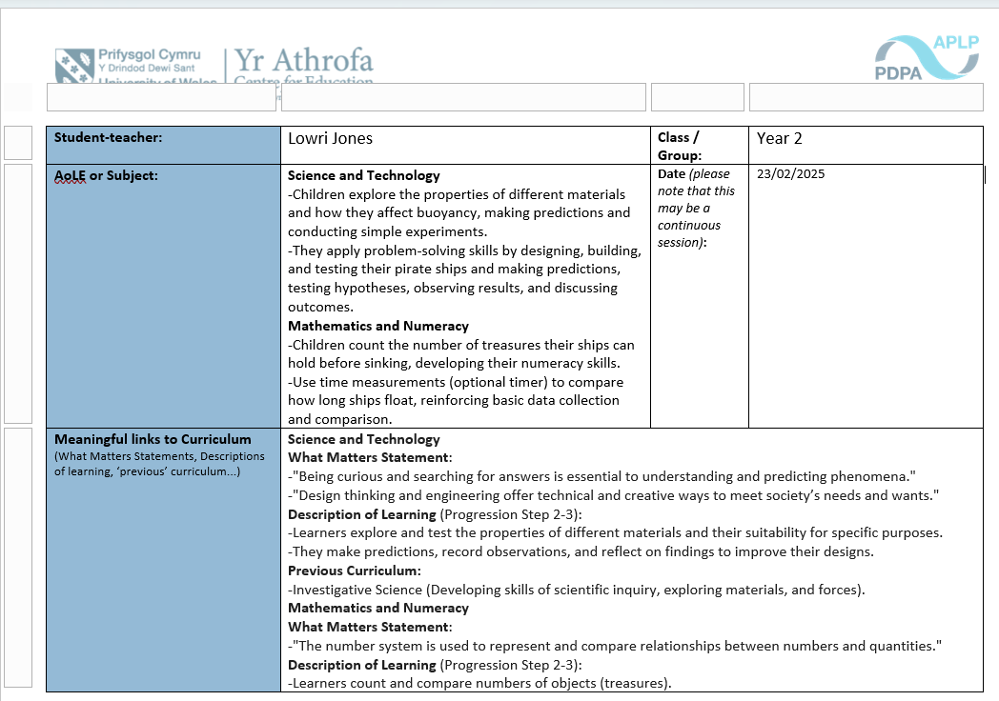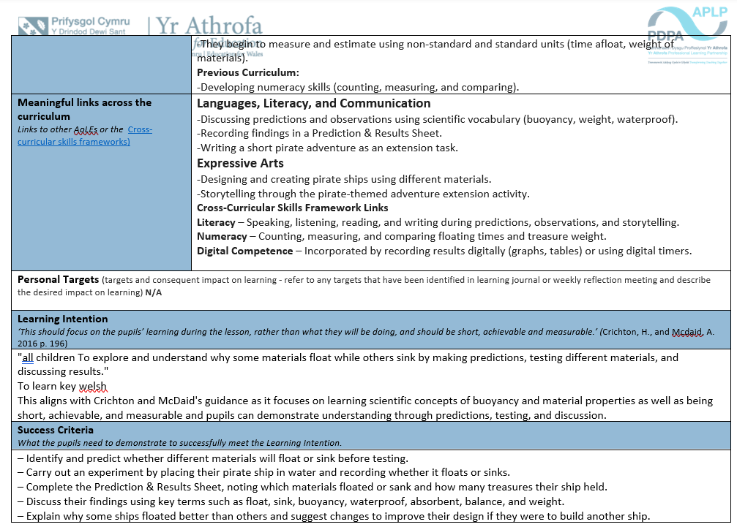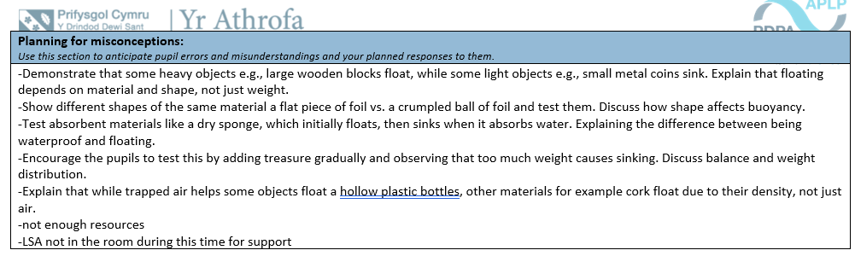
Appendix 2:
Pirate Ship Experiment:
To investigate which materials float and sink by designing and testing a pirate ship. Children will predict, observe, and record their results.
Instructions for Teaching Assistant (TA):
Materials Needed:
-Water tray or large container filled with water Various materials foil, plastic, cork, paper, sponge, cardboard, sticks, straws, etc for the children to create their ship resource.
-Small objects coins, buttons, toy figures to act as "treasure"
-Prediction sheet (see below) Timer optional, to measure how long ships float
Step 1: Introduction (Whole Class – 10 mins) Begin with the book The Pirate Cruncher: “Pirates need a strong ship to carry their treasure! But what happens if the ship is too weak? Will it sink?” Ask children to share what they know about floating and sinking. Show different materials and ask, “Do you think this will float or sink?”
Step 2: Design & Build (Small Groups – 20 mins) Give each child a selection of materials to build their pirate ship. Ask them to fill out the Prediction Sheet before testing their ship. Support them in constructing their ships, thinking about balance and stability implementing basic Welsh like what clours have they used.
Step 3: Testing the Ships (Small Groups – 15 mins) Children place their ships in the water tray one at a time. Observe and record whether the ship floats or sinks. Challenge: How many ‘treasures’ can each ship hold before sinking? Can we count how many it can hold in Welsh un dau tri... encourage discussion: “Why do some ships float better than others?”
Step 4: Reflection & Discussion (Whole Class – 10 mins) Discuss results: Which materials worked best? Why? Introduce key scientific words: buoyancy, balance, weight, waterproof, absorbent. Children can draw or write about their ship and what they learned.

Appendix 3: Resource as well as this resource the children will be creating their boat resource for this activity.


