

Changemakers: Creativity and Value Creation
Professions (BMHP5014)

Component 1: Online portfolio of set exercises

Student name: Zumira Fernando Franco
Student number: 2424773
Lecturer’s name: Layla Surani

Table of contents
Introduction ................................................................................................................ 3
Innovation, Creativity, Value Creation and Change ................................................. 4
Convergent and Divergent Thinking .........................................................................5
Systems Thinking ....................................................................................................... 6
Change Management and the Role of the Change Agent ....................................... 7
Digital Innovation in Health and Social Care ........................................................... 7
Leadership and Collaborative Working .................................................................... 8
Person-Centred Care and Value Creation ................................................................ 8
Reflective Practice (Gibbs’ Reflective Cycle) .......................................................... 9
Conclusion ..................................................................................................................9
Reference List ............................................................................................................10

Introduction

After studying innovation, creativity, value creation, and change, I recognised that these concepts are interconnected and vital for providing high-quality, person-centred care as a Senior Carer. Innovation should not just focus on introducing new ideas, it must enhance outcomes for residents and improve the quality and safety of care. For instance, the implementation of electronic care records has facilitated better communication and minimised documentation errors in my workplace, allowing staff to access accurate information more efficiently (NHS England, 2023). However, there are drawbacks to innovation. Digital systems necessitate sufficient staff training and ongoing technical support, and they may lead to decreased face-to-face interaction if overused. Therefore, it is important that technology supports rather than replaces professional judgment and compassionate care.

Task 1 – Clarifying Important Concepts in Action
After learning about these concepts, I realised they are all connected and important in my role as a Senior Carer.
Creativity plays a vital role as it inspires healthcare providers to tailor solutions for each resident rather than using a one-size-fits-all method. For instance, modifying communication techniques or incorporating music and reminiscence therapy for dementia patients can enhance their engagement and overall wellbeing (Byers, 2017). Regardless, it is essential that creativity is grounded in evidence and adheres to professional standards to maintain the safety and effectiveness of care.
I understand that creating value involves not just cutting costs, but also enhancing the quality of life, dignity, and independence of residents while optimally utilising available resource (Patrício et al., 2020). This has led me to realise that effective healthcare prioritises outcomes that are significant to service users, families, and professionals, rather than merely finishing tasks.
Ultimately, gaining insight into the dynamics of change has underscored the importance of ongoing improvement in health and social care. While changes within organisations may occasionally lead to uncertainty or pushback from staff, strong leadership, clear communication, and adequate training can facilitate successful transitions (Randall, Burnes and Sim, 2018). This understanding has inspired me to be more receptive to innovative practices and to assist my colleagues during times of change.
In summary, this learning experience has shaped my approach as a Senior Carer. Moving forward, I plan to carefully assess new concepts before putting them into practice, advocate for innovation grounded in evidence, promote creative, person-centred methods, and facilitate positive changes that enhance the safety, wellbeing, and independence of residents. This reflective journey has deepened my awareness that effective innovation arises from the integration of critical thinking, teamwork, and compassionate care.
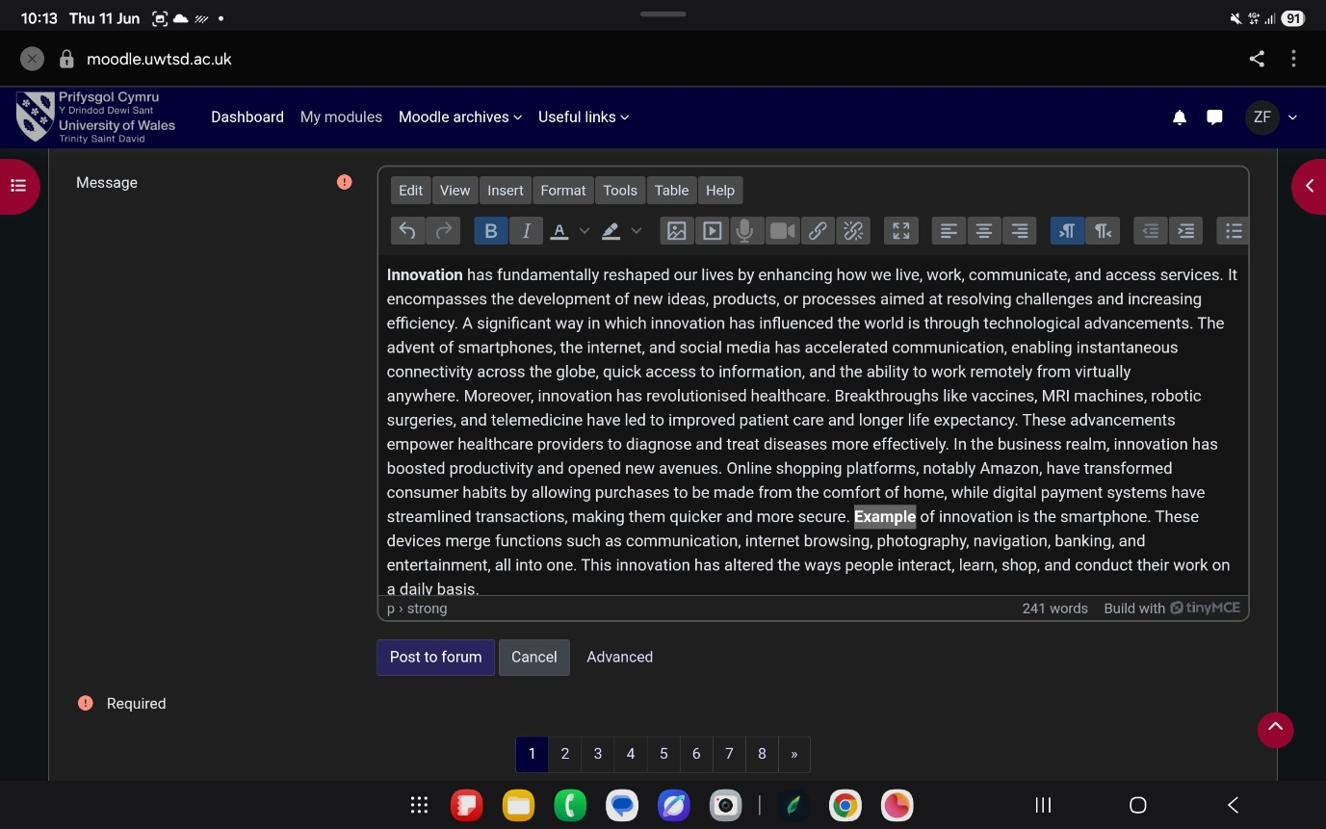

Task 2 - Mind Map

I opted to focus on drug abuse in Kennington for my mind map, as it represents a critical public health concern that impacts individuals, families, and the community at large. Creating the mind map allowed me to grasp the complexity of drug abuse, revealing that it stems from various interconnected issues such as poverty, mental health challenges, unemployment, and peer influence. This indicates that focusing on just one aspect is unlikely to lead to sustainable solutions. While the Systems Thinking Approach offers a comprehensive view of these interrelations and promotes cooperation among multiple agencies, a significant drawback is the difficulty in harmonising different organisations due to their differing priorities, communication styles, and resource availability (Meadows, 2018).

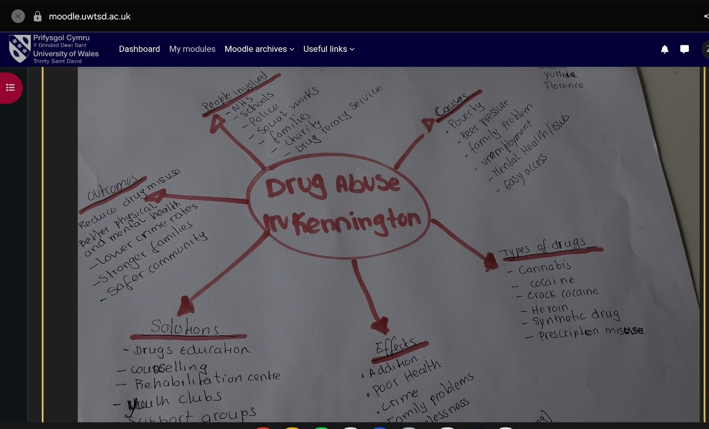
Reflecting on this activity has deepened my comprehension of the significance of person-centred and collaborative care in my position as a Senior Carer. It emphasized that providing effective support involves looking at an individual’s broader social and environmental factors instead of just the issue of substance misuse. This realisation will shape my future practice by motivating me to collaborate more closely with other professionals, acknowledge the various factors impacting people’s health, and take part in coordinated care that enhances health and wellbeing outcomes (NHS England, 2022).

Task 3 - Self-Reflection of Group Activity.

While engaging in the convergent and divergent thinking activity, I came to understand that both methods are vital in my position as a Senior Carer. Divergent thinking helped me come up with a variety of creative ideas to enhance person-centred care, while convergent thinking allowed me to critically assess those ideas and choose the most feasible, safe, and evidence-based option. I realised that, even though divergent thinking fosters innovation, not every idea may be practical or appropriate given the available resources, policies, and regulations in a care environment. Likewise, while convergent thinking aids in effective decision-making, it can stifle creativity if alternative viewpoints are dismissed too quickly (OECD, 2024).

Hearing the perspectives of my group members highlighted the importance of teamwork, as everyone brought unique experiences and viewpoints that enriched our conversation. This exercise emphasized that working together in decision-making typically results in superior outcomes compared to individual efforts. Reflecting this experience has motivated me to embrace a wider range of opinions while keeping decisions focused on the individuals, ensuring they are safe and attainable. In my future practice, I will make a concerted effort to invite quieter team members to voice their thoughts, carefully assess various options before finalising decisions, and foster a collaborative environment that enhances the quality of care for residents (Gibbs, 1988).

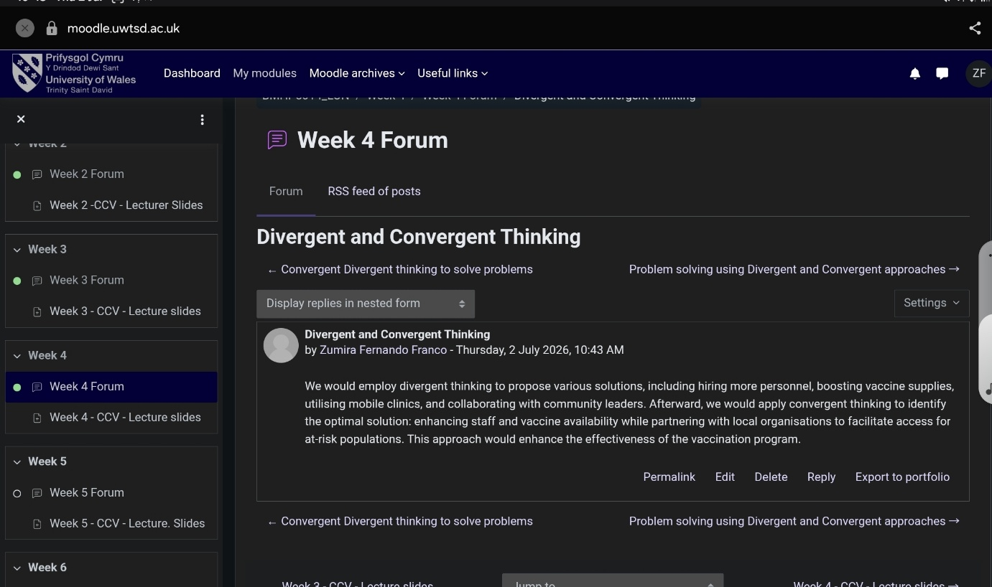

Task 4 – Case Study Analysis of a UK Innovation .

I chose for NHS Virtual Wards because they represent a forward-thinking method of providing health and social care. Initially, I thought virtual care would take the place of in-person services. However, I have since realised that Virtual Wards are intended to enhance traditional care by allowing eligible patients to receive safe, hospital-quality treatment at home, all while being monitored by healthcare professionals An important advantage of this innovation is its ability to promote independence, decrease unnecessary hospital admissions, and enhance the patient experience. Additionally, it allows hospitals to utilise their resources more efficiently by keeping beds available for those with the most urgent clinical needs (NHS England, 2023).

I also acknowledge certain limitations. Virtual Wards may not be appropriate for every patient, especially those with intricate needs, significant cognitive challenges, or restricted access to technology. Furthermore, successful implementation relies on good communication, proper staff training, and robust collaboration between healthcare and social services (NHS England, 2023).

Considering this topic has shifted my perspective on how innovation can enhance care while still preserving the essential human elements of healthcare. As a Senior Carer, this newfound understanding will shape my future practice by motivating me to assist residents who could gain from digital healthcare services, while also acknowledging when in-person care is a better option. Additionally, I will advocate for clear communication with multidisciplinary teams to ensure that innovative methods are implemented safely, suitably, and centred around the individual needs of residents to achieve optimal outcomes (NHS England, 2023).

Task 5 - Research Task

For my research project, I investigated staff stress and burnout, an issue I have noticed in my position as a Senior Carer. This research clarified that burnout is affected by various factors such as high workloads, insufficient staffing, emotional pressures, and inadequate support from the organisation (Galanis et al., 2021). One important takeaway from the research is how significantly burnout impacts staff wellbeing as well as the quality and safety of care delivered to residents. However, I also acknowledge that the reasons for and consequences of burnout can differ across healthcare environments, indicating that organisations require customised strategies instead of a one-size-fits-all approach.

This research has emphasized the necessity of fostering a supportive work environment where employees feel appreciated, heard, and can utilise suitable wellbeing resources. It has also highlighted that prioritising staff wellbeing is crucial for ensuring consistent, person-centred care. This insight will shape my future practice by prompting me to identify early signs of burnout, encourage open communication among the team, support colleagues during challenging times, and help cultivate a positive workplace atmosphere. I believe that these efforts will enhance both staff wellbeing and the quality of care offered to residents.

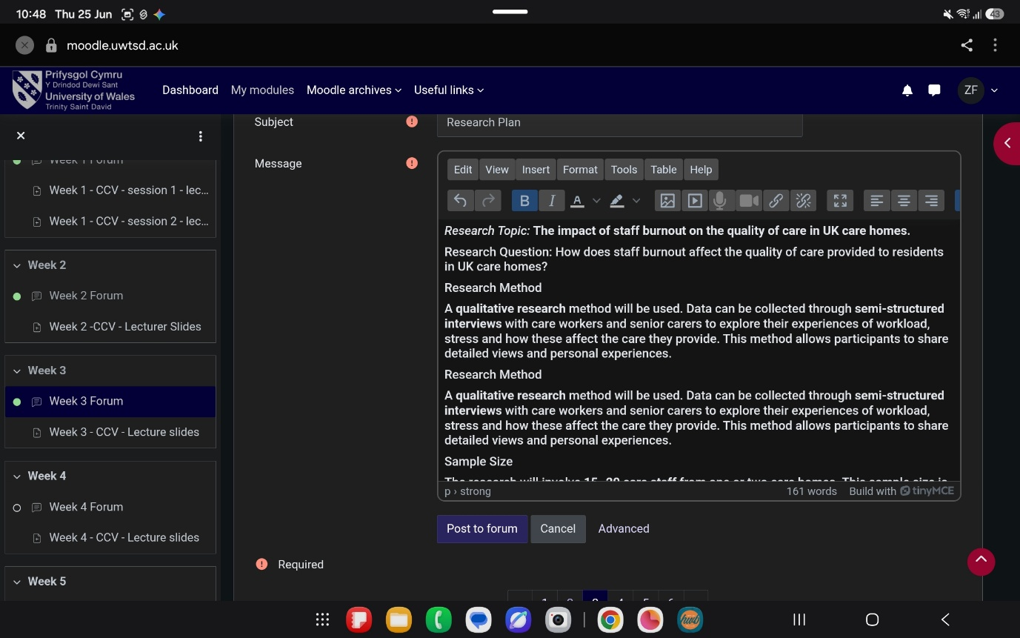

Task 6 - Exploring Digital Innovation in Health and Social Care

This task helped me develop a deeper understanding of how digital technology is transforming health and social care. As a Senior Carer, I use electronic care records daily, and I have seen how they improve communication, reduce documentation errors, and enable healthcare professionals to access accurate information more efficiently. I also learned that technologies such as wearable devices and remote monitoring can support people with long-term conditions to remain independent while reducing unnecessary hospital admissions.
However, I also recognise that digital innovation has limitations. Some service users may have limited digital skills, cognitive impairments, or restricted access to technology, which can reduce its effectiveness. In addition, digital systems rely on staff being adequately trained and maintaining high standards of data security and confidentiality. This highlights that technology should support, rather than replace, professional judgement and person-centred care.
Reflecting on this activity has transformed my view of technology’s role in healthcare. I have come to realise that digital innovation goes beyond just information recording it also enhances communication, aids in prevention, improves decision-making, and allows for more personalised care. This insight will shape my future practice by motivating me to enhance my digital skills, assist both colleagues and residents in confidently utilising technology, and ensure that digital tools are implemented safely, ethically, and in ways that enhance care quality. According to the Technology Acceptance Model, people are more inclined to embrace digital technologies if they find them beneficial and user-friendly (Davis, 1989).
Task 7 - Understanding the NHS Leadership Framework

Learning about the NHS Leadership Framework helped me understand that effective leadership is not only about managing people but also about supporting, motivating and empowering teams to deliver safe, person-centred care. As a Senior Carer, I regularly lead shifts and support care staff, but this activity encouraged me to reflect more critically on my own leadership style. A key strength of the framework is that it promotes collaboration, effective communication and continuous professional development, all of which contribute to improving the quality of care However, I also recognise that applying leadership principles can be challenging in busy care environments where staff shortages, time pressures and limited resources may affect decision-making and staff morale.
Reflecting on this learning has reinforced the importance of leading by example, listening to colleagues perspectives and creating a supportive environment where team members feel confident to share ideas and concerns. I now understand that effective leadership directly influences both staff wellbeing and resident outcomes. This learning will influence my future practice by encouraging me to develop my leadership skills further, promote open communication, support colleagues during challenging situations and foster a positive team culture. By doing so, I aim to improve staff confidence, enhance teamwork and contribute to delivering consistently high-quality, person-centred care (NHS Leadership Academy, 2023).

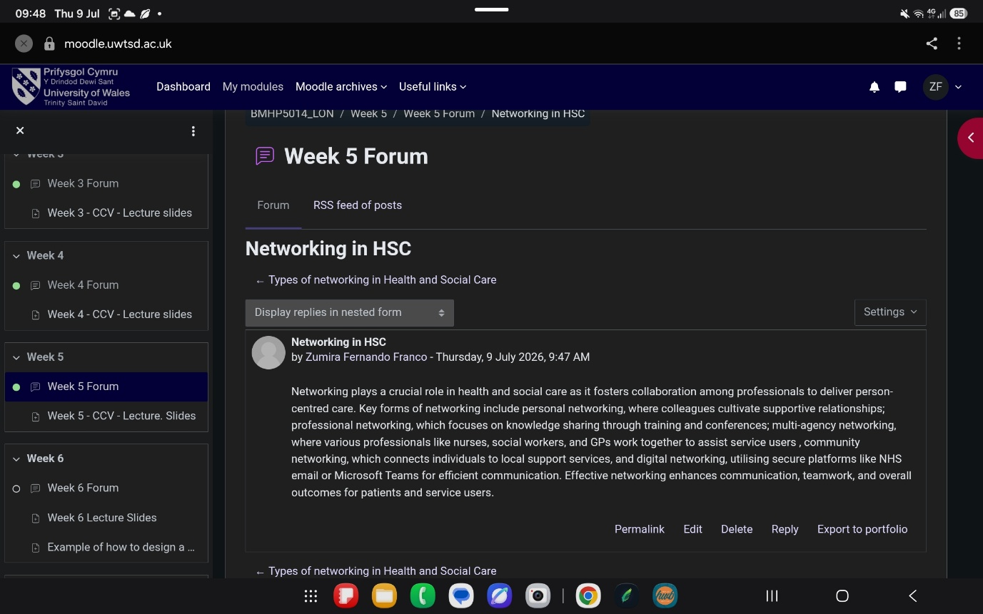

Task 8 – Self-Reflection Journal Entry

Completing this module has changed the way I understand creativity and innovation in health and social care. Before studying this module, I mainly associated innovation with new technology. I now recognise that innovation also involves improving communication, problem-solving, leadership and person-centred practice to achieve better outcomes for service users. Throughout the module, I learned that while innovation and creativity can improve the quality, safety and efficiency of care, they also have limitations. Successful implementation depends on effective leadership, staff engagement, appropriate training and the willingness of organisations to embrace change (Gibbs, 1988).

Reflecting on the activities has helped me appreciate the importance of critically evaluating new ideas rather than assuming that every innovation will automatically improve care. Using Gibbs’ Reflective Cycle enabled me to identify my strengths as a Senior Carer while recognising areas where I can continue to develop, particularly in leadership, digital skills and supporting innovation within my team

This learning will influence my future practice by encouraging me to adopt evidence-based innovations, support colleagues through change, and promote creative, person-centred approaches to care. I will also be more confident in evaluating new initiatives, contributing ideas for service improvement and leading by example to enhance both staff wellbeing and resident outcomes. Overall, this module has strengthened my commitment to lifelong learning, reflective practice and continuous professional development, which are essential for delivering high-quality health and social care

References

Byers, T. (2017) Creativity in Care: Developing Person-Centred Practice. London: Jessica Kingsley Publishers.

Connolly, M., Lowthian, E., Barrance, D.R. and Brookfield, C. (2026) ‘The philosophical, methodological and empirical problems in OECD’s approach to creativity within PISA 2022’, Research Papers in Education, pp. 1–27.

Coram, R. And Burnes, B. (2001) ‘Managing organisational change in the public sector: Lessons from the privatisation of the Property Service Agency’, International Journal of Public Sector Management, 14(2), pp. 94–110. Doi:10.1108/09513550110387381.

Davis, F.D. (1989) ‘Perceived usefulness, perceived ease of use, and user acceptance of information technology’, MIS Quarterly, 13(3), pp. 319–340.

Galanis, P., Vraka, I., Fragkou, D., Bilali, A. And Kaitelidou, D. (2021) ‘Nurses’ burnout and associated risk factors during the COVID-19 pandemic: A systematic review and meta-analysis’, Journal of Advanced Nursing, 77(8), pp. 3286–3302.

Gibbs, G. (1988) Learning by Doing: A Guide to Teaching and Learning Methods. Oxford: Oxford Polytechnic.

Meadows, D.H. (2018) Thinking in Systems: A Primer. White River Junction, VT: Chelsea Green Publishing.

NHS England (2022) Working in partnership with people and communities: Statutory guidance. Updated 21 May 2026. Available at: https://www.england.nhs.uk/long-read/working-in-partnership-with-people-and-communities-statutory-guidance/ (Accessed: 28 July 2026).

NHS England (2023) What are Electronic Care Records? Available at: https://digital.nhs.uk/services/national-care-records-service (Accessed: 9 July 2026).

NHS England (2023) What are Virtual Wards? Available at: https://www.england.nhs.uk/long-read/virtual-wards/ (Accessed: 12 July 2026).

OECD (2024) Seven Questions about Creativity and Creative Thinking: Divergent and Convergent Thinking. Paris: OECD Publishing. Available at: https://www.oecd.org/en/publications/seven-questions-about-creativity-and-creative-thinking_0aa52128-en/full-report/divergent-and-convergent-thinking-which-tasks-led-to-more-creative-ideas-on-the-pisa-test_5cd626c8.html (Accessed: 22 July 2026).

Randall, J., Burnes, B. And Sim, A.J. (2018) Management Consultancy: The Role of the Change Agent. London: Bloomsbury Publishing

Patrício, L., Teixeira, J.G., Figueiredo, C. And Nunes, N.J. (2020) ‘Service design for value creation in healthcare: A systematic review’, Health Services Management Research, 33(4), pp. 179–193.

Randall, J., Burnes, B. and Sim, A.J. (2018) Management Consultancy: The Role of the Change Agent. London: Bloomsbury Publishing.

