
Foreign language and culture awareness BMIH5003

Title: Foreign languages and culture awareness BMIH5003
Tutor: Giulia Chifari
Shunom Begum Qureshi
My ID: 2238718

Table of Contents
Introduction: 2
Critical Differences Between the UK and Italy in Cultural Aspects: 2
Religion: 2
Civilisation: 2
Nation: 2
Gender: 2
Race: 2
Class: 2
Values of the culture and leadership: GLOBE’s Project. 2
Power Distance: 3
Italy: 3
UK: 3
Uncertainty Avoidance: 3
Individualism vs. Collectivism: 3
Gender egalitarianism 3
Future Orientation: 3
Performance Orientation: 4
Humane Orientation: 4
Challenges of Intercultural Leadership: 4
Confrontation: 4
Attitudes towards Change: 4
Analysis: 5
Conclusion: 5
Recommendations: 5
Inclusive Decision-Making: 5
Conflict Resolution Mechanisms: 5
Team-Building Activities: 6
References 6

Introduction:
The report will provide insight into the adaptation of Italian staff members who will be arriving at a Hotel in London in July 2024. It is vital to draw on the cross-cultural research findings of the culture and leadership study in the GLOBE project (Rutherford, 2009). This analysis explores significant cultural differences that may raise potential concerns in team functioning, information sharing, and leadership assumptions.

Critical Differences Between the UK and Italy in Cultural Aspects:
Religion: Religion plays a vital role in society for the people in the UK, but the overall trend has gradually shifted toward secularism. The Roman Catholic Church’s influence is deeply rooted in the Italian people and their practices.
Civilisation: Italy's Renaissance contributed to its dominance in art and architecture. The UK has long been recognised for its rich tradition of writing and manufacturing.
Nation: The UK has a highly diverse population as compared to the Italians, while the latter has become more varied in recent years and has a more regionally focused and historically divergent culture.
Gender: Both countries support women's rights, with Italy having more traditional systems on this than the UK in the rural environment.
Race: The research reveals that the UK has more ethnic diversity than any of the countries and hence has a diverse cultural profile. The ethnic distribution in Italy is not as eclectic, but there are tendencies toward multiculturalism present in Italy.
Class: The people of the United Kingdom have admitted the existence of a clear class divide when it comes to social factors (Satria & Dhanin, 2022). Modern Italy's class divide is less apparent, even though regional division plays an important role.

Values of the culture and leadership: GLOBE’s Project.
As we move forward to understand and gain insight into the work culture and leadership styles of the UK and Italy, GLOBE’s cultural dimensions play a vital role in achieving these objectives.

Power Distance:
Italy: Italy demonstrates low to median power distance, which points to a tendency towards impartial power relations and less pyramid-like organisational structures.
UK: The UK scored higher on the dimension, meaning that the British agree more with the statement that people in their culture accept a ‘superior’ prerogative to punish subordinates for their errors (Subakti & Agung, 2012).

Uncertainty Avoidance:
Italy: The research reveals that the Italian culture ranks medium in the uncertainty avoidance index, which indicates a preference for organisations and environments with clearly defined and stable rules and procedures.
UK: The UK scores moderately low on this criterion, which means that it does not strictly adhere to formalities and regulations.

Individualism vs. Collectivism:
Italy: With a score of 41, Italy is ranked in the middle of the list for individualism, but this Mediterranean country values family and community.
UK: The UK is considered individualistic. Employees give more importance to individualism than the group.

Gender egalitarianism
UK: The masculinity index of the UK is moderate, reflecting competitive edge and assertiveness alongside the increasing importance of social care provisions.
Italy: Italy is regarded as more ‘masculine’, meaning competing, succeeding in business, being assertive and having more straightforward gender roles than the southern regions, especially those of a rural background (Sukamerta, Kadek, & Nyoman, 2020).

Future Orientation:
UK: In terms of Hofstede indicators, the United Kingdom is ranked relatively high to moderate in future orientation or the tendency to plan for the future and to invest in it.
Italy: Italy also has a lower future orientation; it focuses on the destination, tangible outcomes, and immediate strategies.

Performance Orientation:
UK: United Kingdom employees are exceptionally Performance-oriented, which means that people there tend towards achievement, initiative, and results-oriented behaviours.
Italy: Italy also appreciates performance, which is why they are always looking for power; they can associate it with quality of work life and well-being.
Humane Orientation:
UK: With an Index score of 71, the UK is moderately humane-oriented, suggesting that the country's people will balance personal interests with an inclination to consider the suffering of others. (Tom&Frances,2007)
Italy: Italy has relatively high scores in terms of humane orientation. This is manifested in thorough sensitivity to the need for fairness and altruism.
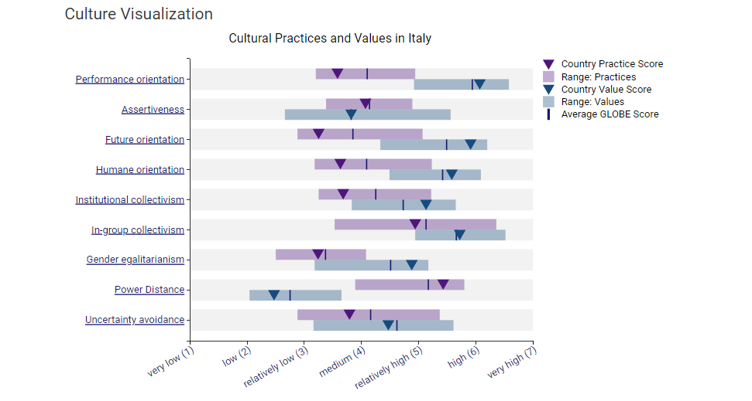
Challenges of Intercultural Leadership:
When the British and French employees in the Hotel practice leadership, there are likely to be a number of intercultural issues:

Confrontation:
The typical British worker generally does not wish to confront his colleagues and prefers to let matters settle down through negotiation. French employees are more at ease with confrontation and debate, and it is fully acceptable to disagree openly with a superior.
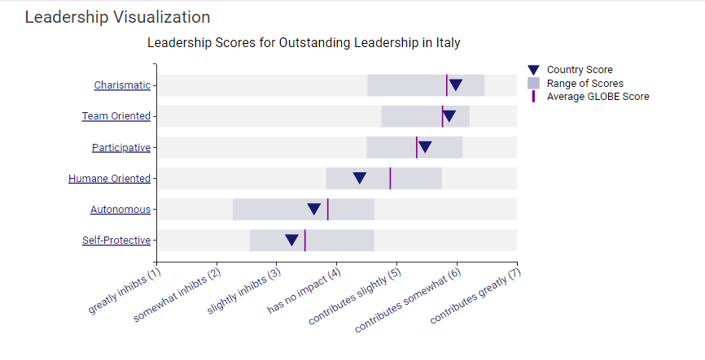
Attitudes towards Change:
The research shows that the level of change that UK employees reveal is considered moderate since they stick to traditional ways while incorporating new ideas and approaches. French workers may be less inclined to change, preferring order and consistency.
Scenario:
Conflict:
In a team meeting, John suggested that there should be a better way for guests to check in at the hotel. Luca quickly tried to express several concerns he had regarding the proposal, arguing passionately about certain areas of concern he pointed out. He gesticulated vigorously and spoke louder, which is considered part of Italian nonverbal communication (Vallen & Vallen, 2014).
This straightforward communication style with John was perceived as aggressive. Luca, unable to persuade John and observing that John was willing to dismiss any other concept, felt offended and left out.

Analysis:
This scenario highlights potential areas of conflict in managing an intercultural team:
- Conflict often arises, and respect is thought to have been degraded.
- Disagreements can worsen the conflict if they are not usually handled very sensitively.

Conclusion:
As in the case of the Hotel, it is essential to observe different communication /decision-making models and conflict resolution methods between the two cultures. The research revealed that Intercultural leadership is demonstrated by stressing cultural awareness, culturally certain behaviors, and practical approaches to avoid or overcome culture clashes and foster teamwork and productivity (Victor, Aguilar-Escobar, Pedro, & Julián, 2021).

Recommendations:

Inclusive Decision-Making:
Encourage equal participation in the decision-making process, as this enhances team cooperation and the efficiency of implementing the decisions

Conflict Resolution Mechanisms:
The conflict of interest and cultures must be addressed through proper conflict resolution mechanisms.

Team-Building Activities:
Ensure that the staff of the respective team engages in practical team-building exercises that would help them develop healthy working relationships (Wahyu, Niken, Mulyati, & Maya, 2022).

References
Rutherford, D. (2009). Hotel management operations. Hoboken, N.J: John Wiley.
Satria, N., & Dhanin. (2022). Analysis Of Leadership Style Application And Motivation By Managers In Improving Housekeeping Employees Performance At Bumi Senyiur Hotel Samarinda. Jurnal Syntax Fusion 2, 520–28.
Subakti, & Agung, G. (2012). Overview the Seven Stars Rating in Hotel Industry. Binus Business Review 3, no. 2, 691.
Sukamerta, I., Kadek, N., & Nyoman, D. (2020). Penanganan Keluhan Tamu dengan Metode ILEAD Oleh Karyawan Kantor Depan di Hotel Holiday Inn Resort Baruna Bali. Jurnal Manajemen Perhotelan dan Pariwisata 3, 36.
Tom, & Frances, D. (2007). Skills and Training in the Hotel Sector: The Case of Front Office Employment in Northern Ireland. Tourism and Hospitality Research 7, 269–80.
Vallen, G., & Vallen, J. J. (2014). Check-in check-out :managing hotel operations Ninth edition. Pearson new international.
Victor, G., Aguilar-Escobar, Pedro, G.-V., & Julián, M.-M. J.-A.-R. (2021). Hotel room cleaning: Time study and analysis of influential variables in a Spanish hotel. Journal of Industrial Engineering and Management, 645.
Wahyu, Niken, U., Mulyati, & Maya, O. (2022). Pengaruh Kualitas Pelayanan Housekeeping Department Terhadap Tingkat Kepuasan Tamu Menginap Di Hotel Santika Premiere Harapan Indah Bekasi. Journal of Mandalika Review 1, 24–29.

