Security Report
  - Cristian Stefan Stancu
  - L5 - Data Security and Compliance (ACCA5034)
  - Student: 2008911@student.uwtsd.ac.uk

Client existing infrastructure

- Webserver hosted on an UK datacenter
- CRM product on the same hosting provider
- Local network within the premisses
- Hybrid working pattern for employees – a few are coming in the office but many are working remotely

Client profile

We identified the client is a data controller and has a big responsibility about the way it handles the data collected. For that reason many rules and policies has to be in place in order to comply to the data protection laws and in order to protect the sensitive data it holds.

Company internet access
Company local network internet access is being made through a dynamic IP. We’d suggest to request a dedicated IP instead to the ISP so they can limit certain access to other resources only to clients having that IP.

Office network
The office network is comprised of workstations and a local storage server which is sharing the most of the resources with the employees. There’s no VPN in place at the moment.

Company Website
The website we identified to be built using the well-known CMS Wordpress. However, even if the website doesn’t hold or capture any of their customers data it doesn’t have any WAF (Web Application Firewall) in front of it, nor the webhosting company is providing such a solution as a standard. So, we suggest to contract a subscription with a WAF company like Cloudflare or AWS (Amazon Web Services) to protect their website as Wordpress is one of the most vulnerable web products on the market and is the target of many attacks and nonetheless if someone can gain access can conduct a Phishing attack using their legit site.

CRM
The CRM is the product they are using for their main activity and all employees have access to it. However, when requested, we haven’t received any recent Pen Test report nor an older so we don’t know exactly how secure is that system. So the first step is to contract a Pen Test company to run tests on CRM.

Access
On verification we conducted we observed that the CRM is publicly accessible without any IP protection hence is the target to many attacks. The best is to limit access only to the IP and/or IP ranges corresponding to their office network after they obtain the static IP(s) from the ISP.

Firewall
Just like the website they own, there’s no WAF in front of this Web Application.

Security improvement

A proposed network topology is looking as following:
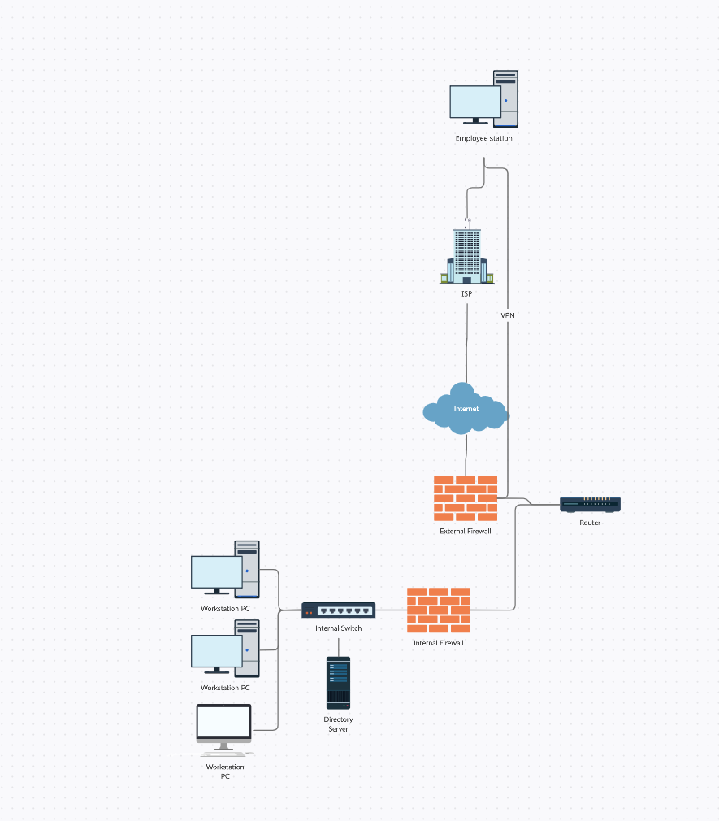
The access to the CRM must be restricted to only from the IP(s) of the local/office network. A VPN solution must be integrated for the remote working employees. OpenVPN is a very reliable and versatile solution we propose to be installed on all the machines that are being sent to the employees. By using a VPN to connect to the office network, they will have access to the shared storage server they have on the premises and to the CRM system as well. Since sensitive data is being captured by the staff of the company, that must be stored safely and ensure a backup solution is being contracted with the hosting provider. Also, it is mandatory to be checked how safe is the CRM web application used by running Penetration Test.

Personnel issues

The workstations delivered to employees must have limited access to storage ports such as USB and printers to prevent any kind of data leak. Also, GDPR compliance policies must be in place and the staff must be trained in that direction.
Employees must be told in writing:
- What is and is not acceptable use of equipment.
- What the penalties for violating regulations will be.
- That their activities may be monitored.
- That security will be a part of performance reviews.

Company issues

As a data controller, the company must decide:
- To collect the personal information of your customers, site visitors, and other targets. You must have legal authority to do so.
- What to collect.
- To change or modify the data that you get.
- Where and how to use the data and towards what purpose.
- Whether to keep the data in-house or to share it with third parties. You also figure out whom to share the data with.
- How long the data is kept, and when to dispose of it.

Since they are working with sensitive data, the connection to the CRM Web Application must be encrypted and the certificate must be valid.
The VPN connection of the employees to the local network will offer a secure way to access the office network and storage resources.

Which document do you need?
- A Privacy Policy – since you’re running a website, this document is made to inform the visitors about how you protect their personal data
- A Data Protection and Security Policy – to set out your detailed internal policies and procedures for processing staff and client personal data
- Employee privacy notice – to train the staff how the data is being collected, used, retain or even disclosed or disposed

As a data controller, the company must ensure the data:
- Is being processed in a fair, lawful and transparent manner
- Collected for specified, explicit and legit purpose
- Is relevant and limited to what is necessary for the company activity
- Accurate and up to date

Conclusion
The security now is low and there’s a risk of data leakage at any moment. Following the report above it can be improved with very little investment such as using an Open Source VPN software or by putting in place some internal rules and policies.

