

Student Name: Taranjot Randev

Student ID: 2436053

Module Name: Marketing Management

Module Code: LCMB7024

Lecturer’s Name: Dr. Jayalakshmi Gopalkrishan

Work Count: 2050

Term 1

Table of Contents
1. Introduction 3
2. Task 1: Critical Analysis of the Macro Marketing Environment 3
2.1 Overview of the Macro Marketing Environment 3
2.2 Selection of Two External Macro Marketing Actors 5
2.3 Critical Analysis of Each Actor 5
3. Task 2: Strategic Responses of Pioneering and Follower Organisations 6
3.1 Pioneering Organisations’ Strategic Responses 7
3.2 Follower Organisations’ Strategic Responses 8
4. Conclusion (Approx. 250 words) 9
5. References (References are NOT included in the word count) 9

1. Introduction
The report involves an analysis on the responsiveness of organisations in the retail fashion industry to the external forces in the macro marketing environment at the strategic level. Within the realms of strategic marketing management, it is important to get to know the macro environment since organisations exist in much larger political, economic, social, technological, environmental and legal environments, which are vital determinants of customer behaviour, competitive activities and overall performance of the organisations. The examination of these external forces will help the firms to recognise the trends that are emerging and manage to uncover threats and opportunities ahead of competitors. This active knowledge assists organisations to develop marketing plans that are current, everlasting and within the expectations of the market.
This report is divided into two major tasks. Task 1 gives critical analysis of the macro marketing environment as the overview of the major external forces based on the PESTEL model, choice of two major macro forces that are the processes of technological development through AI and automation, and pressure of the environment and how these groups of forces affect pioneer and follower organisations. Task 2 explores the strategic responses of pioneer and follower firms to these external pressures with the help of the Growth Matrix by Ansoff and the Generic Strategies by Porter as examples of reducing and increasing strategic behaviour respectively. On the whole, this report is meant to showcase the significance of environmental scanning and flexibility in terms of strategic adaptation to remain competitive in an ever dynamic and technologically driven retailing market.
2. Task 1: Critical Analysis of the Macro Marketing Environment

2.1 Overview of the Macro Marketing Environment
The macro marketing environment entails the broad external forces that influence both the strategic decisions of an organisation yet they are not directly controlled by an organisation. These are societal forces and dictate the consumer behaviour, market demand as well as the competitive conditions (Bayighomog et al., 2020). The study of these external factors enables organisations to know the trends of what will occur in the long-term that will either pose a risk or offer an opportunity. The knowledge as far as the macro environment is concerned is, therefore, crucial in the development of marketing strategies that are resilient and progressive.
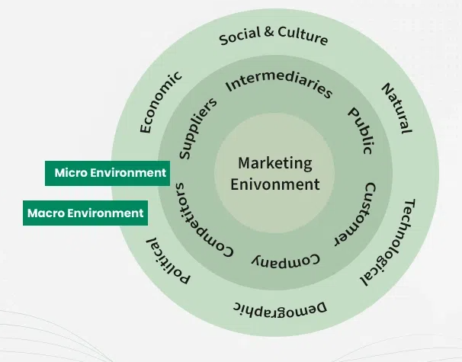
Figure 1: Marketing Environment
(Source: GeeksforGeeks, 2025)
Relevance to Marketing Strategy through PESTEL
The PESTEL framework enables a systematic analysis of the macro environment by including the factors that are Political, Economic, Social, Technological, Environmental and Legal. Political and legal factors provide motivation to regulatory expectations, whereby it influences product standards and advertising. As an economic power, such factors as inflation, an increase or a decrease in interest rates, become factors that influence consumer buying power and pricing (Love, 2020). The social trends like change in population and lifestyle changes influence the segmentation and positioning choices. The technological improvements are the basis of digital facilities, contact with customers, and the potential of the new innovation. Sustainability-driven branding works with the pressure of the environment as well as the legal care ensures a border of protection.
Through the PESTEL, the marketer will be able to align strategic planning with the external realities to ensure that their value propositions, communication strategies and their market product offerings do not become obsolete. This would apply because organisations can examine the environment proactively and can respond to the new risks and can take advantage of the opportunities presented in highly evolving and dynamic marketing environments.

2.2 Selection of Two External Macro Marketing Actors
Artificial intelligence (AI) and automation have emerged as the important external players in the retail fashion industry. In 2025, it is estimated that in the world retailers will allocate more than US $131.6 billion towards digital technologies and this is an 11% increase on an annual basis, as a result of AI, machine learning and automation (MobiDev, 2025). Computer vision, augmented reality, predictive analytics and smart-store automation are all key technologies that are transitioning to mainstream adoption (PwC, 2024). These tools facilitate customisation, price-setting, enriched omni-channel interactions and an improved response to demands in the supply-chain. Their strategic applicability is found in the fact that AI will be capable of transforming customer facing activity, as well as operational process (Budnikevych, and Semkiv, 2022). The risk of low competitive levels continues to rise among fashion brands that fail to incorporate unprecedented technologies as marketing strategies are becoming greatly dependent on digital capability, data-quality management and value-based technology investments. The fashion industry is under intense pressure by environmental forces such as climate change, generation of waste and depletion of resources. The industry contributes to carbon emission of about 10% of the total world carbon emission and the second highest water consumer globally. Textile use contributed approximately 355 kg of CO₂ per capita in Europe in 2022, roughly the amount of CO₂ emitted by 1,800km of petrol-car use (European Parliament, 2023). These are pressure forces that facilitate sustainability expectations, transparency and regulatory compliance. Consequently, marketing choices are now largely influenced by environmental conditions, compelling companies to become a circle and reduce emissions and report plausible sustainability initiatives. The brands that overlook these forces will face reputational losses, low levels of consumer confidence and less competitiveness in the market that has become more sustainability oriented.

2.3 Critical Analysis of Each Actor
Being a pioneer in organisations like Nike and Zara which integrates advanced AI systems is a way to grasp huge opportunities to enhance their operational efficiency and marketing performance. According to a recent report 69% of retailers who adopted AI noted an increase in revenue every year and 72% said their operating expenses had decreased, which proves the financial rewards of the emerging technology (Euristiq, 2024). These innovators use AI to make predictions, design and price dynamically, and offer hyper-personal recommendations, which eventually enhance customer interaction and overall channel speed. Their capacity to operate on the real-time insight also facilitates a better segmentation process and minimizes non-useful inventory planning. On the contrary, the competitive disadvantages to the follower organisations are significant. Instead, they face increased costs of digital transformation, data maturity, and rising maturity as customers develop to the expectation of AI-driven innovators. As a strategic step, to be ahead of the competition, pioneers should retain their AI capability-building by ensuring good data governance, cross-functional integration, and up skilling of the workforce (Rosário, and Raimundo, 2021).
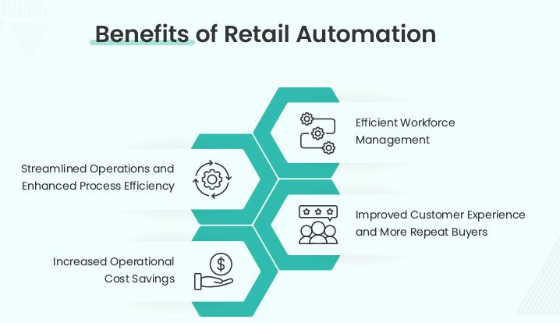
Figure 2: Automation in Retail
(Source: Radixweb, 2024)
However, followers need to enter with less risky and high-impact AI uses, including inventory optimisation or customer analytics, and forge alliances with technology suppliers to speed up implementation. Lack of transition would mean technological obsolescence, commoditisation of their products and loss of competitive thrust. The environment offers equally different paths to innovators or followers. First movers such as Patagonia and Stella McCartney with a more focus on circular design, recycled materials and transparent supply chains will reap big brand equity and more consumer trust. Each year the textile waste generated by the fashion industry reaches a total of approximately 92 million tonne, 8% of the fibres are recycled, which makes sustainable change even more urgent.
Unsuspecting innovators take advantage of this by fostering the principles of durability, repair schemes and closed loop systems, transforming the aspect of environmental responsibility into a strategy (United Nations Environment Programme, 2023). They also acquire strength since carbon reporting rules, waste reduction and long-term producer responsibility go round the world. Instead, followers experience an increase in both regulatory and reputation risks in the event that they do not change. Customers more and more discard brands that have not credible sustainability policies whereas governments are enforcing tougher environmental compliance policies (MobiDev, 2025). As a strategy, pioneers must keep discarding circular models and publishing transparency reports on sustainability. Supply-chain transparency, sustainable sourcing and recycling or end-of-life investment systems should be prioritised by the followers.

3. Task 2: Strategic Responses of Pioneering and Follower Organisations

3.1 Pioneering Organisations’ Strategic Responses
Strategic Responses of Pioneering Organisations
Proactive Innovation Strategies
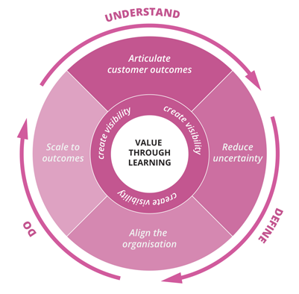
Figure 3: Pioneering Organizational Transformation
(Source: Inditex, 2024)
First-mover organisations are active in regards to outside pressures by introducing innovation as an element of its strategic planning. They have been relying on models such as the Growth Matrix developed by Ansoff to carry out the product development and market penetration processes over the periods of technological and environmental changes, and establishing the industry standards (Love, 2020).
Leveraging Digital Technologies
Nike demonstrates the way innovators use digital developments to boost growth at a quicker rate. The online try-on and data-driven design solutions can make its online customers have a better experience, enhance market penetration, and accelerate the innovational processes. The effects of the technology are the possibility to leverage on the early adoption of digital resources to develop a competitive advantage in highly dynamic markets (Nike, 2024).
AI-Driven Market Advantage
The AI-based demand forecasting software and fast production enables Zara to offer effective replenishing of the stock, waste reduction, and agility in the market. The data connected to the sphere prove that the first users of AI level the accuracy of inventory 2030 percent higher and the conversion rate grows by 15 percent with the introduction of AI, which is the concrete competitive edge (Inditex, 2024).
Application of Porter’s Generic Strategies
The innovative organisations use either Differentiation or Cost Leadership as a strategic response to the pressures of the macro-environment through the implementation of the Porters generic Strategies. According to an example of this is Patagonia, the circle of design, regenerative materials and transparent supply-chain model fits into the consumer group, which is sustainability-oriented (Patagonia, 2023). It is specified that the tendencies of sustainability based brands are identified having 28% tendency in terms of customer retention which contributes to the competitive value of the role of the green leadership.
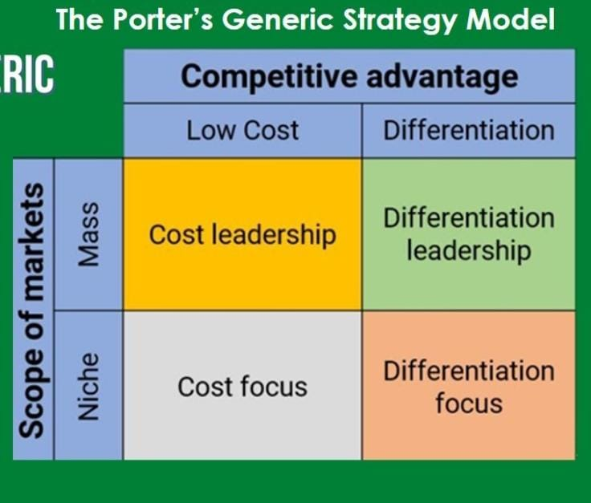
Figure 4: Porter’s Generic Strategic
(Source: Created by Author)
On the other hand, the design innovation is the Cost Leadership strategy, under which the company deploys robotics, 3D printing, and automated production to shorten the lead times of the final product to up to 50% and still have no significant impact on the quality of the final product is also utilised on Adidas (Adidas Group, 2024). Along with the strategies, the leaders form the creaking benefit taking advantage of any technological changes and environmental threat.
Critical Implications for Pioneers
Macro-environment forces, including technological disruption, environmental pressure and tightening in regulatory instruments, on the whole, become long-term strategic advantage on the part of unprecedented organisations. They make serious investments in digital capabilities, advanced analytics, resource friendliness and responsiveness in supply chain designs (PwC, 2024). The type of collaboration between the sustainability organizations, such as United Nations Environment Programme, assists in preparing in the future regarding environmental regulations (UNEP, 2023). The pioneers shape the future trends of the industry and make people know what to expect in their purchase by inculcating innovation into culture and planning in a way to stay ahead of the so-called follower organisations.

3.2 Follower Organisations’ Strategic Responses
Strategic Responses of Follower Organisations
Follower organisations will react in different ways to external pressures than pioneers as they will start taking less risky and controlled approaches which give them the chance to stay competitive without investing heavily. The followers of the firms tend to use Markets Penetration and Markets Development to stabilise their position using the Growth Matrix proposed by Ansoff (Oroh, 2020). They do not invest heavily in new technologies and superior AI or automation but most often, they follow the trail of early adopters to get the returns and realize these returns can be measured. Indicatively, several mid-market fashion merchants started adding AI-supported inventory technologies after trailblazers like Nike and Zara had a 15 to 20% better accuracy and fewer inventory outs in the market. Such a follower strategy has low risk exposure at the cost of slowing down competitive advantages. Incremental product enhancements that supplant radical innovation are also being used by the followers to retain their place in the existing markets. These encompass the development of cost-efficient product ranges or a modification of eco-friendly material, only after the innovators prove consumer behavioral trends.
Application of Porter’s Generic Strategies
Niche Competitive Strategies
Porter developed Generic Strategies based on either Cost Focus or Differentiation Focus and this is what follower organisations tend to advance. They cannot compete with pioneers on the level of innovation, but instead, focus on niches or on low cost, sustainability or utility. Focusing on the strategic choice of strengths, these businesses remain relevant without having to compete head-on with the leaders of this industry, leaving them in a strong position to cater to the needs of a few specific customer groups without excessive consumption of resources (Memon et al., 2021).
Choosey Affairs of Sustainability
Retailers, such as Primark and H&M, choose specific sustainability strategies, with some using recycled cloth collections and reacting to the needs of consumers. Industry statistics display that more than 60% of customers choose the brands that exhibit evident green practices. The followers choose sustainable initiatives with great care, so that between costs and targeting their audience these initiatives are sustainable and allow them to stay competitive and socially responsible without making any extensive, high-cost innovation strategies. This will be an effective way of improving brand perception.
Free-thinking Digital Adoption
To maximize their operations and enhance customer engagement, followers use cost-effective digital applications, such as straightforward chatbots and inexpensive predictive analytics. These cost efficient technologies enable them to respond to the macro trends efficiently without huge financial involvement. Strategically embracing scalable digital solutions, the follower organisations become more efficient in their operations, retain their market relevance and compete with more innovative pioneers, prudently. This conservative strategy balances the idea of risk management and competitiveness.
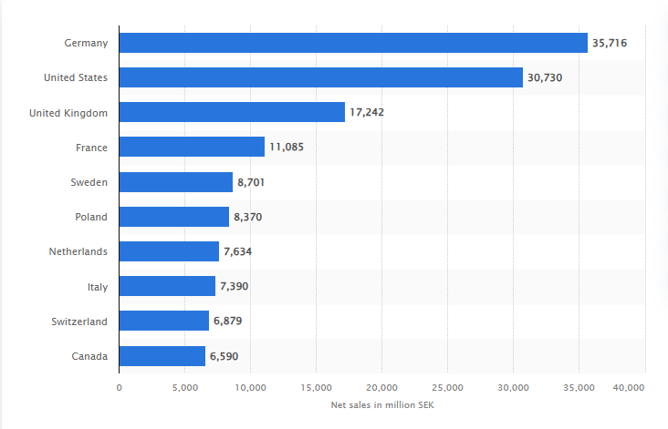
Figure 4: Net sales of the H&M Group worldwide in 2024
(Source: Statista, 2025)
Critical Implications for Followers
There are opportunities and threats that the follower organisations have in responding to the challenges of the external macro-environment. The opportunities involve the exploration of established technologies at a lesser cost and learning about the mistakes made by pioneers and changing the strategies according to the confirmed market information (Matshoba-Ramuedzisi et al., 2022). Nevertheless, there are threats, such as reduced responsiveness, more challenges of addressing the emerging consumer expectations and even market irrelevancy. The followers need to prioritize then strategically scalable and affordable innovations and devote resources to supply-chain transparency, digital skills development, and focused sustainability measures. Following selective, evidence-based approaches based on the model developed by Ansoff and Porter, the follower organisations will be able to be competitive and go around the risks imposed by the aggressive pioneering.

4. Conclusion
In conclusion, it is possible to reiterate that macro marketing environment plays an important role in defining the strategic direction of organisations particularly in the dynamic retail fashion market. As the outcomes of Task 1 illustrated, technological innovations- specifically, AI and automation, and environmental factors are overwhelming forces that influence the rates of competitiveness, consumer demands and regulatory policies. To overcome such challenges, pioneering organisations embrace the challenge by being proactively innovative, adopt new advanced technology, performance sustainability, and capitalisation of strategic model in ensuring that the organisation is always ahead. Comparatively, follower organisations are significantly conservative in approach, employ with cost-delimited strategies, and may not realise the value of an innovation had adopted by innovators. Task 2 also suggests that pioneers implement Ansoff models and Porters models to implement offensive penetration, product development and differentiation and the followers merely perform additions of margins and restricted scopes to reduce risk. The point of comparison is that regardless of the opportunities and threats of both parties, pioneers tend to gain more competitive advantages due to the early adaptation. Overall, the report has noted the strategic importance of continuous environmental scanning, evidence-based decision-making and responsive marketing. By investing in innovation, sustainability and data-driven capabilities, companies will be more successful in overcoming external pressure and becoming resilient in the competitive and dynamic environment of the marketplace.

5. References
Adidas Group (2024) Sustainability and Innovation Initiatives. Available at: https://www.adidas-group.com (Accessed: 10 November 2025).
Bayighomog Likoum, S.W., Shamout, M.D., Harazneh, I. and Abubakar, A.M., 2020. Market-sensing capability, innovativeness, brand management systems, market dynamism, competitive intensity, and performance: an integrative review. Journal of the Knowledge Economy, 11(2), pp.593-613.
Budnikevych, I. and Semkiv, A., 2022. Consideration of the trends and challenges of the marketing environment when forming the directions of event activity of domestic companies, cities and territories. Economic Bulletin of Cherkasy State Technological University, 2(23), pp.61-69.
Euristiq (2024) AI in Retail: Benefits, Use Cases and Trends. Available at: https://euristiq.com/ai-in-retail/ (Accessed: 10 November 2025)
European Parliament (2023) Fast fashion: the environmental impact of textile consumption in the EU. Available at: https://www.europarl.europa.eu/topics/en/article/20201208STO93327/fast-fashion-eu-laws-for-sustainable-textile-consumption/ (Accessed: 10 November 2025).
GeeksforGeeks (2025) Marketing Environment: Features and Types. Available at: https://www.geeksforgeeks.org/marketing/marketing-environment-features-and-types/ (Accessed: 11 November 2025).
Inditex (2024) Zara’s Digital and Supply Chain Innovation. Available at: https://www.inditex.com (Accessed: 10 November 2025).
Love, T.R., 2020. Indigenous knowledges, priorities and processes in qualitative organization and management research: State of the field. Qualitative Research in Organizations and Management: An International Journal, 15(1), pp.6-20.
Matshoba-Ramuedzisi, T., De Jongh, D. and Fourie, W., 2022. Followership: A review of current and emerging research. Leadership & Organization Development Journal, 43(4), pp.653-668.
Memon, A.A., Afshan, G., Memon, A.A., Rajput, O. and Kumar, K., 2021. War for Competitive Advantage–‘Porter’s Generic Strategies Past–Present–Future’–A Review. Available at SSRN 3846056.
MobiDev (2025) 7 Technology Trends Transforming the Retail Industry. Available at: https://mobidev.biz/blog/7-technology-trends-to-change-retail-industry (Accessed: 10 November 2025).
Nike (2024) Digital Transformation and Consumer Innovation. Available at: https://www.nike.com (Accessed: 10 November 2025).
Oroh, A., 2020. Dynamic Capabilities-Based and Environment Serving Organization-Based Concepts in Strategic Management: Are They Complementary? A Theoretical Overview. KnE Social Sciences, pp.88-103.
Patagonia (2023) Environmental and Social Responsibility Report. Available at: https://www.patagonia.com (Accessed: 10 November 2025).
PwC (2024) Digital Transformation and Retail Industry Insights. Available at: https://www.pwc.com (Accessed: 10 November 2025).
PwC (2024) Retail technology trends shaping the future of shopping. Available at: https://www.pwc.com/us/en/industries/consumer-markets/library/retail-technology-trends.html (Accessed: 10 November 2025).
Radixweb (2024) Retail Automation: A Re-imaged Flow Management Approach. Available at: https://radixweb.com/blog/guide-to-retail-automation (Accessed: 11 November 2025).
Rosário, A. and Raimundo, R., 2021. Consumer marketing strategy and E-commerce in the last decade: a literature review. Journal of theoretical and applied electronic commerce research, 16(7), pp.3003-3024.
Statista (2025) Net sales of the H&M Group worldwide by country (in billion U.S. dollars). Available at: https://www.statista.com/statistics/964217/net-sales-of-the-h-and-m-group-worldwide-by-country/ (Accessed: 11 November 2025).

