

Programme:
Master of Business Administration
Module:
Marketing Management | Module code: LCMB7024
Module Lecturer:
Dr Mustakkima Afrin
Assignment Tittle:
Marketing Strategies Portfolio:
NVIDIA AI Smart Traffic System
Submitted by:
[AJITH NAGARAJAN]
Student ID: [2525947]
Submission Date: 30 April 2026

Table of Contents
1 Element 1: Brand Extension Poster Presentation 3
2 Element 2: Segmentation, Targeting, Differentiation, and Positioning (STDP) Analysis 4
2.1 Segmentation 4
2.2 Targeting 4
2.3 Differentiation 5
2.4 Positioning 6
3 Element 3: Marketing Mix (4Ps or 7Ps) 8
3.1 Product 8
3.2 Price 9
3.3 Place 10
3.4 Promotion 10
4 Element 4: Reflection 12
4.1 Reflection on Brand Extension Development 12
4.2 Reflection on Poster Presentation 12
5 References 13

Element 1: Brand Extension Poster Presentation
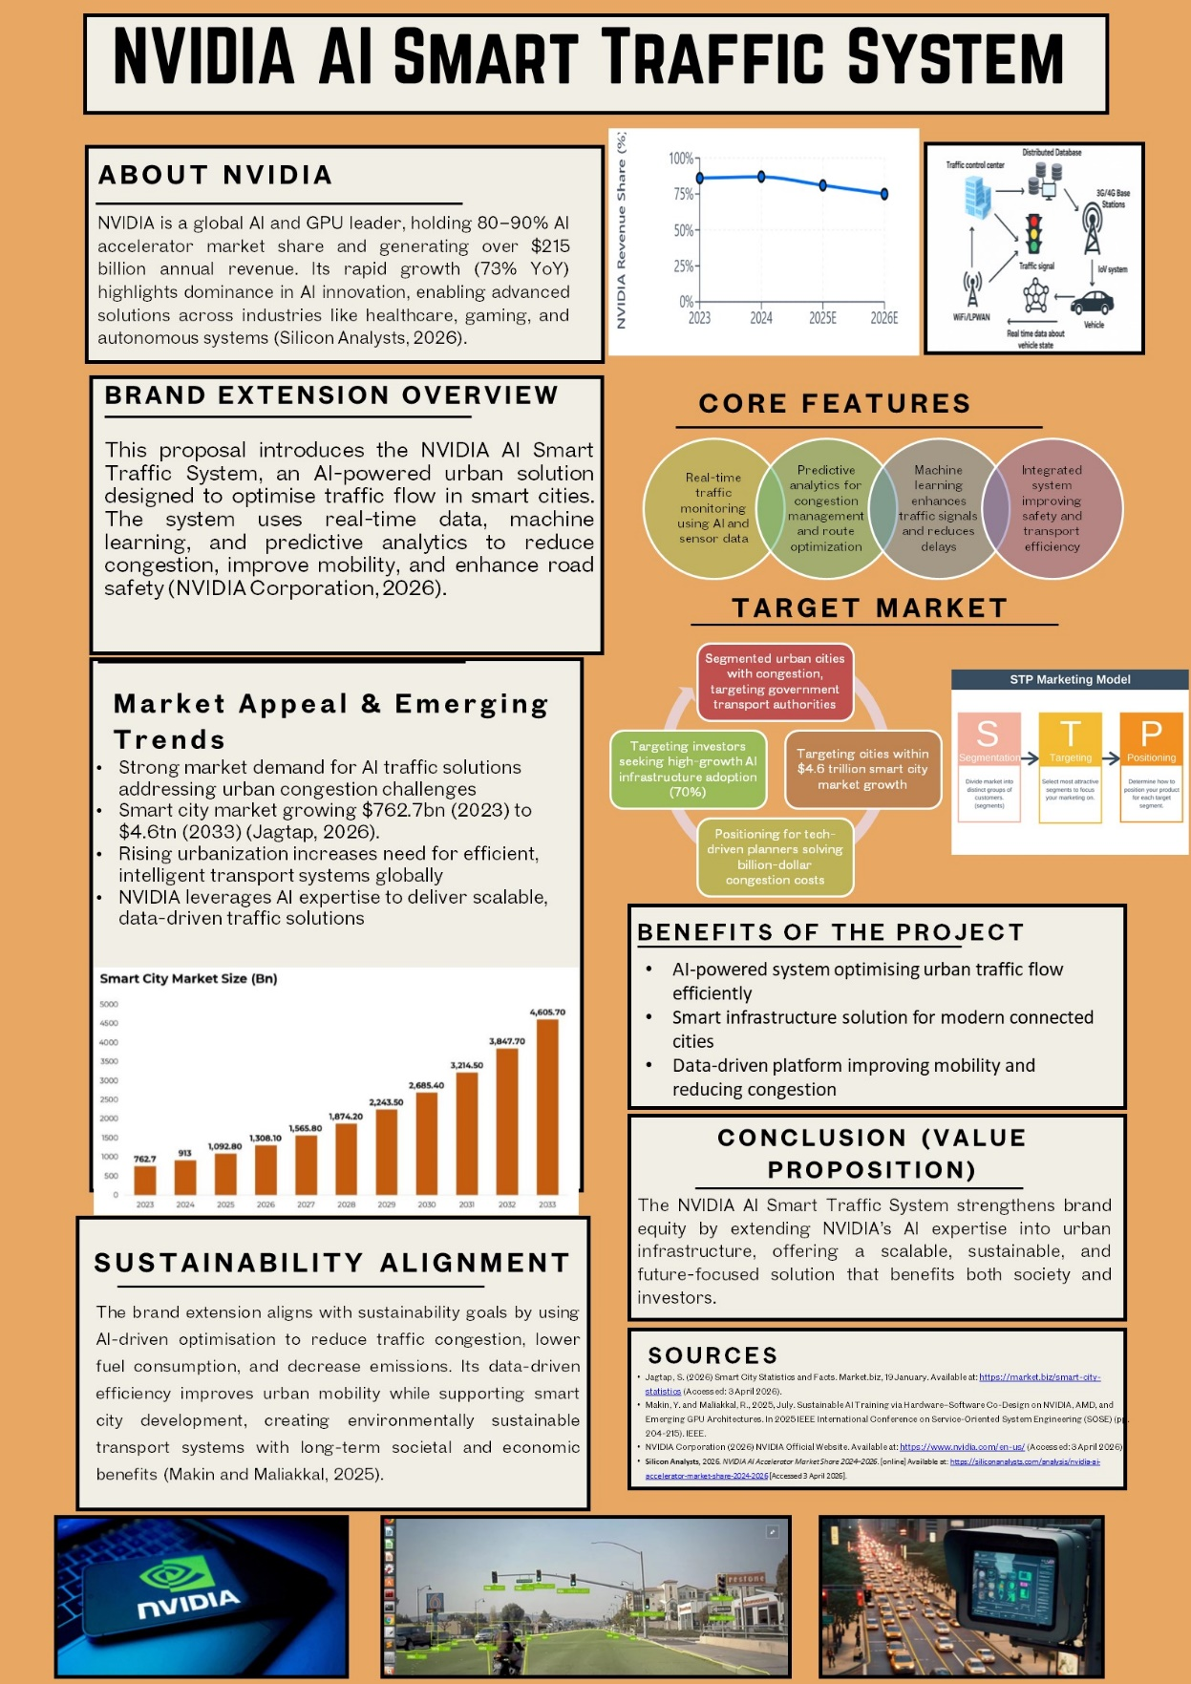

Element 2: Segmentation, Targeting, Differentiation, and Positioning (STDP) Analysis

Segmentation
The NVIDIA AI Smart Traffic System geographic segmentation strategy is intended to embrace urban cities where serious traffic jams are a major issue of concern in terms of transportation efficiency. The old infrastructure in these cities also defines them as being normally problematic in terms of serving the increased population and the increased number of vehicles (Allen et al., 2025). The intended audience, regarding demographics, is the city planners, municipal authorities, and government transportation agencies, tasked to govern the infrastructure of the population, and to develop solutions to urban mobility.
At the psychographic level, the target group is the group of technologically advanced and socially conscious individuals and organizations who are interested in the implementation of sustainable solutions into urban design. Such stakeholders value smart, data-driven approaches to city issues. The main actors in the behavioral part are the government agencies that actively engage in seeking innovative applications for handling traffic congestion and enhancing the efficiency of the transport systems that serve society (Rehman et al., 2024). This segmentation is a reaction to the growing demand for smarter, more efficient mobility systems, which are motivated by the necessity to deal with the issues of urbanization and environmental objectives in contemporary cities.

Targeting
The NVIDIA AI Smart Traffic System targets the government transport authorities and municipalities, which are the primary consumers of the system, mainly because they are currently in search of scalable and high-tech solutions to the traffic jams in their cities. These organizations are particularly interested in the improvement of the traffic flow with the help of AI-based solutions that would help to make it more efficient and time-saving.
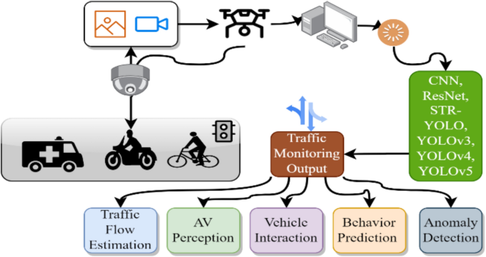
Figure 1: In-depth review of AI-enabled (Pal et al., 2024)
Transport authorities are considering long-term solutions to enhance mobility and minimize costs in the city. The second target market is the companies in the private sector that have been involved in the smart city programs, such as technology partners and infrastructure developers. Such enterprises will be able to incorporate AI-driven traffic control systems into their projects, and this will enhance the smart city infrastructure.
The global smart city market will expand by a substantial percentage, and it is estimated that the market will reach 762.7 billion dollars in 2023 and 4.6 trillion dollars in 2033, which illustrates the expansive nature of the innovation of urban mobility solutions (Almatar, 2024). It is an opportunity to solve the problems of the city and to meet the increasing needs of sustainable urban development with the help of this growing market of smart infrastructure.

Differentiation
The uniqueness of the NVIDIA AI Smart Traffic System over conventional traffic management systems lies in the fact that the traffic management system offers real-time traffic optimization, which is AI-enriched, making it flexible and dynamic to the road conditions. Such a system can also respond in real-time to traffic volume and environmental changes, as compared to traditional systems that could rely on fixed algorithms and manual adjustments. The competitive advantage of the system is its capacity to optimize the traffic signal management, minimize traffic jams, and increase road safety with the help of constant learning and data processing (PILLAI, 2024).
Moreover, by focusing on green solutions, such as the reduction of emissions and fuel consumption, the system encourages more holistic sustainability goals. Such differentiation comes at a most opportune time, with sustainable development trending its way upwards in a market that is becoming more receptive to green technologies in the city. The adaptive traffic management and the environmental conscience makes the system a leader in intelligent and future-resistant traffic management in cities across the globe and present a host of benefits that are unprecedented in the present stagnant systems.

Positioning
The NVIDIA AI Smart Traffic System will be sold as a novel product regarding the smarter cities in terms of traffic flow. The system must be capable of a smooth integration into smart city infrastructures to provide AI-based, machine learning-based, scalable, and sustainable traffic management. The slogan, Revolutionizing urban mobility with sustainable, AI-powered traffic systems, is a one-liner that sums up the two-sided character of the system that is anchored in making traffic efficient and environmentally friendly (Gheorghe and Soica, 2025). The system will transform the transport systems in cities by using knowledge based on data to enhance decisions, reduce traffic congestion, and make the roads safer.
The market will be marketed towards high-tech, environmentally friendly, and futuristic ideologies. The brand extension will capitalize on the fact that NVIDIA has a track record of being a leader in other sectors through its AI and GPU technology (Injac et al., 2024). With the focus on sustainable urban development in the cities of the world, the NVIDIA AI Smart Traffic System will emerge as a crucial resource that can be used by governments and urban planners to deploy smart, green infrastructure solutions in the future of mobility.
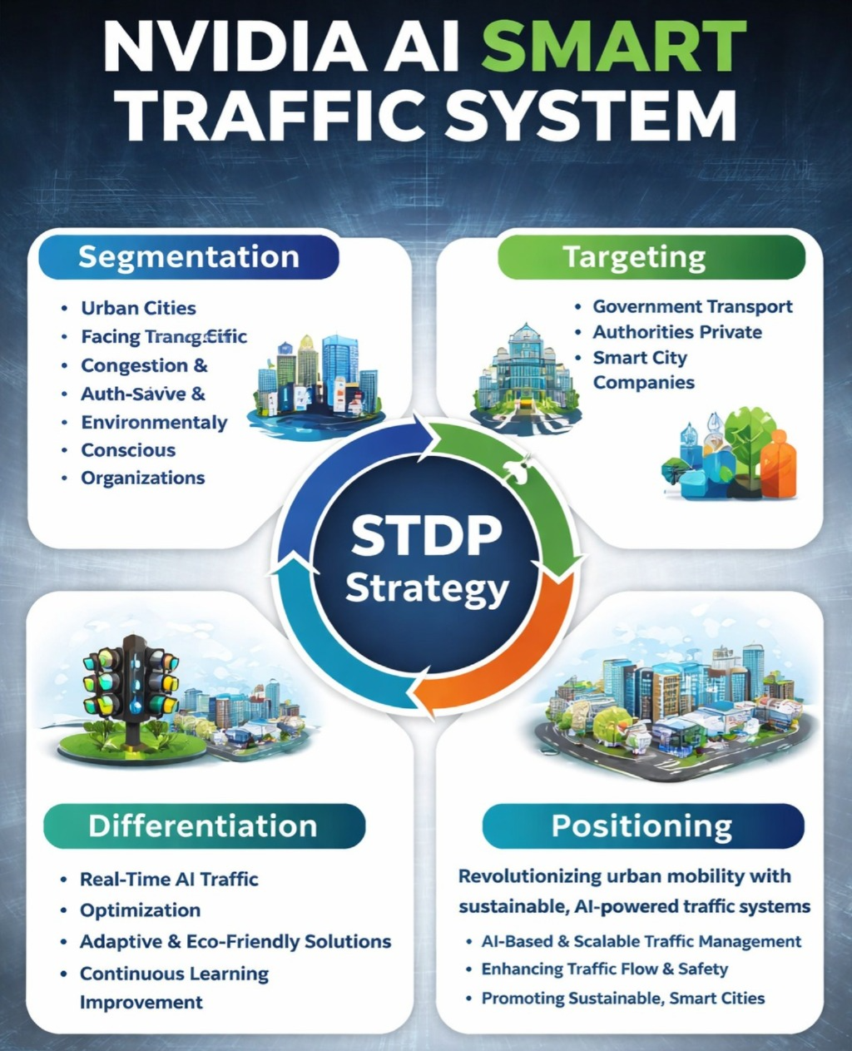
Figure 2: STDP Strategy
The STDP framework for the NVIDIA AI Smart Traffic System. It covers Segmentation, Targeting, Differentiation, and Positioning with the theme of AI-based traffic management, smart cities, and sustainability.

Element 3: Marketing Mix (4Ps or 7Ps)
The Marketing Mix, also referred to collectively as the 4Ps, of the NVIDIA AI Smart Traffic System provides insight into how each component of the marketing mix communicates with the larger overall brand strategy. The components of the marketing mix (product, price, place, and promotion) are critical elements to meet the changing needs of today’s marketplace while also supporting the long-term viability of urban mobility.
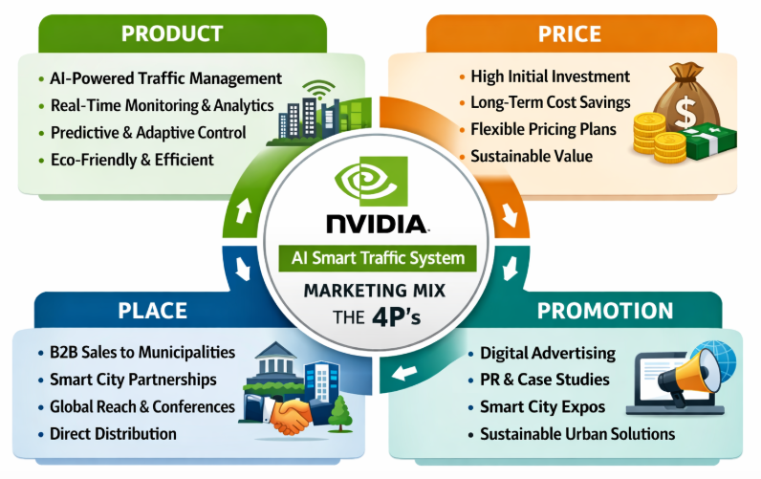
Figure 3: 4P’s

Product
The NVIDIA traffic management system is an intelligent traffic mobility solution for city life that is based on AI. It uses real-time monitoring that is AI and machine learning enabled to streamline traffic movement, curb congestion, and enhance road safety. The system checks the traffic information at all times and dynamically changes the traffic lights and routes (Xia, 2023). Its main characteristics are predictive analytics that are used to predict congestion and tune signal timing, and adaptive traffic management, which keeps traffic flow efficient during peak and off-peak periods.
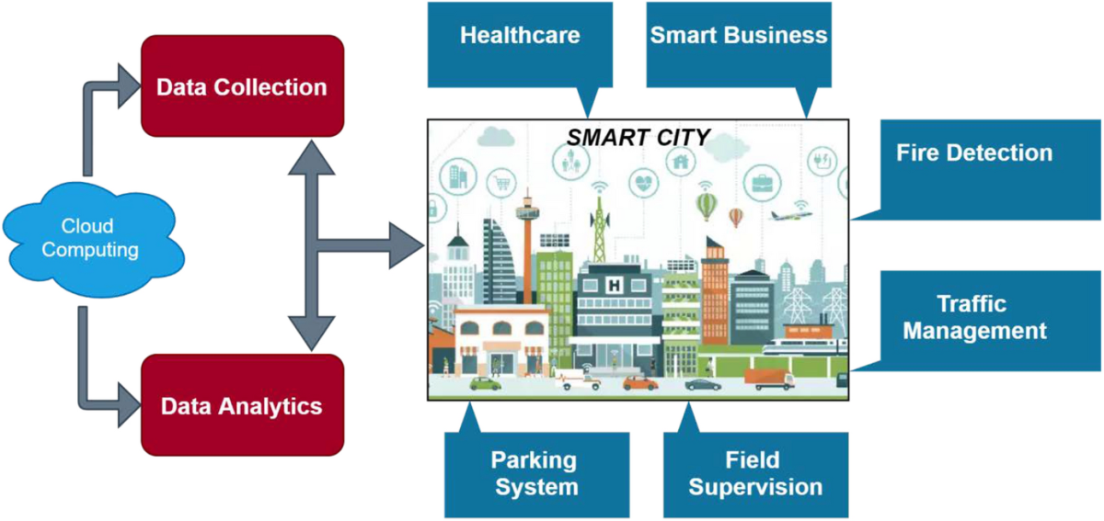
Figure 4: Smart cities and the IoT: an in-depth analysis of global (Nuseir and Madanat, 2025)
The system can be extended and coupled with smart city infrastructure, and hence can be acceptable in any city of any size. It has the power to collect and process large volumes of data to provide the right and current information to make better decisions. The system is also environmentally friendly and contributes to the reduction of fuel consumption and emissions because the traffic flow is perfected. Since the smart city market is projected to grow to a maximum of $4.6 trillion by the year 2033, such a product will offer a solution to the cities (Abu-Rayash and Dincer, 2023). This will make them future-proof in terms of coping with the increased traffic volume and reducing the negative effects on the environment.

Price
The NVIDIA AI Smart Traffic System is expensive, which could be justified by the fact that the existing AI and machine learning technologies offer the possibility to integrate with the existing urban infrastructure with ease. The first cost of the system can be higher than that of the traditional traffic management systems, the cost savings in the long run make the system a worthwhile investment. The system will reduce the amount of congestion by optimizing the traffic flow, which will help a great deal in saving fuel and reducing the operating cost of the cars, benefiting the municipalities and the residents (Suryani et al., 2025).
In addition, the fact that the system is eco-friendly produces less and serves the sustainability goals, which are aligned with international urban planning. The flexible pricing model is tailored to meet the needs of municipalities of various sizes and budgets, but gives a chance to expand the system to the needed level. This is what makes it a feasible alternative to the cities at the different stages of smart cities development. The market of smart cities in the world is projected to reach up to 2.5 trillion and 800 billion in 2030 and 2023, respectively (Leo and Miragliotta, 2025). This pricing model qualifies the system to be a priority investment by cities that will be interested in modernizing their infrastructure.
The system is also a powerful reaction to the urban problems of traffic jams, air pollution, and obsolete transport systems since it dwells on sustainability and efficiency (Raza et al., 2022). Such a high cost is what makes the product remain a must-have component in the inventory of progressive cities that desire to integrate recent technologies in their mobility strategies.

Place
The NVIDIA AI Smart Traffic System distribution strategy aims at direct B2B sales to governments in the transport sector, urban planners, and municipalities. Such parties will participate in the introduction and operation of the urban transportation system and will be the primary buyers of the system. Another aspect of selling the system will be through forming partnerships with developers of smart cities and technology companies that already undertake the development of urban infrastructure (Hussain and Badi, 2025). These collaborations can help in reaching wider geographies, especially where smart cities are being established.
The distribution channels will include the possibility to attend the major smart city conferences, during which the prospective clients will be able to experience the technology themselves. International smart city conferences will also be used to present the product with a focus on its mass adoption (Shin et al., 2021). Besides, collaboration with city technology companies will guarantee the seamless adoption of the AI Smart Traffic System into the varied city systems.

Promotion
The NVIDIA AI Smart Traffic System marketing plan will involve a combination of online promotion, PR, and visiting the key exhibitions on smart cities. The digital advertisement will be introduced to the decision makers within the government and city planning departments through websites like LinkedIn and industry websites. The adverts will revolve around the functionality, eco-friendliness, and the high AI features of the system and its application in addressing the issues of urban mobility (Dia et al., 2021). The PR will consist of the press releases and case studies of successful implementations of the system in real cities, where the savings that the system can give in terms of cost and environmental benefits will be highlighted.
The expos and technological conferences will be crucial promotional vehicles, and there it will be introduced to more people, including government officials, technology companies, and potential investors. The events will focus on maximizing the system in the traffic flow, avoiding congestion, and building sustainable cities (Papadakis et al., 2024). The value proposition of the system that will be supported by the promotional strategy will be the improvement of urban mobility and encouragement of global sustainability activities by placing the system as a high-tech, eco-friendly, and innovative solution. The strategy will cause the NVIDIA AI Smart Traffic System to become an important component for cities planning to modernize their physical infrastructures and implement smarter and more efficient urban transport.
Summary Table
Element | Description
Product | Traffic management system based on AI that uses real-time monitoring, machine learning, and predictive analytics to streamline traffic flow, minimize congestion, and improve road safety.
Price | Compared to the current urban infrastructure, the higher price is due to high technology and integration with the existing urban infrastructure. Rationalized by the long-term savings of costs incurred due to less congestion and fuel consumption.
Place | Direct B2B sales to urban planners, municipalities, and governments. Collaborate with smart cities developers and technology companies to increase coverage.
Promotion | Digital ads and PR, along with attendance at smart city expos. Online advertisements to government and city planners. PR consists of press releases and case studies. Pay attention to environmental friendliness, AI capabilities, and transportation in the city.

Element 4: Reflection

Reflection on Brand Extension Development
It was a very prudent decision to come up with the NVIDIA AI Smart Traffic System as an extension to its brand. It required the combination of the existing experience of NVIDIA in the domain of AI and the novelties of the requirements of urban mobility and the establishment of smart cities. The key difficulty was how to position the product in such a manner that the innovative AI features are emphasized, but at the same time, it is connected with the larger objectives of sustainability and efficiency. I had to find and integrate real-time data analytics, machine learning, and predictive technologies into a solution that would be able to engage in direct interactions with traffic congestion, fuel savings, and the reduction of emissions.
The research on the market of smart cities and the understanding of the growing demand for sustainable solutions helped work out the final vision of the product. Some of the lessons included the importance of being flexible in terms of pricing and scalable in terms of product design, such that it could be adopted by other cities at various levels of development. This also justified the need to consider governmental institutions and business developers within the smart city ecosystem. I also learnt more about the value of technological products to not only be innovative, but also practical in order to create long-term value. The invention also demonstrated the need to match the technological solutions with the global sustainability targets in a bid to realize mass adoption.

Reflection on Poster Presentation
The process of making the poster presentation on the NVIDIA AI Smart Traffic System was a priceless experience. It was necessary to plan how to make the intricate data regarding the AI-driven traffic solution captivating to the eyes in the shape of a poster. Efficiency, sustainability, and AI technology were the most significant messages that I had to pay attention to, yet the design must be straightforward, business-like, and attractive. The greatest challenge was to strike the right balance of technical knowledge and not to be too boring to the audience. I had to ensure that the poster does not just present the practical application of the product, but also the socio-environmental benefits.
During the presentation, I had to be concise and persuasive since I was engaging potential investors and government stakeholders in the room. I learned that the opportunity to discuss the advantages of the system, and even its integration into the projects of the smart cities, within a rather short time was an advantage that helped to develop credibility. The interaction helped me to develop the skills of talking to people, especially on how to deliver complex ideas simply and excitingly. Furthermore, the response I received during the presentation was quite helpful in terms of the aspects that I should work on during the presentation, such as the inclusion of more real-life examples of the impact of the product.

References
Abu-Rayash, A. and Dincer, I. (2023). Development and application of an integrated smart city model. Heliyon, [online] 9(4), pp. 14347.
Allen, W., Young, J., King, T. and Michael, I. (2025). The Role of Demographics and Psychographics in Shaping Green Consumer Behavior. [online] [Accessed 7 Apr. 2026].
Almatar, K.M. (2024). Smart transportation planning and its challenges in the Kingdom of Saudi Arabia. Sustainable Futures, [online] 8, pp.100238.
Dia, H., Bagloee, S. and Ghaderi, H. (2021). Technology-Led Disruptions and Innovations: The Trends Transforming Urban Mobility. Handbook of Smart Cities, [online] pp.1163–1198.
Gheorghe, C. and Soica, A. (2025). Revolutionizing Urban Mobility: A Systematic Review of AI, IoT, and Predictive Analytics in Adaptive Traffic Control Systems for Road Networks. Electronics, [online] 14(4), pp.719.
Hussain, K. and Sadi Badi (2025). Smart Traffic Management in Urban Transportation: AI Innovations for Infrastructure Optimization and... ResearchGate. [online]
Injac, Z., Arsić, S., Drašković, D. and Arsić, M. (2024). Urban Traffic Management Using Artificial Intelligence: A Sustainable Approach to Enhancing Urban Mobility. JTTTP - JOURNAL OF TRAFFIC AND TRANSPORT THEORY AND PRACTICE, [online] 14(1), pp. 179.
Leo, G. and Miragliotta, G. (2025). Sustainability of autonomous cars: Environmental, social, and economic insights from a systematic review. Sustainable Production and Consumption, [online] 60, pp.159–175.
Nuseir, M. T., and Madanat, H. (2025). 4Ps: A Strategy to Secure Customers’ Loyalty via Customer Satisfaction. International Journal of Marketing Studies, 7(4).
Pal, O.K., Shovon, M.S.H., Mridha, M.F. and Shin, J. (2024). In-depth review of AI-enabled unmanned aerial vehicles: trends, vision, and challenges. Discover Artificial Intelligence, [online] 4(1).
Papadakis, D.M., Savvides, A., Michael, A. and Michopoulos, A. (2024). Advancing sustainable urban mobility: insights from best practices and case studies. Fuel Communications, [online] 20, pp.100125.
PILLAI, A.S. (2024). Traffic Management: Implementing Ai To Optimize Traffic Flow And Reduce Congestion. Ssrn Electronic Journal. [Online]
Raza, A., Ali, M. U., Ullah, U., Fayaz, M., Alvi, M. J., Kallu, K. D., Zafar, A. and Nengroo, S. H. (2022). Evaluation of a Sustainable Urban Transportation System in Terms of Traffic Congestion. Sustainability, 14(19), pp. 12325.
Rehman, A., Naeem Nawaz, S.M. and Alvi, S. (2024). Is it the behavior and actions of people that determine sustainable urban communities? Cities, [online] 148, pp.104854.
Shin, S.-Y., Kim, D., and Chun, S. A. (2021). Digital Divide in Advanced Smart City Innovations. Sustainability, 13(7), pp. 4076.
Suryani, E., Hendrawan, R.A., Widodo, B., Chou, S.-Y., Az Zahra, A. and Eka Adipraja, P.F. (2025). System Dynamics Models for Sustainable Transportation Systems: Integrating Economic, Environmental, and Social Dimensions. International Journal of Intelligent Transportation Systems Research, [online] 23(3), pp.1625–1643.
Xia, Y. (2023). The 4Ps of Marketing and Applications in Various Brands. Journal of Education, Humanities and Social Sciences, [online] 16, pp.165–170.
‌

‌

