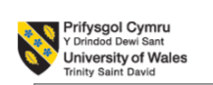

BMSW4012
Professional Career Development

C1- Reflection

Professional Career Development Reflection and Interview

Petru Alexandru Stanescu
2244013
09.11.2023

Table of Contents
Introduction 3
Kolb’s model 4
SWOT Analysis 4
SMART 6
Johari Window 6
PDP 8
Learning Styles 10
Conclusion 11
References 12

Introduction
By attending the Professional Career Development seminars, I set out on a path of development both in my professional and personal life. I have experience to work in a car wash business. These discussions presented me with new concepts and ideas that significantly changed my perspective on and strategy for professional growth. In this project, I will use Kolb's concept of experiential learning to reflect on how various models have affected my learning and development (Xie, 2023).

Kolb’s model
I will use Kolb’s model in this assignment. I have experience to work in a car wash business. The experiential learning framework proposed by Kolb has provided me with a useful foundation for both my personal and professional development. As a result of the classes, I entered the "Concrete Experience" phase of Kolb's model and created a personal development plan. I do a SWOT analysis and use the SMART criteria to establish both short-term and long-term objectives (Skakni et al, 2023).
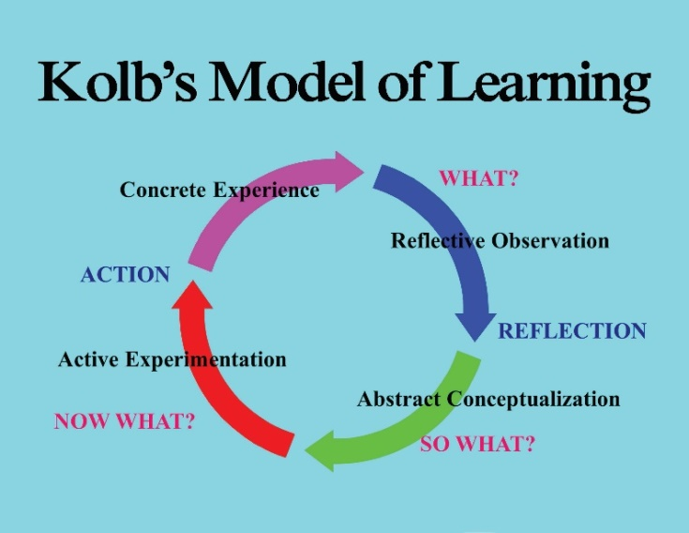

Figure: Kolb’s model (Sefora et al, 2023).

SWOT Analysis
Strengths  - The SWOT analysis looked like a useful tool that could help me gain perspective during the lectures when I was initially introduced to it  - My education taught me that my strengths and shortcomings are both internal to me, while opportunities and threats are both external (Skakni, 2023). | Weakness  - After being introduced to SWOT, I started to evaluate my personal and professional efforts with this structure in mind (Ruparel, 2023).  - I realized that my strengths included great communication abilities and a hunger for learning.  - However, I had imperfections including hesitation and a tendency to avoid conflict.
Opportunities  - At this point, I was actively implementing the SWOT framework into many different areas of my life. Trends in the sector and possibilities for professional networking were two of the opportunities I saw, while economic uncertainty was one of the risks (Sefora et al, 2023).  - To determine whether or not my business idea was viable, I used a SWOT analysis. By conducting this study, I was able to foresee possible obstacles (threats) in the market and adjust my business strategy accordingly (Skakni et al, 2023). | Threats  - I used the SWOT method to analyze my job options. A customer-facing position was where I knew I could shine because of my proficiency in communication (Ruparel, 2023).  - However, I also recognized my tendency to delay as a flaw that required improvement. I improved my time management and priority-setting skills to compensate for this deficiency and boost my employability (Xie, 2023).

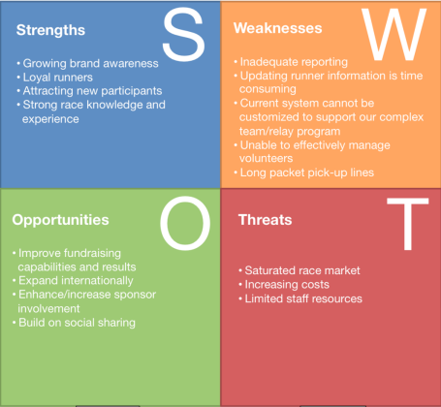
Figure: SWOT (Sefora et al, 2023).

SMART Analysis
Specific: The SMART goal-setting framework that I learned about in class was a real eye-opener for me. It stressed the value of having well-defined goals (Ruparel, 2023).
Measurable: As I discovered more about the SMART framework, I reflected on my history of goal-setting failures due to vagueness and a lack of an established deadline (Sefora et al, 2023).
Achievable: In place of a broad objective like "get a promotion," I wrote down the specifics: "achieve a promotion to managerial status within the following twelve-month period by finishing a program on leadership and taking on a management task." (Ruparel, 2023).
Relevant: I made it SMART (specific, measurable, attainable, relevant, and timely) by identifying the degree of proficiency I wanted to achieve, keeping track of my progress as I went, allocating a particular amount of time for each day, and establishing a deadline for reaching fluency
Time-bound: I've started using SMART criteria for each assignment and the overall project goals at work. I was better able to plan out the project, as well as monitor its development and make revisions as necessary (McDonald et al, 2023).

Johari Window
The Johari Window is a concept for reflection and communication. It helped me recognize my flaws and enhance my sense of self and ability to express myself.
Open Area: I made an effort to widen my "Open Area" by discussing my ideas and experiences with superiors and peers. My professional and personal development benefited from the enhanced teamwork and feedback that resulted (Ruparel, 2023).
Hidden Area: To grow as a person and advance professionally, I knew I had to put light on previously hidden aspects of my character and abilities. It helped me develop as a person by displaying these hidden qualities to select friends in a safe environment (McDonald et al, 2023).
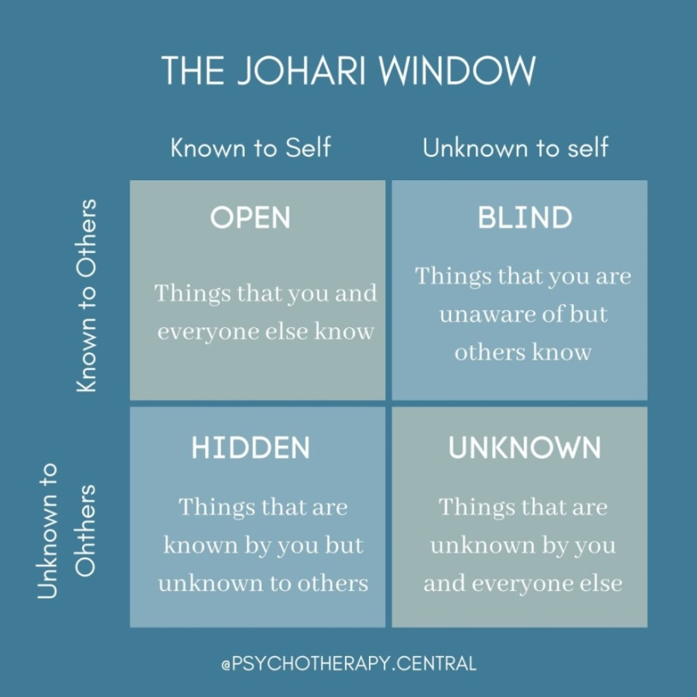
Figure: Johari Window (McDonald et al, 2023).

PDP
Personal Development Plan
Skills and competencies | Goals | Actions needed | Timescale | Criteria for success | Deadline
Customer service skills | To supplement my visual learning, I always make an effort to pay close attention to seminars and webinars. | I've found that combining the two helps me retain information far better (Fouad, 2023). | Although reading and writing are not my preferred methods of study, I still find them useful | Reading and taking notes or writing essays have helped me much with knowledge retention. | Within 7 months
Networking skills | I've broken my goals down into small portions, including participating in webinars relevant to my field, expanding my business network, and improving my public speaking abilities. | I was able to gain insight from my experiences and adjust my objectives through routine reflection sessions (Linardou et al, 2023). | Getting additional qualifications is part of my long-term plan to move up the corporate pyramid (Ruparel, 2023). | Of success, the "Reflective Observation" phase required me to assess the goal's viability and significance in light of my progress toward the shorter-term objectives (Fouad, 2023). | Within 7 months
Team working | I proactively pursued opportunities to engage in experiential learning.  Although auditory learning isn't my strongest point, I've come to appreciate its benefits (Linardou et al, 2023). | Discovering my learning style was another key component of my development.  I realized that this methodology may make a huge difference in my goal-setting strategy (Ruparel, 2023). | At this point, I had started actively implementing the SMART framework into many different areas of my life. I used SMART for my education goals (Fouad, 2023). | In this way, I've resolved to learn a new language better. I have formulated a SMART objective. | Within 7 months

Learning Styles
The fact that I acquire information best when it is presented visually or through physical activity has shaped how I approach learning VARK new material (Chaaban et al, 2023).
Visual Learning
I've started using more diagrams and mind maps as part of my study process. Because of this method, I was able to better understand the advanced material presented in class.
Auditory Learning: I found that I retain more information when I listen to lectures, podcasts, and debates rather than reading or writing it down (Ruparel, 2023).
Reading/Writing Learning: When I'm curious about something new, I usually start by reading a lot about it, making numerous notes, and then writing my summary of the most important parts (Chaaban et al, 2023).
Kinaesthetic Learning:- I actively engaged in kinaesthetic learning by participating in actual seminars, active modelling, and pursuing hobbies that required physical activity (de Jong, 2023).
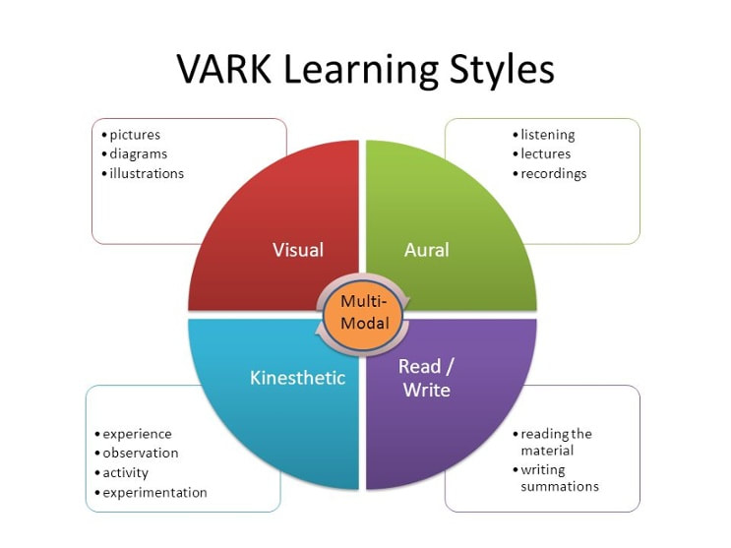
Figure: VARK Learning Styles (de Jong, 2023).

Conclusion
The Professional and Career Planning courses proved to be an eye-opening educational adventure, grounded firmly on Kolb's theory of learning through doing. These instances have become essential resources for personal development, business planning, peace of mind, and academic success. They have not only increased my understanding but also motivated me to continue my education and develop as a person. I'm excited to keep putting these lessons into practice and expanding my knowledge and skillset in light of this new information. This experience has prepared me for future growth and success in my personal and professional life (Chaaban et al, 2023).

References
Chaaban, Y., Alkhateeb, H., Abu-Tineh, A. and Romanowski, M., (2023). Exploring teachers’ perspectives on career development: Q methodology research. Teaching and Teacher Education, 122, p.103987.
de Jong, D., Kimby, E. and Specht, L., (2023). Career development: A balance of opportunities and choices. Hematological Oncology.
Fouad, N.A., Kozlowski, M.B., Schams, S.S., Weber, K.N., Tapia, W.D. and Burrows, S.G., (2023). Why aren’t we there yet? The status of research in women’s career development. The Counseling Psychologist, p.00110000231178539.
Linardou, H., Adjei, A.A., Bajpai, J., Banerjee, S., Berghoff, A.S., Mathias, C.C., Choo, S.P., Dent, R., Felip, E., Furness, A.J.S. and Garassino, M.C., (2023). Challenges in oncology career: are we closing the gender gap? Results of the new ESMO Women for Oncology Committee survey. ESMO open, 8(2), p.100781.
McDonald, K.S. and Hite, L.M., (2023). Career development: A human resource development perspective. Taylor & Francis.
Ruparel, N., Bhardwaj, S., Seth, H. and Choubisa, R., (2023). Systematic literature review of professional social media platforms: Development of a behavior adoption career development framework. Journal of Business Research, 156, p.113482.Tanvir
Sefora, S. and Ngubane, S.A., (2023). Career development for students with disabilities in an open distance learning institution: A narrative inquiry. Disability & Society, 38(3), pp.445-459.
Skakni, I., Maggiori, C., Masdonati, J. and Akkermans, J., (2023). Ready for careers within and beyond academia? Assessing career competencies amongst junior researchers. Higher Education Research & Development, 42(4), pp.968-983.
Xie, L.L., Luo, Z. and Zhao, X., (2023). Critical factors of construction workers' career promotion: evidence from Guangzhou city. Engineering, Construction and Architectural Management, 30(6), pp.2334-2359.

