HPAN4012
Theories of Visual Perception
(Summary based on Gross 2010: 233-238)

A fairly basic distinction can be made between theories, according to the direction of flow of information:
- Top-down processing (Constructivist Theories or indirect theories)
- Bottom-up processing (Direct Theories)

Constructivist Theories (Top-down Processing)
Gregory’s Constructivist Theory
“Perception is not determined simply by stimulus patterns; rather it is a dynamic searching for the best interpretation of the available data.” (Gregory, 1966)
Such inferential processing involves Top-down processing, whereby incoming sensory data is interpreted in the light of past experience - we construct the world through reference to stored schematic knowledge. This ability to refer to past knowledge means we can use our experience to advantage when drawing inferences about current events. Occasionally, such inferences will be wrong, and we will be mistaken. Nevertheless, Gregory’s view holds that the occasional error will be more than made up for by the overall advantages this brings to perception in terms of speed and efficiency.
The Ames Room Illusion – an example of misplaced perceptual interpretation (Ames 1952)
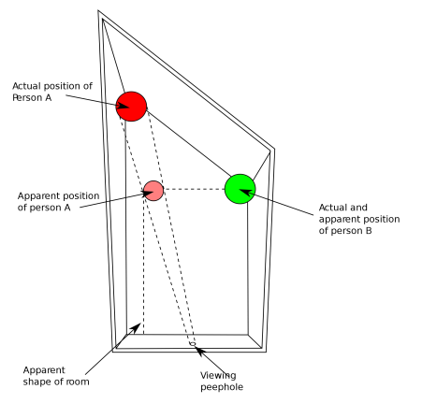
https://learningwiththeworld.wordpress.com/2013/10/18/redesign-my-brain-my-notes-and-thoughts/ https://en.wikipedia.org/wiki/Ames_room

https://www.youtube.com/watch?v=-IWk5NkxQF8 (10 optical illusions – includes Ames Room)
https://www.youtube.com/watch?v=NrlsCeR_MwA (How to make an Ames Room in model form)
https://www.youtube.com/watch?v=QWMFpxkGO_s (LOTR: forced perspective with moving camera) [Accessed 18.05.20]
The ability to make reference to past experience when interpreting the visual scene allows us to access information beyond its mere physical sensations in order to make better sense of our

observations. Gregory’s theory emphasises the active nature of perception and its recourse to schematic knowledge and hypothesis testing. Gregory holds that the perceptual constancies provide further evidence for the active, interpretive nature of perception, giving further weight to the notion of perception being an indirect process.
Gregory draws on evidence provided by visual illusions to demonstrate the role of past experience in perception. He explains the Muller-Lyer illusion as an example of misinterpreting size constancy and perceptual depth cues because of prior experience.
Perceptual set also provides supporting evidence for Gregory’s Top-down processing view of perception since, as Vernon (1955) suggests, perceptual sets actively help us to select and interpret incoming data (Gross 2010: 235).

Evaluation of Gregory’s Theory
- Groome et al. (1999) make the point that Gregory’s theory tends to provide adequate explanations when the incoming data is ambiguous in some way, but does not offer such an insightful explanation of the process under good viewing conditions (Groome et al., cited in Gross 2010: 235). Since much of Gregory’s ambiguous data involves visual illusions, Gibson’s (1966) major criticism of Gregory’s theory is that it lacks ecological validity.
- Gregory’s explanation for the Muller-Lyer illusion fails to satisfactorily explain the fact that the illusion persists even after we are aware of it, which should not be the case if we are bringing past experience to bear upon the problem. Also, the illusion still persists in the Delboeuf (1892) variation, when the arrow heads are replaced by circles;

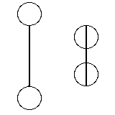
- In Gregory’s favour, Seagall et al. (1966) found supporting evidence for the ‘Carpentered World Hypothesis’, whereby Western participants were fooled to a larger extent than non-Western participants. Some cultures, such as rural Zulus for example, were not as susceptible since their buildings were circular and they had less experience of straight lines (Berry et al. 2002: 204).

Direct Theories of Perception (Bottom-up Processing)
Major theories here include Gestalt Theory and Gibson’s Theory of Direct Perception.
Direct Theories hold the view that perception is more of an automatic process, reliant upon lower order mechanisms able to interpret the visual field without the need of accessing higher levels of functioning, such as schemas.

Gibson’s (1966) theory of Direct Perception contrasts with Gregory’s Constructivist Approach. Instead of a Top-down approach, Gibson places greater importance upon the sensory mechanisms receiving the incoming data. Direct theorists therefore take a Bottom-up processing approach, believing many important aspects of perception are resolved by lower order mechanisms, without the need for guidance from higher order cognitive functioning.
Like Gregory, Gibson argues that perception is a direct, active process, which does not involve seeing things in a vacuum, but always in a context. In support of his view, Gibson points out that visual perception does not rely solely on a simple two-dimensional retinal image. It is more appropriate to think in terms of an ‘optic array’ when referring to the sophisticated layout of the retina which enables the position of objects in three-dimensional space to be determined due to a continual flow of data. As a result, he believes this provides a very rich source of information for the perceiver. Further visual cues, such as texture gradient, also help to clarify the perceptual situation.
Gibson also believes that the movement of light across the optic array provides important information. As we move around our environment, the pattern of incoming light creates patterns in this optic array. Gibson refers to this as the Optic Flow. Gibson argues this delivers important information, providing visual cues about the surrounding environment.

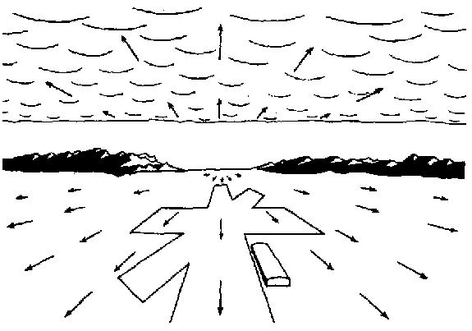
Idealised Flowfield: From Gibson’s book: The Perception of the Visual World (Gibson 1950: 125)

Gibson suggests that motion is the key to visual perception; if we have an ambiguous situation, a small movement of the head will resolve it due to a change in angle, or viewpoint. He argues that Gregory’s illusions are often not real tests of perception due to their two-dimensional status, which prevent further resolution by movement.
In this respect, Gibson was interested in aspects of perception which occurred in everyday life (He formed his theory partly as a result of his experience in helping to train pilots in WWII when he developed the idea of Optic Flow Patterns).

Another aspect studied by Gibson was texture gradient, which he suggests is automatically processed for, providing a useful depth cue for distance, without the need for inference, taking place at the most basic level of perception (Bottom-up processing).

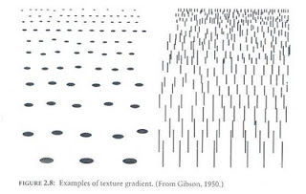
Examples of texture gradients (Gibson 1950: 83-86)

Gibson believed laboratory studies of perception were often devoid of context stimuli. Due to his emphasis on the need for ‘real-life’ context, Gibson’s theory is often referred to as an Ecological Theory of perception.

Evaluation of Gibson’s Direct Theory
- Unlike Gregory, Gibson believes there is little need to draw upon past experience when interpreting the world around us. Although his theory does little to explain the workings of visual illusions, Gibson suggests they are isolated tests of perception, lacking in ecological validity.
- Gibson has demonstrated that sensory data involved in visual perception is richer in information than was perhaps originally understood.
- His theory has been influential to the work of other researchers such as Marr (1980) and Neisser (1976); however, it is perhaps better to think of his theory of Direct Perception as being complementary to other theories, rather than providing a complete explanation on its own.

How can we reconcile Top-down and Bottom-up processing?
Read and make brief notes on Neisser’s (1976) Analysis by Synthesis or Cyclic Model of Perception
(See Gross: 238 or Sternberg: 140)

References

Berry, J.W., Poortinga, Y.H., Segall, M.H. & Dasen, P.R. (2002) Cross-Cultural Psychology, Research and Applications. Cambridge UK: Cambridge University Press.
Gibson, J.J. (1950) The Perception of the Visual World. Cambridge Mass. USA: The Riverside Press. Available at: https://archive.org/details/perceptionofvisu00jame [Accessed 18.05.20]
Gross, R.D. (2010) Psychology: The Science of Mind and Behaviour. London: Hodder Education.
Sternberg, R.J. (2003) Cognitive Psychology. London: Thompson Learning.

