ECIE4012
The Principles of Learning and Teaching

Portfolio

Student Number: 2215303

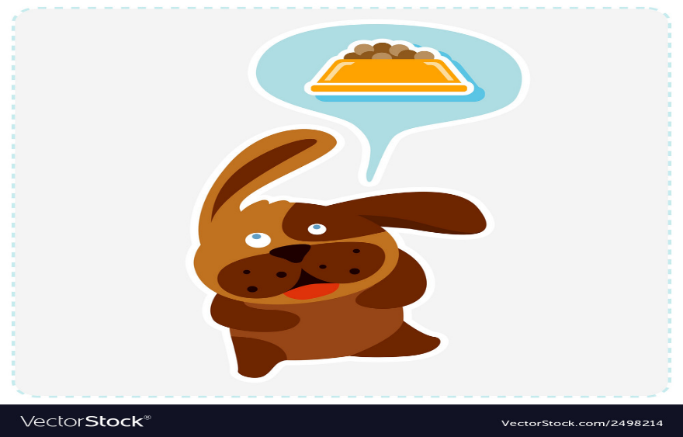
What could happen if I just used my brain?

(VectorStock, n.d.)

Every morning without fail as soon as I open the door to my fridge, my dog runs into the kitchen and sits instantly in a place he knows il see him, He hears the sound of the jars in the door clink together and this triggers a response in him to run to the kitchen as he knows he’s about to have his first meal of the day, my dog was not born to have this response to a fridge door opening but rather something he has learnt along the way , over time, when preparing his meal, I would call his name and wait for him to arrive then I would say the command ‘Sit’ and once he did this id place his food on the floor, I would do this every single day twice a day, until he learnt that his response to my command would result in a positive reinforcement .. food. Now the only step I need to do is open the fridge and prepare the food, my dog has learnt the following steps and does this without prompting, this simple morning routine that I have with my dog made me think about a psychologist theory by Burrhus Frederic Skinner, now you’re probably thinking, how on earth can a dog eating and a theory by a psychologist have anything in common? Well, if you’re interested to know how I think you should read on.
My story about my dog isn’t as random as it seems as Skinner did his early research on behaviourism on animals too, rats and pigeons to be exact, Skinner would box these animals and withhold food from them, well almost withhold it, the food was always there but they just had to ‘use their brain’ to find it, once they learnt that pushing a button or pulling a lever would release the food for them. Their hunger would become so strong that they would try anything they can inside the chamber their in to find a way to eat. “Skinner came to the conclusion that some form of reinforcement was crucial in learning new behaviours.” (Biography.com Editors, 2021) Skinner believed that people can learn behaviours from the type of reinforcement they receive from doing it, for example its used in schools daily without even realising its being used , if you think back to when you where in school and your teacher offered you the class a reward for finishing your work or a project, this would be an example of his theory in action, if the teacher (the reinforcer) offers an hour of golden time on Friday if everyone in the class finishes their work (the behaviour that is wanted from the teacher), over time if students got distracted and didn’t finish their work causing the class to miss out on golden time, the desire is that eventually they will realise their work will gain them reward and then the desired behaviour will be learnt.

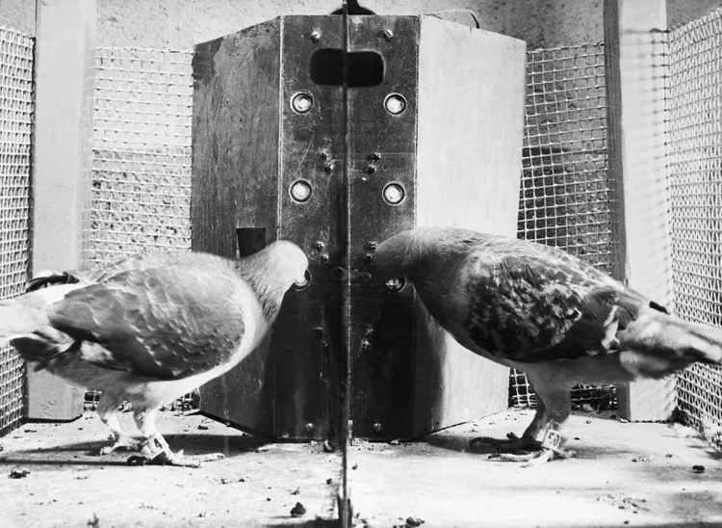
This theory is used every day and is proven to have a lot of successful benefits to behaviourism in schools, work places and every day life but it doesn’t come without some negative aspects, if we ignore the obvious negative points to his research using animals and withholding food from them to get a reaction from them, in the classroom Skinners theory on behaviourism sometimes neglects the fact that some people have different learning needs, behaviour needs and everyone achieves things in different ways and or at different time frames, however these issues are easily adaptable in this present time as in schools, learners have personal plans to work towards their education, I myself work in a special school and every single learner in my class has a plan the teacher and staff help them follow in regards to their learning and their behaviours in class, its not a one shoe fits all system and it really works. “Critics argue that Skinner's theory focuses too much on observable behaviour and neglects the role of internal mental processes such as thoughts, emotions, and motivations.” (Quora, n.d.)
(Cherry, 2021)
So, skinners theories really do make you think, what could happen if I just used my brain?

Blog 1: Reference list
Biography.com Editors (2021). B.F. Skinner - Theory, Psychology & Facts. [online] Biography. Available at: https://www.biography.com/scientists/bf-skinner.
Cherry, K. (2021). Skinner Box or Operant Conditioning Chamber. [online] Verywell Mind. Available at: https://www.verywellmind.com/what-is-a-skinner-box-2795875.
VectorStock. (n.d.). Cute cartoon dog is thinking food vector image on VectorStock. [online] Available at: https://www.vectorstock.com/royalty-free-vector/cute-cartoon-dog-is-thinking-food-vector-2498214

Quora. (n.d.). What are the disadvantages of Skinner’s theory? [online] Available at: https://www.quora.com/What-are-the-disadvantages-of-Skinners-theory#:~:text=Some%20of%20the%20disadvantages%20include

We are what we see. We are products of our surroundings.( Amber Valletta)

If someone told you to read a book about how to drive a car, and then told you to attempt to drive that car on a main road during the daytime, do you think you could do it? In theory you’d have read all the information that is needed to know how to operate the car, and what you’d need to do to and when to do it, so why not? Well because there is so much more that goes into driving than just how to operate and drive the car, you need to learn to be aware of your surroundings, the distance you should leave between cars, the timings on when to pull out of junctions , to listen out for oncoming cars is only to name a few, these are things that reading from a book just could not teach you, Theorist John Dewey believed that “genuine learning only occurs when we actively engage with an experience, interact with our environment or work through a scenario” (Cloke, 2023) ,Dewey believed that to truly learn about something you need to be involved practically, and experience things in real time and in real life.

Of course, this does not mean that no reading should be done when it comes to learning, because just like driving you need to research and revise for your theory test before you can complete your practical test, but even so the things you learn from your driving lessons will give you a lot of the answers you need in your theory test.
(www.istockphoto.com, n.d.)

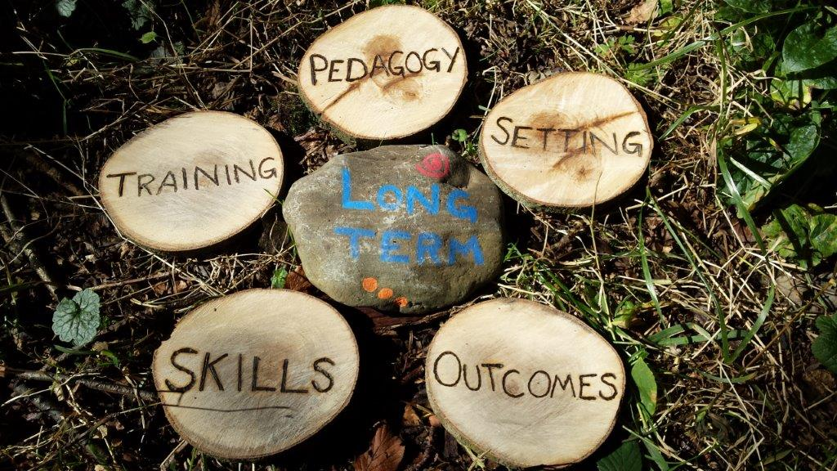
Part of Dewey’s theory was that he believed it was down to the staff in school and the teachers to ensure that learners were given the opportunity to learn and explore lots of different ways of learning, rather than just putting pen to paper. He believed that children should explore and learn things out and about and in hope that this way of learning would create more ways of thinking critically and encouraging their creative side. Dewey believed that “Students should be active, not passive.” (Gibbon, 2019) and this really showed in his work over the years, it is believed that Dewey’s theories really inspired the way schools worked and encouraged them to teach learners from all backgrounds vital skills they’d need to go straight into a workplace, his hands on approach set them up really well for working life and would really set them up for a love for hands on work. Dewey believed that the education for children should be “based on the child’s own experiences, and that the method of teaching should vary based on the child’s interests” (Pio and Assistant, n.d.). As amazing as that sounds, if everything that got taught in school was based on each individual child’s interests, I think it would be very difficult to do that for every single child’s individual interest. If we followed Dewey’s theories fully in schools it’s a worry to some that some students would start to lack in the academic skills they need to get by in life, “Others were fearful that classroom order and the teacher's authority would disappear.” (The Institute of World Politics, 2018), I think that his theories are very inclusive and everyone can achieve what he believes with the correct opportunities presented to them, people from all walks of life and all academic ability will benefit from a hands on approach to aspects of their learning but I do agree that there needs to be a balance of academic learning and hands on learning this balance would create a great way of learning without missing out basic necessities in their education.
(Lax, 2018)
A brilliant example of hands on learning is the forest school program, it is a couple of hours a week of outdoor, hands on learning, this program I have seen first hand and it is so beneficial for so many reasons, it encourage students to go outdoors, get fresh air and exercise, they’re encouraged to forage for leaves , twigs and other things in order to create something else, like a camp fire. Some students who have parents that work full time or children that live in really built-up areas that wouldn’t always have much access to activities outside thrive from this type of learning, it helps team bonding between classmates and overall is a really great form of hands-on learning in schools today. Dewey’s theories where thought of many years ago in the 30’s/40’s but programs like this show how we can incorporate his work into modern day education. After all, nothing beats the great outdoors, whether that’s a drive in the car or a lesson in the forest, I think we can all use a bit of a hands-on approach, don’t you?

Blog 2: Reference list
Amber Valletta Quotes. (n.d.). BrainyQuote.com. Retrieved December 29, 2023, from BrainyQuote.com Web site: https://www.brainyquote.com/quotes/amber_valletta_388105
Cloke, H. (2023). John Dewey’s Learning Theory: How We Learn Through Experience. [online] Growth Engineering. Available at: https://www.growthengineering.co.uk/john-dewey/#:~:text=The%20Role%20of%20Experience%20in.
Gibbon, P. (2019). John Dewey: Portrait of a Progressive Thinker. [online] The National Endowment for the Humanities. Available at: https://www.neh.gov/article/john-dewey-portrait-progressive-thinker#:~:text=In%201899%2C%20Dewey%20published%20the.
Pio, A. and Assistant, A. (n.d.). Relevance of Educational Thoughts of John Dewey to the Present Educational Context - Perception of Middle School Teachers in Sivagangai District.
Lax, M. (2018). Some More Thoughts on Forest School. [online] Rewilding Adventure. Available at: https://www.rewildingadventure.co.uk/some-more-thoughts-on-forest-school/
The Institute of World Politics. (2018). The Tragedy of American Education: The Role of John Dewey. [online] Available at: https://www.iwp.edu/articles/2018/02/01/the-tragedy-of-american-education-the-role-of-john-dewey/#:~:text=Some%20critics%20believed%20and%20still.
https://www.worldwidejournals.com/paripex/recent_issues_pdf/2016/October/relevance-of-educational-thoughts-of-john-dewey-to-the-present-educational-context--perception-of-middle-school-teachers-in-sivagangai-district_October_2016_0990456192_3905818.pdf.

Learning, is it mind over matter?

Is the secret to learning mind or matter? Are our behaviours moulded by the reactions we get from others, or do you think the way we think is all because of the surroundings we are exposed to? B.F Skinner believed that reinforcement and giving punishments, would help mould the learner to learn a behaviour or skill that is desired by the teacher or parent, is it really possible to shape the mind with the hope of seeking a reward at the end or from the fear of getting a punishment, to some this might sound extreme but it’s a tactic used in schools and homes everywhere , probably without even realising it? Have you ever found yourself saying to a family member, do the dishes for me and il give you my last chocolate bar or If you don’t clean your room you’re not allowed to go out to play, well this is Skinners theory in action in everyone’s everyday life, it doesn’t seem so radical then does it? Although in his original research it wasn’t the most humane practise, using live pigeons and mice to do his research some people frown upon this method however back in the 30’s/40’s things like this wouldn’t be frowned upon or questioned. “If children experience a positive consequence after a behaviour, they are more likely to repeat that behaviour again in the future.” (Cherry, 2023). Skinner’s approach is referred to as ‘Radical behaviourism’ as his approach is quite radical, but it just makes sense.
John Dewey is another theorist who believed that the way we learn is highly impacted by our surroundings, the environment we learn in and the resources we are presented with in the space we learn In, he believes in a much more hands on approach to learning which I believe is a very beneficial way of learning and has a lot of benefits, he is believed to think that “Progressive education is essentially a view of education that emphasizes the need to learn by doing.” (Study.com, n.d.)
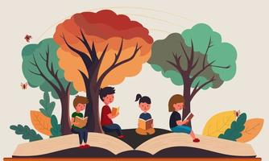
Both of these theories are very valuable pedagogies used in everyday practise and although both are theories researched many years ago the way we teach children and adults to this day still follows similar values and methods.
(Vecteezy, n.d.)
I could talk about the positives to these theories for paragraphs and paragraphs but it wouldn’t be an accurate evaluation of them if I didn’t touch upon some of the not so positive outlooks on them, I’ve already mentioned how skinners radical beliefs come under fire for the mistreatment of animals but it’s also believed that he didn’t take in to consideration some of the flaws in his work in regards to children that cant always follow simple instructions or children who simply don’t care about the rewards at the end of the task, even some children having the approach that any attention is good attention meaning that a punishment to them is still giving them social gratification because its attention from someone, all of these things can be a result of many different things like a child with ALN, their home life, and not being exposed to a wide variety of social situations meaning that this theory is not a one size fits all and although successful is some aspects, not successful for all, but in life I don’t think everything would be so straight forward as life would be pretty boring if it was and a lot of these theorists would have been out of a job.
Dewey’s theory similarly didn’t take into account the different setbacks some learners face in life and that they wouldn’t always be given equal opportunities to be hands on, there are many different factors that can play in this like funding in schools, location of the school like Forrest school but you live in the centre of London. It would be pretty hard to achieve, of course back in the 1880’s forest school wasn’t a thing so that wouldn’t have been able to come into his process of thought but I’m sure there would have been similar obstacles to learning.
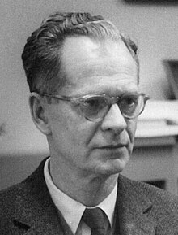
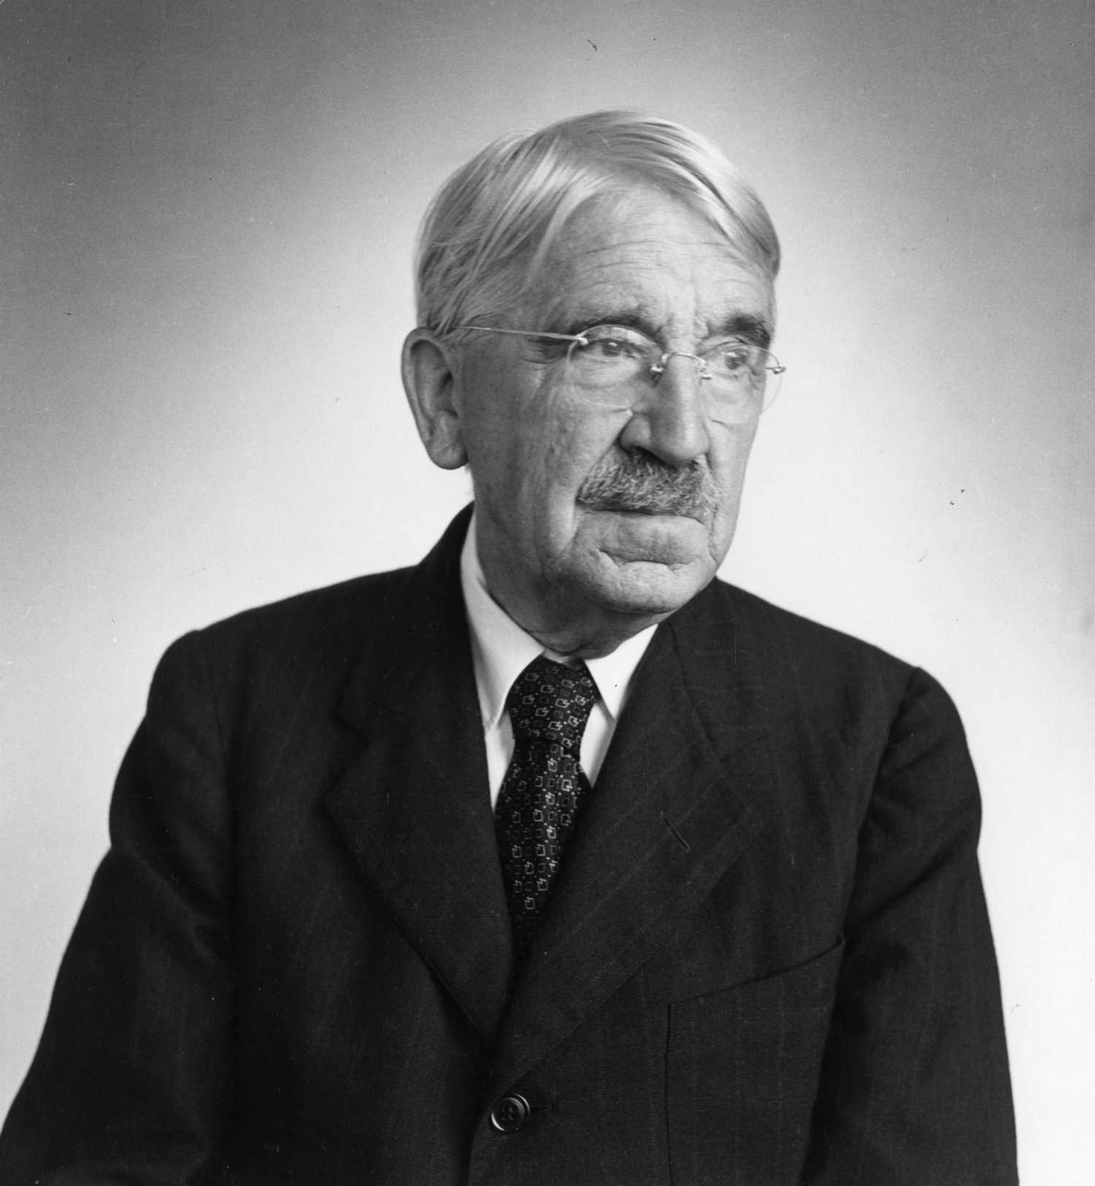
John Dewey and B.F skinner both lived to reach their late 80’s/90’s and watched the world of education evolve around them, they both have extensive years of experience and are very well educated, this is why their theories are believed to be well trusted and used to this very day, although they have a modern spin on them now and other theorists and people in education take these theories and add their own twist to them to adapt to the new world we live in. Depending on how you look at these theories do you think learning is mind or matter?
Picture of skinner(Wikipedia Contributors, 2019) Picture of John Dewey (Kendra Cherry, 2018)

Blog 3: Reference list

Cherry, K. (2023). B. F. Skinner: The Life of Psychology’s Radical Behaviorist. [online] Verywell Mind. Available at: https://www.verywellmind.com/b-f-skinner-biography-1904-1990-2795543#:~:text=Skinner%20believed%20that%20all%20learning.
Kendra Cherry (2018). John Dewey’s Instrumental Contributions to Educational Philosophy. [online] Verywell Mind. Available at: https://www.verywellmind.com/john-dewey-biography-1859-1952-2795515.
Study.com. (n.d.). John Dewey on Education: Impact & Theory - Video & Lesson Transcript. [online] Available at: https://study.com/academy/lesson/john-dewey-on-education-impact-theory.html#:~:text=The%20Views%20of%20John%20Dewey.
Vecteezy. (n.d.). Download Free Vectors, Clipart Graphics, Vector Art & Design Templates. [online] Available at: https://www.vecteezy.com/free-vector/outdoor-learning [Accessed 3 Jan. 2024].
Wikipedia Contributors (2019). B. F. Skinner. [online] Wikipedia. Available at: https://en.wikipedia.org/wiki/B._F._Skinner.

The world is changing!


This year it will be 10 years since I left secondary school, which in the grand scheme of things doesn’t sound like a very long time but if we step back and look at how much the world has changed in 10 years , it goes without saying that A LOT can change in that time, we’ve had multiple royal weddings in the UK, America has had 3 different presidents, Wars have ended and started, and so much more but one thing that has really evolved and changed is the resources and support that is offered in schools in the UK, when I was in school, the support was there but it was limited, 1:1 support was something rarely seen, classes would have an LSA if enough students in the classroom needed support, they had a school counsellor in one a couple of days a week, and a portion of students would have free school meals but that’s about as far as the support went, a lot of students would fall through the cracks and not get the support they needed, but as the world has changed luckily so has the education system, the interventions available today are really inclusive and offer support to every learner that needs it.
(creazilla.com, n.d.)
I work in a special school for learners aged 3 to sixth form, so the range of support and interventions are amazing and help the learners and their families significantly, from feedback from families and personal plans for the learners we monitor what works and what doesn’t work for each specific learner as of course not everything works for every learner, I have worked in a secondary school in the LRC and I’ve worked in a special school so I’ve seen a wide range of support being offered to learners and some of the ones that have really stuck out to me are;
- Play therapy.
- Respite support.
- Sensory therapy.
- Free school meals.
- Forrest school.
- Transport to and from school regardless of distance.
John Dewey believed in a hands on approach to learning and for a student with ALN this can be an issue, sometimes a part of ALN makes it difficult for them to join in with group activities or even on a 1:1 basis, sometimes they’d rather just observe and take it all in, an intervention like play therapy is a really useful tool to get them involved with playing, helping them to use their imagination and enjoy using their hands to have fun. “Play therapy allows a child to make choices, take risks, fail and problem solve which builds their self- esteem, their resilience and their internal resources.” (Information for Schools, n.d.)
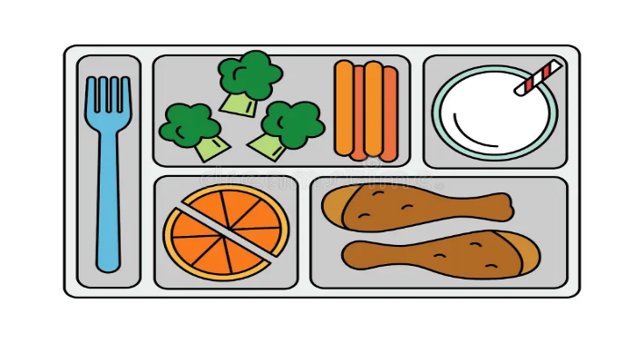
Free school meals, respite support and school transport are really beneficial to helping families out, and making their life as easy as possible in as many ways as possible, and even though they help parents/guardians/care givers out they really do benefit the student too, transport to school can be really helpful with reducing anxiety and being put into situations they might not have been used to like going to school without their parents or guardians, helping them to trust school staff and getting used to journeys on the bus or taxi can help with any time they need to take transport outside of school. Free school meals being available to everyone is an amazing recourse and takes a big strain off financial worries for families, the main objectives for the scheme are “tackling child poverty, ensuring no child goes hungry in school, there are also wider benefits of free school meals, including: promoting healthy eating across the school, increasing the variety of food options, improving social skills at mealtimes, improving behaviour and attainment” (Welsh Government, 2022)
(Dreamstime, n.d.)
Forrest school is great for getting pupils and students in the great outdoors, it’s amazing for exercise, mental health, expanding students’ curiosity and is something to look forward to for them, from working in a mainstream secondary school in the past I seen it used a lot as a reward or taken away as a punishment for bad behaviour, B. F Skinner based most of his theories and research on the basis of operant conditioning, he believed that students could be conditioned to learn with a reward or punishment, Forrest school would be used as a reward to students and because they loved it so much, they made sure to get their work done and behave, when the idea that they wouldn’t be able to attend this intervention was mentioned they would apologize and rectify their mistakes, its amazing what can happen when the thought of something they enjoy so much can be taken away from them, although I didn’t always agree with this approach as I believe everyone deserves to have access to outdoor learning , it’s a strategy that although at times radical it really does work for the most part.
I really wonder how my experience in school would have been if I had all these resources on offer, and although a lot of them wouldn’t apply to me, I’m sure we all had some friends in school who we always knew could have done with a helping hand in school or at home, but as the world is changing and hopefully education keeps following in the footsteps of the world, I cant wait to see what else there will be to offer!

Blog 4: Reference list
creazilla.com. (n.d.). School clipart. Free download transparent .PNG | Creazilla. [online] Available at: https://creazilla.com/nodes/63211-school-clipart.
Dreamstime. (n.d.). School Lunch Stock Illustrations – 10,684 School Lunch Stock Illustrations, Vectors & Clipart. [online] Available at: https://www.dreamstime.com/illustration/school-lunch.html.
Information for Schools. (n.d.). Available at: https://operationdiversityacademy.co.uk/wp-content/uploads/2019/01/Operation-Diversity-Play-Therapy-Information-for-Schools.pdf.
Welsh Government (2022). Universal Primary Free School Meals (UPFSM). [online] GOV.WALES. Available at: https://www.gov.wales/universal-primary-free-school-meals-upfsm.

