

Data Security, Governance and Compliance

Programme Name: MSc Cybersecurity & Digital Forensics
Module Name: Data Security, Governance and Compliance
Module code: ACCA7028
Lecturer: Dr DIPO DUNSIN
Student Name: Babariya Ashthaben Girishbhai
Student ID: 2507706

Abstract
The fast utilisation of cloud computing, wireless networks and bring-your-own-device (BYOD) has greatly exposed organisations to risks of data security, governance and compliance. In this report, the author studies the implementation of the existing information security frameworks in the setting of the multinational organisation NatureGreen (NG), with a broad digital and wireless presence. Such recognised frameworks as ISO/IEC 27001 and ITIL are examined to find out best practices in information security in complex and distributed environments. Based on the findings of this review, a specific security governance and compliance strategy is suggested to help NG solve the issue of its data protection, risk management, regulatory compliance, and intellectual property protection. The report also critically discusses why it is important to keep on reviewing regulations and standards related to security in relation to changing technologies and cyber threats. The results prove that a combined, governance-based, and risk-oriented security strategy is the key to guaranteeing the protection of organisational information value and sustainable business processes.
Table of Contents
Introduction 4
Literature Review 4
Introduction to Frameworks of Information Security. 4
ISO/IEC 27001 Information Security Management System (ISMS). 5
ITIL and Service-Oriented Security Governance. 6
NIST Cybersecurity Framework. 6
COBIT and Enterprise Governance of IT. 7
Comparative Analysis and Relevance to NatureGreen 7
NatureGreen Security Design Approach 7
Assumptions 8
Governance and Strategic Security Planning. 9
Compliance and Security Policies. 11
Risk Management and Protection Mechanisms. 12
Contingency Planning and Service Level Agreements. 16
Summary of the Proposed Approach. 16
Critical Discussion: Regulations & Standards 16
Conclusion 17
References 19

List of Tables
Table 1 : Key Information Assets at NatureGreen (NG) 8
Table 2:Risk Register 13

List of Figures
Figure 1 : Integrated Security Governance Model for NatureGreen 10
Figure 2 : BYOD Security Control Model for NatureGreen 11
Figure 3 : Information Security Risk Management Lifecycle Applied at NatureGreen 13

Introduction
The recent phenomenal pace of growth of cloud computing, wireless networking, and bring-your-own-device (BYOD) practices have created significant vulnerability of organisations to the threats of data security, governance and compliance (Datta, Shinu Abhi and Kumar, 2024). This report examines the application of the data security and data governance frameworks to the case of the situation at NatureGreen (NG), a multinational organisation that is proud of having a large scale digital and wireless presence. The study has reviewed distinct security framework models and models like ISO/IEC 27001 and ITIL to establish what best practice can be applied in the current information security management (Merchan-Lima et al., 2020). According to such models, the specific security governance approach is developed in relation to the issues of NG in the context of data security, regulatory adherence, risk control, and intellectual property protection. Besides that, the report is critical of the manner in which security regulations and standards should be continually updated to reflect the dynamic technological, legal and threats landscape. The findings show that safe management of information assets by organisations in the tricky digital settings demands organised, pliable and governance directed security plan, which is essential in ensuring confidentiality, information integrity and availability of information assets.

Literature Review
Information security models and frameworks give organisations an organised way of managing risks, securing information assets and ensuring that organisations are in compliance with the law and regulations. Abdulsalam and Hedabou (2021) theorise that with increased use of cloud computing, wireless networks, and mobile technologies in organisations, well-known security frameworks are now needed to ensure the confidentiality, integrity, and availability of data. The frameworks also complement the governance of organisations by aligning the security goals to the business approaches and facilitating efficient reaction to cyber threats which keep on changing.

Introduction to Frameworks of Information Security.
Information security frameworks refer to formalised policies, procedures, controls, and best practices that are aimed at assisting organisations to handle information security in a systematic and uniform way. According to Reuben-Ohew and Haig (2025), ISO/IEC 27001, ITIL, the NIST Cybersecurity Framework, and COBIT are popular frameworks that are appreciated because they can be applied to various industries. These frameworks give high-level principles and control structures which organisations may adapt to their operational and regulatory environments as opposed to prescribing particular technologies.
In the case of global organisations like NatureGreen, that rely so much on cloud services, wireless infrastructure, and bring-your-own-device (BYOD) practices, security frameworks provide a standard and auditable way of managing complex security environments. By pointing out that such frameworks are also vital to regulatory compliance, Srikrishna and Murthy (2024) note that these frameworks introduce security controls, which are in tandem with data protection and privacy laws.

ISO/IEC 27001 Information Security Management System (ISMS).
One of the best known global information security management standards is the ISO/IEC 27001. The standard offers a risk-based and systematic method of creating, executing, sustaining, and continuously enhancing an Information Security Management System (ISMS) (Alrehili and Alhazmi, 2024). It focuses on the discovery of information assets, evaluation of risks, and the identification of the right controls in order to counter the identified threats.
One of the strengths of the ISO/IEC 27001 is its risk-based approach. Organisations must discover the threats and vulnerabilities, evaluate the risk probability and impact, and provide corresponding security measures. This method is especially appropriate to the dynamic environment, i.e. cloud-based and wireless networks, in which the risks can develop quickly. The standard is facilitated by the controls of Annex A, which cover such areas as access control, cryptography, physical security, incident management, and relationships with suppliers.
Even with the strengths, ISO/IEC 27001 is limited in a number of ways. Alrehili and Alhazmi (2024) observe that the implementation process may be resource-consuming, which would demand a lot of time, knowledge and organisational dedication. The certification process can be expensive and complicated to smaller organisations or those that are fast growing. Moreover, the standard does not have extensive technical implementation advice, despite offering a comprehensive control framework, which may require some supplementary standards and best-practice documents to be used.

ITIL and Service-Oriented Security Governance.
Information Technology Infrastructure Library (ITIL) is an information technology best-practice model of managing IT services that aims at aligning IT services to commercial goals. Although ITIL is not a specific security framework, it has a profound influence on security governance since it integrates security management in the service design and transition, operation, and continuous improvement.
As Swain and Garza (2022) note, ITIL provides information security with its focus on service availability, incident management, change management, and service level agreements (SLAs). The factors are especially applicable to the cloud-based world, where the reliability of the services and reliance on third parties present new security threats. ITIL governance-based practice makes sure that the security is addressed as a continuous service and not as a single-time technical application.
The business alignment is one of the primary strengths of ITIL. Organisations can achieve efficiency in the operations and customer satisfaction by ensuring that the security controls advance the service management processes through the incorporation of security in service management processes. Nevertheless, Swain and Garza (2022) also emphasize that ITIL does not have detailed security controls, and it is most effectively utilized with other standards like ISO/IEC 27001.

NIST Cybersecurity Framework.
The NIST Cybersecurity Framework (CSF) has served as a versatile and top-level model of cybersecurity risk management. It is designed with five fundamental functions, namely, Identify, Protect, Detect, Respond, and Recover. This functional structure allows organisations to determine the present security posture and improve them according to the level of risk exposure.
Edwards (2024) suggests that NIST framework can be especially helpful to organisations that run their activities in a complex and dynamically changing digital space because it allows ongoing monitoring and gradual enhancement. It is flexible and enables organisations to integrate controls to the unique circumstances of operations such as cloud computing and wireless infrastructures. Nonetheless, just like ISO/IEC 27001, the framework needs to be interpreted and customised carefully, which can be a challenge to organisations that have in-house security specialisation.

COBIT and Enterprise Governance of IT.
COBIT emphasizes business goals, risk management and compliance of information and technology governance in the enterprise through the aligning of IT processes with business goals. According to Setyadi and Abdul Rahman (2025), COBIT is especially topical when an organisation aims to build information security governance into the framework of corporate governance.
One of the strengths of COBIT is that it is focused on accountability, performance measurement and strategic alignment which is appropriate to organisations that have international operations and complicated regulatory requirements. It is noted, nevertheless, that COBIT is frequently viewed to be quite high-level and abstract, and the integration with more operational frameworks is needed to reach successful security implementation (Setyadi and Abdul Rahman 2025).

Comparative Analysis and Relevance to NatureGreen
The individual strengths and weaknesses of each framework under the common review have been identified. The ISO/IEC 27001 offers a strong and certifiable security management system, ITIL facilitates service-based governance, and the NIST framework facilitates an adaptive risk management system, and the COBIT enhances strategic oversight. To provide an all-encompassing and balanced solution to NatureGreen, an integrated approach that makes use of ISO/IEC 27001 as a security control tool, ITIL as a service management tool and COBIT as a governance tool would be the most suggestive.
To conclude, the literature shows that none of the frameworks stands alone. To ensure effective data security, governance, and compliance, several frameworks should be integrated to deal with the technical, organisational and strategic issues. This combined strategy is the basis of the customized security design suggested to NatureGreen in the following section.

NatureGreen Security Design Approach
This part offers an information security, governance and compliance design recommendation to NatureGreen (NG), depending on the circumstances of operation of the organisation and the security challenges identified. The solution will focus on the wide use of cloud services, wireless networks, and bring-your-own-device (BYOD) strategies by NG, as well as an assurance that sensitive organisational data, customer information, and intellectual property remain secure. The suggested design incorporates governance, policy development, risk management, protection mechanisms, contingency planning and service-level management to establish a designed and sustainable security environment.

Assumptions
The given security design is suggested on a number of assumptions that are based on the NatureGreen scenario. First, NatureGreen is presumed to be a huge multinational enterprise working in different geographical areas, which have different legal and regulatory mandates. Second, the organisation is also presumed to have heavy use of cloud-based infrastructure offered by third party services with little on-premise systems. Third, the assumption is that around 95 percent of the network hardware of NG is wireless, exposing the organisation to unauthorised access and network based attacks. Fourth, the organisation also allows BYOD, both to its staff and customers, which creates further risks of endpoint security and data leakages. Lastly, there is an assumption that NatureGreen does not have a consolidated and formally documented security governance practice at the moment, which leads to the existence of irregular security practices throughout the organisation.
Table 1 : Key Information Assets at NatureGreen (NG)
Information Asset | Description | Sensitivity Level | Business Impact if Compromised
Customer Personal Data | Personal and contact information of customers collected through online platforms and services | High | Severe reputational damage, regulatory penalties, loss of customer trust
Employee Personal Data | Staff records including identification, payroll, and employment information | High | Legal consequences, breach of privacy laws, loss of employee confidence
Intellectual Property | Proprietary product formulations, research data, and trade secrets | High | Competitive disadvantage, financial loss, erosion of market position
Financial Records | Financial statements, transaction data, and budgeting information | High | Financial fraud, regulatory scrutiny, operational disruption
Cloud Infrastructure Data | Configuration data and access credentials for cloud services | High | Service disruption, unauthorised access, large-scale data breaches
Wireless Network Credentials | Authentication details for internal wireless networks | Medium | Network intrusion, unauthorised system access
Marketing and Social Media Content | Digital content used for branding and customer engagement | Low | Minor reputational impact, limited operational disruption
Operational Business Data | Internal reports, performance metrics, and operational procedures | Medium | Reduced efficiency, poor decision-making, competitive exposure

Governance and Strategic Security Planning.
The appropriate governance is a very important backbone of the proposed security design. NatureGreen ought to develop an official information security governance framework that will align the security goals with the organisational strategy. This must have a good leadership on information security that must be backed by agreed roles and accountability at all the levels of the organisation. The involvement of senior management is needed to make sure that the security initiatives will be provided with necessary resources and incorporated into business-level decision making.
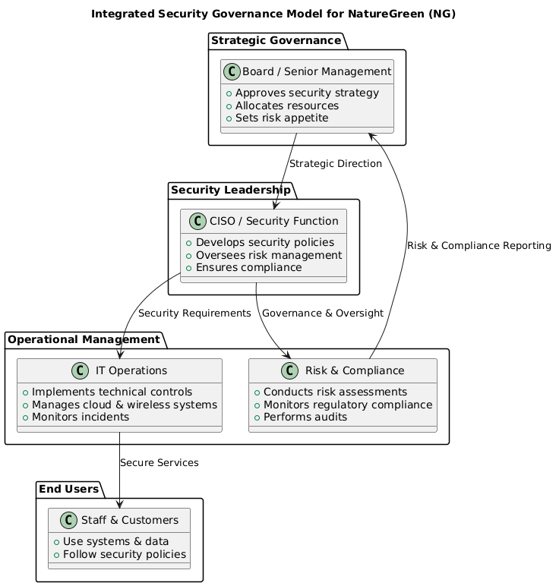
Figure 1 : Integrated Security Governance Model for NatureGreen
Source: Self-made (Adapted from (Marquez-Tejon, Montserrat Jiménez Partearroyo and Benito-Osorio, 2023).
Strategic security planning is expected to be concerned with integration of security concerns in organisational planning processes (Marquez-Tejon, Montserrat Jiménez Partearroyo and Benito-Osorio, 2023). This involves the alignment of the security objectives with the business objectives, risk tolerance, and regulatory requirements. The security strategies must also be updated on a regular basis as a reflection of the changes in the operational environment of the organisation e.g. the adoption of more clouds or venturing into new markets. It should also adopt governance mechanisms like regular reporting, internal audits and performance metrics to check on the effectiveness of security and compliance.
NatureGreen can make sure that the issue of information security is regarded as an organisational priority instead of a technical operation by instituting effective governance and strategic control. This will foster uniformity, responsibility and sustainability of security practices.

Compliance and Security Policies.
Security policies give stability to the consistency and enforceability of security behaviour within the organisation. NatureGreen ought to come up with a set of elaborate security policies that outlines acceptable practices, responsibilities, and mechanisms of enforcement. The top management should endorse these policies and make them known to all the stakeholders.
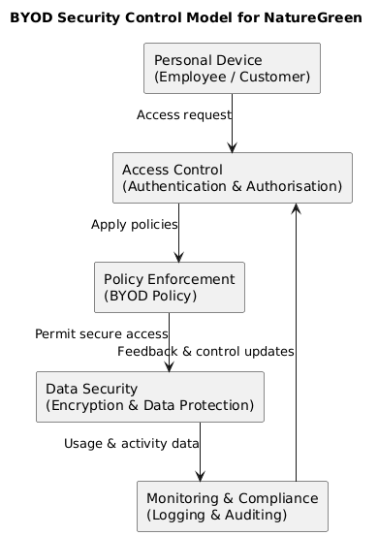
Figure 2 : BYOD Security Control Model for NatureGreen
Source: Self-made (Adapted from Palanisamy, Norman and Mat Kiah, 2020).
The policies that should be key include data protection policy, BYOD policy, access control policy, and acceptable use policy. The data protection policy must stipulate the manner in which sensitive information such as customer information and intellectual property are gathered, processed, stored, and published. It must also define the levels of data classification and handling. The BYOD policy must also stipulate the minimum security levels of personal gadgets, limitations on access to sensitive systems, as well as device registration and tracking (Palanisamy, Norman and Mat Kiah, 2020).
The principle of least privilege should be applied in access control policies to ensure that the information and systems accessible to the user are restricted to those required by his or her position. The systems of compliance should also provide frequent review of the policies, staff training, and monitoring of activities to guarantee compliance. NatureGreen can minimize security threats posed by human factors and facilitate rules and regulations by enacting clear, enforceable policies.

Risk Management and Protection Mechanisms.
The proposed security design includes the risk management. To address information security risks in its cloud, wireless, and BYOD environment, NatGreen needs to implement a formal risk management strategy to address, evaluate, and treat these risks. Risks identification must take into consideration both internal and external threats such as cyberattacks, unauthorised access, data breaches and disruptions of services (Norozpour Sıgaroodı, SAJEDEH, 2025).
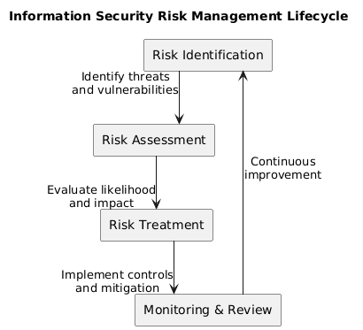
Figure 3 : Information Security Risk Management Lifecycle Applied at NatureGreen
Source: Self-made (Adapted from (Omotunde and Ahmed, 2023)
Risk analyses must be assessed in relation to the probability and possible effect of the risks identified so that the organisation can prioritize the mitigation processes. Different risk treatment approaches can be used depending on the risk tolerance of an organisation and these approaches can be risk reduction, risk avoidance, risk transfer, or risk acceptance. Risks and mitigation measures should be documented in a risk register which should be used to monitor identified risks.
Table 2:Risk Register
Risk ID | Risk Description | Threat Source | Likelihood | Impact | Risk Level | Mitigation Measure
R1 | Unauthorised access to cloud-hosted customer data | External attackers, weak authentication | High | High | Critical | Implement multi-factor authentication, encryption of data at rest and in transit, and strict access controls
R2 | Data leakage from employee BYOD devices | Lost or compromised personal devices | Medium | High | High | Enforce BYOD policy, device registration, remote wipe capability, and endpoint security controls
R3 | Wireless network intrusion | Rogue access points, insecure Wi-Fi configurations | Medium | High | High | Secure wireless configuration, network segmentation, continuous monitoring
R4 | Insider threat or misuse of access privileges | Employees or contractors | Low | High | Medium | Apply least-privilege access, user activity monitoring, and regular access reviews
R5 | Cloud service outage affecting business operations | Cloud service provider failure | Medium | Medium | Medium | Business continuity planning, disaster recovery procedures, and strong SLAs
R6 | Non-compliance with data protection regulations | Inadequate governance and policies | Low | High | Medium | Regular compliance audits, updated security policies, staff training
R7 | Malware or ransomware attack | Phishing emails, malicious downloads | Medium | High | High | Security awareness training, endpoint protection, email filtering
R8 | Intellectual property theft | External cybercriminals or competitors | Low | High | Medium | Encryption, access restrictions, monitoring of sensitive data access

The protection mechanisms must consist of technical, administrative and physical controls. Technical controls can also comprise of encryption, robust authentication systems, secure wireless settings, and endpoint security systems (Omotunde and Ahmed, 2023). Administrative control involves awareness training of the staff, stipulated procedures and periodic security evaluations. Where necessary, physical controls must secure key infrastructure and points of access.
To ensure that the controls are in place, continuous monitoring together with periodic risk reassessment should be employed to guarantee that the controls are in place as threats and technologies change. Such dynamic methodology is more resilient and minimizes the possibility of severe security accidents.

Contingency Planning and Service Level Agreements.
A contingency planning is necessary to sustain the continuity of the operations in case of security incident or failure of the system. The nature of naturegreen needs to devise formal incident response, business continuity as well as disaster recovery strategies. The incident response plan must stipulate roles and responsibilities, communication procedures and escalation pathways to guarantee the prompt and synchronized responses towards security incidents.
The scenarios in business continuity and disaster recovery plans should cover cloud service failures, data victims, and network failures. Such plans must establish recovery goals, such as levels of tolerable downtimes and data recovery levels (Gjoko Stamenkov, 2024). The effectiveness of the contingency plans should be tested and simulated on a regular basis so that areas of improvement are indicated.
Since NatureGreen is dependent on the third-party cloud service providers, service level agreements (SLAs) are an essential part of the security governance. SLAs must explicitly specify security roles, availability, and incident reporting schedules, and information security requirements. There is more accountability and less risk of third parties due to clear contractual terms.

Summary of the Proposed Approach.
The information security and governance and compliance framework offered by the proposed security design approach gives NatureGreen a structured and integrated structure in managing information security. NatureGreen can achieve a great improvement in its security position by ensuring good governance, enforcing clear policies, applying systematic risk management measures, installing the right protection mechanisms, and creating effective contingency plans. This is a holistic methodology that can tackle both technical and organisational issues and which preconditions long-term security resilience.

Critical Discussion: Regulations & Standards
The modern digital environment has made the constant revision of regulations and security standards by organisations a good practice since the technological environment is evolving at a rapid rate and the nature of cyber threats is shifting. Traditional or obsolete regulation systems cannot in most cases deal with current risks of cloud computing, wireless network and bring-your-own device (BYOD) settings. Regulatory and security standards will have to change with the new technologies that organisations are moving towards to enhance efficiency and scalability.
The challenges of emerging threats offer more than just advanced persistent threats, ransomware, as well as a massive data breach, which underscores the constraints of those old security demands. Attack methods are increasingly more advanced, automated and targeted, and they commonly take advantage of the vulnerabilities in the legacy systems and controls. Failure to incorporate such changes by regulations means that organisations might be compliant yet exposed to massive security breaches. This gives a false sense of safety, as a compliance is given more importance than a real risk minimisation.
Old compliance systems are also legal and reputation risks. These regulations that are not sufficient to cover contemporary data protection issues can create inconsistencies in enforcement, regulatory lapses and uncertainty about organisational responsibilities. Organisations operating with outdated standards might find it difficult to prove due diligence in case there is security breach, which means there is high tendency of financial fines, litigation, and loss of credibility.
On the other hand, constantly revised regulations and standards have a number of advantages. They help organisations embrace both proactive security practices and risk-based approaches and invest in continuous improvement. Revised standards also facilitate uniformity within industries and jurisdiction enabling more transparent responsibilities and better governance. Reflecting the security requirements onto the current technologies and threat environment, the evolving regulations contribute to the organisational resilience and increase long-term sustainability.
.

Conclusion
This report has discussed the guidelines and standards of data security, governance and compliance as applied in the digital operating environment of NatureGreen. The study identified the significance of structured and risk-based measure of handling complex security issues related to cloud computing, wireless networks, and the use of BYOD devices through the review of existing information security frameworks. It is based on this that a customized security design strategy was offered to meet the needs of governance, policy, risk management, and contingency planning requirements of NatureGreen. The report also highlighted the need of the constant development of regulations and standards to keep them effective in countering new threats and overall technological improvements. All in all, the results prove that a governance-based security plan is fundamental in guarding organisational information resource, guaranteeing regulatory adherence, and facilitating on sustainable business practices.

References
Abdulsalam, Y.S. and Hedabou, M. (2021). Security and Privacy in Cloud Computing: Technical Review. Future Internet, [online] 14(1), p.11. doi:https://doi.org/10.3390/fi14010011.
Alrehili, A.A. and Alhazmi, O.H. (2024). ISO/IEC 27001 Standard: Analytical and Comparative Overview. Lecture notes in networks and systems, pp.143–156. doi:https://doi.org/10.1007/978-981-99-9524-0_12.
Datta, A.N., Shinu Abhi and Kumar, N. (2024). Enhancing BYOD Security: A Risk Assessment Framework for Corporate Resources. Lecture notes in networks and systems, pp.483–496. doi:https://doi.org/10.1007/978-981-97-6588-1_36.
Edwards, J. (2024). A Comprehensive Guide to the NIST Cybersecurity Framework 2.0. John Wiley & Sons.
Gjoko Stamenkov (2024). Cloud service models, business continuity and disaster recovery plans, and responsibilities. International journal of organizational analysis. doi:https://doi.org/10.1108/ijoa-12-2023-4127.
Marquez-Tejon, J., Montserrat Jiménez Partearroyo and Benito-Osorio, D. (2023). Integrated security management model: a proposal applied to organisational resilience. doi:https://doi.org/10.1057/s41284-023-00381-6.
Merchan-Lima, J., Astudillo-Salinas, F., Tello-Oquendo, L., Sanchez, F., Lopez-Fonseca, G. and Quiroz, D. (2020). Information security management frameworks and strategies in higher education institutions: a systematic review. Annals of Telecommunications. doi:https://doi.org/10.1007/s12243-020-00783-2.
Norozpour Sıgaroodı, SAJEDEH (2025). Risk Assessment for Identifying Threats, vulnerabilities and countermeasures in Cloud Computing. Jordanian Journal of Informatics and Computing, [online] 1(1). doi:https://doi.org/1515123c-088b-40c5-8da7-063f8253ea55.
Omotunde, H. and Ahmed, M. (2023). A comprehensive review of security measures in database systems: Assessing authentication, access control, and beyond. Mesopotamian Journal of CyberSecurity, [online] 2023(2), pp.115–133. doi:https://doi.org/10.58496/MJCSC/2023/016.
Palanisamy, R., Norman, A.A. and Mat Kiah, M.L. (2020). BYOD policy compliance: Risks and strategies in organizations. Journal of Computer Information Systems, 62(1), pp.1–12. doi:https://doi.org/10.1080/08874417.2019.1703225.
Reuben-Owoh, B. and Haig, E. (2025). A Systematic Review of Voluntary Cybersecurity Standards and Frameworks. International Journal of Information Security, 24(5). doi:https://doi.org/10.1007/s10207-025-01121-0.
Setyadi, R. and Abdul Rahman, A. (2025). Enhancing IT Governance Based on Risk and Security Analysis in a Private School: A COBIT 2019 Approach. JOIV : International Journal on Informatics Visualization, 9(5), p.2148. doi:https://doi.org/10.62527/joiv.9.5.3414.
Srikrishna, H.V. and Murthy, J.S. (2024). Securing Mobile Workspaces in the Cloud. Chapman and Hall/CRC eBooks, pp.238–262. doi:https://doi.org/10.1201/9781003455448-13.
Swain, A.K. and Garza, V.R. (2022). Key Factors in Achieving Service Level Agreements (SLA) for Information Technology (IT) Incident Resolution. Information Systems Frontiers, [online] 25(2). doi:https://doi.org/10.1007/s10796-022-10266-5.

