An investigation into the impacts of smartphone use for social media on event experience within the Swansea based population.

Chapter 1: Introduction

“It’s connections to other human beings — real-life connections, not digital ones — that nourish us and make us feel like we count. Our presence, our full attention is the most important thing”
Nancy Collier (2018)

1.1. Background and Rational

The above extract – taken from “The Power of Off” by Nancy Collier – is narrating the perplex ways in which technology has infiltrated its way into human behaviour and take its toll upon our interactions, connections and emotions. Harris (2019) summaries the complexity perfectly - human beings are spending large amounts of time disconnecting from the real world in order to be connected within the online world, driving the fortuitous contradiction of being connected and disconnected at the same time.
The purpose of this dissertation is to further understand how this continual connection with technology is impacting upon the events industry – whose fundamental essence is so largely embedded with human connection. The dissertation will centre upon social media use at live events as a focal point of technology, and the City of Swansea as the geographical area of study.
Kaplan and Haenlein (2011, p.60) refer to social media as:
“A group of internet-based applications that build on ideological and technological foundations of the Web 2.0 and that allow the creation and exchange of user-generated content”.

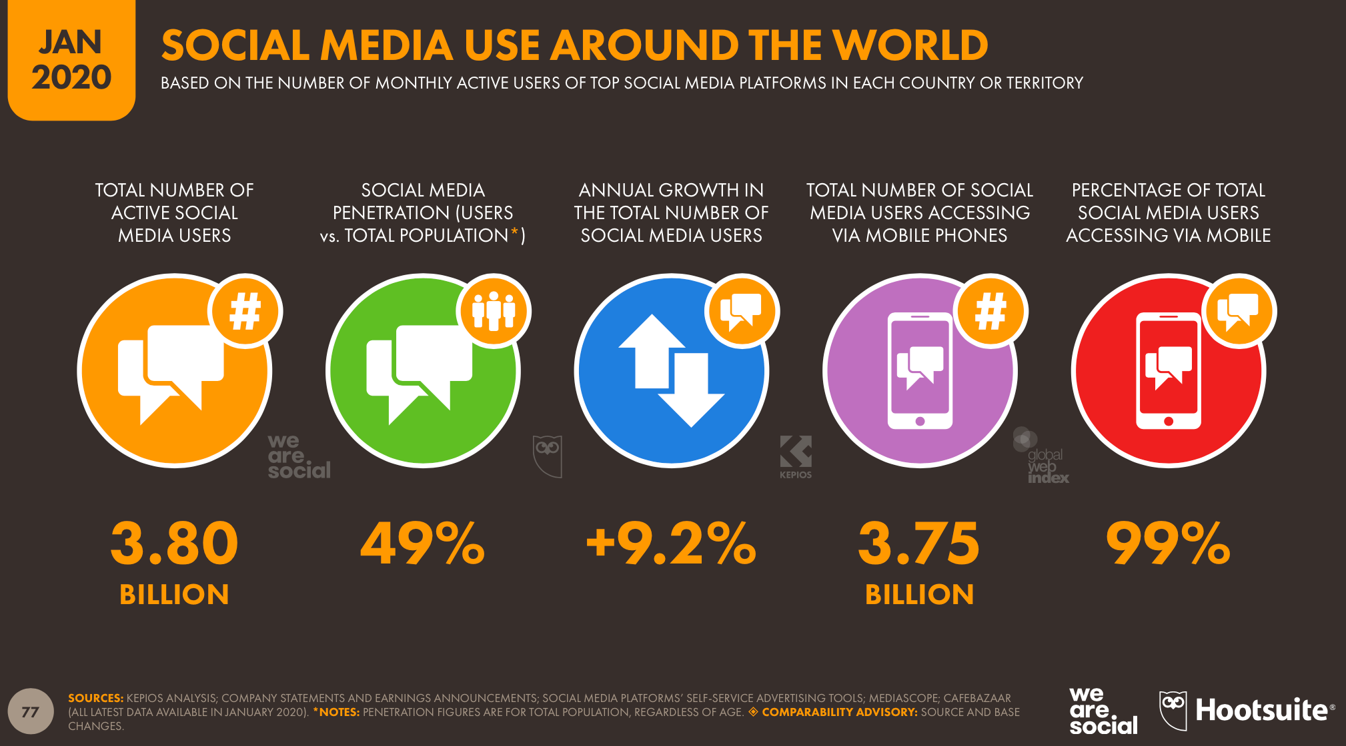
Figure 1.: A summary of global social media users around the world (Chaffey, 2020).
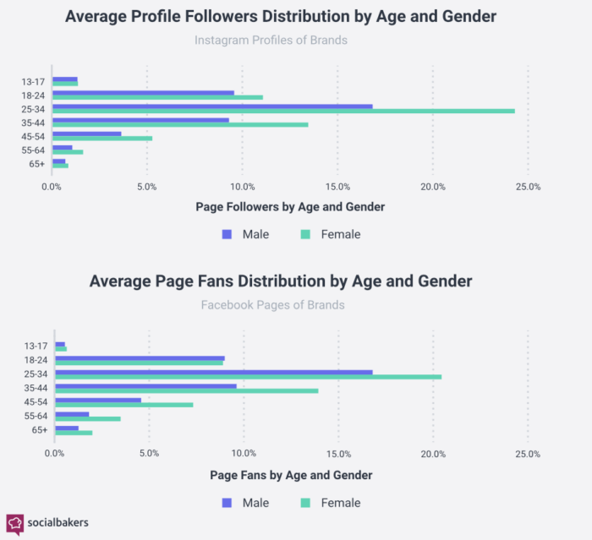

Figure 2.: Social media use by demographics (Chaffey, 2020).

As depicted in Figure 2, Chaffey (2020) highlights how women are often perceived as being more vocal, expressive and willing to share more about their personal lives than men and as a result tend to use social media to share more personal information. Gender will therefore be noted as a key influence on this study and used to further develop the understanding of social media use and gender.

The rise of social media

Whilst the internet has always offered content sharing and creation capabilities, Web 2.0 technologies such as social media platforms provide a much easier and more accessible channel for data to be exchanged (Gretzel and Yoo, 2013). As such, Gillin (2009) discusses what is often referred to as the ‘Social Web’ as a platform that enables content to be more moveable and interactions more visible. Safko and Brake (2009) describe the Social Web as “activities, practices, and behaviours among communities of people who gather online to share information, knowledge, and opinions”. The concept of the Social Web therefore plays an important role in influencing social dynamics through its vast network of conversational space (Gretzel and Yoo, 2013).
Previous research from Van Dijck and Poell (2013) highlight’s how the rise in social media use has meant that its platforms have now deeply penetrated into the mechanics of everyday life, and as a result has affected institutional structures and people’s informal interactions. Perrin (2015) notes how Pew Research reports documented a near tenfold jump in social media use over the past decade with 65% of all adults now using social networking sites. The Pew Research reports also highlight how the rise in social media use has largely impacted communication patterns around the globe and has changed the way people get and share information (Perrin, 2015). Social media has now changed the rules and restrictions of social interaction. For instance, Dijck and Poell (2013) argue that the logic of social media has become entangled with the logic of mass media in the sense that social media is gradually dissipating into all areas of public life. With social media use rising so rapidly, it has created a paradigm shift that has drastically modified how customers engage with brands. The question that then naturally arises is to what extent this consumer paradigm shift has impacted how consumers engage with live events specifically.

The value of social media

Previous studies by Dolan et al., (2016) have emphasized that organisations are increasingly recognising the value of social media engagement for business success and so are consistently seeking new ways to improve engagement through their social media content. Social media platforms are often discussed in literature in relation to control. A number of authors discuss how social media platforms are often viewed in an editorial sense, whereby selection juxtaposition takes places and platform users have the ability to shape and manipulate content and interaction (Dijck and Poell, 2013). Examples of this theory could be largely ‘liking’, or retweeting content related to a certain topic. This idea of using social media for control is also largely linked to the subject of social media popularity. Aalberg et al., (2012) discusses how social media platforms are creating celebrities by pushing “likeable” people to become social media personalities and using their popularity to largely influence, manipulate media and lure in crowds. In this sense, popular social media users are able to enforce power in relation to agenda setting or discussing certain topics. Businesses are also able to capitalize on this by using both popular and powerful social media users to advertise products and services in order to grow their consumers base.

Social media and the events industry

This rapid growth and infiltration of social media into modern society has meant that many industries have now been transformed as result, including the events industry. According to Zeng and Gerritsen (2014) social media plays an imperative role in many aspects of the events industry, largely in information search and decision-making, tourism promotion and interacting with consumers. According to (Nezakati et al., 2015) social media provides users with “virtual socialization” whereby users can share knowledge of an experience or event through social media interaction with others and as a result can largely affect others attendance or behavior at the same experience. This influence then also has a direct result on the financial performance. Gretzel and Yoo (2013) discuss the commercial potential of social media in a marketing sense, highlighting how the viral aspects of social media platforms mean that events organizations can achieve enormous reach without the large cost often associated with marketing investments.
However, observations by New York psychotherapist Nancy Collier (2018) addressed how people have become disconnected from the moment and what really matters as a result of social networking, which has in turn taken its toll on personal relationships. Brody (2017) suggests that many individuals have become slaves to digital devices and as a result are having less time to experience life. As stated by Collier (2018) “It’s connections to other human beings — real-life connections, not digital ones — that nourish us and make us feel like we count. Our presence, our full attention is the most important thing”. The question then becomes to what extent are consumers becoming disengaged and whether this affectivity is impacting upon live event experiences.

1.2. Value of Research

Research such as that carried out by Collier (2016) simply cites the relevance between social media use and disconnection from the moment. Additional research is needed to understand and explore how lived experiences have been impacted within an events environment and whether there are additional elements that are pertinent to the process. Bell et al., (2018) states that the gap between theoretical reflection and evidence based analysis provides a capacity for future research.

1.3. Aims and objectives

The aim of this dissertation is to advance the understanding of how live event experiences are impacted through smartphone use for social media by building on existing research. This dissertation will help to further the understanding of current theoretical discussions surrounding the topic and propose new understanding’s.
Objectives:
- To critically analyse previous academic literature surrounding the impacts of smartphone use for social media on events experience.
- To conduct primary research using mixed methods to identify the extent in which live event experiences are impacted through smartphone use for social media within the Swansea based population.
- To synthesise extant literature and primary research to determine the role that social media plays within the events industry.
- To provide recommendations to the events industry on how to successfully use social media to increase event participation whilst improving the event experience for the consumer.

Chapter 1 has summarized the range of research and rationale behind the chosen topic and provided essential background information as well as a brief consideration of the literature from previous research. Chapter 2 moves on to investigate in further detail the key themes surrounding the chosen topic that arise from a variety of published literature.

Chapter 2: Literature Review

2.1. Introduction

This chapter aims to address the first objective of this thesis;
- To critically analyse previous academic literature surrounding the impacts of smartphone use for social media on live events experience.
The researcher aims to accomplish this objective by conducting an extensive literature review using a variety of sources including relevant textbooks and literature, peer reviewed academic journals and trade publications. This chapter will first provide key definitions relative to the thesis, followed by an overview of the varied theoretical observations and epistemological foundations related to increased social media use and its influence on the events industry. The literature analysed in this chapter will provide the fundamental basis and underpinning of the data that will construct the methodology chapter.

2.2. Social Media defined

Joosten (2012) defines social media as a wide-ranging term that is largely used to group together any technological platform that is related to community and collaboration. Hjorth and Hinton (2019) however address the difficulty of truly defining social media but highlight how the practice of integral role sharing have recalibrated social media into now being synonymous with the role of the mobile. Nasr and Rached (2019) note that in a world migrating to digital, smartphones are omnipresent. This is similar to research carried out by Li and Wang (2011) that address how in in today’s era, social media has reconstructed internet use from what was once a broadcasting medium into being a participatory platform which enables individuals to themselves become the “media”. Inevitably, the transforming uses of social media has impacted many current industries including that of the Events and Tourism sector. Further findings from Leung et al (2013) highlight that both the Tourism and Events industries can capitalise on the capacity of social media by exploiting its ability to engage with potential consumers, increase online presence and as a result generate greater economic income.

2.3. Digital Technology and Memory

A series of recent studies have indicated that digital technology is having an increasing impact on memory. Prior research by Soares and Storm (2018) states that when taking a photo to capture an experience, the individual disengages from the moment and as a result, the memory is stored less deeply that it otherwise would be. Their research also discusses the “photo-taking impairment effect” – a phenomenon which highlights how individuals are less likely to remember objects or experiences that they photograph than objects or experiences that they only observed. The research carried out by Soares and Storm (2018) also focused on a new hypothesis that suggested that an individual is removed from the present moment when engaging with a camera or phone, so much so that it is enough to weaken memory formation even after they put the camera down – this is known as “attentional disengagement”. Memory impairment can be further impacted through social media apps such as Snapchat or Instagram, whereby filters or texts found on the app interfaces can provide greater distractions from the moment or experience itself (Yu, 2019). These findings, alongside prior research by McGaugh (2000) linking emotional stimulation and memory in hand, indicate that adding content to social media platforms severely impacts a whole generation’s ability to stay present and engaged in the moment, whilst also effecting personal memory development. Ultimately, individuals are putting a screen between themselves and the moment, which in itself is a barrier to not only personal presence but in the individual’s ability in remembering the moment itself. However, whilst interrupting moments can be seen as the pinnacle reason behind memory-impairment, there is also evidence to suggest that the intention behind why individuals feel the need to capture a moment can in itself alter whether or not the memory is stored (Yu, 2019). Whilst Soares and Storm (2018) indicate that the studies into this are in preliminary stages, they still suggest that using volition in the process of meticulously taking a photo for memory’s sake can actually show an advantage in memory retention. Similar findings have been highlighted by Barasch et al (2017) whose research suggests that the photo taking act itself can alter the creation of memories and appraisals of an experience compared to not taking photos at all. This theory is further developed by Lashbrook (2020) who proposes that well-chosen photos can spark further memories after the event has happened, without which the individual may have forgotten. This research could indicate that despite the screen being seen as a hindrance to the moment, the more thought and intention that is behind taking the photo will lead to lesser impacts of the impairment effect. Historically, there has been a great deal of confusion in literature regarding technology and memory and so this is an area that will benefit from further research.

2.4. Photo Sharing

Early research from Myers (2000) suggests that photo sharing with others allows individuals to improve their social relationships and thus, the act is a vital aspect of human well-being. This has been discussed by a great number of authors in literature who also propose that the act of photo sharing can greatly increase consumer enjoyment of an experience. Findings from Lambert et al. (2013) suggest that consumers who have a sharing vision of an experience, gain value in the present through predicting their future sharing behaviour after the experience itself. In addition to this, the actions in the present associated with the consumer’s future sharing goal such as photo taking could result in increased current enjoyment (Fishbach et al., 2004).
Yet despite these theories, there exists a considerable body of literature on how the intention of photo sharing can also have the opposite effect. Barasch et al. (2018) argues that the intention of photo sharing actually decreases enjoyment of the current experience as the desire to photo share generates disutility and provokes self-presentational concern. This increasing issue of self-presentational concern is brought on by the prospect of being evaluated or judged by others in photo sharing, therefore decreasing the consumer’s enjoyment of the experience (Barasch et al., 2018). Early research from Leary and Kowalski (1990) also touches upon this argument in stating that individuals have a self-presentational motive of communicating desired identities to others due to photographs conveying information about the individual that others may judge or evaluate. As a result of this, consumers are frequently worried about managing social media impressions and spend considerable time and effort curating their social media existence (Gonzales and Hancock, 2011). In addition to this, Leary (2007) discusses how self-presentational concern is largely associated with several self-conscious emotions such as anxiety and peer pressure. These negative self-conscious sentiments have long been discussed in literature as possible direct contributors to the reduction in hedonic enjoyment (Diener, 1979). Whilst there are many studies into the relationship between human emotions and the reduction of hedonic enjoyment, the research into whether this relationship maintains itself within an events environment remains limited.

2.4.1. Photo ‘likes’ and comments

Moreover, photo sharing is often linked to photo ‘likes’ and positive comments; with both being seen as key motivational factors behind sharing evidence of an experience. Jacob (2018) discusses how these elements are often seen as social currency which strengthens the notion of each picture or post being an applause worthy performance. This in itself creates an online culture that is designed and centred around the motive to impress. Social media has made these aspects quantifiable which has deepened the need for validation from others (Ormerod, 2018). Sean Parker - one of Facebook’s earliest inventors - stated that a social media site is a “social-validation feedback loop exploiting a vulnerability in human psychology” (Ormerod, 2018). He further explained that social media platforms were designed to attract as much of the consumer’s attention as possible, and as a result the ‘like’ button was created, giving users what he described as a ‘little dopamine hit’, which would result in consumers using the platform on a greater scale and being driven to upload more content. Prior studies by Frith (2017) into this human vulnerability found that the need for ‘likes’ and external validation from others was highly linked to greater anxiety and lower self-esteem. There are however key questions and notions that are still not discussed in the literature relating to whether this desire to achieve ‘likes’ on content posted from an event can indirectly impact on the individual’s experience and their perception of the event after it has happened.

2.5. Fear of missing out and social comparison orientation

A recent study by Kross et al (2013) found that higher levels of social media engagement were often linked with diminished levels of life satisfaction. Both the fear of missing out (FoMO) and social comparison orientation (SCO) have been investigated in literature as two potential mediating factors behind this (Reer et al., 2019).
Przybylski et al (2013) broadly defines FoMO as the feeling of exclusion due to the impression that others are having more rewarding experiences. Recent studies by Oberst et al (2017) found that individuals with a decreased psychological well-being were more likely to experience FoMO and would increase their use of social media as a result. This increase in social media use can in turn lead to SCO – described in early literature by Gibbons and Buunk (1999) as an individual’s tendency to compare themselves to others – and similar to FoMO, commonly prevalent in individuals with a lower psychological well-being (Butzer and Kuiper, 2006; Gibbons and Buunk, 1999).
Due to the tendency of people to present a more positive image or experience on social media (Appel et al., 2016) there is often a concern of what negative consequences could come from upward comparisons with positively biased information (Reer et al., 2019). A study by Chou and Edge (2012) found that those who frequently used social media had an over-optimistic perception towards other’s lives. It could be said that this perception that other’s people’s lives are better or more interesting could lead to negative criticism of one’s own life. Research findings from Appel et al (2016) found that comparisons based upon social media often lead to jealousy, depression and anxiety, as well as negative perceptions of one’s own social competence. Though there is an abundance of literature discussing the concepts of (FoMO) and (SCO), the relationship of these concepts within the events industry is less consistent and demonstrates a gap that would benefit from further research.

2.6. Social media and photography

Over time, an extensive literature has developed narrating the relationship between photography and the tourism industry. A number of authors have recognised that photography is often the fundamental motivation behind tourists travelling to an event or a specific destination. This motivation leads to expectations that have been created from exposure to visual representation prior to their visit (Kozak and Kozak, 2015). Social media has now also become an intricate part of this system by transforming photography from what was initially a private endeavour, into a practice that shares photographs to new, geographically dispersed networks of strangers (Lo et al., 2011). In short, the literature pertaining to social media sharing strongly suggests that images posted online play a large role in influencing others to attend the same event or destination through the narrative the images have portrayed. This creates a search for imitating the images seen elsewhere and is known as the “circle of representation” (Jenkins, 2003). Some authors have also suggested that this “circle of representation” has meant that whereby tourists are sharing their photographs on public social media platforms, they have become active participants in establishing what the must-see events and destinations are (Månsson, 2011). An established example of this is the ‘Quokka-selfie’, which is a recent selfie phenomenon with the quokka’s (small wallaby’s) that are found in Rottnest Island, Australia.


Figure 2.1.: Google images (2019).

The trend, which sees selfies posted on social media outlets with the Quokka’s, led to a sharp increase in tourism numbers and has now become a must-do activity. The idea of tourists subconsciously becoming destination marketers as previously reported in the literature (Månsson, 2011) has here been further developed as (Gretzel, 2019) notes how the ‘Quokka trend’ was not initially promoted by destination marketers and was only exploited and recognised by them after the tourists had promoted it. The literature review here further reiterates the power that individuals have through social media sharing. There have been numerous studies to further investigate this power and its connection to expressivity. The increasing importance of self-expression and identity formation has meant that tourist photography has seen a parallel shift, with photos of the self or ‘selfies’ becoming abundant on social media (Senft and Baym, 2015). As a result, it is argued that social media now promotes a self-directed tourist gaze that positions the destination in the background and the self in the foreground (Dinhopl and Gretzel, 2016).

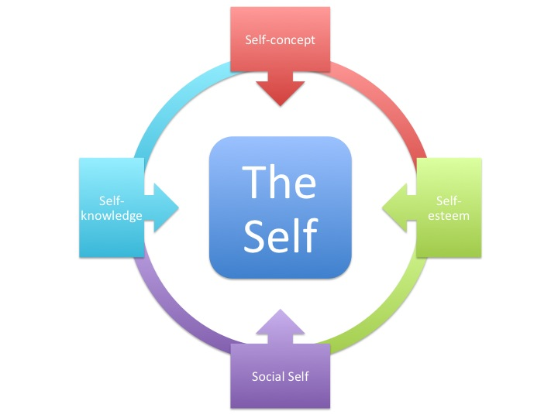

Figure 2.2.: Charles Cooley’s looking-glass self (2016).

This increase in ‘selfies’ could further be explained with the early psychological concept of the “looking-glass self” created by Charles Horton Cooley in 1902 which resonates the idea that individual’s cannot truly see themselves, and only through their reflection from others can they understand who they are (Seiter, 2016). This is depicted in Figure 2.2. An additional systematic and theoretical analysis would be beneficial in further understanding the intricate relationship between social media and photography and how this affiliation unfolds within live events.

2.7. The Attention Economy

A large number of existing studies in the broader literature have examined the relationship between social media, self-image and social currency. A recent study by (Seiter, 2016) stated that Oxytocin levels could rocket by 13%; which is a hormonal boost comparable to that of some people on their wedding day, for every 10 minutes spent on social media. Several studies suggest that with social media becoming an exceedingly consumer-centric space, individuals are actively searching for the resources they are most interested in – which drives the need for self-branding and visibility (Khamis et al., 2017) and largely propels the ‘need to be seen’ motive. Some authors have also suggested that capturing social-media-worthy moments is the eventual goal when attending an event, as the unspoken rule of photo sharing suggests that if you didn’t post a picture – you weren’t there (Jacob, 2018). As a result of this, Brody (2001) describes the shift in marketing towards the ‘attention economy’. Despite the sociological vacuity or validity of this shift, the attention economy is now an established reality that has inspired new flexible and evolving relationships with consumers (Fairchild, 2007). Identity construction is a large influence behind what users post and share on social media and creates an elaborated and often abridged snapshot of how the user wants to be seen (Khamis et al, 2017). Relating this to events as the research area in question, it could be argued that there is often a large motivation to be seen at a certain event and in a certain way, often influenced by others who have attended similar events. This research further provides evidence that the use of social media at events is largely linked to the individual’s creation of their aspirational self and their need to keep up appearances. Social-science theorist Bandura (1988) is largely responsible for our understanding of this need, by identifying how new patterns of behaviour are acquired through observing the behaviour of others. Social media provides a global platform to view and observe others in a way that has never been seen before. Further research from Khamis et al (2017) highlights how users often curate their social media content, enhancing what they consider appealing aspects and underplaying the aspects that do not fit to their ideal. Social media can portray people in consistently extraordinary and interesting settings, which often creates a false sense of portrayal and creates an unrealistic expectation of achievement for the viewers trying to imitate or live up to such media.

2.8. Interaction with the digital screen

According to Larsen (2005) the need to portray a specific and often staged instant is what drives the intention of photographs. This practice may then lead to the ritualistic examination of the screen, which Haldrup and Larsen (2010) describe as consumers checking if they have accurately captured the moment or celebrating the picture itself. This is often common practice at live events where consumers look to accurately capture the experience. Both the practice of taking the photo and then examining the screen result in the disruption of the experience that the consumer sought to initially capture in the first place (Dinhopl and Gretzel, 2016). This remains an open discussion as other authors such as Diehl et al., (2016) contrastingly suggest that photo-taking can actually increase engagement with the experience as the process of taking the photo directs greater visual attention to aspects of the event that may have been overlooked had they not been trying to capture it. These unexpected findings signal the need for additional studies to understand in greater depth exactly how social media interaction can increase engagement and whether this relationship pertains itself in an events environment.

2.9. Social media and events

Previous studies have emphasized that the increase of sharing information on social media has largely reshaped and challenged the boundaries of live events as they once were. Social media is often discussed as an influential tool for event marketing and there has been numerous studies to investigate the intricate relationship between the two. Evans (2010) discusses how social media marketing is a powerful tool for any industry in its ability to promote far beyond regular means, and to contact and create relationships with desired consumers. According to Hajli (2014), social media outlets can increase brand popularity, facilitate word-of-mouth communication, increase sales and generate support from consumers. Other benefits discussed by Tuten and Solomon (2017) highlight how social media can provide an advanced environment from which an industry can disseminate content to an audience whilst also facilitating audience contribution and sharing. This contrasts with conventional media whereby consumers aren’t able to contribute to the creation of the contents (Ward and Wasserman, 2010). This suggests a greater connectivity benefit through social media and the possibility of further engagement and involvement between event creators and event goers. Further findings from Bennett (2012) also highlight that the online tools provided by social media allow fans who are not physically present at the event to be incorporated into the real-time “live” experience. Haimson and Tang (2017) discuss how the emergent sociotechnical phenomenon of live streaming platforms act as a window of opportunity for individuals to use social media to remotely experience events. Dezuli et al (2013) further highlights how the possibility of intertwining physical and digital experiences to the live streams can make the experience more vivid and engaging for the audience. Yet, despite these standpoints, theorists such as Lingel and Naaman (2012) discuss how even with the sharing capabilities of live streaming, the experience of being there in person simply cannot be replaced through videos of live events. Discussing the ‘hierarchy of uniqueness’, Sinnreich (2010) contended that live performances and music achieved the greatest level of authenticity, compared to pirated or lifted content which placed within the bottom tier. This in itself creates a paradoxical situation whereby individually produced and distributed content of live music events is signifying a point of convergence between the highest and lowest points of media authenticity and legitimacy (Lingel and Naaman, 2012).

2.10. Conclusion of chapter

To conclude, there is a comprehensive amount of literature surrounding how social media has become embedded into modern society and the impact this cultural shift can have on human behaviour. With this increased assimilation, social media has also become a key element within the events industry, influencing aspects both before, during and after the event has happened. Giving the existing literature, it appears that the rapid growth of social media is massively beneficial in relation to influence and advertisement, but it is also largely linked with memory impairment, attention span, self-presentational concern and deeper psychopathological effects. Despite strong intrinsic links between social media use and the aforementioned elements, it is unclear how the event experience is impacted. This has been identified as a gap in the research for this dissertation to fill as it is an area that has been under explored and could benefit from further research.

The following chapter will discuss the details of the research design and procedure, instrumentation, ethical considerations and data processing and analysis. The chapter will provide all data collection techniques and justifications which will underpin the reliability and validity of the research.

Chapter 3: Research Methodology

This chapter aims to discuss the second research objective of this thesis:

- To conduct primary research in the form of a questionnaire and interviews to identify the extent in which live event experiences are impacted through smartphone use for social media within the Swansea based population.

As discussed by Mugenda (1999):
“Research generates new knowledge and information; it extends the frontiers of understanding as we gain new insights into phenomena. There can be no improvement of higher education without sound research.”
Isaeva et al., (2015) discusses the importance of ontology and epistemology in research, and how together they form research philosophies and contribute to methodological implications. In choosing research methodologies, the researcher will draw upon ontological and epistemological assumptions, which will underpin the choice of research methods (Ghauri et al., 2020).

3.1. Research Onion



Figure 3.1.: The Research Onion. Source: (Saunders et al., 2016)

In order to formulate an effective research strategy, Saunders et al., (2007) developed an approach entitled ‘The Research Onion’. This is depicted in Figure 3.1. The use of the Research Onion provides an effective system for the researcher to develop an extensive strategy to satisfy the overall research question and so has been applied to this thesis. The research onion creates a clear pathway for evolving an effective and efficient research strategy (Saunders et al., 2007). Sahay (2016) notes how the outer layers of the onion are used to form effective understandings and decisions, which then provide the context within which appropriate data collection techniques and analysis procedures are selected.
Delving into the inner layers of the onion, the research for this thesis is cross-sectional as it has been observational in nature and collected at a specific point in time. The cross-sectional research process enables the researcher to regulate measurement procedures and control the choice of respondent and the study of context and therefore contributes to increased reliability and the reduction of bias (Rindfleisch et al., 2008).

3.1.1. Philosophy

Crossan (2003) highlights how research philosophy enables the researcher to evaluate various methodologies and select the appropriate route through identifying the limitations of other approaches at an early stage.
The researcher has largely adopted a philosophical angle known as interpretivism, which can be seen in the outer layer of Saunders’s research onion. Interpretivist research focuses on a shift from deterministic explanation by establishing relationships between different variables that are grounded in people’s self-understandings (Leitch et al. 2010). This interpretivist paradigm has enabled the researcher to gain an understanding of the different perceptions among individuals in relation to social media.
This thesis also incorporates elements of positivism. A positivist approach allows the researcher to avoid influencing the findings by remaining neutral and detached from the research when collecting the results from the questionnaire survey (Saunders, 2007). An additional purpose of integrating this paradigm is to have elements of statistical analysis, strategic patterns and generalizable findings.
As discussed by Lin (1998) a combination of philosophical methods can be beneficial to research as a positivist approach identifies qualitative data with propositions than can be tested, while the interpretive approach enables the researcher to combine that data into systems or beliefs. As a result of incorporating more than one philosophical approach, the research method could be considered as pragmatism, which often acts as a mediator between competing philosophical hypotheses (Sidorsky, 2019).
Additionally, this thesis could also be considered in the ontological position of constructionism. As discussed by Bell et al., (2018) constructionism asserts that social phenomena are continually being altered by social movements and interaction, and that the phenomena’s and their meanings are in a constant state of revision. As this thesis aims to review the ever-growing phenomenon of social media, the research will offer a specific version of social reality, rather than one that can be regarded as definite (Bell et al., 2018).

3.1.2. Approach

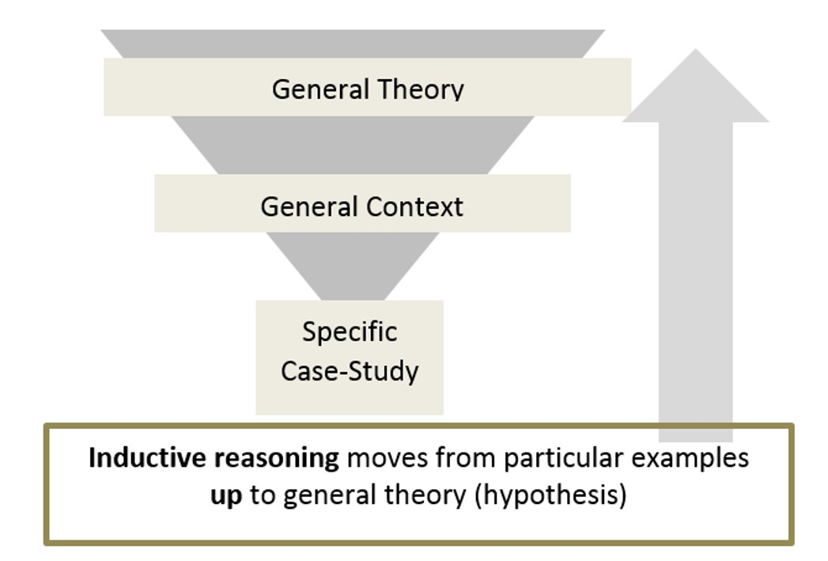

Figure 3.2.: Inductive Research. Source: (Google Images, 2020)

Applying the Research Onion to this thesis, a mainly inductive approach has been applied to gather research starting from the bottom up as depicted in Figure 3.2. The reason for this is that the researcher’s mind was not entirely blank at the beginning of this study, and there were some pertinent assumptions that were practically directing the analysis (Schreier et al., 2019). This research aims to further the understanding of behavioural standpoints in regards to social media and live events and develop theoretical explanations linking the two.
This dissertation is exploratory in its purpose as it aims to explore the understanding of the research question in greater depth, seek new insights and assess the phenomena in a new light (Robson, 2002). As this dissertation is aiming to explore the impacts of social media, this purpose has allowed the initially broad study to progressively become narrower as the research has developed (Saunders et al., 2003).

3.1.3. Strategy

According to Bell et al., (2018) a research strategy refers to the overall approach taken including philosophical assumptions, research design, research questions, methods chosen and data collection. As shown in Figure 1, Saunders et al., (2009) suggests five potential techniques for collecting primary data.
This dissertation largely incorporates a survey strategy. Fink (2002) describes surveys as;
“A system for collecting information to describe, compare or explain knowledge, attitudes and behaviour”.
This strategy can provide multiple realities and multiple interpretations from different individuals that are all equally valid (Geertz, 1973). Additionally, the varied data that can be collected from this method provides the opportunity for distinct clarification that can be approached from both a positivistic and interpretivist philosophical approach (Newman et al., 1998).
Furthermore, the researcher has also incorporated two semi-structured interviews. According to Longhurst (2003) semi-structured interviews provide a conversational manner for participants to explore issues whilst also providing an interaction with the individuals whereby the interpretive paradigm can explore inconsequential accentuations of body voice, language or situational details (Black, 2006).

3.1.4. Choice

In order to enhance the value of the data collected, the researcher implemented a mixed-method triangulation approach. This choice helps to expand the analytical options by collecting both quantitative and qualitative data from different methods that can then be integrated in the overall interpretation of the results (Gibson, 2017). The various methods and measures of an empirical phenomenon used in triangulation can also help to overcome problems of bias and validity (Blaikie, 1991) which in itself helps to limit the prospect of inaccurate inferences often associated with inductive research (Thomas, 2003).
Though there are several variations of triangulation, this thesis is largely dominated by theory triangulation as multiple theories will be utilised to interpret the data (Denzin, 1978). This approach enables the researcher to capture a holistic and contextual portrayal of the research (Hassard et al., 2008) and therefore will deepen the confidence in the research findings.

3.1.5. Collection and Analysis

3.1.5.1 Collection

The first primary data collection method is the creation of a self-completion online questionnaire. The questionnaire survey provides an exploratory snapshot of behaviour and attitudes during the particular time that the data was collected and so can further be considered cross-sectional in its nature (Mathers et al., 1998). This method of collection has been chosen as not only is it cost effective, but it also has greater ethical advantages as it does not expose individuals to invasive techniques (Mathers et al., 1998) and it reaches a significantly large proportion of people with similar characteristics in a short amount of time (Wright, 2005).
The researcher ensured that the font, brightness, spacing and colouring of the questionnaire was tailored to optimise the questionnaire as prior studies by Dr Leeuw (2008) noted how visual presentation and general layout of the questionnaire is extremely important.

3.1.5.2. Questionnaire design

The questionnaire comprises of twenty-three separate questions that aim to collect quantifiable data. The questions also aim to collect demographic information, as well as information linked to events, motivations and social media use and are largely facilitated by close-ended questions. Goddard and Villanova (2006) discuss the importance of close ended questions in generating more comparable and accurate answers and increasing the likelihood that the same interpretation of the question will be made by respondents. The questions also avoid the use of biased phrases and have simple, concrete language to ensure that they yield usable data and avoid respondent confusion (Slattery et al., 2011).
A large proportion of the questions are nominal and measured through frequencies and percentages. The researcher has chosen to utilise nominal level variables as they provide data that can be profitably compared, contrasted and combined with qualitative-data gathering techniques (Nemoto and Beglar, 2014). A final copy of the distributed questionnaire can be seen in Appendix 2.

3.1.5.3. Pilot Study

In order to increase the likelihood of success, the researcher has carried out a pilot study of the questionnaire survey before final distribution. Van Teijlingen and Hundley (2002) describe a pilot study as a mini-version of the full-scale study that can used to ensure the questionnaire achieves its maximum potential and gives advance warning about areas where the research might fail. This provided the researcher with the opportunity to address any issues highlighted and make final alternations before distributing to respondents.

3.1.5.4. Interview design

In addition to the questionnaire survey, the researcher has conducted two separate face-to-face interviews that comprised of semi-structured, open-ended questions and featured respondents with opposing social media views. Reja et al., (2003) highlights how incorporating open-ended questions into research helps to overcome bias that may result from suggesting answers to the respondents. By giving the respondents the opportunity to answer spontaneously, it will provide the researcher with the opportunity to better gauge the importance of a certain issue (Slattery et al., 2011).
The declared opposing views of social media within the respondents provided the researcher with the opportunity to incorporate aspects of a case study analysis. Yin (2002) proposes how a case study analysis can help to address the “how” or “why” questions relating to the phenomenon in question. The aim is to gather a deeper understanding into how enjoyment of a live event can impact people differently, depending on their relationship with social media. This approach to research is beneficial for triangulating purposes as it has the ability to build on the development of theoretical propositions that can guide both data collection and analysis (Yazan, 2015). Merriam (1998) highlights several important factors to a case study analysis – including asking clear and appropriate questions and creating interaction between the interviewee and respondent. The researcher has therefore ensured that any questions asked were conversational, personally tailored and created room for discussion to ensure that the data collected is varied, reliable and comparable.

3.2. Sampling

The data collection for this study has been subject to purposive sampling. Etikan et al., (2016) describes the purposive sampling technique as a deliberate choice of respondents due to the assets or qualities that the respondent possesses. This process also involves the selection of individuals that are competent and well-informed with the phenomenon of interest (Cresswell and Plano Clark, 2011) which for this study is social media users aged between 18-50 and living in or around the Swansea City area. The researcher has chosen to focus on the Swansea City and surrounding areas to identify whether the impacts of social media on event experiences could be defined by geographic patterns. The results of this study could also then be used to compare and contrast with future studies to understand whether the results of analysis shift depending on the region in which the research is carried out. Additionally, the 18-50 age category has been chosen as this selection of people are said to be the largest users of social media platforms as highlighted in Chapter 2. However, the questionnaire has still included the age option of over 50 as this may be a group of people who hold distinct preferences or opinions related to this study that may contrast with the original age group focus. By targeting these niche demographics, the researcher is able to obtain specific data in relation to the research question whilst still gaining variation in the results. The purposive sampling technique also helps to satisfy the overall objective of this study as it provides the researcher with the justification to make theoretical, analytical and logical generalisations (Sharma, 2017).
In order the correctly manage error and variance estimation within the sample, the sample size has been carefully considered. According to Israel (1992) if a population is considered largely heterogeneous, then a greater sample size will be required to ensure that the researcher can obtain a higher level of precision. Methodologists such as Chassan (1979) argue that for a reasonable probability of collecting reliable results, a minimum of 50 to 100 respondents is required. In order to maximise this probability and ensure that the findings are a greater representation of the population, the researcher ensured at least one-hundred respondents aged eighteen or above completed the questionnaire.

3.3. Reliability and Validity

Both reliability and validity are significant and essential elements of this study.
Joppe (2000) defines reliability as;
“The extent to which results are consistent over time and an accurate representation of the total population under study is referred to as reliability and if the results of a study can be reproduced under a similar methodology, then the research instrument is considered to be reliable”. P.1
Joppe (2000) defines validity as;
“Validity determines whether the research truly measures that which it was intended to measure or how truthful the research results are”.
Reliable and valid results ensure that the study findings are trustworthy, bias has been eliminated and the researcher’s truthfulness has been increased (Denzin, 1978). Alongside the pilot test of the questionnaire, the researcher also incorporated the establishment of face validity. This process ensures an individual considered knowledgeable in the research topic in question reviewed the questionnaire to ensure it was addressing the subject area effectively. The researcher also ensured a fully unbiased and impartial stance when collecting data.
The triangulation approach of this research also helped to improve the validity and reliability of the findings in both naturalistic and qualitative approaches and assisted in controlling bias and establishing valid propositions (Golafshani, 2003).

3.4. Limitations

The main limitation that acts as a hindrance to this study is the limited time frame in which the data has been collected, reviewed and analysed. In order to mitigate this limitation, a Gantt chart was created by the researcher to help set a realistic schedule that ensures that time is managed wisely and effectively.
Additionally, the researcher also chose to utilise two methods of data collection in order to gather both qualitative and quantitative data. As the time limitation may raise the question of the reliability and validity of the data findings, the mixed method approach and the combination of data will help to improve the richness of the data and the comprehensive understanding of the research topic.

3.5. Ethical Considerations

The ethics of educational research is often associated with the notions of ‘consent’ from participants (Butz, 2008) and the level of ‘harm’ that may be placed on the participant as a result of conducting the research (Beschorner and Mueller, 2007). This study has abided by rigorous ethical regulations that are displayed in a completed Ethics form which is available for viewing in Appendix A.
As participants of this study are voluntary and over the age of 18, there is minimal risk involved in this investigation. However, to ensure the utmost protection and professionalism, the researcher first confirmed that all participants had given informed consent for their results to be analyzed and used in the purpose of this research. The researcher also ensured this through the use of a statement regarding confidentiality and volunteerism at the beginning of the questionnaire. This statement can be seen in Appendix C. The data has also been collected anonymously, and personal information kept strictly confidential to guarantee legislation on data protection is followed. The data will only be viewed by the researcher and the faculty at the University of Wales Trinity Saint David who are supporting the research.
The following chapter goes on to analyze the results of this interpretive phenomenological research and will be integrated with thematic descriptions and connections with Chapter 2.

Chapter 4: Data Analysis

4.1. Introduction

This chapter is undertaken in order to analyse the data gathered through the methods discussed in Chapter 3; primary data collection and secondary data analysis.
This chapter aims to resolve the following objective:
- To synthesise extant literature and primary research to determine the role that social media plays within the events industry.
According to Creswell et al., (2011), an explanatory sequential design involves collecting quantitative data first, followed by qualitative data that can be used to elaborate on the quantitative results. The researcher used this approach during the collection of data as the results provided from the quantitative research provided a general picture that could be further refined and explained through the qualitative research that followed. The researcher will however synthesize both the quantitative and qualitative data throughout this analysis. As discussed by Cooper et al., (2019) research synthesis is appropriate for creating generalisations as it allows for the integration of empirical research.

4.1.1. Descriptive Statistics

 | Male |  | Female |  | Total
 | No. | % | No. | % | No.
Responses by gender | 47 | 29.40% | 113 | 70.60% | 160

Figure 4.0.: Respondents by gender.

Overall, more women completed the questionnaire (70.60%) than men (29.40%). These demographics are fitting with the research outlined in Chapter 1 by Chaffey (2020) regarding women being more active on social media than men. Where relevant, the results will be segmented to highlight any potential similarities and differences between the two markets. However, as the value of male respondents is low, any differences will only be highlighted as assumptions of the male Swansea based population rather than definitive findings.

4.2 Synthesized Quantitative and Qualitative Analysis

Quantitative data has been collected through an online questionnaire method and has been analysed through the use of Microsoft Excel and SPSS software. Field (2013) notes how SPSS is an efficient instrument in high complex data analysis as it provides the essential tools for thorough data management.
To effectively analyse the qualitative data, the researcher has chosen to enlist the use of Nvivo analysis software. Wong (2008) highlights how Nvivo can greatly enhance research quality and enable fluid analysis of the results. This software will be utilised for both interviews and the final open-ended question from the questionnaire.

4.2.1. Social media event marketing

Crosstabulation
Have you ever attended an event that you saw advertised online?
 |  |  | Q8 |  | Total
 |  |  | Yes | No | Total
Q1 | Male | Count | 39 | 8 | 47
Q1 | Male | Expected Count | 42.3 | 4.7 | 47.0
Q1 | Male | % within Q1 | 83.0% | 17.0% | 100.0%
Q1 | Male | % within Q8 | 27.1% | 50.0% | 29.4%
Q1 | Male | Standardized Residual | -.5 | 1.5
Q1 | Female | Count | 105 | 8 | 113
Q1 | Female | Expected Count | 101.7 | 11.3 | 113.0
Q1 | Female | % within Q1 | 92.9% | 7.1% | 100.0%
Q1 | Female | % within Q8 | 72.9% | 50.0% | 70.6%
Q1 | Female | Standardized Residual | .3 | -1.0
Total |  | Count | 144 | 16 | 160
 |  | Expected Count | 144.0 | 16.0 | 160.0
 |  | % within Q1 | 90.0% | 10.0% | 100.0%
 |  | % within Q8 | 100.0% | 100.0% | 100.0%

Figure 4.1.: Event attendance.

As discussed in the literature review, the sharing of information online has largely reshaped the concept of live events and allowed events to reach far wider audiences (Bennett, 2012). This research has tested the assumption that individuals within the Swansea based population have attended an event that they had seen advertised online and the results indicated in Figure 4.1. depict that 90% of the sample selected confirmed that they had. This is a significant finding as it indicates that online platforms are playing a vital role in relation to event advertising and marketing within the tested population.

Figure 4.2.: Sourcing event information.

Question 10 of the questionnaire asked respondents to identify how they had sourced information online about the last event that they had attended. These results indicate that there is a positive correlation between using social media as a source for finding event information. As depicted in Figure 4.1., 94% of respondents indicated that they had used social media to source information about an event that they had attended. This finding is consistent with the theory discussed in Chapter 2 by Evans (2010) regarding how the events industry can use social media to promote itself far beyond regular means.
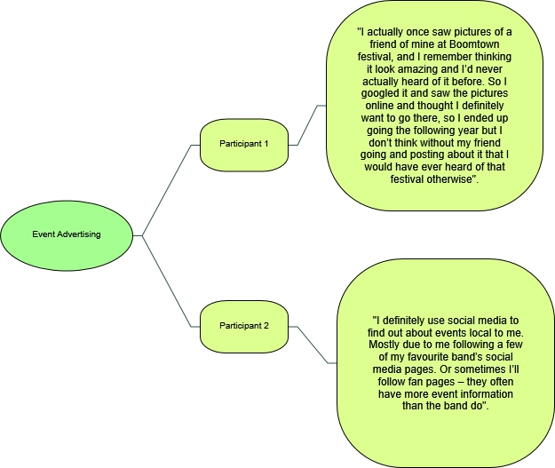

Figure 4.3.: Mind map for event advertising (Online survey data 2020).

This finding was tested further within the qualitative research, whereby an interpretivist stance was utilised to explore how different individual’s experience the same objective reality. The participants were asked whether they use social media to find out about events that may interest them. The results are depicted above in Figure 4.3. The theme that emerges from this research is that both types of social media users had similar behavioural tendencies in their use of social media to source event information and be inspired to attend future events. This analysis has here provided evidence of categorical aggregation and established a singular perception of social media use across both interviews. This is a generalizable theory and is consistent with the academic proposal of Jenkins (2003) who suggested that images that are shared on social media play a large role in influencing others to attend the same event, a phenomenon known as the “circle of representation”.

4.2.2. Motivations for using social media

Figure 4.4.: Photo taking motivations.

Figure 4.4. highlights the options selected by respondents as motivations behind photo taking at events. The results depict that memory keeping was selected as the largest driving factor. 31% of respondents stated that they saw both social media and memory keeping as their motivation behind photo taking at events. When considering this percentage alongside the other 14% who solely take photos for social media, it indicates that 45% of the respondents are driven to photograph an event for the purpose of social media.


Figure 4.5. High level word cloud of social media motivations (Online survey data 2020).

In order to elaborate upon these findings, further qualitative research was carried out. Nvivo was utilised in running a high level word cloud to explore the words most frequently used by respondents in relation to the motivations and benefits of sharing content on social media. Both the interview’s and the open-ended question within the questionnaire were utilised for this analysis. As depicted above in Figure 4.5., the words most heavily weighted in the frequency count were “memories” and “remember”. This could be seen as significant as respondents appear to link the use of social media to preserving the memories of past events. This finding is also consistent with the research of Lashbrook (2020) who discusses how well-chosen photos can increase the chances of individuals engaging with the photos on a meaningful basis after the event and therefore spark further memories of the event itself.
Further findings in correlation with this theme were observed within the qualitative data collected from the questionnaire and are depicted in Appendix 8. The data unveiled that the pressure to portray a positively biased appearance on social media can significantly improve the fondness of the memory after it has happened. This largely correlates with the theory of Gonzales and Hancock (2011) who discuss how individuals often create a heavily skewed version of their lives on social media – which in an events sense is now leading consumers to reflect or look back on positively biased information from the experience.

4.2.3. Improving social relationships

Figure 4.6.: Social media’s influence on social relationships.

Chi-Square Tests
 | Value | df | Asymptotic Significance (2-sided) | Exact Sig. (2-sided) | Exact Sig. (1-sided)
Pearson Chi-Square | .207ª | 1 | .649
Continuity Correction^{b} | .070 | 1 | .791
Likelihood Ratio | .205 | 1 | .651
Fisher's Exact Test |  |  |  | .704 | .392
Linear-by-Linear Association | .206 | 1 | .650
N of Valid Cases | 160
a. 0 cells (0.0%) have expected count less than 5. The minimum expected count is 13.81.

Figure 4.7.: Chi-Square test for gender and using social media to improve social relationships.

The results depicted in Figure 4.6 indicate that 60% of the questionnaire respondents stated that sharing content on social media improved their social relationships. A Chi Square test was then used to test the accuracy of these results and the relationship between the categorical variables. The Chi-Square test is a non-parametric tool that permits an evaluation of both dichotomous independent variables to test whether the variables are independent of each other (McHugh, 2013). This approach was appropriate for this data set as it has two categorical variables from a single population and because the expected frequency count was at least 5 in each cell of the contingency table. This test can be seen in Figure 4.7. As the test results indicated that the p value was greater than 0.05, it suggests that the results were not statistically significant and therefore indicates that social media and improving social relationships are not dependant of one another. The lack of statistical significance within this set of results could however be a consequence of the variables in this study not being categorical (Sharpe, 2015).

4.2.4. Self-presentational concern

Figure 4.8.: Fear of judgement, selective social media posting and the enjoyment of social media ‘likes’ and comments.

As discussed in Chapter 2, social media sharing can often decrease the enjoyment of an experience as the desire to photo share often provokes a self-presentational concern (Barasch et al., 2018). Shown in Figure 4.8. are the results of a multiple correspondence analysis that aimed to investigate the link between social media and human emotions. The results highlight that 71% of respondents were fearful of being judged based on what they posted on social media, 96% were selective over what photos they posted and 92% enjoyed getting ‘likes’ and comments on social media posts. A positivistic approach was here beneficial in understanding how social norms have largely influenced people’s actions. The continual theme throughout these results suggests that individuals are largely concerned with the version of themselves that is presented on social media and therefore social media posting can be linked to self-conscious emotions such as worry or fear. Additionally, the researcher used a data visualisation technique to help explore emotions expressed by respondents when discussing social media.


Figure 4.9.: High level word cloud for emotions linked to social media (Online survey data, 2020).

As shown in Figure 4.9, an Nvivo word frequency count found that the words most heavily weighted in relation to social media use and emotions included: judged, anxiety and pressure. This suggests that social media is having a large psychological impact and that negative emotions are prevalent when using social media platforms. As discussed in Chapter 2, this could be a result of an over-optimistic perception towards others’ lives (Chou & Edge, 2012) and provoked feelings of jealousy or depression as a result of social comparison with positively biased information (Reer et al., 2019). The theme that emerges here is that social media appearances are linked significantly to the events industry, and whilst previous results found that they can improve the memories of an event – here we find the positive appearances of social media leading to social comparison and thus feeling chronically inferior. It is this connection to negative emotions that suggests that sharing content on social media at an event can reduce the enjoyment of the experience. This is consistent with the early academic research by Diener (1979) outlined in Chapter 2 regarding the reduction of hedonic enjoyment as a result of self-conscious emotions.

4.2.5. Social media and memory

Figure 4.10.: Q12 Do you feel you remember the moment less as a result of taking a photo?

The findings depicted in Figure 4.10 indicate that the majority of respondents did not feel taking a photo at an event effected their memory of the moment.
The researcher also covered this topic during the face-to-face interviews to gauge a deeper understanding of the issue. During the interviews it was evident that both respondents felt that posting content on social media largely improved their ability to remember an event. As stated by participant A;
“If you spend a lot of time looking at or thinking about the photo, you’re therefore thinking about the moment too”.
This was further addressed by participant B who claimed that when you post photos of an event you have attended on social media; it brings the event itself to the forefront of your mind. The key theme that is highlighted in both the quantitative and qualitative findings is that the process of recollecting, expressing and sharing experiences of an event on social media increases the chances of remembering the event itself. This finding also underpins the theory by Soares et al., (2018) linking photo taking and increased memory retention that was outlined in Chapter 2.
As a result of the researcher’s inductive approach and the large body of academic research linking social media and diminished memory outlined in Chapter 2, there was an axiological assumption by the researcher that respondents would agree that their memory was impaired or potentially diminished by social media use at the time of the event. The results however disprove this assumption and so are helping to increase our understanding of the lived experiences of different groups of people and capture the distinction between experience-near understandings of culture and experience-distant conceptualisations (Spencer et al., 2014).

4.2.6. Social media as a distraction

Figure 4.11.: How often respondents check their phone during events.

The data depicted in Figure 4.11 illustrates how often respondents declared to check their smartphone during the last live event that they attended. The data shows that 22% stated ‘rarely’, 36% stated ‘once or twice’, and 42% stated that they checked their phone ‘frequently’. This alignment between the progressive growth in numbers being in unanimity with the increase in phone use transcends the trend that smartphones are becoming largely embedded within the event experience and so could be seen as a distraction from the event itself.

Descriptive Statistics
N | Valid | 160
N | Missing | 0
Mean |  | 1.11
Median |  | 1.00
Mode |  | 1
Std. Deviation |  | .317
Variance |  | .100
Skewness |  | 2.476
Std. Error of Skewness |  | .192
Range |  | 1
Sum |  | 178

Figure 4.12.: How many respondents used their phone to take photos or videos at the last event they attended.

According to Kaliyadan and Kulkarni (2019) descriptive statistics are useful as they offer a summary of the sample and measures being studied without drawing inferences. As shown in Figure 4.12., measures of central tendency such as the mode have been utilised and indicate that the majority of respondents did use their phone to photograph or video the last event they attended. This result indicates that smartphones have become an omnipresent part of the event experience. This theme has been further explored below in Figure 4.13.

Figure 4.13. Comparing results from Q5: Did you check any of your social media at the last event you attended, Q6: Did you use your phone to take photographs and or videos at the last event you attended, and Q15: Have you ever missed something at an event as a result of looking at your phone?

Depicted in Figure 4.13. are the results for three questions within the questionnaire relating to the use of social media and smartphone use during events. The central tendency of these results indicates that smartphones and social media have a dominant presence within the events industry. As the results indicate that the majority of respondents had both a large social media presence during events as well as stating that they felt they had missed something as a result of looking at their phone, this largely suggests that our interaction with such technology can detract attention away from the event in a detrimental way.
Throughout Figure’s 4.11, 4.12 and 4.13, the aims of the research have been tested in relation to determining the role that social media plays within live events. It is evident that the established pattern that emerges from this analysis and connects these results is the conclusive finding that individuals are incessantly relying upon instant gratification and information-dependency and thus social media is playing an increasingly interfering role within events.

4.2.7. Implications of social media on presence and engagement
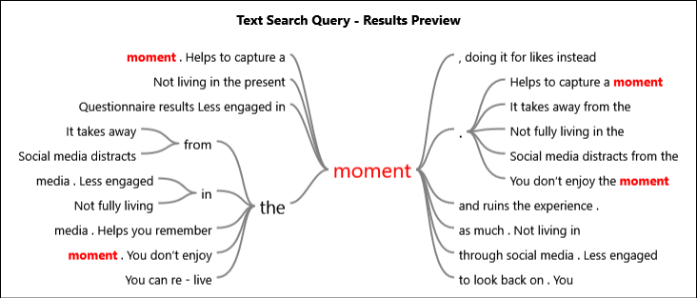

4.14.: Text query analysis on how social media can impact on the moment (Online survey data 2020).

A text query analysis was run into how social media can impact on an individual’s ability to be present in the moment. This is depicted below in figure 4.14. The largest theme identified in the text query is that as individual’s become more engaged with social media platforms, they become less engaged in the present moment. This finding is consistent with McGaugh’s theory (2000) regarding attentional disengagement that is discussed in Chapter 2. This finding also suggests that there is a larger need for the events industry to create stronger control measures to ensure that social media is used to enhance the event experience without impacting on the ability to stay present and engaged in the moment.

4.3. Main Findings

The main finding of this analysis is that social media plays a crucial role in both the attendance of live events and the event experience. The results indicating that social media is frequently utilised in sourcing event information and inspiring future event attendance is overwhelming. The conclusive evidence regarding this finding suggests that events can use social media as a powerful tool in leveraging growth for the industry and connecting and engaging with event consumers on a never-before-seen level.
Furthermore, the results also found that most respondents used social media during and after an event as a means of memory keeping. Building on from this finding, the data also suggested that most respondents did not find the use of the social media harmful to their memory of the event, but found that it in fact heightened the memory. Based on an extensive body of academic literature within Chapter 2 discussing the connection between social media and memory, there was a rudimentary assumption by the researcher that social media would not serve to improve the memory of past events attended by respondents. The social constructionist perspective however reveals the reality of individual’s attitudes towards the memory privileges of social media and therefore effects the inferences that can be drawn from this thesis.
Lastly, the analysis also highlighted that a large proportion of the respondents stated that they associated social media with negative emotions such as judgement or anxiety. It is this link between the frequent use of social media at events and the negative self-conscious emotions that are provoked through this use that supports the academic debate discussed in Chapter 2 suggesting that the hedonic enjoyment of live events can be significantly reduced as a result of social media use.

4.3.1. Conclusion

Throughout the following chapter the researcher will explore conclusions along with the finding implications. The following chapter will also include recommendations aimed at improving social media use within the events industry for the purpose of enhancing the live event experience for the consumer.

Chapter 5: Conclusion and Recommendations

5.1. Introduction

This chapter concludes the findings of Chapter 4 and discusses how these findings create real world-implications for the events industry and beyond. This chapter also proposes to complete the final objective:
- To provide recommendations to the events industry on how to successfully use social media to increase event participation whilst improving the event experience for the consumer.
Additionally, this chapter will also discuss the limitations of this study and will offer recommendations for future studies into this field.

5.2. Summary of findings

It can be concluded from the quantitative findings that the most valuable functionality of social media is its influence on event attendance. This finding supports the previous suggestion by Evans (2010) who stated that social media marketing allows the events industry to promote itself far beyond regular means. The findings showed that social media was a highly utilised tool in sourcing event information and in encouraging consumers to attend events. Additionally, social media is also a beneficial platform in connecting individuals and allowing them to share event experiences with one another. Social media is woven into the texture of people’s personal lives and is now used as a platform to build, express and inspire. In an event’s sense, individuals are now able to connect on a much broader spectrum with like-minded individuals. As discussed by McPherson et al., (2001) similarity breeds connection, a concept known as the homophily principle. This finding was further explored within the qualitative research through a thematic analysis and the results showed that there is a collective notion that connecting with like-minded people will influence and re-enforce one’s interest’s and so further serves in the purpose of encouraging attendance of particular events. Social media catapults the homophily principle by enabling users to connect with people who have attended the same events, and suggest similar upcoming events that may be of interest to them.
Further findings from the quantitative research indicated that most individuals used social media as a means of keeping memories from events they had attended. This finding was further explored in the qualitative analysis. When asked, both interviewees stated that social media actively helped in remembering about previous events that they had been too and that it was a useful tool in keeping memories from past events. The collective perception was that the time that was invested into posting content on social media relating to the event meant that the memory of the event was greater thought about and so could be remembered in considerable lasting detail. This finding supports the previous proposal by Soares et al., (2018) that the process of photo taking for memories showed an advantage in memory retention. The findings also indicated that as a result of the pressure to portray a positively biased appearance on social media, the memory after the event appeared often fonder than the actual live event may have been at the time. This is consistent with the findings of Appel et al., (2016).
However, the quantitative findings also concluded that social media can be viewed as a distraction and in an event’s sense is actively taking the consumer away from the live experience. The distraction element of social media has played a role in diminishing the enjoyment of the moment and further quantitative findings highlighted this in evidencing that most individuals are now looking for more authentic experiences. This was further explored in the qualitative research and the findings indicated that the abundance of information readily available from social media and the upsurge of features meant that individuals could be interrupted at any minute and this detracts attention away from the live event. The findings indicate that social media is in a competitive rivalry to captivate our attention. This finding is underpinned by the literature discussed in Chapter 2 by Ormerod (2018) noting how social media is exploiting a vulnerability in human psychology and is designed to attract as much of the consumer’s attention as possible. It is evident that social media is now competing with our everyday experiences and so in a sense, is acting as an abettor in taking us away from them.

Figure 5.1.: Primary development of the key impacts of social media within the events industry model (James-Deane, 2020).

As depicted in Figure 5.1., the model identifies that there are seven significant impacts on the events industry as a result of social media, all of which can contribute to the overall live experience of any given event. Though there are several un-mentioned social media impacts within the model, it could be said that these are the key aspects that the events industry must focus on to capitalise on the breadth of possibility provided by social media platforms whilst enhancing the live event attendee experience.

5.3. Implications of research

The findings from this research are highly important for the policy, practice and theory of the events industry. Without sufficient control measures, social media is increasingly becoming a self-perpetuating distraction of live events and can largely diminish attendee experience.
The statistical findings and correlations of this study also suggest that there are direct implications on social media users. The thesis findings indicate that there is now a large cultural dependency on social media and this dependency can result in significant psychopathological effects.

5.4. Recommendations for the events industry

These findings can be used to help engage and grow the events industry in the same revolutionary and leading-edge stratagem from which social media platforms exist. In order for this level of effectuality to be reached, the following recommendations have been made:

- To utilise social media influencers to actively encourage, inspire and engage future event attendees, centring largely on the homophily principle.
- To use out-of-the-box concepts to create authentic event experiences that have an element of smartphone escapism that can counteract the continuity and albatross of social media.
- To minimise screen distraction by creating smartphone control measures to ensure that there is a healthy balance between allowing attendees to share their experience of the moment without diminishing the enjoyment of it.
- To increase the use of official event photographers to capture large amounts of content from the event that can be made readily available to share immediately after the event.

5.5. Limitations of the research

The main limitation of this research was the restricted time availability in which to carry out and analyse the primary research. As a result of the time limitation, the data collection methods were only able to be implemented over a three-month period. As the data collected asked respondents to refer to the most recent event they attended, it may suggest that the results are based upon events that took place over the winter period and so may not provide a broader representation of summer season events which are often seen as the largest contributors to the event industry. This limited time availability also meant that the opportunity to measure change over time offered by a longitudinal study, was in this study restricted by a deadline.
Additionally, within the interviews and questionnaire results other factors were mentioned including the desire of participants to frequently check their smartphones during live events. However, the researcher was unable to statistically test this circumstantial piece of evidence as a key factor in impacting event experience as it is difficult to determine whether this action was influenced by social media or by other essential provisions of a smartphone.
From an epistemological standpoint, the thesis could also have benefited from a deeper pragmatic approach. As a mixed-method study, the research already contained elements of pragmatism. A greater application of the pragmatic approach however would have acted as an objective mediator between the interpretivist and positivistic approaches of the thesis and therefore helped to better understand the multiple realities of the subject matter and helped to reach a more balanced conclusion.

5.6. Recommendations for future studies

The geographical element of this research has meant that the results are representative of only a particular geographical location. This same study therefore could be applied to other Cities similar to Swansea, or areas both larger and smaller than Swansea to further understand whether geographical location or population statistics contributes to differences in results. The study could also be applied internationally to further understand how social media impacts the events industry in the United Kingdom compared to other countries. It is recommended that both the quantitative and qualitative element of this study also be applied to attendees of a singular live event to determine whether different individual events are affected differently by social media rather than the events industry as a whole.

5.7. Conclusion

As a result of this research, it can be concluded that social media does contribute significantly to the events industry and the overall experience of live events. It is evident that event manager’s play a significant role in creating a healthy balance of social media use throughout events to successfully promote and engage event audiences but without hindering the overall ability of individuals to feel present in the experience.

