
DATE OF SUBMISSION: 23/11/25
WORD COUNT: 2317
Project Planning
ACHA5012 Engineering Management
Alexandros Griffiths
2403677
ENGINEERING ACADEMIC DESCLIPINE
MOTORSPORT ENGINEERING BNG

Contents
Introduction 3
Team Roles 3
My Role 3
My Tasks 4
Task 1: Analysis of Underhood Cooling and Engine Bay Measurement 4
Task 2: Computational Fluid Dynamics (CFD) Software Training and Turbulence Model Validation 5
Task 3: Determination of an Optimal Computational Wind Tunnel Size 5
Gantt Chart (Tasks) 6
Preliminary Bill of Materials 6
Milestones and Gateway Objective 6
Risks 7

Introduction
The group project was set as redesigning a Morgan Super 4’s aero. Split into 2 groups, one side on improving the current bodywork and the other side completely redesigning the body work. As the university is running a Morgan Super 4 on the track, they are looking for ways to improve its performance one of those being in aerodynamics. The first half of the group that is improving the current bodywork need to come up with solutions to increase downforce and reduce drag without changing the bodywork; rear wings, splitters and aerofoils. The second group is focused on a whole redesign of the body work but still focusing on increasing downforce and reducing drag, a conceptual redesign. To measure these, we have researched into similar vehicles in the respective regulations and getting within a acceptable count of CoL and CoD.

Team Roles
Name | Role | Responsibilities
Ryan Williams |  | The Project Leader will ensure that all teams work as efficiently as possible while communicating deadlines. The team leader is responsible for overseeing the full development process of both the conceptua l team and the current Morgan Plus 4 team. The team leader will also be responsible for creating the main documentation, such as the presentation and any technical report.
  Project Leader
Dominic Walton | Conceptual Leader | The Conceptual Leader will oversee the development of retrofitting the Morgan Plus 4 chassis with a GT coupe-style bodywork. The Conceptual Leader should try to keep the Morgan away from creating bodywork that will hinder maximum performance. The Conceptual Leader will be responsible for communicating the design work to both the project leader and the team.
Tom Holland | Morgan Plus 4 Leader | The Morgan Plus 4 Leader will be in charge of improving the current bodywork, which is one of the things holding Morgans within the workshop at WNDS. This means adding additional things that improve the handling and performance of the vehicle, such as a rear wing, splitter, diffuser, etc. The Morgan Plus 4 Leader will be responsible for communicating the process to the team leader and the project leader.
Ethan Davies | Technical Director | The Technical Director in each team is going to be responsible for the CFD methodology and for setting performance goals, such as how much more downforce we want to achieve, how much drag we want to cut away, etc., working closely with the leader of their respective team.
Oscar Price | Technical Director | The Technical Director in each team is going to be responsible for the CFD methodology and for setting performance goals, such as how much more downforce we want to achieve, how much drag we want to cut away, etc., working closely with the leader of their respective team.
Luca Gray | CFD Engineer | The CFD Engineer is going to be designing and performing CFD analysis on the area which they are working on during that time. Trying to reach the targets that have been set, if not why, so we can write it up for the final report. Even if it doesn’t work, it’s still valuable information for us to learn from.
Alexandros Griffiths | CFD Engineer | The CFD Engineer is going to be designing and performing CFD analysis on the area which they are working on during that time. Trying to reach the targets that have been set, if not why, so we can write it up for the final report. Even if it doesn’t work, it’s still valuable information for us to learn from.
Figure 1

My Role
In my role as a CFD Engineer, the key skills required include strong technical expertise problem-solving abilities, and attention to detail. I need to design and perform CFD analysis to meet performance goals such as optimizing downforce and reducing drag which demands proficiency in using CFD software and interpreting data accurately. This aligns well with my highest score in the Shaper (16) role as I am comfortable pushing for performance improvements and tackling challenges head on. The Monitor Evaluator (11) score further reflects my strength in critically analysing results and making data driven decisions. Additionally, my Resource Investigator (11) score indicates that I am proactive in exploring new ideas and solutions which is important for driving innovation and continuous improvement within my technical work. However, my lower scores in Team Worker (5) and Implementer (6) suggest that I may not naturally focus on the collaborative or organizational aspects of the team preferring instead to concentrate on technical tasks.

When analysing my self-assessment from the teamwork lecture, I realized that while I scored highly in areas related to problem solving and analytical thinking, I could improve my focus on team cohesion and interpersonal dynamics. My lower score in the Team Worker category indicates that I may not always prioritize the emotional and supportive aspects of teamwork which could impact the team’s overall morale and communication. This is an area I can work on as it’s crucial for maintaining a healthy cooperative team environment. Although I can achieve technical outcomes improving my collaborative skills would ensure that my contributions not only meet performance targets but also enhance team dynamics and communication. By balancing my technical strengths with a greater emphasis on supporting and motivating the team I could become more effective in my role and contribute more holistically to the team's success.

Role | Your Score | Score Range | Percentage | Range (%)
Implementer (Im) | 6 | 6-8 | Low | 0-33%
Coordinator (Co) | 9 | 8-11 | High | 68-85%
Shaper (Sh) | 16 | 14-17 | Very High | 85-100%
Plant (Pl) | 6 | 6-8 | Low | 0-33%
Resource Investigator (Ri) | 11 | 9-12 | High | 68-85%
Monitor Evaluator (Me) | 11 | 9-12 | High | 68-85%
Team Worker (Tw) | 5 | 4-5 | Low | 0-33%
Complete Finisher (Cf) | 6 | 5-7 | Low | 0-33%
Figure 2

My Tasks

Task 1: Analysis of Underhood Cooling and Engine Bay Measurement
My initial task involved an analysis of the existing underhood cooling system of the Morgan Super 4. The problem was 'undercooling,' where the engine operates at a temperature above its optimal, leading to potential risks of pre-ignition, reduced engine efficiency, and long-term reliability issues.
The analysis revealed that the intake aperture was likely insufficient for the required volumetric flow rate of cooling air. By comparing the measured intake area with empirical data for engines of similar displacement and power output, I found a significant shortfall. Furthermore, the measurements of the engine bay indicated a lack of defined, low-resistance exit paths for the heated air, causing it to stagnate and reduce the temperature differential across the radiator—a key driver for heat rejection. The justification for focusing on intake and exit areas is rooted in fundamental thermodynamics and fluid dynamics; a cooling system's effectiveness is governed by the mass flow rate of air through the radiator, which is a function of intake size, pressure differential, and exit availability.
The proposed solution arising from this analysis is a two-fold approach: firstly, to increase the size of the functional intake aperture to increase mass flow, and secondly, to design and incorporate strategic venting or louvres in the bonnet or downstream bodywork to create a high-pressure-to-low-pressure escape route for the hot air. The cost of this solution is primarily in the re-tooling for new body panels or the custom fabrication of bonnet louvres, which must be weighed against the performance and reliability gains of a cooler-running engine.

Task 2: Computational Fluid Dynamics (CFD) Software Training and Turbulence Model Validation
A part of my contribution was to establish a validated and accurate Computational Fluid Dynamics (CFD) workflow for the project. The problem to solve was selecting the most appropriate turbulence model from several available options (k-epsilon, k-omega, Reynolds Stress Model, and Spalart-Allmaras) to ensure our subsequent aerodynamic simulations of the Morgan Super 4 would yield reliable and physically meaningful results.
I began by learning ANSYS Fluent software, focusing on the meshing strategies for external aerodynamics and the setup and convergence criteria for the different turbulence models. To evaluate these models, I adopted a comparative analysis approach using a known benchmark: the well-documented MIRA model car. I compiled the published wind tunnel data for the MIRA car, which provided objective, real-world results for key parameters like drag coefficient (Cd).
I then got the digital model of the MIRA car and ran a series of identical CFD simulations, altering only the turbulence model for each run. The results of each simulation were then compared against the real-world wind tunnel data. The k-epsilon model demonstrated the least discrepancy in the prediction of the overall drag and lift coefficient when compiled against the benchmark data. The justification for selecting k-epsilon is therefore not based on its general reputation but on this specific, evidence-based evaluation. It proved to be the most appropriate for this application, likely due to its robustness and accuracy for fully turbulent, external flows around bluff body shapes, which are characteristics shared by both the MIRA car and our target vehicle, the Morgan Super 4.
I also evaluated the limitations of this approach. While k-epsilon performed best for overall drag, other models like k-omega are often more accurate in predicting flow separation in adverse pressure gradients. However, given that our initial goal is drag and lift reduction and cooling flow analysis—both of which are well-served by an accurate overall pressure field prediction—the k-epsilon model was judged to be the most fit-for-purpose. The cost of this decision is computational efficiency; k-epsilon is less computationally expensive than the Reynolds Stress Model, allowing for faster iteration times during the design phase.

Task 3: Determination of an Optimal Computational Wind Tunnel Size
Before the CFD analysis on the Morgan Super 4, it was necessary to define an appropriate size for the virtual wind tunnel (the computational domain). The problem is that an incorrectly sized domain can introduce simulation errors; a domain that is too small will cause unrealistic flow acceleration around the vehicle and artificially high pressure on the domain boundaries, while an excessively large domain incurs a high computational cost with diminishing returns on accuracy.
I started researching established best practices and academic literature on domain sizing for external automotive aerodynamics. This involved breaking down the recommendations into their constituent parts: the distance from the vehicle front to the inlet boundary, the vehicle rear to the outlet boundary, and the vehicle sides and roof to the lateral/top boundaries. These distances are typically expressed as multiples of the vehicle's reference length.

Gantt Chart (Tasks)
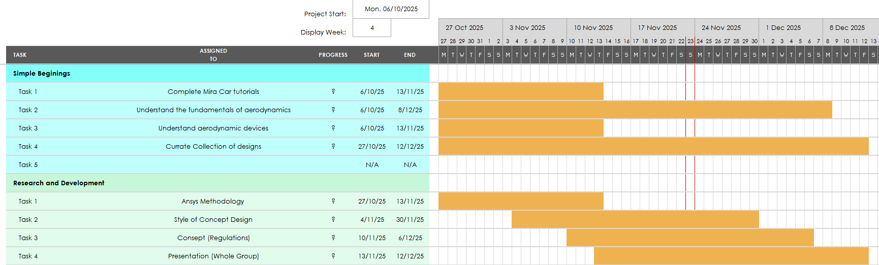
Figure 3

Preliminary Bill of Materials
Item | Approximate Cost (Annual License) | Reasoning / Justification
SOLIDWORKS | £3,000 - £4,000 | Essential for creating accurate 3D CAD models of the existing Morgan Super 4 bodywork and for designing new aerodynamic components. It provides the precise geometry required for high-fidelity CFD analysis.
ANSYS Fluent CFD | £2,000 - £3,000 | Industry-standard software for performing the computational fluid dynamics simulations. This is non-negotiable for analysing airflow, predicting drag and lift coefficients, and validating the performance of design iterations before physical prototyping.
Figure 4

Milestones and Gateway Objective
The first major milestone is the Finalisation of CFD Methodology. This milestone represents the completion of the foundational work for the aerodynamic analysis. Reaching this point means we have successfully validated our simulation process against real-world data of the MIRA car then the Morgan, selected the most accurate turbulence model, and established a reliable and repeatable workflow for testing new designs.

The second critical milestone is the Selection of a Final Design Concept. This is a major decision point where the team, based on comprehensive CFD data, agrees on a single aerodynamic package to proceed with. This selection will be based on the design that best meets our predefined performance targets for drag and lift reduction. Following this, the third milestone is the Finalisation of the Chosen Design. This step involves creating detailed, manufacturing-ready CAD drawings and addressing any practical integration issues, officially freezing the design and releasing it for prototype fabrication.

The control point in the project is the Final Aerodynamic Design Freeze Gateway by December 15th. This gateway acts as a firm decision-making barrier, ensuring we do not commit substantial resources to prototyping a design that offers only minor improvements. The objective is to select a single, optimal aerodynamic bodywork package that has conclusively demonstrated its superiority through digital simulation.
To pass this gateway, a design must meet two strict, numerical performance criteria verified through our validated CFD process. First, it must achieve a minimum 8% reduction in the drag coefficient (Cd). This target is focused on improving straight-line efficiency and top-speed potential. Second, it must achieve a minimum 25% reduction in the lift coefficient (Cl). This more ambitious target is crucial for enhancing high-speed stability and cornering confidence by significantly increasing downforce.
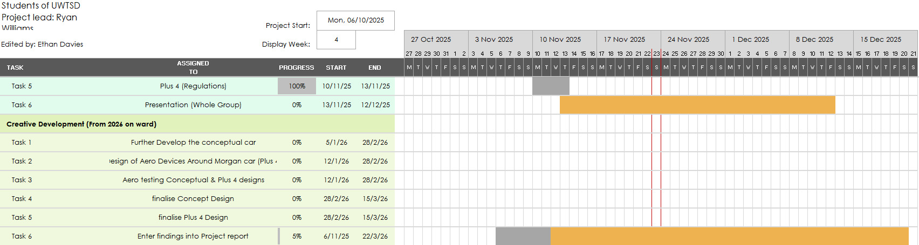
Figure 5

Risks
A major area of concern is the risk of our prototype CAD models being inaccurate and incompatible. If the digital models of our new designs have even small, tricky shape errors, they can cause serious and confusing problems during our fluid simulations. A roughly designed surface can make our carefully chosen turbulence model produce unreliable results, making it impossible to tell if a design is genuinely good or just a digital mistake. To reduce this risk, we will run a quick, simple simulation on every new prototype to check for obvious errors before we commit to a long, full analysis.

Another serious worry is the high cost and slow speed of running all the necessary computer tests. Each detailed simulation takes many hours and uses expensive software, which quickly consumes our budget and time. If we try to test every single idea in full detail, the project will become too expensive and take far too long. To manage this, we will use a smarter two-step process. First, we will use a much faster and cheaper simulation tool to quickly test a wide range of initial ideas and pick only the two or three very best ones. Then, we will only use the expensive, high-detail analysis on this small group of top candidates, saving a significant amount of both time and money.

