University of Wales Trinity Saint David London
Digital Skills and Research Methods (BMSK4003_LON)
Name: MD YOSUF KAMAL CHOWDHARY
ID: 1814645
Lecture Name:Anupam majumder

Executive Summary
Digital skills refer to the skills that include the application of communication, use of digital devices and networks to manage information from the various sources. The use of modern technology has made it even easier for companies to expand or manage their business on a large scale. The aim of this study is to reflect on the ways how digital skills are effectively used in planning marketing strategies for business. The report also describes the various research methods implemented by the companies in order to gather information about the market.

Table of Contents
Introduction 3
Aims and objectives 3
Digital Skills 3
Evaluating modern technologies 4
Exploring social media 5
Facebook 5
Twitter 6
Linkedin 6
Research Methods 7
Primary Data Analysis 8
Results 10
Discussion 11
Conclusion 11
Reference List 12

Introduction
Advancement in the field of technology has led to the emergence of new methods of communication with the help of different social networking sites and video conferences. Technologies have also helped in increasing the flow of communication in big and small companies. One of the main advantages of using digital skills is that it helps in expanding the business and also helps to increase the target customers with the help of using advertisements. The digital skills mainly refer to the replying of emails, creating websites for the business or company, handling the Google drive for the company, content marketing skills, search engine marketing, and social media marketing and so on. This report explains the effects of digital skills that help in storing and sharing of various documents in an organisation.

Aims and objectives
The aim of this study is to understand the advantages of using different digital technologies in order to get information about the market and clients. The study also focuses on the different digital marketing tools such as Facebook, Twitter, and LinkedIn and so on and how they are helpful in developing more customers and clients for a business. It also discusses the various kinds of research methods that are helpful in gathering important information about various markets and businesses.
The objectives of the report include:
- Identifying the effective tools that help in creating market strategies.
- Exploring different digital skills that are required for the betterment of the business
- Suggesting the areas where improvements can be made using these digital technologies and skills.

Digital Skills
As stated by Van Laar et al. (2017), digital skills are the use of various technologies that help to create, share and develop new ideas and gather information about organisational needs. Digital skills help to increase the reputation of a brand, look for more target customers, improve career prospects and also create an active platform for the audience to place their comments about a specific brand or an organisation (Sekara and Bougie, 2016). With the development of digital technologies more and more businesses are switching for a digital transformation.
Digital skills are extremely helpful for carrying out product research online (Correa, 2016). With the help of digital transformation, the workload has decreased in several workplaces by automating the tasks which require manual working of the employees. The use of digital skills has also helped in the efficiency of the workers. According to van Laar et al .(2018), the introduction of digital technologies has also opened the path for ensuring the safety of the various information that is related to the organisation using cyber activities such as hacking, spying and selling of important data (Valos et al.2016). Digital skills usually refer to the higher-level abilities that allow people to make many empowering and transformative changes. Digital advances like AI, big data analytics and so on help to increase the digital economy (Hair Jr et al. 2015).

Evaluating modern technologies
As per Vogel (2016), the use of modern technologies by various companies has helped in making the marketing easier and wider. The digital technologies help in dealing with the important information that is gained through the research (Karjaluoto et al. 2015). Digital technologies may include:
Marketing Information System (MIS)
This system helps to analyse data and generate the report based on the findings (Karlsen and Enjolras, 2016).. The output generated helps in the planning of different marketing strategies that might be helpful for the organisation in future. MIS also helps to distribute important data to the managers who might use this data for service promotion on a larger scale (Young, 2017). MIS data is an efficient tool that helps to access data without cost to companies.
Search Engine Optimization
This is another technology that is in large use these days. According to Thorson and Wells (2015), this technology helps to optimize the contents or websites as per the needs of the company or businesses. Search engines are helpful in gathering web traffic to a particular website with the help of different search keywords mentioned on that particular website or link. SEO is a helpful technology that helps to distribute channels for developing proper content (Quan-Haase et al. 2015)

Exploring social media
Social Media is an obvious benefit for both the new and existing businesses (Kampf et al. 2015). With the use of social media, companies gain an insight into the working of different companies. The social media helps to give information about the campaigns that are carried out by the company and check the feedbacks that are given about the performance of the company.

Facebook
Facebook is an important part of the social media platform that helps to gain a maximum audience for the betterment of the business. It is seen that seven out of ten employees (which is almost 70%) use the social-networking site, Facebook (Salloum et al. 2017). For instance, employers often check the online behaviour of the accounts to know about the various terms and conditions of employment. Facebook page can be used for the purpose of search engine optimization. Facebook groups also help to attract more and more customers and help in sharing of different posts and campaigns. Facebook page is the starting point for all marketing needs. It is important to handle the accounts properly on Facebook because a large number of people search for the brand name on Facebook. It is also very necessary to have proper content for the brand page that may attract the audience.

Source: https://www.facebook.com/YT-Fashions-LTD-321178801922890/

Twitter
Twitter is an important social media tool that helps to ignite the content for a better marketing strategy. Twitter helps to build more audience or followers the fastest. The reason is that Twitter helps in better communication and interaction with the audience. Twitter also helps in providing areas which help to develop content. There are also different tools that might b used for better marketing. With the use of social mentions, the business gets highlighted and as a result, more and more audience get attracted to the website.
Source: https://twitter.com/

Linkedin
LinkedIn allows setting up a personal profile that helps to connect with the professionals. LinkedIn is different from Facebook and Twitter mainly because it has better progress in terms of gaining connections. The LinkedIn profile helps a person to create resumes that showcases one’s experience and capabilities. There are also community features in LinkedIn that helps to effectively communicate and collaborate with other users.
Source: https://www.linkedin.com/feed/

Research Methods
There are different methods that help to gain information about the competitors, market as well as employees. There are different types of market research methods that are generally used by companies that include Primary research methods, Secondary research methods, Qualitative research method and Quantitative research method.
Primary research method
This research method helps to gain information from authentic sources rather than relying on the published sources. These research methods include:
- Surveys
- Direct observations
- Interviews and focus groups that are conducted by the researchers
Secondary research method
This research method gathers information about different market and organisations through published and available sources such as:
- Information on the internet
- Existing market research details
- Customer database
- Information from government agencies, libraries and so on.
Secondary research is necessary to get an understanding of market ups and downs. Secondary research helps in developing better business decisions.
Qualitative research method
Qualitative research helps to gather information from potential customers or clients and understand their feelings and attitudes about a brand or product. Formal and informal discussions with the clients about their experience with a specific brand or product help to get qualitative information.
Quantitative research method
Quantitative research helps to gather numerical information by the help of sales figures, questionnaires, customer return frequency and so on. Quantitative research helps to get a useful overview of the market and helps to produce statistics based on the information.

Primary Data Analysis
To conduct a survey the respondents are collected and asked questions based on the use of digital marketing. In the first question, the respondents are asked their age group to see which age group makes the maximum use of digital marketing and is interested in the study.In the second question, they are asked about the use of different digital marketing methods and in the third and final question, the survey is conducted to see if the digital methods are better than the traditional methods that were used by the companies.
Q1. Age group of respondents
Responses | No. of Respondents | Total No. of Respondents | Percentage
18-35 | 14 | 35 | 40
36-60 | 13 | 35 | 37.1
60+ | 8 | 35 | 22.9

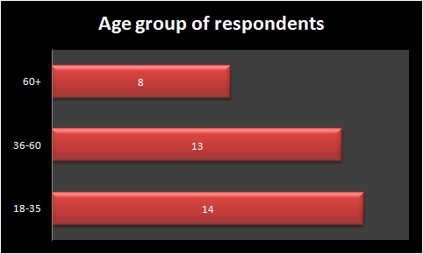
Figure 1: Age group of respondents

Implication
After conducting this survey it is seen that the maximum respondents who are interested in this study or use the digital technologies lie in the ages group of 18-35. They are mostly working people who are using different digital technologies in day to day life.
Q2. What are the different types of digital marketing methods that you use?

Responses | No. of Respondents | Total No. of Respondents | Percentage
Facebook Marketing | 11 | 35 | 31.4
MIS | 9 | 35 | 25.7
SEO | 15 | 35 | 42.9

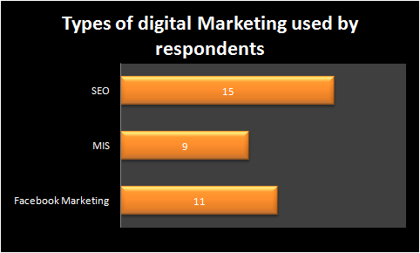
Figure 2: Types of digital marketing methods used

Implication
After conducting this survey it is seen that the marketing platform that is used by the majority of the respondents in marketing is Search Engine Optimization. Facebook Marketing and MIS are also used averagely by many of the respondents.
Q3. Do you agree that digital marketing methods are more effective than traditional ones?

Responses | No. of Respondents | Total No. of Respondents | Percentage
Strongly Agree | 9 | 35 | 25.7
Agree | 17 | 35 | 48.6
Neutral | 4 | 35 | 11.4
Disagree | 3 | 35 | 8.6
Strongly Disagree | 2 | 35 | 5.7
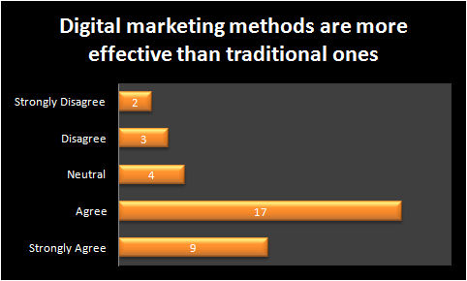
Figure 3: Digital marketing methods are more effective than traditional ones

Implication
After conducting the above survey it can be implicated that most people agree with the fact that digital marketing methods are more effective and beneficial than the traditional ones.
So after the whole survey is completed it can be implied that the digital technologies and platforms such as Facebook, Twitter, Linkedin and so on can be helpful in managing different implementations and integrations of information that are helpful for the company.

Results
The result of the survey that was conducted is that many users support the use of digital skills and technologies when it comes to increasing productivity and bringing target audience for a business that has started or already exists. The survey also presents to us the result that mostly the ones who were interested in this study belong to the age group of 18-35 and they are mostly working. These people know the importance of using digital technologies to expand their business efficiently. It is also found through the surveys that people use various tools to develop effective marketing strategies such as MIS, SEO and others. Many also use different platforms such as Facebook, Twitter and LinkedIn for achieving desired business goals.

Discussion
The advancement of technology has helped in the development of social media marketing. The modern technologies gather useful information and help in expanding the business. Digital skills are used in almost all the businesses in order to develop better productivity, better security and cost management. The various research methods help to gain information in different ways. The use of effective research methods and digital technologies help to reduce the workload among the employees. Due to advanced technologies, marketing has become a lot easier and profitable. It has also helped in the wide recognition of the brand and enabled the business to expand on a global scale. Therefore, it can be recommended that the industries must switch to the use of digital technologies and skills that will help in the progress of a business or company. The ventures can also be recommended to use social media sites such as Facebook, Twitter and so on because they help in effective digital media marketing.

Conclusion
After completing this report it can be concluded that digital skills play an important role in marketing. The digital skill help the company to expand its business on a global level and also helps to gather important information about the various rival companies and take proper steps to compete with them. It can also be understood from the study how the various technologies such as MIS and SEO help in communicating with the clients. Apart from this, the research methods are also analyzed by which companies directly get to know what people have to say about their ventures.

Reference List
Correa, T., (2016). Digital skills and social media use: how Internet skills are related to different types of Facebook use among ‘digital natives’. Information, Communication & Society, 19(8), pp.95-110.
Hair Jr, J.F., Wolfinbarger, M., Money, A.H., Samouel, P. and Page, M.J., 2015. Essentials of business research methods. Eds- 4th Routledge.
Kampf, R., Manor, I. and Segev, E., (2015). Digital diplomacy 2.0? A cross-national comparison of public engagement in Facebook and Twitter. The Hague Journal of Diplomacy, 10(4), pp.331-362.
Karjaluoto, H., Mustonen, N. and Ulkuniemi, P., (2015). The role of digital channels in industrial marketing communications. Journal of Business & Industrial Marketing, 30(6), pp.703-710.
Karlsen, R. and Enjolras, B., (2016). Styles of social media campaigning and influence in a hybrid political communication system: Linking candidate survey data with Twitter data. The International Journal of Press/Politics, 21(3), pp.338-357.
Quan-Haase, A., Martin, K. and McCay-Peet, L., (2015). Networks of digital humanities scholars: The informational and social uses and gratifications of Twitter. Big data & society, 2(1), pp.76-98
Salloum, S.A., Al-Emran, M., Monem, A.A. and Shaalan, K., (2017). A survey of text mining in social media: facebook and twitter perspectives. Adv. Sci. Technol. Eng. Syst. J, 2(1), pp.127-133.
Sekaran, U. and Bougie, R., (2016). Research methods for business: A skill building approach. Eds- 2nd John Wiley & Sons.
Thorson, K. and Wells, C., (2015). Curated flows: A framework for mapping media exposure in the digital age. Communication Theory, 26(3), pp.309-328.
Valos, M.J., Haji Habibi, F., Casidy, R., Driesener, C.B. and Maplestone, V.L., (2016). Exploring the integration of social media within integrated marketing communication frameworks: Perspectives of services marketers. Marketing Intelligence & Planning, 34(1), pp.19-40.
Van Laar, E., van Deursen, A.J., van Dijk, J.A. and de Haan, J., (2017). The relation between 21st-century skills and digital skills: A systematic literature review. Computers in human behavior, 72(9), pp.577-588.
van Laar, E., van Deursen, A.J., van Dijk, J.A. and de Haan, J., (2018). 21st-century digital skills instrument aimed at working professionals: Conceptual development and empirical validation. Telematics and informatics, 35(8), pp.21-90.
Vogel, R., (2016). Closing the cybersecurity skills gap. Salus Journal, 4(2), pp.32-45
Young, J.A., (2017). Facebook, Twitter, and blogs: The adoption and utilization of social media in nonprofit human service organizations. Human Service Organizations: Management, Leadership & Governance, 41(1), pp.44-57.

