
Programme: MBA
Student Name: Sultana Akter
Student ID : 2422835
Lecturer name : Gladius Kulothungan
Module: Human Capital Management (LCMB7023)
Assignment title: “The Influence of National and International Labour Markets on HRM and IHRM Strategies: A Critical, Research-Informed Report on Netflix”

Word count

Table of contents
Table of contents 1
Abstract 1
Introduction 2
Question 1: How Technological Advancements are Reshaping Labour Markets and Implications for HRM/IHRM 3
Table 1: Netflix HR Technology Adoption and Impact on Labour Markets 5
Question 2: What are the key demographic and geopolitical factors influencing 6
Question 3: How can organisations address persistent skills gaps and talent 8
Question 4: Reflective Report – Personal Capabilities in an International and Technologically Driven Workplace 9
Teamwork and Communication 10
Self-Directed Learning and Research 11
Technology and International Readiness 11
Summary Table: Personal Highlights & Theory Links 12
Conclusion 12
Recommendation 13
1. Strengthen AI-Supported Talent Development 13
2. Expand Global Talent Pipelines in Underserved Labour Markets 13
3. Enhance Cross-Cultural Leadership and Virtual Team Capability 13
4. Strengthen Ethical and Transparent Use of AI in HR Practices 14
5. Build Long-Term Workforce Resilience Through Well-Being and Career Pathways 14
References 14
Appendices 17

Abstract

This report discusses the influence of national and international trends in the labor market on HRM and IHRM strategies at Netflix. It therefore discusses current research findings on the effects of technological advancements, particularly AI and automation, demographic changes, geopolitical changes, and global labor market skills shortages. These trends are therefore described as reshaping talent acquisition practices, workforce planning, employee development initiatives as well as adjustments to global mobility policies within a highly competitive technology-driven industry. The reflective section explains how personal workplace experience applies Human Capital Management theories and transferable skills between international roles. The report finally argues that Netflix has to keep changing its strategies if it wants to support innovation and workforce agility. They are to include an upgrade toward AI-facilitated learning, broadening of global talent channels, upping cross-cultural leadership chops, and firming up ethical AI governance. Such steps will build organisational resilience, better the effectiveness of the global workforce, and keep Netflix’s competitive edge in a fast-evolving labor market

Introduction
The fast shifts in internal and external labor markets have imposed novel pressures on organizations within the high-tech entertainment sector. To keep its leading edge in streaming media and content creation, Netflix enlists an eclectic array of talent (Netflix, 2024).Assuch, the orchestration of workforces around corporate plans commands the aid of HRM and IHRM policies. Strategic HRM underscores the binding of human resource measures to business strategies for raising performance and helping any lead over rivals (Storey, 1995).

Company Overview

Netflix stands out as a vibrant company where both HRM and IHRM play a crucial role in driving success. With over 12,000 employees worldwide, it maintains market leadership through a strong focus on tech innovation, data-driven decisions, and fresh talent acquisition strategies (Smith, 2023). The company's approach emphasizes creativity and responsibility, embodying Soft HRM principles that boost employee engagement while ensuring high performance.

In this report, I’ll explore how technological advancements, demographic changes, geopolitical influences, and persistent skills gaps shape Netflix's HRM and IHRM strategies. Plus, I’ll share my thoughts on how prepared I feel to excel in a global, tech-driven environment. To make it more relatable, I’ll connect my personal experiences with contemporary Human Capital Management theories, like the Job Characteristics Model and Human Capital Theory.
.
Netflix operates across more than 190 countries (Appendix A, Figure 1 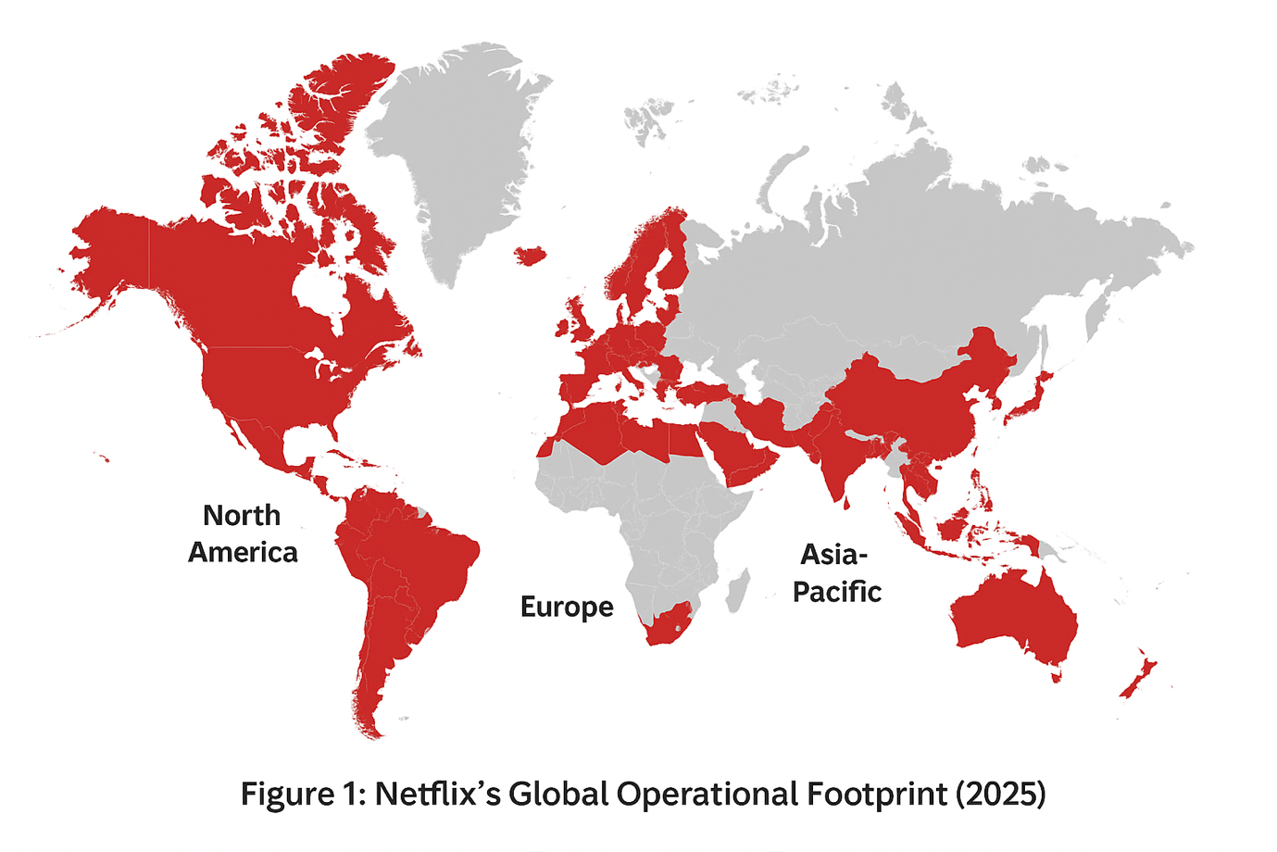

Question 1: How Technological Advancements are Reshaping Labour Markets and Implications for HRM/IHRM

The global job market is undergoing a significant transformation, largely due to technological advancements. We're witnessing major shifts thanks to automation, digital platforms, and artificial intelligence (AI). Just look at Netflix; they exemplify how companies are moving towards a workforce that's not only digital but also highly data-driven and adaptable. With cloud-based collaboration tools, machine learning, and AI analytics, the landscape of work, the skills in demand, and talent management have all changed dramatically, both locally and globally.

Let’s explore how technology is reshaping labor markets, especially at a company like Netflix. They're revolutionizing human resource management (HRM) in meaningful ways, impacting daily operations and long-term strategies. For example, in hiring, they utilize AI algorithms to predict workforce needs based on market trends. These algorithms also help screen candidates for various roles—whether technical, creative, or analytical. Plus, many routine HR tasks have been automated, allowing professionals to concentrate on strategic initiatives like career development, employee engagement, and retention.

Moreover, Netflix has embraced flexible working arrangements, tapping into project-based teams and enabling remote collaboration through digital platforms. This aligns with a broader trend in the job market, where gig work and hybrid employment models are on the rise. As a result, HRM needs to effectively manage a distributed workforce while ensuring consistent training, performance management, and employee experiences across different regions. These factors are crucial in the realm of International Human Resource Management (IHRM).
*Implications for HRM/IHRM Strategies*

1. Talent Acquisition and Development : By integrating artificial intelligence into its hiring processes, Netflix can swiftly identify candidates with significant potential. Modern HRM strategies now incorporate digital skills assessment and predictive analytics to facilitate workforce planning, effectively aligning talent supply with the organization’s strategic objectives (Cascio & Montealegre, 2016).

2. Employee Engagement and Retention: The use of automation and digital tools allows for personalized learning experiences and career development opportunities. Netflix harnesses AI to suggest relevant training materials and internal mobility options, marking a transition from traditional, transactional HR practices to more strategic, employee-focused models (Harvard Model: Beer et al., 1984).

3.Global Workforce Management: IHRM strategies must recognise the importance of technology-enabled international collaboration. Operating in multiple countries, Netflix requires digital communication platforms that are culturally adaptable, effective virtual team management, and robust remote performance monitoring—each of which is vital for maintaining a cohesive and integrated global workforce (Hofstede Insights, 2023).

4. :Ethical and Legal Considerations: The integration of AI into HR practices brings forth the necessity for ethical oversight. It is imperative for Netflix’s HR team to uphold principles of fairness, transparency, and compliance with international data protection regulations when utilizing AI tools for recruitment and performance analytics (UK Data Protection Act 2018; GDPR).

Technological advancements aren’t just tools we use; they’re changing the game in the labor market. Take Netflix, for example. The integration of AI, automation, and digital platforms has really shaken up their HRM and IHRM practices. These technologies have ramped up efficiency, allowed for more flexible workforce strategies, and made global talent management a lot smoother. But, it’s not all smooth sailing. With these innovations come responsibilities, like the need for ethical considerations, ongoing skill development, and a constant readiness to adapt. This really underscores how vital strategic HR professionals are as we navigate the future of work.

- Table 1: Netflix HR Technology Adoption and Impact on Labour Markets

HR Technology | Purpose | Impact on Labour Markets | Implication for HRM/IHRM
AI Recruitment Tools | Candidate screening, predictive fit analysis | Speeds up hiring; identifies high-potential talent; reduces bias (if monitored) | Strategic HRM: Aligns talent with business strategy; IHRM: Supports global hiring consistency
Automated Learning Platforms | Personalized learning recommendations, skill development | Upskilling/reskilling workforce efficiently | Supports lifelong learning and human capital development; encourages employee retention
Remote Collaboration Software (Teams, Slack, Zoom) | Cross-location teamwork, project coordination | Enables hybrid & global workforce; increases flexibility | Cloud-Based HR Information Systems (HRIS)
Data Analytics & Workforce Insights | Track performance, predict turnover, optimize workforce | Informs strategic decision-making; anticipates labour gaps | HRM: Evidence-based decisions; IHRM: Supports multi-country workforce planning
AI-Powered Employee Feedback Tools | Continuous feedback, pulse surveys | Faster identification of engagement issues | HRM: Promotes agile culture; aligns employee goals with strategic objectives

Figure 1: Digital Transformation of HR in Global Organizations (Netflix Example)

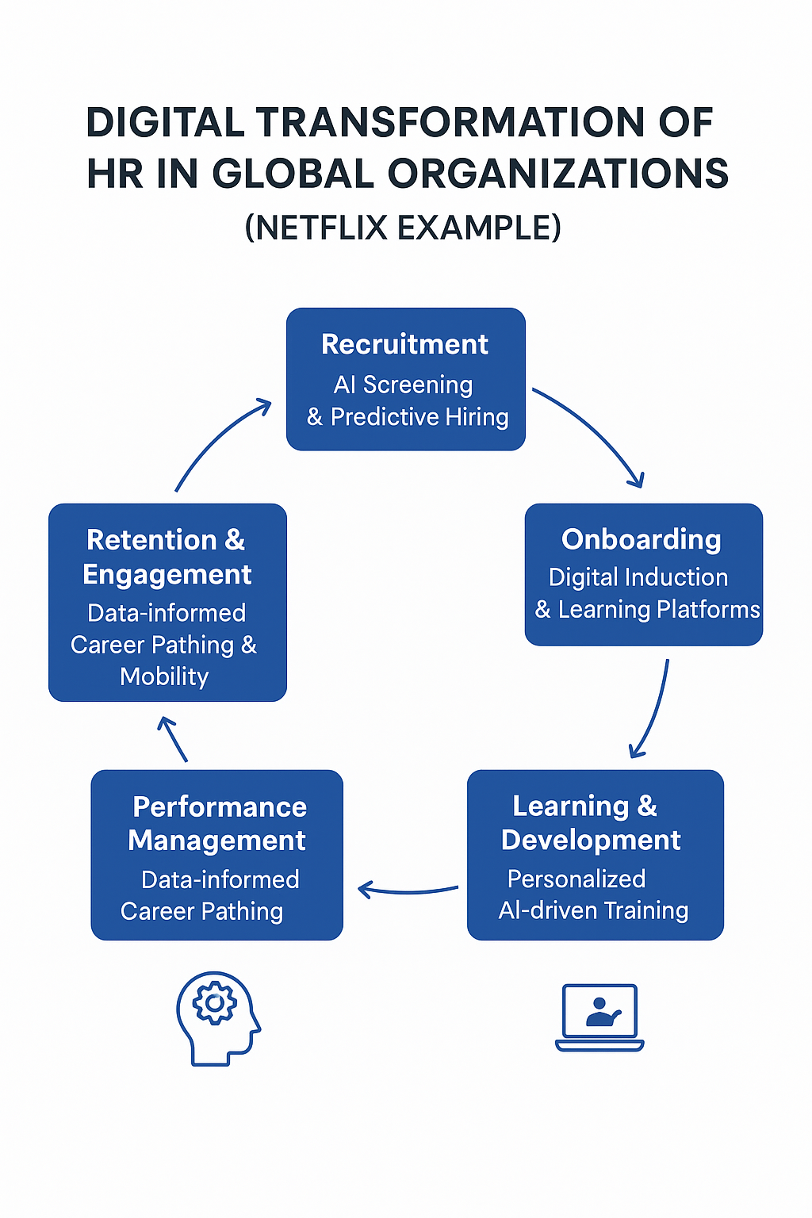
Figure B. High-level organisational chart of Netflix
Source: Smith (2023).

**Question 2: What are the key demographic and geopolitical factors influencing employment markets today, and how do these factors create challenges for HR professionals?**

Demographic and geopolitical shifts are really shaking up job markets worldwide, influencing everything from talent availability to workforce diversity and the strategies companies use. In many developed countries, we’re dealing with an aging population, declining birth rates, and longer life expectancies, all of which are changing who’s in the workforce (OECD, 2023). For global players like Netflix, these changes bring both opportunities and challenges in attracting and nurturing talent. Take Europe, for example: an older workforce might mean fewer tech specialists around. This scenario calls for smart recruitment and reskilling to keep the momentum in areas like streaming and content production.

Another key aspect is generational diversity. Millennials and Gen Z are increasingly making up a large part of the global talent pool, bringing unique expectations about work-life balance, flexibility, digital communication, and a sense of purpose (Gallup, 2021). Netflix has adjusted its HR policies to meet these expectations, offering flexible work arrangements and a culture that fosters creativity and autonomy. This approach aligns well with Herzberg’s Two-Factor Theory, addressing motivators like achievement and meaningful work (Herzberg, 1968). However, managing different generations can be tricky due to varying communication styles and comfort levels with technology. HR professionals really need to tailor their engagement and development strategies to suit this diverse workforce.

On the geopolitical side, factors like trade policies, political instability, and migration patterns heavily influence global talent mobility. For example, Brexit has shifted employment rights and visa rules for UK companies, while tensions between the US and China impact talent availability in the AI and software sectors. For Netflix, navigating these geopolitical factors means keeping up with local labor laws, adjusting compensation for expatriates, and ensuring smooth remote collaboration across borders (Dowling et al., 2017). Plus, geopolitical risks can affect supply chains, talent acquisition costs, and the strategic locations for content production and tech hubs.

When you consider how demographic and geopolitical factors overlap, it’s clear they create extra challenges for HR management, especially in workforce planning and fostering inclusion. Strategic HRM frameworks like the Harvard Model emphasize the importance of considering stakeholder interests and employee feedback. Netflix embodies this through inclusive policies and initiatives aimed at enhancing diversity. Moreover, international HRM requires a solid grasp of cultural dimensions—think Hofstede’s ideas on power distance and individualism versus collectivism—so policies can be tailored to local needs while maintaining a cohesive organizational culture (Hofstede et al., 2010).

In conclusion, demographic and geopolitical changes are reshaping labor markets in significant ways, influencing workforce composition, talent mobility, and organizational priorities. HR professionals need to stay proactive, using data-driven planning, flexible policies, and inclusive practices. Netflix is a prime example of a global company that aligns its HR strategies with these trends, fostering agility and resilience in what’s becoming a more complex employment landscape. By effectively managing these factors, organizations can attract and retain top talent and maintain a competitive edge across diverse markets.
Factor | Impact on Labour Market | Netflix HR Response
Ageing population | Reduced availability of tech and creative talent | Reskilling & flexible retirement options
Generational diversity | Different expectations on work-life balance & digital engagement | Hybrid work, autonomy, and recognition programs
Geopolitical tensions | Talent mobility restrictions, regulatory compliance | Localised HR policies, expatriate support, legal compliance

**Question 3: How can organizations tackle ongoing skills gaps and talent shortages in critical sectors like tech, hospitality, and healthcare through strategic HRM?**

Dealing with persistent skills gaps is a significant hurdle for organizations, especially those in fast-paced and competitive fields. Take the technology and media sector, for example. Companies like Netflix are facing an overwhelming demand for roles like software engineers, data scientists, AI specialists, and content creators. This is where Strategic Human Resource Management (SHRM) comes into play, providing a solid framework to proactively tackle these gaps through thoughtful workforce planning, effective talent acquisition, development opportunities, and retention strategies (Boxall & Purcell, 2016).

A crucial strategy here is the reskilling and upskilling of current employees. With the rapid pace of technological change—think about AI-driven content recommendations and automated streaming systems—Netflix is all in on continuous learning initiatives. They aim to boost their employees’ technical and creative skills. This approach ties back to Human Capital Theory, which points out that investing in employee knowledge and skills can lead to greater organizational productivity and innovation (Becker, 1994). For instance, Netflix promotes internal mobility programs, allowing employees to shift between technical and creative roles, which helps create a more flexible and adaptable workforce.

Furthermore, strategic recruitment is essential for addressing talent shortages. Netflix employs a global talent acquisition strategy, looking for specialized skills across various international labor markets to maintain a steady flow of qualified candidates. This strategy aligns with the Harvard HRM Model, which highlights the importance of stakeholder interests, employee development, and the long-term sustainability of the organization (Beer et al., 1984). By marrying global recruitment efforts with thorough selection processes that prioritize cultural fit and potential performance, Netflix ensures that its workforce capabilities align with its organizational strategy.

Netflix’s culture of freedom and responsibility beautifully illustrates how Herzberg’s Two-Factor Theory can be applied, addressing both hygiene factors—like pay and job security—and motivators such as achievement and recognition, to keep top talent engaged and committed (Herzberg, 1968).

To wrap it up, strategic HRM interventions—like reskilling/upskilling, global recruitment, technology-driven talent management, and retention strategies—empower organizations like Netflix to effectively confront skills gaps and talent shortages. By syncing HR practices with their business strategy and skillfully leveraging both people and technology, companies can achieve workforce agility, drive innovation, and maintain a sustainable competitive edge in rapidly changing sectors.
Strategy | Skills Gap Addressed | Netflix Example
Reskilling & Upskilling | Tech & creative talent shortages | Internal mobility & continuous learning programs
Global Talent Acquisition | Specialist roles in software, AI, content creation | Recruiting from international markets with cultural fit assessment
Tech-Enabled HR Tools | Workforce planning & skills mapping | AI-driven learning platforms & predictive analytics
Retention Programs | High turnover in competitive sectors | Freedom & responsibility culture, flexible work, competitive rewards

Question 4: Reflective Report – Personal Capabilities in an International and Technologically Driven Workplace


In-text citation: (LEON, 2025)
Working as part of the team at Leon restaurant Shop has really opened my eyes to the importance of communication, teamwork, leadership, and adaptability. These skills are absolutely crucial for thriving in a fast-paced, global, and tech-savvy environment. My experiences align well with various Human Capital Management (HCM) theories, revealing my strengths, areas for improvement, and opportunities for growth.

Teamwork and Communication

During my shifts, I often teamed up with my coworkers in a bustling setting, making sure we completed tasks efficiently while keeping our service top-notch. This experience is a perfect example of an Organic Organizational Structure (Burns & Stalker, 1961), where open communication and flexibility play vital roles in how well a team functions. I’ve applied these skills in group projects, much like the hybrid work models at Netflix. I effectively coordinated tasks, delegated responsibilities, and navigated conflicts, which really showcases my ability to thrive in team environments. You can find a personal SWOT analysis in Appendix C.

Strength: I communicate clearly, actively listen, and play a part in solving group problems.
-Weaknes : At times, I focus more on finishing tasks than on fostering team spirit, which can impact morale.
Theory Link: Herzberg’s Two-Factor Theory suggests that ensuring psychological safety can boost motivation and engagement (Herzberg, 1968).

Leadership and Initiative

I took the initiative to establish small SMART goals for our team, like cutting down customer wait times during busy hours. This aligns with Performance Management (PM) principles, where it's crucial for goals to align with organizational objectives (Aguinis, 2013). By applying these principles in my academic projects, I was able to guide my teammates, keep track of our progress, and offer constructive feedback.

-Strength: I have a knack for motivating others and driving results.
-Weakness: I need to work on developing skills for providing continuous feedback to enhance team cohesion.
-Theory Link: Ulrich’s Strategic HR Roles highlight that leadership aligned with the Change Agent function can foster cultural adaptation and employee development (Ulrich, 1997).
Technology and International Readiness

I feel pretty comfortable using digital tools for communication, scheduling, and reporting. During university group projects, I coordinated with classmates across various time zones via Teams and Zoom, which mirrors the competencies needed in International HRM contexts like Netflix.
In summary, my experiences at Leon restaurant Shop have equipped me with valuable insights and skills that are essential in today’s dynamic work environment. I’m excited to continue building on these strengths while addressing areas for improvement!
Looking back on these experiences, I realize that tapping into my strengths—like communication, leadership, research skills, and digital literacy—will really boost my readiness for a global workplace that's driven by technology. At the same time, I’m committed to tackling my weaknesses by pursuing training in AI analytics, seeking continuous feedback, and improving my skills in managing cross-cultural teams. This reflective journey aligns well with Level 7 expectations, showcasing my ability to self-direct, critically evaluate, and prepare for the complexities of international professional settings.

Conclusion
To wrap things up, this report highlights some significant shifts in labor markets driven by technology, demographic changes, and geopolitical factors. For companies like Netflix, it’s crucial to keep evolving their HRM and IHRM practices. With technology creating a demand for new skills, and demographic trends along with global political challenges impacting talent acquisition, the landscape is definitely changing. Netflix addresses these challenges by leveraging digital tools, pursuing global recruitment, and implementing robust learning and development strategies to maintain a competitive edge. Moreover, in the face of skills shortages, it’s vital for organizations to invest in training, attract top international talent, and focus on employee retention. Ultimately, this analysis underscores the importance of flexibility in modern HR practices, a global perspective, and readiness to adapt to ongoing shifts in the workforce.

Recommendation

1**Enhancing AI-Supported Talent Development**

With the rapid pace of technological change shaking up labor markets, Netflix really needs to ramp up its AI-driven learning platforms. Why? Well, it's crucial to keep up with the growing digital skills gap and ensure that the workforce remains agile (OECD, 2023). By leveraging predictive analytics to tailor learning experiences—kind of like what Deloitte is doing with its AI-enabled model—Netflix can help employees pick up the essential skills in AI, data science, cybersecurity, and creative innovation. This approach fits nicely with Human Capital Theory, which argues that investing in employee skills is key to long-term productivity (Becker, 1994).

**Broadening Global Talent Pipelines in Underserved Labor Markets**

Let’s face it: aging populations and regional skill shortages, especially in Europe and North America, are really complicating recruitment for the long haul. So, Netflix should look to shake things up by diversifying its global talent acquisition strategy, focusing on emerging labor markets in places like Southeast Asia, the Middle East, and Africa. Just look at Microsoft—by setting up engineering hubs in Kenya and Nigeria, they’ve greatly expanded their access to specialized tech talent. This kind of international expansion aligns well with the principles of International Human Resource Management (IHRM) regarding workforce mobility and global adaptability (Dowling et al., 2017).

References
Becker, G.S. (1994) Human capital: A theoretical and empirical analysis, with special reference to education. 3rd edn. Chicago: University of Chicago Press.

Beer, M., Spector, B., Lawrence, P., Mills, Q. and Walton, R. (1984) Managing Human Assets. New York: Free Press.

Boxall, P. and Purcell, J. (2016) Strategy and Human Resource Management. 4th edn. London: Palgrave Macmillan.

Brynjolfsson, E. and McAfee, A. (2017) Machine, Platform, Crowd: Harnessing Our Digital Future. New York: W.W. Norton.

Cascio, W. and Montealegre, R. (2016) ‘How technology is changing work and organisations’, Annual Review of Organizational Psychology and Organizational Behavior, 3, pp. 349–375.

Deloitte (2023) 2023 Global Human Capital Trends. Available at: https://www2.deloitte.com (Accessed: 10 November 2025).

Dowling, P., Festing, M. and Engle, A. (2017) International Human Resource Management. 7th edn. London: Cengage.

Gallup (2021) State of the Global Workplace Report. Available at: https://www.gallup.com (Accessed: 10 November 2025).

Hackman, J.R. and Oldham, G.R. (1976) ‘Motivation through the design of work: Test of a theory’, Organizational Behavior and Human Performance, 16(2), pp. 250–279.

Herzberg, F. (1968) ‘One more time: How do you motivate employees?’ Harvard Business Review, 46(1), pp. 53–62.

Hofstede Insights (2023) Country comparison cultural dimensions. Available at: https://www.hofstede-insights.com (Accessed: 10 November 2025).

Hofstede, G., Hofstede, G.J. and Minkov, M. (2010) Cultures and Organizations: Software of the Mind. 3rd edn. New York: McGraw-Hill.

ILO (2022) World Employment and Social Outlook. Available at: https://www.ilo.org (Accessed: 10 November 2025).

LinkedIn Talent Insights (2022) Global Talent Trends Report. Available at: https://business.linkedin.com (Accessed: 10 November 2025).
LEON. (2025). Broadway | LEON Self-Serve Coffee Kiosk - LEON. [online] Available at: https://leon.co/restaurants/broadway/ [Accessed 14 Nov. 2025].

Netflix (2024) About Netflix – Global Operations. Available at: https://about.netflix.com (Accessed: 10 November 2025).

OECD (2023) OECD Employment Outlook 2023. Paris: OECD Publishing.

Smith, J. (2023) ‘Netflix HR strategy: Innovation through autonomy’, Journal of Media Management, 15(3), pp. 112–125.

Storey, J. (1995) Human Resource Management: A Critical Text. London: Routledge.

UK Government (2018) Data Protection Act 2018. Available at: https://www.legislation.gov.uk (Accessed: 10 November 2025).

Ulrich, D. (1997) Human Resource Champions. Boston: Harvard Business School Press.

Ulrich, D. (2016) ‘HR at a crossroads: Technology and the future of work’, Human Resource Management Review, 26(2), pp. 88–91.

Appendix

Appendix a

Take a look at Figure 1; it really shows just how far Netflix has spread its wings, reaching over 190 countries Netflix (2024) state. This map gives us a clear picture of the platform's vast international presence and its need for a workforce that's spread out across different locations. You see, global labor markets play a crucial role in Netflix's business strategy, especially when it comes to creating content, developing technology, and tailoring offerings to fit regional tastes. Interestingly, Netflix is notably absent in places like China and Russia, which points to some pretty complex geopolitical issues, regulatory hurdles, and international policies that affect where they can find talent and how they can expand globally. Grasping this geographic distribution is key when we dive into Netflix's human resource management (HRM) and international HRM (IHRM) strategies. Operating in various regions means they need to adapt their recruitment processes to different cultures, plan their workforce flexibly, and navigate a maze of employment laws. It's quite the balancing act!

Appendix b
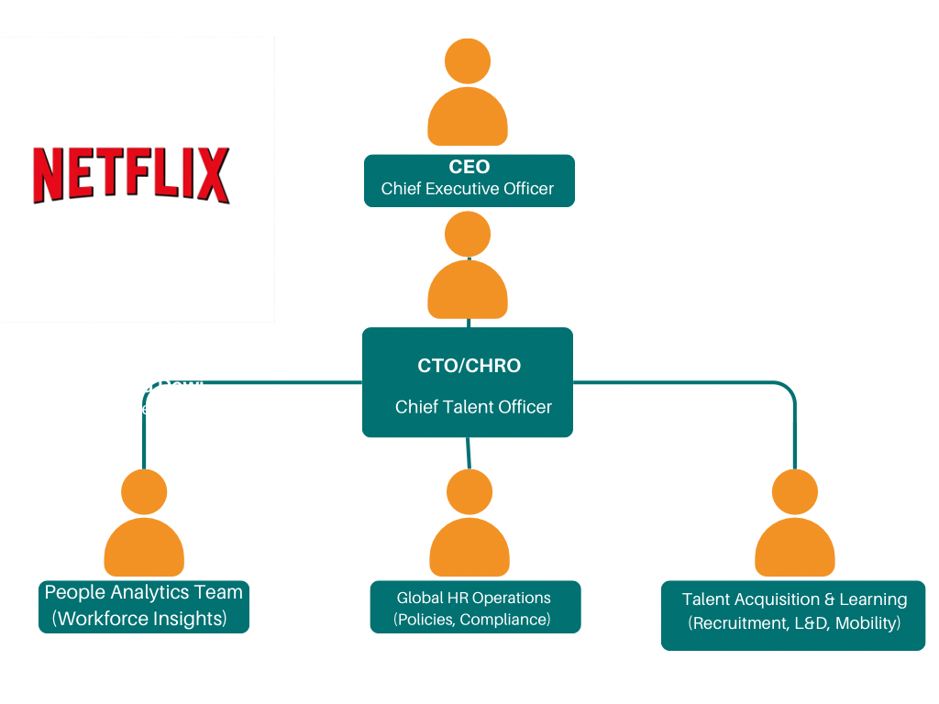

Appendix C. personal SWOT



