Final exam_ACCA7026
Name: Kaicheng Li Student Number: 2106269
Question one Question three and Question four.
Question one
- C
- E
- B
- A
- A
If the positive point is removed, the decision boundary will move towards the positive point.
If the negative points are removed, the decision boundary will be skewed towards the negative points.
- B

Question three
3a)
X=(Outlook=Sunny, Temperature=Cool, Humidity=Normal, Wind=Strong)
Look up tables
Outlook | Play=yes | Play=No
Sunny | 2/9 | 3/5
Overcast | 4/9 | 0/5
Rain | 3/9 | 2/5
Temperature | Play=yes | Play= No
Hot | 2/9 | 2/5
Mild | 4/9 | 2/5
Cool | 3/9 | 1/5

Humidity | Play=yes | Play= No
High | 3/9 | 4/5
Normal | 6/9 | 1/5
Wind | Play=yes | Play= No
Strong | 3/9 | 3/5
Weak | 6/9 | 2/5

P(Play=Yes) = 9/14 P(Play=No) = 5/14

P(Outlook=Sunny|Play=Yes) = 2/9
P(Temperature=Cool|Play=Yes) = 3/9
P(Huminity= Normal |Play=Yes) = 6/9
P(Wind=Strong|Play=Yes) = 3/9
P(Outlook=Sunny|Play=No) = 3/5
P(Temperature=Cool|Play==No) = 1/5
P(Huminity= Normal |Play=No) = 1/5
P(Wind=Strong|Play=No) = 3/5

MAP rule：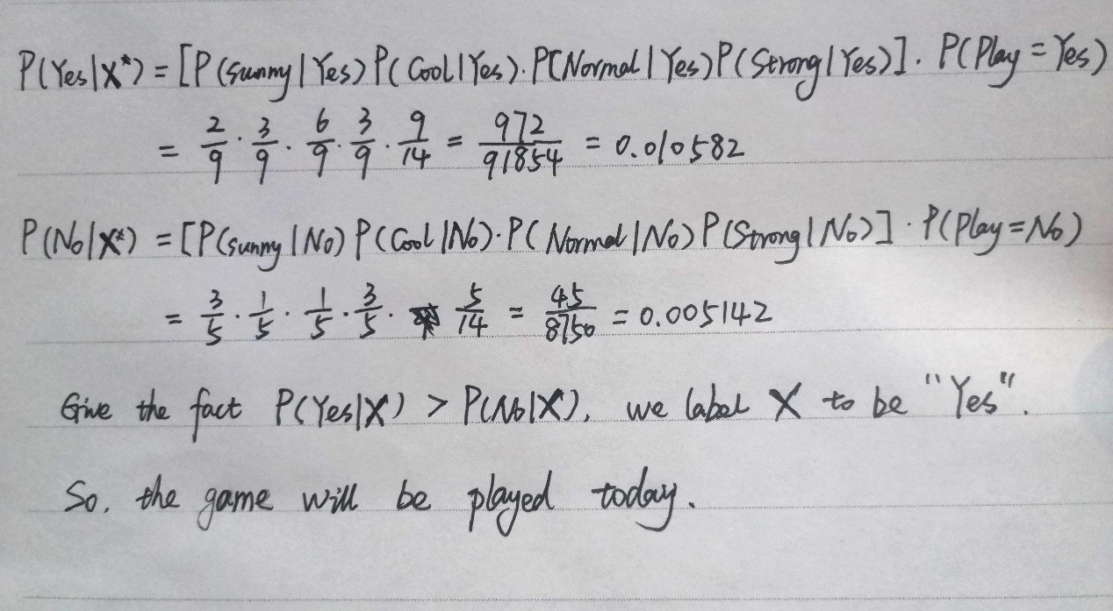
3b)
- It would likely improve the performance generally.
The performance of machine learning models generally increases with the size of the dataset used for predictive modeling.
This depends on the specific dataset and model choice, although this usually means that using more data leads to better performance, and findings that use smaller datasets to estimate model performance can often be scaled to using larger data set.
Increasing the dataset size is the most important way to solve overfitting.
- It would likely improve the performance generally.
Dimensionality reduction is needed.
• Discover hidden correlation between features.
• Remove redundant and noisy features.
• Have a better interpretation and visualisation.
• Reduce the storage space.
• Reduce the processing time.
• May enhance the performance of the learning algorithms, and reducethe complexity

Question four
4a)
 |  | True Class
 |  | Spam | Not Spam
Predicted Class | Spam | TP=70 | FP=30
Predicted Class | Not Spam | FN=70 | TN=330

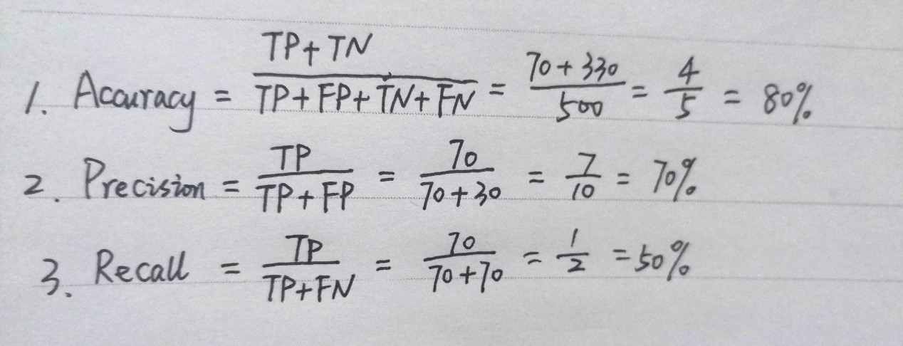
4c)
1. negative (-)
2. negative (-)
3. positive (+)
4. NO.
- Small k
o Good at capturing fine-grained patterns
o It can be sensitive to the noise in the training data
- Large k
o Makes stable predictions by using majority vote.
o May fail to capture important patterns.
- Balancing k:
o The optimal choice of k depends on the number of data points n.
o $k=n^{\frac{2}{2+d}}$, where d is the number of features.
There are only 5 negative (-) instances in total in the training set.
This is ok if the test instance (o) is positive.
If test instance (o) is negative, it will be classified as positive whenever it is. This can lead to wrong judgments.

