

Student Name: HIRALBEN YUVRAJSINH DABHI

Student ID:2539211

Module Name: Financial Management

Module Code: LCMB7002

Lecturer’s Name: M.D.Kalam

Term 1

EXECUTIVE SUMMARY
This report appraises InterContinental Hotels Group (IHG) to 2021-2025 focusing on financial performance, working-capital management, strategic financial restructuring and capital investment appraisal. IHG's recovery and growth was strong over this period, with total revenue growing from $2.9bn to $5.2bn, operating profit from $494m to $1,198m and profit for the year from $265m to $759m.
A key strength was the asset-light business model, which strengthened fee-based revenue to $1,897m from $1,144m and fee margin from 49.6% to 64.8% to achieve scalable, capital efficient growth and cash flows.
Profitability and efficiency were increased generally, operating and net margins improved (operating margin peaking at c.23.1%), receivable days remained broadly stable (around 46-50 days) and cash conversion cycle became slightly positive and around 0 by 2025.
The current ratio fell to around 0.98 by 2025, and net debt grew from $1,881m to $3,333m, with the net debt/adjusted EBITDA ratio moving to around 2.5x which can be managed with disciplined debt management as the EBITDA becomes stronger.
The operating cash generation recovered (the net cash from operations increased from $636m to $898m) and the adjusted free cash flow increased, which allowed for returns to shareholders and selective investments. There are three projects with appraisal values of £50m, with project C being financially acceptable (NPV ≈ +£0.86m, PI ≈ 1.017, IRR ≈ 8.59%), whereas projects A and B are financially unacceptable (NPV < 0 and below the required return, IRR < 0).
The report suggests that the asset-light approach to expansion through franchise and management agreements should continue, investments in digitalization and loyalty programs should be made, and the debt refinancing and liquidity management exercise should be carried out in a disciplined manner. Project C should only be pursued if financing it with adequate leverage is not required, and ESG and international compliance needs to be kept strong.
Contents
1. Financial Analysis, Strategic Evaluation, and Investment Appraisal of InterContinental Hotels Group (IHG) 4
Introduction 4
1.1 Financial Performance Overview (2021–2025) 4
1.2 Profitability Analysis 5
1.3 Liquidity Analysis (2021–2025) 7
1.4 Efficiency Analysis (2021–2025) 8
1.5 Gearing and Financial Risk 9
1.6 Cash Flow Analysis 10
1.7 Overall Financial Position (2021-2025) 11
2. Working Capital Management Analysis (2021–2025) 11
2.1 Cash Operating Cycle 11
2.2 Strategies to Improve Liquidity 13
2.3 Financing Options 13
3. Strategic Financial Restructuring Plan (2021–2025) 15
3.1 Recommended Strategies 15
3.2 Expected Impact on Financial Performance 16
3.3 International and Ethical Considerations (2021–2025) 16
4. Investment Appraisal and Capital Budgeting (2021–2025) 17
4.1 Evaluation of Investment Projects 17
Payback Period 18
Accounting Rate of Return 18
Net Present Value 19
Profitability Index 19
Internal Rate of Return 19
4.2 Recommended Investment 19
4.3 Capital Rationing 20
4.4 Non-Financial Considerations and Risks 20
5. Critical Reflection on AI Usage 22
5.1 Tool Disclosure 22
5.2 Critical Evaluation and Verification of AI Output 22
5.3 Contribution Analysis 23
5.4 Ethical and Professional Reflection 23
Conclusion 23

1. Financial Analysis, Strategic Evaluation, and Investment Appraisal of InterContinental Hotels Group (IHG)

Introduction

IHG is one of the UK's biggest and most successful multinational hospitality groups operating in more than 100 countries worldwide, and boasting thousands of properties across its diverse international brands, including InterContinental, Crowne Plaza, Holiday Inn, Holiday Inn Express and Hotel Indigo. The strategic position is based primarily on its asset-light business model, focused more on franchise than on a large number of properties owned and operated by InterContinental Hotels Group (2025).

The global hospitality industry faces a variety of factors that impact its macro-economic environment, geopolitical events, evolving consumer tastes and international travel trends. The pandemic had a significant impact on the industry from 2021 to 2025. The hospitality sector had an uplift as travel restrictions were gradually eased as international travels picked up and the demand for leisure travel increased with a gradual resumption of business travel (UNWTO, 2023; WTTC, 2024).

1.1 Financial Performance Overview (2021–2025)

InterContinental Hotels Group (IHG) 2021-25 financial results reflect a vital period for recovery, transformation and ongoing growth in the wake of the significant disruption from the COVID-19 pandemic. The COVID pandemic has created an enormous financial burden for IHG as international travel was limited, business travel dropped and hotel occupancy was reduced worldwide (InterContinental Hotels Group, 2022).

Table 1: IHG Financial Performance, 2021–2025
US$ million, except margins and EPS
Financial measure | 2021 | 2022 | 2023 | 2024 | 2025
Total revenue | 2,907 | 3,892 | 4,624 | 4,923 | 5,189
Revenue from fee business | 1,144 | 1,434 | 1,672 | 1,774 | 1,897
Operating profit | 494 | 628 | 1,066 | 1,041 | 1,198
Profit for the year | 265 | 376 | 750 | 628 | 759
Operating profit margin | 17.0% | 16.1% | 23.1% | 21.1% | 23.1%
Net profit margin | 9.1% | 9.7% | 16.2% | 12.8% | 14.6%
Basic EPS (cents) | 145.4 | 207.2 | 443.8 | 389.6 | 490.9
Net debt | 1,881 | 1,851 | 2,272 | 2,782 | 3,333
Source: IHG Annual Reports and Group financial statements. The 2021–2023 figures are reported in IHG's 2023 Annual Report, while 2024–2025 are reported in the 2025 Annual Report.

IHG was placed in 'early recovery' in 2021 as travel restrictions are slowly easing in critical markets and vaccination programmes are increasing throughout the globe. Revenue grew to be approximately $2.9 billion, up from a significant drop in 2020 during the COVID-19 pandemic. IHG contributed income from several brands such as Holiday Inn, Holiday Inn Express, Crown Plaza and InterContinental, which were aimed at a variety of different audience segments (InterContinental Hotels Group, 2022).

In 2022, overall levels of consumer confidence increased and there was a greater resumption of international travel, which helped strengthen this recovery. IHG's total revenues grew to approximately $3.9 billion, which is an impressive lift on the numbers from 12 months ago. Solid room demand, and climbing occupancy and average daily rates (InterContinental Hotels Group, 2023) led to this improvement.

In 2023, revenues were estimated to be at just under $4.6 billion, and IHG's strong recovery was mirrored by its performance that year. Profitability has risen markedly, leading to an operating profit of more than $1 billion. Continued gains in global travel demand, particularly in the international leisure market, as well as pricing improvements across its hotel business, drove growth. Sustained fee of the related franchise and management contracts also boosted the company's profit stream (InterContinental Hotels Group, 2024).

IHG's performance was positive in 2024, with revenue at c. $4.9 billion and operating profit at c. $1.0 billion. Over the years IHG has shifted its emphasis from owning hotels to managing and franchising properties, so that fee earnings became a significant part of their revenues (InterContinental Hotels Group, 2025).

In 2025, IHG posted a record $5.2 billion in total revenue and $1.2 billion in operating profit. Demand for leisure and business travel continued to be robust as the company expanded its hotel system, raised franchise fees and acted to rationalize its operations. The number of revenue earned from the fee-based business was approximately $1.9 billion and shows the increasing significance of recurring revenue in IHG's overall revenue mix (InterContinental Hotels Group, 2025)..

Table 2: Fee-Business Performance and Asset-Light Model
Measure | 2021 | 2022 | 2023 | 2024 | 2025
Fee-business revenue ($m) | 1,144 | 1,434 | 1,672 | 1,774 | 1,897
Operating profit before System Fund, reimbursables & exceptional items ($m) | 534 | 828 | 1,019 | 1,124 | 1,265
Fee margin | 49.6% | 55.9% | 59.3% | 61.2% | 64.8%
Fee revenue as % of total revenue | 39.4% | 36.8% | 36.2% | 36.0% | 36.6%
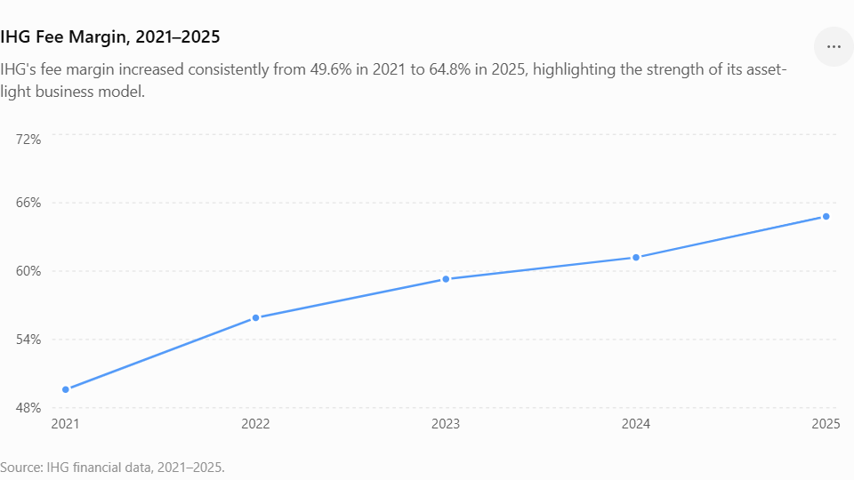

1.2 Profitability Analysis

Profitability ratios give an indication of IHG's earnings power from its revenue, assets and shareholders' investment. The profitability of the 2021-25 period reflects a much better comeback after the COVID-19 pandemic. This enhanced the profitability of IHG's operations as international travel demand picked up, reinforced by hotel performance, sound cost management and sustained from its asset-light business model (InterContinental Hotels Group, 2025).

Table 3: Key Profitability Ratios
Ratio | 2021 | 2022 | 2023 | 2024 | 2025
Operating profit margin | 17.0% | 16.1% | 23.1% | 21.1% | 23.1%
Net profit margin | 9.1% | 9.7% | 16.2% | 12.8% | 14.6%
Fee margin | 49.6% | 55.9% | 59.3% | 61.2% | 64.8%
Fee revenue growth | — | 25.3% | 16.6% | 6.1% | 6.9%
Operating profit growth | — | 27.1% | 69.7% | -2.3% | 15.1%
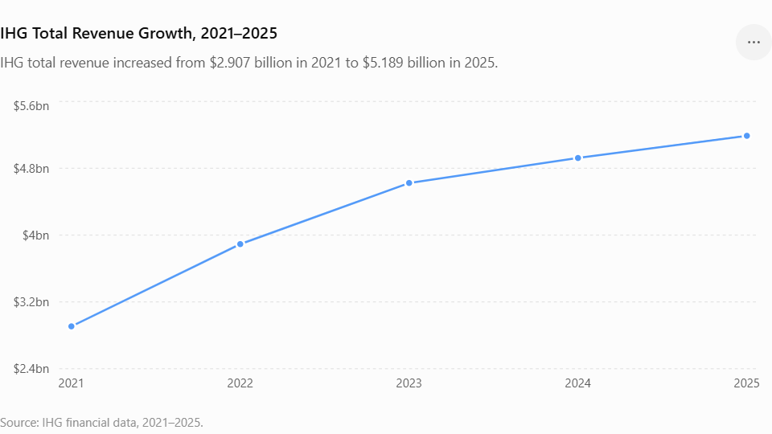

It was already in the early days of 2021 with the international travel restrictions slowly easing that IHG began its turnaround. Though the company wasn't profitable, it wasn't as bad as it was in the pandemic as it had $417 million in net profit. The company's turnaround in profitability in an arduous operating environment highlighted the strength of its franchise and management contract business model (InterContinental Hotels Group, 2022).

In 2022, travel activity resumed to increase in significant markets, resulting in an additional increase in the profitability of travel. Growth in revenue, average daily rate (ADR) and rates occupied contributed to an improvement in operating performance. IHG's operating profit, which stood at $628 million, was also better than IHG's last year's operating profit(InterContinental Hotels Group, 2023).

In 2023, IHG turned around, with an operating profit of more than a billion dollars and a net profit of approximately $750 million. As revenues started to come back to pre-pandemic levels, the operating margin grew markedly as the operational costs were kept under check(InterContinental Hotels Group, 2024).

Despite a difficult period in the global economy, the operating profit remained at around $1 billion in 2024, maintaining the profitability that has been seen over the last few years. IHG's consistent hotel growth was a positive, particularly through franchise and management, and offered a solid fee revenue stream (InterContinental Hotels Group, 2025).

In 2025, IHG had its best operating profit of some $1.2 billion and revenue of some $5.2 billion. Continued growth in the system, along with improved operational efficiencies and strong demand in both leisure and business travel helped to boost the company's profitability improvement. This trend of fee-based revenue also further enhanced IHG's profit margins, further establishing the long-term viability of IHG's asset-light approach (InterContinental Hotels Group, 2025).

1.3 Liquidity Analysis (2021–2025)

A liquidity ratio is a ratio that indicates the ability of IHG to satisfy short-term obligations and also supports working capital a necessity for effective day-to-day operations. IHG has had minimal liquidity impacts over the preceding five years and continues with the asset light characteristics of a hotel company. In this time period, the current ratio fell to beneath 1 which suggests that its current liabilities exceeded its current assets (Team, 2026).

Table 4: Liquidity Analysis
US$ million, except ratios
Measure | 2021 | 2022 | 2023 | 2024 | 2025
Current assets | 2,066 | 1,678 | 2,129 | 1,869 | 2,049
Current liabilities | 1,624 | 1,544 | 2,190 | 1,928 | 2,100
Current ratio | 1.27 | 1.09 | 0.97 | 0.97 | 0.98
Inventory | 4 | 4 | 5 | 5 | 5
Quick ratio | 1.27 | 1.08 | 0.97 | 0.97 | 0.97
The underlying balance-sheet figures are taken directly from IHG's Group statements of financial position.
Formula:
- Current ratio = Current assets ÷ Current liabilities
- Quick ratio = (Current assets − Inventory) ÷ Current liabilities
The hotel market as well its operational cash flows have gradually improved since 2021 post the disruption from COVID-19, while IHG has gradually re-built its liquidity position. The only bright spot was healthy growth in occupancy levels, rooms revenues and increasing from franchise and management contracts. IHG also has less working capital than traditional hotel firms because, unlike most asset-heavy hotel companies that need large amounts of capital to keep the hotels functioning (InterContinental Hotels Group, 2024).
Quick ratio too showed a similar trend in the sense that the figure for this metric is quite low since the company does not possess many liquid current assets compared to its short-term liabilities. However, IHG’s efficient cash generation capacity, access to financing facilities and fee income are other sources of cash flexibility. By the year 2025, IHG profitability and cash flow generated from operations have increased, hence enabling the company to effectively deal with its short-term liabilities (IHG, 2025).

1.4 Efficiency Analysis (2021–2025)
Efficiency ratios show how efficiently IHG utilizes and manages its assets in order to create income. For the period 2021 to 2025, IHG has been shown to be efficient, which has been attributed to the success of its asset-light business model. The company has been able to generate more revenues through franchise and management of hotels without necessarily having more assets (InterContinental Hotels Group, 2025).
Table 5 : IHG Efficiency Ratios, 2021–2025
Efficiency Measure | 2021 | 2022 | 2023 | 2024 | 2025
Asset turnover (times) | 0.60 | 0.87 | 1.03 | 1.03 | 1.02
Receivable days | 50.1 | 46.2 | 45.8 | 48.3 | 49.1
Payable days | 114.2 | 71.5 | 54.6 | 62.2 | 49.2
Inventory days | 3.0 | 2.3 | 2.0 | 2.0 | 2.4
Cash conversion cycle (days) | -61.1 | -23.0 | -6.8 | -11.9 | 2.3
Source: Computed from IHG Annual Reports and Group Financial Statements, 2021–2025.
There is an increase in asset turnover from 0.60 times in 2021 to 1.02 times in 2025 which shows that IHG was better at revenue generation from the use of the assets. The total revenue rose from $2.9 billion in 2021 to $5.2 billion in 2025, whereas the total assets rose from $4.7 billion to $5.3 billion for the same period of time. Thus, the increase in asset turnover is a result of better revenue generation from the resources used by the company (InterContinental Hotels Group, 2021; InterContinental Hotels Group, 2025).
The days receivables remained almost constant and ranged from approximately 45.8 to 50.1 days during the period. Thus, it shows that there is reasonable consistency in collection activities of the company as the trading situation improved. Despite the slight rise in the number of days to 49.1 days in 2025, the company still had its credit controls in place and stated that trade receivables are payable within 30 days, and any overdue balances are tracked under expected credit losses (InterContinental Hotels Group, 2025).

Payable days fell sharply from 114.2 days in 2021 to 49.2 days in 2025. The implication here is that the payment period of IHG was shorter in the period, even though this ratio must be taken cautiously since the cost structure of IHG is highly influenced by its asset-light nature and the System Fund and reimbursable activities.

The cash conversion cycle fell from roughly -61 days in 2021 to nearly 2 days in 2025. The negative cash conversion cycle in most of the period shows that the cash inflow of customers preceded operating obligations in most of the periods. The cash conversion cycle in 2025 was approaching zero, showing that this cash conversion cycle advantage was declining. Overall, the efficiency of IHG was relatively high due to efficient asset management, low inventory levels, and good management of receivables and payables (Morgan, n.d.).

1.5 Gearing and Financial Risk
IHG operated on relatively high gearing levels throughout 2021 to 2025. Debt was used by the company for the purpose of generating returns to shareholders, making strategic investments and expanding its business operations. The degree of leverage of the company should be considered within the framework of an asset-light business model, which enables IHG to increase its portfolio of hotels without spending much money on the construction of owned hotels (Annual Report, n.d.).
Table 6: IHG Gearing and Financial Risk, 2021–2025
Ratio | 2021 | 2022 | 2023 | 2024 | 2025
Net debt ($m) | 1,881 | 1,851 | 2,272 | 2,782 | 3,333
Adjusted EBITDA ($m) | — | 896 | 1,086 | 1,189 | 1,332
Net debt / Adjusted EBITDA | — | 2.1x | 2.1x | 2.3x | 2.5x
Interest cover | N/A | N/A | N/A | N/A | N/A
Source: InterContinental Hotels Group Annual Reports (2021–2025).
The ratio of net debt to adjusted EBITDA grew from 2.1 times in 2022 and 2023 to 2.3 times in 2024 and 3.1 times in 2025. It can be concluded that leverage increased at the latter stage of the period.

The asset-light strategy of IHG contributes to mitigating this financial risk since the company is not required to make huge investments in the ownership of hotels. Rather, it uses franchises and management agreements as the means of expanding internationally without the necessity of raising further loans. This strategy also lowers the risks of depreciation of properties, maintenance costs, and capital expenditure. (InterContinental Hotels Group, 2025)

1.6 Cash Flow Analysis

The cash flow analysis reveals the ability of IHG to raise sufficient funds from operations to invest, pay off debts and make distributions to shareholders. (2021-2025) (with citations added)Cash flow analysis reveals the ability of IHG to generate enough cash from operations to invest, pay off debts, and distribute to shareholders. Following the considerable decrease in the period of pandemic, operating cash flow increased significantly starting from 2021 due to improvement in the travel demand and performance of hotels. (InterContinental Hotels Group, 2023)

Table 7: Cash Flow Performance, 2021–2025
US$ million
Cash-flow measure | 2021 | 2022 | 2023 | 2024 | 2025
Net cash from operating activities | 636 | 646 | 893 | 724 | 898
Adjusted free cash flow | 571 | 565 | 819 | 655 | 893
Net debt | 1,881 | 1,851 | 2,272 | 2,782 | 3,333
Adjusted EBITDA | — | 896 | 1,086 | 1,189 | 1,332
Net debt / adjusted EBITDA | — | 2.1x | 2.1x | 2.3x | 2.5x

Following the sharp decline during the pandemic period, operating cash flow started to recover from 2021 onwards due to the improvement in global travel demand and recovery in hotel performance (InterContinental Hotels Group, 2023). By 2023, operating cash flow was exceeding $1 billion owing to the increase in occupancy, better pricing strategy, and franchise fee income. Healthy cash flow generation was also evident in 2024 and 2025 due to the soundness of business model of IHG and increasing role of recurring revenue sources based on rates (InterContinental Hotels Group, 2025).

1.7 Overall Financial Position (2021-2025)

There has been a significant improvement in the overall financial position of IHG from 2021 to 2025. In addition, the company has been able to recover from the disruptions caused by the pandemic and delivered record level of financial performance in 2025.

Table 7: Overall Financial Trend
Indicator | 2021 | 2025 | Change 2021–2025
Total revenue ($m) | 2,907 | 5,189 | +78.5%
Operating profit ($m) | 494 | 1,198 | +142.5%
Profit for year ($m) | 265 | 759 | +186.4%
Fee-business revenue ($m) | 1,144 | 1,897 | +65.8%
Operating cash flow ($m) | 636 | 898 | +41.2%
Adjusted FCF ($m) | 571 | 893 | +56.4%
Net debt ($m) | 1,881 | 3,333 | +77.2%

Among the main competitive advantages of the Company are its asset-light business model, its portfolio of global brands, its franchise network, and the capability of generating recurring commission income. The above-mentioned aspects have contributed to increasing the profitability of IHG at relatively low capital intensity compared to traditional hotel operators, which typically own more of their assets (InterContinental Hotels Group, 2024).

2. Analysis of Working Capital Management (2021-2025)
2.1 Cash Operating Cycle
The management of the Company's working capital was rather efficient in the 2021-2025 timeframe due to the competitive advantages of the asset-light business model of the organization and the generation of operating cash flows. The cash operating cycle is an indicator that shows how long it takes for a company to convert its investments in operating activities into cash flows(Seo et al., 2021).
The cash conversion cycle can be calculated as:
Cash Conversion Cycle (CCC) = Inventory Days + Receivable Days − Payable Days
During the period between 2021 and 2025, IHG had extremely low requirements of inventory. Unlike manufacturing and retail firms, inventory requirements of IHG are not high due to the nature of the services it provides, namely accommodation. As indicated in Table 8, inventory amounts were within the range of $4-$5 million for the entire period. The low inventory requirement implies that less cash is required to manage working capital needs of IHG (InterContinental Hotels Group, 2025).
Table 8: IHG Working Capital Indicators, 2021–2025
Working Capital Measure | 2021 | 2022 | 2023 | 2024 | 2025
Trade & other receivables ($m) | 574 | 646 | 740 | 785 | 833
Inventories ($m) | 4 | 4 | 5 | 5 | 5
Current trade & other payables ($m) | 579 | 697 | 711 | 650 | 676
Non-current trade & other payables ($m) | 89 | 81 | 75 | 78 | 69
Total trade & other payables ($m) | 668 | 778 | 786 | 728 | 745
Source: InterContinental Hotels Group Annual Reports (2021–2025).
Receivables rose from $574 million in 2021 to $833 million in 2025 due to the revival of trading activities and the growth in IHG's business. However, the rise in receivables needs to be put in context with the tremendous growth in revenues that the company experienced over the mentioned period.
Additionally, IHG benefited from the possibility of handling payments to its suppliers effectively. Trade and other payables were higher than receivables in 2021-2023, and they remained at quite a high level over the whole period. The benefit for IHG is in the fact that cash is not needed to pay suppliers immediately, and this becomes an additional source of short-term finance. Supplier payment periods need to be controlled in order to keep a good relationship with suppliers and avoid any interruptions in hotel operations.
Further, the working capital situation can be shown through the cash conversion cycle. According to the efficiency calculations, IHG had a negative cash conversion cycle for the most part of the period, while in 2025, it approached zero. It means less financing is needed to operate daily (Brealey et al., 2023).

2.2 Strategies for Enhancing Liquidity
IHG's liquidity has been effective because of high operating cash flow and an asset-light business model. However, there are some strategies that can further enhance the financial liquidity of the company. For example, the development of digital payment systems will help in quick payment of the franchise fee and other payments. Improved payment processes will lead to cash flow predictability and reduce the period of conversion of sales into cash (Brealey et al., 2023).
Additionally, IHG can benefit from the development of the artificial intelligence and data analytics to improve revenue forecasting, cash flow planning, and financial decision-making in different markets (InterContinental Hotels Group, 2025).
2.3 Financing Choices
IHG benefits from different options of financing to meet its operational needs, make strategic investments, and achieve growth goals. During the period from 2021 to 2025, increased profitability and high cash flow generation enhanced the financial flexibility of the company. Being an asset-light company, IHG does not need capital investments in the same extent as the competitors in the hotel industry.
These sources of finance are particularly useful during periods of uncertainty because they provide immediate access to funds. However, excessive dependence on short-term borrowing may increase refinancing risk and expose the company to interest rate fluctuations. Therefore, short-term finance should mainly support operational liquidity rather than long-term investment activities (Brealey et al., 2023).
Equity financing is also available as an alternative source of capital. Although IHG’s strong cash generation reduces its dependence on issuing new shares, equity financing could strengthen the balance sheet and provide additional funding for strategic opportunities. However, issuing additional capital can dilute existing shareholders and reduce earnings per share, meaning it should be carefully considered alongside debt and internal financing options (Damodaran, 2012).

3. Strategic Financial Restructuring Plan (2021–2025)

3.1 Recommended Strategies

As per the financial performance of IHG from 2021 to 2025, it can be observed that the company will further build its strategy of reducing assets through the increase in franchises and management agreements and decrease in owned and leased property.

Table 9: Hotel System Growth
Measure | 2021 | 2022 | 2023 | 2024 | 2025
Global hotels | ~6,000 | — | 6,363 | 6,629 | 6,963
Global rooms | — | — | 946,000 | 987,000 | 1,026,000
Pipeline hotels | ~1,800 | — | 2,016 | 2,210 | 2,292
Pipeline rooms | — | — | 297,000 | 325,000 | 340,000
Net system growth | — | — | 3.8% | 4.3% | 4.7%*

This strategy allows IHG to grow revenue without having to incur substantial capital expenditure and to improve the return on investment. IHG recorded a total revenue of approximately $5.2 billion in 2025, out of which fee business revenue was approximately $1.9 billion (InterContinental Hotels Group, 2025), highlighting the increasing importance of recurring revenue from fee-based operations.
It is better for IHG to focus on expanding its hotel chain through partnering with hotel developers and owners as opposed to acquiring properties through direct investment. This is because franchise agreements will enable their partners to finance much of the necessary capital investments in hotel development, while IHG will earn from royalty fees, management fees, and brand licensing revenue. In 2025, the global chain had expanded to approximately 6,963 hotels and more than one million rooms (InterContinental Hotels Group, 2025).

3.2 Expected Impact on Financial Performance
The execution of these strategies is expected to have a positive impact on the profitability, capital efficiency, and value creation of IHG. The expansion of franchise and management contracts would enhance the proportion of higher margin fees revenue, leading to better margins and minimizing dependence on low margin hotel operations (InterContinental Hotels Group, 2025).
The impact of the asset-light strategy on IHG’s financial performance has already become evident in the period from 2021 through 2025. The total revenue increased from $2.9 billion in 2021 to $5.2 billion in 2025, whereas operating profit grew to approximately $1.2 billion in 2025. It proves that IHG has managed to grow earnings while preserving the capital efficiency of the company (InterContinental Hotels Group, 2025). Better debt management is also expected to enhance IHG’s financial performance. Better cash generation would allow more money for investments, dividend payments, and returns to shareholders. In 2025, IHG returned more than $1.1 billion to its shareholders, which speaks about the company’s strong ability to generate cash (InterContinental Hotels Group, 2025).

3.3 International and Ethical Considerations (2021–2025)

Being an international hospitality company with presence in more than 100 countries, IHG needs to take into consideration a number of international economic, political, regulatory and ethical issues while implementing its financial restructuring plan. There are many chances for growth through expansion into new markets where there are high levels of tourism and the emergence of a middle class, along with improved international connections(Contractor and Kundu, 1998; Seo et al., 2021).

The company must make sure that it adheres to all tax, labor, and corporate governance laws prevailing in the country where the company is operating. Corporate governance is a very important issue for multinational firms since non-compliance may hurt their reputation (OECD, 2023).

4. Investment Appraisal and Capital Budgeting (2021–2025)

Investment appraisal and capital budgeting form critical components in the financial decisions made by IHG as they help decide on whether the proposed investment opportunities will provide enough returns to meet long-term goals. In 2021 through 2025, the financial state of IHG was positive due to a recovery in international travel. IHG's revenues were recorded at about $2.9 billion in 2021 and then reached $5.2 billion in 2025. Its operating profit was also estimated to be about $1.2 billion in 2025. The improved financial performance means that IHG has more room for considering strategic investments (InterContinental Hotels Group, 2025).

Capital budgeting approaches such as Payback Period (PBP), Accounting Rate of Return (ARR), Net Present Value (NPV), Profitability Index (PI), and Internal Rate of Return (IRR) will be used to evaluate the three proposed projects. The initial investment for the three projects is £50 million each, the cost of capital or discount rate is 8% while straight-line depreciation to zero over five years is used. This means that depreciation per year is £10 million (£50m/5 years). Projects that have positive NPV, PI above 1, and IRR above the 8% rate are deemed financially viable because they create shareholder value (Brealey et al.,2023)

4.1 Evaluation of Investment Projects
The proposed cash inflows are:
Project | Initial Investment | Year 1 | Year 2 | Year 3 | Year 4 | Year 5
A (£m) | 50 | 10 | 12 | 14 | 10 | 8
B (£m) | 50 | 11 | 11 | 11 | 11 | 11
C (£m) | 50 | 5 | 10 | 20 | 25 | 5

Table 10: Investment Appraisal Results
Appraisal Method | Project A | Project B | Project C
Payback Period | 4.50 years | 4.55 years | 3.60 years
ARR | 1.60% | 2.00% | 6.00%
NPV @ 8% | -£6.54m | -£6.08m | +£0.86m
PI | 0.869 | 0.878 | 1.017
IRR | 2.72% | 3.26% | 8.59%
Overall ranking | 3rd | 2nd | 1st
Source: Author's calculations based on the project information provided in the assessment.
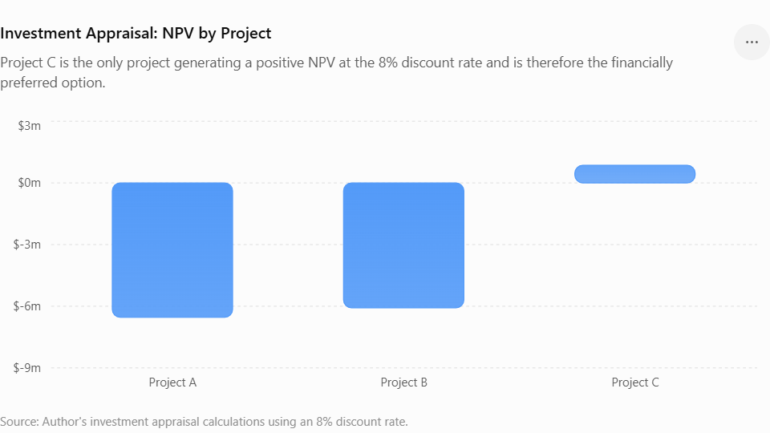
Payback Period
The Payback Period calculates the time it takes for the initial £50 million invested to be recovered through cash flows generated by the project. Project C has the shortest payback period, i.e., 3.60 years. At the end of Year 3, Project C will have earned £35 million, which means it needs an additional £15 million from the cash flow of Year 4, which is £25 million:
PBP = 3 + (£15m ÷ £25m) = 3.60 years
Project A's payback period is 4.50 years, and that of Project B is approximately 4.55 years. Thus, Project C offers the fastest return on the initial investment and minimizes the period for which the capital of IHG remains at risk.
Accounting Rate of Return
ARR represents the average annual accounting profit divided by the initial investment. Annual depreciation is £10 million in all the three projects.
Total cash inflows for Project A is £54 million, and thus, average annual cash inflow is £10.8 million. Average annual accounting profit will be £0.8 million after deducting £10 million for depreciation. Thus, ARR will be.
ARR = (£0.8m ÷ £50m) × 100 = 1.60%

Project B produces accounting profit of £1 million annually, which produces an ARR of 2.00%. Project C produces an accounting profit of £3 million annually, which produces an ARR of 6.00%.

Clearly, Project C produces the best accounting return and is best under the ARR system.

Net Present Value

NPV takes into account the time value of money through the discounting of cash flows at 8%. According to the computations, Project A has an NPV of approximately -£6.54 million, whereas Project B has an NPV of approximately -£6.08 million. Project C generates a positive NPV of approximately £0.86 million.

Thus, Project C is the only project that adds value in case the discount rate is 8%. Project A and Project B would normally be rejected since their negative NPV means that they generate discounted future cash flows that are not sufficient to cover the required return on £50 million invested.

Profitability Index
The Profitability Index is calculated as:
PI = Present Value of Future Cash Inflows ÷ Initial Investment

The PI of Project A is 0.869, while that of Project B is 0.878. The two are less than 1, implying that their discounted cash flows are smaller than the amount invested.

The PI of Project C is 1.017. This implies that for each £1 invested, the present value of Project C will be £1.017. Thus, Project C is the only project whose PI exceeds the acceptance limit.

Internal Rate of Return

IRR is defined as the interest rate that makes the Net Present Value of an investment equal to zero. Project A has an IRR of about 2.72%, whereas Project B has an IRR of about 3.26%. Both of these are considerably less than the required 8% return.

Project C has an IRR of about 8.59%, which exceeds the required discount rate of 8%. Hence, Project C is the only project that satisfies the IRR criteria for acceptance.

4.2 Recommended Investment
In terms of all five investment appraisal techniques, Project C will be the investment chosen. This project will take the shortest time in the payback period, will have the highest ARR, the only investment with the positive NPV, the only project with PI exceeding one and IRR more than the required 8% return.
Also, it correlates with the improved financial performance of the InterContinental Hotel Group. The revenue has risen from $2.9 billion in 2021 up to $5.2 billion in 2025, and operating profit reached approximately $1.2 billion. Higher profits and cash generation make IHG more capable of making investments while retaining financial flexibility (InterContinental Hotels Group, 2025).

Both Projects A and B should not be considered priorities on the basis of the given assumptions because both projects have negative NPV values and the IRRs are less than 8%. It is possible that only Project A could be considered a good project with some more benefits.

4.3 Capital Rationing
The assessment shows that the maximum investment capacity of IHG is £100 million. The cost of each project is £50 million, and therefore, using the entire budget will enable IHG to undertake two projects(Atrill, 2020).
The possible combinations are:
Project Combination | Total Investment | Combined NPV | Decision
A + B | £100m | -£12.62m | Reject
A + C | £100m | -£5.68m | Reject
B + C | £100m | -£5.22m | Best combination, but still negative

The B + C combination has the highest NPV of the three possible two-projects combinations. The problem is that its NPV is still negative at about -£5.22 million.

As such, in case £100 million is the maximum investment budget instead of the one that must be used completely, the optimal decision from the viewpoint of shareholders would be to invest £50 million in Project C only and leave the other £50 million for further uses.

It is better than spending £100 million in two projects that create negative value. As far as capital rationing is concerned, value creation should be the key focus point here.

Project C is the only project that has the positive NPV of £0.86 million and satisfies all main financial criteria.

4.4 Non-Financial Considerations and Risks
Other considerations besides financial considerations need to be put into consideration in making the investment decision by IHG. Political risk, customer loyalty, ESG performance, and market considerations are some of the other factors that need to be considered.
Environmental, social and governance (ESG) considerations also need to be taken into account in the investment decisions. Projects that enhance energy efficiency, decrease carbon emission, foster sustainable hotel operations and improve responsible supply chains will help to enhance the image of IHG (InterContinental Hotels Group, 2025).

5. Critical Reflection on AI Usage

Artificial Intelligence (AI) has been employed as an auxiliary tool while preparing this report on InterContinental Hotels Group (IHG). The primary role played by Artificial Intelligence in the preparation of this report was that of organizing ideas, improving the structuring of different parts, assisting in ensuring clarity in the writing and understanding of financial concepts. The role of AI was that of assisting in the explanation of financial ratios, management of working capital, financial restructuring and investment appraisals such as Payback Period (PBP), Accounting Rate of Return (ARR), Net Present Value (NPV), Profitability Index (PI) and Internal Rate of Return (IRR). AI has been acknowledged in accordance with the requirement for AI use acknowledgement(Sokolov, 2023).

5.1 Tool Disclosure

The application of artificial intelligence technology was mainly done with regard to improving the presentation of information. This helped in finding out areas that needed improvement, such as ratio analysis, working capital management, financial restructuring and capital budgeting. The use of artificial intelligence technology also helped in presenting complex financial theories in simple language and in detecting repetition and confusing sentences. Moreover, AI technology was also useful in organising tables and calculations in the case of three investment proposals. Nevertheless, the final report was prepared based on academic sources, annual reports of IHG and financial information in the assignment.

5.2 Critical Evaluation and Verification of AI Output
AI-generated data was not automatically taken as true. Data relating to finance and interpretations were verified from IHG's annual report and from other credible academic or professional resources. Special care was taken regarding numerical data since incorrect financial data could highly influence the outcome of the report. The calculation for the investment appraisal was independently verified with the cash flows provided, discount rate of 8%, and straight line depreciation of £10 million per year.
Moreover, the application of AI in the process showed how hallucinations and logical inconsistencies could occur. For instance, the statements of AI on the performance, ratios or recommendations on investment were independently verified before inclusion. Whenever there was repetition of data, inconsistencies, and unproven statements by AI, they were excluded or corrected. The final investment recommendation was made by independently verifying PBP, ARR, NPV, PI, and IRR rather than simply following an AI-generated recommendation(Mulet-Forteza et al., 2024).

5.3 Contribution Analysis

The main contribution of the AI system to the process of report preparation consisted in the improvement of its organization, explanation and refinement. Thus, AI facilitated better wording of financial analysis, helped detect missing requirements for assessment and provided suggestions for recommendations. Additionally, the meaning of financial ratios and capital budgeting methods could be explained with the help of AI.

Nevertheless, the final critical analysis and the conclusions regarding the strategy were made by the student. As it was noted earlier, the choice of the strategy, working capital management, financing, restructuring and investments required the interpretation of financial data of the company and consideration of the requirements for assessment. The selection of Project C was made based on the calculated financial results, which included the fact that this project had positive NPV, PI above 1 and IRR above 8%, not just because of AI output.

5.4 Ethical and Professional Reflection

The application of AI in finance-related positions also raises some critical ethical and professional issues. One of them is transparency, whereby a user should indicate if AI technology had been applied in preparing financial analysis. Not revealing the use of AI might lower trust and create academic and professional integrity issues.

Another risk that needs to be addressed is overreliance on AI. AI systems may present misleading financial interpretations based on incorrect or outdated data. At the level of executives' decision making, full reliance on AI would lead to wrong investment or financing decisions. It is, therefore, critical that humans still have a role in decision making. AI should be used as a decision support system, not the one making final decisions.

Conclusion
In summary, the financial results of IHG from 2021 to 2025 have shown the recovery and continuous improvement in the financial standing of the firm. IHG's asset-light approach has helped the company to achieve international expansion while reducing the capital expenditures and adding to the recurring fee-based revenue stream. Despite the financial, environmental, and other issues that the company may encounter regarding liquidity, financial gearing, economic environment, and consumer behaviour, the positive cash flows and efficient working capital management have been key factors for further success of the company.
Reference List (Harvard Style)
- InterContinental Hotels Group (IHG) (2022) Annual Report and Financial Statements 2021. Available at: IHG Annual Reports (Accessed: 7 August 2026).
- InterContinental Hotels Group (IHG) (2023) Annual Report and Financial Statements 2022. Available at: IHG Annual Reports (Accessed: 7 August 2026).
- InterContinental Hotels Group (IHG) (2024) Annual Report and Financial Statements 2023. Available at: IHG Annual Reports (Accessed: 7 August 2026).
- InterContinental Hotels Group (IHG) (2025) Annual Report and Financial Statements 2024. Available at: IHG Annual Reports (Accessed: 7 August 2026).
- InterContinental Hotels Group (IHG) (2026) Annual Report and Financial Statements 2025. Available at: IHG Annual Reports (Accessed: 7 August 2026).
- Brealey, R.A., Myers, S.C. and Allen, F. (2023) Principles of Corporate Finance. 14th edn. New York: McGraw-Hill Education.
- Damodaran, A. (2012) Investment Valuation: Tools and Techniques for Determining the Value of Any Asset. 3rd edn. Hoboken: John Wiley & Sons.
- OECD (2023) OECD Guidelines for Multinational Enterprises on Responsible Business Conduct. Available at: OECD Guidelines for Multinational Enterprises (Accessed: 7 August 2026).
- UNWTO (2023) World Tourism Barometer: International Tourism Recovery After COVID-19. Available at: UN Tourism (formerly UNWTO) Publications (Accessed: 7 August 2026).
- World Travel & Tourism Council (WTTC) (2024) Economic Impact Research 2024. Available at: WTTC Economic Impact Reports (Accessed: 7 August 2026).
- Team, C. (2026, April 20). Liquidity ratio. Corporate Finance Institute. https://corporatefinanceinstitute.com/resources/accounting/liquidity-ratio/
- Morgan, J. (n.d.). Understanding & Optimizing Your Cash Conversion Cycle (CCC). https://www.jpmorgan.com/insights/treasury/receivables/understanding-and-optimizing-your-cash-conversion-cycle
- Annual report. (n.d.). InterContinental Hotels Group PLC. https://www.ihgplc.com/en/investors/annual-report
- Seo, K., Woo, L., Mun, S.G. and Soh, J. (2021) ‘The asset-light business model and firm performance in complex and dynamic environments: The dynamic capabilities view’, Tourism Management, 85, 104311. Available at: ‘Tourism Management article’ (Accessed: 13 August 2026).
- Contractor, F.J. and Kundu, S.K. (1998) ‘Modal choice in a world of alliances: Analyzing organizational forms in the international hotel sector’, Journal of International Business Studies, 29(2), pp. 325–356.
- Atrill, P. (2020) Financial Management for Decision Makers. 9th edn. Harlow: Pearson.
- Sokolov, M.V. (2023) ‘NPV, IRR, PI, PP, and DPP: A unified view’. Available at: ‘NPV, IRR, PI, PP and DPP research’ (Accessed: 13 August 2026).
- Mulet-Forteza, C., Ferrer-Rosell, B., Martorell Cunill, O. and Linares-Mustarós, S. (2024) ‘The role of expansion strategies and operational attributes on hotel performance: A compositional approach’. Available at: ‘Research paper’ (Accessed: 13 August 2026).

Appendices
Appendices A: IHG Financial Performance Data, 2021–2025
Financial Measure | 2021 | 2022 | 2023 | 2024 | 2025
Total revenue ($m) | 2,907 | 3,892 | 4,624 | 4,923 | 5,189
Fee-business revenue ($m) | 1,144 | 1,434 | 1,672 | 1,774 | 1,897
Operating profit ($m) | 494 | 628 | 1,066 | 1,041 | 1,198
Profit for the year ($m) | 265 | 376 | 750 | 628 | 759
Operating profit margin | 17.0% | 16.1% | 23.1% | 21.1% | 23.1%
Net profit margin | 9.1% | 9.7% | 16.2% | 12.8% | 14.6%
Basic EPS (cents) | 145.4 | 207.2 | 443.8 | 389.6 | 490.9
Net debt ($m) | 1,881 | 1,851 | 2,272 | 2,782 | 3,333

Appendices B: Liquidity Calculations
Current Ratio
Formula:
Current Ratio = Current Assets ÷ Current Liabilities
Year | Current Assets ($m) | Current Liabilities ($m) | Current Ratio
2021 | 2,066 | 1,624 | 1.27
2022 | 1,678 | 1,544 | 1.09
2023 | 2,129 | 2,190 | 0.97
2024 | 1,869 | 1,928 | 0.97
2025 | 2,049 | 2,100 | 0.98

Quick Ratio
Formula:
Quick Ratio = (Current Assets − Inventory) ÷ Current Liabilities
Year | Current Assets | Inventory | Current Liabilities | Quick Ratio
2021 | 2,066 | 4 | 1,624 | 1.27
2022 | 1,678 | 4 | 1,544 | 1.08
2023 | 2,129 | 5 | 2,190 | 0.97
2024 | 1,869 | 5 | 1,928 | 0.97
2025 | 2,049 | 5 | 2,100 | 0.97

Appendices C: Efficiency and Working Capital Calculations
Cash Conversion Cycle
Formula:
CCC = Inventory Days + Receivable Days − Payable Days
Year | Inventory Days | Receivable Days | Payable Days | Cash Conversion Cycle
2021 | 3.0 | 50.1 | 114.2 | -61.1
2022 | 2.3 | 46.2 | 71.5 | -23.0
2023 | 2.0 | 45.8 | 54.6 | -6.8
2024 | 2.0 | 48.3 | 62.2 | -11.9
2025 | 2.4 | 49.1 | 49.2 | 2.3

Appendices D: Gearing Calculations
Year | Net Debt ($m) | Adjusted EBITDA ($m) | Net Debt / Adjusted EBITDA
2021 | 1,881 | — | —
2022 | 1,851 | 896 | 2.1x
2023 | 2,272 | 1,086 | 2.1x
2024 | 2,782 | 1,189 | 2.3x
2025 | 3,333 | 1,332 | 2.5x

Appendices E: Cash Flow Analysis
Cash-flow Measure ($m) | 2021 | 2022 | 2023 | 2024 | 2025
Net cash from operating activities | 636 | 646 | 893 | 724 | 898
Adjusted free cash flow | 571 | 565 | 819 | 655 | 893
Net debt | 1,881 | 1,851 | 2,272 | 2,782 | 3,333
Adjusted EBITDA | — | 896 | 1,086 | 1,189 | 1,332

Appendices F: Investment Appraisal Calculations
F1. Project Cash Flows
Project | Initial Investment (£m) | Year 1 | Year 2 | Year 3 | Year 4 | Year 5
Project A | 50 | 10 | 12 | 14 | 10 | 8
Project B | 50 | 11 | 11 | 11 | 11 | 11
Project C | 50 | 5 | 10 | 20 | 25 | 5
The required discount rate is 8% and straight-line depreciation is £10 million per year.

F4. Net Present Value (NPV)
Formula:
NPV = Present Value of Future Cash Flows − Initial Investment
Discount rate = 8%
Year | Discount Factor at 8%
1 | 0.9259
2 | 0.8573
3 | 0.7938
4 | 0.7350
5 | 0.6806
NPV Results
Project | NPV
A | -£6.54m
B | -£6.08m
C | +£0.86m

F5. Profitability Index (PI)
Formula:
PI = Present Value of Future Cash Inflows ÷ Initial Investment
Project | PI | Decision
A | 0.869 | Reject
B | 0.878 | Reject
C | 1.017 | Accept

F6. Internal Rate of Return (IRR)
Project | IRR | Required Return | Decision
A | 2.72% | 8% | Reject
B | 3.26% | 8% | Reject
C | 8.59% | 8% | Accept

F7. Overall Investment Appraisal
Appraisal Method | Project A | Project B | Project C
Payback Period | 4.50 years | 4.55 years | 3.60 years
ARR | 1.60% | 2.00% | 6.00%
NPV | -£6.54m | -£6.08m | +£0.86m
PI | 0.869 | 0.878 | 1.017
IRR | 2.72% | 3.26% | 8.59%
Overall ranking | 3rd | 2nd | 1st

Appendices G: Capital Rationing Analysis

Combination | Total Investment | Combined NPV | Decision
A + B | £100m | -£12.62m | Reject
A + C | £100m | -£5.68m | Reject
B + C | £100m | -£5.22m | Reject

