Ariat Marketing Plan
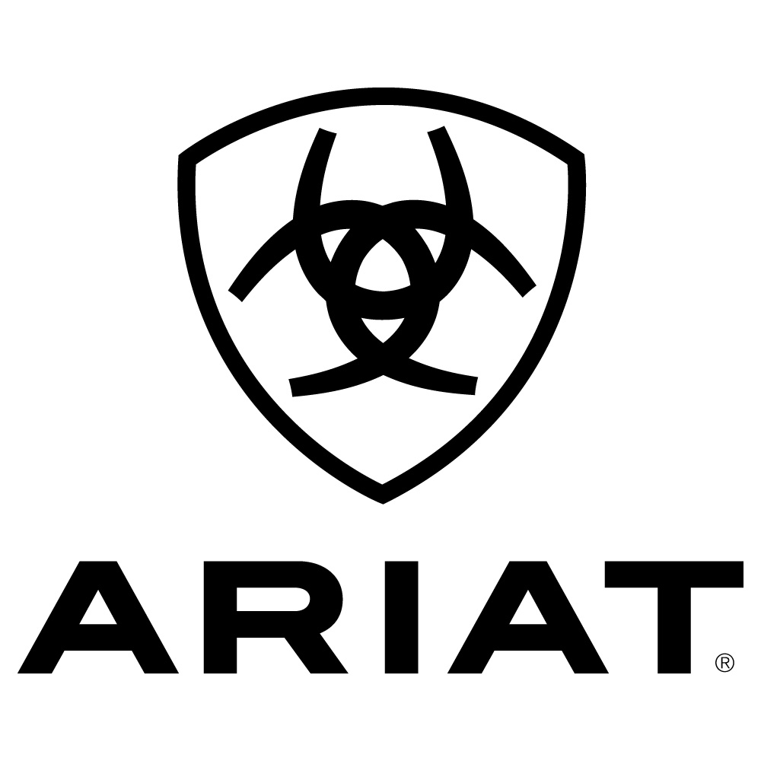
Name: Shannon Jenkins
Student Number: 1706656
Module: Marketing Planning & Practice
Module Code: M6X00884
Table of Contents

- Executive Summary | Page 3
- Introduction | Page 4
- Situation Analysis | Page 6
- Objectives | Page 11
- Strategy | Page 13
- Tactics | Page 14
- Action | Page 15
- Control | Page 16
- Conclusion and Recommendations | Page 18
- References | Page 19

- Executive Summary

- Introduction

This report seeks to thoroughly explain what is thought to be an efficient marketing plan for equestrian company Ariat. According to (Cross, 2020), she grew up surrounded by animals and was inspired by racehorse Secretariat to do something incredible. She claims to remember watching him win the 1973 Kentucky Derby and becoming the Triple Crown Winner, which is when she was taken aback by the horse’s big heart and competitive spirit. It was this experience that led to the company being named after Secretariat, hence the company being named Ariat when it opened in 1993. It is claimed by Cross that the company was founded as “The New Breed of Boot” as they were the first to combine all of the positives of athletic footwear with equestrian footwear. Thus, an innovative brand was built and customers now fully expect Ariat clothing and footwear to be of an incredible quality without having to choose between fashion, practicality and comfort. It is stated by (Ariat International, Inc., 2018) that company founder Beth Cross won EY’s Entrepreneur of The Year award in Northern California in 2018, with Ariat being described in this article as being the “leader in developing innovative performance equestrian footwear and apparel.” This in itself shows how much the company has grown since 1993.
Throughout this document, the SOSTAC model will be mentioned in relation to marketing strategies that are relevant to Ariat. PR Smith’s SOSTAC Planning model has been described by (Swan, 2019) as being an extremely popular tool used for marketing planning and, in general, business planning. What is more, it is claimed in Swan’s piece that the SOSTAC model is among “the top three most popular marketing models.” According to (McKnight, 2019), the first step in using the SOSTAC model is to begin with looking into the company’s current position within the market. She also recommends using a SWOT analysis to evaluate the company’s position. Furthermore, (Egles Digital Marketing, 2017) give some examples of objectives, which are brought up during the second part of the model. For example, incentives, goals, reputations and costs are mentioned as being some of the things commonly associated with being company objectives. Smith’s marketing model has also been brought up by (Nilsson, 2020), who states that a strategy can be simply explained as being how we are able to meet our objectives. (PR Smith Marketing, 2020) mentions the strategy section of the model. Smith himself goes on to claim that although strategy is the smallest part of the plan, it is considered as being the most important of them all. He goes on to state that the strategy gives direction for the tactics, which are considered by (Marketing Magazine, 2017) as being the “nitty-gritty” of which marketing tools are appropriate for your business and how exactly they can be put to use. For example, this source brings up examples of questions that should be asked while working through this section of the model. These include, but are not limited to looking into how your choice of tools will target the intended audience and what content is seen as being necessary to develop. (Business Balls, N.D.) claims that the “A” in SOSTAC stands for action, which can also be known as implementation and, in simple terms, means putting the plan created to appropriate work. The final part of the SOSTAC model is control, which has been defined by (Digital 88, 2019) as being how a business assesses performance and monitors any progress made as a result of the marketing plan.

  - Situation Analysis

To further the points aforementioned, situation analysis has been defined by (Boyce, 2017) as being the starting point for any good marketing plan. He goes on to state that the situation analysis is what the digital marketing planning process is based upon and that in some cases it can take up over 50% of the time available for creating the content of a marketing plan.
What is more, one efficient tool for evaluating a company’s current situation is a SWOT analysis. As stated by (Mind Tools, N.D.), a SWOT analysis can be used to assess the company’s situation within the current environment before any new strategy is decided upon. According to this source, it stands for “Strengths, Weaknesses, Opportunities, and Threats.” Strengths, as mentioned by (Shewan, 2020), is the element of a SWOT analysis that looks into anything that the company does well and that is relevant. For Ariat in particular, this is being a company that has always valued innovation. For example, they were the first company to use the practical assets of athletic footwear within a range of equestrian footwear. For example, it is stated by (Speedgate, 2020) that Ariat uses various technologies within their footwear. This includes “4LR,’ which is also known as Four Layer Rebound, “ATS,” which is known also as Advanced Torque Stability, ATS Pro, Nitro, and Wiggle Room. These technologies are something that sets Ariat apart from other companies and is something that the company’s loyal customers have come to know and love. A second strength that Ariat possesses is the fact that they use high quality materials to create all of their products, including children’s footwear and clothing. Many parents share the worry that their child will outgrow their footwear before they are able to make full use of them. Ariat have found a way to use high quality materials, with adaptations to make them suitable for children. For example, their Wiggle Room technology is described by (Ariat, N.D.) as “footbeds” that give “young athletes the opportunity to keep their favourite new boots longer.” This works as the company includes removeable insoles in the shoes, which creates an additional half size to give room for children’s growing feet. This is a positive as it means the boots will not have to be replaced as often, which draws in custom.
Furthermore, (Parsons, 2018) claims that for a SWOT analysis to be the most effective that it can, then founders and leaders of a company all need to be as involved as possible. This is due to the fact that they and they only will have the best idea of what they wanted to do with the company and what they hope to do with it in the future. This source in particular goes on to state that weaknesses are things that “detract from” the company’s strengths and will potentially need to be improved on in order to be competitive. For Ariat in particular, the current price point is both a blessing and a curse. Although the current price point of products ensures that the company is able to continue offering fair wages to all of their employees and is able to continue using high quality materials, it can also be seen as a negative. From a competitive point of view, there are a variety of companies that are able to offer lower prices than Ariat for similar products. Although this may mean compromising quality, many potential customers would be more than happy to pay a lower price for a product that will essentially do the same job as one offered by Ariat. Thus, price point may be seen as a weakness. Another weakness is the fact that Ariat’s factories are primarily based in America. According to (Ariat, N.D.), the majority of the leathers that the company uses are sourced in America, with leathers coming from “American cattle ranches.” It is also stated that Ariat searches for “the best factory partners” and the “most advanced material suppliers” that they can possibly find. Although it can be seen as an advantage that the company only use what they deem to be the highest quality materials possible, it can also be seen as a disadvantage. Due to the fact that materials are sourced and manufactured in America, it is fairly easy for unforeseen events to be able to put a stop to international trade. For example, Dash Equestrian had issues with receiving products from companies such as Ariat due to countries going into lockdown in a bid to fight against the Coronavirus. Production of products was temporarily halted, which meant that products could not be manufactured in order to be shipped abroad. Those that were able to continue producing products and shipping them experienced significant delays, which will have a knock-on effect on trade throughout supply chains in any given situation. For a company like Ariat, who trade internationally in a large number of countries, such an issue could be extremely detrimental.
Moreover, (Bush, 2016) argues that opportunities are a series of different curcumstances that a business may find itself in at any given time that can offer a positive outcome if handled correctly. Such a circumstance is external, meaning businesses constantly need to be looking out for opportunities that may be of a benefit them. Bush goes on to explain that opportunities can be defined simply as “positive, external factors” that a company can choose to take advantage, despite being totally unable to control them. They provide information that, in the correct hands within the business, can be useful for planning purposes. In regard to Ariat, an opportunity that is currently available is Coronavirus. With equestrians being encouraged to temporarily stop riding in order to put as little pressure on the NHS as possible, riders are taking more notice of . relevant posts as they are anxious to know when they can get back to riding. Ariat could be creating a line of loungewear products that are specifically for this period of time. For example, a number of Coronavirus-related items of clothing could be created and sold. If the company were to do this, a portion of the profits could be donated to either an NHS charity or another charity depending on what country the products are sold in. This would be an opportunity as it would bring in profits and gain attention for the company as it would encourage people to see the company as an entity that seeks to support charities and spur people on to help the situation. Another current opportunity is the fact that the company now has time to liaise with potential customers in new countries without the pressure of needing to ship products out in a short timescale. This gives them time to come to agreements in terms of trade prices, recruiting representatives within the new countries and researching into the best possible logistics for any new companies.
Additionally, the fourth section of the SWOT analysis, threats, has been defined by (Grant, 2020) as being a part of an analysis used in order to assess the internal situation and the external situation that a company currently trades in, along with giving some idea of a company’s future potential. This source refers to threats as being factors that have the ability to potentially prove themselves as harmful to a business. For Ariat in particular, a huge threat would be competitors who are able to charge a cheaper price for products that will essentially do the same job as the prodycts that are offered by Ariat. For example, Ariat uses a high quality of materials and charges customers for this accordingly, but many potential customers are totally okay with paying a lesser price for a similar product, despite the risk of buying a product of a lower quality. This is the case for many customers who may have a lower expendable income and for those who simply do not see the point in paying a higher price for a product when there is a cheaper alternative. A second threat currently having an impact on Ariat is Coronavirus, despite being aforementioned as something positive for the company. In a different light, the virus that is currently causing chaos around the world is proving itself to be a threat for Ariat. According to (Stubley, et al., 2020), the official United Kingdom’s official Coronavirus death toll is currently standing at 33,998, with the United States of America’s official Coronavirus death toll standing at more than 50,000 according to (BBC News, 2020). For this reason, countries all around the world have entered lockdown. Said lockdown has impacted Ariat in so many ways. These include, but are certainly not limited to a very limited workforce, delayed shipping times and a lot of unprecedented ways of working. Companies everywhere are now having to implement social distancing measures within their factories and stores, or giving staff the opportunity to work from home, which is something that no company has had to do to this extent until now. For this reason, the coronavirus has been a learning curve for everyone and it has been a little difficult for some people to wrap their heads around the new way of working. The situation that Ariat finds itself in with regard to the Coronavirus has been a threat simply because the company now has to operate with limited personnel and customers are now either in self-isolation or are hesitant to leave their houses, meaning less in-store purchases are being made.

  - Objectives

In correlation with the aforementioned SWOT analysis, Ariat will have a series of objectives, which need to be SMART. According to (Herridge, N.D.), the “S” in SMART stands for Specific, which means that you need to be able to specify exactly what your objective is. This will make it much more valuable to you as a company. For Ariat, specific objectives are to increase sales by 10% and to gain social media exposure by 20% since this is an incredibly popular form of advertising and is the most likely to reach most people in today’s day and age.
Furthermore, the “M” in SMART is said to stand for Measureable. This is backed by (Mind Tools, N.D.), who state that measureable objectives are meaningful and motivating. For Ariat’s previously mentioned objectives, this means that sales will be monitored by allocating someone to look into profits. In order for Ariat to be considered as successfully achieving goals, profits must increase by 10% each quarter. From there, profits can be invested in new products or ensuring that staff are always on a respectable wage. Also, social media exposure will be measured by post engagements, which can be viewed if you are an admin of a page or if you are simply logged into some socials. These will need to be monitored and should increase by 20% quarterly. Progress in relation to both of the objectives outlined in this document must be recorded in a suitable way. This may include using a programme the person allocated to the task is comfortable with, such as Microsoft Excel. Updates will need to be shared with all relevant teams.
Additionally, the “A” in SMART objectives stands for achievable, which is thought of by (Clear Review, 2019) as being attainable, aligned and agreed. For Ariat, this simply means that objectives must not be too far-fetched. Both objectives aforementioned are attainable with the correct resources used. For example, if a little more time is put into social medias content, exposure will be increased, which will lead to increased sales.
Moreover, (Chartered Management Institute, N.D.) states that the “T” in SMART objectives stands for “timely” or time-bound. This simply means that objectives must be set to be achieved within a certain time-frame. For Ariat, each objective will be set to be achieved quarterly and, therefore will have quarterly reviews.

  - Strategy

For Ariat, the strategy for achieving both of the objectives set out within this document is one that is suitable for both objectives. Firstly, more time and thought must be put into social media content. Marketing employees must keep their eyes peeled for what the equestrian community is currently proving to be popular and, for example, creating polls on social media sites to find out what type of content the company’s follwers would be the most interested in. from there, it will be easier for the team to get an idea of what exactly they should be posting. Content should always berelevant to the season and should always be something that could potentially draw new customers in, whilst keeping existing customers and existing followers interested in the social media pages in order to ensure that they do not grow bored of the company. It is hoped that, from there, people will be encouraged to make sales. Where possible, links to the website should be included in posts, with specific products being promoted at the most appropriate times. It is also important to post during the times of day where people are the most active on social media, in order to get higher exposure and to be able to drive more traffic on to the website. It is important that all filters are correct on the website so that customers are easily able to find what they are looking for as they may be discouraged from making a purchase if they are unable to find what they are looking for.

  - Tactics

As mentioned previously, it is highly important to know when social media posts are at their most useful. For example, the time posted is crucial because the general population is more active on their social medias between 6am and 9:30 am. If this timeslot is missed then 3pm to 10:30pm is also a busy time in terms of traffic on social media sites. Marketing teams must be made aware of this so that they can put up posts at the times when they will be the most useful. Therefore, there will be more post engagement and there are more potential customers who may be able to be redirected to the Ariat website in order to make purchases. The teams are already good at running social medias and generating sales. The company is estimated to be making approximately $82.7m according to (Owler, N.D.). In terms of sales, all Ariat representatives must be well-presented, must behave in a friendly manner and should be able to give advice and recommendations to stockists and the general public at any time. Stockists must be given incentives to encourage their customers to purchase Ariat products, such as a staff discount.

  - Action

Daily goals will be set for both objectives. For the social media teams, they will be simple. For each social media, two social media posts must be created per day. Also, followers must be communicated with, whether this be through replying to private messages or responding to comments. Interaction will be important as it will build up a good company-customer relationship. For Sales teams, also known as representatives, the daily goal will be to be available to help advise stockists and customers and to attend at least one meeting with a stockist. Days off are not included in these goals as they will then be fulfilled by other members of staff.
What is more, weekly goals must also be achieved. The marketing team will need to ensure that a weekly review is held. This will include looking into any issues that may have occurred and discussing ways to correct these issues and prevent them in the future. Also, positives should be discussed and highlighted as an example. For representatives, the monthly goal will be to have been in contact with each stockist that they are responsible for at least once, whether this be via email communication, telephone conversations or face-to-face meetings, although it would be preferable that meetings are held in person. The reason for this is the fact that stockists can often be persuaded to make a purchase if they get to see the product before supporting it.

  - Control

As aforementioned, daily and weekly goals will be put in place for members of both the sales team and the marketing team. These must be met under all circumstances. If a member of staff is ill or is on holiday, then their goals will not need to be met as there will be other staff working and they will meet their own goals.
What is more, meetings will take place monthly in order to assess the situation. Positives must be noticed in these meetings and team members must be rewarded accordingly. Rewards may include gift cards, an item of clothing or footwear of their choice or simply taking a well-earned day off. This, in effect, will encourage the teams to work their hardest and will entice them to want to achieve the goals set out for them.
Moreover, members of the social media team will need to record daily post interactions for each social media account, weekly statistics and monthly data. This may be recorded in any way that the team feels comfortable with. It is recommended that Microsoft Excel is used as it is simple, well-presented and can be picked up by fairly easy by anyone who has no experience in recording data.
Additionally, the sales representatives will be responsible for recording sales, in terms of what stockists are willing to stock. Similarly to the social media exposure, this must be recorded in Microsoft Excel or in another programme that the team feels comfortable using.
Finally, at the end of each quarter, there will be a review of the quarter and any progress will be praised. Any issues will be looked into and teams will need to come up with ways to solve the issues and prevent issues from reoccurring in the future.

- Conclusion and Recommendations

To conclude, the SOSTAC model has been used throughout this document to analyse the situation that Ariat is trading in and to form a basis of a marketing plan. A SWOT Analysis was carried out and found that Ariat’s strengths are high-quality products, an incredible reputation and innovation. Their weaknesses are a high price pont and the fact that all of their products are manufactured in America, meaning they are having difficulty shipping overseas due to the current situation. Coronavirus has provided the company with opportunities and threats, meaning it has been both a blessing and a curse for the company. It is recommended that Ariat works on achieving a 10% increase of sales and a 20% increase of social media exposure.

- References

