​
Research and case scenario in Data Security and Compliance

Alona Tovkach
Student ID: (2427250)
August 12, 2026
​​—​
Data Security and ComplianceACCA5034

​​—​
Lecturer: Ayman El Hajjar



​
​
​
​
​
​
​
Table of Contents
​ Introduction 3
Task 1 – Research in Data Security and Compliance 3
2. The Changing Landscape of AI Governance 4
3. Key Governance Challenges in AI and Machine Learning Systems 5
4. Creating an Environment That Anticipates, Protects, Detects, and Responds to AI Threats 6
5. Governance Frameworks for AI Security and Compliance 7
Task 2 – Designing a Structured Cybersecurity Programme Based on the Equifax Breach 14
1.Organisational Structure and Accountability 14
2.Policies and Procedures 15
3. Governance and Strategic Alignment 16
4. Risk Management and Assessment 16
5. Compliance, Incident Response, and Protection Controls 17
Conclusion 18
References 19

​
​

​ Introduction

Artificial Intelligence (AI) is transforming how organisations operate, make decisions, and manage information. As AI systems become embedded in business processes, they introduce new forms of risk, new governance requirements, and new expectations for accountability. Modern organisations must therefore build governance structures that anticipate threats, protect sensitive data, detect misuse, and respond effectively when issues arise. Many of the challenges associated with AI—such as bias, drift, data leakage, and insecure integrations—are not entirely new; they are extensions of long-standing data and security problems appearing in more complex and dynamic forms.
This work examines the governance, security, and compliance requirements needed to manage AI responsibly. Task 1 explores the foundations of AI governance, including data quality, lifecycle management, ethical considerations, and organisational controls. Task 2 applies these principles to a real-world failure—the Equifax breach—to demonstrate how weak governance, poor patching, and unclear accountability can lead to catastrophic consequences. Together, these sections show how organisations can build a structured, risk-aware, and security-aligned AI environment that supports innovation while protecting people, systems, and data.
The report also outlines practical governance mechanisms such as model cards, risk tiering, decision review, regulatory mapping, and audit trails. These tools help organisations understand how AI is used, what risks it creates, and how to ensure responsible outcomes. Ultimately, the work argues that AI governance is not separate from cybersecurity or data management—it is an extension of them. Effective AI systems require trusted data, secure infrastructure, clear accountability, and continuous oversight.
​
Task 1 – Research in Data Security and Compliance

Governance of AI and Machine Learning Systems: Managing Risk, Ethics, and Compliance for AI Data and Models.

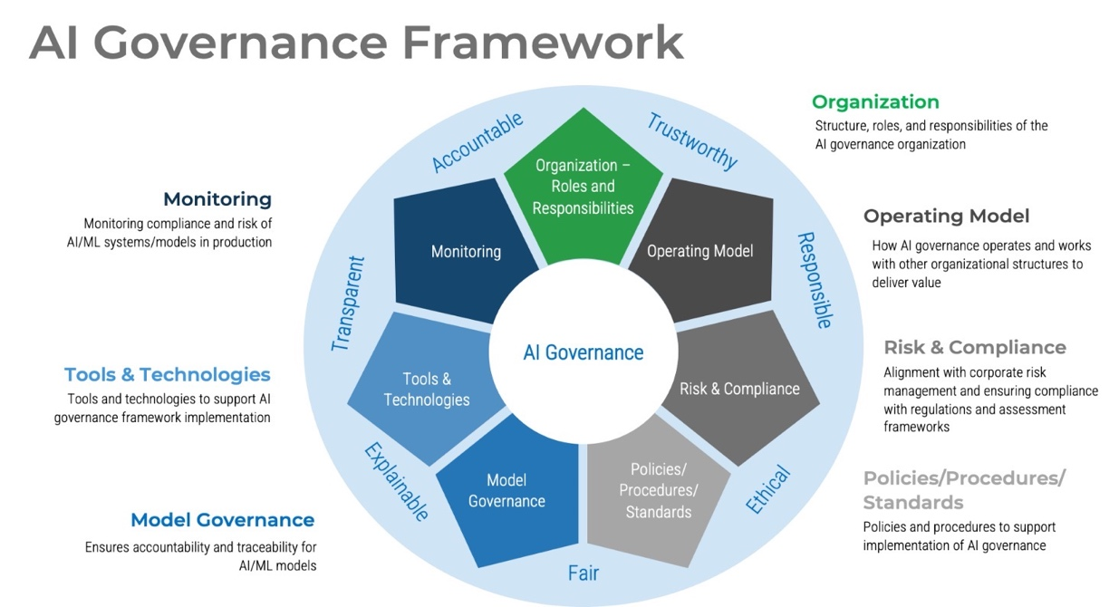
Figure 1 Governance Framework

Artificial Intelligence (AI) and Machine Learning (ML) have become central components of modern digital ecosystems. Organisations across sectors now rely on predictive models, automated decision-making, and large-scale data analytics to improve efficiency, reduce costs, and gain competitive advantage. However, the rapid adoption of AI has also introduced new categories of risk that traditional cybersecurity and governance frameworks were not originally designed to address. AI systems behave differently from conventional software: they learn from data, adapt over time, and often operate in ways that are not fully transparent to their human operators. As a result, organisations must rethink how they govern data, models, and automated decision processes to ensure security, compliance, and ethical integrity.
This report critically examines how modern organisations can create an environment that anticipates, protects, detects, and automatically responds to threats associated with AI and ML systems. It explores the governance challenges that arise from the use of AI, including data quality, bias, adversarial manipulation, regulatory compliance, and ethical accountability. It also evaluates how organisations can implement structured governance frameworks to manage these risks effectively and maintain trust in AI-driven operations.

2. The Changing Landscape of AI Governance
AI governance refers to the policies, processes, and oversight mechanisms that ensure AI systems are developed, deployed, and monitored responsibly. Unlike traditional IT governance, AI governance must address issues such as algorithmic fairness, explainability, data provenance, and continuous model evolution. As AI systems become more embedded in critical services — from healthcare diagnostics to financial risk scoring — the consequences of poor governance become more severe.
Several factors contribute to the growing importance of AI governance:
Scale and sensitivity of data AI systems often rely on vast datasets, including personal, behavioural, and sometimes biometric information. Poor data governance can lead to privacy violations, regulatory breaches, and reputational damage.
Opacity of decision-making Many AI models, especially deep learning systems, operate as “black boxes,” making it difficult to understand how decisions are made. This lack of transparency complicates accountability and compliance.
Dynamic behaviour of models AI models evolve as they encounter new data. This means their behaviour can change over time, potentially introducing new risks or degrading performance.
Emerging regulatory pressures Governments and regulators are increasingly introducing AI-specific legislation, such as the EU AI Act, which requires organisations to demonstrate risk management, transparency, and human oversight.
These factors highlight why AI governance is now a core component of modern cybersecurity and compliance programmes.

3. Key Governance Challenges in AI and Machine Learning Systems
AI systems introduce several unique governance challenges that organisations must address to maintain security and compliance.
3.1 Data Governance and Quality
Data is the foundation of every AI system. Poor-quality data leads to poor-quality models, and insecure data pipelines expose organisations to significant risks. Key challenges include:
Bias and discrimination If training data reflects historical inequalities or biased patterns, the model may reproduce or amplify these biases. This can lead to unfair outcomes in areas such as hiring, lending, or law enforcement.
Data poisoning attacks Attackers may intentionally manipulate training data to corrupt model behaviour. For example, injecting malicious samples into a dataset can cause a model to misclassify certain inputs.
Privacy and confidentiality risks AI systems often require large volumes of personal data. Without strong governance, organisations risk violating data protection laws such as GDPR.
Data provenance and lineage Organisations must be able to trace where data came from, how it was processed, and who had access to it. This is essential for audits, compliance, and incident investigations.
Effective data governance requires strict access controls, encryption, data minimisation, and continuous validation of data quality.
3.2 Model Risk and Lifecycle Management
AI models must be governed throughout their entire lifecycle — from design and development to deployment, monitoring, and retirement. Key risks include:
Model drift Over time, the data entering a model may change, causing its performance to degrade. Without monitoring, organisations may rely on outdated or inaccurate predictions.
Adversarial attacks Attackers can craft inputs designed to deceive AI models. For example, slight modifications to an image can cause a model to misidentify it.
Model extraction and theft Attackers may attempt to replicate a model by querying it repeatedly, stealing intellectual property and exposing sensitive decision logic.
Unintended behaviour Complex models may behave unpredictably in edge cases, especially when exposed to data outside their training distribution.
Lifecycle governance ensures that models are regularly tested, validated, monitored, and updated. It also ensures that models are retired when they no longer meet performance or compliance requirements.
AI systems raise significant ethical questions, particularly when they influence decisions that affect individuals’ rights or opportunities. Organisations must address:
Fairness and non-discrimination AI systems must not produce outcomes that unfairly disadvantage certain groups.
Transparency and explainability Users and regulators increasingly expect organisations to explain how AI decisions are made.
Accountability Organisations must define who is responsible for AI decisions, especially when errors occur.
Regulatory compliance Laws such as GDPR, the UK Data Protection Act, and emerging AI-specific regulations require organisations to demonstrate responsible AI practices.
Ethical governance frameworks help organisations ensure that AI systems align with societal expectations and legal obligations. [1]

4. Creating an Environment That Anticipates, Protects, Detects, and Responds to AI Threats
To manage AI risks effectively, organisations must adopt a proactive and structured approach. This involves building capabilities that anticipate threats, protect data and models, detect anomalies, and respond automatically to incidents.

4.1 Anticipation: Proactive Risk Identification
Anticipating AI risks requires organisations to:
Conduct AI-specific risk assessments that evaluate data sources, model behaviour, and potential harms. Implement ethics-by-design practices, embedding fairness and transparency into development processes. Perform AI threat modelling, identifying potential attack vectors such as adversarial inputs or model extraction. Establish governance committees that oversee AI projects and ensure alignment with organisational values.
Proactive anticipation reduces the likelihood of unexpected failures and ensures that AI systems are designed with security and compliance in mind.

4.2 Protection: Safeguarding Data and Models
Protection mechanisms must secure both the data used to train AI models and the models themselves. Key protective measures include:
Secure data pipelines with encryption, access controls, and validation checks.
Robust training processes that detect and prevent data poisoning.
Model hardening techniques, such as adversarial training, to improve resilience.
Documentation and audit trails that support regulatory compliance and internal oversight.
Protection ensures that AI systems operate reliably and that sensitive data remains secure.

4.3 Detection: Monitoring AI Behaviour and Data Flows
Continuous monitoring is essential to detect anomalies, security incidents, and performance degradation. Organisations should implement:
Model performance monitoring to detect drift or unexpected behaviour. Anomaly detection systems that identify unusual data access patterns. Logging and audit mechanisms that track model decisions and data flows. Automated alerts for governance teams when ethical or compliance issues arise. Detection capabilities help organisations identify problems early and reduce the impact of incidents.

  - Automated Response: Rapid Mitigation and Adaptation
AI systems require automated response mechanisms to maintain resilience. These may include: Rolling back models to previous safe versions when issues are detected. Triggering retraining processes when drift occurs. Isolating compromised data sources to prevent further contamination. Escalating alerts to security and governance teams for human review.
Automated responses reduce dwell time, limit organisational impact, and ensure that AI systems remain aligned with business objectives.

5. Governance Frameworks for AI Security and Compliance
To manage AI risks effectively, organisations must adopt structured governance frameworks that combine ethical principles, regulatory requirements, and operational controls.

5.1 Multi-Layered Governance
A multi-layered governance has 6 connected layers:
- AI Inventory
- Data Foundation
- Security & Access
- Model Assurance
- Human Oversight
- Compliance & Audit

Each Layer answer different question.

The 1 Layer

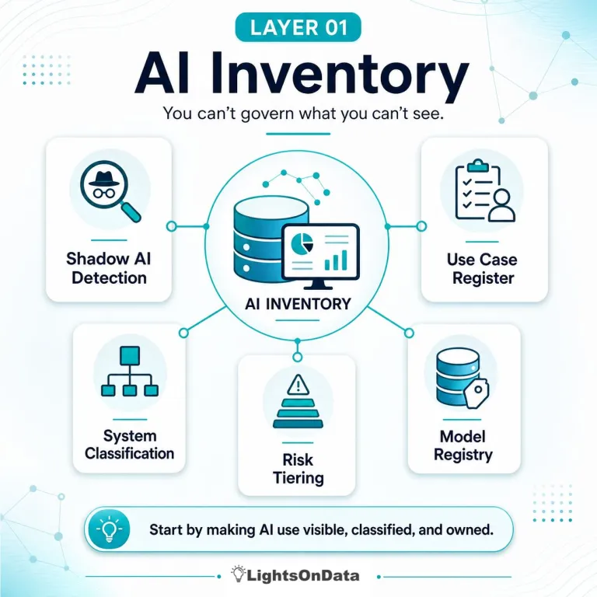
Figure 2 Layer 1.

Shadow AI Detection refers to identifying AI tools and systems that employees are using
without formal approval. This should not be approached as a policing activity. Instead, it can be framed as a discovery process that helps the organisation understand real demand, support responsible adoption, and reduce unnecessary risk.
A Use Case Register records how AI is being applied across the organisation. An effective register should document the business purpose, the process owner, the stakeholders affected, the data involved, the vendor or system used, the expected benefits, the assessed risk level, and the current governance status.
System Classification helps differentiate between various types of AI usage. For example, an internal productivity assistant has a very different risk profile compared to an AI system that influences decisions about hiring, lending, healthcare, public services, or customer eligibility.
Risk Tiering assigns a risk category to each AI use case. This ensures governance efforts are proportionate. Low-risk use cases may only require a lightweight review, while higher-risk use cases may need more detailed assessment, stronger controls, and ongoing oversight.

Layer 2. Data Foundation

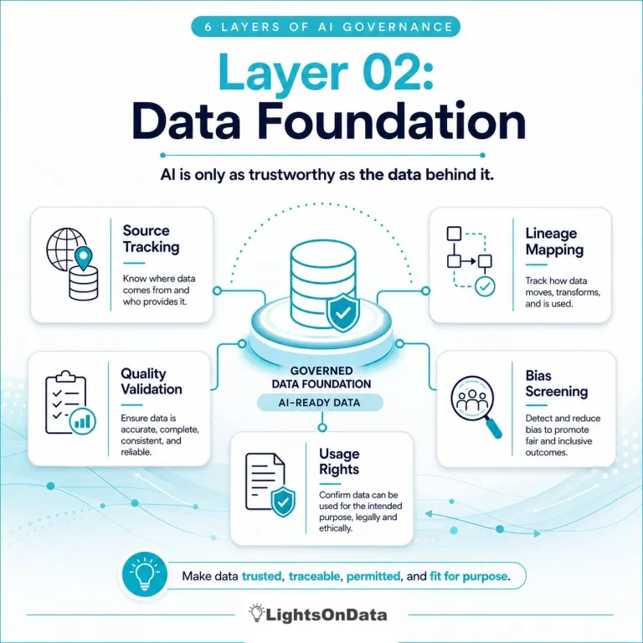
Figure 3 Layer 2.

AI is entirely dependent on data — and while this seems obvious, it is often underestimated. Many AI governance problems are actually data governance failures appearing in a new form. If data is inaccurate, incomplete, biased, outdated, poorly labelled, or used outside its intended context, the AI outputs will be unreliable or even harmful.
A strong data foundation requires five core capabilities:
Source Tracking – Knowing exactly where data originates, whether from internal systems, third-party providers, open datasets, user inputs, logs, images, or transactions.
Lineage Mapping – Understanding how data moves, transforms, and influences models, prompts, outputs, and decisions. Lineage answers: Where did this data come from? How was it changed? What did it affect?
Quality Validation – Ensuring data is accurate, complete, consistent, timely, valid, representative, and appropriate for the AI use case.
Bias Screening – Detecting patterns that may lead to unfair outcomes, including historical bias, sampling issues, proxy variables, or flawed labelling.
Usage Rights – Confirming the organisation is legally and ethically allowed to use the data for model training, analysis, or external outputs.

Layer 3. Security and Access

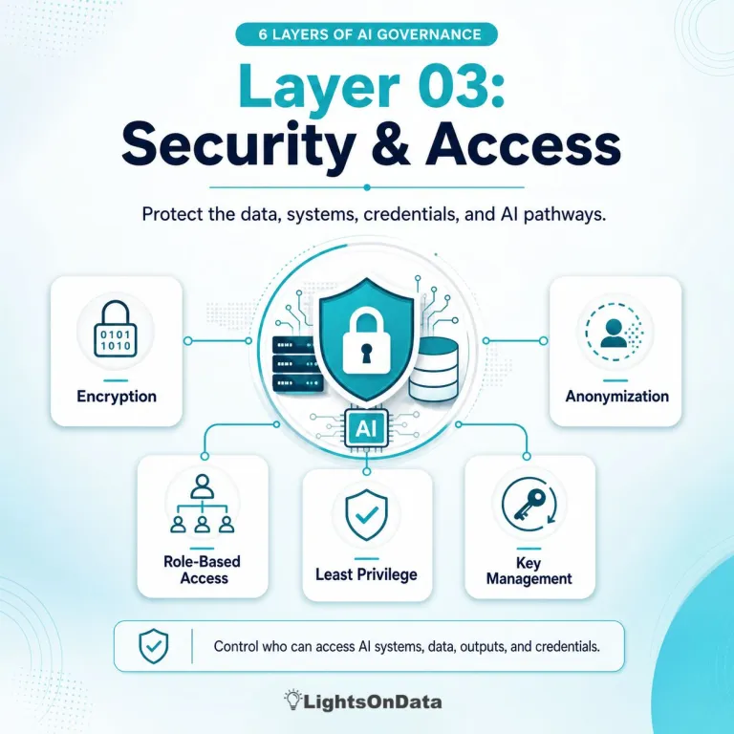
Figure 4 Layer 3.

AI introduces new security and access challenges. Some are familiar — protecting sensitive data, managing permissions, and securing credentials. Others are uniquely AI-specific, such as prompt injection, data leakage, model exposure, insecure plugins, uncontrolled API access, and misuse of generated outputs.
A strong security and access layer requires:
- Encryption
- Anonymization
- Role-Based Access
- Least Privilege
- Key Management
Encryption protects data at rest and in transit, especially when AI systems handle sensitive or regulated information.
Anonymization reduces exposure of personal or confidential data. Depending on the use case, organisations may use masking, tokenisation, pseudonymisation, aggregation, or synthetic data.
Role-Based Access Control (RBAC) ensures users and systems only access the AI tools and datasets they are authorised to use — whether internal AI assistants or external vendor platforms.
Least Privilege restricts access to the minimum required level, which is critical when AI systems connect to enterprise data, code repositories, HR systems, financial records, or customer information.
Key Management protects API keys, secrets, and tokens used by AI applications. Poor key handling creates major vulnerabilities, especially when AI tools integrate with sensitive systems or external services.

Layer4. Model assurance.

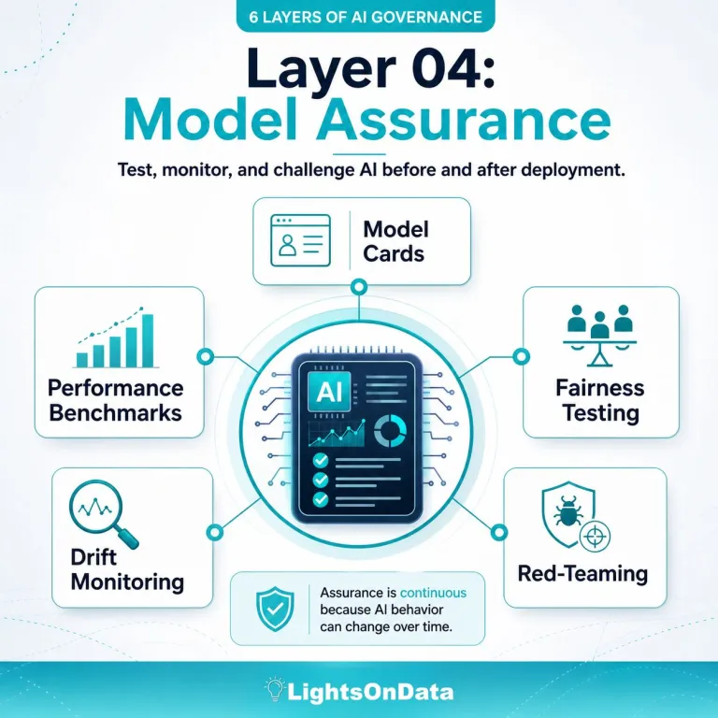
Figure 5 Layer 4.

Model Cards summarise essential information about an AI system — its purpose, intended users, approved use cases, limitations, training data, evaluation methods, performance results, ethical considerations, and known constraints.
Performance Benchmarks define how success is measured. Accuracy alone is rarely enough; depending on the use case, organisations may also track precision, recall, false positives, false negatives, hallucination rate, robustness, latency, cost, user acceptance, or business impact.
Fairness Testing checks whether outputs differ across groups in ways that create unfair or inappropriate outcomes. This is critical in high-impact domains such as hiring, lending, healthcare, education, insurance, policing, public benefits, and customer eligibility.
Drift Monitoring detects changes in model performance over time. Drift can occur when data, environments, business processes, or user behaviour shift, or when the model encounters scenarios it was not designed for.
Red-Teaming stress-tests the system under adversarial or unexpected conditions. For generative AI, this includes attempts to produce harmful content, reveal sensitive information, bypass guardrails, follow malicious instructions, or generate

Layer 5. Human Oversight

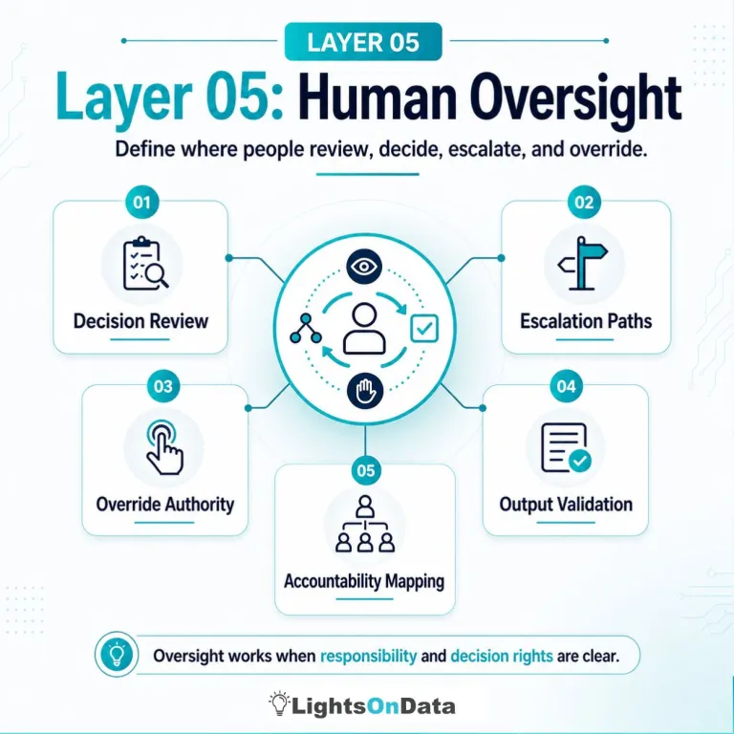
Figure 6 Layer 5.

Decision Review identifies which AI-supported decisions still require human judgement. Some outputs are purely informational, while others influence decisions about people, money, access, safety, compliance, or reputation.
Escalation Paths define what happens when an AI output looks wrong, uncertain, risky, or outside policy. Staff need clear guidance on where to report issues, who to involve, and how quickly concerns must be addressed.
Override Authority clarifies who can stop, reverse, or modify an AI-generated recommendation or automated action — especially when AI is embedded into operational workflows.
Output Validation sets out how people check AI outputs before using them. This may include fact-checking, source verification, expert review, legal assessment, or comparison against known standards.
Accountability Mapping defines who owns the AI use case, who owns the business process, who owns the data, who manages the model or vendor system, who monitors performance, and who is accountable for the final decision.

Layer 6. Complience and Audit

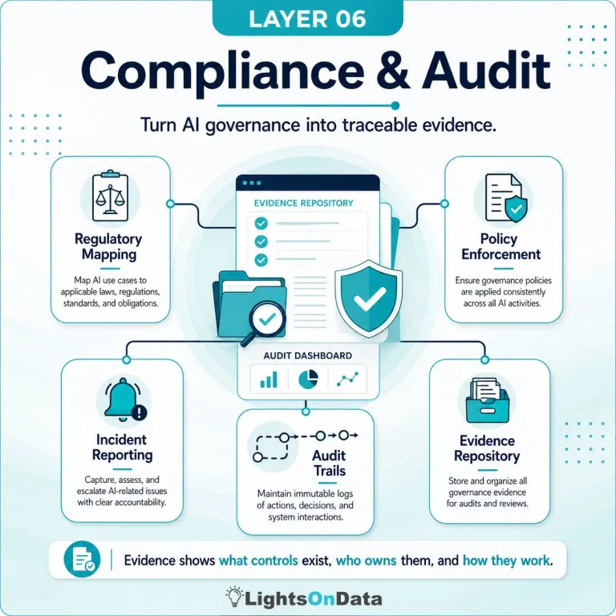
Figure 7 Layer 6.

Regulatory Mapping links each AI use case to the relevant legal, regulatory, contractual, ethical, and industry requirements — including privacy laws, sector-specific rules, records obligations, human rights considerations, cybersecurity standards, procurement requirements, and emerging AI regulations.
Policy Enforcement turns governance expectations into operational controls. This includes approval workflows, access restrictions, required documentation, risk assessments, vendor checks, testing requirements, monitoring thresholds, and usage standards.
Incident Reporting defines how AI-related issues are captured, assessed, escalated, resolved, and learned from. Incidents may involve harmful outputs, privacy concerns, security events, biased results, incorrect recommendations, policy violations, unexpected model behaviour, or vendor failures.
Audit Trails preserve records of key AI activities — such as model changes, access logs, approval decisions, prompts and outputs (where appropriate), validation results, monitoring alerts, review outcomes, and incident actions.
Evidence Repository stores the documentation needed to demonstrate governance. This includes risk assessments, model cards, data lineage, testing results, approval records, monitoring reports, issue logs, vendor documentation, policy exceptions, and audit findings.

5.2 Operational Governance Frameworks
Operational frameworks translate high-level principles into actionable practices. These frameworks typically include:
Clear accountability structures defining roles such as AI risk owners, data stewards, and model validators.
Lifecycle management processes covering design, development, deployment, monitoring, and retirement.
Alignment with business strategy, ensuring that AI systems support organisational goals.
Continuous improvement mechanisms that incorporate lessons learned from incidents and audits.
Operational governance ensures that AI systems are managed consistently and responsibly across their lifecycle. [2]

Task 2 – Designing a Structured Cybersecurity Programme Based on the Equifax Breach

1.Organisational Structure and Accountability

1.1 Executive-Level Security Leadership
A core failure in the Equifax case was the absence of clear executive accountability for cybersecurity. A modern organisation must establish:
Chief Information Security Officer (CISO) reporting directly to the Board of Directors
Chief Risk Officer (CRO) overseeing enterprise-wide risk, including cyber risk
Chief Technology Officer (CTO) responsible for secure engineering and infrastructure
Data Protection Officer (DPO) ensuring compliance with GDPR and privacy regulations
This structure ensures cybersecurity is treated as a strategic priority rather than an IT operational issue.
Justification: The U.S. House Oversight Committee report on Equifax concluded that unclear leadership and fragmented reporting contributed to the breach (U.S. Congress, 2018). Modern governance models emphasise board-level visibility for cybersecurity risks (NIST, 2023).
  - Operational Security Roles
Below the executive level, operational roles must be clearly defined:
Security Architecture Team Designs secure systems, validates configurations, and ensures patching is embedded into architecture.
Secure Software Development Team Implements secure coding standards, conducts code reviews, and integrates DevSecOps pipelines.
Threat Intelligence and Monitoring Team Performs continuous monitoring, threat hunting, and anomaly detection.
Vulnerability Management Team Owns patch management, scanning, prioritisation, and remediation.
Incident Response Team (IRT) Coordinates detection, containment, eradication, and recovery.
Justification: Equifax lacked a unified vulnerability management function, leading to missed patches and unmonitored systems (GAO, 2018). A structured operational hierarchy ensures accountability and reduces gaps. [3]

2.Policies and Procedures

2.1 Vulnerability and Patch Management Policy
A measurable, enforceable policy must include:
Weekly automated vulnerability scans
Mandatory patching of critical vulnerabilities within 72 hours
Asset owners accountable for remediation
Monthly compliance audits
Patch exceptions requiring CISO approval
Why this matters: Equifax failed to patch Apache Struts despite receiving alerts. A strict policy ensures vulnerabilities cannot remain unaddressed.

2.2 Secure Software Development Lifecycle (SSDLC)
Policies must enforce:
Threat modelling during design. Mandatory code reviews. Static and dynamic application security testing (SAST/DAST). Secure configuration baselines. DevSecOps pipelines integrating automated security checks
Evidence: Secure SDLC reduces exploitable flaws and aligns with OWASP and NIST recommendations (OWASP, 2023; NIST SP 800-218).

  - Asset Visibility and Configuration Management
Policies must require: a complete, continuously updated asset inventory, automated discovery tools, configuration baselines aligned with CIS Benchmarks, monitoring for unauthorised changes, equifax lacked visibility into internet-facing systems, contributing to delayed detection.

2.4 Monitoring and Data Protection Policies
Policies should enforce:
Continuous monitoring of network and endpoints
Encryption of sensitive data at rest and in transit
Role-based access control (RBAC)
Multi-factor authentication (MFA)
Logging and audit retention for at least 12 months
These controls reduce the likelihood of data exfiltration and unauthorised access.
[1]

3. Governance and Strategic Alignment
A cybersecurity programme cannot function effectively without strong governance and alignment with organisational strategy. The Equifax breach demonstrated that cybersecurity was treated as an operational IT concern rather than a strategic business risk. Modern organisations must embed cybersecurity into their governance structures, decision-making processes, and long-term planning. This section explains how governance should be structured and how it aligns with recognised frameworks such as the NIST Cybersecurity Framework (CSF) 2.0. [5]

3.1 Using the NIST Cybersecurity Framework 2.0
The cybersecurity programme must align with NIST CSF 2.0’s five core functions:
- Identify – Asset management, governance, risk assessment
- Protect – Access control, data security, patching
- Detect – Continuous monitoring, anomaly detection
- Respond – Incident response planning and communication
- Recover – Restoration, lessons learned, resilience planning
Why NIST CSF 2.0? It provides a widely adopted, flexible framework that aligns cybersecurity with business objectives (NIST, 2023). [6]

  - Alignment with Business Continuity and Trust
Cybersecurity must support: Operational continuity Preventing outages and ensuring systems remain available. Customer trust Protecting personal data to maintain reputation. Regulatory compliance Avoiding fines and legal consequences.
Equifax suffered severe reputational damage and financial penalties. A governance model aligned with business resilience ensures long-term stability.

3.3 Board-Level Reporting
The CISO must present quarterly reports to the board covering:
- Risk posture
- Vulnerability status
- Incident trends
- Compliance metrics
- Investment needs
This ensures cybersecurity is continuously evaluated at the highest level.
[2]

4. Risk Management and Assessment

4.1 Identifying Key Vulnerabilities
A high-level risk assessment reveals several critical vulnerabilities:
Internet-Facing Assets
Equifax’s breach originated from an unpatched public-facing web application. Risk: High Mitigation: Automated discovery, WAF protection, patching.
Patch Gaps
Critical patches were missed despite alerts. Risk: High Mitigation: Patch SLAs, automated scanning, compliance dashboards.
Supply Chain Exposure
Third-party software (Apache Struts) introduced risk. Risk: Medium Mitigation: Vendor risk assessments, SBOMs (Software Bill of Materials).
Network Segmentation Weaknesses
Attackers moved laterally for over two months. Risk: High Mitigation: Zero Trust architecture, micro-segmentation.
Data Storage and Encryption Weaknesses
Sensitive data was accessible without sufficient encryption controls. Risk: High Mitigation: Encryption, tokenisation, strict access controls.

4.2 Risk Prioritisation
Risks should be prioritised using:
- Likelihood
- Impact
- Regulatory exposure
- Business criticality
Critical risks (patch gaps, internet-facing assets, segmentation) must be addressed first due to high exploitation likelihood and severe consequences.

4.3 Mitigation Rationale
Mitigation strategies reduce:
- Attack surface
- Lateral movement
- Data exposure
- Regulatory penalties
A structured risk programme ensures continuous improvement and proactive defence.
[2]

5. Compliance, Incident Response, and Protection Controls
The Equifax breach highlighted severe weaknesses in compliance management, incident response readiness, and technical safeguards. A modern cybersecurity programme must integrate regulatory alignment, structured response processes, and advanced protection controls to reduce dwell time and limit organisational impact. This section provides a detailed, project-style explanation of how these components should be designed and implemented.
  - Regulatory Alignment and Breach Notification
Compliance is not optional; it is a legal requirement. Organisations must demonstrate that they handle personal data responsibly, maintain adequate safeguards, and notify authorities promptly in the event of a breach.
Organisations must comply with GDPR (72-hour breach notification), UK Data Protection Act 2018, PCI-DSS (if handling payment data), Sector-specific regulations
Equifax faced regulatory scrutiny for delayed detection and reporting. A compliance programme ensures timely communication and legal adherence.

5.2 Incident Response and Disaster Recovery Planning
Incident response (IR) is a structured process that enables organisations to detect, contain and recover from security incidents. Equifax lacked a mature IR capability, contributing to prolonged attacker dwell time
An effective IR plan includes Preparation (training, tools, playbooks); detection and analysis (relies on SIEM alerts, EDR behavioural analysis, threat intelligence feeds, log correlation, anomaly detection); containment, eradication (eradication removes the threat completely), recovery (restores normal operations:), post-incident review
Disaster recovery must include:
Backup strategies
Failover systems
Recovery Time Objectives (RTO)
Recovery Point Objectives (RPO)
5.3 Technical Safeguards
Continuous Monitoring
Detects anomalies and suspicious behaviour in real time.
Automated Vulnerability Scanning
Ensures rapid identification of patch gaps.
Endpoint Detection and Response (EDR)
Provides behavioural analysis and rapid containment.
Encryption
Protects data even if systems are compromised.
Strong Authentication (MFA)
Reduces credential-based attacks.
5.4 How These Controls Reduce Dwell Time
“Dwell time” refers to how long attackers remain undetected. Equifax attackers remained inside for 76 days.
Controls reduce dwell time by:
- Detecting anomalies early
- Preventing lateral movement
- Blocking unauthorised access
- Automating alerts and responses
This limits organisational impact and prevents large-scale data theft.

Conclusion

AI offers significant opportunities for efficiency, insight, and automation, but it also introduces risks that organisations cannot ignore. The Equifax breach demonstrated how failures in patching, monitoring, and governance can escalate into large-scale harm affecting millions of people. Modern organisations must learn from these failures and adopt governance models that treat AI as part of the enterprise control environment—not as an isolated technical tool.
Across both tasks, several themes emerge. First, AI governance is fundamentally built on strong data foundations: source tracking, lineage mapping, quality validation, and bias screening. Without trustworthy data, AI outputs become unreliable, unfair, or unsafe. Second, AI requires robust security controls, including encryption, anonymisation, least privilege access, and strong key management. Third, organisations must implement structured oversight mechanisms such as model cards, fairness testing, drift monitoring, red-teaming, escalation paths, override authority, and accountability mapping.
Finally, governance must be proactive rather than reactive. AI systems evolve, data changes, and risks shift over time. Continuous monitoring, regular audits, and clear incident response processes ensure that organisations can detect issues early and respond effectively. When governance, security, and data management work together, AI becomes not only more powerful but also safer, fairer, and more aligned with organisational values.
This work demonstrates that responsible AI is achievable when organisations combine strong technical controls with clear policies, defined accountability, and ongoing oversight. By embedding these principles into everyday operations, organisations can innovate confidently while protecting people,data and trust.

References

[1] | “deloitte.com,” [Online]. Available: https://www.deloitte.com/uk/en/Industries/financial-services/blogs/the-5-key-challenges-of-ai-governance-and-our-learnings.html. [Accessed 11 08 26].
[2] | “lightsondata.com,” [Online]. Available: https://www.lightsondata.com/ai-governance-framework/. [Accessed 11 08 26].
[3] | [Online]. Available: https://www.gao.gov/products/gao-18-559.
[4] | “gao.gov,” [Online]. Available: https://www.gao.gov/products/gao-18-559.
[5] | [Online]. Available: https://www.nist.gov/cyberframework.
[6] | [Online]. Available: https://csrc.nist.gov/pubs/sp/800/218/final.
[7] | “cisecurity.org,” [Online]. Available: https://www.cisecurity.org/insights/podcast. [Accessed 10 02 2026].
[8] | “nist,” [Online]. Available: https://www.nccoe.nist.gov/news-events/news-insights.

