An Evaluation on Implementing Green Measures with 3-H Approach for Skyline Tower

Background of Skyline Tower
- A Grade A office tower, located at Kowloon Bay
- 39-storey tower with a gross floor area of 910,000 s.f.
- An eight-level car-park for more than 360 vehicles

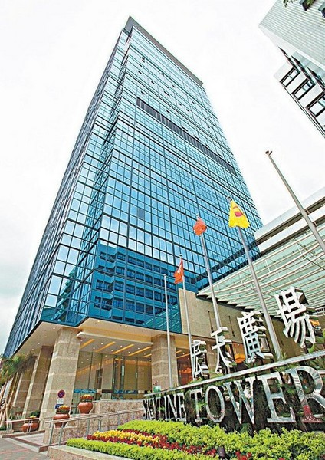

Business Nature of Housing Management?
Housing management is a “master of all trades” in its job nature, includes:
- Building repairs and maintenance;
- Management of the property environment;
- Property management services for owners, tenants and the community;
- Facility management;
- Law in practice;
- Finance and asset management; and
- Human resources management. (Yuen, 2011, p.73-74)
- Introduction
- The global awareness of environmental protection has been increasing
- To cope with company social responsibility and customers’ demand, private sectors already started to input environmental elements to their business models
- All measures and practices by the property management which contribute to environmental sustainability are regarded as green measures

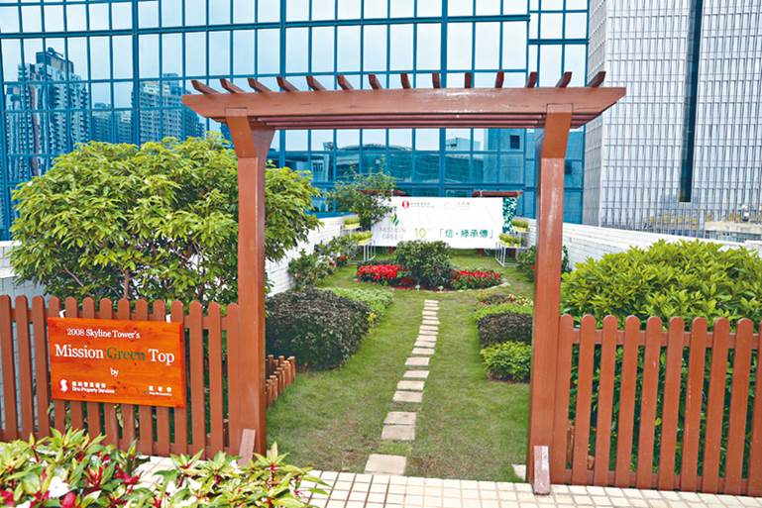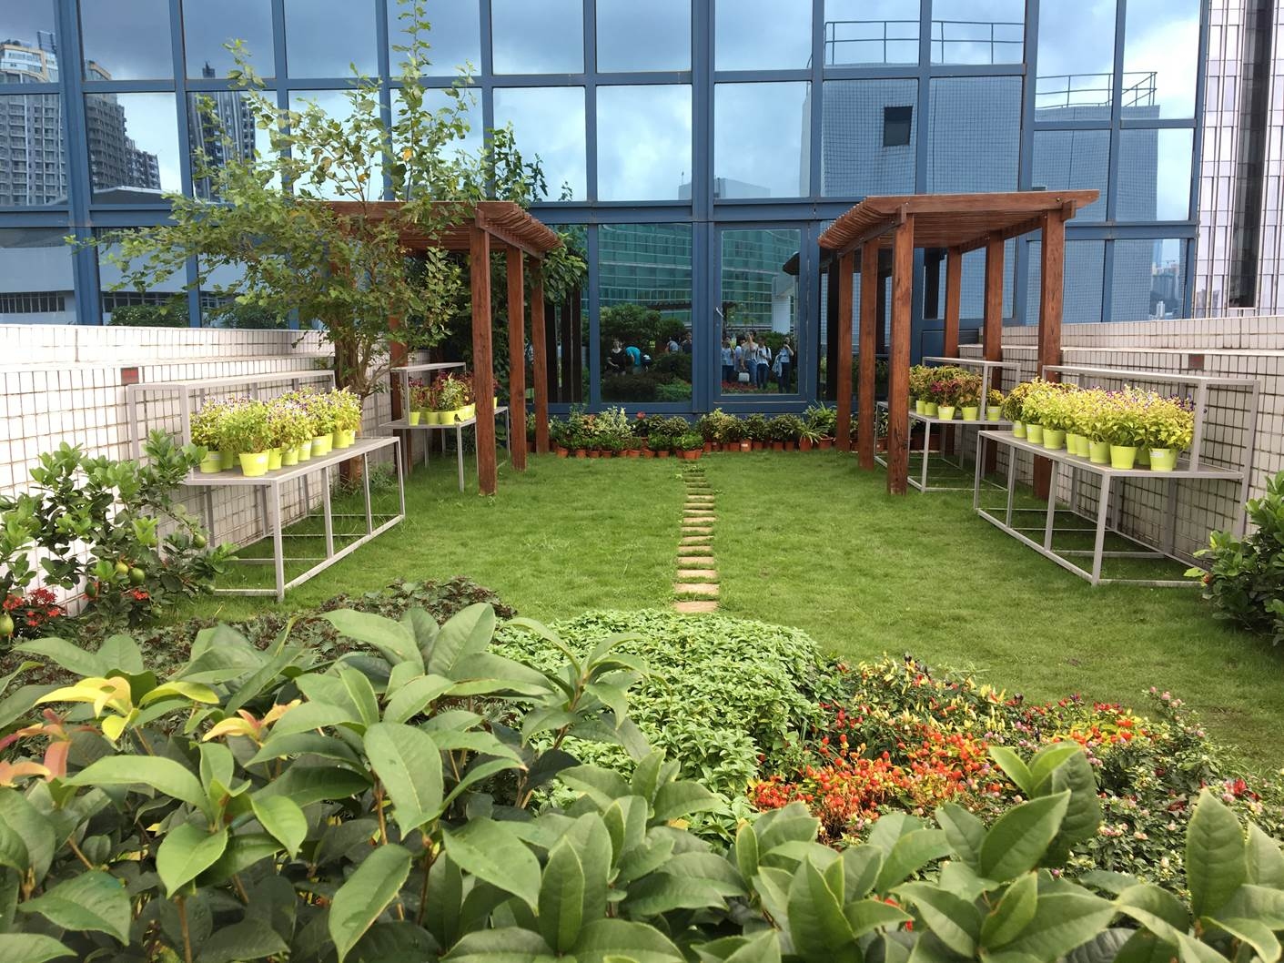

Green Measures of Skyline Tower

Green Rationale:
- Total Involvement – Encourage participation of staff and customers in environmental programs through newsletters, training programs and green activities
- User Friendliness – Use simple and practical measures to implement the green policies
- Eco Living – To make green practices a habit of the staff and customers

Skyline Tower has participated and got recognition in numerous green awards and competitions, such as HKAEE (Property Management), Low-carbon Office Operations Program (LOOP) Labelling Award by WWF Hong Kong, Program on Source Separation of Commercial & Industrial Waste by EPD, HSBC Living Business Award (Green Achievement) by HSBC and GREEN PLUS Award by CLP Power Hong Kong Limited.

- Research Objectives

- To evaluate on the role of office building in Hong Kong’s environmental/ sustainable development
- To examine how and why Skyline Tower implements green measures
- To reflect on the process and outcomes in implementing green measures for Skyline Tower that all stakeholders experienced or observed
- What key lessons can draw from the reflection for the future possibility of office building towards better green management and better social responsibility on environmental sustainability
- To suggest ways and give insights on achieving better green management as well as better synergy on improving environmental sustainability
- Significance of the Issues

- To focus on the green measures implemented by skyline Tower
- To examine the management teams’ effort on managing, operating and improving building environment (e.g. company mission and vision, cost and building’s marketing positions)
- To focus on how green implementations of office building can contribute to the society’s environmental/ sustainable development on both tangible physical improvement and intangible public awareness on environmental conservation

- Key Words

H1 Heart-related Literature:
Motivation, Leadership, Communication, Groups and Teams, Corporate Social Responsibility
- Communication is facilitated by internal platforms such as regular meetings, green notice board, internal publications and mobile communication group
- Green-related leisure activities are organized in promoting environmental protection including horticultural workshop, green lunch and eco-tour. Staff is educated in the green working environment
- Communication towards external stakeholders is carried out via different channels such as green report, notices to tenants as well as display inside building (e.g., LED TV and poster)

H2 Head-related Literature:
Resourced-based View, Balanced Scorecard,
- Adopting various measures in energy saving including replacement of low-efficiency lightings to LED and T5 fluorescent tubes, installation of motion sensors at staircases, using of LED exit signs and regular review of facilities operating hours, etc.
H3 Hand-related Literature:
Competence, Functional Strategy and Practice (Promotion, Operations & Technologies), Recruiting, Training and Coaching Skills
- Coaching staff through internal activities such as green academy as leisure activities in promoting staff’s green awareness

- Methodology
Green measures implemented by Skyline Tower will be accessed and analyzed through:

Green Leadership: Company and the management’s commitment in the pursuit of environmental sustainability as well as the communication between all levels of staff;

Program and Performance: Solid accomplishments on environmental sustainability, including regulatory compliance, environmental program implementation, air pollution and odour control, water conservation and wastewater control, waste management, energy conservation and carbon reduction, indoor air quality, noise control, housekeeping and landscaping.

Partner Synergy: Building’s effort on encouraging stakeholders to achieve synergy on environmental sustainability. Stakeholders include staff, visitors, tenants, suppliers and contractors, the government and the general public.

Qualitative Data Collection

- To interview with stakeholders to gather and collect the directions towards green management, as well as green measures adopted such as energy saving, waste management and awareness by the public
- To reflect on the process and outcomes of the green project that making Skyline Tower a green building that the stakeholders had experienced or observed

- Research Questions

- People’s recognition and awareness on building’s green measures (e.g. people may not relate environmental sustainability to an office building)
- People’s recognition on building’s green positioning (e.g. marketing positioning, even the building staff may not aware on building’s green measures since they don’t treat acting green as a traditional property management duty)
- People’s knowledge on the concept of green building (e.g. green elements/ contributions recognized by stakeholders?)
- Relationship between tenants’ choosing preference and green measures of the building (e.g. image? Or need to co-work with the building on recycling?)

- Recommendations and Conclusions

- Commitment from top management, staff to aware of their green duties and get used to a greener working habit and working culture
- Public disclosure of green achievements
- Synergy with tenants

https://enmobile.prnasia.com/releases/apac/sino-group-celebrates-10-anniversary-of-mission-green-thumb--248291.shtml

https://topick.hket.com/article/2369985/%E5%8C%A1%E6%99%BA%E6%9C%83%E5%A4%A5%E4%BF%A1%E5%92%8C%E7%B6%A0%E5%8C%96%E5%95%86%E5%BB%88%E5%A4%A9%E5%8F%B0%E3%80%80%E6%99%BA%E9%9A%9C%E5%AD%B8%E5%93%A1%E5%AD%B8%E5%9C%92%E8%97%9D%E5%8D%81%E5%B9%B4%E7%8D%B2%E8%81%98%E8%8A%B1%E7%8E%8B

